**TRAIN MODEL**

**INSTALLATION MANUAL**

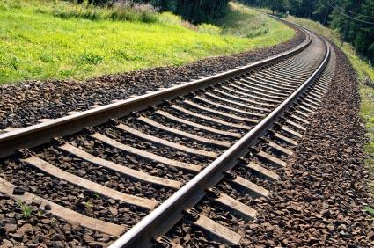

*This document contains the installation instructions for the Track Model Module of it Bits Please Train Control System

*The module has been tested extensively, but is not guaranteed to be without error.

In order to run:

* Ensure that your system is running Java 6 or any newer version.
* If download required, see here: <https://java.com/en/>
* To modify the Track, open the track file TrackM.txt in your favorite text editor. The formatting is as follows,

BlockID, BlockType, Tail, Head, BlockLength, Elevation%, SpeedLimit, BlockType(String), StationName, Crossing, Elevation, Underground.

Note that the Red Line is from block id 0 – 77 and the Green Line is from 78 – 229.