Bandana biswal

Abstract
This project presents a Python‑based password strength checker built using Tkinter. It evaluates password robustness through regex‑based scoring and provides real‑time visual feedback via a modern GUI interface. The tool aims to promote secure password practices by educating users on strength indicators and requirements.
PASSWORD STRENGTH CHECKER
Enhancing User Security Through Real-Time Password Evaluation

PASSWORD STRENGTH CHECKER USING PYTHON AND TKINTER

Abstract
- This project demonstrates a GUI-based password strength checker developed using Python’s Tkinter library. The application evaluates password robustness based on multiple criteria such as length, uppercase and lowercase letters, digits, and special characters. It provides real-time visual feedback through color-coded indicators and progress bars, helping users understand how secure their passwords are. The tool promotes awareness of password security and encourages users to create stronger, more resilient passwords.

Objective
- To design a user-friendly interface that evaluates password strength dynamically.
- To educate users on secure password creation practices.
- To implement regex-based validation for password components.
- To visualize password strength using color and progress indicators.

Tools and Technologies
Component | Description
Language | Python
Library | Tkinter (for GUI)
Module | re (Regular Expressions for pattern matching)
Platform | Windows
IDE | VS Code

Methodology
- Input Handling: The user enters a password in a Tkinter entry box.
- Regex Validation: The program checks for:
  - Minimum length (≥8 and ≥12 for bonus)
  - Uppercase letters [A-Z]
  - Lowercase letters [a-z]
  - Digits \d
  - Special symbols `[@$!%*?&#^()_+=\-{}
|:;"\'<>,./~]
- Scoring System: Each satisfied condition adds one point to the total score (max 6).
- Strength Classification:
  - 0–2 → Weak
  - 3–4 → Medium
  - 5–6 → Strong
- Visual Feedback:
  - A progress bar changes color (red → orange → green).
  - A checklist updates dynamically with filled circles for satisfied conditions.
  - A label displays the strength text.
- User Experience Enhancements:
  - Show/hide password toggle.
  - Dark-themed interface with accent colors.
  - Real-time updates as the user types.

Algorithm
- Start program
- Accept password input
- Initialize score = 0
- Check each condition using regex
- Increment score for each match
- Display strength level and update GUI elements
- End program

Code
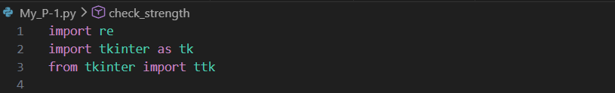

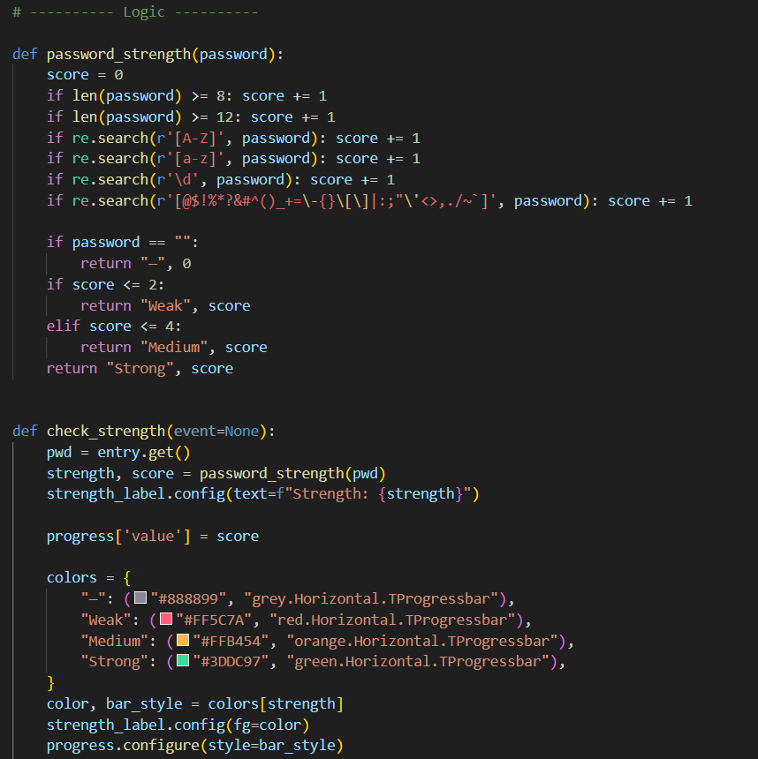
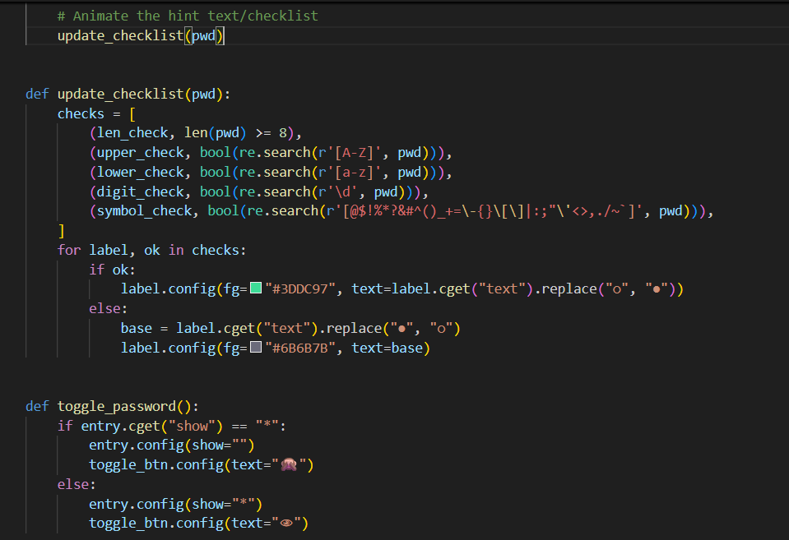

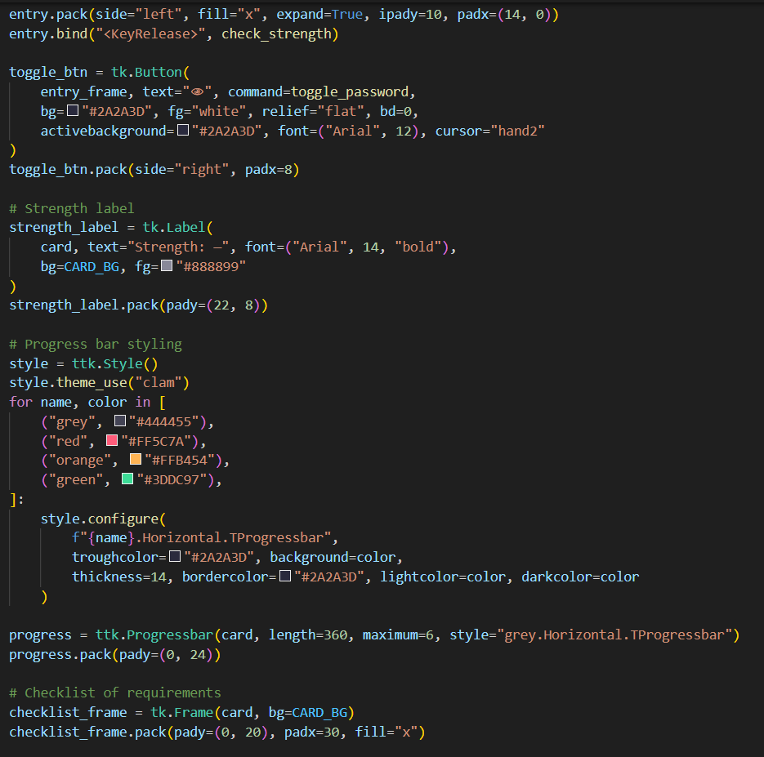
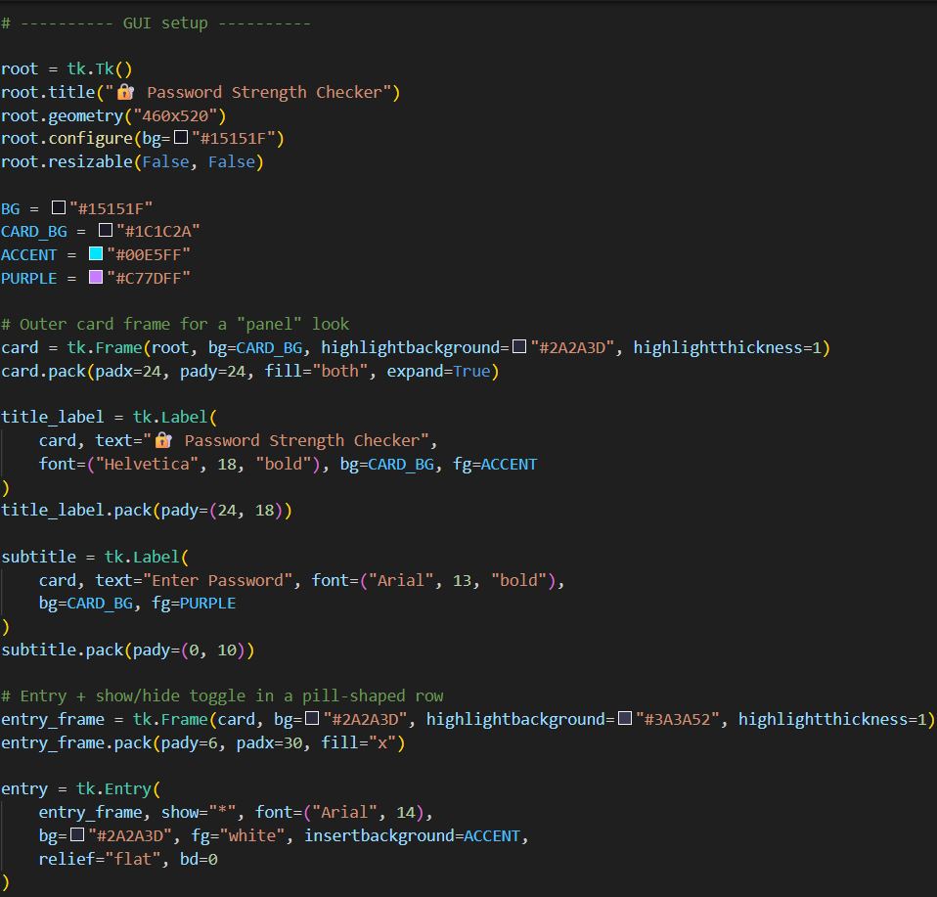

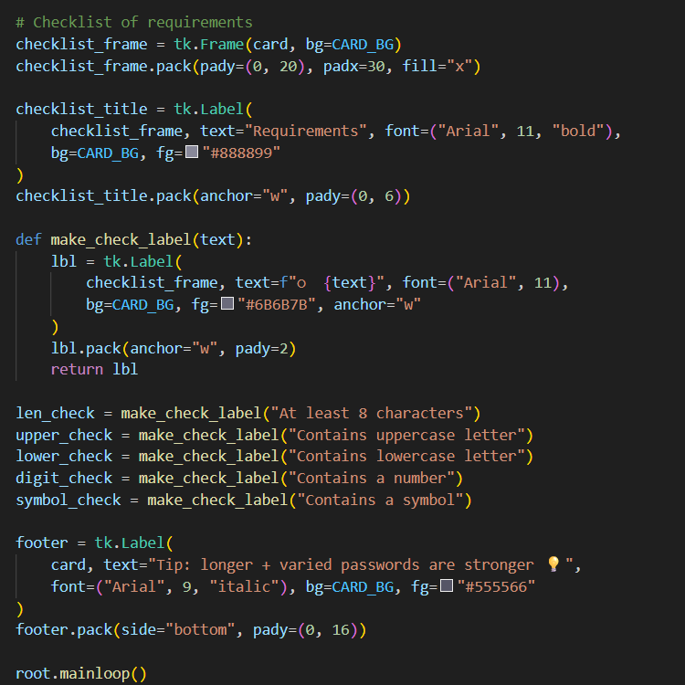

Output
The program displays:
- Weak → Red color, low progress
- Medium → Orange color, moderate progress
- Strong → Green color, full progress
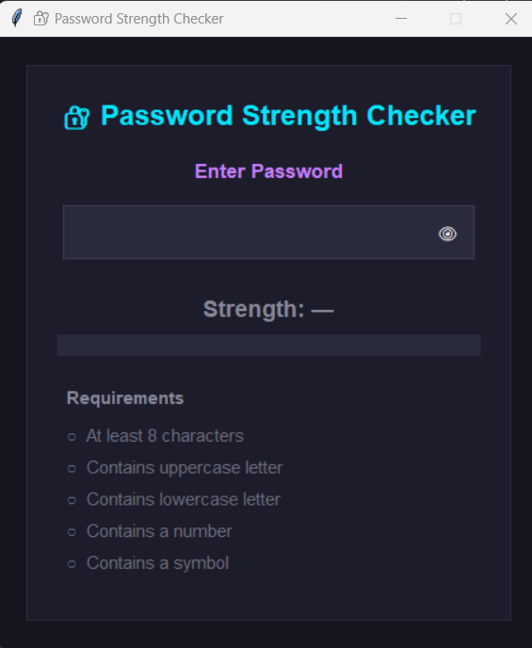
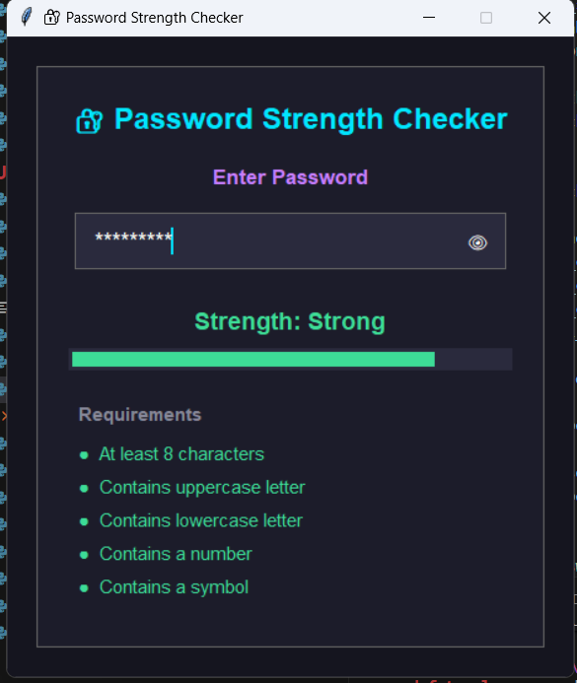
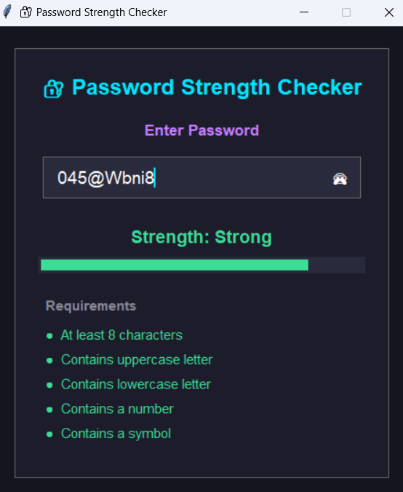
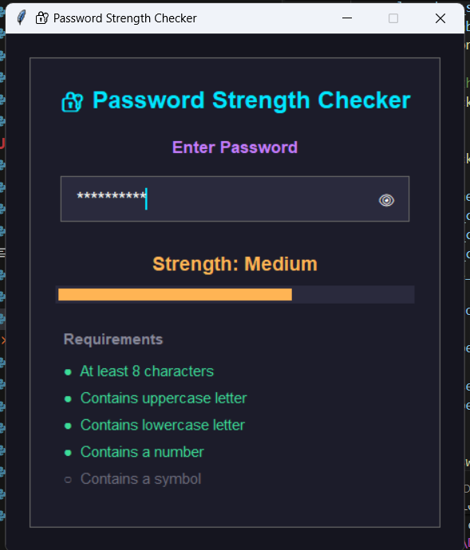
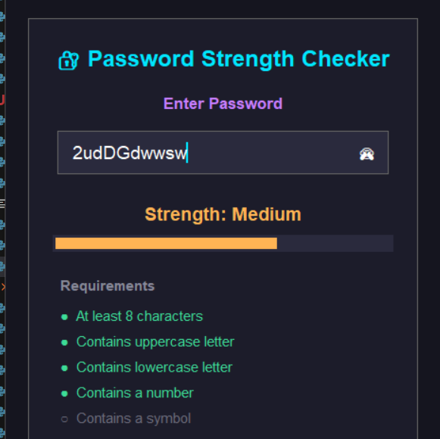
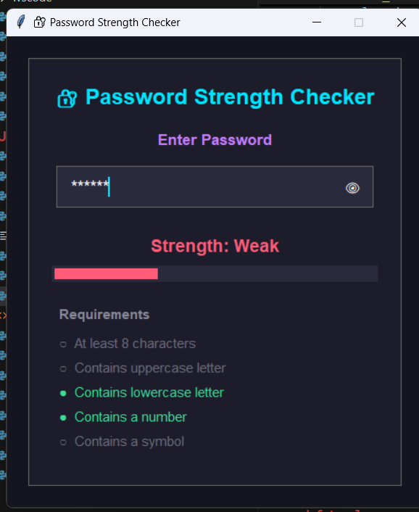
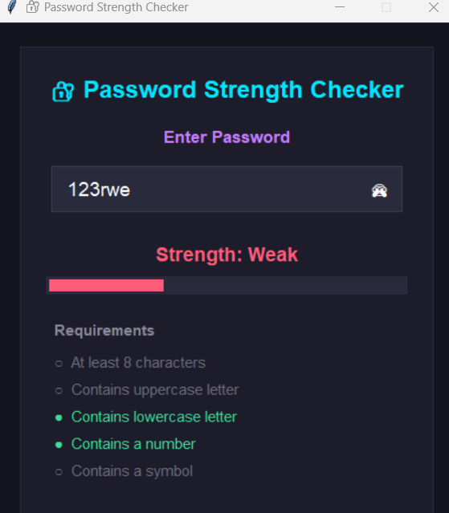

- Each requirement turns from ○ to ● when satisfied, providing instant feedback.

Conclusion
- This project successfully implements a visually appealing password strength checker that helps users understand password security principles. By combining Python’s regex capabilities with Tkinter’s GUI elements, the tool offers both functionality and aesthetics. It can be extended further to include password suggestions, entropy calculation, or integration with web forms.

Future Scope
- Add password generation feature.
- Integrate with web applications for real-time validation.
- Include entropy-based scoring for advanced analysis.
- Store user feedback or logs for usability testing.

