**Observations**

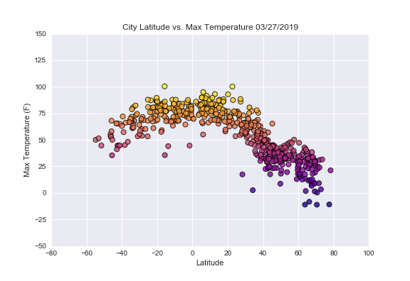**Latitude vs. Temperature**

The analysis of the latitude versus the maximum temperature is done on March 26, 2019. During this time of year the Northern hemisphere (latitude > 0°) is cooler than the Southern hemisphere (latitude < 0°).

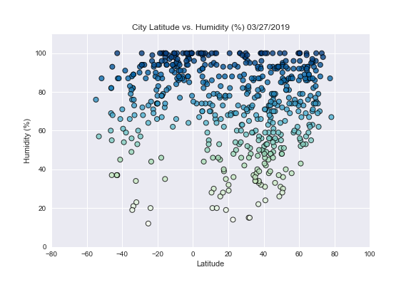**Latitude vs. Humidity**

The analysis of the latitude versus the humidity is done on March 26, 2019. Analysis of the data shows that latitude does not impact the percent humidity. However, the majority of the cities generated from the analysis had humidity levels greater than 60%.

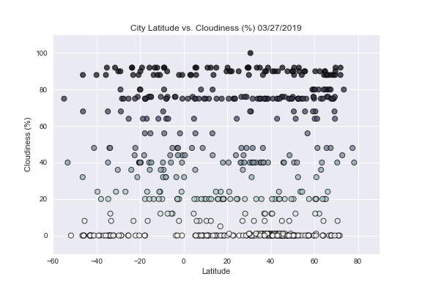**Latitude vs. Cloudiness**

The analysis of the latitude versus cloudiness is done on March 26, 2019. The data show that there is no relationship between latitude and cloudiness.

**Latitude vs. Wind Speed**

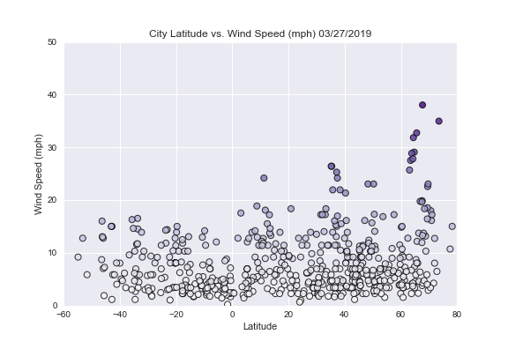The analysis of the latitude versus wind speed is done on March 26, 2019. On this day, the data show that the majority of the randomly generated cities had wind speeds <20 mph.