**COMP136 PP4 Report**

Beibei du

**Task 1: Gibbs Simpling**

|  |  |  |  |  |
| --- | --- | --- | --- | --- |
| based | night | rights | light | sky |
| torque | sho | shifter | clutch | car |
| matter | mph | blah | mustang | diesels |
| drive | lights | used | service | oil |
| satellite | oort | point | system | writes |
| even | extra | cost | make | don |
| back | george | people | moon | bill |
| sci | world | long | nasa | space |
| washington | apr | article | writes | edu |
| temperature | zoo | spencer | toronto | henry |
| spacecraft | information | internet | mars | science |
| redesign | option | shuttle | station | launch |
| steering | turbo | such | power | engine |
| shuttle | pat | solar | hst | mission |
| time | article | day | etc | large |
| nice | probe | driving | ford | car |
| two | book | price | want | car |
| geico | good | article | edu | insurance |
| incoming | ics | uci | gif | edu |
| toyota | buy | manual | small | cars |

**Task2 : Classification**

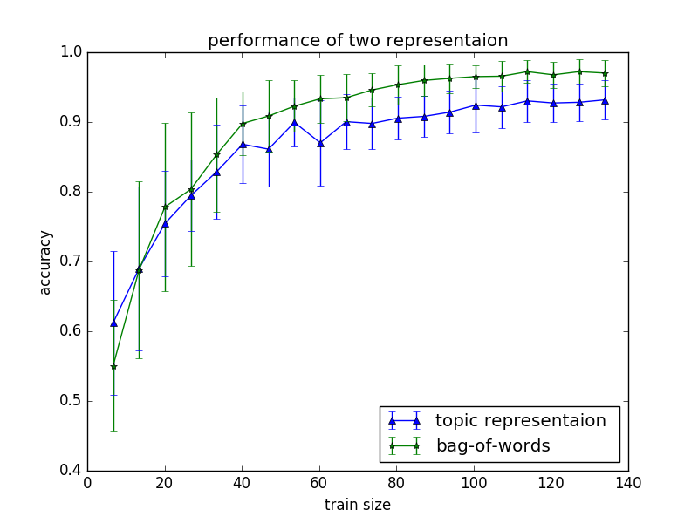

From figure above, we can see that when train size is small, two representations are relative close, when train size is bigger, both of them have accuracy more than 90% when train size is big , bag of words representation performs better. But bag-of-words representation have more features (405 in this example) than topic representation, run time is longer than topic representation (20 in this example). LDA can reduce dimension and performance not so bad.

import numpy as np

import random

from numpy.linalg import inv

from random import shuffle

import matplotlib.pyplot as plt

from collections import OrderedDict

import csv

import math

alpha_prime = 0.01

def read_file(filename):

with open(filename, 'r') as f:

content = f.read().split()

return content

def read_file_r(filename):

result = []

with open(filename, 'r') as f:

for line in f:

line = line.strip('\n').split(',')

result.append(line[1])

return result

##############################################################################

# discrimitive

##############################################################################

def compute_y (w0, phi):

a = np.dot(w0, phi)

return 1 / (1 + np.exp(-a))

# compute R

def compute_R(y):

r = map(lambda x: x * (1 - x), y)

return np.diagflat(r)

# compute w

def compute_w(phi, phi_tranpose, R, y, t, w0):

global alpha_prime

N = len(phi[0])

p1 = inv(np.dot(alpha_prime, np.identity(N)) + np.dot(np.dot(phi_tranpose, R), phi))

p2 = np.dot(phi_tranpose, (y-t)) + np.dot(alpha_prime, w0)

w1 = w0 - np.dot(p1, p2)

return w1

def compute_w_sN(data, data_label, tr_index):

global alpha_prime

phi = []

t = []

for i in tr_index:

phi.append(data[i])

t.append(data_label[i])

t = np.array(t).astype(float)

d = len(phi[0])

N = len(phi)

# add feature in the last row

phi_p = np.ones((N, d+1))

phi_p[:,:-1] = phi

phi = phi_p

w0 = [0] * (d + 1)

phi_tranpose = np.transpose(phi)

y = compute_y(w0, phi_tranpose)

R = compute_R(y)

# compute w1

w1 = compute_w(phi, phi_tranpose, R, y, t, w0)

sum1 = 1

n = 1

while n < 100 and sum1 >= 10 ** (-3):

w0 = w1

y = compute_y(w0, phi_tranpose)

R = compute_R(y)

w1 = compute_w(phi, phi_tranpose, R, y, t, w0)

sum1 = sum(np.square(np.subtract(w1, w0))) / sum(np.square(w0))

n += 1

y = compute_y(w1, phi_tranpose)

R = compute_R(y)

s = np.dot(np.dot(phi_tranpose, R), phi)

s0 = inv(np.identity(d + 1) / alpha_prime)

sN = inv(s0 + s)

return w1, sN

# compute error

def compute_accu(data, data_label, index_test, w_map, sN):

acc = 0

for te_i in index_test:

temp = data[te_i].tolist()

temp.append(1)

d = np.array(temp)

ua = np.dot(w_map, d)

sig_s = np.dot(np.dot(d, sN), d)

a = ua / math.sqrt(1 + np.pi * sig_s / 8)

if a >= 0:

if data_label[te_i] == '1':

acc += 1

else:

if data_label[te_i] == '0':

acc += 1

return acc / float(len(index_test))

#####################

def main():

filename = range(1, 201)

K = 20

N_iters = 500

data = []

doc_len = []

# array of document indices d_n

d_n = []

# array of initial topic indices z_n

z_n = []

for i in filename:

res = read_file(str(i))

doc_len.append(len(res))

temp = [str(i)] * len(res)

d_n += temp

data.append(res)

# array of words indices w(n)

words = [w for d in data for w in d]

print "number of words:"

print len(words)

vocab = list(set(words))

vocab = sorted(vocab)

print "vocab length"

print len(vocab)

word_indices = OrderedDict()

for v in vocab:

word_indices[v] = vocab.index(v)

#print word_indices

w_n = []

for word in words:

w_n.append(word_indices[word])

# total number of N_words

N_words = len(w_n)

# array of initial topic indices

for i in range(N_words):

z_n.append(str(random.choice(range(1, K+1))))

V = len(vocab)

alpha = float(50) / float(K)

alpha_1 = alpha * np.ones(K)

beta = 0.1

beta_1 = beta * np.ones(V)

# random permutation of N_words

pi_n = np.random.permutation(range(0, N_words))

# initialize a D * K matrix C_d

D = len(filename)

C_d = []

i = 0

k = 0

while i < N_words:

j = i

temp = [0] * K

end = j + doc_len[k]

while j < end:

temp[int(z_n[j]) - 1] += 1

j += 1

C_d.append(temp)

i = j

k += 1

# initialize a K * V matrix C_t

C_t = []

for i in range(K):

temp = [0] * V

C_t.append(temp)

for i in range(N_words):

topic = z_n[i]

topic_index = int(topic) - 1

word_index = w_n[i]

C_t[topic_index][word_index] += 1

# initialize a 1 * K array of probabilities P (to zero)

P = [0] * K

# step 5

for i in range(N_iters):

print i

for n in range(N_words):

index = pi_n[n]

word = w_n[index]

topic = z_n[index]

doc = d_n[index]

C_d[int(doc) - 1][int(topic) - 1] -= 1

C_t[int(topic) - 1][word] -= 1

for k in range(K):

p_1 = (C_t[k][word] + beta) / (V * beta + sum(C_t[k]))

p_2 = (C_d[int(doc)-1][k] + alpha) / (K * alpha + sum(C_d[int(doc) - 1]))

P[k] = p_1 * p_2

# normalize P

total = sum(P)

for k in range(K):

P[k] /= float(total)

#print C_t

r = random.uniform(0,1)

for k in range(K):

if r >= sum(P[:k]) and r <= sum(P[:k+1]):

topic = str(k+1)

break

z_n[index] = topic

C_d[int(doc) - 1][int(topic) - 1] += 1

C_t[int(topic) - 1][word] += 1

"""

print "z_n"

print z_n

"""

print "C_d and C_t"

print C_d

#print "C_t"

#print C_t

fre_word = []

for k in range(K):

fre = []

temp = sorted(range(len(C_t[k])), key = lambda x: C_t[k][x])

index_list = temp[-5:]

for index in index_list:

for key, val in word_indices.iteritems():

if val == index:

fre.append(key)

fre_word.append(fre)

print fre_word

file = open("topicwords.csv", "w")

wr = csv.writer(file, dialect = 'excel')

wr.writerows(fre_word)

file.close()

# Task2 Classification

# step1: prepare presentation

# topic representation

for d in range(D):

for k in range(K):

C_d[d][k] = (alpha + C_d[d][k]) / (K * alpha + sum(C_d[d]))

print "C_d representation:"

print C_d

# bag-of-words representation

C_b = []

for d in data:

d_v = []

order_vocab = OrderedDict()

for v in vocab:

order_vocab[v] = 0

for word in d:

order_vocab[word] += 1

for v in vocab:

d_v.append(order_vocab[v] / float(len(d)))

C_b.append(d_v)

print "C_b representation:"

print C_b

data_2 = []

data_2.append(C_d)

data_2.append(C_b)

# x, store length of train file for plot use

x = []

data_label = read_file_r('index.csv')

# i = 0, topic representation; i = 1, bag-of-words

error_list = []

for i in range(2):

data = np.array(data_2[i])

N = len(data)

x.append(N-int(N/3))

error_list_rep = []

index_N = range(N)

# run 30 times

for t in range(30):

# set up 1/3 data set index

te_N = int(N/3)

index_test = np.random.choice(N, te_N, replace = False)

# remain 2/3 train set

index_train = [v for j, v in enumerate(index_N) if j not in index_test]

tr_N = len(index_train)

# Record performance

splits = np.arange(0.05, 1.05, 0.05)

#splits = np.arange(0.2, 1.2, 0.2)

error_rate = []

for s in splits:

# train set index

tr_index = np.random.choice(index_train, int(s*tr_N), replace = False)

tr_label = []

for l in tr_index:

tr_label.append(data_label[l])

while (len(set(tr_label)) <= 1):

tr_index = np.random.choice(index_train, int(s*tr_N), replace = False)

tr_label = []

for l in tr_index:

tr_label.append(data_label[l])

# discrimitive

w_map, sN = compute_w_sN(data, data_label, tr_index)

# test file

accu = compute_accu(data, data_label, index_test, w_map, sN)

error_rate.append(accu)

error_list_rep.append(error_rate)

error_list.append(error_list_rep)

topic_error_list = error_list[0]

print len(topic_error_list)

vocab_error_list = error_list[1]

print "len vocab error list"

print len(vocab_error_list)

topic_mean = np.mean(topic_error_list, axis = 0)

topic_std = np.std(topic_error_list, axis = 0)

print "topic mean"

print topic_mean

vocab_mean = np.mean(vocab_error_list, axis = 0)

vocab_std = np.std(vocab_error_list, axis = 0)

print "vocab mean"

print vocab_mean

print "start to plot:"

splits = np.arange(0.05, 1.05, 0.05)

plt.figure(1)

x1 = x[0] * splits

plt.errorbar(x1, topic_mean, topic_std, marker = '^')

plt.errorbar(x1, vocab_mean, vocab_std, marker = '*')

plt.title('performance of two representaion')

plt.xlabel('train size')

plt.ylabel('accuracy')

plt.legend(['topic representaion ', 'bag-of-words'], loc = 0)

plt.savefig("task2_3.png")

plt.clf()

main()