# Musculoskeletal model

## Introduction

Different human walking models have been developed in different simulations environments. Wang [1]–[3] proposed a walking musculoskeletal model developed in a three-dimensional simulation environment (ODE), composed of rigid elements and muscles. The model developed was compared initially with SIMBICON model by Yin and Colleagues [4]. The parameters of the latter model were taken from Laszlo and Colleagues [5], that were used also by Wooten and Hodgins [6] and obtained by Dempster and Gaughran [7].

Figure 0‑1: Wang's model

Table 1: Rigid bodies properties: Inertia, mass and com position.

|  |  |  |  |  |  |  |  |  |  |  |
| --- | --- | --- | --- | --- | --- | --- | --- | --- | --- | --- |
| Rigid body | I11 [kg∙m2] | I22 [kg∙m2] | I33 [kg∙m2] | I12 [kg∙m2] | I13 [kg∙m2] | I23 [kg∙m2] | MASS [kg] | COM_X [m] | COM_Y [m] | COM_Z [m] |
| trunk | 0,355667 | 0,281527 | 0,224534 | -0,00066 | 0,046738 | 0,000573 | 19,73372 | -0,02687 | 0 | 0,418811 |
| head | 0,020577 | 0,025556 | 0,016009 | 0,000103 | -0,00455 | -0,00019 | 4,340525 | 0,044758 | 0 | 0,727415 |
| larm | 0,014082 | 0,013769 | 0,003605 | -0,00011 | 0,000609 | 0,003195 | 2,07099 | -0,04751 | 0,230317 | 0,420066 |
| lforearm | 0,003846 | 0,004819 | 0,001705 | -8,40E-05 | 0,001554 | 8,40E-05 | 1,106703 | 0,01435 | 0,29966 | 0,169661 |
| lhand | 0,000294 | 0,000326 | 0,000263 | 5,41E-05 | 6,18E-05 | -3,67E-05 | 0,340742 | 0,124985 | 0,28817 | -0,01471 |
| rarm | 0,014082 | 0,013769 | 0,003605 | 0,000113 | 0,000609 | -0,00319 | 2,07099 | -0,04751 | -0,23032 | 0,420066 |
| rforearm | 0,003846 | 0,004819 | 0,001705 | 8,40E-05 | 0,001554 | -8,40E-05 | 1,106703 | 0,01435 | -0,29966 | 0,169661 |
| rhand | 0,000294 | 0,000326 | 0,000263 | -5,41E-05 | 6,18E-05 | 3,67E-05 | 0,340742 | 0,124985 | -0,28817 | -0,01471 |
| pelvis | 0,172383 | 0,128551 | 0,137961 | -0,00103 | -0,01024 | 0,003287 | 13,92486 | -0,00933 | 0 | 0,055554 |
| lthigh | 0,116352 | 0,122695 | 0,0305 | 0 | 0 | 0 | 8,082408 | -0,01689 | 0,119198 | -0,16101 |
| lshank | 0,043804 | 0,044413 | 0,004433 | 0 | 0 | 0 | 3,222323 | -0,02189 | 0,127317 | -0,58163 |
| lfoot | 0,001314 | 0,003847 | 0,003659 | 0 | 0 | 0 | 1,172905 | 0,013716 | 0,109219 | -0,87142 |
| rthigh | 0,116352 | 0,122695 | 0,0305 | 0 | 0 | 0 | 8,082408 | -0,01689 | -0,1192 | -0,16101 |
| rshank | 0,043804 | 0,044413 | 0,004433 | 0 | 0 | 0 | 3,222323 | -0,02189 | -0,12732 | -0,58163 |
| rfoot | 0,001314 | 0,003847 | 0,003659 | 0 | 0 | 0 | 1,172905 | 0,013716 | -0,10922 | -0,87142 |
| ltoe | 8,71E-05 | 0,000871 | 0,000174 | 0 | 0 | 0 | 0,188729 | 0,136157 | 0,107308 | -0,89295 |
| rtoe | 8,71E-05 | 0,000871 | 0,000174 | 0 | 0 | 0 | 0,188729 | 0,136157 | -0,10731 | -0,89295 |

Table 2: Relative positions between joints and link COMs by Wang..

|  |  |  |  |
| --- | --- | --- | --- |
| Relative positions between joints and link COMs | X [m] | Y [m] | Z [m] |
| neck - trunk | 0,030144 | 0 | 0,222712 |
| head - trunk | 0,041488 | 0 | 0,085892 |
| lshoulder - trunk | -0,02392 | 0,16471 | 0,079314 |
| larm - lshoulder | 0,003289 | 0,065607 | -0,07806 |
| lelbow - larm | 0,030199 | 0,052112 | -0,16104 |
| lforearm - lelbow | 0,031657 | 0,017231 | -0,08937 |
| lwrist - lforearm | 0,078953 | -0,00262 | -0,14279 |
| lhand - lwrist | 0,031682 | -0,00887 | -0,04158 |
| rshoulder - trunk | -0,02392 | -0,16471 | 0,079314 |
| rarm - rshoulder | 0,003289 | -0,06561 | -0,07806 |
| relbow - rarm | 0,030199 | -0,05211 | -0,16104 |
| rforearm - relbow | 0,031657 | -0,01723 | -0,08937 |
| rwrist - rforearm | 0,078953 | 0,002617 | -0,14279 |
| rhand - rwrist | 0,031682 | 0,008873 | -0,04158 |
| back - trunk | -0,01936 | 0 | -0,22048 |
| pelvis - back | 0,036908 | 0 | -0,14277 |
| lhip - pelvis | -0,00756 | 0,117592 | -0,03764 |
| lthigh - lhip | 0 | 0,001606 | -0,17892 |
| lknee - lthigh | -0,005 | 0,002567 | -0,23786 |
| lshank - lknee | 0 | 0,005552 | -0,18277 |
| lankle - lshank | 0 | -0,01752 | -0,23817 |
| lfoot - lankle | 0,035607 | -0,00057 | -0,05162 |
| lball - lfoot | 0,098725 | 0,000574 | -0,02034 |
| ltoe - lball | 0,023716 | -0,00248 | -0,00118 |
| rhip - pelvis | -0,00756 | -0,11759 | -0,03764 |
| rthigh - rhip | 0 | -0,00161 | -0,17892 |
| rknee - rthigh | -0,005 | -0,00257 | -0,23786 |
| rshank - rknee | 0 | -0,00555 | -0,18277 |
| rankle - rshank | 0 | 0,017524 | -0,23817 |
| rfoot - rankle | 0,035607 | 0,000574 | -0,05162 |
| rball - rfoot | 0,098725 | -0,00057 | -0,02034 |
| rtoe - rball | 0,023716 | 0,002485 | -0,00118 |

Zatsiorsky and Seluyanov collected data such as mass, length and inertia [8]. A detail review of available anthropometric data was done by Leva and Dumas [9], [10] to adjust measurement collected by earlier works by Zatsiorsky, McConville and Young. In the following, anthropometric data proposed by De Leva were considered as are the reference for human movement studies Table 1.

Table 3: anthropometric data for masculine subject by (Table 4 Leva 1996). Inertia values of hip and shoulders are included in the body of the trunk.

|  |  |  |  |  |  |  |
| --- | --- | --- | --- | --- | --- | --- |
| Segment | Mass [% of 73 Kg] | Radii of gyration sagittal (Z)[%] | Radii of gyration transverse (X) [%] | Radii of gyration longitudinal (Y)[%] | Length [m] | COM (from proximal) [%] DIRECTION X: IN LOCAL COORDINATE OF THE BODY |
| Head | 6.94 | 31.2 | 0.36.2 | 37.6 | 0.3143 | 0.5976 |
| Arm | 2.71 | 15.8 | 0.28.5 | 26.9 | 0.2817 | 0.5772 |
| Forearm | 1.62 | 12.1 | 0.27.6 | 26.5 | 0.2689 | 0.4574 |
| Hand | 0.061 | 40.1 | 0.62.8 | 51.3 | 0.0862 | 0.7900 |
| Trunk | 43.46 | 19.1 | 0.37.2 | 34.7 | 0.5319 | 0.4486 |
| Thigh | 14.16 | 14.9 | 0.32.9 | 32.9 | 0.4222 | 0.4095 |
| Shank | 4.33 | 10.3 | 0.25.5 | 24.9 | 0.434 | 0.4459 |
| Foot* | 1.37 | 0.124 | 0.257 | 0.245 | 0.1 | 0.4415 |
| Toes * |  |  |  |  | 0.06 |  |
| Hip |  |  |  |  | 0.3* |  |
| Shoulders |  |  |  |  | 0.45* |  |

*Foot and toes values to be checked (coming from Isman and Inman, 1969’, ‘Lee et al., 2011’ and ‘Zatsiorsky, 2002’.

Figure 0‑2: Actual newton Dynamic model.

## Type Hill’s muscle

Figure 1 describes the type Hill’s muscle model used in this work [3]. The force generated by type Hill’s muscle is defined as:

|  |  |  |
| --- | --- | --- |
|  |  | () |

where and $F^{PE}$ are the forces generated by the contractile element and the parallel element respectively, expressed as:

|  |  |  |
| --- | --- | --- |
|  |  | () |
|  |  | () |

is a function of the actuation level $a$, the maximum force that the muscle can exert $F^{0}$, the length of the contractile element $f_{l}\left({\tilde{l}}^{CE}\right)$ and its contraction velocity $f_{v}\left({\tilde{v}}^{CE}\right)$. $a$ is a value between 0 and 1 and is a function of the neural actuation and will be described the following chapter. $F^{0}$ depends on the actuated muscle and is derived from literature. $f_{l}$ is expressed by the following formula:

|  |  |  |
| --- | --- | --- |
|  |  | () |

is the length of the contractile element normalized by its optimal length $l_{opt}$, defined when the muscle can exert the maximum force $F^{0}$. In detail:

|  |  |  |
| --- | --- | --- |
|  |  | () |

is expressed by to different formulas, depending if the muscle flexes (Hill’s formula) or extends (Aubert’s formula):

|  |  |  |
| --- | --- | --- |
|  |  | () |

where is the maximum contraction velocity of the muscle derived by literature and ${\tilde{v}}^{CE}$ is the contraction velocity on the contractile element normalized by $l_{opt}$, in detail:

|  |  |  |
| --- | --- | --- |
|  |  | () |

The parallel force to the contractile element is the sum of the contribution of the lower parallel element (LPE), that prevents the CE contracting below reasonable limit, and the higher parallel element (HPE) that is the equivalent stiffness of the muscle. In detail:

|  |  |  |
| --- | --- | --- |
|  |  | () |
|  |  | () |

A damper in parallel to the contractile element prevents a singularity in the following equilibrium equation when the muscle is deactivated (a = 0). The damping value is small (β=0.01) since the water content the muscle is 82.3% (ref).

|  |  |  |
| --- | --- | --- |
|  |  | () |

where

and $F^{SE}$ is the force exerted by the tendon modeled by the element in series (SE) with the contractile element expressed as :

|  |  |  |
| --- | --- | --- |
|  |  | () |

where is the length of the series element normalized by slack length of the tendon ($l_{slack}$), derived from literature. In detail:

|  |  |  |
| --- | --- | --- |
|  |  | () |

Where .

SE exerts a force if its length is higher than the slack length of the tendon, else no force is generated by SE. Also $F^{LPE}$ is different from zero if the CE contracts below the 44% of $l_{opt}$. Finally, $F^{LPE}$ is different from zero if $l_{CE}$ is bigger than $l_{opt}$.

For a given muscle, the length is defined as:

|  |  |  |
| --- | --- | --- |
|  |  | () |

where is the set of joints attached to the muscle, $θ$ is the joint angle and $Δ^{i}$ expresses the length variation of the muscle according to joint angles.

For the hip:

|  |  |  |
| --- | --- | --- |
|  |  | () |

while for knee and ankle:

|  |  |  |
| --- | --- | --- |
|  |  | () |

Where accounts for the pennation angles, $ϕ^{M}$ is defined as the joint angle with the maximum moment arm and $ϕ^{R}$ is the joint angle without length variation ($Δ^{i}=0$).

Since $l^{MTU}$ is completely defined by the geometry of the muscle model, $l_{CE}$ is the only quantity to be computed.

### Implicit integration method

Each time step, find the increment $Δl$ of ${\tilde{l}}^{CE}$ which satisfies the equilibrium equation (10) by using a Newton-Raphson algorithm. The integration method is the same described in [11] for elastic-tendon muscle.

* Initialize $Δl=Δl_{0}$
* Compute the error $ε= F^{CE}+F^{HPE}-F^{LPE}+F^{DE}-F^{SE}$ with formulas from 2 to 12.
* Compute the derivative of the error with respect to $Δl$ as:

$\frac{dε}{dΔl}= {\frac{dε}{dΔl}(F}^{CE}+F^{HPE}-F^{LPE}+F^{DE}-F^{SE})$.

$${\frac{dε}{dΔl}F}^{CE}\left(Δl,\frac{Δl}{Δt}\right)=a∙F_{0}∙\left(\frac{df_{l}}{dΔl}\left(Δl\right)∙f_{v}\left({\tilde{v}}^{CE}\right)+f_{l}\left({\tilde{l}}^{CE}\right)∙\frac{df_{v}}{dΔl}\left(\frac{Δl}{Δt}\right)\right)$$

where

$$\frac{df_{l}}{dΔl}\left(Δl\right)= e^{\left(\ln\left(0.05\right){\left({0.56}^{-1}\left({\tilde{l}}^{CE}-1\right)\right)}^{4}\right)}∙ \frac{4 ∙\ln\left(0.05\right)}{l_{opt}∙{0.56}^{4}}∙{\left[\frac{{(l}_{CE}-Δl)}{l_{opt}}-1\right]}^{4}∙{\left(\frac{l_{CE}+Δl }{l_{opt}}-1\right)}^{3}$$

$$\frac{df_{v}}{dΔl}\left(Δl\right)=\frac{6 ∙v_{m}}{l_{opt}∙Δt}{\left(-v_{m}+5 \frac{Δl}{l_{opt}∙Δt}\right)}^{-2}if v_{ce}<0$$

$$\frac{df_{v}}{dΔl}\left(Δl\right)=\frac{38.8 ∙v_{m}}{2 ∙ l_{opt}∙Δt}∙{\left(37.8 \frac{Δl}{l_{opt}∙Δt}+v_{m}\right)}^{-2}if v_{ce}≥0$$

$$\frac{d}{dΔl}F^{HPE}\left(Δl\right)=\frac{2∙F_{0}∙{0.56}^{-2}}{l_{opt}} \left(\frac{l+Δl}{l_{opt}}-1\right)$$

$$\frac{d}{dΔl}F^{LPE}\left(Δl\right)=\frac{2}{{l_{opt}∙0.28}^{2}}\left(0.44-\left(\frac{l+Δl}{l_{opt}}\right)\right)$$

$$\frac{d}{dΔl}F^{SE}\left(Δl\right)=\frac{2}{l_{slack}∙{0.04}^{2}}\left(\frac{l_{mtu}-(l+Δl)}{l_{slack}}-1\right)$$

$$\frac{d}{dΔl}F^{DE}\left(Δl\right)=\frac{β}{l_{opt}∙Δt}$$

* Update $Δl=Δl-\frac{ε}{\frac{dε}{dΔl}}$
* Iterate the computation while $ε>{10}^{-3}$
* Then apply use force $F^{SE}$ to compute the mono-articular muscle torque, according to

$$τ=F^{SE}*arm*cos⁡(ω-θ)$$

Where $arm$ and $θ$ are muscle parameters [12] and $ω$ is the joint angle.

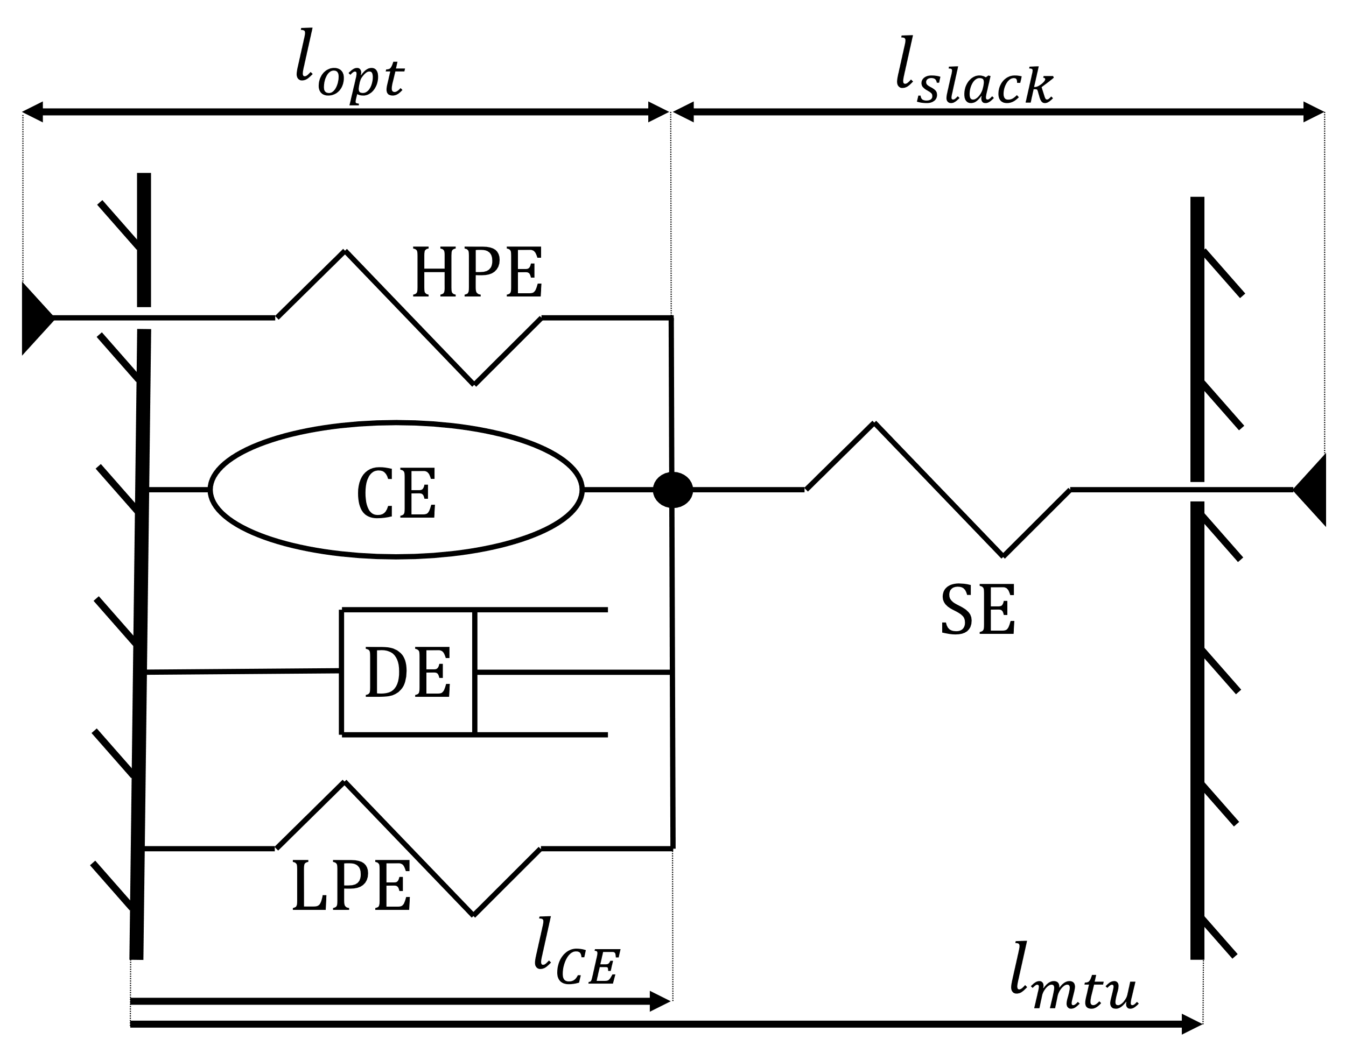

Figure 1: Type Hill's muscle with contractile element (CE), higher parallel elasticity (HPE) , lower parallel elasticity (LPE) and series elasticity (SE).

## Bibliography

[1] J. M. Wang, D. J. Fleet, and A. Hertzmann, “Optimizing walking controllers,” *ACM Trans. Graph.*, vol. 28, no. 5, pp. 1–8, 2009, doi: 10.1145/1661412.1618514.

[2] J. M. Wang, D. J. Fleet, and A. Hertzmann, “Optimizing walking controllers for uncertain inputs and environments,” *ACM Trans. Graph.*, 2010, doi: 10.1145/1833351.1778810.

[3] J. M. Wang, S. R. Hamner, S. L. Delp, and V. Koltun, “Optimizing locomotion controllers using biologically-based actuators and objectives,” *ACM Trans. Graph.*, vol. 31, no. 4, 2012, doi: 10.1145/2185520.2185521.

[4] K. Yin, K. Loken, and M. Van De Panne, “SIMBICON: Simple biped locomotion control,” in *Proceedings of the ACM SIGGRAPH Conference on Computer Graphics*, 2007, doi: 10.1145/1275808.1276509.

[5] J. Laszlo, M. Van De Panne, and E. Fiume, “Limit cycle control and its application to the animation of balancing and walking,” in *Proceedings of the 23rd Annual Conference on Computer Graphics and Interactive Techniques, SIGGRAPH 1996*, 1996, doi: 10.1145/237170.237231.

[6] W. L. Wooten and J. K. Hodgins, “Simulation of human diving,” in *Proceedings - Graphics Interface*, 1995.

[7] W. T. Dempster and G. R. L. Gaughran, “Properties of body segments based on size and weight,” *Am. J. Anat.*, 1967, doi: 10.1002/aja.1001200104.

[8] V. M. Zatsiorsky and V. N. Seluyanov, “MASS AND INERTIA CHARACTERISTICS OF THE MAIN SEGMENTS OF THE HUMAN BODY.,” in *International Series on Biomechanics*, 1983, vol. 4 B, pp. 1152–1159.

[9] P. de Leva, “Technical Note: Adjustment to Zatsirosky-Seluyanov’s segment inertia parameters,” *J. Biomechanics*, vol. 29, no. 9. pp. 1223–1230, 1996.

[10] R. Dumas, L. Chèze, and J.-P. Verriest, “Adjustments to McConville et al. and Young et al. body segment inertial parameters,” *J. Biomech.*, vol. 40, no. 3, pp. 543–553, 2007, doi: 10.1016/j.jbiomech.2006.02.013.

[11] M. Millard, T. Uchida, A. Seth, and S. L. Delp, “Flexing Computational Muscle: Modeling and Simulation of Musculotendon Dynamics,” *J. Biomech. Eng.*, vol. 135, no. 2, Feb. 2013, doi: 10.1115/1.4023390.

[12] H. Geyer and H. Herr, “A Muscle-reflex model that encodes principles of legged mechanics produces human walking dynamics and muscle activities,” *IEEE Trans. Neural Syst. Rehabil. Eng.*, vol. 18, no. 3, pp. 263–273, 2010, doi: 10.1109/TNSRE.2010.2047592.