מחצית המסע המשותף שלנו

User Stories

US-NEW:
Multi-select buildings - export building cards to a PowerPoint (next semester)
As a viewer, I want to multi-select buildings from the buildings table and export a PowerPoint containing the building cards for the selected buildings, so that I can quickly prepare presentations for the municipality/client.

Export to Excel
As a municipality staff user (admin/editor), I want to export the buildings table (optionally with current filters) to an Excel file, so that I can keep a backup of the database locally, and restore it later via “import from excel”.

Removed User Story:
Remove logs
As an admin, I should not be able to remove logs (log records are immutable).
The original HLD allowed an Admin to delete log entries as per client request.
We removed this requirement: admins must not be able to remove logs, and logs are treated as immutable, append-only records. This strengthens traceability/auditability

מה היה ה POC שלכם ב- HLD ואיך עמדתם בבחינה שלו.

3.2 POC recognition
A Proof of Concept (POC) will be developed to validate a critical functional requirement of the system: the ability to ingest existing municipal data into the new application. The POC will focus specifically on importing data from an Excel file into the system’s database.
Objective: Verify that the system can reliably read, parse, and migrate abandoned-building records from legacy Excel spreadsheets into the SQL Server database that will be used in the final application. // verified

Scope
The POC demonstrated the following:
- Excel File Parsing
  - Correct extraction of rows, columns, and data types. // done
  - Handling of Hebrew text and right-to-left formatting. // done
- Data Validation
  - Identifying missing fields, incorrect formats, and invalid values. // done
  - Ensuring required fields (e.g., building ID, address) are consistent. // done
- Database Import Workflow
  - Mapping Excel fields to database schema. // done
  - Writing validated data into SQL Server tables. // writing done, validate in progress
  - Preventing duplicate entries through primary key or unique field checks. // still in doing
- Error Handling and Reporting
  - Reporting invalid rows. // still in doing

Outcome
The POC successfully confirmed that:
- Existing Excel data can be used as a reliable source for initializing the new system. // yes
- Full-scale data migration is feasible with minimal risk. // yes
- The planned backend and database architecture supports structured data ingestion. // yes
- Hebrew-text records are parsed and stored correctly. // yes

איתור סיכון נוכחי לפרוייקט
אינטגרציה בשרתים של הערייה

ניהול סיכונים במצב הפרוייקט הנוכחי
הסיכון | חומרת הסיכון לפרויקט | סבירות שהסיכון יתממש | דרך טיפול | חומרת הסיכון אחרי טיפול | סבירות הסיכון אחרי טיפול
There is a risk that external municipal systems (GIS, CRM-106, Water, Property Tax) may have unstable APIs, downtime, or schema changes. | High | Medium | Build a modular integration layer that abstracts each external system. Implement retry logic, fallback batch processing, data-staleness indicators in the UI, and monitor data feed health continuously. | Low | Medium
Integration with the municipality’s identity provider (SSO and MFA) may face delays, unexpected policy constraints, or outages. | High | Medium | Schedule a kickoff meeting with the IDP/IT team to gather requirements and obtain sandbox access. Establish scoped interface contracts and early prototype login flow. Deploy a temporary fallback authentication service for internal testing until full IDP integration is verified. Set up monitoring of IDP SLA and establish escalation paths with the provider. | Low | Low
Heavy search/filter operations on buildings and log records may degrade system response time and affect user experience. | Medium | Medium | Design database indexes and query plans in advance for high-filter usage. Implement pagination and default limits, caching of frequent queries, and conduct early load testing with realistic volumes. Monitor key performance metrics post-deployment and tune as needed. | Medium | Low
Incorrect role or permission configuration could allow unauthorized edits or data access, jeopardizing data integrity and compliance. | High | Low | Define the role model (Viewer, Editor, Admin) clearly in the requirements. Implement Role-Based Access Control (RBAC) at API gateway/middleware. Conduct a permission review and penetration test before launch, and log all permission-change actions for audit. | Medium | Low
Differences between staging and production (container versions, database config) may lead to failures after deployment. | Medium | Low | Standardize environments using infrastructure-as-code (Docker Compose). Maintain version control for infrastructure. Run automated smoke tests after deployment. Ensure roll-back capability is in place. | Low | Low
External dependencies (data access approvals, municipal IT coordination) may delay critical milestones and impact delivery schedule. | Medium | Medium | Build schedule buffers for external dependency tasks. Track dependencies in the project plan. Prioritize long-lead tasks (e.g., API keys, data access contracts) early and monitor progress. | Medium | Low

דיאגרמות

Use case
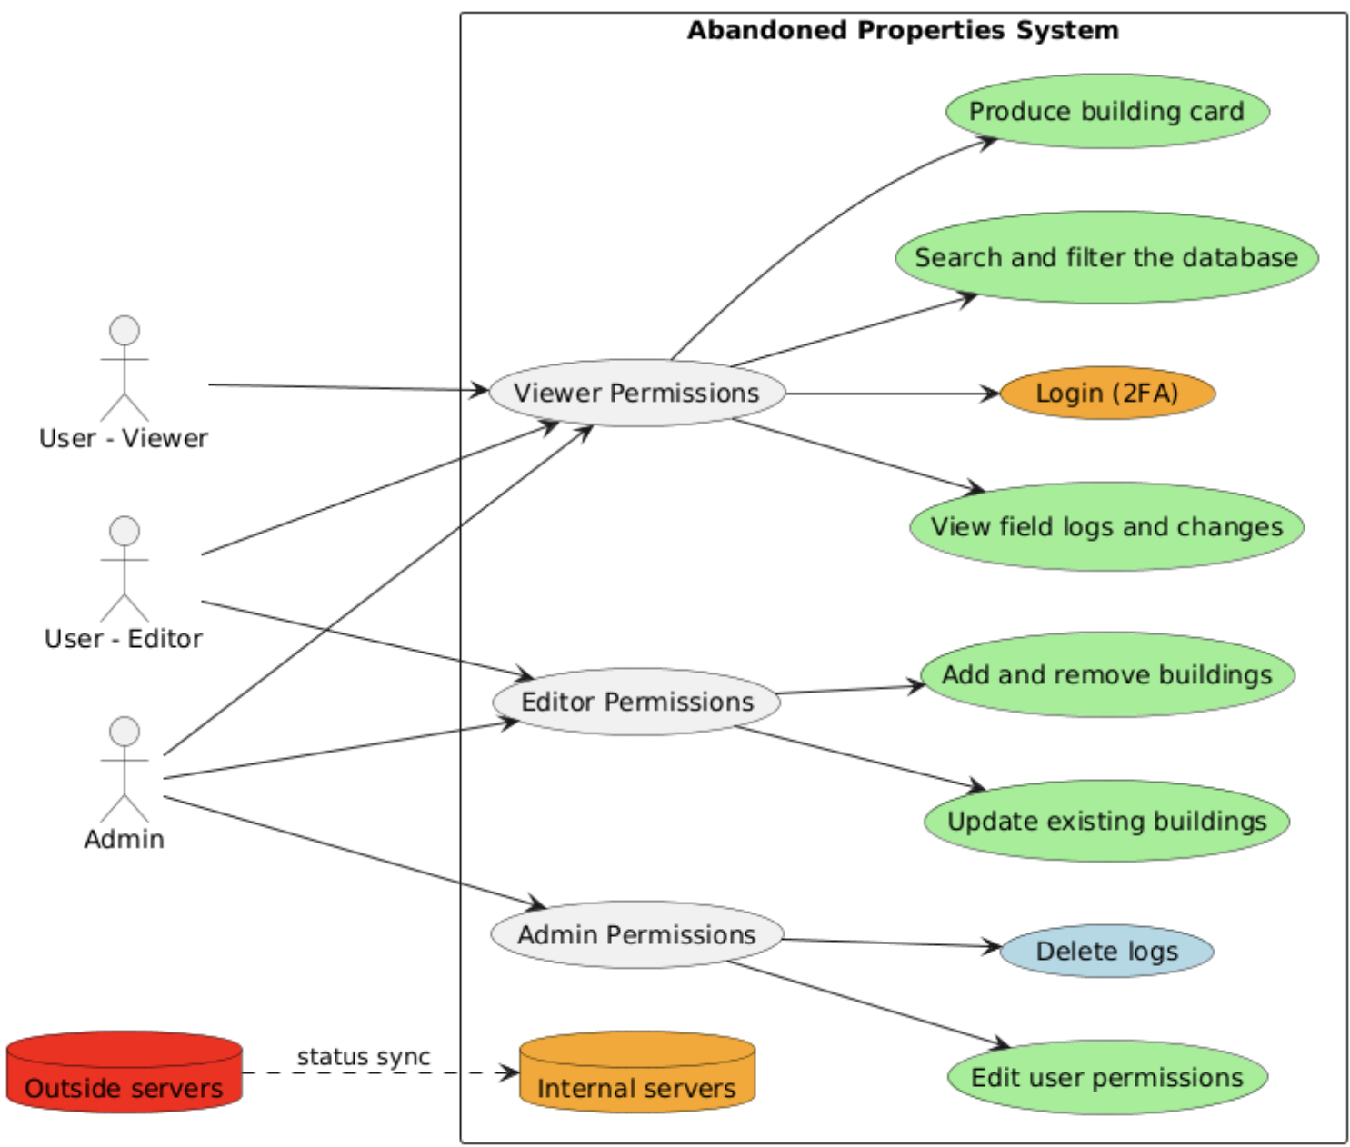
ירוק = סיימנו
כתום = בתהליך
אדום = לא התחלנו
כחול = הלקוח ביקש ואז ביטל
וורוד = בשביל היופי

Class
https://www.plantuml.com/plantuml/png/bLLDRzim3BthLmYv31WGOBjtGTCbmmAa6r2ds9cnYLQ8B1aItJNx-E-BsZ2o8yTQVKWiyebyZoBbQq_WgAsry3jb6d1GorA3ztCYfxOjuQgqfb2_K7uGuftyDFmSF9-j8MUrHkT7S0AsdXoKz9f5pXiLDzw0Ho6EZfOUe-Tel6cLhfHvy8bdRGUCznvTQlsAe7knHK92NlsPJiyf3ACYfooKIMPGp3e3IsNq-ShfT2OtTeUcGFUaIXpq_xHVe2JhHZ213xl5kLe6pPjciGqsVARBeBPIT0grjkDHH2p489d4dwGORzW54CWrxD6DmBWREyJaRo4Fps9R85snrDc0RMrxvaECmBXd2coNXjn-9lvohWAn2jo4uBUaDXbbjxP2xVEgcEXHaJ8aLzNBgoSNxD-Wnh0-8Gi2Qhry_OkKe-8qLgWpRbIDClnuWhhffhX5x-41arYSQenQt1GBUN73l2HbpGL6CTBocT0PqCNU4zQ5WSO_MXfHTOVa53vXDQSOvNZM5yaiQr0wmWFspchCgZsTsEJZvAKh9kydtUf7G73sIocOLDZ3UpbpRbOstpFzn7VsWgm_EycEQMrvnRB3CfFyECvv0ltfxvzdcADXJx4tvG_hTlo1Y9Tcn2RtP1J05j5DdauiGmUTvoGPDDoC8cNEw4Hg2dthPN9FIYjI_rF-bNU0Eao5k4PJjRN-1m00

Deployment - רצוי
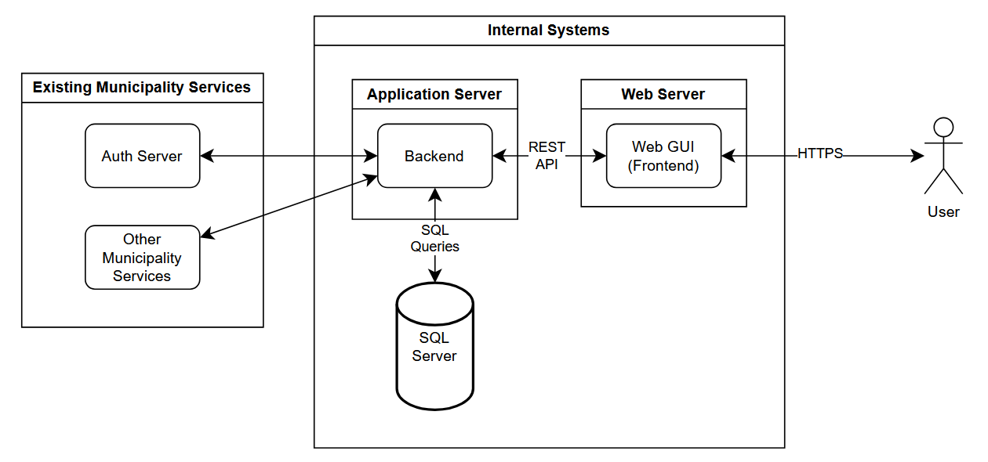
The system is built around a central Backend that connects all components. The User interacts with the system through the Web GUI (Frontend), which sends all requests to the Backend. The Backend performs business logic and communicates with:
- SQL Server for all data storage and retrieval.
- Auth Server (Provided by the client) to authenticate existing municipality users.
- Other Municipality Services (Provided by the client) for data integration with existing municipal systems.
The diagram shows a simple, service-oriented flow: the user works through the GUI, the GUI talks to the Backend, and the Backend handles all external system interactions.

Deployment - מצוי
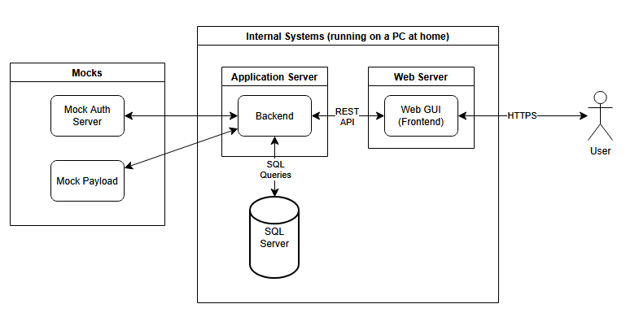
At the moment the server is running on a PC at home, with all the municipality services replaced by mocks (2FA, arnona, water…) and some not yet implemented (citizen complaints, GIS…).

