## FHIR Converter technical note

This document describes the FHIR converter/Transformer “toolkit” developed by the BBMRI-IT team to support the Transform step of the ETL process.

The toolkit is based on the open source FHIR RESOURCES library available at <https://github.com/nazrulworld/fhir.resources>

The main modules of the converter are:

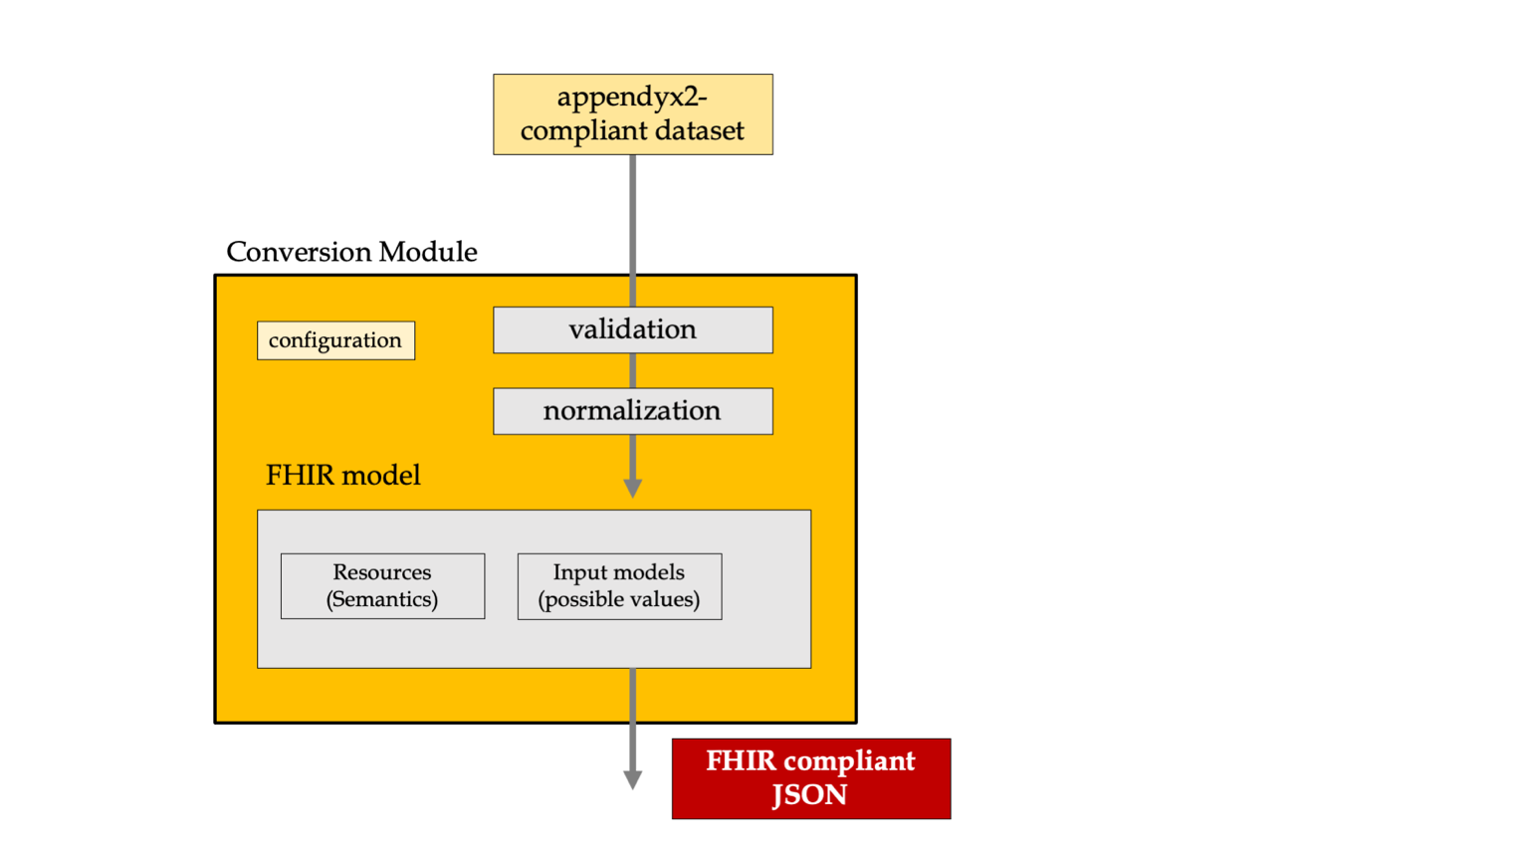

**Conversion**: overall wrapper, takes as input one excel (classic dataset table) written in the BBMRI appendix format and creates the FHIR-structured JSON to be uploaded on the Biobank Locator.

**Configuration**: contains a series of configuration values such as the organization id and the locator URL

**Normalization**: the normalization module maps many non-compliant fields to a series of normalized fields, for instance patient.SEX to *M; F; other; unknown;*

**INPUT-MODELS:** contains all the possible values for the input employed in the validation and normalization process.

The FHIR final JSON is built by two separate modules:

**FHIR-MODEL**: this module is the high-level converter from the dataset to the FHIR

**FHIR-RESOURCES**: is employed bu the FHIR-MODEL module and maps each field / entity to its FHIR counterpart

