Southwest University
School of Computer & Information Science

Course Design Report

Course： Principles of Programming
Topic ： ********
Grade&class：Grade 2019 Class CS3
Student Name： ************
Submission Date： *********

1、Description of the problem （main task and the problem you resolved）
Use the regular rule to analyze, extract the content you want, and then process the data (calculate the number of outline, calculate the proportion of each assessment mode, calculate the number of assessment methods).
I will deal with specific issues in Article 3.
- Basic Conceptions and Principles
1. Get the file directory, open the file
2. Two methods of extraction are used, one is that the keyword is after the first percentage sign, the other is the percentage sign after the first key word.
3. To exclude repeating elements in a variety of ways; exclude unreasonable elements.
4. Using collections and lists, for the number of review modes (question 1), the number of times the review pattern occurs (question 3, emphasizing the default value of 0) (see below for a specific count method)
5. Calculate the percentage of each examination method (emphasis on splitting such as: final exam:40%, at this time calculated by 20%)
6. Drawing images with matplotlib
3、Design Scheme（your plan, includes the structure of your program and the necessary description）
I had intended to use only those two methods to judge, but I found that the proportion of my answers was quite the same as the answer, but there were a lot of unnecessary factors. I will then discuss the methods I need to get rid of the wrong data.
I have four python files, namely the main program (question 1), the second question, the third question, and the drawing question, which is easy to read.
Q1: how to get rid of duplicate data when extracting the first question?
I use the canonical rule to make all the extracted data into tables and strings, and then I bring the elements in each table into the string, and if that element appears more than once, then it's a duplicate element. Delete it. 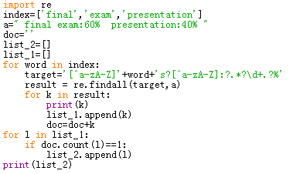
Of course, this method also has drawbacks. What should we do if exam40% final exam:60%? But overall, the advantages outweigh the disadvantages.
Q2：With regard to the application of the canonical law:
target='[^a-zA-Z]'+word+'s?[^a-zA-Z]:?.*?\d+.?%' target='\d+.?%.*?[^a-zA-Z]'+word+'s?:?[^a-zA-Z]'
Two approaches have been used. First, it must be guaranteed that it is a separate character (such as finally and final) that needs to be preceded by [^ a-za-z], and that this character may be plural, so it needs to be added to the sg. And then until there's a number plus a percentage, but there's a problem here, if the data is' final exam:40%', then that's incalculable, because the expression of [^ a-za-z] 'word must be preceded by a letter. So I added spaces before and after each string, and I converted all the letters to lowercase to prevent uppercase.
Q3：About how to remove the wrong elements:

Third, the big question is how I can avoid double-counting (for example, final exam and final), should notice if the default is 0!
I first calculated the string with a string length of 2, found it and deleted it from the list, and then I found a digit length, which was effectively avoided. The reason why I didn't use all the data to do the calculation here is that:
- The amount of data is too large to slow down
- If I take in the calculations, but the list I take comes from the first question, which is only taken in ['final','exam','project','assignment','homework',' midterm, 'participation','presentation'] 8 and does not include quiz, Words such as report,demo, which can take a lot of time if retrieved again, now take me five minutes to run at a time (of course, the performance of the computer is a bit low)
………………………………………………………………………………………………………………………………………
4、Resource Code（detailed comments are required）
############################主程序#########################
…………………………………………………..
…………………………………………………..
…………………………………………………..
…………………………………………………..

plt.bar(range(len(list__4)), list_4, bottom=list__4, label='76-100%',tick_label = name_list,fc = 'yellow')
#设定各数值
plt.legend()
plt.show()
return
………………………………………………….. ………………………………………………….. ………………………………………………….. ………………………………………………….. ………………………………………………….. ………………………………………………….. ………………………………………………….. ………………………………………………….. …………………………………………………..
- Instructions(give the steps and necessary screenshot to show how to run your program):：
Open ‘python主程序’,then press f5 to run
To make it easy to read, and to reduce the computational time, I turned all the data into .txt file

The first method of calculating count
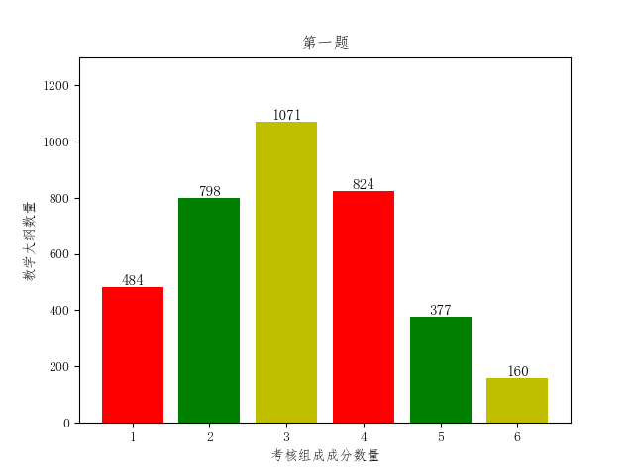
The second method of count calculation：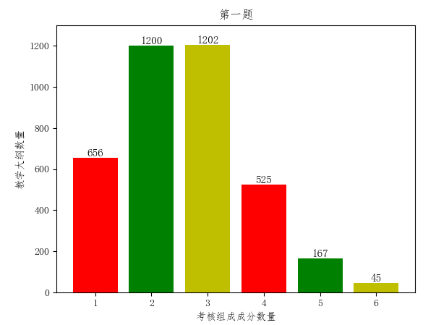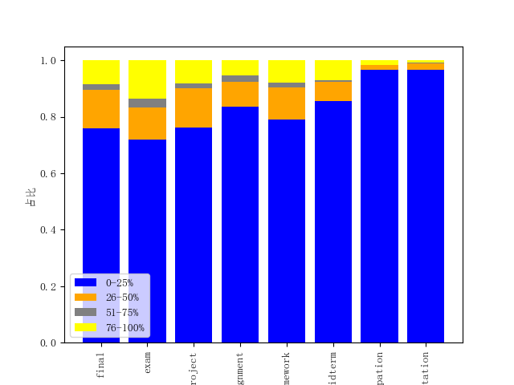
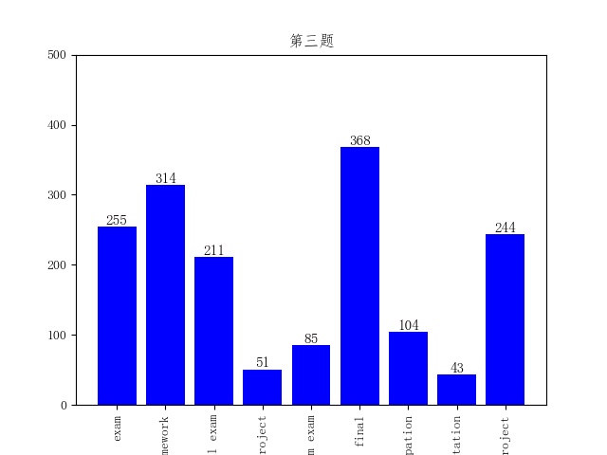
The third question has a slight error in each operation, because in the first question I use a set, and there is no order. And some documents, some expressions that I didn't think about, and what I got in different order of reading was different, so there was some bias in the data that was brought into the three questions.

I think the gap between the data error and the answer is caused by the following questions:
Status 1：
The way to judge Project(60%) 'is as follows :
Exam:20%
Presentation:40%
The data extracted by using regular expression are three kinds of judgment methods, but in fact they are two kinds of methods, which leads to the results being too large
.It may explain why the count of 1 and 2 in the first question is so large .Make the third question less data (many default values of 0 cannot be calculated )
Status 2：
The grade of exam will lost if the number of words in the operation was not up to 80% of the required number
This situation does not require counting, but regular expressions count it, so a large number of files that should not be counted are counted. It may explain why the count of 1 and 2 in the first question is so large .
Status 3：whether the data needed to be averaged？
Project exam:50%
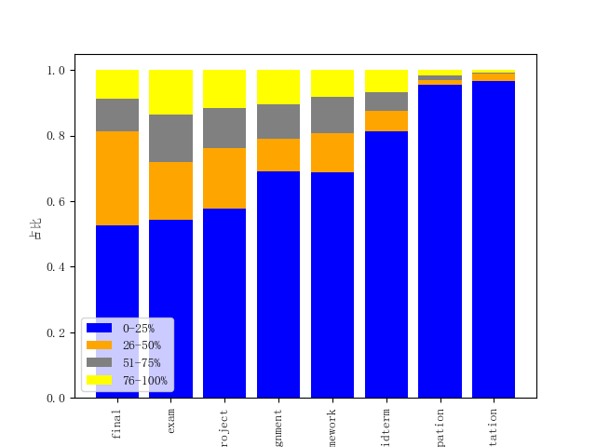
Do we need to split 50 into 25?If not separated, the 0-25% ratio would be a good match to the picture in the title.

Status4:
In the first question, I had some flaws in my method of removing repeating elements.

6、Summary
The programming took much longer than l expected, and it took me ten days to get it done.l think the most important problem of this question is how to extract the right elements and delete unnecessary elements.

There are lots of algorithms involved. To achieve this goal, my program runs for a very long time. But even so, the program is still running out of plenty of some unsatisfactory, because l got out of the data and answer data is a big difference.
In this case, l can only say that l have tried my best. My programming ability is limited, and l do not have much energy to put into this problem. l think the two biggest things l learned from this question were that the first taught me how to apply regular rules, and the second showed me the power of the python programming language.

Speaking of harvest at the same time. I also feel more and more lack of programming skills, I think on the one hand because of our shorter learning time. On the other hand, because we lack of practice, not to expand and access to new things, our level have not been an effective upgrade. Of course, in addition to not get the right answer, there are some more regrettable places. For example, when the final drawing of the use of drawing code, mostly from the Internet.Part of it is because l am not familiar with the library. To be fair, l do not think this problem is very difficult, but his way judgement and thinking of judgement is l can not think of, this is what we need to master in the future. In the end, thanks for having this opportunity, let me have so many feelings, which also inspires my interest in programming.

