Brian Hogan

Multivariate Statistics – SC 703
Professor John B. Williamson
Boston College, Spring

Assignment #6

Table of Contents

Results Discussion

Appendices

- Syntax
- Appendix 1 – Path Analysis
- Appendix 2 – Logistic Regression
- Appendix 3 – Discriminant Analysis
- Appendix 4 – Advanced Discriminant Analysis with Two Functions that Failed
- Appendix 5 – Advanced Discriminant Analysis That was Successful

Results Discussion
Basic Material Part 1 – Path Analysis:
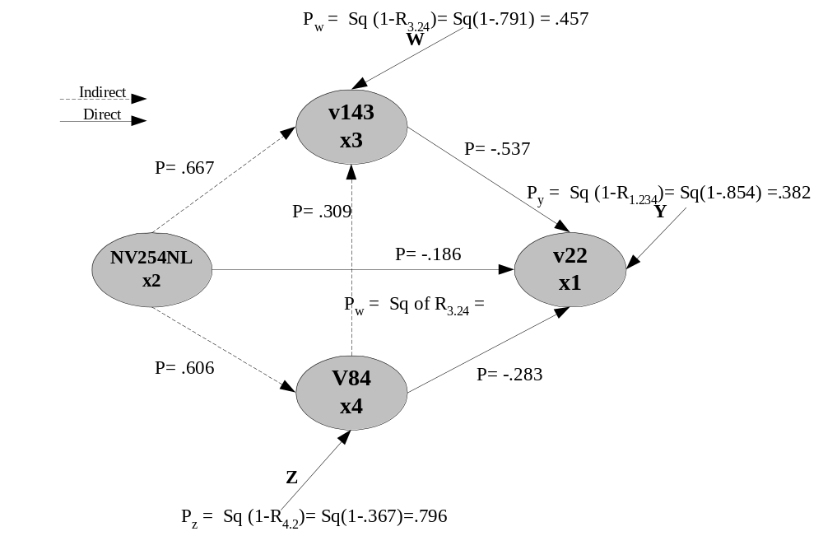
Path analysis was performed on dependent variable (DV) v22, Total Fertility Rate 1990, where the independent variables (IV) were: v84, Woman Childbearing Age % Woman 1990, nv254nl, the natural log of Real GDP/Capita 1991, and v143, % Contraceptive Prevalence 1980-92. An R-square of .854 was found where an F=195.436 was significant at the P<.001 level. The Beta coefficients generated were all significant at the P<.01 level. Linearity and normality assumptions were assumed for this exercise. The following represents the path analysis diagram:

It was causally modeled that X₄, woman of childbearing, predicted X₃ % of contraceptive prevalence and this construct was predicted by X₂ the GDP per capita. If we were to look at the X₁X₂ relationship, the total effect is -.816, as seen in appendix 1 page coefficients table. The Beta coefficients generated were significant at the P<.001 level. The direct effect would be (-.186). The indirect effects are (.667*-.537)+(.606*-.283)+(.606*.309*-.537)= -.630. The sum of the direct and indirect effect is (-.186)+(-.630)= -.816 which is equivalent to the total effect.
If we were to consider the X₄X₁ relationship where the total effect=direct effect+indirect effect+the spurious component we find the direct effect = (-.283). The indirect effect is (.309*-.537)= -.1659. And, the spurious effect is (.606*-.186)+(.606*.667*-.537)=.3297. The total effect equals (-.3298+(-.1659)+(-.283)=.778 which is approximately equivalent the total effect in this relationship of -.779.
The calculations for the path WYZ are seen above. These scores represent variance explained by other variables not included in the model as calculated by R_{1.xxx}.
Basic Material Part 2 – Logistic Regression: (could note the 20 cases)21
The variables utilized in the path analysis model were also subjected to logistic regression with the difference being that the cases in V22, Total Fertility Rate 1990, were divided into high or low categories to create a dichotomous variable. The following syntax represents the creation of the variable, review of categories and running of the model:
FREQUENCIES VARIABLES=V22
/STATISTICS=MIN MAX MEDIAN.
RECODE V22 (1.4 THRU 4.6=0) (4.7 THRU 8.3=1) (ELSE=SYSMIS) INTO NVLR22.
RECODE NVLR22 (0=1) (1=2) INTO NVLR22B.
FREQUENCIES VARIABLES=NVLR22 NVLR22B.
LOGISTIC REGRESSION VARIABLES=NVLR22 WITH v143 nv254nl v84
/PRINT=ALL GOODFIT.
The two categories created in NVLR22 were both found to have a valid 50% of the total scores in V22, as seen in appendix 2 page 5.
At step 0, 104 cases were processed with only the constant in the model and an initial –2 Log Likelihood of 144.175 was generated. In step 1 of the model when variables V143, NV254NL, and V84 where entered a –2 Log Likelihood of 15.656 was generated and the Chi-square test of the Model/Block/Step was significant at the P<.001 where Chi-square equaled 128.518, seen below in top right hand table. Only 1 case was predicted incorrectly in the equation, as seen in Classification Table below.
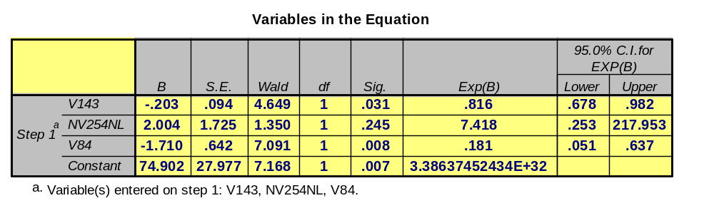
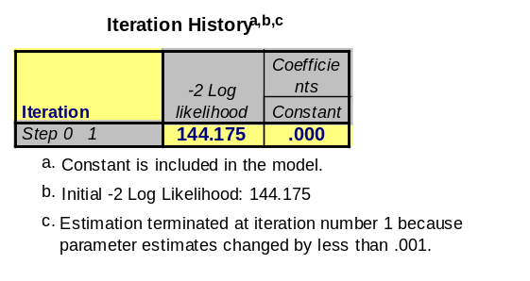
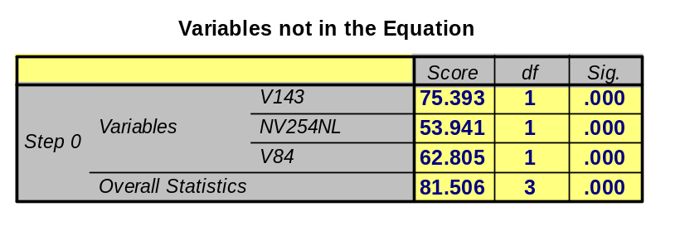
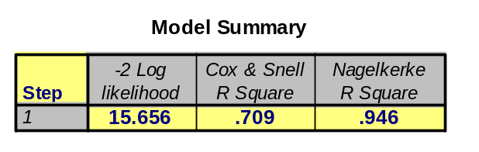
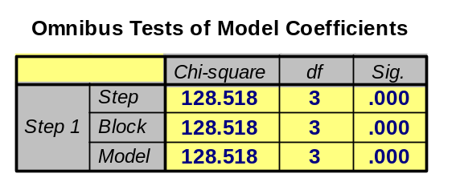
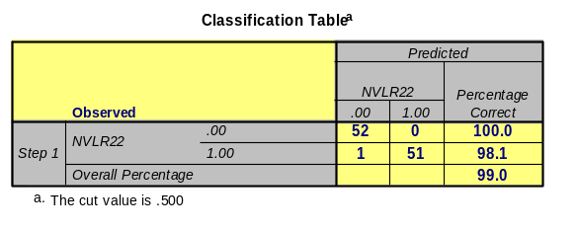

Where Z=the linear combination, the logistic regression model can be written as Z=74.902 - .203(V143) + 2.004(NV254NL) – 1.71(V84). If the probability of an event occurring is 1/(1-e^{-z}), and we were to consider the United States case were its V143=74, NV254NL=10, and V84=52, then Z would equal –144.20 and P(e)=2.37E-63. Thus, in general if the probability of an event is less than .5 we would predict the event as not occurring (SPSS Logistic Regression pg38-39), or in this case not being considered in the low fertility category. Thus, since 2.37E-63<.05, we predict that this case will be correctly classified. The odds of this case not being considered in the low fertility category is P(e)/P(no e) or 2.37E-63/(1-2.37E-63)=1 and the natural log of 1 is 0. Thus the odds of the case being in the high fertility rate category are virtually zero1.
The Wald statistic tests that a coefficient is zero. The significant score relates to the Wald statistic and when coefficients are significant then knowledge of the variable does improve our predicted equation. As such, we find that the presence of v143 and the presence of v84 are significant while the presence of nv254nl is not. Thus, in regards to predicting total fertility rate in high/low categories knowledge of GDP/Capita is not helpful while of contraceptive prevalence and woman childbearing is helpful. But how helpful are these coefficients?
For Reference

The R-statistic is helpful for interpreting the magnitude of contribution that an individual predictor brings to the equation and its score range from –1 to 0 to 1. (Note: the R-statistics for this model were calculated manually due to SPSS difficulties.) The equation for R= +/- (√((Wald-2k)/(-2LL₀))). Thus calculation of V143 = √(4.649-2*1)/(144.175) = .136. This R of .136 would be negative because the B coefficient is negative, thus -.136. The R-statistic of NV254nl is 0 and v84 is -.189. Thus we do not have an indication that either V143 or V84 have a strong influence on the equation’s predictiveness. As such, we would keep v84, woman of childbearing age, and look for other predictors to build this equation while removing v254 as its R-statistic of 0 was consistent with its non-significant Wald statistic.
In summary, the equation utilized was a good starting point for logistic regression but the statistical results indicated that more work could be performed to improve the model.
Basic Material Part 3 – Logistic Regression Article Review:
In the article, The Culture of Poverty and African-American Culture: An Empirical Assessment, authors Jones and Luo deploy the use of logistic regression in the assessment of Work Ethic, Family Values, and Ethic of Dependency by dichotomizing eight dependent variables from multi-year General Social Survey data sets with variables that capture these dimensions. The studies’ equations were formed by assigning DVs with a value of 1. For example in Table 1’s Work Ethic dimension if respondents agreed as opposed to disagreeing that they would continue to work if they didn’t need the money then there response was recoded with a 1. The eight DV were regressed by three models of IVs where the first model tested the interactive effects of attitudes from race and poverty status, the second model tested the interaction of race and poverty by creating 3 groups of categorical variables statistically equivalent to an interaction of (status*race), and the third model viewed the effects of race and poverty by controlling for demographic variables. This work resulted in three tables of logistic coefficients and odds ratio scores that were then used to support and refute theories used in the argument.
The cleverness in the article stems not from the individual scores generated in the three equations but in the collective grouping of the scores to be compared and contrasted across equations and by a specific model targeted to argue, support, or enlighten theory. This is accomplished by comparing significant versus non-significant coefficients and odds ratios. For example, we see in the table below the results of Model 2 from Table 1.
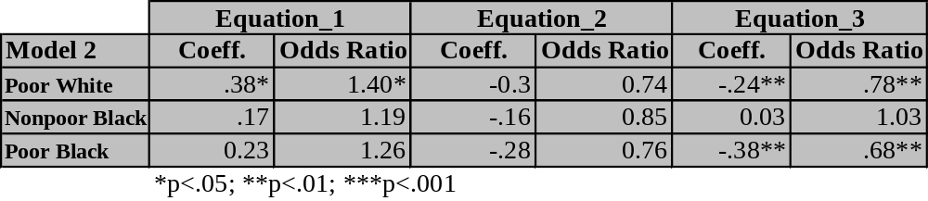
By the poor white variable having a significant coefficient we can say that poor white are more likely than nonpoor whites (poor white is dichotomously coded) to indicate that they would continue working if they did not need the money. Another way to say this is by recognizing that in positive coefficient we see poor whites would continue to work while the odds indicate that it is less likely that the other category of the IV, or nonpoor white, would continue to work if they did not need the money. Model 2 was particularly clever because it also deployed interaction amongst race and poverty variables and created class categories to displays the results of this model. From this, we then understand why the authors were able to argue how poverty and race did not provide significant affects to the model because the chi-squares changes in –2LL were not significant.

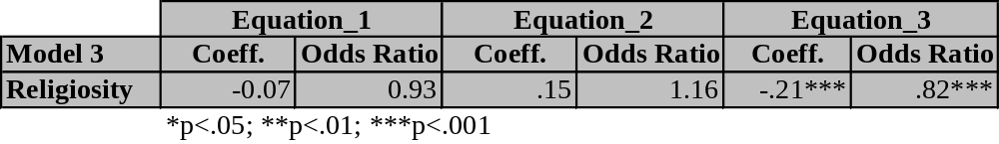
One final review will be performed to illustrate how this article utilized the logistic regression technique by focusing on the results of the religiosity variable in model 3, seen below. In equation 1 and 2 no significant coefficients are found suggesting that people who regard themselves as very religious have no significant opinion whether they would continue working if they did not need the money or that work is not a significantly important activity for them. However, by the coefficient in equation 3 being both negative and the odds ratio significant at the p<.001 level we have an argument that detects a decrease in the odds that very religious people would support raising their children to work hard. This is supported by the coefficients of the other two equations not being significant. This represents the logic deployed to either support, refute, and enlighten the theoretical arguments covered in the first part of the paper.

Basic Material Part 4 – Discriminate Analysis:
Direct discriminant function analysis was performed using the following three predictors of a country’s total fertility Rate: v84, Woman Childbearing Age % Woman 1990, nv254nl, the natural log of Real GDP/Capita 1991, and v143, % Contraceptive Prevalence 1980-92. The dependent variable was dichotomized based on the frequencies cumulative 50% to create two groups with group 1 representing low fertility rate countries and group 2 representing high fertility rates countries.
Of the original 148 cases, 44 were dropped from analysis because of missing data. Assumptions of normality, linearity, multicollinearity and equal variance-covariance matrices were reviewed and found to have acceptable levels for this analysis2.
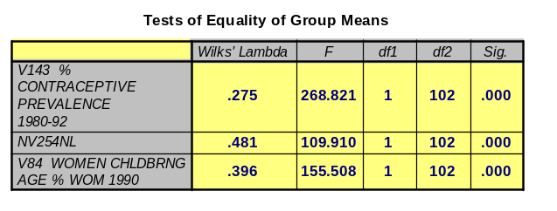
The Wilks’ Lambda generated in the Tests of Equality of Group Means, below, provides the results of SS_{W}/SS_{T} that indicates differences amongst groups where 0 is strong group difference and 1 is no difference. We see that V143 and V84 learn towards strong groups differences while nv254nl lies in the middle revealing sameness in the groups. The F-statistic is the ANOVA of variable
group means. All variables were significant at the
P<.001 level thus none were considered for removal.
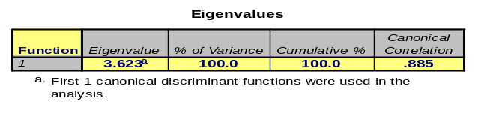

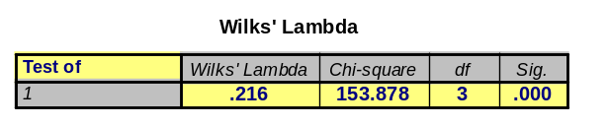
The Eigenvalues table displays the results of SS_{B}/SS_{W}. The first functions eigenvalue will always be greatest because of the least squared method calculation. This value is helpful for measuring centroids when two or more functions are created. The Canonical Correlation measures the association between the discriminant scores and the groups (SPSS Base 10 App Guide pg255). Because we have only two groups in the model it represents a Pearson correlation result illustrating much variance in the model.

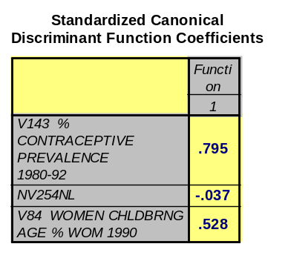
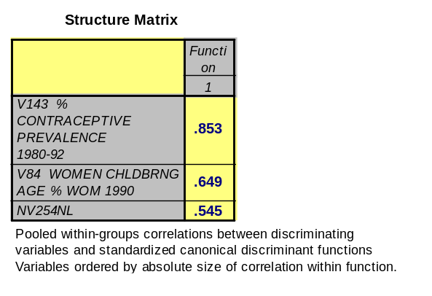
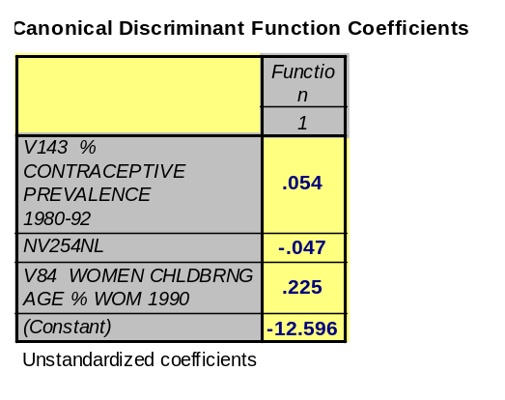
This Wilk’s Lambda statistic represents the proportion of the total variance in the discriminant score not explained by the differences amongst the groups. In this model, 22% of the variance is not explained by group differences. The Chi-square statistic is measuring the difference between the two group centroids (the means of the three variables simultaneously(SPSS Base 10Guide-pg257)) and indicating that it is significant at the P<.001 level.
1
3
2
1
3
2

In comparing the ranking of IVs in the Standardized Canonical… and Structure Matrix tables we find the ranking change based on NV254nl changing direction and increasing in strength. The standardized score for the natural log of GPD/ Capita illustrates a small but inverse relationship to total fertility rate while the structure matrix indicates it as a strong positive impact. If this was being presented in an article I would lean towards using the standardized coefficient to illustrate that more developed countries may have a smaller tendency towards large birthrates based on prior analysis work performed. Regardless, either sets of scores indicates contraceptive prevalence as the most important variable in understanding total fertility rate. (Please note: all table in this section are available in appendix 3.)
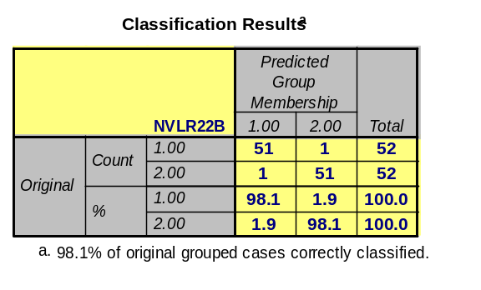
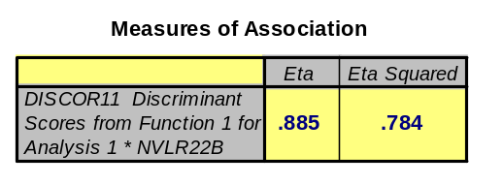
The model yielded one discriminant function, prior page, where D=-12.596+.054(v1243)-.047(nv254nl)+.225(v84) can be used to calculated case discriminant scores.

The model resulted in 2 out of the 104 cases not being correctly classified. Because of this result, and the other favorable statistics generated, this model could be used to classify future countries in regards to their fertility group. The results from an ANOVA test between the discriminate scores of low/high fertility groups resulted in an Eta score of .885 indicating a very strong model.
Overall, the findings of the logistic model and discriminant model were similar. When the variables where loaded in Step 1 of the logistic model a Chi-square of 128.518 with P<.001 level was found indicating the favorable acceptance of all the variables in the model and this result was synonymous with the significant results in the Tests of Equality of Group Means. The logistic model only categorized 1 variable incorrectly while the discriminant model categorized 4 incorrectly but both classified 98.1% group cases correctly. In conclusion, I would prefer to utilize the logistic model in this case because statistics generated from the variables in the equation were more helpful in identifying the issues embedded. For instance, in nv254nl’s B was 2.004 and sig.=.245 revealing underlying issues in this variable.
The following code was utilized for the discriminant regression run and it was not displayed prior because of issues with document formatting:
DESCRIPTIVES
VARIABLES=v22 v143 nv254nl v84
/STATISTICS=MEAN STDDEV MIN MAX .

RECODE NVLR22 (0=1) (1=2) INTO NVLR22B.

DISCRIMINANT GROUPS=NVLR22B (1,2)
/VARIABLES= v143 nv254nl v84
/ANALYSIS= v143 nv254nl v84
/SAVE SCORES=DISCOR1
/STATISTICS=MEAN STDDEV UNIVF CORR RAW TABLE BOXM
/PLOT=CASES SEPARATE.

DESCRIPTIVES VARIABLES=DISCOR11.

MEANS TABLES=DISCOR11 BY NVLR22B
/STATISTICS=ANOVA.
Basic Material Part 5 – Discriminant Analysis Article Review:
In the article Differences Between Stayers and Leavers Among Part-Time Workers, the authors Sightler and Adams deployed a discriminant analysis technique using stepwise and forward stepwise methods to identify differences between part-time workers who stay and part-time workers who leave. The authors considered use of the stepwise and forward techniques as exploratory procedures likely because they indicated a lack of applicable theory regarding this segment of the working population. This use of eight dichotomously coded IVs is suspect considering the course readings reflect that interval/ratio level measurement is standard for this technique. However, the readings did not indicate the use of dichotomous IVs as a violation of this method.
The model presented in Table 2 the correlations of the eight IV for stayers and leavers revealed a number of significant correlations. If more than a handful of the correlations were greater than .40, it would have increased the models overall variance explained. The overall model’s Wilks’ Lambda of .8470 indicates that 85% of the model’s variance in the discriminant scores is not explained by differences among the groups. Although the model was significant at the P<.0001, the Canonical correlation value was only .3911 thus explaining 39% of the variance between the two groups. Because this is an explorator research this value may be considered favorable.
The model began with a stepwise procedure and then changed to forward procedure. The stepwise procedure starts as a forward procedure but then removes variables entered if not found significant. They changed to a forward procedure in an attempt to significantly discriminate between groups while controlling for multicollinearity. Instead of the authors utilizing Wilks’ Lambda (from the Tests of Equality of the Group Means) they displayed the results of the F-statistic. The higher the F-statistic, the greater the group differences. Its rank was not dependent upon whether the F-statistic was significant. Interesting enough this was compared to the ranking of the discriminant loadings which was the correlation between the IV discriminant score and the model’s canonical discriminant function. The ranking was the same between the significant variables thus furthering the author’s arguments that hourly pay rate, length of employment, gender, and managerial status were issues of consideration in defining the pros and cons surrounding this employer decision.
It is obvious from this article that extra work was deployed in the creation of the discriminant loadings to further the arguments developed in the article. The authors also made a point that there model classified an additional 15.2% of the cases correctly and this would indicate that the error range area between stayers and leavers’ curve was small. The article represented an interesting application of this analytical method.

Advanced Material Part 8 –Additional Discriminant Analysis Run:
Direct discriminant function analysis was performed using the following three predictors of a country’s total fertility Rate: v84, Woman Childbearing Age % Woman 1990, nv254nl, the natural log of Real GDP/Capita 1991, and v143, % Contraceptive Prevalence 1980-92. The dependent variable was dichotomized based the countries world system position (v159) thus grouping would have sought to understand total fertility rate based on peripheral, semi-peripheral, and core nations.
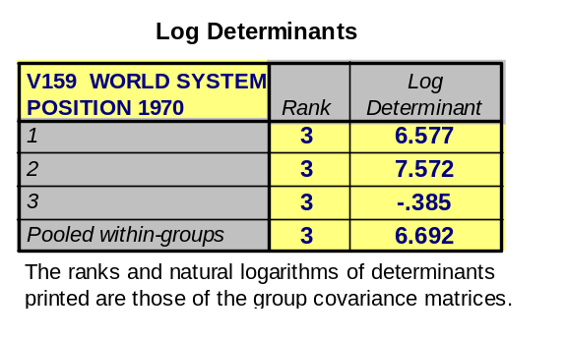
When the discriminant function was run the following resulted in regards to the equality of covariance matrices test:
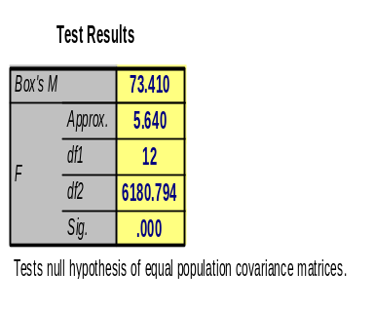

Based on the Box’s M statistic of 73.410 significant at the P<.001 level the null hypothesis of equal covariance matrices is rejected, full results for this run are seen in appendix 4a. In reviewing the SPSS Base 10 Applications Guide pg 290, it noted that log determinant values represent the proportion of the shape created in the data by grouping classifications. By my group three score being negative (-.385) this means that the countries grouped here are relatively smaller to the other two groups. This led to the idea to narrow down the group classification. To do this V149, World Bank Country Grouping, was utilized.
V149 is composed of five categories where 1 is the lowest income and 5 is the highest. When discriminant analysis was run the 5 categories and 4 categories (where groups 4 and 5 were combined) the function still produced significant Box’s M tests. However, when the upper-middle and two high income classifications were combined the null hypothesis of equal covariance matrices was not rejected at the p<.05 level were the sig. generated was .065. As such, we will now review the results created for the two discriminant functions, all output for this run is in appendix 4b.
The following code was utilized to perform the run:
RECODE V149 (1=1) (2=2) (3=3) (4=3) (5=3) (ELSE=SYSMIS) INTO NV149.

DISCRIMINANT GROUPS=NV149 (1,3)
/VARIABLES= v143 nv254nl v84
/ANALYSIS= v143 nv254nl v84
/SAVE SCORES=DISCR
/STATISTICS=MEAN STDDEV UNIVF CORR RAW TABLE BOXM
/PLOT=CASES SEPARATE.

DESCRIPTIVES VARIABLES=discr1 discr2.

MEANS TABLES=discr1BY Nv149
/STATISTICS=ANOVA.

MEANS TABLES=discr2BY Nv149
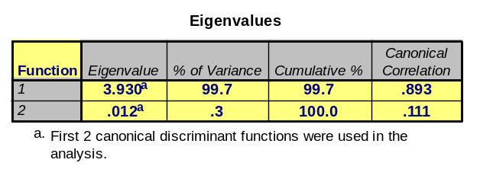
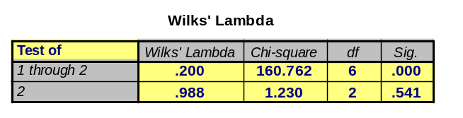
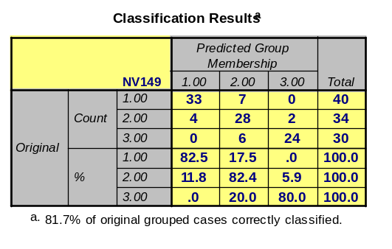
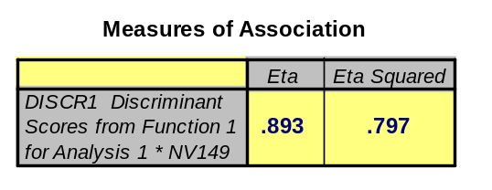
/STATISTICS=ANOVA.

Referring to the table above, the eigenvalue table illustrates that function 1’s canonical correlation is initially indicating a better model than function 2. The Wilk’s Lambda for function 1 is significant and the statistic of .2 is indicating that the function does not explain 20% of the overall variance. Function 2 is not significant thus it would be excluded. The classification results ended with 81.7% of the cases classified correctly. When and ANOVA was done with the discriminant scores from function 1 a very large amount of overall variance was explained as eta = .893.
In thinking about these results, because I utilized the World Bank position which is based on GNP per capita the output results where similar when I divided the Total Fertility Rate variable between low and high countries in basic material section 4. The eigenvalue/canonical correlation from the basic material was 3.623 / .885. compared to this run of 3.93 and .893. The Wilk’s Lambda in the basic material was .216 and here is was .20. The main difference was in the standardized canonical discriminant functions because in the basic results the ranking was contraceptive prevalence, woman childbearing age, and then GDP per capita. In the advanced run it was GDP per capita, contraceptive prevalence, and woman childbearing age. I believe GDP reversed to being the strongest variable because the DV was in part based on GDP per capita.
In conclusion, as I attempted to create multiple discriminant functions, in reality I ended up the same result because higher fertility rates are associated with low-income countries and lower fertility rates are associated with high-income countries.

1 Prof. Williamson, in an effort to better understand the material I have gone out on a limb regarding this odds interpretation. Because of the creation of the high/low categories, I am not sure if I can say what was said in that paragraph with accuracy. I am concerned because I don’t know if the odds in this case are simply testing whether the score would be a fertility score or not a fertility score. And since all the scores are fertility scores then perhaps this is the reason I ended up with zero!
2 Prof. Williamson, after I read Tabachnick & Fidell on this subject I ran a correlation’s matrix on these variables and found very high results: v22&v143=-.898, v22&nv254nl=-.816, and v22&v84=-.779. As such, when the Box’s M was run it resulted in a score of 21.21 sig=.002 indicating we would reject the Ho that posits equal covariance matrices. I appreciate that this test is not totally reliable but I also know from my multiple regression notes such high correlations can lead to multicollinearity issues. As such, this point is recognized but additional work was not performed to correct the issue at this time.

