Your name, BS, MS, PhD

<[email](mailto:bhogan@clarku.edu)><[in](http://www.linkedin.com/in/bhoganphd)><github><this.pdf>

Instuctor of Computer Science Faculty

American Language and Culture Institute, Clark University

950 Main Street, Worcester, MA, 01610

**#=> portfolio.links.and.summary**

I equip students with skills in [data wrangling](https://r4ds.had.co.nz/wrangle-intro.html), machine learning, stats, and [systems thinking](https://github.com/bbe2/instructor.brian/blob/it.304.fall.2023/it.304.re-engineering.paradigms.pdf).

I teach foundational computer science topics ranging from machine and assembly to C++, IT.304 system design and MSCS.3050 software engineering. Currently I fact check curriculum design for advanced K-12 AI curriculum with scientific literature for [Dr. Bartolf](https://www.linkedin.com/in/dmarie-bartolf-092482a/) at [QuantHub](https://www.quanthub.com/).

My expertise includes industrial re-engineering, theoretical system design, Python and R programming, and STEM communication. I’m grateful for my Syracuse University data science professors who provided quality theoretical knowledge and practical skills to perform pipeline machine learning and authoring courses like [Get Started with Python](https://www.coursera.org/learn/get-started-with-python) at Google.

Blah blah

**#=> <add a new hook here><this is on impact of GPT and job dessimination>**

I deeply value each classroom learning experience because our Lacanian REAL is skill replacement by large language models (LLMs) and generative pretrained transformers (GPTs). In 2023, a study by [Eloundou, Manning, Mishkin, and Rock](https://arxiv.org/abs/2303.10130) (p.1,3) found that 80% of the US workforce have at least 10% of their work tasks affected by LLMs and 19% of all jobs having 50% skill replacement exposure. According to [Manning](https://cdn.openai.com/papers/Economic_Impacts_Research_Agenda.pdf) et al., in 2022, GPTs generated functional code 28.8% of the time. It’s a fantastic opportunity for struggling coders and neuro-diverse learners to build deep coding skills with AI assistance. I assist by emphasizing sustainable skills and the necessity of continuous skilling.

**#=> what's.happening? -> <add what your learning or course here>**

To help student mnemonics at crucial moments, I’m tooling GPT AI agents to

1. Convert lecture audio to text; integrating into a class corpus repository.
2. Synthesize disparities across audio, lecture notes, and textbooks using GPT APIs.
3. Email lecture summary and disparity index.
4. Aggregate and feed repository media to AI agent for student interactive learning.

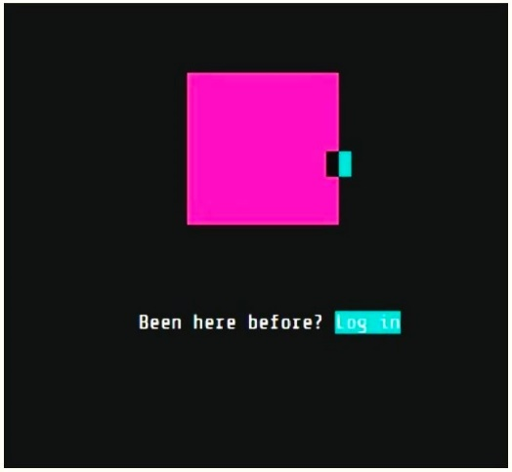portfolio.home <add hyperlink>

Add an image here if precise and relevant to

Your offerings; I have google foobar here

as I got access to it and performed work

|  |  |  |
| --- | --- | --- |
| industrial.reengineering  recommendations  research.experience | code  editing & tech.write  tutor.an.volunteer | |
| google.learning.lab.Get.Started.w.Python | | |
| View.online download  - [cv](https://github.com/bbe2/portfolio/blob/main/a.brian.hogan.cv.pdf) .pdf  - evaluations .pdf  - diversity.statement .pdf  - scholarly.activities .pdf  - teaching.statement .pdf  - [7.pillars.of.skills](https://github.com/bbe2/portfolio/blob/main/7.pillars.of.skills.pdf) [.pdf](https://github.com/bbe2/portfolio/files/11655571/7.pillars.of.skills.pdf) | |

p.s. I love [Lex Fridman](https://lexfridman.com/podcast) podcasts and harvesting their text for a Lex computer literacy ai assistant.