# STEM Department/ Cybersecurity School of Arts and Sciences

# Problem Solving and Programming Fundamentals II/Lab, CS-105-01

# Course No: CSC 105-01 / CSC 150L-L2

* Semester/Year: fall.2025
* Credits: 4
* Class Type: Lecture/Lab

Meeting Times: asynchronous, google meet\similar

Faculty: Lecturer Brian Hogan, MS <[in](http://www.linkedin.com/in/bhoganphd)><[cv](https://docs.google.com/document/d/1HpDXQvXiIA0Har_No9Zm_3MBIP_Ql82u/edit?usp=sharing&ouid=102337878551539739303&rtpof=true&sd=true)><[research.statement](https://docs.google.com/document/d/1TNsV8TP2dnOlG9eLykJES-caAcnYLMYEQxHNnQVAWNg/edit?usp=drive_link)><[teach.phil](https://docs.google.com/document/d/17ksqAZ_sFQD7S-rFpq3kDEHQSKOSrsMNiDIuhP_0VPQ/edit?usp=drive_link)> <[github:brian](https://github.com/bbe2/instructor.brian)>

Course Materials: <https://github.com/bbe2/instructor.brian/tree/CS105.01.cybersecurity.regis.college>

* + Telephone/Google meet: 857-339-6115 [recommendation: actively email brian]
  + E-mail: [instructor.b.hogan@gmail.com](mailto:instructor.b.hogan@gmail.com); [regis email on setup xxx@regis.edu]
  + Office Hours: class will inform assistant professor best times; and ondemand

HINT: you want to read all of this and print skill.MAPS(cheatsheets) on final pages

Program admin

| Fran Power-Charnitsky, Ph.D.  Associate Professor  Microbiology Coordinator  Biology Program Director  Chair, Department of STEM  Pronouns: she/hers/her | REGIS COLLEGE  School of Arts and Sciences  Watson-Hubbard Science Center 208  235 Wellesley Street | Weston, MA 02493-1571  O: 781.768.7428  regiscollege.edu |
| --- | --- |

**PERMANENT AND MOST CURRENT SYLLABUS LIVES IN THIS LINK ON A GOOGLE DRIVE**

* [I.E. READ THIS ONE](https://docs.google.com/document/d/13xGwRqwgSDNDArAOMGrKVFcI-LNiRFoK/edit?usp=sharing&ouid=102337878551539739303&rtpof=true&sd=true) aka my google drive
* Its an interactive document so insert comment questions if you like and ill answer
* <https://docs.google.com/document/d/13xGwRqwgSDNDArAOMGrKVFcI-LNiRFoK/edit?usp=sharing&ouid=102337878551539739303&rtpof=true&sd=true>

# Catalog Description [h2]



A continuation from CS-104, focusing on methods of planning, designing, and implementing solutions to problems using Python and Java. Emphasis focuses on the use of Object Oriented Programming (OOP) style of problem solving while building experience in data structures, object.method programming libraries, retrieving and loading data, and experiencing common machine learning techniques.

**Course modality**

# Scheduled real-time meetings treated as optional help sessions

# Primary delivery via online discussions, assignments, recorded micro-lectures, and labs in moodle

# All real-time sessions take place during days/times as noted on the Student Planner Schedule and as outlined on the syllabus

# Class is primarily taught using online discussion boards, online assignments, recorded lectures, and labs in moodle <version of a hybrid class>

1. Course materials always on GitHub (available now) <Regis pending IT access>
   * <https://github.com/bbe2/instructor.brian/tree/CS105.01.cybersecurity.regis.college>

## Institutional Undergraduate Major Learning Outcome

## -> i.e. Teamwork, In Depth Understanding, Experiential Learning, or Civic Engagement

1. Summarize and evaluate fundamental cybersecurity concepts, theories, and strategies as they apply to real world case studies
2. Analyze national and federal laws, policies, and guidance documents related to information assurance/cybersecurity
3. Demonstrate knowledge of the social, psychological, ethical, and legal policies and requirements within the field of information assurance/cybersecurity
4. Assess the philosophical, historical, ethical, behavioral, technological, legal, and policy dimensions related to cybersecurity
5. Evaluate and appropriately apply different methodologies for combatting cyber security attacks
6. Synthesize and apply the knowledge and skills learned through the planning
7. implementation of an original project

**Credits**

# One hour of classroom or direct faculty instruction and a minimum of two hours of out of class student work each week for approximately fifteen weeks for one semester or trimester hour of credit, or ten to twelve weeks for one quarter hour of credit, or the equivalent amount of work over a different amount of time; or

# At least an equivalent amount of work as required in paragraph (1) of this definition for other academic activities as established by the institution including laboratory work, internships, practica, studio work, and other academic work leading to the award of credit hours.

# 

# Online and Hybrid Course Hour Requirements

+----------------+------------------------------+------------------+

| Course Work | Hours/Week × Weeks | ~Total Hours |

+----------------+------------------------------+------------------+

| Reading | 3 × 15 weeks | 45 |

| Labs | 5 × 15 weeks | 75 |

| Discussion | 2 × 14 weeks | 30 |

| Quizzes | 2 × 15 weeks | 30 |

+----------------+------------------------------+------------------+

| Total | | 180 |

+----------------+------------------------------+------------------+

# II. Course Particulars [h2]



**Course coding notebooks and integrated development environments (IDE) [h3]**

# 

Google [Colab](https://colab.research.google.com/) is the primary, browser-based IDE for this course. Most labs run entirely in Colab with pinned libraries and a reproducibility “setup” cell. Weeks 4–7 add Java parity (jshell/maven snippets) alongside the Python notebooks to satisfy CS105’s Java outcomes; Weeks 12–16 retain Colab + Java and optionally layer a Linux VM (SSH/web desktop) to experience more advanced cybersecurity environments in an approachable manner. Colab handles curated PCAP/log datasets and unit-tested analysis; the optional Linux stage enables privileged operations such as live packet capture, file permissions/auditing, service hardening, Zeek/Suricata logs, and Ghidra headless runs.

This staged path builds fluency in production [libraries](http://pypi.org) underpinning compute and cybersecurity workflows like pandas, numpy, scikit-learn, scapy, lxml. Data structures include such lists, dicts, tuples, arrays, dataframes, JSON, XML.

-> plain english: learning is staged to build fundamental programming

construct skills necessary to survive and thrive

# Required text(s)

1. Gaddis, T. (2019). Java control structures through objects (7th ed.). Boston, MA: Pearson Higher Education. ISBN ISBN-13: 9780134793658
   * Note: This textbook comes packaged with a MyProgramming lab access card. Section Access Code If the print edition of this book is referenced here, electronic versions also may be available and may be acceptable for use in this course. If an electronic version is listed, no print version is available. All other required materials will be available in Moodle
2. skill.MAPs: Programming constructs, data structures, Python code ([.pdf](https://github.com/bbe2/instructor.brian/blob/904b3e5657ce9dd0e02f6905d9094c9fa62a58a3/code.how.TO.Programming.Constructs.an.Data.Structures.2024.pdf))
   * <https://github.com/bbe2/instructor.brian/blob/904b3e5657ce9dd0e02f6905d9094c9fa62a58a3/code.how.TO.Programming.Constructs.an.Data.Structures.2024.docx>
   * new ones are added weekly and updated here
3. Severance, C. R. (2016). [Python for everybody](https://www.amazon.com/Python-Everybody-Exploring-Data/dp/1530051126): Exploring data in Python 3, Charles Severance. ISBN 978-1530051120
   * free website: <https://do1.dr-chuck.com/pythonlearn/EN_us/pythonlearn.pdf?utm_source=chatgpt.com>
   * Google: <https://books.google.com/books/about/Python_for_Everybody.html?id=zjqzDAEACAAJ&utm_source=chatgpt.com>

other items:

# skill.MAPS - The instructor will continuously provide highly curated learning maps and cheatsheets. It is “highly recommended” you print them and assemble into a quickly accessible flip binder readily available to you

# Platforms: Moodle gradebook; Starfish advising flags as needed, Github, Colab

* + You will not need GitHub account, but if you plan on building a presence in computing, it’s recommended and the instructor will ensure proficiency

# Brower: Google Chrome recommended

* + a Google account is recommended as its an impressive compute platform

# Testing: a majority of the time you will submit the work, thinking, phone pictures, and similar in a single Colab notebook downloaded and emailed to the professor

# Testing may require respondus lockdown browser + webcam for quizzes/final

# File exchange: downloading of Google .ipynb and use of .pdf files as needed

**Minimum technical skills and cybersecurity software overview**

Minimum computer and digital information literacy skills include proficiency in email, word processing, programming, library databases and resources, video web-conferencing software like MSFT Teams or Google Meet.

Most importantly! There is a strong desire to learn essential tools for performing cybersecurity and other computer-related skills in a fun, interactive learning environment..

If you need technical assistance at any time during the course, you can contact the Regis College Office of Information Technology by using the IT ticketing system.

**>_The root skilling goal**

* Use of [Colab](https://colab.research.google.com/) is to help you focus on grokking programming fundamentals, cybersecurity constructs, performing root-skilling, and concentrating on challenge-solving
* Downstream course materials provide other cybersecurity environments, like Linux and Java, to ensure topic breadth and depth

**Overview -> Cybersecurity software landscape**

* INTRO: Google Colab with Python and [pypi.org](http://pypi.org) libraries: cryptography, pandas, numpy, matplotlib, scapy, requests, pytest
  + optional: Jupyter/VS Code local, Docker Desktop, Ubuntu VM, Wireshark (view-only), python-nmap (offline), Git/GitHub

# <https://colab.research.google.com/>

* ADVANCED: SIEM: elastic; IDS/NDR: zeek; packet: wireshark; vuln mgmt: nuclei; containers: trivy; cloud: AWS GuardDuty + Security Hub

**References and citations**

Student papers must be written according to APA 7th edition manual. Please consult the Regis Library for additional information or ask the instructor for a cheatsheet.

**Email**

All email correspondence between students and course instructors for Regis College courses are to utilize the Regis College email. Individual course instructors will determine their procedure related to timing and frequency of response to student emails. emails sent from personal addresses are usually caught up in our spam firewall. In general, students will receive a reply to their emails for this course within a 48 hour period during weekdays; emails received after 4 pm on a weekday will receive a response the following day.

-> update! generally instructor.brian responds daily or early next day

**Moodle**

Regis College’s official course management system is Moodle. At the minimum, all faculty are to post their course syllabus in Moodle and maintain student grades using Gradebook in Moodle.

**Starfish**

Starfish is an online advising and retention management tool used at Regis. Starfish is used to display contact information, set up appointments, track and monitor course attendance, document meetings, and raise alerts when a student is not meeting faculty expectations in a course. A student with any course concerns or flags should connect with the faculty member of the course and their Faculty Advisor to create a plan for addressing the raised concern.

# II.b Generative AI: how we’ll use it in CS105 [h2]



Brian Hogan trained in natural language processing with [Dr. Nancy McCracken](https://ischool.syracuse.edu/nancy-mccracken/) (Syracuse University, 2020). His practice spans content generation, ontological structuring, instructional design, and prompt engineering. He focuses on the authentic use of generative AI systems, such as ChatGPT, to solve problems more effectively by interacting meaningfully. It's a new space, so please consider the following:

Your part:

* Please let me know early if you’re feeling bored, blocked, or if you'd prefer a more challenging route. I adapt fast when I see what you need
* Use AI as a scaffold, not a substitute. You must be able to explain any code you submit, and I provide you with cool “learning trees” to help authentically solve and grow your skills
* Disclose AI helps with a 2-line “AI Assist” note in each lab/assignment:

tools/prompts used

What you kept/changed and why

* Zero AI for serious stuff like exams unless explicitly allowed
* Verbatim pasting of AI outputs can exhibit AI system residue
  + hint: detectable & quantifiable b/c semantic similarity

My part:

* Keep the course lively and useful
* Iterate future exercises based on your "weekly feedback"
* Ensure innovative challenges that reward curiosity

-> plain English: if what you're experiencing has a certain odor around it, I'd rather throw it out so you have a great picnic

Academic integrity is central. By demonstrating your own reasoning, you build the skills necessary to survive in our new, strange world.

* I'm available for help most days between 4 and 6 PM, so just ask!

Honesty signals?

I love words and know a lot about them. I use information-gain signals, function words, like “that”, repetition patterning, n-gram/stop-word bursts, and entropy to build code fingerprints. There is zero need for such surveillance here.

* When you finish this course, you'll understand and grow code fingerprints

By staying focused on the reading, exercises, and asking questions you’ll recognize the value of solving authentically and learn to use the tooling provided wisely to continue such in the future.

My goal is to provide you with the absolute substrate to ensure love and kindness in your learning experience.

# III. Student Learning Outcomes [h2]



**Program Outcomes** **[h3]**

The Regis College Cybersecurity Program in the School of Arts and Sciences provides qualified students with the ability/competence to understand, analyze and develop the complex relationships between ethics and the resources that comprise the world of cyber security. In alignment with the Regis heritage of the pursuit of truth and social justice, the program focuses on a strong liberal arts curriculum and a Catholic education of the whole person that is a signature of Regis. Both the government and the private sector have recognized the urgency of addressing the complex strategies needed to assess network designs and operations, and to evaluate data analysis together with the different aspects of security architecture. As such, students will be prepared for employment opportunities both in government and in private commercial organizations. In addition, students with this degree will be eminently prepared for graduate programs. In fulfillment of the Regis College mission, the program will target “complex issues of civic responsibility and global citizenship,” and allow students to develop the competence to assess, evaluate, and respond to cybersecurity attacks.

• Assess the philosophical, historical, ethical, behavioral, technological, legal, and policy dimensions related to cybersecurity

• Analyze national and federal laws, policies, and guidance documents related to information assurance/cybersecurity

**Course SLOs (student learning outcomes, map to course PLO(s)**

1. To continue the development of discipline in program design, in style and expression, in debugging and testing.

2. To use the features of Python, cybersecurity libraries, and Linux

3. To design, implement, and use classes

4. To solve problems using concepts of object oriented programming

Regis 2025 Syllabus Dimensions

| Course SLO  1 & 2  3 | Content/Readings/Lectures | Assignments | Performance  Assessment Measure |
| --- | --- | --- | --- |
| Reading/Lectures | Weekly  assignments | Assignments  grade |
| Textbook | Weekly  exercises/Labs | Labs weekly  grade |

**For undergraduate courses:**

**-> Institutional Undergraduate Major Learning Outcome includes team, in-depth understanding, experiential learning, and civic Engagement**

* Summarize and evaluate fundamental cybersecurity concepts, theories, and strategies as they apply to real-world case studies
* Analyze national and federal laws, policies, and guidance documents related to information assurance/cybersecurity
* Demonstrate knowledge of the social, psychological, ethical, and legal policies and requirements within the field of information assurance/cybersecurity
* Assess the philosophical, historical, ethical, behavioral, technological, legal, and policy dimensions related to cybersecurity
* Evaluate and appropriately apply different methodologies for combating cybersecurity attacks
* Synthesize and apply the knowledge and skills learned through the planning
* Implementation of an original project

# 

# IV. Course schedule [h2]



# weekly syllabus with Severance (Py4E) ontology column added

-> each weeks cocebook will be hyperlinked in this table

legend

java(A) = light parity via jshell/maven snippets

technique path = Py/Colab | Py/Colab + Java(A) | Py/Colab + Linux+(opt)

**\*\*\*READING*** ***READING\*\*\***

+---+--------------------------+----------------------+---------------------------------------+------------------------+----------------------+---------------------------------------+-------------------------------------+

|wk | Learning prog. construct | platform | pypi (key) | READ JAVA w Gaddis (7e)| technique path | cybersecurity topic area | READ PYTHON Severance |

+---+--------------------------+----------------------+---------------------------------------+------------------------+----------------------+---------------------------------------+-------------------------------------+

|w01| programming & constructs | colab-only | explain what it [pypi.org](http://pypi.org) | — | Py/Colab | crypto primitives + hashing | Ch1 intro, Ch2 variables/expressions|

|w02| decision structures | colab-only | flask,pytest, bleach, requests | — | Py/Colab | secure coding basics (inputs/forms) | Ch2 variables, Ch6 strings/input |

|w03| data structures | colab-only | Flask-WTF | Ch. 6, 8 | Py/Colab | modular handlers (routes, validators) | Ch14 OOP basics |

|w05| classes & objects | colab-only | flask,Flask-WTF, jinja2, bs4 | Ch. 6, 8 | Py/Colab +Java(A) | web security xss/csrf | Ch14 OOP methods (± Ch11 regex) |

|w06| java fundamentals | colab + java(A) | flask,Flask-WTF, jinja2 | Ch. 12–13 | Py/Colab +Java(A) | web forms security (inputs/events) | Ch12 HTTP basics(forms), Ch6 strings|

|w07| advanced gui | colab + java(A) | flask,bs4 | Ch. 12–13 | Py/Colab +Java(A) | anti-xss patterns, same-site cookies | Ch12 HTTP, Ch13 HTML parsing (BS4) |

|w08| loops and files | colab-only | scapy,dpkt, pyshark(optional) | — | Py/Colab | traffic analysis from pcaps | Ch5 iteration, Ch7 files |

|w09| methods | colab-only | bcrypt,argon2-cffi, passlib | — | Py/Colab | auth + password storage | Ch4 functions |

|w10| databases | colab-only | bcrypt,passlib | — | Py/Colab | parameterization + secrets management | Ch15 databases/SQL |

|w11| loops and files | colab-only | pandas,numpy, matplotlib, scikit-learn| — | Py/Colab | log analysis + anomaly scoring | Ch5 iteration, Ch7 files, Ch9 dicts |

|w12| exceptions + adv file i/o| colab + linux+java(A)| pandas,numpy | Ch. 11 | Py/Colab +Linux+(opt)| fail-closed logging + error channels | Ch7 files (try/except), Ch3.7 except|

|w13| recursion | colab + linux+java(A)| numpy, scikit-learn | Ch. 15 | Py/Colab +Linux+(opt)| algorit cost awareness (anomaly scans)|(recursion not core in Py4E) |

|w14| exceptions + adv file i/o| colab + linux+java(A)| python-nmap, libnmap, lxml, defusedxml| Ch. 11 (streams)+ supp | Py/Colab +Linux+(opt)| safe parsing of nmap xml | Ch13 XML/JSON parsing |

|w15| inheritance | colab + linux+java(A)| capstone, lief, pyelftools, pefile | Ch. 10 | Py/Colab +Linux+(opt)| reverse eng. literacy (static only) | Ch14.10 inheritance |

|w16| review + final | colab + linux+java(A)| pandas, matplotlib | review selected chs | Py/Colab +Linux+(opt)| synthesis brief+ reproducibility cell | |

+---+--------------------------+----------------------+---------------------------------------+------------------------+----------------------+---------------------------------------+-------------------------------------+

linux option

• depending on student experience, add linux enrichment by weekly topic (not required for grading)

project option

• a small, scoped project may be added around weeks 10–12 depending on coverage pace

optional containers (footnote, not a column)

• {docker:nginx for wk05–wk06} • {docker:nmap (offline xml) for wk14} • {docker:ghidra (opt) for wk15}

**V. Grading [h2]**



Regis standards:

| Posting in Moodle Gradebook with the following grading standards:   | **Category** | **Weight** | | --- | --- | | Discussion | 20% | | Labs/projects | 40% | | Quizzes | 20% | | Final-Midterm | 20% | | TOTAL | 100% | | **Regis AY 2025 Syllabus**   | Percentage | Grade | Value  Points | | --- | --- | --- | | 94-100 | A | 4.0 | | 90-93 | A- | 3.7 | | 87-89 | B+ | 3.3 | | 83-86 | B | 3.0 | | 80-82 | B- | 2.7 | | 77-79 | C+ | 2.3 | | 73-76 | C | 2.0 | | 70-72 | C- | 1.7 | | 67-69 | D+ | 1.3 | | 63-66 | D | 1.0 | | 60-62 | D- | 0.7 | | 59 or below | F | 0.0 | |
| --- | --- | --- | --- | --- | --- | --- | --- | --- | --- | --- | --- | --- | --- | --- | --- | --- | --- | --- | --- | --- | --- | --- | --- | --- | --- | --- | --- | --- | --- | --- | --- | --- | --- | --- | --- | --- | --- | --- | --- | --- | --- | --- | --- | --- | --- | --- | --- | --- | --- | --- | --- | --- |

**Rounding Policy** **[h3]**

All instructors determine policy concerning the rounding up of course total scores in a given class. All instructors determine policy concerning the rounding up of course total scores in a given class. Any percentage total with a decimal of .5 or higher will round up to the next whole number. For instance, a score of 89.53% would become an A-minus; a score of 89.47% would remain a B MINUS.

**Timeframe for Feedback** **[h3]**

Faculty will provide you with feedback for your assignment within 7 days of the due date for a 15-week course.

**Late Work Policy** **[h3]**

Late submission of any assignment will NOT be accepted after five days past the due date. The only exception to this will be made in cases of extreme emergencies (such as hospital stays) in which case a hospital/doctor note will be required. Otherwise, a late penalty will be assessed (as much as one point for each day (no more than five days) late. Once an assignment has been graded and returned to class, those who did not submit their work on time will no longer be allowed to submit late. Late Discussion assignments will not be accepted or graded after the due date.

Assignments will NOT be accepted through email unless the instructor directs the students to do so.

**VI. Institutional Academic Policies [h2]**



**Inclusive Excellence** **[h3]**

Regis is committed to ensuring that each individual is known and accepted for who they are. We consider this an essential tenet of the founding values of this institution. The university is committed to fostering a community that values, is welcoming to and accepting of the range of human experiences such as age, class, ethnicity, race, gender identity, nationality, (dis)ability, religion, sexual orientation, language, personality, communication style, work style, and veteran status. Other dimensions of diversity include the varying functions and divisions of the university, as well as the variety of environments in which we operate.

As defined by Association of American Colleges and Universities (AACU), inclusive excellence is the “active, intentional and ongoing engagement with diversity” using ways that enhance our individual and collective “awareness, content knowledge, and empathetic understanding” of one another without distinction.

**Academic Integrity**  **[h3]**

All students enrolled in classes at Regis College are expected to maintain integrity in all academic pursuits. Such academic pursuits may include, but are not limited to, the writing of papers, examinations, assignments, and lab reports. Any dishonesty with regard to these matters is subject to censure or penalty in proportion to the seriousness of the action and may result in dismissal from the College. All students are directed to the Academic Catalog for the current academic year for all information regarding academic dishonesty at: http://www.regiscollege.edu/academics/academic-catalog.cfm

**Attendance Statement** **[h3]**

Regardless of whether the course is offered in person, online, or hybrid, students are expected to attend all classes and class-related activities as outlined by the instructor during the semester. Attendance and class participation are contributing factors in the instructor’s determination of the student’s course grade. It remains a student’s responsibility to make up any class work that has been missed (Regis College Academic Catalog).

**Attendance Policy** **[h3]**

Attendance for each class meeting—Regardless of the course delivery mode, it is critically important that the attendance policy is clear about expectations for attendance, and the repercussions for students if they do not meet those expectations.

**Recording Policy** **[h3]**

Any audio or visual recording by students of class meetings, lectures, discussion, or other class activities is allowed only with the permission of the instructor or under terms and conditions as approved by Regis College’s Office of Student Accessibility Services. Instructors who permit recordings must inform the class of this fact prior to the recording taking place. The full Recording Policy can be found in the Academic Catalog.

**Classroom Code of Conduct** **[h3]**

The classroom is a learning community where every member shares an obligation and responsibility to foster attentiveness, courtesy, respectfulness and meaningful dialogue. Students are asked to review the Classroom Code of Conduct as indicated in the Academic Catalog for the current academic year.

**Final Examinations** **[h3]**

The final examination period is specified in each year’s academic calendar. The official schedule for final examinations is also posted and distributed by the Registrar.

**Withdrawal from Courses & Incomplete Course Work** **[h3]**

Students are referred to the Academic Catalog for the current academic year for all information regarding the policies on Withdrawals from Courses and Incomplete Course Work. Withdrawing from courses may have a serious impact on your academic plan and students are encouraged to discuss with their course instructor and faculty academic advisor.

**VII. Institutional Academic Services [h2]**



Regis College is a community of diverse learners. As such, the college is committed to making reasonable accommodations for students with documented disabilities. Eligible students should contact the Office of Student Accessibility Services to begin the registration process. Accommodations are not retroactive, so early reporting is highly encouraged.

**Office of Student Accessibility Services (OSDAS)[h3]**

Regis College is a community of diverse learners. As such, the college is committed to making reasonable accommodations for students with documented disabilities. Eligible students should contact the Office of Student Accessibility Services to begin the registration process. Accommodations are not retroactive, so early reporting is highly encouraged.

**Student Mental Health and Wellbeing[h4]**

Regis College is committed to supporting and advancing the mental health and well-being of our students. During the course of their academic careers, students often experience personal challenges that contribute to barriers in learning, such as drug/alcohol problems, strained relationships, chronic worrying, persistent sadness or loss of interest in enjoyable activities, family conflict, grief and loss, domestic violence, difficulty concentrating, problems with organization, procrastination and/or lack of motivation. Students sometimes come to college with a history of learning difficulties, difficulties succeeding in a particular subject (e.g., math, reading), or have experienced some form of trauma be it emotional or physical (e.g., head injury). These mental health concerns can lead to diminished academic performance and can interfere with daily life activities. If you or someone you know has mental health concerns, or if you are unsure and would like a consultation, a variety of free and confidential services are available. The Counseling Center is located in the rear of Maria Hall. You can schedule an appointment by calling 781-768-7290, dropping by or emailing Health Services. The Counseling Center page contains a wealth of information about our Counseling Center and staff, different mental health issues and numerous links to resources.

All Regis students are welcome to utilize our Student Assistance Program from AllOne Health. This is a service offering free, 24/7, phone counseling for “in the moment support” and/or referral to private counselors for 6 free counseling sessions. To access the Student Assistance Program, use Institution Code: regissa or call 1-800-756-3124. The Counseling Center page on the Regis College website also contains a wealth of information about different mental health issues and numerous links to resources.

**VIII. Misc**



**Academic Advising [h3]**

The mission of Academic Advising at Regis is to support students and their faculty advisors throughout the student’s academic experience. This includes assistance to students in reaching their academic goals and defining their career goals. Academic advising guides students in making class choices toward the completion of their degree requirements, and in taking advantage of the many curricular and extracurricular activities available at Regis. In support of faculty advising, the department provides tools and resources to enable faculty to subscribe to best practices in academic advising. Go to Academic Advising for resources for students, faculty and staff.

**Finucane and O’Sullivan Institute for Learning [h3]**

The Finucane and O’Sullivan Institute for Learning works collaboratively within the Regis community to provide all students with access to the tools necessary to become resilient lifelong learners. The mission of the Institute for Learning is to promote academic, personal, and professional growth for the diverse undergraduate and graduate student populations at Regis.

We collaborate with faculty, library staff, and other campus offices to create an interconnected web of support for students. Services include academic coaching, and content tutoring. Additionally, writing support services are available across all content areas. Resources for students, faculty and staff regarding Learning Commons’ services can be found on the second floor of the library.

To make an academic coaching appointment, or if you have any questions, please contact the Institute for Learning.

Find the tutoring schedule and tutor request form on SPIKE (the Student Portal for Information, Knowledge and Education) (password required).

During Class 🡪 Get Academic Help 🡪 Get Tutoring Help 🡪 Get Content Tutoring Schedule

**Online Support [h3]**

24/7 Technical Support provides round-the-clock support to students. Please visit the Technical Support Portal anytime for assistance with technology questions or issues with online courses. The site provides answers to common questions and a browser troubleshooting page.

Representatives are available through Live Chat or by calling toll free 1-888-605-3640, Option 1.

Representatives can assist with:

• Basic hardware, software, and browser issues

• Difficulties accessing MyOnline Moodle or courses

• Navigation within courses

• Problems accessing or submitting assignments, discussions, and quizzes online • MyOnline Moodle password resets

• Zoom how-to guidance

• General Respondus support

**Regis College Information Technology Services (ITS) Helpdesk [h3]**

Regis College Information Technology Services (ITS) Helpdesk provides technical support Monday through Thursday, 8:00 am to 8:00 pm, Friday 8:00 am to 5:00 pm, and Saturday from 8:00 to 2:30 pm. Please visit the Technical Support Portal anytime for assistance with technology questions or issues with the software that is administered by Regis College. The site provides answers to common questions and a ticketing service.

The Regis College Information Technology Services (ITS) Helpdesk can assist with:

• Regis password resets

• Office 365

• Regis Access

• Logging into Regis email

• Starfish

**Library[h3]**

Ask a librarian for help with your research in this class. Drop by the library’s Research & Reference Help Desk to ask questions or meet with a librarian. Librarians help students find, evaluate, and ethically use information sources ranging from book/ebooks to scholarly articles, databases, websites, films, government documents, and more to meet the needs of undergraduate, graduate and doctoral students. Librarians are available days, evenings and weekends. Electronic resources are available 24/7, on and off campus. For more information, visit the library’s website.

# IX. Course assistants, strategies, and authentic learning



**Learning Trees**

You will experience ASCII character learning trees designed to assist with organizing, indexing, and facilitating topic absorption. The following outlines their intended benefits.

* usage will be explained by week 2
* in short, copy and paste into a generative AI tool like chatgpt requesting information returned in similar format specifically indicating “ascii and IDEF0” rendering

"""purpose: another dynamic mechanism to break down complicated problems into steps

authentic learning is learning the steps and methods to get to an answer

if your ever stuck and perform or provide this type of assessment you will

confirm your work and problem solving approach on any challenging item"""

>_1.0 template: learning tree [h2]

""" purpose: used with generative AI like chatgpt, grok3 to summarize information """

┌──────────────────────────────────────────────────────────────────────────────┐

│ LEARNING TREE — WHAT / WHY │

└──────────────────────────────────────────────────────────────────────────────┘

>_1.0 what they are [h2]

─> compact visual mnemonics. left→right. top→bottom. stable geometry

─> goal. encode course structure so recall triggers by shape and order

─> unit. one learning tree per module. one mini-tree per lab

INPUTS → ┌───────────────────────┐ → OUTPUTS

[ topic ] [ goals ] [ data ] ──>│ LEARNING TREE │───► quick scan (1-glance)

│ dynamic geometry │───► memory cue (shape)

│ may read left to right│───► fast explain(path)

| or top/bottom │───► fast recall (order)

└─────┬───────────┬─────┘───► assess (artifacts)

| |

spine pillars # 1-n swimlanes\information sum

▼ ▼

┌───────────┴───────────┴─────────────────────────┐

│ lane 1 lane 2 │

│ concept method │

│ topic α │

│ ┌───────┐ ┌───────┐ ┌──────────────┐ │

│ │ a1 │────>│ m1 │────>│ artifact e1 │ │

│ └───────┘ └───────┘ └──────────────┘ │

│ ┌───────┐ ┌───────┐ ┌──────────────┐ │

│ │ a2 │────>│ m2 │────>│ artifact e2 │ │

│ └───────┘ └───────┘ └──────────────┘ │

│ lane 3 (evidence) │

└─────────────────────────────────────────────────┘

legend #usually very minimal

a* = leaf (verb). m* = step (how). artifact e* = proof (table, plot, memo)

>_2.0 template: top to bottom nodal tree [h2]

"""purpose: dynamic mechanism to break down complex items into steps and tasks to solve

{item.title}

|

+─────────────┼───────────────+

| concept | method | evidence

| (why) | (how) | (what proves it)

┌─┴─┐ ┌─┴─┐ ┌──┴──┐

a1 a2 m1 m2 e1 e2

| | | | | |

note:

- verbs only for leaves

e.g., analyze, defend, compare. artifacts = table, plot, memo

# X. Week 1 main learning objectives



>_2.0 template: key word tree learning [h2]

"""assistant: identify significant words explaining a tree of knowledge

conditions: a) be discriminative providing abbreviated story telling

b) use adaptive words meta categorizing existing words

c) determiners are entirely unnecessary

d) ensure use of any type of ascii character to help distinguish a nodal tree network

syllables

│

are mapped

│

to

/ \

identical timing

pitch uniform

\ /

generate sound

**1 of 3: Data structures(objects) x programming constructs**

you need to tell chatgpt this is what your learning and ask it to organize information from the templates to help learn about these programming features

information ▼

▼

├─ External Data ETL

└ {‘etl’: [‘extract’,’translate’,’load’]}

▼

├───────────────── **y** ───────────────────

| **Programming*

│ ~Data structures~ ~ Constructs ~

│ ├─ Conditionals

│ ├─ Dataframe ├─ Iterators

│ ├─ Lists ├─ Operators

**x** ├─ String ├─ Functions

│ ├─ Tuple ├─ Variables

│ ├─ Set ├─ Class Objects

│ └─ Stack/Queue ├─ Inheritance

│ └─ Polymorphism

│ └─ Documentation

├────────────────────────────────────────── **z** ─> pypi.org libraries

**2 of 3: Essential Data Transformation**

- [Data Transformation](https://drive.google.com/file/d/1XQJYkYRC-Kzwi7zOxjQB3vv79FfD1HTU/view?usp=sharing)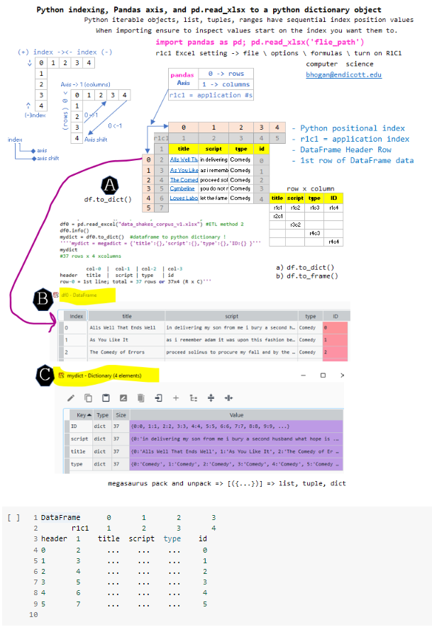



**3 of 3: Essential Python Data Structures and Constructs**

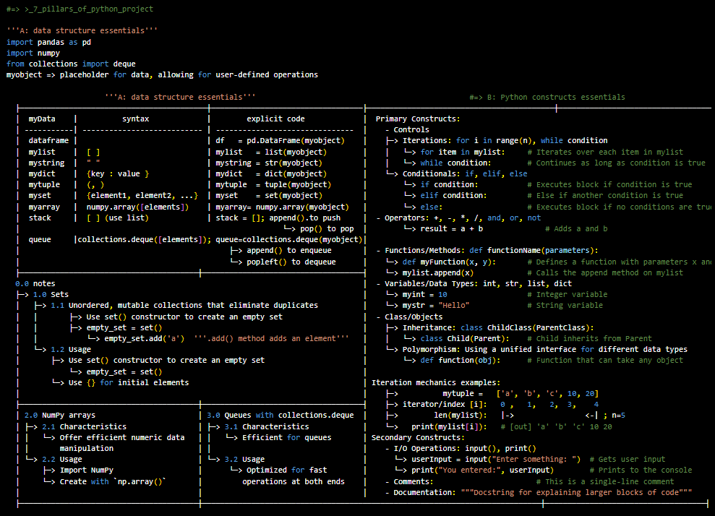

===============

versions

09/02/2025

09/10/202

===============

===============

construction format

===============

# Header.2 [h2]



Abc

**Header.3[h3]**

Abc

====

#end

====

'Subject: Next steps for IT access and course posting

Hi Beth,

Thank you for the helpful email! To move processing, attached are required documents via Google Drive and PDS.

Request: Please advise on the steps to activate my Regis IT credentials so I can load CS105 materials and support students

1. Availability. I'm substitute teaching in Peabody, MA next few days but will come thursday or friday if I cant get whatever needed for Regis college IT access
2. By the weekend, I'd like to ensure IT access so students have Regis continuity versus emailing me at Endicott
3. Please advise on any missing item or preferred course of action as I'll ensure you have the data or whatever else is necessary so my course is in good standing

Best regards,

Brian Hogan, MS

Adjunct—CS105

bhogan@endicott.edu