**Statement on diversity**

**by: Brian Hogan, MS**

As a designer of applied organic structures to facilitate computer science learning, I focus on interactive learning experiences, code, and networks enabling active student learning.

The following explains the application of bee structures to this philosophy as a means for students to learn how to scaffold internally and with their peers. This approach is not possible with the underlying principles of information democracy and information transparency.

**Festooning students**

Students post assignments into an interactive learning [structure](https://docs.google.com/spreadsheets/d/1tetBgbIfdwdFhnc37WUCIk1tlRTKVnFIcKz8tqvd7PA/edit?usp=sharing) building a corpus array of styles and problem-solving approaches. This information exchange enables those behind to seek help directly via active learning collaboration JAMs and indirectly sorting the corpus and learning from peer solving techniques. Hive structures are the apparatus to facilitate festooning, i.e., organic scaffolding, amongst students to solve, repair, and collaborate. Irrespective of a student’s personality and prior experiences, each builds accountability.

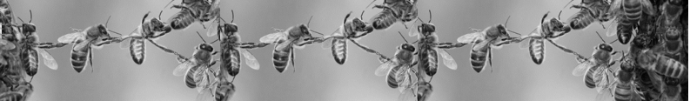

**Festooning Bees [2]**

The formed corpus is transcribable into a data pipeline supporting teaching moments of this technology and provides a means to harvest the classroom’s information honey. While ChatGPT is ladened with controversy, it’s suitable to consolidate and summarize student outcomes providing a valuable walkaway nexus of know-how that is part of my >_7.Pillars.of.Skills; forming cheat sheets. Whether solving individually or collectively, equity presents as all students leaving a course with summarized and searchable outcomes to navigate future challenges.

Scientific literature continues to assess classroom AI with ontologies such as adaptive student achievement[3] and performance prediction[4]. My courses at ICARUS-AI apply tasks by AI scored priors. I connect such principals in tow with active learning and collaborative JAMs. Jupyter Notebooks real time [collaboration](https://jupyterlab.readthedocs.io/en/stable/user/rtc.html) is almost bug-free and will make a marvelous addition to this dynamic learning experience kit. Are students overwhelmed? I’m often told, “at first, I didn’t get it, but now I like it.”**[1]** Students have also shared, “you keep it engaging; unlike many teachers, the class isn’t boring.”**[2]**

**Diversity, equity, and inclusion (DEI)**

DEI embodies a hive mind. Cloud workspaces, GitHub, and Microsoft teams facilitate swarming to address unfinished activities. Hyperlinks provide “at the moment” connections to everything students need to focus on 2D. I take workstation equity very seriously, as improper setups and not owning a mouse impact situational learning. I’ve obtained local e-trash center permission to help provide each student with a second and even third monitor et al., to direct attention in active moments. I love that interactive learning structures leaves no accessibility student behind and strengthens their scaffolding. For instance, one student with disparate inner-city experiences isn’t inclined to speak but behaves dramatically differently in JAMs. I don't know the accessibility issue, but by chance, when another student kindly explained their approach in detail, it alleviated into churn and flow.

Best Regards,

Brian Hogan

1. Student testimonials DanH, ChristianP
2. Student testimonials [JacksonG](https://github.com/bbe2/portfolio/blob/teaching/student_evaluations.pdf).