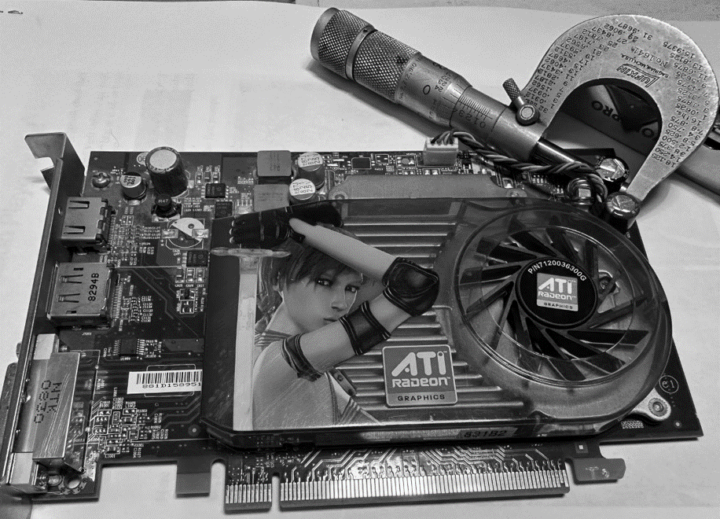**Teaching Statement**

**by: Brian Hogan, MS**

**Precision and rigor** <grandfather’s micrometer>

Channeling the spirit of American industrialism from the 1890s to 1920s, my teaching philosophy emphasizes the importance of precision and rigor in computer science students. I achieve this through the provision of thorough feedback on their code, imparting advanced concepts on complex data structures, and demystifying intricate Python Package Index [libraries](https://pypi.org/). To facilitate the creation of a comprehensive learning resource, I utilize interactive spreadsheet workspaces that enable students to develop a corpus of activities, reflections, and code comments easily accessed and sorted for knowledge reinforcement. This corpus serves as a standard for learning precision and quality, akin to the precision tools used in machining such as a micrometer and parts gauge. Moreover, it underscores the significance of constructing easily searchable information trees enabling students to achieve sustained accuracy.

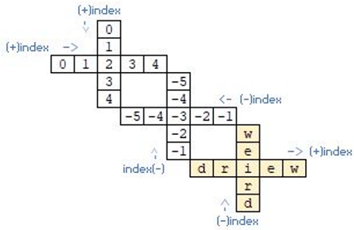Skilling in the core Python built-in data structures, i.e., lists, strings, tuples, and dictionary (a.k.a. [built-in](https://docs.python.org/3/library/stdtypes.html)), forms a backbone in data exchange, transformation, and interoperability. Students become programmers when intuiting built-in objects by iterating or referencing data to suit a snapshot. Like mastering a set of wiggly data blocks, one’s rigor grows by ensuring proper cases and no blank spaces. This work trains in tidy data[1] arrangements reflecting the grok required to index, sort, and transfer data to suit statistical and machine learning objectives.

Demystifying the Python Package Index connects students to the 600,000+ coders who design and skill open-source amazingness, such as the NASA Mars Ingenuity [helicopter](https://github.com/readme/featured/nasa-ingenuity-helicopter). Instead of re-inventing a transformation, teach students to learn the right words to query pypi and discover suitable objects and methods. Why weed through poor search outcomes fattening Google's pocket? While working at Google, my manager tasked me to create effective search trees to provide career certificate learners with efficient search parameters. Such explicit search language empowers student attention by restoring focus to task completion. “Yes!” more upfront attention to language detail is required but saves time with specific outcome pages. Super coders embrace this approach upon learning that an inventory of quality searches can [open](https://github.com/bbe2/portfolio/blob/tech_curriculum_an_GwG/e_foobar.pdf) Google’s [foobar](https://foobar.withgoogle.com/) challenge.

**Festooning students**

Underlying precision and rigor are the principles of information democracy and information transparency. Students post assignments into an interactive learning [structure](https://docs.google.com/spreadsheets/d/1tetBgbIfdwdFhnc37WUCIk1tlRTKVnFIcKz8tqvd7PA/edit?usp=sharing) building a corpus array of styles and problem-solving approaches. This information exchange enables those behind to seek help directly via active learning collaboration JAMs and indirectly sorting the corpus and learning from peer solving techniques. Hive structures are the apparatus to facilitate festooning, i.e., organic scaffolding, amongst students to solve, repair, and collaborate. Irrespective of a student’s personality and prior experiences, each builds accountability.

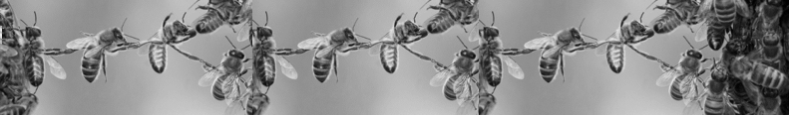

**Festooning Bees [2]**

The formed corpus is transcribable into a data pipeline supporting teaching moments of this technology and provides a means to harvest the classroom’s information honey. While ChatGPT is ladened with controversy, it’s suitable to consolidate and summarize student outcomes providing a valuable walkaway nexus of know-how that is part of my >_7.Pillars.of.Skills; forming cheat sheets. Whether solving individually or collectively, equity is present as all students leave a course with summarized and searchable outcomes to navigate future challenges.

Scientific literature continues to assess classroom AI with ontologies such as adaptive student achievement[3] and performance prediction[4], among others. My courses at ICARUS-AI apply tasks by AI scored priors. I connect such principles with active learning and collaborative JAMs. Jupyter Notebook's real time [collaboration](https://jupyterlab.readthedocs.io/en/stable/user/rtc.html) is almost bug-free and will make a marvelous addition to this active learning experience kit. Are students overwhelmed? I’m often told, “at first, I didn’t get it, but now I like it.”**[1]** Students have also shared, “you keep it engaging; unlike many teachers, the class isn’t boring.”**[2]**

**Diversity, equity, and inclusion (DEI)**

DEI embodies a hive mind. Cloud workspaces, GitHub, and Microsoft teams facilitate swarming to address unfinished activities. Hyperlinks provide “at the moment” connections to everything students need to focus on 2D. I take workstation equity very seriously, as improper setups and not owning a mouse impact situational learning. I’ve obtained local e-trash center permission to help provide each student with a second and even third monitor et al., to direct attention in active moments. I love that interactive learning structures leaves no accessibility student behind and strengthens their scaffolding. For instance, one student with disparate inner-city experiences isn’t inclined to speak but behaves dramatically differently in JAMs. I don't know the accessibility issue, but by chance, when another student kindly explained their approach in detail, it alleviated into churn and flow.

|  |
| --- |
| **>_7.Pillars.of.Skills**  **The pillars of skills contributing to student success and substance formation include a hive mind, research skills, adaptability and preparedness, polysyllabics, journaling, ethical behavior, and active listening. Alongside are reminders to use the situational response technique of stop-> pause-> reflect to facilitate decision-making with a mindful course of action[5].** |
| **1. Hive mind**  **The "hive mind" refers to the collective intelligence of a group of individuals. In a university setting, it emphasizes the importance of collaboration and community-building among students. Students build their people skills and develop the mutual respect critical for academic and professional success by working together and supporting one another.**  **Interactive learning structures, such as cloud workspaces, facilitate JAMs, i.e., swarming activities, to foster this sense of community. These resources provide systems and support for students who need additional assistance, encourage altruistic behavior, and reinforce learning.**  **By engaging in collaborative activities and peer help, students exercise and challenge their brain's neuroplasticity to adapt and achieve sustained learning and positive achievement. To promote this collaborative learning environment, I encourage students to seek peer help after 20 minutes so active learning moments don't turn reactive.**  **The importance of a hive mind is providing students with collaboration and community-building skills. Equipping them with supportive and inclusive structures leads to academic and professional success.** |
| **2. Research skills**  **Gathering and analyzing information effectively is critical for undergraduate and graduate students across disciplines. By promoting effective research techniques and critical thinking, students can evaluate sources and make informed decisions based on evidence.**  **Promoting research skills helps students appreciate scientific methods and enables them to design, conduct, and analyze research efforts. While extensive research methods training is essential, it's also crucial to provide students with baseline knowledge of the structure of scientific articles, including the abstract, introduction, methods, results, and discussion. This way, they learn to find knowledge kernels to support arguments and guide inquiry.**  **In today's data-driven world, gathering and analyzing information is highly valued. Many high-tech companies, such as DeepMind, issue in-depth white papers. Raising awareness of research skills helps foster a culture of intellectual curiosity and enables one to appreciate first principle thinking.** |
| **3. Adaptability and Preparedness**  **Adaptability and preparedness are essential for success in both academic and professional contexts. I focus on developing resilience, flexibility, adaptability, effective time management, and organizational skills to help students stay on track and meet their goals. I encourage creativity, critical thinking, and problem-solving and want my students to be comfortable taking risks, asking questions, and trying original approaches while preparing for the challenges they'll face.**  **A rapidly changing world is blasé. Ray Kurzweil's singularity[6] is near, and Google executives nixed his protege's chatbot after AI safety and fairness standards. Let's use specific and precise language; the alien chatbot used grotesque and threatening language. It's speculated that Ray's pupil Daniel De Freitas did it intentionally[7].**  **Preparedness is computer science literacy, learning to adapt, and looking ahead. I aim to prepare students with the tools, tricks, methods, and legerdemain to oversee any challenge confidently. I provide engaging lectures and facilitate round-table discussions to encourage open discussions, discerning realistic outcomes and practical applications of learned concepts.**  **Preparedness is crucial to succeeding in any field. Students should come to class ready to learn and participate, having completed any required readings or assignments. In return, I provide clear and concise explanations of complex concepts, offer opportunities for students to practice what they've learned, and receive feedback on their performance. This approach helps students develop the skills and mindset needed to navigate the ever-changing landscape of academia and work professions.** |
| **4. Polysyllabics**  **In my teaching, I balance using clear, concise language with introducing students to new, challenging polysyllabic words. Building a strong vocabulary is a lifelong process reinforced in the classroom. I encourage my students to engage with wordbook learning, build syllable word trees, and practice polysyllabics in their writing and speaking.**  **Using big words doesn't necessarily equate to effective communication. I emphasize the importance of clarity and precision in language and encourage students to use language appropriate to the context and audience—avoiding overly complex terminology when it is not necessary or proper and focusing on clear and effective communication.**  **Developing a diverse and nuanced vocabulary is essential for success in both academic and professional contexts. As a teacher, I strive for students to feel comfortable exploring novel words and concepts. Pleasant surprises and fun instructor poking are welcome, like when Pietro informed me of his metastasizing hippopotomonstrosesquipedaliophobia.** |

|  |
| --- |
| **5. Active Listening**  **Active listening is a critical skill for effective communication and collaboration, and instilling and honing this skill helps prepares my students. As an undergraduate in psychology, I trained in Carl Rogers and Richard Farson's active listening technique[8] and journaling, and interestingly, both were also essential components of my process engineering training.**  **Active listening is necessary for understanding the ideas and perspectives of others, building rapport, and creating an atmosphere conducive to learning. As a teacher, I strive to create a safe and supportive environment where students feel comfortable sharing their ideas and perspectives. All voices are heard and valued, and I encourage students to ask questions, clarify information, and respond thoughtfully to others' views and ideas. Awareness of the power of listening improves persuasive communication and pointed feedback.**  **Skills require practice, and I repeatedly ask specific questions from prior classes to help with recall and reinforce learning. Building rapport is essential to understanding, and responding thoughtfully to another equips students to succeed in their careers and personal lives.** |
| **6. Journaling**  **Reflection through writing is fundamental for personal and intellectual growth, especially for university students. As educators, we must encourage students to develop regular writing practice through journaling, blogging, or other forms of written expression to cultivate critical thinking skills essential for success in academia and beyond.**  **Journaling, in particular, is a valuable practice for students to adopt, as it strengthens their recall ability and enhances their ability to analyze their experiences critically. As we strive to connect with our students and support their learning, it helps to acknowledge the evolving landscape of education and Gen-Z learners' unique preferences and habits. Incorporating digital technologies such as Tiktok and other platforms can facilitate engagement and provide opportunities for new forms of written expression.**  **Incorporating methods from experts such as Cal Newport and Scott Young's life of focus course reinforces the importance of the rigor of journaling. Augmenting these focus methods with active listening and journaling enables computer science students to hone the skills necessary for success. It fosters a positive self-outlook rooted in critical thinking and self-reflection. As university professors, we must continue encouraging our students to embrace writing as a personal and intellectual growth tool.** |

|  |
| --- |
| **7. Ethical behavior**  **Ethical behavior is essential in academic and social settings to establish trust, credibility, and integrity. However, developing a robust ethical framework can be a complex task. As an educator, it's important to emphasize the importance of honesty, fairness, and respect in all aspects of one's academic, professional, and personal life.**  **To reinforce, I provide reminders about profane language and encourage active consideration of how another perceives their action. I also share the recommendations of experts such as Dr. John M Curtis, who advocates for avoiding negativity and controversy while emphasizing the importance of fair-minded behavior[10].**  **In computer science, statistical fairness measures are crucial in measuring information exchange and access for all. AI technology advances, and it's important to emphasize the responsibility that comes with it. While features may seem cool or innovative, it's crucial to consider their impact and avoid misuse like image distortion or clouding one's judgment.**  **Overall, promoting ethical behavior and responsible use of technology is critical for building a culture of respect and dignity in academic and social settings. Educators must emphasize these values and help students embrace and grow an ethical framework that informs and guides their substance.** |

**References**

|  |  |
| --- | --- |
| 1 | Wickham, H. (2014). Tidy Data. Journal of Statistical Software, 59(10), 1–23. <https://doi.org/10.18637/jss.v059.i10>. |
| 2 | Festooning bees from Wildflower Meadows[1]. Retrieved from: <https://wildflowermeadows.com/2016/07/festooning-bees/> |
| 3 | Elham, A. (2020). The impact of an adaptive e-course on students’ achievements based on the students’ prior knowledge. Education and Information Technologies, 25(5), 3541-3551. <https://doi.org/10.1007/s10639-020-10125-3>. <[bh.git](https://github.com/bbe2/my_library/blob/student.performance/(adaptive).the.impact.of.adaptive.e.course.pdf)> |
| 4 | Albreiki, B., Zaki, N., & Alashwal, H. (2021). A Systematic Literature Review of Student’ Performance Prediction Using Machine Learning Techniques. Education Sciences, 11(9), 552. <https://doi.org/10.3390/educsci11090552>. <[bh.git](https://github.com/bbe2/my_library/blob/student.performance/(stu.performance).Systematic_Literature_Review.pdf)> |
| 5 | Trish Ganly (2018) Taking time to pause: Engaging with a gift of reflective practice, Innovations in Education and Teaching International, 55:6, 713-723, [DOI: 10.1080/14703297.2017.1294492](https://www.tandfonline.com/doi/abs/10.1080/14703297.2017.1294492) |
| 6 | Kurzweil, R. (2005). The Singularity Is Near: When Humans Transcend Biology. United States: Penguin Publishing Group. Retrieved from: <https://www.google.com/books/edition/The_Singularity_Is_Near/9FtnppNpsT4C?hl=en&gbpv=0> |
| 7 | Business Insider International, “Two Google engineers built a ChatGPT-like AI chatbot years ago, but execs reportedly shut it down due to safety concerns.” INTERNATIONAL  09/03/2023 a las 08:27am. Retrieved from: <https://businessinsider.mx/google-ai-chatbot-chatgpt-years-ago-execs-shut-down-report-2023-3/>. |
| 8 | Levitt, D.H. (2001). "Active listening and counselor self-efficacy: Emphasis on one microskill in the beginning counselor training". The Clinical Supervisor. 20 (2): 101–115. [doi:10.1300/J001v20n02_09](https://www.tandfonline.com/doi/abs/10.1300/J001v20n02_09). S2CID 145368181. |
| 9 | Sacks, Oliver (2016). On the move. A life. Pan Macmillan. ISBN 9781447264064, 1447264061. |
| 10 | Curtis, PhD, J.M., (1999). [Dodging the bullet](https://www.google.com/books/edition/Dodging_the_Bullet/Pl0_PQAACAAJ?hl=en). Survival strategies for life in the fast lane. |

1. Student testimonials DanH, ChristianP
2. Student testimonials [JacksonG](https://github.com/bbe2/portfolio/blob/teaching/student_evaluations.pdf).