1.

**Smith vs Smyth**

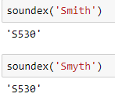

It got the same value because of its sounds is similar to each other

Sm_th vs Sm_th with _ = a, e, i, o, u, y, h, w will also return with same value because those

occurrences got zero value from soundex algorithm

**Jarovsky vs Jurafsky**

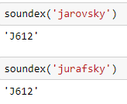

If we filter those occurrences to _ in jarovsky and jurafsky we will get j_r_vsk . So we got same consonants that’s why the soundex value is the same

2.1) Expected Same Soundex codes that give different name

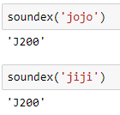

2.2) Unexpected same Soundex codes that give different name

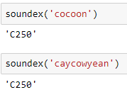

2.3) Similar names but different soundex

