SIEN STREAMFLOW RECORDS

The primary source of streamflow records is the National Water Information System (NWIS) maintained by the U.S. Geological Survey (USGS). Streamflow records for California were accessed at http://waterdata.usgs.gov/ca/nwis/dv. The NWIS database contains streamflow records collected at gaging stations operated by PG&E and SCE as well as the USGS. All of the streamflow records in the NWIS database are reviewed by the USGS to ensure that they are collected and analyzed in a consistent manner.

The USGS NWIS database for California was searched by county to identify all available streamflow gaging stations located within or receiving runoff from drainage basins bordering the SIEN. The location and period(s) of record of several hundred active and discontinued gaging stations were reviewed to identify those suitable for detailed evaluation. Complete information describing the extent of streamflow diversions, reservoir storage and/or regulation is frequently unavailable in the NWIS database, especially for those gaging stations discontinued a decade or more ago. Various additional information resources, including the USGS Water Supply Paper Series issued prior to 1963, USGS Water Data Reports for California published annually since 1963, topographic maps and California Department of Water Resources reports were consulted to identify the gaging station records that represent essentially unimpaired streamflow. The term “essentially” has been applied because only a few gaging stations in the southern Sierra Nevada area represent streamflows totally free from any human manipulations. For example, as much as 1.5 ft3/s was diverted from the Merced River in Yosemite Valley upstream of the Happy Isles Bridge gage prior to 1983. While the diverted flow is very small compared to the annual mean discharge, it is an appreciable portion of summer low flows, especially during the driest years.

A degree of judgment was required to evaluate the extent to which streamflows at a particular gage have been impaired and, thus, were unsuitable for the objectives of this study. The magnitudes and timing of flow diversions and regulation typically vary year-to-year depending upon many factors, including the priority of water rights, accessibility of the diversion site, and capacity of the headgate and diversion canal. (Note: For the purpose of this study, only complete water years of record, October 1 to September 30, are considered. In those instances, which are common, in fact, when a gage began operation during the middle of a water year, the partial year of record has been deleted.) When in doubt, my bias has been to exclude a suspect streamflow record.

Twenty streamflow gaging station records from the NWIS database were determined to be essentially unimpaired and suitable for all of the proposed analyses. An additional two gaging stations listed in the NWIS database and five gaging stations not listed in the NWIS database, as described below, were suitable or available for only partial analysis. The 20 gaging stations selected for complete analysis are listed in Table 1. The locations of the 27 gaging stations are shown in Figure 1. Table 1 contains a summary of information about the gaging station records, including the USGS station number, period of record, mean annual discharge and contributing drainage area. Also, shown in Table 1, you will find a 3 or 4 letter abbreviations to identify each gaging station. The abbreviations are used in Figure 1 to show the gaging station location. Furthermore, the attached files of daily mean discharge, in cubic feet per second, for complete water years of record are identified by the gaging station abbreviation with q appended to indicate daily mean discharge.

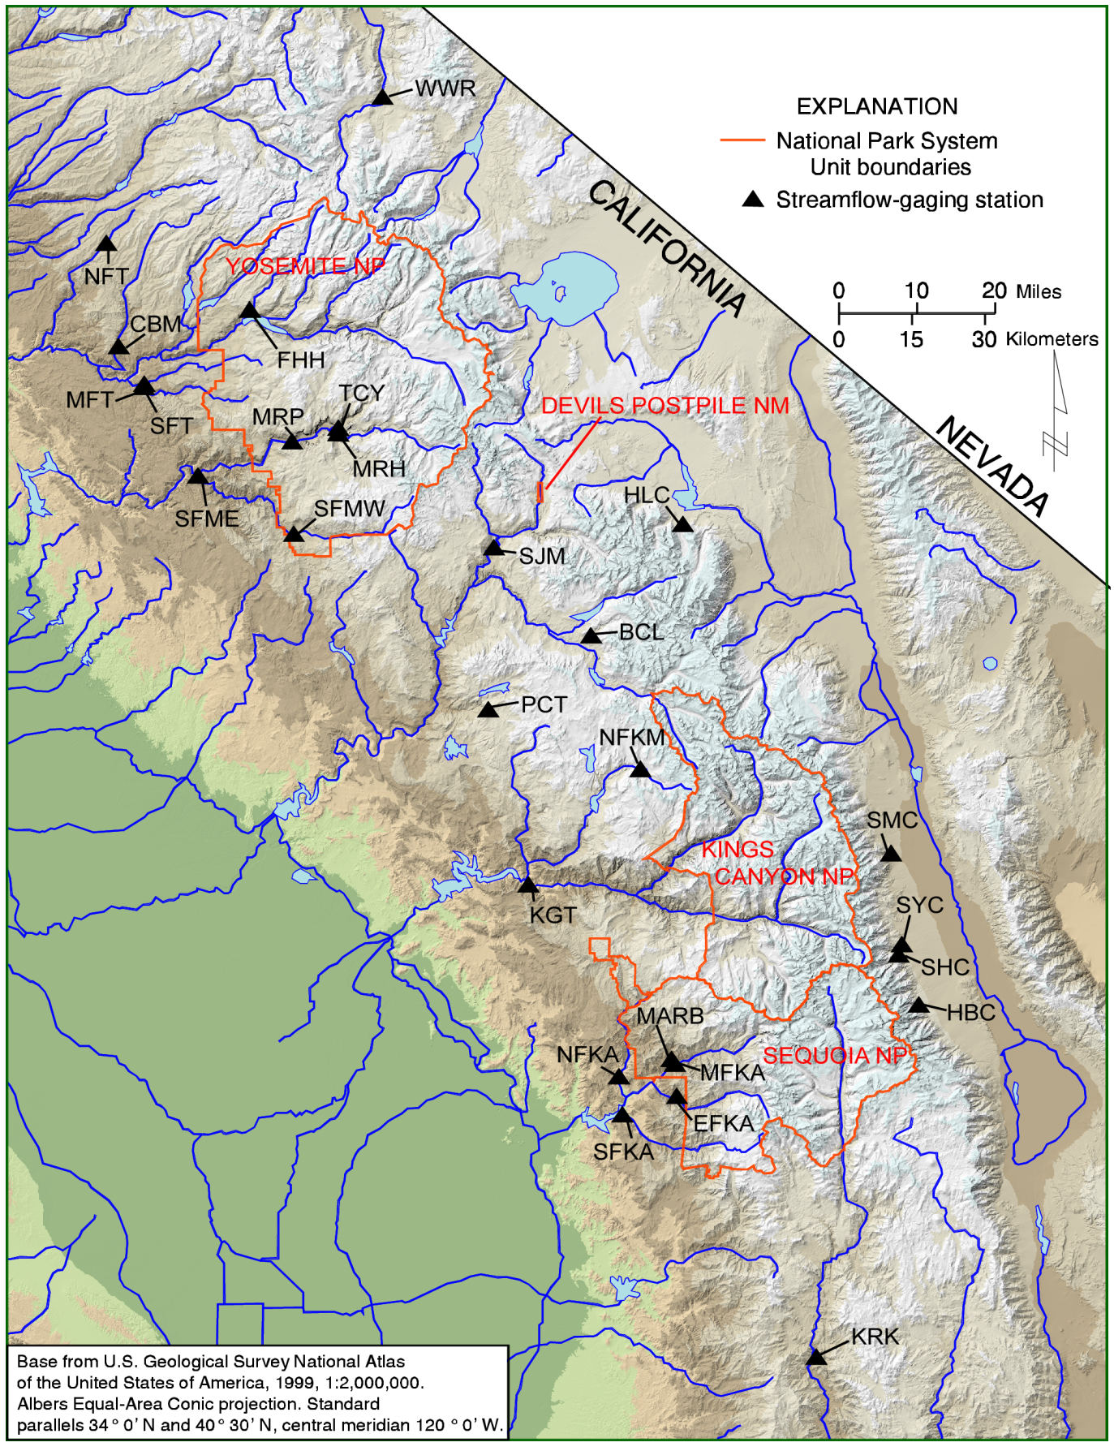

Figure 1. Map of the southern Sierra Nevada showing the 27 streamflow gaging stations selected for this study

Table 1. Streamflow gaging stations within and adjacent to the SIEN including a summary of characteristics.

| Streamflow station | Station No. | Abbrev. | Period of Record | Water Years  of Record | Area | Elevation | Mean Annual  Discharge |
| --- | --- | --- | --- | --- | --- | --- | --- |
|  |  |  | Water Year | Year | (mi)2 | (feet) | (ft*.3*/sec) |
| Merced River at Happy Isles Bridge near Yosemite | 11264500 | MRH | 1916-20091 | 94 | 181 | 4017 | 354 |
| Merced River at Pohono Bridge near Yosemite | 11266500 | MRP | 1917-20091 | 93 | 321 | 3862 | 625 |
| Bear Creek near Lake Thomas A. Edison | 11230500 | BCL | 1922-20091 | 87 | 52.5 | 7367 | 93.3 |
| Pitman Creek below Tamarack Creek | 11237500 | PCT | 1928-20091 | 80 | 22.9 | 7020 | 42.7 |
| Kern river near Kernville | 11186000 | KRK | 1913-20091 | 96 | 846 | 3620 | 757 |
| West Walker River below Little Walker River near Coleville | 10296000 | WWR | 1939-20091 | 71 | 180 | 6590 | 267 |
| MiddleTuolumne River near Oakland Recreation Camp | 11282000 | MFT | 1917-2002 | 85 | 73.5 | 2800 | 78.5 |
| South Fork Tuolumne River near Oakland Recreation Camp | 11281000 | SFT | 1924-2002 | 78 | 87.0 | 2800 | 96.7 |
| Middle Fork Kaweah river near Potwisha Camp | 11206500 | MFKA | 1950-20091 | 53 | 102 | 2100 | 179 |
| Marble Fork Kaweah River at Potwisha Camp | 11208000 | MARB | 1951-2002 | 52 | 51.4 | 2210 | 102 |
| East Fork Kaweah River near Three Rivers | 11208730 | EFKA | 1953-2002 | 32 | 85.8 | 2700 | 104 |
| North Fork Kings River below Meadow Brook | 11214000 | NFKM | 1922-2009 | 48 | 37.7 | 8144 | 74.2 |
| North Fork Kaweah River at Kaweah | 11209500 | NFKA | 1911-1982 | 50 | 129 | 1027 | 100 |
| Falls Creek near Hetch Hetchy | 11275000 | FHH | 1916-1982 | 66 | 46. | 5350 | 143 |
| Kings River above North Fork near Trimmer | 11213500 | KGT | 1927-1982 | 53 | 952 | 1002 | 1460 |
| Tenaya Creek near Yosemite Village | 11265000 | TCY | 1916-1958 | 53 | 46.9 | 4000 | 106 |
| South Fork Kaweah River at Three Rivers | 11210100 | SFKA | 1958-1990 | 32 | 86.7 | 807 | 76.8 |
| San Joaquin River Miller Crossing | 11226500 | SJM | 1922-1991 | 47 | 249 | 4570 | 600 |
| Clavey River near Buck Meadows | 11283500 | CBM | 1960-1983 | 24 | 144 | 2374 | 286 |
| North Fork Tuolumne River Long Barn | 11284700 | NFT | 1963-1986 | 24 | 23.1 | 4650 | 32.5 |
| South Fork Merced River at Wawona | 11267300 | SFMW | 1958-1968 | 10 | 100 | 3955 | 174 |
| South Fork Merced River near El Portal | 11268000 | SFME | 1952-1975 | 24 | 241 | 1490 | 350 |
|  |  |  |  |  |  |  |  |
| Owens River Tributraries | |  |  |  |  |  |  |
| Hogback Creek |  | HBC | 1959-2009 | 51 | N/A | 6590 | 2.15 |
| Shepherd Creek |  | SHC | 1959-2009 | 51 | N/A | 6100 | 5.84 |
| Symmes Creek |  | SYC | 1959-2009 | 51 | N/A | 5700 | 1.95 |
| Sawmill Creek |  | SMC | 1959-2009 | 51 | N/A | 4760 | 3.89 |
| Hilton Creek |  | HLC | 1959-2009 | 51 | N/A | 7480 | 6.94 |

1 Stream gage operated during 2010 water year.

Two types of streamflow records, one included and one excluded, need additional explanation. Three of the streamflow records listed in Table 1, the Kern River near Kernville, the Marble Fork Kaweah River at Potwisha Camp, and the Middle Fork Kaweah River near Potwisha Camp are calculated by summing the flow of a diversion canal and the flow remaining in the river channel below the diversion. That is, the streamflow is reconstructed as if the diversion did not exist. The USGS assigns a number to the reconstructed streamflow record that is the same as the river channel gage, except that the last digit is 1 instead of 0. For example, the number assigned to the Kern River near Kernville is 10296000. The reconstructed streamflow record for the Kern River near Kernville, plus the diverted flow is assigned the 10296001 in the NWIS database. The primary or “river only” gaging station numbers are shown in Table 1, because it is generally easier to find a complete description of the gage station record under the” river only” number, e.g. annual instantaneous peak flow are stored under the “river only” number. Under most conditions, the reconstructed streamflows are nearly identical, if not indistinguishable, to the unimpaired flows upstream of the diversion. (Notes: The period of record for the Marble Fork Kaweah River at Potwisha Camp ends in Sept. 2002 and for the Middle Fork Kaweah River near Potwisha Camp ends in Sept. 2003. The river channel gages continue to be operated, though the point at which the diverted flow is gaged has been moved downstream closer to the powerhouse. The U.S. Geological Survey has determined that it is no longer possible to reconstruct the unimpaired flow at these gages.) At the extremes of the range of flow, both high and low, it is possible that the reconstructed streamflows are not identical to the unimpaired flow immediately upstream of the diversion. Diversion dams and head gates typically leak as much as a few cubic feet per second, which would be an appreciable portion of the summer low flow. The 7-day summer annual minimum flow equaled or exceeded 95 percent of the time is about 10 ft3/s at the Marble Fork Kaweah gage and about 400 ft3/s at the Kern River near Kernville gage. In contrast, the annual peak flows are not reconstructed by adding in the diverted streamflow. Annual peak flows are reported for the gage only under the river channel gage number. For example, the capacity of the diversion from the Kern River near Kernville is 650 ft3/s, while the mean annual peak flood, equaled or exceeded 45 percent of the time is about 3200 ft3/s. Following a thorough review of the 3 reconstructed streamflow records, it was concluded that they are a reasonably accurate record of the unimpaired flows.

An additional seven gaging station records were determined to contain some worthwhile information, but were not suitable for all of the planned analysis. These gaging stations are listed at the bottom of Table 1. The U.S. Geological Survey previously operated two gaging stations on the South Fork Merced River; at Wawona within Yosemite National Park, discontinued in 1968, and near the El Portal gage, discontinued in 1975. Streamflows at both of these gages are depleted by diversions, primarily from late spring through the early fall. Only a few cubic feet per second are diverted at the Wawona gage, and although the total volume diverted is small compared to the annual runoff or annual maximum flows, it is a substantial fraction of summer low flows. Streamflows in the South Fork Merced River near El Portal are affected by a much larger diversion. Therefore, neither of these gage records represents unimpaired low and perhaps even intermediate flow. The annual peak floods, however, are appreciably larger than the diversions. Furthermore, annual peak floods were determined at the South Fork Merced River at Wawona over a 17 year period from 1956-1975, whereas the record of daily mean flow is only 10 years. Accordingly, both of the South Fork Merced River gages, at Wawona and near El Portal, have been included in the analysis of flood frequency. Annual peak floods recorded at the 22 gaging stations shown in Table 1 are saved in a separate folder; sien_hydro_floods.

The City of Los Angeles Department of Water and Power (LADWP) operates an extensive network of streamflow gages along the east slope of the southern Sierra Nevada as part of their diversions from the Owens River. Based upon a description of the study objectives, the LADWP Hydrology Office in Bishop, CA selected and provided mean monthly flows recorded at five gaging stations for the period of 1959-2009. Daily mean discharges are calculated from the continuous stage record; however, daily mean discharges prior to the early 1990s have not been stored in a digital form. The five selected gages are located near the mountain front upstream from the reaches substantially affected by infiltration into alluvial aquifers. Monthly mean discharges, cubic feet per second, recorded at the five LADWP gaging stations are saved in a separate folder; sien_hydro_ladwp.