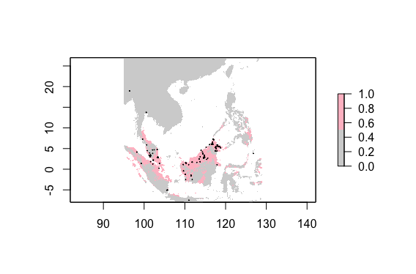

**Fig. 1 Current distribution of *Callosciurus prevostii* (Prevost’s Squirrel).**

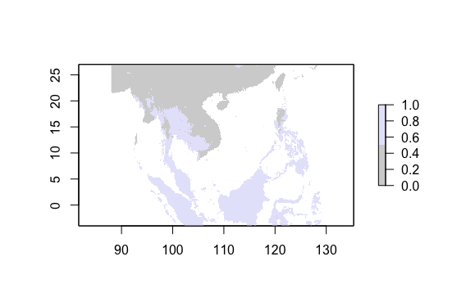

**Fig. 2 Predicted future distribution of *Callosciurus prevostii* (Prevost’s Squirrel).**

The predicted future distribution of *Callosciurus prevostii* is more widespread across Southeast Asia than the current distribution. Currently, *Callosciurus prevostii* inhabits parts of the Malay Peninsula (mostly closer to the water) and the islands Sumatra, Borneo, and Sulawesi. *Callosciurus prevostii* only inhabits small portions of the Malay Peninsula and the islands. The future distribution shows *Callosciurus prevostii* inhabiting all of the Malay Peninsula, Sumatra, Borneo, and Sulawesi. It also predicts that *Callosciurus prevostii* will inhabit the Philippines, the islands in the Banda Arc, and parts of Thailand, Cambodia, Myanmar, Laos, and Vietnam. The *Callosciurus* population could inhabit more northern areas in the future due to global warming. *Callosciurus prevostii* currently inhabits land right across the equator. This suggests that the animal thrives in hot environments. As global temperatures increase, *Callosciurus prevostii* may be able to thrive in areas farther north of the equator. The *Callosciurus prevostii* population seems to be predicted to expand based on climate data, because the population is predicted to be much more widespread than the current distribution. Though the population appears to expand based on climate data, the apparent expansion could be due to sampling bias for the current population data. There are a few reported observations of *Callosciurus prevostii* near Myanmar and Thailand, so it is possible that there is already an established population there. People in those areas may not report observing *Callosciurus prevostii* in the wild, and many people who live in the areas that *Callosciurus prevostii* inhabit may not have access to the technology required to report observations to iNaturalist. Current population distributions are entirely reliant on people reporting observations of the species, so it is possible that the distribution of *Callosciurus prevostii* may not change much in the future.