A systematic mapping study of the use and implementation of coroutines on resource-constrained devices

Procedure notes

# Overview

The original data was saved in SLR/Results/170924_2

# ACM search procedure

## Get bib

The search is the equivalent of using dl.acm.org with the following settings:

|  |  |
| --- | --- |
| Search type | Advanced Search |
| Search | The ACM Full-Text Collection |
| Query | +(coroutine coroutines "lightweight threads") +(IoT "Internet of Things" "Cyber Physical Systems" "Cyber-physical Systems" RTOS "Real-time Operating Systems" "Embedded systems" WSN "Wireless sensor networks" WSAN) |
| Publisher | All |
| Content type | Conference Publications + Journals & Magazines + Early Access Articles |
| Publication Year | 2007-2017 |

1. Use the URL:

http://dl.acm.org/results.cfm?query=%252B(coroutine%20coroutines%20%22lightweight%20threads%22)%20%252B(IoT%20%22Internet%20of%20Things%22%20%22Cyber%20Physical%20Systems%22%20%22Cyber-physical%20Systems%22%20RTOS%20%22Real-time%20Operating%20Systems%22%20%22Embedded%20systems%22%20WSN%20%22Wireless%20sensor%20networks%22%20WSAN)&within=owners.owner=HOSTED&filtered=&dte=2007&bfr=2017

2. Export results to bibtex:

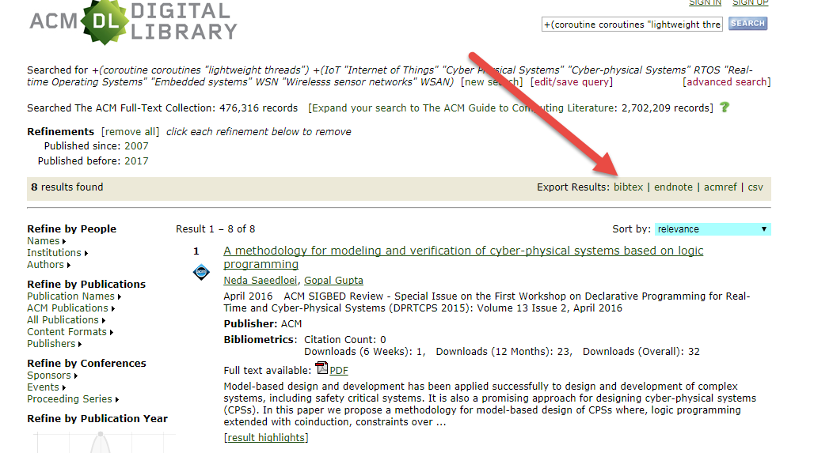

3. Save the file and rename it: acm.bib.

## Save abstracts

1. Open the acm.bib file in JabRef.

2. For each result, follow the link in the ACM library.

3. Copy the abstract.

4. Paste into JabRef, using Edit > Set/Clear/Rename fields to set the field abstract to the clipboard contents.

Clearly this process needs to be automated, using a script similar to the SpringerLink script, but for only 8 results at this time, a manual process is quicker.

# IEEE search procedure

## Get bib

The search is the equivalent of using ieeexplore.ieee.org with the following settings:

|  |  |
| --- | --- |
| Search type | Advanced Search |
| Search | Full Text & Metadata |
| Content filter | All results |
| Publisher | All |
| Content type | Conference Publications + Journals & Magazines + Early Access Articles |
| Publication Year | 2007-2018 |

The search needs to be performed in steps to avoid overflow of search term count (15).

The left hand side term set is:

("lightweight threads" OR "lightweight thread" OR Coroutine OR Coroutines)

The right hand side terms are listed in the table below:

|  |  |  |
| --- | --- | --- |
| # | Search Term 2 | Count |
| 1 | IoT | 14 |
| 2 | Internet of Things | 17 |
| 3 | Cyber Physical Systems | 13 |
| 4 | Cyber-physical Systems | 13 |
| 5 | RTOS | 17 |
| 6 | Real-time Operating Systems | 3 |
| 7 | Real-time Operating System | 11 |
| 8 | Embedded Systems | 74 |
| 9 | Embedded System | 32 |
| 10 | WSN | 22 |
| 11 | Wireless sensor network | 26 |
| 12 | Wireless sensor networks | 36 |
| 13 | WSAN | 0 |

1. Build the URL from a concatenation of:

http://ieeexplore.ieee.org.elibrary.jcu.edu.au/search/searchresult.jsp?action=search&newsearch=true&searchField=Search_All_Text&matchBoolean=true&queryText=((.LB..QT.lightweight%20threads.QT.%20OR%20.QT.lightweight%20thread.QT.%20OR%20Coroutine%20OR%20Coroutines.RB.)%20AND%20

.QT.<Search Term 2>.QT.

)&refinements=4291944822&refinements=4291944246&refinements=4291944245&ranges=2007_2018_Year

The URL hostname need not include the .elibrary.jcu.edu.au suffix if the search is run on the JCU network.

2. Open the web-page in Chrome

3. If the result set is greater than 25, change the “Per Page” setting to contain all results. (Note that this can be done through the URL if more than 200 and less than 1000.)

4. “Select All on Page” to true.

5. Click Export > Citations. Set “Format” to BibTex, “Include” to Citation & Abstract. Click Export.

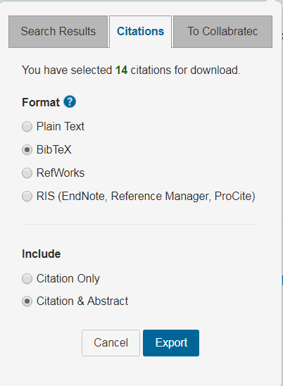

6. A new tab will be opened with URL http://ieeexplore.ieee.org.elibrary.jcu.edu.au/xpl/downloadCitations. Select all and copy (Ctrl+A, Ctrl+C).  
The tab may fail to open because of popup restrictions:

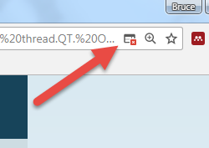  
Override it:  
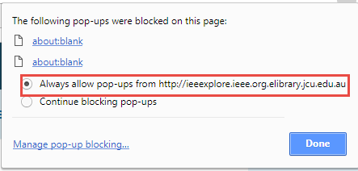

7. Paste into a Unicode-sensitive editor (VS Code) and save as a file with a “.bib” extension.

## Process bib

1. Open JabRef.

2. Create a new empty BibTex database and save as ieee.bib

3. Use File > Append to select all the mini-bibs and append them all to ieee.bib.

4. Remove duplicates: Quality > Find Duplicates > Automatically Remove Exact Duplicates. This only removes some of the pairs. Repeat until 0 duplicates are found.

5. Save.

# ScienceDirect search procedure

## Get bib

The search is the equivalent of using www.sciencedirect.com with the following settings:

|  |  |
| --- | --- |
| Search type | Expert Search |
| Search | Full Text & Metadata |
| Content filter | All results |
| Publisher | All |
| Content type | Journals & Books |
| Publication Year | 2007+ |
| Search terms | (coroutine OR coroutines OR "lightweight threads") AND (IoT OR "Internet of Things" OR "Cyber Physical Systems" OR "Cyber-physical Systems" OR RTOS OR "Real-time Operating Systems" OR "Embedded Systems" OR WSN OR "Wireless sensor networks" OR WSAN) |

The left hand side term set is:

("lightweight threads" OR Coroutine OR Coroutines)

(Note that the first term does not need to be explicitly pluralised because it is in quotes and is part of a multiple term set.)

The right hand side term set is:

(IoT OR "Internet of Things" OR "Cyber Physical Systems" OR "Cyber-physical Systems" OR RTOS OR "Real-time Operating Systems" OR "Embedded Systems" OR WSN OR "Wireless sensor networks" OR WSAN)

The steps are as follows.

1. Go to <http://www.sciencedirect.com.elibrary.jcu.edu.au/science/search>

2. Select Expert search.

3. Set ‘Search for’ to:

(coroutine OR coroutines OR "lightweight threads") AND (IoT OR "Internet of Things" OR "Cyber Physical Systems" OR "Cyber-physical Systems" OR RTOS OR "Real-time Operating Systems" OR "Embedded Systems" OR WSN OR "Wireless sensor networks" OR WSAN)

4. Set period to 2007 to present. Press Search.

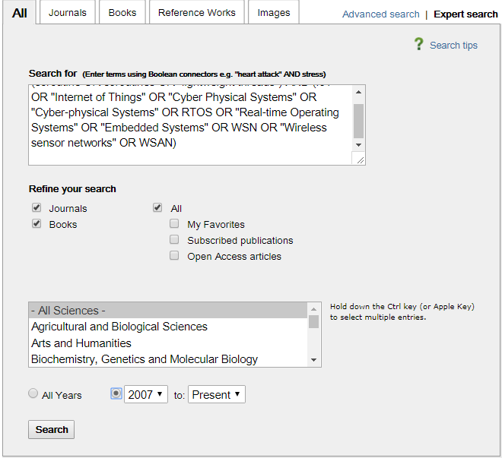

5. In the results screen, ensure that all results are visible, by using the ‘Results per page‘ control.

6. Click on the Export drop-down. Check ‘BibTex’ and ‘Citations and Abstracts’. Click the ‘Export’ button.

## Reproducibility

Note that the URL for the first search part was:

http://www.sciencedirect.com.elibrary.jcu.edu.au/science?_ob=ArticleListURL&_method=list&_ArticleListID=-1235892671&_sort=r&_st=4&md5=3f7c99781579c6e8bb1aeb768838354d&searchtype=a

This use of an md5 hash (local to the server) instead of the search terms themselves means that the URL cannot be reused, and this approach is not automatically reproducible. A different methodology for large scale searches would need to be used in order to achieve automated reproducibility (see, for example, <https://dev.elsevier.com/search.html#!/ScienceDirect_Search/ScienceDirectSearch>.)

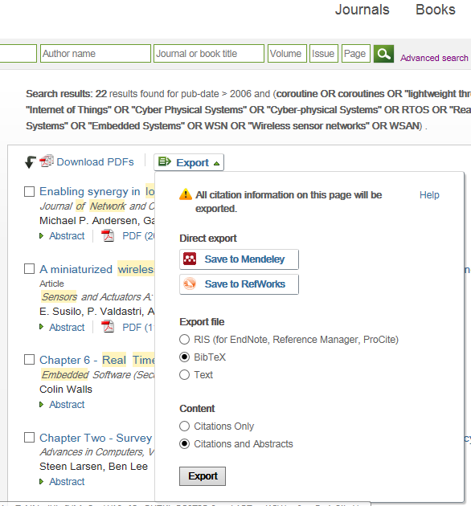

# Scopus search procedure

The search is the equivalent of using www-scopus-com with the settings below. Note that the query is run in two parts because of a 256 character limit.

|  |  |
| --- | --- |
| Search type | Documents |
| Search | Article Title, Abstract, Keywords |
| Query 1 | TITLE-ABS-KEY((coroutine OR coroutines OR "lightweight threads" ) AND ( iot OR "Internet of Things" OR "Cyber Physical Systems" OR "Cyber-physical Systems" OR rtos OR "Real-time Operating Systems" OR "Embedded Systems" OR wsn OR "Wireless sensor network")) AND PUBYEAR > 2006 |
| Query 2 | TITLE-ABS-KEY ( ( coroutine OR coroutines OR "lightweight threads" ) AND ( "Wirelesss sensor networks" OR wsan ) ) AND PUBYEAR > 2006 |
| Publisher | All |
| Document type | All |
| Publication Year | 2007+ |

1. Use the URLs:

https://www-scopus-com.elibrary.jcu.edu.au/results/results.uri?sort=plf-f&src=s&sid=084d5b740439f93692c7e341387dbf13&sot=a&sdt=a&sl=275&s=TITLE-ABS-KEY%28%28coroutine+OR+coroutines+OR+%22lightweight+threads%22+%29+AND+%28+iot+OR+%22Internet+of+Things%22+OR+%22Cyber+Physical+Systems%22+OR+%22Cyber-physical+Systems%22+OR+rtos+OR+%22Real-time+Operating+Systems%22+OR+%22Embedded+Systems%22+OR+wsn+OR+%22Wireless+sensor+network%22%29%29+AND+PUBYEAR+%3E+2006&origin=searchadvanced&editSaveSearch=&txGid=1d2c96d922e73f666c3007e595b50eba

https://www-scopus-com.elibrary.jcu.edu.au/results/results.uri?sort=plf-f&src=s&sid=d379c67c1f25cd2d5ff1343ada26d492&sot=a&sdt=a&sl=127&s=TITLE-ABS-KEY%28%28coroutine+OR+coroutines+OR+%22lightweight+threads%22+%29+AND+%28%22Wirelesss+sensor+networks%22+OR+WSAN%29%29+AND+PUBYEAR+%3E+2006&origin=searchadvanced&editSaveSearch=&txGid=db7e1957230f4d45f9d83b9885c33952

2. For each non-empty result set, select all results.

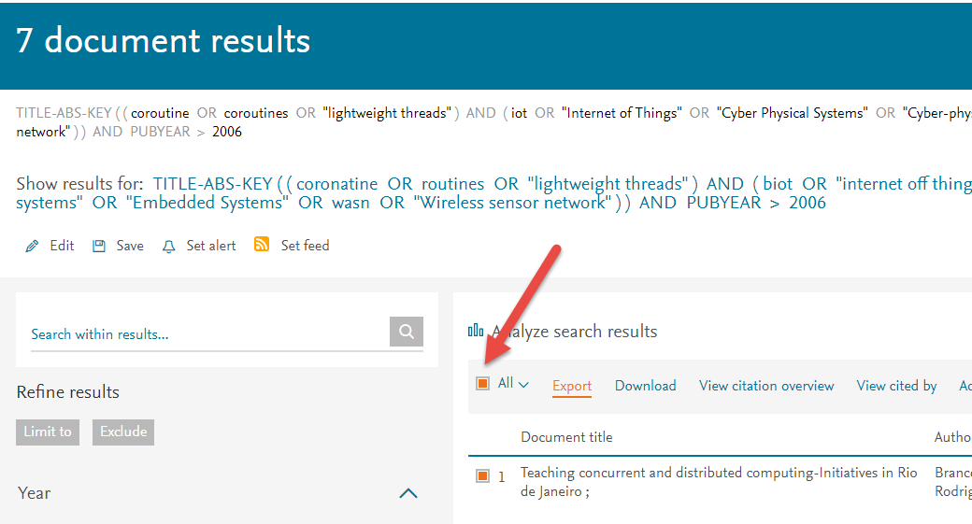

3. Export citations to BibTex, with abstract and keywords:

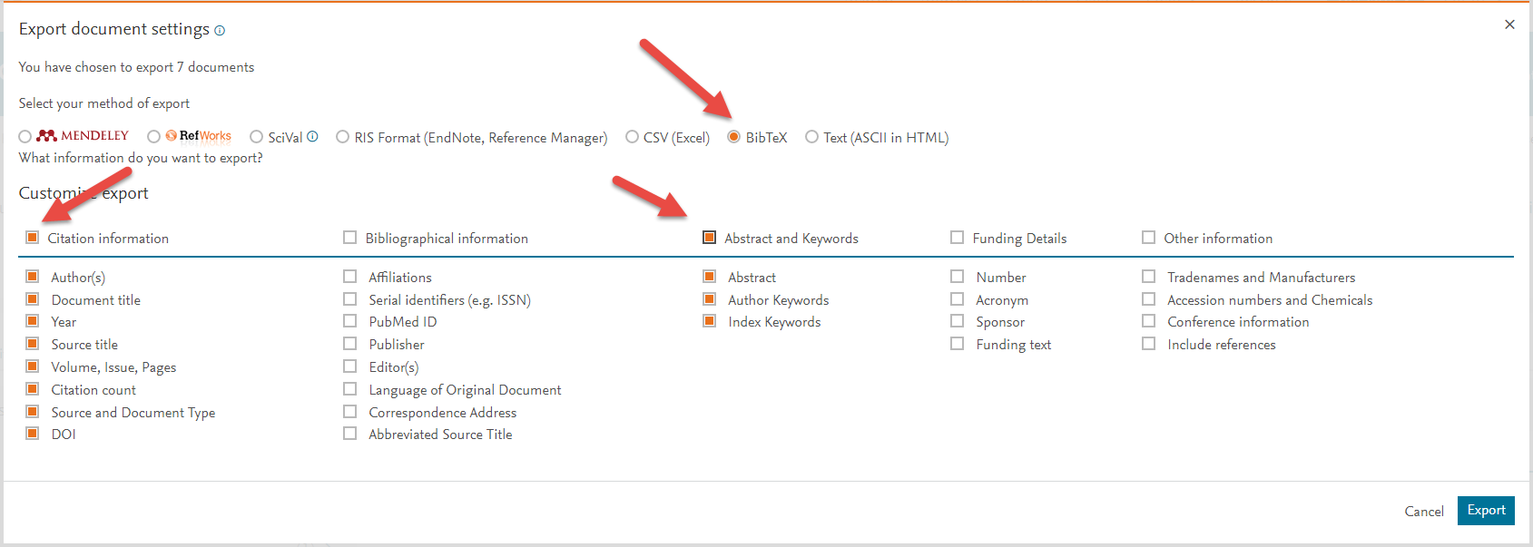

3. If there are multiple files, concatenate them.

4. Copy the file as scopus.bib to the results folder.

Note that Scopus does not support document download on Browsers other than IE 11 or 12, and that there are compatibility issues with these.

# Springer search procedure

## Manual procedure[1]

The search is the equivalent of using link.springer.com/search with the following settings:

|  |  |
| --- | --- |
| Search type | Normal |
| Language | English |
| Content type | All (Chapter + Conference Paper + Article + Reference Work Entry) |
| Discipline | All (Computer Science + Engineering + Business and Management) |
| Subdiscipline | All |
| Publication Year | 2007-2017 |
| Include | Include Preview-Only Content |

Use the following search string:

'(coroutine OR coroutines OR "lightweight threads") AND (IoT OR "Internet of Things" OR "Cyber Physical Systems" OR "Cyber-physical Systems" OR RTOS OR "Real-time Operating Systems" OR "Embedded Systems" OR WSN OR "Wirelesss sensor networks" OR WSAN)'

The equivalent URL is:

https://link.springer.com/search?date-facet-mode=between&facet-start-year=2007&facet-language=%22En%22&facet-end-year=2017&query=%28coroutine+OR+coroutines+OR+%22lightweight+threads%22%29+AND+%28IoT+OR+%22Internet+of+Things%22+OR+%22Cyber+Physical+Systems%22+OR+%22Cyber-physical+Systems%22+OR+RTOS+OR+%22Real-time+Operating+Systems%22+OR+%22Embedded+Systems%22+OR+WSN+OR+%22Wirelesss+sensor+networks%22+OR+WSAN%29

1. Go to the URL

2. Click “Download search results (CSV)”  
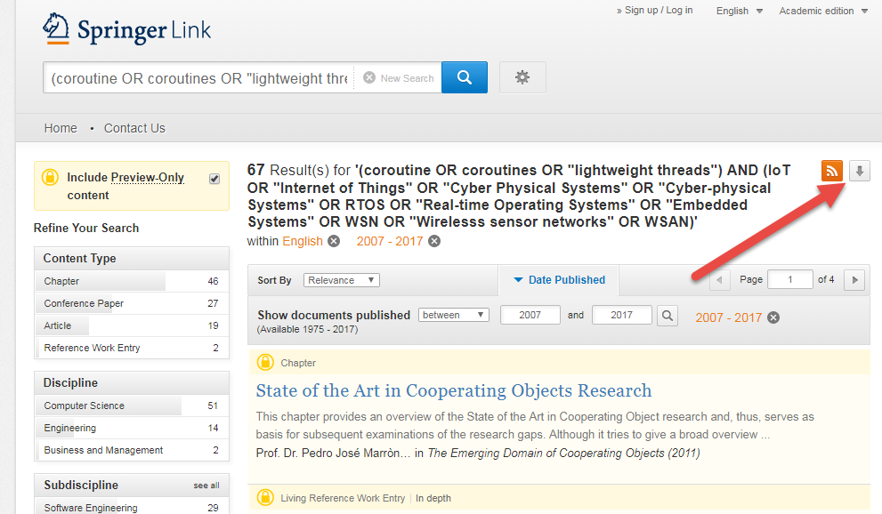

3. Save as Springer_ic.csv

4. Open the CSV in Excel. Select the Item DOI column (excluding the header cell) and copy.

5. Open Zotero.

6. File > New Collection… > Springer_ic

7. Import the DOIs – click the “Add items by identifier” tool.  
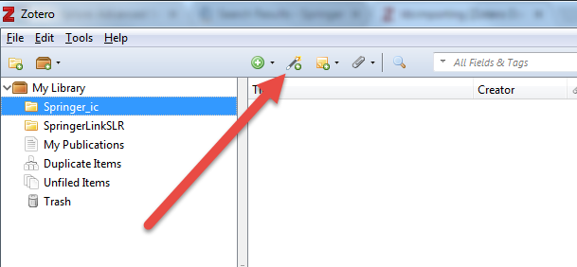  
Paste the DOIs into the dialog field and press Search.

8. Export the bibs. Right-click the collection folder in the tree and click Export collection…  
Choose BibTex format and ensure that Export Notes is checked.  
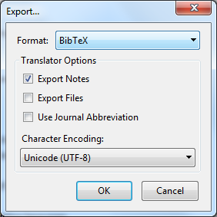

Save as bib file: Springer_ic.bib.

9. Close Zotero. Start Jabref and open Springer_ic.bib.

10. Select all and then click Quality > Cleanup entries (Ctrl+A, Alt+F8).

11. Ensure that ‘Move DOIs…” is checked:  
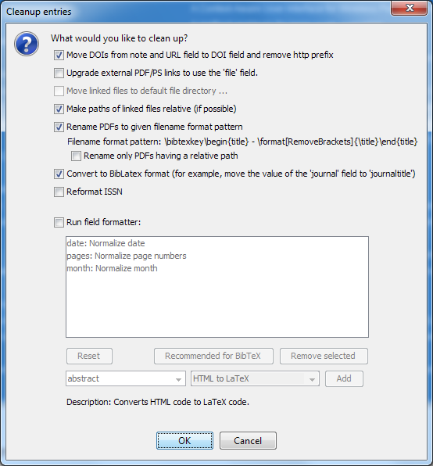

12. Save as Springerlink.bib

## Automated procedure

The manual procedure above does not reliably acquire abstracts or keywords; it has therefore been replaced by a script.

The automated procedure below is based on Luis Augusto Melo Rohten’s GitHub at <https://github.com/luisaugustomelo/node-web-systematic-review>. It has been changed to use the Springer citation download facility instead of screen-scraping.

The node.js script, search-springer.js, contains all the logic. To run the script, follow these steps:

1. Install Node JS version 6 or above.

2. At the command line, navigate to the directory containing the script app.js.

3. Run:  
node ./app.js  
  
4. Copy the resulting bib file to the working folder and rename it as springerlink.bib

The following steps will be run by the script:

1. Open the search results using the URL:

https://link.springer.com/search?date-facet-mode=between&facet-start-year=2007&facet-language=%22En%22&facet-end-year=2017&query=%28coroutine+OR+coroutines+OR+%22lightweight+threads%22%29+AND+%28IoT+OR+%22Internet+of+Things%22+OR+%22Cyber+Physical+Systems%22+OR+%22Cyber-physical+Systems%22+OR+RTOS+OR+%22Real-time+Operating+Systems%22+OR+%22Embedded+Systems%22+OR+WSN+OR+%22Wirelesss+sensor+networks%22+OR+WSAN%29

2. Inspect the record count and page count:

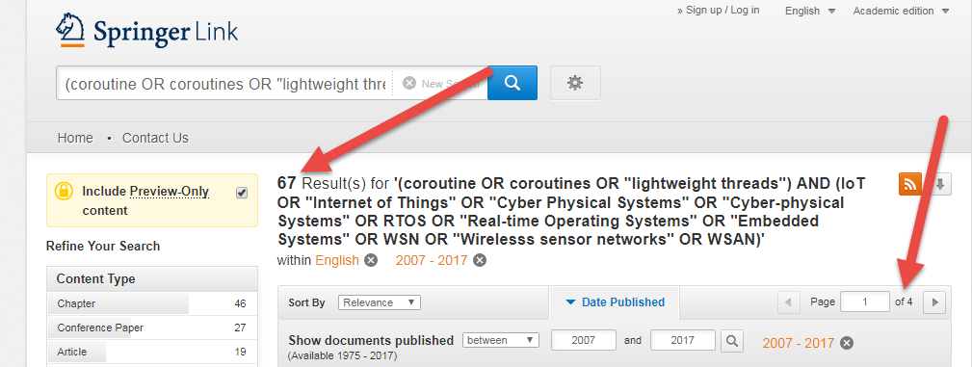

3. Iterate through all pages, using a modified url, e.g. for page 2:

https://link.springer.com/search/page/2?date-facet-mode=between&facet-start-year=2007&facet-language=%22En%22&facet-end-year=2017&query=%28coroutine+OR+coroutines+OR+%22lightweight+threads%22%29+AND+%28IoT+OR+%22Internet+of+Things%22+OR+%22Cyber+Physical+Systems%22+OR+%22Cyber-physical+Systems%22+OR+RTOS+OR+%22Real-time+Operating+Systems%22+OR+%22Embedded+Systems%22+OR+WSN+OR+%22Wirelesss+sensor+networks%22+OR+WSAN%29

4. As each page is returned, iterate through each result, using the link of the title:

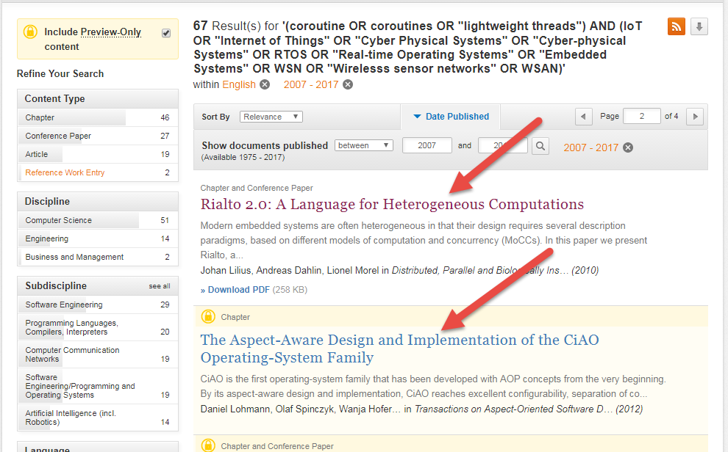

This will be of the following form, using an encoded DOI:

https://link.springer.com/chapter/10.1007/978-3-642-15234-4_3

5. On each result page, click the button to download a citation in BibTex format:



The url will be of the following form:

https://citation-needed.springer.com/v2/references/10.1007/978-3-642-35551-6_5?format=bibtex&flavour=citation

6. The resulting page is Unicide text. Append the text to a global result string.

@Article{Bjørk2013,

author="Bj{\o}rk, Joakim

and de Boer, Frank S.

and Johnsen, Einar Broch

and Schlatte, Rudolf

and Tapia Tarifa, S. Lizeth",

title="User-defined schedulers for real-time concurrent objects",

journal="Innovations in Systems and Software Engineering",

year="2013",

month="Mar",

day="01",

volume="9",

number="1",

pages="29--43",

abstract="Scheduling ...",

issn="1614-5054",

doi="10.1007/s11334-012-0184-5",

url="https://doi.org/10.1007/s11334-012-0184-5"

}

7. When all results have been inspected, save the concatenated result string to a text file with a .bib extension.

# WebOfScience search procedure

The search is the equivalent of using apps.webofknowledge.com, via the JCU library database list, with the settings below. To reach the engine:

1. Go to <https://www.jcu.edu.au/library> & click on Databases.



2. At <http://libguides.jcu.edu.au/az.php>, go to W, and click on Web Of Science.

|  |  |
| --- | --- |
| Database | Web of Science Core Collection |
| Search type | Advanced Search |
| Query | TS=(("lightweight threads" OR "lightweight thread" OR Coroutine OR Coroutines) AND (IoT OR "Internet of Things" OR "Cyber Physical Systems" OR "Cyber-physical Systems" OR RTOS OR "Real-time Operating Systems" OR "Embedded Systems" OR WSN OR "Wirelesss sensor network" OR "Wirelesss sensor networks" OR WSAN)) OR TI=(("lightweight threads" OR "lightweight thread" OR Coroutine OR Coroutines) AND (IoT OR "Internet of Things" OR "Cyber Physical Systems" OR "Cyber-physical Systems" OR RTOS OR "Real-time Operating Systems" OR "Embedded Systems" OR WSN OR "Wirelesss sensor network" OR "Wirelesss sensor networks" OR WSAN)) |
| Languages | All |
| Document type | All |
| Timespan | 2007+ |

1. Select Advanced search

2. Set Timespan.

3. Click the Search button.

4. In the Search history, click the ‘Results’ column:

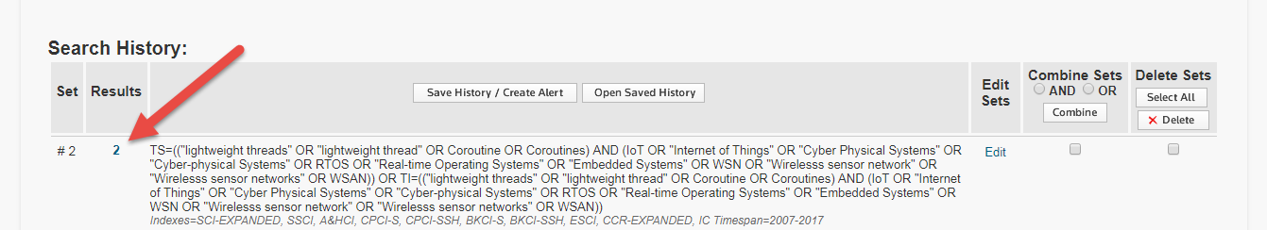

5. Check ‘Select Page’ .

6. Use the drop-down to ‘Save to Other File Formats’:

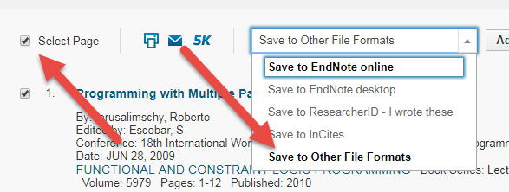

7. Select Full record and BibTex. Press Send.

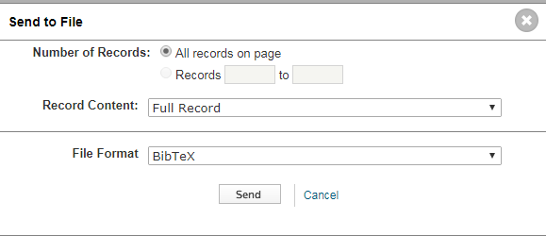

8. Open the file in a Unicode text editor. Replace text as follows:

|  |  |
| --- | --- |
| Search | Replace |
| {{ | { |
| }} | } |

Copy the file as wos.bib to the results folder.

# Post-process bib files

## Set db field

1. Start Jabref.

2. Open each of the collected bib files.

3. For each file, select all entries, right-click and then use the command “Set/clear/rename fields”.

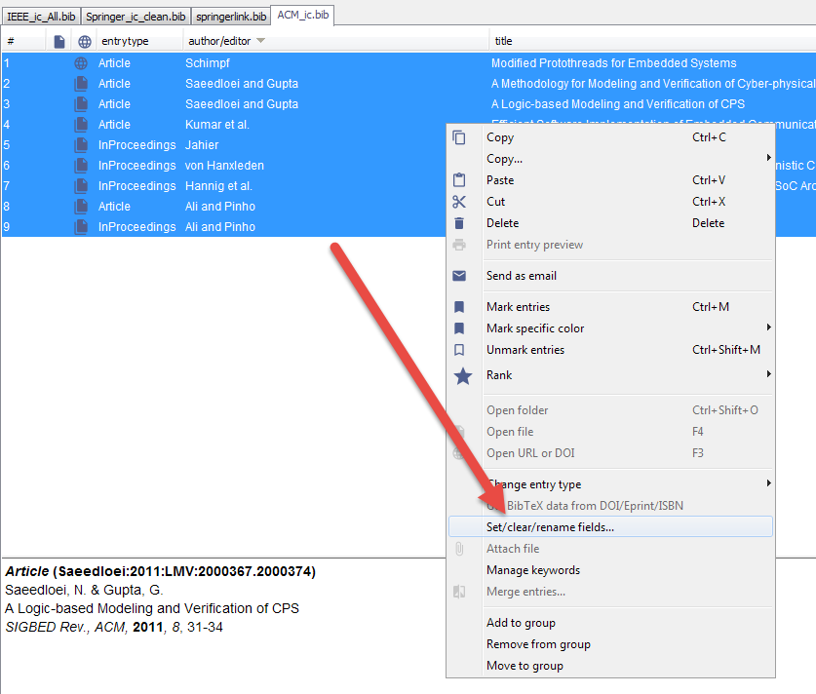

In the dialog, set the db field to an appropriate name. This field will be exported from the library at the end of the process.

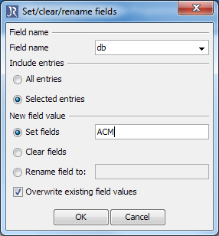

|  |  |  |
| --- | --- | --- |
| Source | File | db field |
| ACM | acm.bib | ACM |
| IEEExplore | ieee.bib | IEEE |
| ScienceDirect | ScienceDirect.bib | ScienceDirect |
| Scopus | scopus.bib | Scopus |
| SpringerLink | springerlink.bib | SpringerLink |
| WebOfScience | wos.bib | WebOfScience |

## Concatenate bib files

1. Start JabRef.

2. Create a new bib file and save as all.bib.

3. For each post-processed source bib file, select all and copy/paste in to the final file.

4. Save.

## Export to CSV

A JabRef export custom layout is used to export the concatenated citations. See <http://help.jabref.org/en/CustomExports> for details.

The following fields and transformations are used:

|  |  |  |
| --- | --- | --- |
| Header | Field formatter | Comments |
| Identifier | "\bibtexkey" |  |
| db | \db | This was set during an earlier post-processing phase |
| doi | "\format[Replace("https://doi.org/,")]{\doi}" | Remove non-standard prefix |
| Type | \bibtextype |  |
| Author | "\format[AuthorLastFirst,AuthorAndsReplacer,FormatChars]{\author}" | FormatChars is used to handle Unicode |
| Title | "\format[RemoveBrackets,RemoveWhitespace,FormatChars]{\title}" |  |
| Year | \year |  |
| Abstract | "\format[Replace(\n, ),RemoveWhitespace,FormatChars]{\abstract}" |  |
| Keywords | "\keywords" |  |
| BibliographyType | \format[GetOpenOfficeType]{\bibtextype} |  |
| ISBN | "\begin{isbn}\isbn\end{isbn}" |  |
| Journal | "\format[Replace("\,,")]{\journal}" |  |
| Volume | "\format[Replace("\,,")]{\volume}" |  |
| Number | \number |  |
| Month | "\month" |  |
| Pages | "\pages" |  |
| Address | "\address" |  |
| URL | "\url" |  |
| Booktitle | "\format[FormatChars]{\booktitle}" |  |
| Edition | "\edition" |  |
| Series | "\series" |  |
| Editor | "\format[AuthorLastFirst,AuthorAndsReplacer,FormatChars]{\editor}" |  |
| Publisher | "\publisher" |  |

## Import CSV to Excel

#### Importing to Excel (Manual)

The problem discussed below can be circumvented by using Copy/Paste from a Unicode-capable text editor (e.g. VS Code). While this approach resists simple automation, it is preferred at this stage.

1. Open the CSV file using a Unicode-capable editor (Visual Studio Code). Select all and Copy (Ctrl+A, Ctrl+C).

2. Open the target spreadsheet in Excel.

3. Create a new sheet, select cell A2, and paste (Ctrl+V).

4. Copy in the extra columns from the Template sheet, and copy row 3 down to the end of the data range.

5. Select cell B1 & Use Data > Filter to apply standard data filters

6. Use Data > Sort to sort by Identifier

#### Importing to Excel (Automated)

Importing CSV into Excel can be troublesome for non-ASCII characters. We must import into Excel as UTF-8:

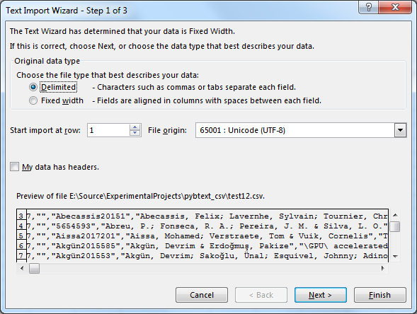

The default setting causes bad transliteration, e.g. line 6 below:

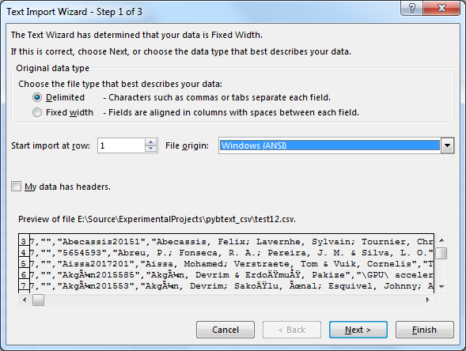

The following is a VBA macro to open the named file as a new sheet in the current workbook. The TextFilePlatform property sets the code page to 65001 (UTF-8).

Public Sub ImportFileFromJabref(ByVal filePath As String)

Dim fn As String, sn As String, i As Integer, qt As Variant

i = InStrRev(filePath, "\")

fn = Mid(filePath, i + 1)

i = InStrRev(fn, ".")

sn = Left(fn, i - 1)

'MsgBox "fn=" & fn & "; sn=" & sn

ActiveWorkbook.Worksheets.Add

Set qt = ActiveSheet.QueryTables.Add(Connection:= _

"TEXT;" & filePath _

, Destination:=Range("$A$1"))

With qt

'.CommandType = XlCmdType.xlCmdTable

.Name = sn

.FieldNames = True

.RowNumbers = False

.FillAdjacentFormulas = False

.PreserveFormatting = True

.RefreshOnFileOpen = False

.RefreshStyle = xlInsertDeleteCells

.SavePassword = False

.SaveData = True

.AdjustColumnWidth = True

.RefreshPeriod = 0

.TextFilePromptOnRefresh = False

.TextFilePlatform = 65001

.TextFileStartRow = 1

.TextFileParseType = xlDelimited

.TextFileTextQualifier = xlTextQualifierDoubleQuote

.TextFileConsecutiveDelimiter = False

.TextFileTabDelimiter = False

.TextFileSemicolonDelimiter = False

.TextFileCommaDelimiter = True

.TextFileSpaceDelimiter = False

.TextFileTrailingMinusNumbers = True

.Refresh BackgroundQuery:=False

End With

End Sub

However, this approach leaves links between the source data file and the Excel workbook which can raise security warnings.

# Second search iteration

It was discovered during Phase 4 that some accepted papers included “co-routine” (with a hyphen) rather than “coroutine”. It was decided to repeat the search process with an expanded search term set to include the hyphenated versions.

The new data was saved in SLR/Results/171111_1

## ACM

The search is the equivalent of using dl.acm.org with the following settings:

|  |  |
| --- | --- |
| Search type | Advanced Search |
| Search | The ACM Full-Text Collection |
| Query | +(coroutine coroutines "co-routine" "co-routines" "lightweight threads") +(IoT "Internet of Things" "Cyber Physical Systems" "Cyber-physical Systems" RTOS "Real-time Operating Systems" "Embedded systems" WSN "Wireless sensor networks" WSAN) |
| Publisher | All |
| Content type | Conference Publications + Journals & Magazines + Early Access Articles |
| Publication Year | 2007+ |

Use this URL without dates:

https://dl.acm.org/results.cfm?within=owners.owner%3DHOSTED&srt=_score&query=%252B%28coroutine+coroutines+%22co-routine%22+%22co-routines%22+%22lightweight+threads%22%29+%252B%28IoT+%22Internet+of+Things%22+%22Cyber+Physical+Systems%22+%22Cyber-physical+Systems%22+RTOS+%22Real-time+Operating+Systems%22+%22Embedded+systems%22+WSN+%22Wireless+sensor+networks%22+WSAN%29&Go.x=25&Go.y=12

Or with date restriction:

https://dl.acm.org/results.cfm?query=%252B%28coroutine%20coroutines%20%22co-routine%22%20%22co-routines%22%20%22lightweight%20threads%22%29%20%252B%28IoT%20%22Internet%20of%20Things%22%20%22Cyber%20Physical%20Systems%22%20%22Cyber-physical%20Systems%22%20RTOS%20%22Real-time%20Operating%20Systems%22%20%22Embedded%20systems%22%20WSN%20%22Wireless%20sensor%20networks%22%20WSAN%29&filtered=&within=owners%2Eowner%3DHOSTED&dte=2007&bfr=&srt=_score

## IEEE

Get bib

The search is the equivalent of using ieeexplore.ieee.org with the following settings:

|  |  |
| --- | --- |
| Search type | Advanced Search |
| Search | Full Text & Metadata |
| Content filter | All results |
| Publisher | All |
| Content type | Conference Publications + Journals & Magazines + Early Access Articles |
| Publication Year | 2007-2018 |

The search needs to be performed in steps to avoid overflow of search term count (15).

The left hand side term set is:

("lightweight threads" OR "lightweight thread" OR Coroutine OR Coroutines)

The right hand side terms are listed in the table below:

|  |  |  |  |
| --- | --- | --- | --- |
| # | Search Term 2 | Old count | Count |
| 1 | IoT | 14 | 16 |
| 2 | Internet of Things | 17 | 19 |
| 3 | Cyber Physical Systems | 13 | 17 |
| 4 | Cyber-physical Systems | 13 | 17 |
| 5 | RTOS | 17 | 27 |
| 6 | Real-time Operating Systems | 3 | 11 |
| 7 | Real-time Operating System | 11 | 23 |
| 8 | Embedded Systems | 74 | 104 |
| 9 | Embedded System | 32 | 47 |
| 10 | WSN | 22 | 27 |
| 11 | Wireless sensor network | 26 | 32 |
| 12 | Wireless sensor networks | 36 | 42 |
| 13 | WSAN | 0 | 0 |

1. Build the URL from a concatenation of:

http://ieeexplore.ieee.org.elibrary.jcu.edu.au/search/searchresult.jsp?action=search&newsearch=true&searchField=Search_All_Text&matchBoolean=true&queryText=((.LB..QT.lightweight%20threads.QT.%20OR%20.QT.lightweight%20thread.QT.%20OR%20Coroutine%20OR%20Coroutines%20OR%20.QT.Co-routine.QT.%20OR%20.QT.Co-routines.QT..RB.)%20AND%20

.QT.<Search Term 2>.QT.

)&refinements=4291944822&refinements=4291944246&refinements=4291944245&ranges=2007_2018_Year

The URL hostname need not include the .elibrary.jcu.edu.au suffix if the search is run on the JCU network.

## ScienceDirect

The search is the equivalent of using www.sciencedirect.com with the following settings:

|  |  |
| --- | --- |
| Search type | Expert Search |
| Search | Full Text & Metadata |
| Content filter | All results |
| Publisher | All |
| Content type | Journals & Books |
| Publication Year | 2007+ |
| Search terms | (coroutine OR coroutines OR "co-routine" OR "co-routines" OR "lightweight threads") AND (IoT OR "Internet of Things" OR "Cyber Physical Systems" OR "Cyber-physical Systems" OR RTOS OR "Real-time Operating Systems" OR "Embedded Systems" OR WSN OR "Wireless sensor networks" OR WSAN) |

The left hand side term set is equivalent to:

(coroutine OR coroutines OR “co-routine" OR "co-routines" OR "lightweight threads")

However, SD has a 256 character limit so this search returns:

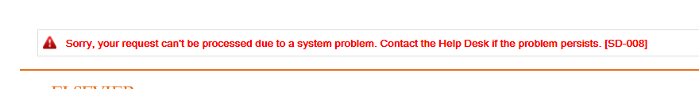

We therefore expand to this to 2 lhs sets:

(coroutine OR coroutines OR "lightweight threads")

("co-routine" OR "co-routines")

(Note that the first term does not need to be explicitly pluralised because it is in quotes and is part of a multiple term set.)

The right hand side term set is:

(IoT OR "Internet of Things" OR "Cyber Physical Systems" OR "Cyber-physical Systems" OR RTOS OR "Real-time Operating Systems" OR "Embedded Systems" OR WSN OR "Wireless sensor networks" OR WSAN)

The steps are as follows.

1. Go to <http://www.sciencedirect.com.elibrary.jcu.edu.au/science/search>

2. Select Expert search.

3. Set ‘Search for’ to:

[Part 1] AND (IoT OR "Internet of Things" OR "Cyber Physical Systems" OR "Cyber-physical Systems" OR RTOS OR "Real-time Operating Systems" OR "Embedded Systems" OR WSN OR "Wireless sensor networks" OR WSAN)

|  |
| --- |
| [Part 1] |
| (coroutine OR coroutines) |
| ("co-routine" OR "co-routines") |
| ("lightweight thread" OR "lightweight threads") |

4. Set period to 2007 to present. Press Search.

5. & 6. As before

7. Create a new bib file and merge the two result sets, using the same technique as for IEEE.

## Scopus

As before, but query is split into 4

The search is the equivalent of using www-scopus-com with the settings below. Note that the query is run in two parts because of a 256 character limit.

|  |  |
| --- | --- |
| Search type | Advanced |
| Search | Article Title, Abstract, Keywords |
| Query 1 | TITLE-ABS-KEY((coroutine OR coroutines OR "co-routine" OR "co-routines" OR "lightweight threads" ) AND ( iot OR "Internet of Things" OR "Cyber Physical Systems" OR "Cyber-physical Systems" OR rtos OR "Real-time Operating Systems" OR "Embedded Systems" OR wsn OR "Wireless sensor network")) AND PUBYEAR > 2006 |
| Query 2 | TITLE-ABS-KEY ( ( coroutine OR coroutines OR "lightweight threads" ) AND ( "Wirelesss sensor networks" OR wsan ) ) AND PUBYEAR > 2006 |
| Publisher | All |
| Document type | All |
| Publication Year | 2007+ |

1. We used the following URLs (note that sid and txGid are session-dependent):

https://www-scopus-com.elibrary.jcu.edu.au/results/results.uri?sort=plf-f&src=s&sid=dfbe6929aa4b744d16554c9fae0ce804&sot=a&sdt=a&sl=275&s=TITLE-ABS-KEY%28%28coroutine+OR+coroutines+OR+%22lightweight+threads%22+%29+AND+%28+iot+OR+%22Internet+of+Things%22+OR+%22Cyber+Physical+Systems%22+OR+%22Cyber-physical+Systems%22+OR+rtos+OR+%22Real-time+Operating+Systems%22+OR+%22Embedded+Systems%22+OR+wsn+OR+%22Wireless+sensor+network%22%29%29+AND+PUBYEAR+%3E+2006&origin=searchadvanced&editSaveSearch=&txGid=b385dd91c63cfd0d16c0c36a63638b68

https://www-scopus-com.elibrary.jcu.edu.au/results/results.uri?sort=plf-f&src=s&sid=8d2b5d4eba277e67b8e5fc45c3ca0a03&sot=a&sdt=a&sl=127&s=TITLE-ABS-KEY%28%28coroutine+OR+coroutines+OR+%22lightweight+threads%22+%29+AND+%28%22Wirelesss+sensor+networks%22+OR+WSAN%29%29+AND+PUBYEAR+%3E+2006&origin=searchadvanced&editSaveSearch=&txGid=b06e51b71a1416fe412e0acb0912ebf2

https://www-scopus-com.elibrary.jcu.edu.au/results/results.uri?sort=plf-f&src=s&sid=220944e6ba4bfa8149c1b7e6705dd138&sot=a&sdt=a&sl=256&s=TITLE-ABS-KEY%28%28%22co-routine%22+OR+%22+co-routines%22%29+AND+%28+iot+OR+%22Internet+of+Things%22+OR+%22Cyber+Physical+Systems%22+OR+%22Cyber-physical+Systems%22+OR+rtos+OR+%22Real-time+Operating+Systems%22+OR+%22Embedded+Systems%22+OR+wsn+OR+%22Wireless+sensor+network%22%29%29+AND+PUBYEAR+%3E+2006&origin=searchadvanced&editSaveSearch=&txGid=69f31c9307c8e624d8a8bc5058536e3a

https://www-scopus-com.elibrary.jcu.edu.au/results/results.uri?sort=plf-f&src=s&sid=39419e852e6e6d5114beae25600d93ab&sot=a&sdt=a&sl=108&s=TITLE-ABS-KEY%28%28%22co-routine%22+OR+%22+co-routines%22%29+AND+%28%22Wirelesss+sensor+networks%22+OR+WSAN%29%29+AND+PUBYEAR+%3E+2006&origin=searchadvanced&editSaveSearch=&txGid=9a9e5acfc40479bba1edc4f888dc475f

## Springer

Amended script to include two new twerms

## WebOfScience

Search text is now:

TS=(("lightweight threads" OR "lightweight thread" OR Coroutine OR Coroutines OR "co-routine"  OR " co-routines") AND (IoT OR "Internet of Things" OR "Cyber Physical Systems" OR "Cyber-physical Systems" OR RTOS OR "Real-time Operating Systems" OR "Embedded Systems" OR WSN OR "Wirelesss sensor network" OR "Wirelesss sensor networks" OR WSAN)) OR TI=(("lightweight threads" OR "lightweight thread" OR Coroutine OR Coroutines OR "co-routine"  OR " co-routines") AND (IoT OR "Internet of Things" OR "Cyber Physical Systems" OR "Cyber-physical Systems" OR RTOS OR "Real-time Operating Systems" OR "Embedded Systems" OR WSN OR "Wirelesss sensor network" OR "Wirelesss sensor networks" OR WSAN))

1. This manual procedure is no longer used, and has been replaced by an automated procedure described below.