2.1

2.2

2.3

2.4

2.5

2.6

2.7

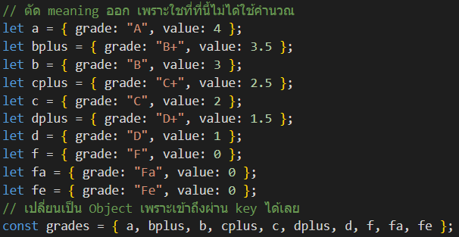

2.8

ข้อมูล

