Polytechnique Montréal - IND8217E Analytics of Faults and Maintenance - Fall 2026
Final Project Report
From Preventive to Predictive Maintenance: Remaining Useful Life of Industrial Air Filters
Bruno Albino Bennertz (2557056) - Rodrigo Fortunato Carvalho (2557001)

1. Introduction

1.1 Problem description
A test bench at Hochschule Esslingen loads a non-woven filter mat with Arizona test dust (ISO 12103-1, grades A2 fine, A3 medium and A4 coarse) carried by an air flow. As particles accumulate, the differential pressure Δp across the filter rises; the filter is considered failed when Δp exceeds 600 Pa (Hagmeyer et al., 2021). The operator currently applies preventive maintenance: every filter is replaced after a fixed interval chosen so that only the shortest ~10 % of lives fail before replacement. This wastes the remaining life of most filters, and it also means that the historical (training) records almost never show a failure: they are right-censored. The objective of the project is to predict the remaining useful life (RUL, in seconds) of a running filter from its condition data, so that the replacement can be planned from the filter's actual state (predictive maintenance).
The problem is a prognosis task, formulated as a regression of RUL. It has two particularities that drive every design decision: (i) only 5 of the 50 training runs reach failure, so the target is missing for most of the training data; (ii) the test set contains 50 complete run-to-failure tests truncated at a random instant, with the true RUL given as ground truth. The test set is used only once, for the final evaluation.

1.2 Hypotheses
- H1 - Monitoring the condition signal Δp improves the RUL prediction compared with a classical reliability model that only knows the operating settings (dust grade, feed rate, flow).
- H2 - Dust feed and dust grade are the dominant drivers of filter life, with life inversely proportional to the feed rate (as assumed by the current replacement rule).
- H3 - A recursive autoregressive model of the Δp dynamics, trained without any RUL label, outperforms the direct RUL regressors trained on pseudo-labels (random forest, XGBoost).

1.3 Machine-learning technique choice
Because the target is censored, two strategies are compared. (i) Direct regression: the training RUL labels are first reconstructed with a physics-informed extrapolation of the clogging curve (Section 3.1) and two tree ensembles learn RUL from condition features - M2, a random forest (bagging of deep trees) and M3, XGBoost (regularised gradient boosting of shallow trees). (ii) Autoregressive simulation: M4 learns only the dynamics of the clogging signal - the growth of Δp over the next 5 s from its own lags and the settings - from every observed transition of the 50 training runs, censored or not, and obtains the RUL by simulating the future recursively until 600 Pa; it needs no RUL label at all. The models are compared with a reference model M1, a Weibull accelerated-failure-time (AFT) regression - the survival model of the course - that only uses the operating settings. Tree ensembles were chosen because they handle non-linear relations and interactions without scaling and are robust with a few thousand samples. Python was used (pandas, SciPy, lifelines, scikit-learn, XGBoost, seaborn).

1.4 Execution plan
(1) Understand the test bench and the data documentation; (2) exploratory analysis of every variable and of the explicit and implicit missing data; (3) cleaning and causal feature engineering; (4) construction of training labels for the censored runs and validation of these labels on the runs that did fail; (5) training and model selection by cross-validation grouped by run, on training data only; (6) a single evaluation on the test set, statistical comparison of the models and translation of the errors into a maintenance decision. Backup options were defined in advance: a pure survival approach if the pseudo-labels proved unreliable, and direct regression only if the recursive simulation proved unstable. All steps are in one reproducible notebook (Filter_RUL_Project.ipynb).

2. Data Preparation

2.1 Data description and variables
The training file has 39,420 rows and the test file 39,414 rows, sampled at 10 Hz, each belonging to one of 50 life tests (Data_No). The settings follow a partial factorial design: 3 dust grades × 8 feed levels (59-317 mm³/s) × 2 flow set-points (≈58 and ≈81). Table 1 categorises the variables as requested: dependent (response) vs independent (state), and controllable (settings) vs non-controllable (sensor measurements).
Table 1 - Variables of the dataset (Data_No is the run identifier).
Variable | Unit | Meaning | Dependency | Controllability
Differential_pressure | Pa | Pressure drop across the filter; health indicator, failure at 600 Pa | Dependent (response) | Non-controllable (sensor)
Flow_rate | ≈ L/min | Air flow through the filter; two set-points | Independent | Controllable (measured setting)
Dust_feed | mm³/s | Dust volume injected per second, constant per run | Independent | Controllable (setting)
Dust | - | Dust grade A2 / A3 / A4 | Independent | Controllable (setting)
Time | s | Age of the filter in the run | Independent (state) | Non-controllable
RUL | s | Remaining useful life (test only) | Dependent (target) | -

2.2 Data cleaning and missing data
No explicit missing value (NaN), duplicated row or gap in the 10 Hz time grid exists. However, the EDA revealed several forms of implicit missing information (Table 2, Figure 1).
Table 2 - Implicit missing data found in the exploratory analysis.
Issue | Train | Test | Interpretation and treatment
Run without observed failure | 45 | 50 | Censored (train) / truncated (test): the failure time is the missing quantity → pseudo-labels (Sec. 3.1)
Δp = 0 rows | 5,672 | 2,722 | Sensor dead-band of the clean filter (median t = 10 s) → kept, smoothed
Flow_rate = 0 rows | 45 | 13 | Sensor dropouts → set to missing, linear interpolation
Non-monotonic timestamp | 1 | 0 | Corrupted first row of train run 28 (t = 157.2 s) → removed
Run starting at 0.2 s | 3 | 9 | First sample lost → negligible, no action

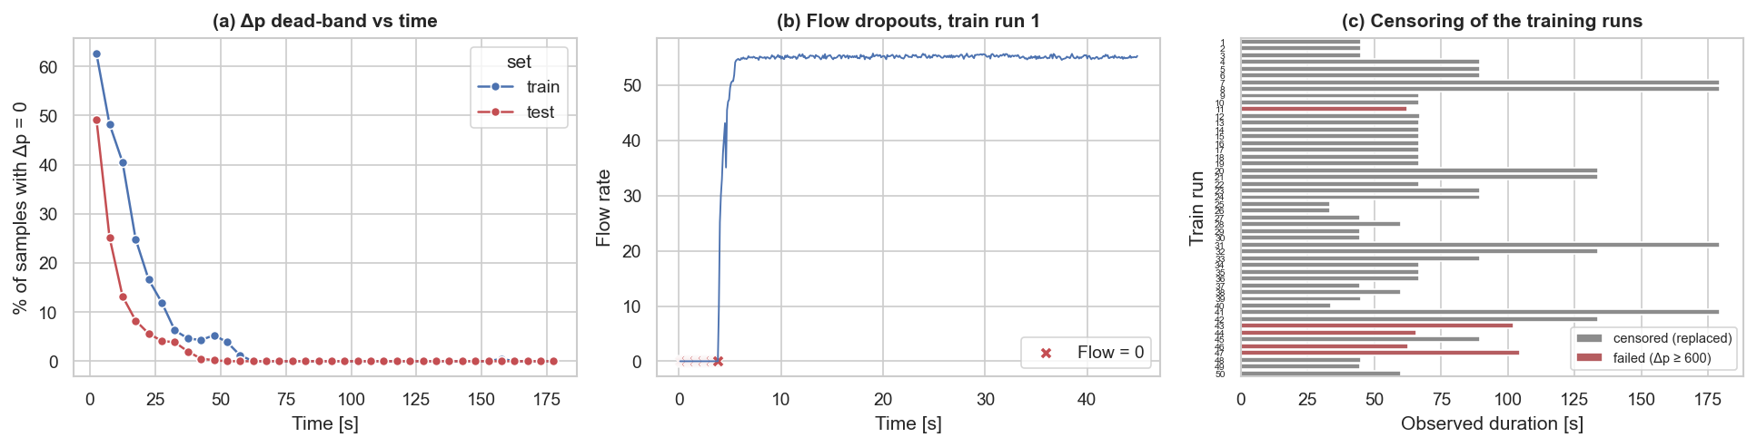
Figure 1 - (a) share of Δp = 0 samples vs time; (b) flow-rate dropouts; (c) censoring of the training runs: only 5 runs reach 600 Pa.
The most important gap is the censoring: the Kaplan-Meier estimate of the training lifetimes only falls to ≈0.9, so the training data describe the shortest 10 % of lives, not a typical life. Moreover, all five failed runs use A2 fine dust: the training data contain no failure at all for A3 and A4 dust.
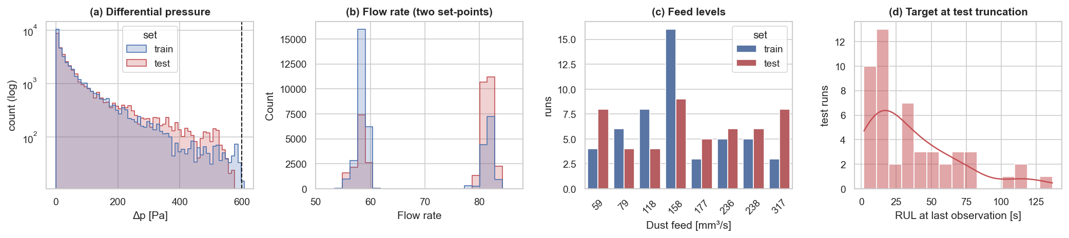
Figure 2 - Distributions: (a) Δp (log scale), (b) flow rate with its two set-points, (c) number of runs per feed level, (d) test target: RUL at the last observed sample.
Δp is strongly right-skewed (most samples come from the flat early part of the curves), the flow rate is bimodal and behaves as a categorical setting, and the feed takes 8 discrete values. Train and test cover the same settings with a similar mix of dust grades, but the test set has more high-flow runs (26 vs 16 of 50) and a higher mean feed (179 vs 161 mm³/s), a mild distribution shift. The test target ranges from 1.9 to 136.6 s (median 26.5 s), so the models must work both close to and far from failure.
Outliers. Large Δp values near 600 Pa are the failure signal, not outliers, so a global IQR rule (which would flag 3,292 training samples) was not used. Within each run no value lies outside the sensor range and no jump exceeds 50 Pa in 0.1 s; a Hampel criterion (deviation > 5 MAD and > 20 Pa from the median of the surrounding 1-s window) flags 17 train and 28 test samples, which are replaced by the local median (the raw value is kept to detect the 600 Pa crossing). Flow readings far from the set-point (104 train samples, median t = 0.2 s) are start-up transients of the controller and were kept.

2.3 Data visualisation and preprocessing
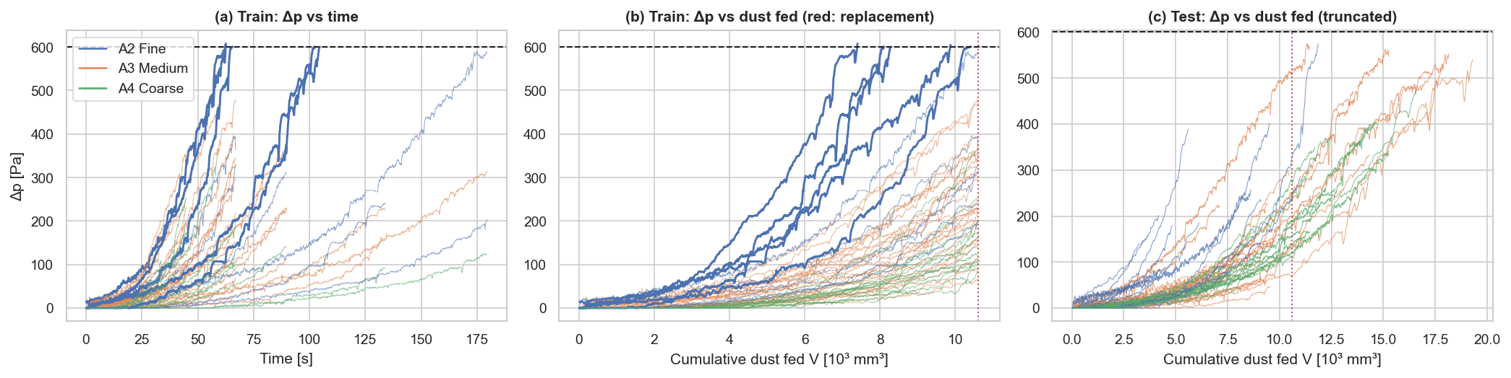
Figure 3 - Δp trajectories: (a) train vs time, bold = failed runs; (b) train vs cumulative dust volume, red line = preventive replacement; (c) truncated test runs.
Figure 3 shows that Δp grows slowly and then accelerates (depth filtration followed by cake filtration). When plotted against the cumulative dust volume V = feed × t instead of time, the curves collapse into a narrow band, and the preventive replacement occurs at a constant volume V ≈ 10,604 mm³ (the interval is inversely proportional to the feed). At equal volume, high flow and fine dust give higher Δp (Spearman correlation of Δp with V = 0.81, with time = 0.71). The test runs reach well beyond the replacement volume, confirming that the preventive policy wastes life.
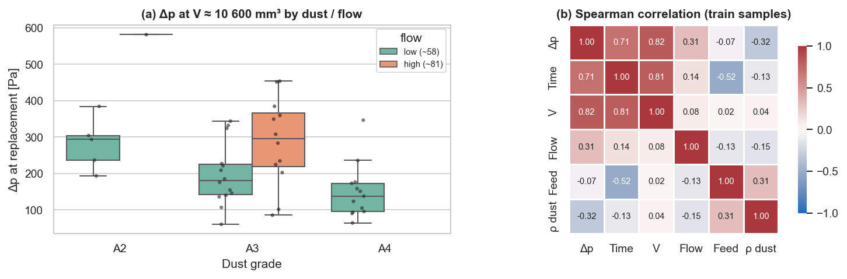
Figure 4 - (a) Δp reached at the replacement volume by dust grade and flow level (censored training runs); (b) Spearman correlation of the training samples.
Figure 4a quantifies the effect of the settings at the same dust load: for A3 dust the median Δp at replacement is 296 Pa at high flow vs 180 Pa at low flow (pressure drop grows with the face velocity, Darcy's law), and at low flow it decreases from fine to coarse dust (294, 180 and 138 Pa for A2, A3, A4): fine particles form a denser cake. Flow and dust grade therefore change the rate of degradation, which is why they are kept as model inputs.
Preprocessing, applied identically and independently to each run: removal of the corrupted row, interpolation of flow dropouts, Hampel replacement of Δp spikes, causal 1-s moving average of Δp, and resampling to 1 Hz for modelling. Features extracted (all causal, i.e. computable online): smoothed Δp and Δp/600, slopes over 5 and 10 s, curvature, growth rate of log Δp, age t, cumulative dust volume V and mass (with the bulk densities 0.900/1.025/1.200 g/cm³ given in the documentation), log feed, dust density and one-hot grade, running mean flow and flow set-point indicator.

3. Methodology

3.1 Training labels for censored runs
For a failed run the label is RUL = T_fail − t. For a censored run we extrapolate its degradation curve to 600 Pa. Four curve shapes were tested (exponential, quadratic, power law, linear tail) by truncating the five failed runs at 30, 50, 70 and 90 % of their life and comparing the extrapolated failure time with the true one (Figure 5a). The exponential model Δp = a·e^(bt) + c has the lowest overall error and is the best up to 70 % observed (at 90 % all forms are within 5 %): its RMS error is 15 %, 9 % and 4 % with 50, 70 and 90 % of the life observed (bias -5, -6, -4 %, i.e. conservative), but 124 % with only 30 % observed. The censored runs were observed for a median 79 % of their extrapolated life (minimum 64 %), inside the reliable range. The failure time is obtained in closed form and constrained to exceed the replacement time:
T̂_fail = ln[(600 − c)/a] / b , T̂_fail ≥ T_censor
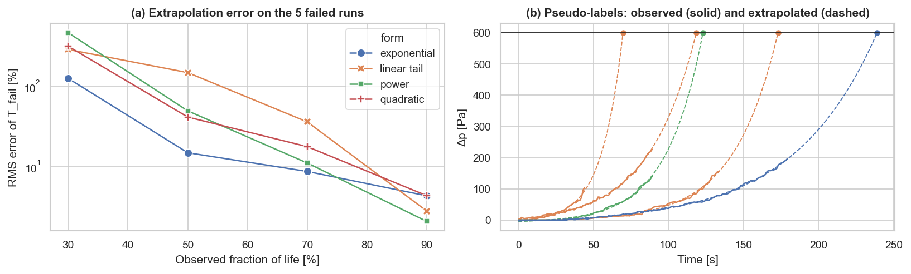
Figure 5 - (a) extrapolation error of the four curve shapes on the truncated failed runs; (b) examples of pseudo-labels.

3.2 Models
- M1 - Weibull AFT: log λ = β0 + β1·log(feed) + β2·A3 + β3·A4 + β4·flow_high, shape ρ. The RUL of a filter of age t is the mean residual life E[T − t | T > t]. Fitted on the 50 run lifetimes (observed + pseudo-labels), the same label information as M2 and M3; the textbook fit on the censored data alone (5 events) left the A3/A4 effects unidentifiable (β(A3) 95 % CI [-0.9, 3.3]).
- M2 - Random forest (scikit-learn): 300 deep trees, each grown on a bootstrap sample and a random subset of features, averaged (bagging reduces variance). Best of four configurations by 5-fold cross-validation grouped by run: "RF leaf=20 features=1.0" (CV RMSE 13.2 s against the labels).
- M3 - XGBoost (xgboost library): shallow trees added sequentially, each fitted to the gradient of the loss left by the previous ones (boosting reduces bias), with L2 regularisation and row/column sub-sampling. Best of four configurations by the same cross-validation: "XGB depth=3 lr=0.05" (CV RMSE 10.3 s).
- M4 - Recursive autoregressive model: XGBoost predicts the growth of log(1+Δp) over the next 5 s from the lags log(1+Δp) at t, t−5 s and t−10 s, the dust load V and the settings, trained on 3,657 one-step transitions of all 50 training runs (no RUL label; configuration "AR-XGB depth=3 lr=0.05" selected on the one-step cross-validation error). The model is iterated on its own predictions in 5-s steps until 600 Pa (increments clipped at ≥ 0, horizon capped at 500 s); the time to the crossing is the RUL (Figure 6). Predicting the growth rate rather than the level lets the trees reach 600 Pa although few training samples exceed 400 Pa.
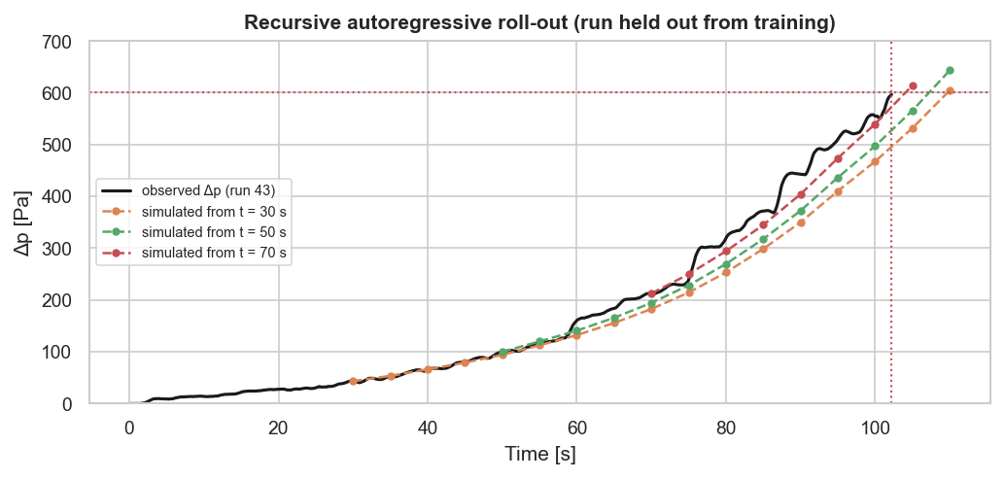
Figure 6 - Recursive autoregressive roll-out started from three instants of failed training run 43, with the one-step model refitted without that run (red: 600 Pa and true failure time).

3.3 Evaluation protocol
Training, scaling, model selection and early stopping use only the training runs, always split by run to avoid leakage between samples of the same filter. The primary evaluation is the RUL predicted at the last observed sample of each of the 50 test runs (the task defined by the dataset), with RMSE, MAE, bias (predicted − true; positive = optimistic), share within ±10 s and the asymmetric PHM08 score, which penalises late (optimistic) predictions more because they lead to unplanned failures. Differences in RMSE are tested with a paired bootstrap over the 50 runs (5 000 resamples). Secondary evaluations: error on all 1 Hz test samples as a function of the horizon, an imminent-failure alarm (RUL ≤ 15 s), and a maintenance-policy simulation (supporting analysis).

4. Results
Table 3 - Test-set performance at the last observed sample of the 50 runs (columns 2-6) and over all test samples (last column).
Model | RMSE [s] | MAE [s] | Bias [s] | Within ±10 s [%] | PHM score | RMSE all samples [s]
M1 Weibull AFT | 24.3 | 17.1 | -11.5 | 46 | 791 | 46.8
M2 Random forest | 19.5 | 13.8 | -5.9 | 52 | 683 | 40.3
M3 XGBoost | 18.8 | 13.3 | -10.7 | 54 | 321 | 38.3
M4 Autoregressive | 15.2 | 10.9 | -9.3 | 62 | 161 | 26.6

Every prediction is compared with the ground truth provided in the test file (the RUL column). Figure 7 shows, run by run, the true RUL at the truncation instant and the four predictions; the full table (settings, true RUL, prediction and error of each model for the 50 runs) is exported to results/test_ground_truth_comparison.csv. Counting the model closest to the ground truth in each run: M1 10, M2 14, M3 6, M4 20 runs.
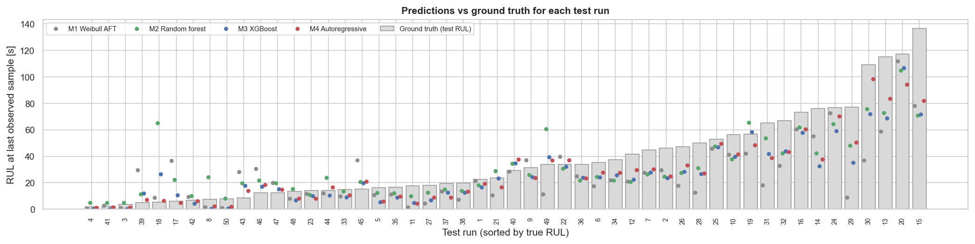
Figure 7 - Ground-truth RUL (black) and predictions of each model at the last observed sample of the 50 test runs, sorted by true RUL.
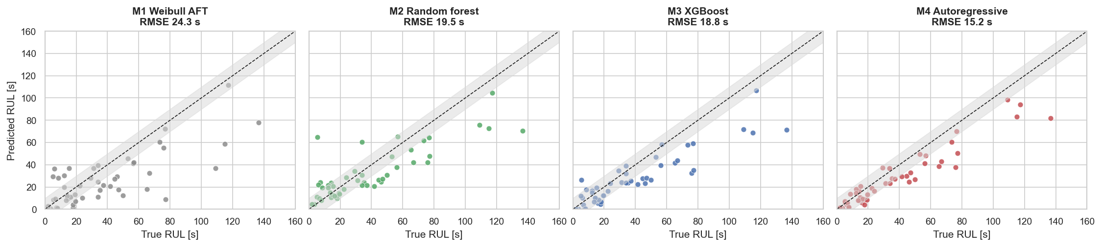
Figure 8 - Predicted vs true RUL at the last observed sample of each test run (grey band: ±10 s).
Table 4 - Paired bootstrap of the RMSE differences (positive = B is better).
Pair (A vs B) | RMSE(A) − RMSE(B) [s] | 95 % bootstrap CI | Significant
M1 Weibull AFT vs M2 Random forest | +4.8 | [-1.8, +10.8] | no
M1 Weibull AFT vs M3 XGBoost | +5.5 | [+1.0, +9.9] | yes
M1 Weibull AFT vs M4 Autoregressive | +9.1 | [+3.7, +14.8] | yes
M2 Random forest vs M3 XGBoost | +0.7 | [-2.3, +4.9] | no
M2 Random forest vs M4 Autoregressive | +4.3 | [+0.6, +8.8] | yes
M3 XGBoost vs M4 Autoregressive | +3.6 | [+1.4, +5.7] | yes

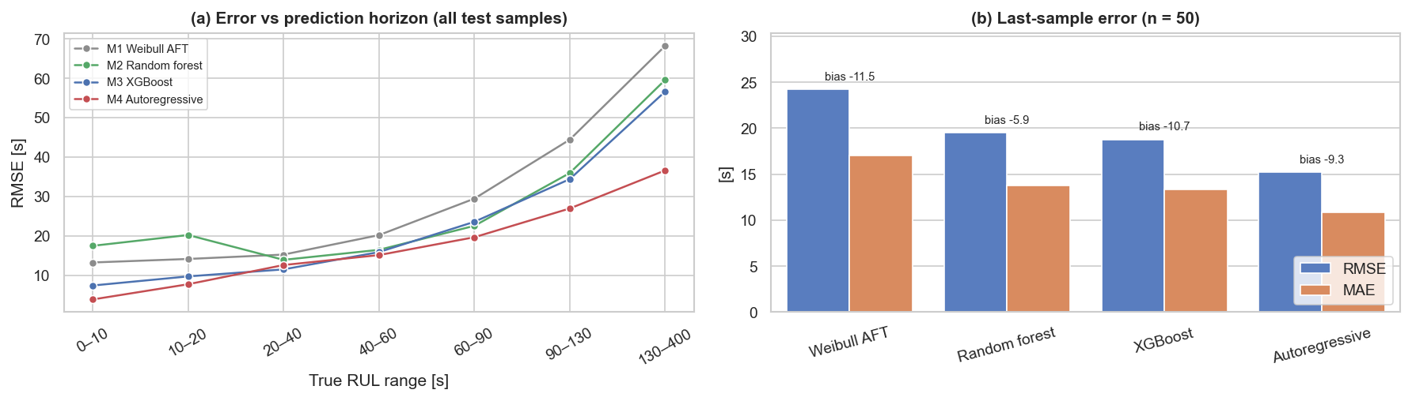
Figure 9 - (a) RMSE as a function of the true RUL on all test samples; (b) last-sample RMSE, MAE and bias.
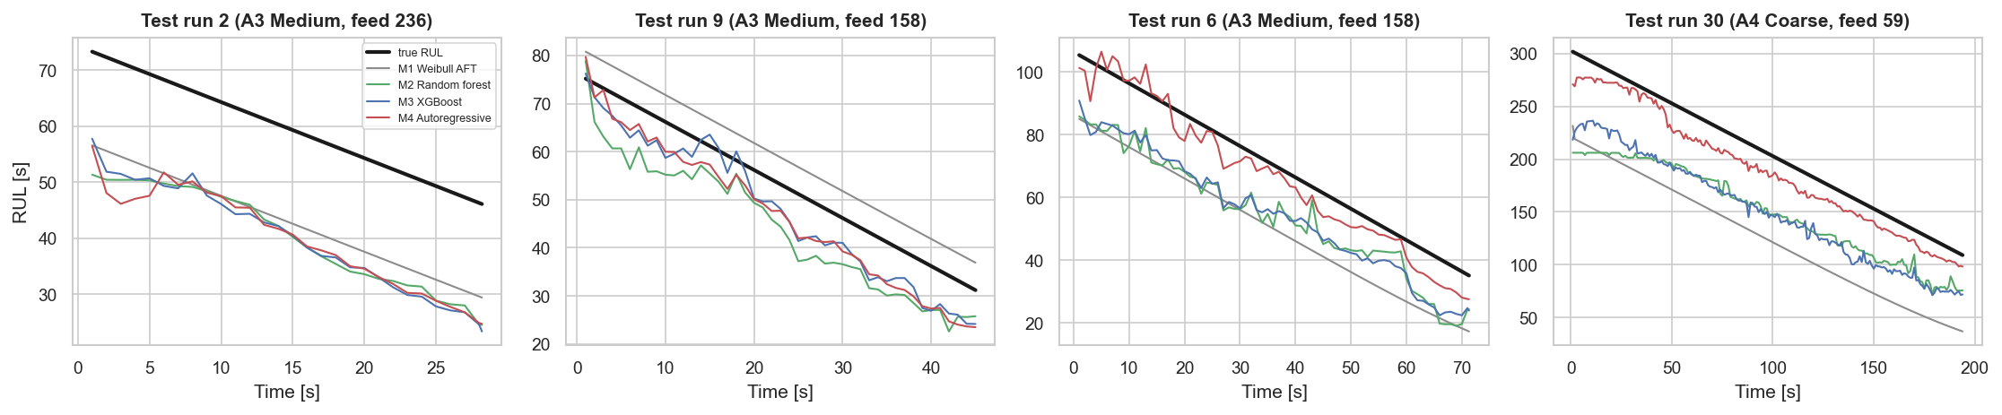
Figure 10 - Predicted RUL along four test runs.
Table 5 - Supporting analysis - replacement policies on the 50 test filters. Predictive: replace at t_last + predicted RUL.
Policy | Unplanned failures (of 50) | Mean wasted life [s] | Life used [%]
Preventive (V = 10 600 mm³) | 5 | 40.9 | 72.4
Predictive: M1 Weibull AFT | 11 | 18.3 | 89.5
Predictive: M2 Random forest | 19 | 15.8 | 92.5
Predictive: M3 XGBoost | 10 | 15.1 | 90.1
Predictive: M4 Autoregressive | 10 | 12.7 | 91.5

Alarm view (RUL ≤ 15 s on all test samples): recall / precision = M1 0.70 / 0.24; M2 0.45 / 0.40; M3 0.66 / 0.30; M4 0.81 / 0.35. Reference comparison: reproducing the set-up of a public Kaggle notebook on this dataset (forecast Δp 1 s ahead from 20 samples) gives MAE 4.41 Pa and R² 0.9968 with linear regression, practically identical to the naive persistence forecast Δp(t+1 s) = Δp(t) (MAE 4.41 Pa, R² 0.9960).

5. Discussion and Analysis of Results
Accuracy. All three machine-learning models have a lower error than the settings-only Weibull model at the last observed sample (15.2 s for the best, M4 Autoregressive, against 24.3 s), but with 50 test runs the improvement is statistically significant only for M3 XGBoost and M4 Autoregressive (Table 4). Over all test samples the gap is consistent (40.3, 38.3, 26.6 s for M2-M4 vs 46.8 s for M1) and present at every horizon, including close to failure where it matters for maintenance (Figure 9a): knowing that Δp is accelerating tells more than knowing the settings. M4 Autoregressive has the best PHM score (161), i.e. the fewest large optimistic errors.
Bias. The models trained on the pseudo-labels (M1-M3) under-estimate the RUL (bias -11.5, -5.9, -10.7 s). This is inherited from the labels, which are conservative by construction (the exponential extrapolation under-estimates the failure time and the training failures are all fine-dust filters), and it is the safe direction. The autoregressive model, which never sees a RUL label, has a bias of -9.3 s: it is also conservative on average, although individual simulations can be optimistic (see below). For all models the error grows with the horizon (Figure 9a): far from failure Δp is still flat and the end of life is hard to see, consistent with the 30 % truncation results of Section 3.1.
Model behaviour. Random forest vs XGBoost: the difference at the last sample is not significant (19.5 vs 18.8 s, 95 % CI of the difference [-2.3, +4.9] s). XGBoost is better on cross-validation RMSE, last-sample RMSE, RMSE over all test samples and PHM score. M2 Random forest is the least biased model (-5.9 s); the boosting model fits the conservative pseudo-labels more closely and inherits more of their negative bias, whereas averaging deep trees keeps the forest closer to zero at the cost of more optimistic errors. In the XGBoost model the most important inputs (permutation importance) are log_feed, dp_s, slope10.
Direct vs autoregressive. The recursive model reaches a last-sample RMSE of 15.2 s (MAE 10.9 s) without using any RUL label, better than M2 Random forest and M3 XGBoost, significantly so against M2 Random forest and M3 XGBoost. Its alarm recall is 0.81 and 0 % of the simulations hit the 500-s cap. Its strength is that it uses every observed transition of the censored runs and does not depend on the pseudo-labels, which under-estimate the long lives of A3/A4 filters: its error grows more slowly with the horizon (Figure 9a) and stays close to the ground truth on long-life runs (Figure 10). Its weakness appears in the first ~15 s of a run, when Δp is still in the sensor dead-band and there is no growth to extrapolate: a few simulations started there are strongly optimistic (up to +200 s), which is why its PHM score over all samples is poor; after 15 s no error exceeds 30 s. In practice the prediction should only be used once Δp leaves the dead-band.
Maintenance value (supporting analysis). The preventive policy used 72.4 % of the filter life and still let 5 of 50 filters fail. Scheduling the replacement exactly at the predicted RUL would use 90.1-92.5 % of the life, but with 10-19 unplanned failures, because the individual prediction errors are still of the order of 15-20 s. The RUL models are therefore ready as decision support (ranking filters, alarms), but an automatic replacement rule needs a safety margin calibrated on the failure risk the company accepts (Section 6.2). The comparison with the reference notebook shows why the problem must be framed as RUL: a one-second-ahead forecast of Δp reaches R² ≈ 0.996 with a rule that has learned nothing, and it says nothing about when the filter will fail.
Limitations: the labels of 45 runs are model-based; no A3/A4 failure was observed in training; the test set has only 50 runs (wide confidence intervals); the policy simulation uses a single decision at the truncation point.

6. Conclusion

6.1 Hypotheses results
Table 6 - Acceptance or rejection of the hypotheses (test set).
 | Result | Evidence
H1 | accepted | best ML RMSE 15.2 s vs 24.3 s for the Weibull AFT; M1−M2: +4.8 s [-1.8, +10.8]; M1−M3: +5.5 s [+1.0, +9.9]; M1−M4: +9.1 s [+3.7, +14.8]
H2 | accepted | beta(log feed) = -1.00 (95% CI -1.08 to -0.93), p = 2.39e-162; p(A3) = 0.000213, p(A4) = 0.000172, p(flow) = 0.223
H3 | accepted | M4 15.2 s vs M2 19.5 s and M3 18.8 s; M2−M4: +4.3 s [+0.6, +8.8]; M3−M4: +3.6 s [+1.4, +5.7]

The coefficient of log(feed) in the Weibull AFT is -1.00 (95 % CI -1.08 to -0.93), consistent with life ∝ 1/feed; the censored-only fit gives the same conclusion (-1.11, CI -1.48 to -0.74). Overall, the project shows that the transition to predictive maintenance is feasible with the existing sensors: the machine-learning RUL models predict the failure of a running filter with a mean absolute error of 10.9-13.8 s, err on the safe side on average, and the best one (M4 Autoregressive) is significantly better than the classical reliability model. The recursive autoregressive model, trained without reconstructing any RUL label, is the most accurate and significantly outperforms the direct regressors trained on pseudo-labels. To replace filters automatically, the predictions must be combined with a calibrated safety margin and used only once Δp leaves the sensor dead-band.

6.2 Future work
- Learn a calibration of the pseudo-labels (or a survival loss that uses the censoring directly, e.g. a deep survival model) to remove the conservative bias.
- Hybrid (physics-informed) model: use the exponential extrapolation, now used only to build the labels, as an input feature of the tree models.
- Collect a few run-to-failure tests with A3/A4 dust and use prediction intervals (quantile regression) to set the safety margin of the replacement policy.
References: Hagmeyer, S., Mauthe, F., & Zeiler, P. (2021). Creation of publicly available data sets for prognostics and diagnostics addressing data scenarios relevant to industrial applications. International Journal of Prognostics and Health Management, 12(2). Dataset: "Preventive to Predictive Maintenance" (Kaggle, Prognostics @ HSE). Reference notebook: "Predictive maintenance using ML and LSTM RNN" (Kaggle). Software: lifelines, scikit-learn, PyTorch. Code and data: Filter_RUL_Project.ipynb, Train_Data_CSV.csv, Test_Data_CSV.csv, requirements.txt.

