# Kaplan-Meier survival estimates: Medicare-age AMI hospitalizations, stratifying by race, sex, age, and year-cohort

Kaplan-Meier survival estimates for Medicare patients admitted to a hospital with a diagnosis of AMI are presented on the following pages. The first page shows 5-year survival estimates for hospitalized men while the second page shows estimates for hospitalized women. Survival is presented for each of the 3 year cohorts 1993-1994, 2002-2003, and 2012-2013 and for patients of any age, 65-70, and 80+.

Survival for the 2012-2013 cohort is shown for only the first 1.5 years after index admission because almost all patients are censored from the data by the end of 2013. Although given the data it is possible to estimate survival for 2 years in this cohort, changes in survival at 2 years would be almost entirely driven by a few patients who were hospitalized in early 2012 and died at the end of 2013. Because most patients are censored by the end of 2013, these few deaths would lead to large discontinuous drops in the survival estimates at 2 years.

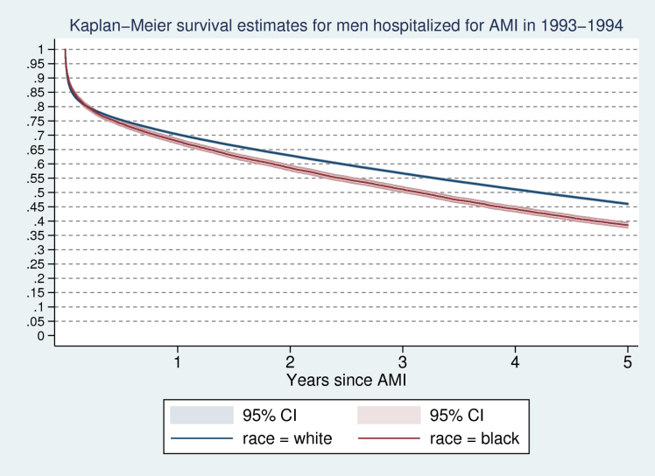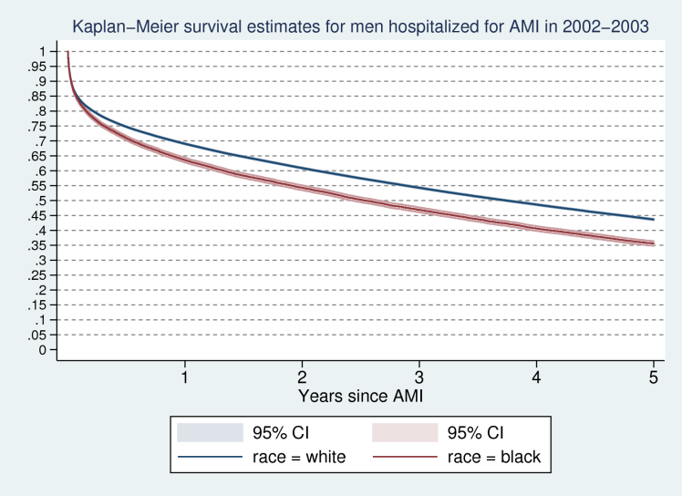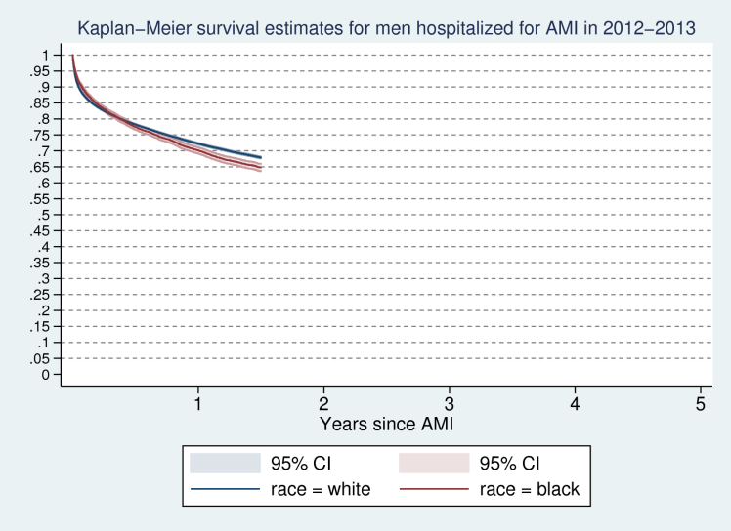

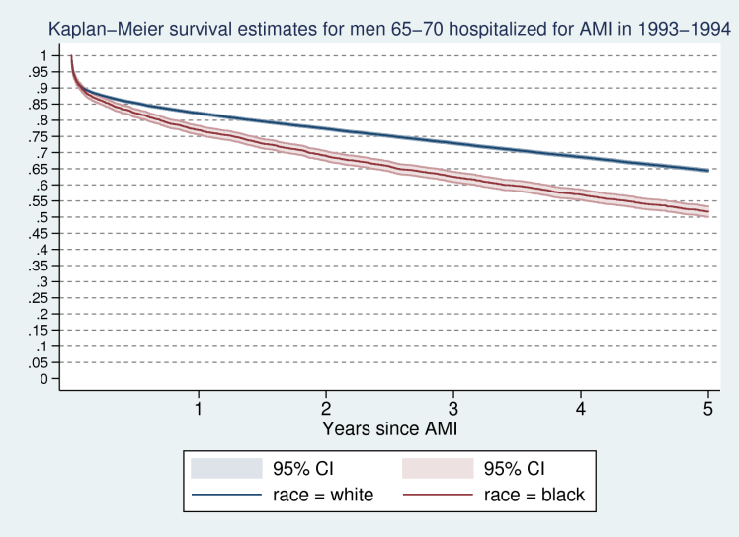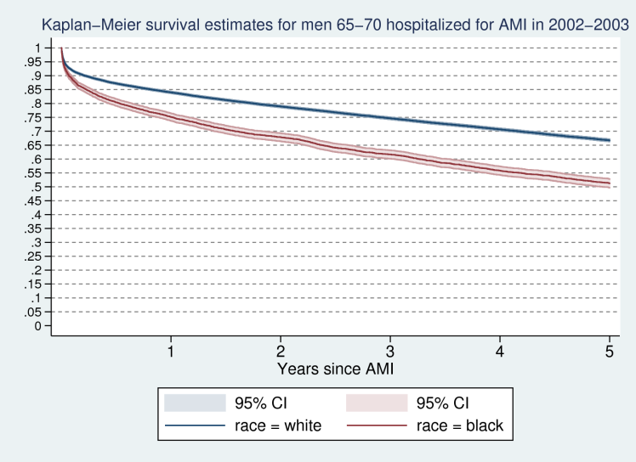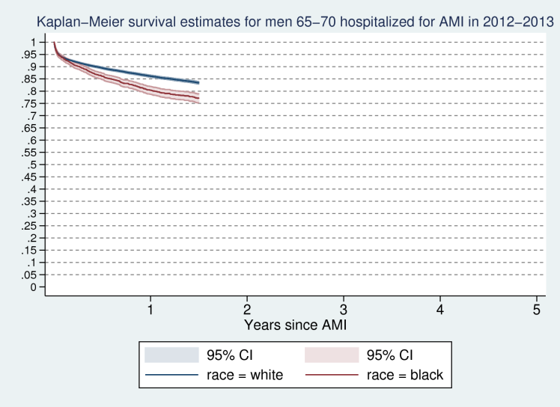

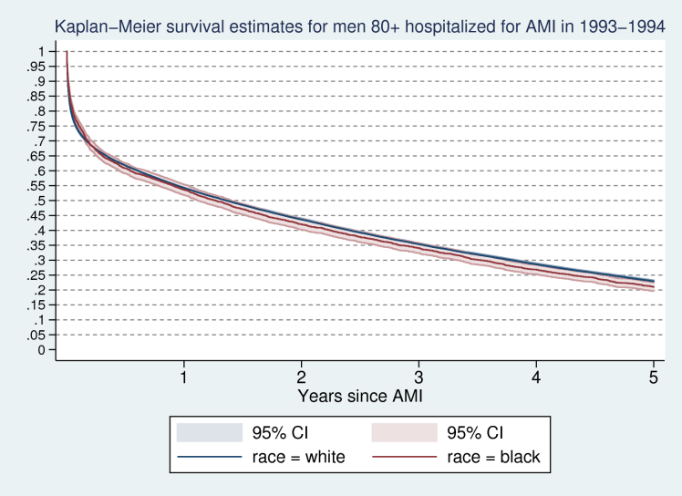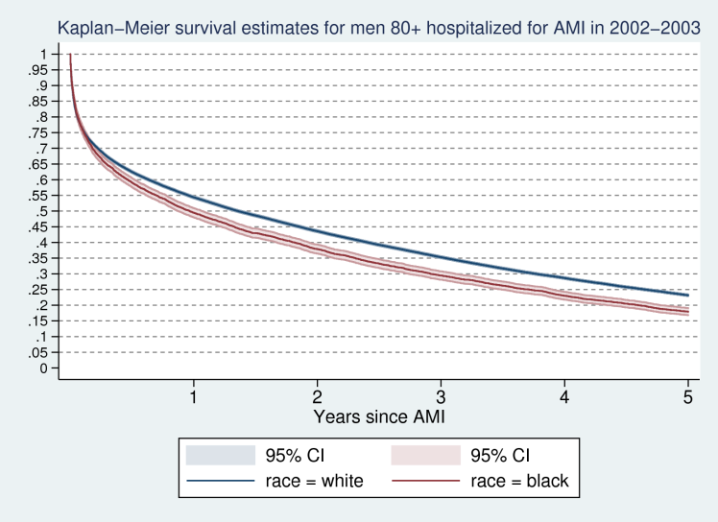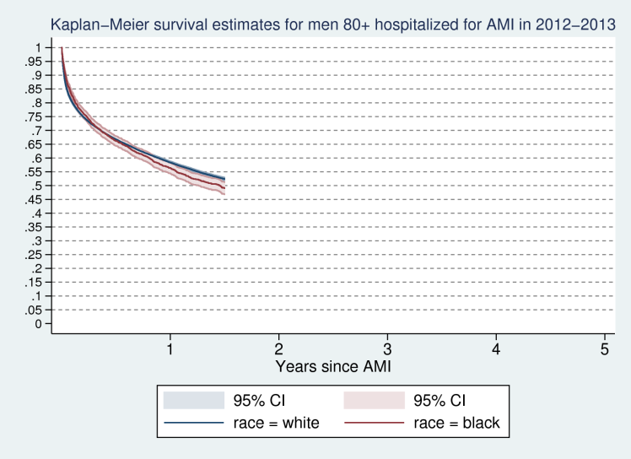

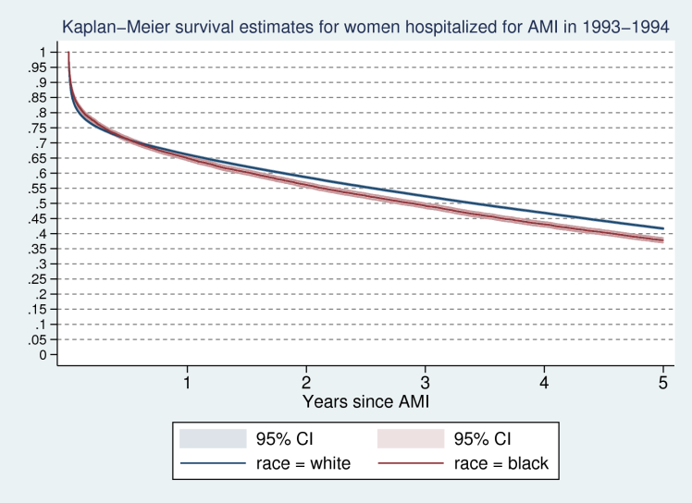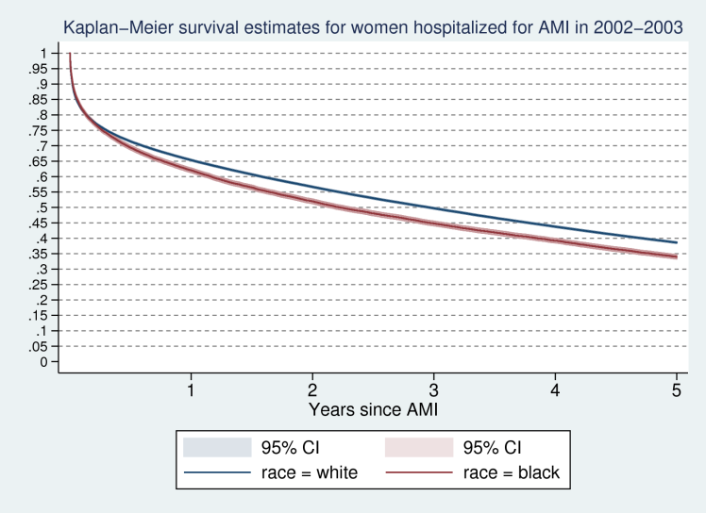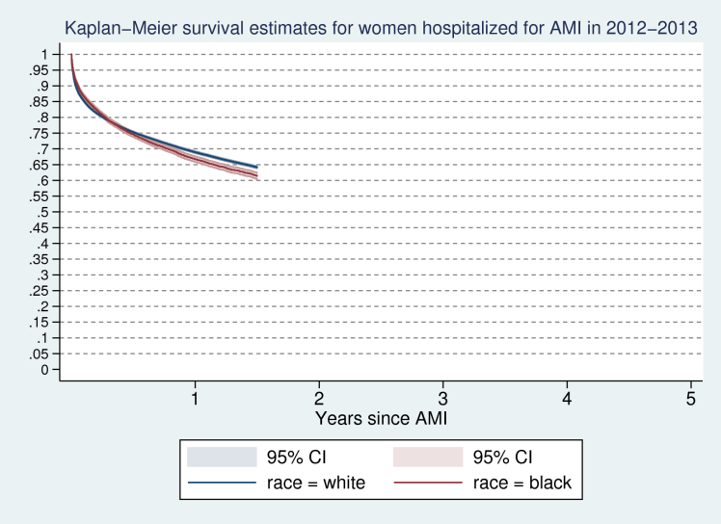

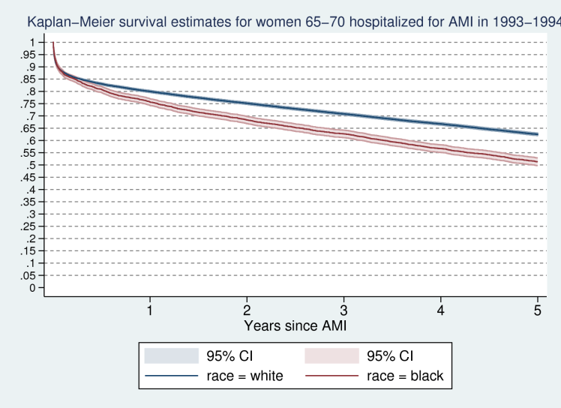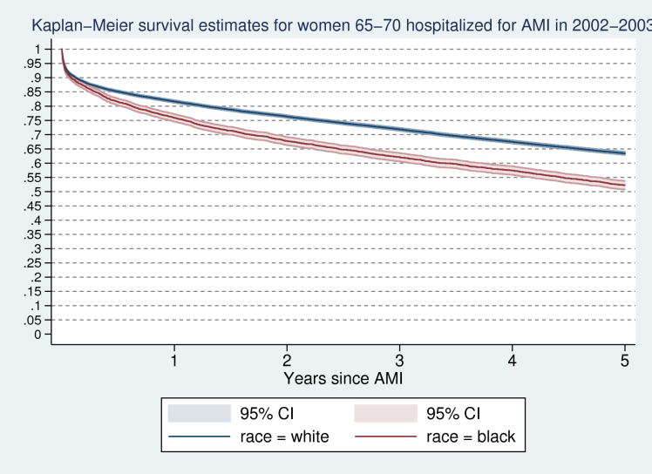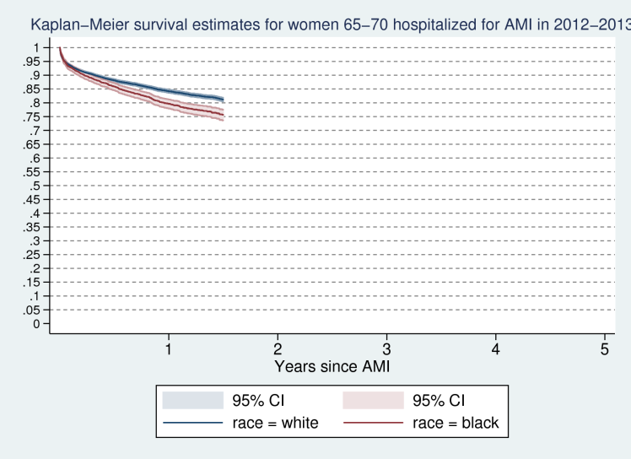

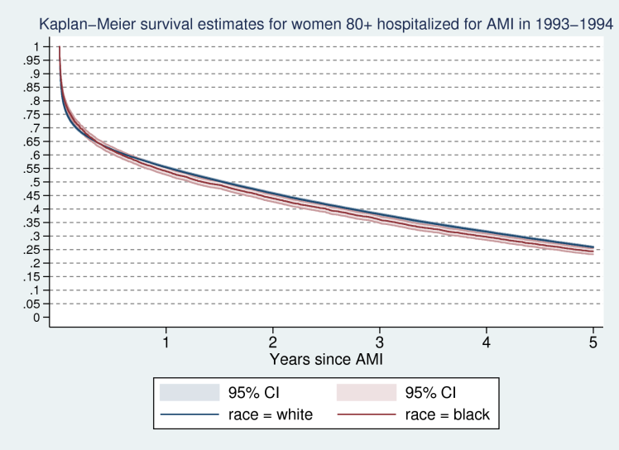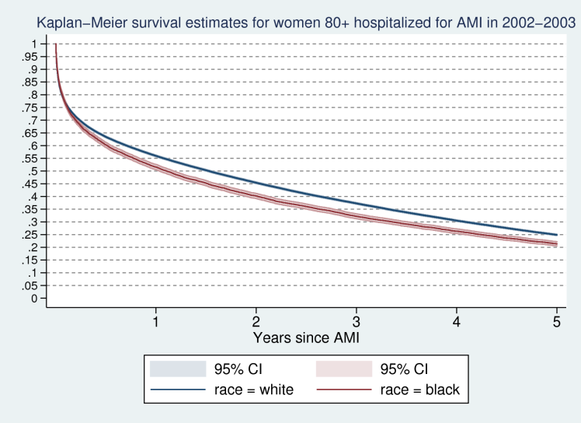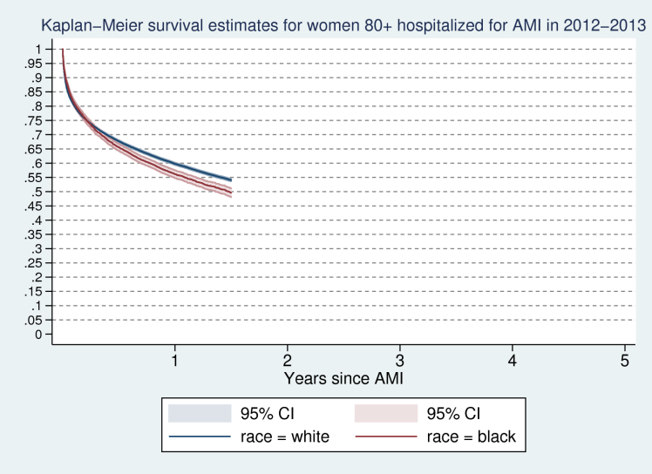

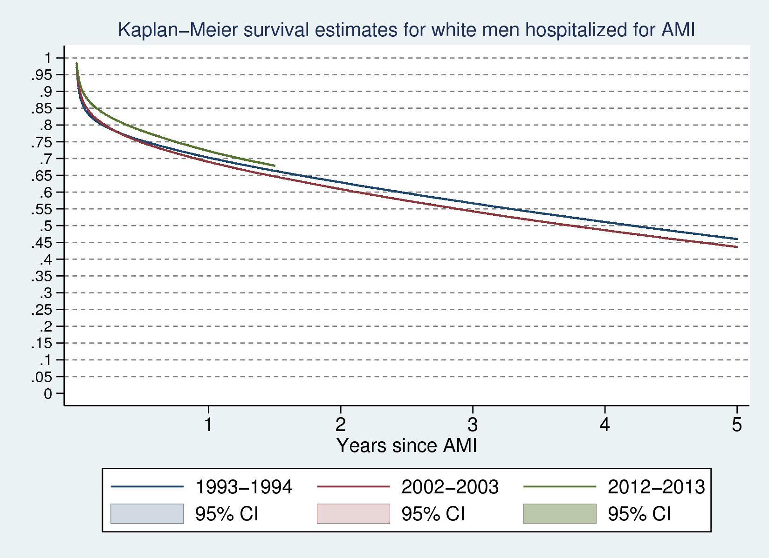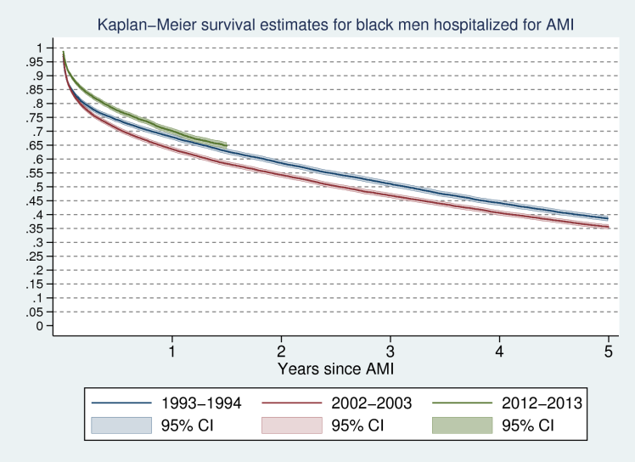

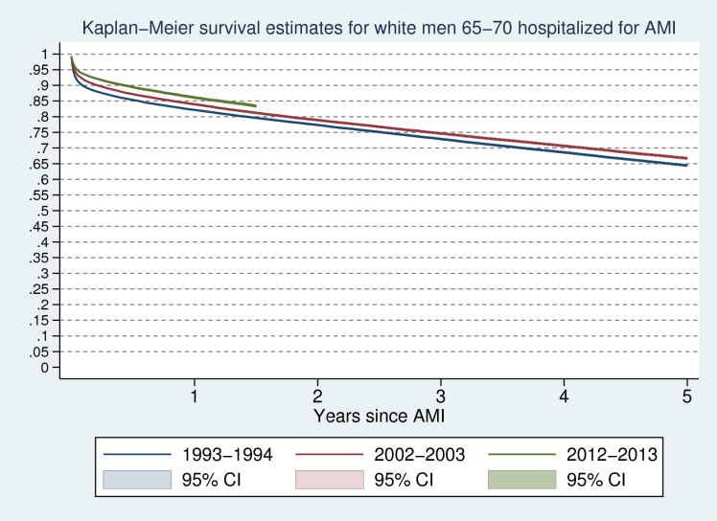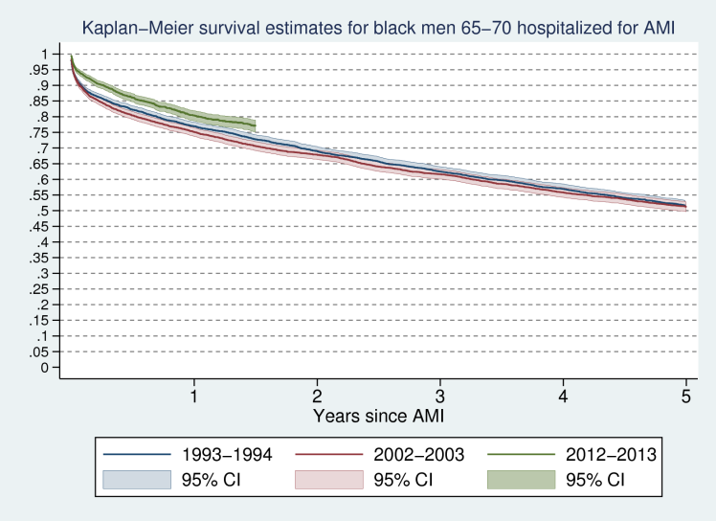

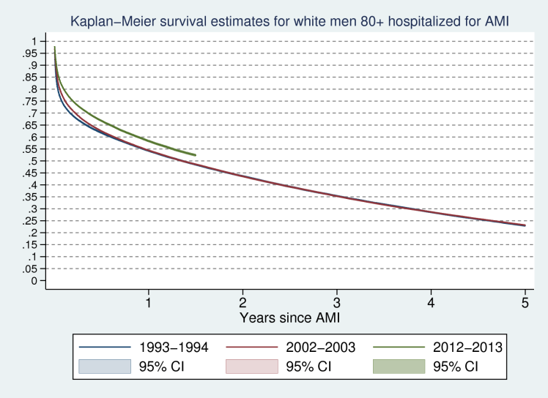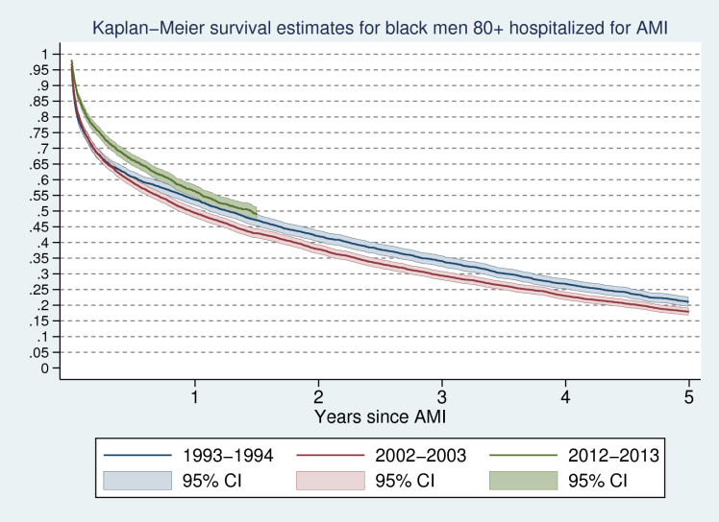

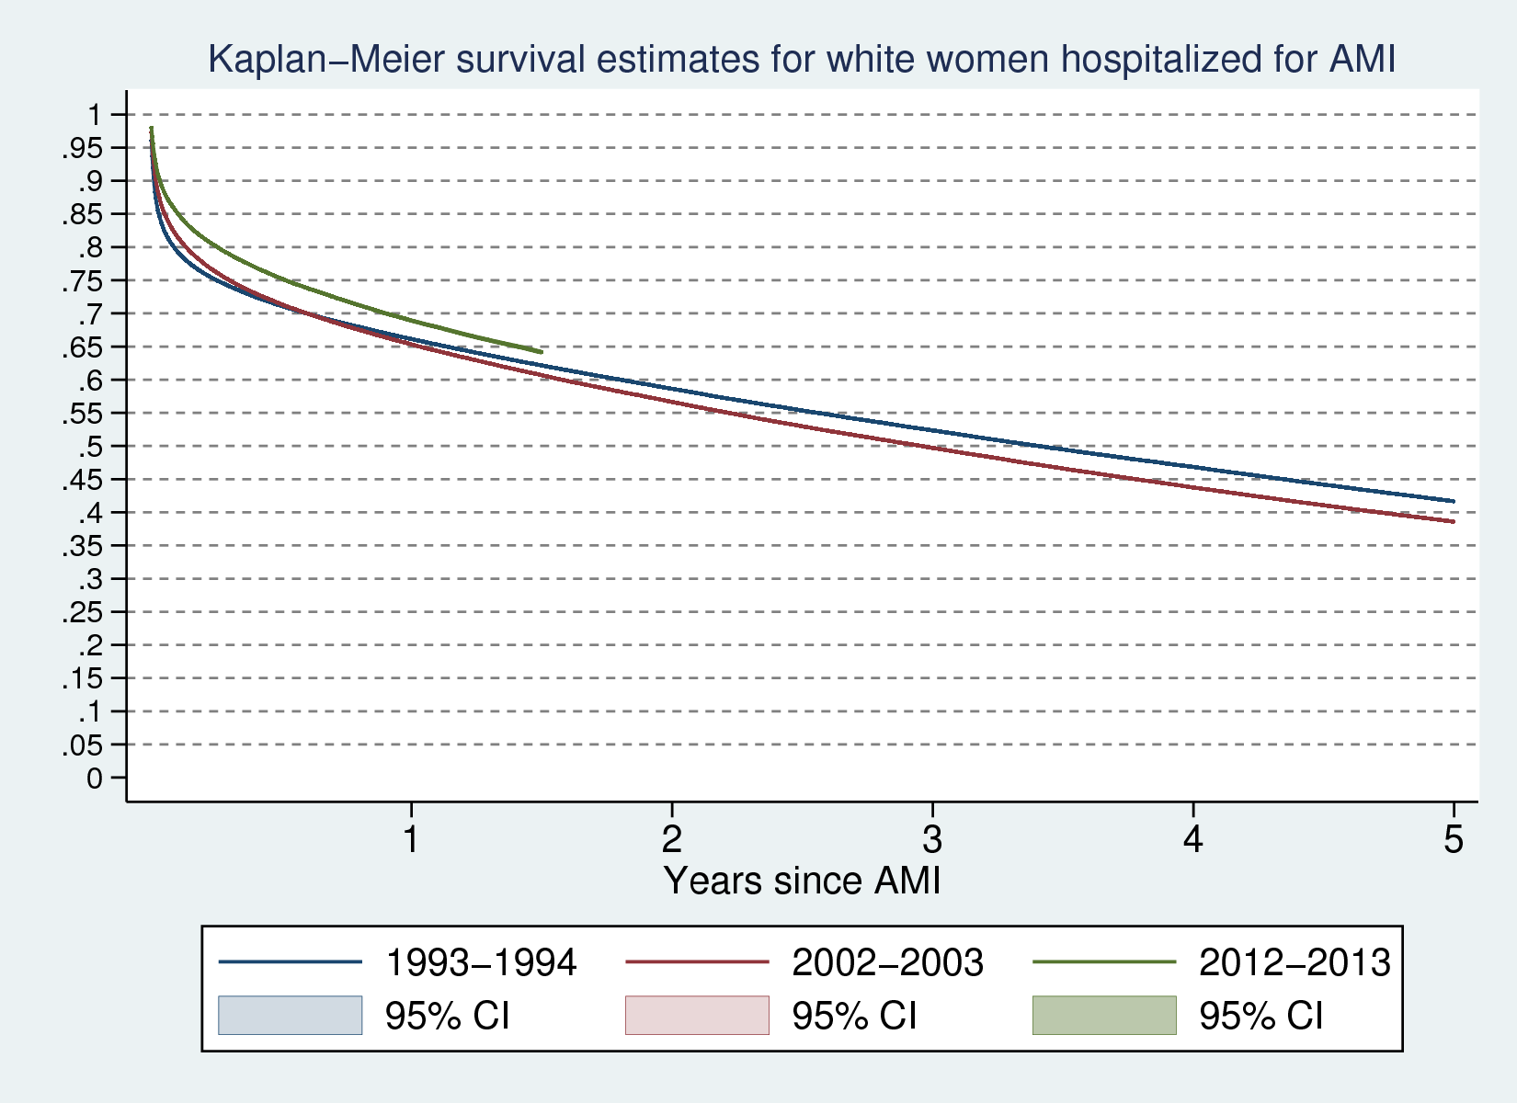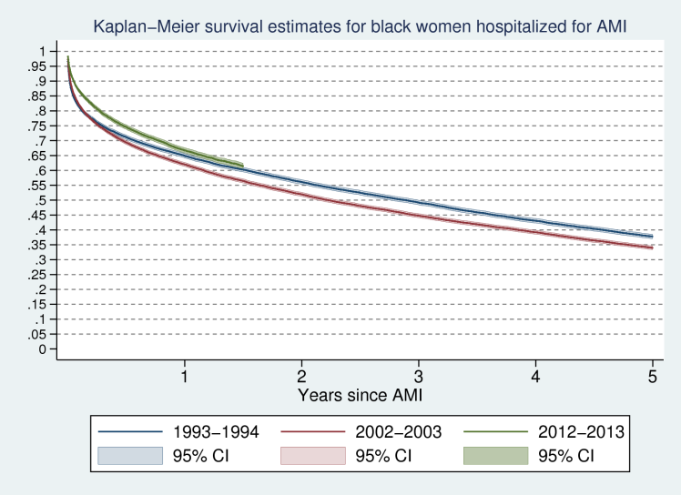

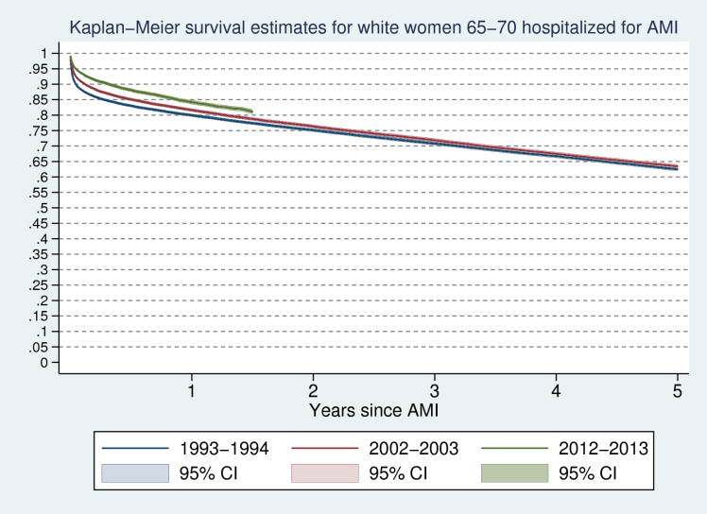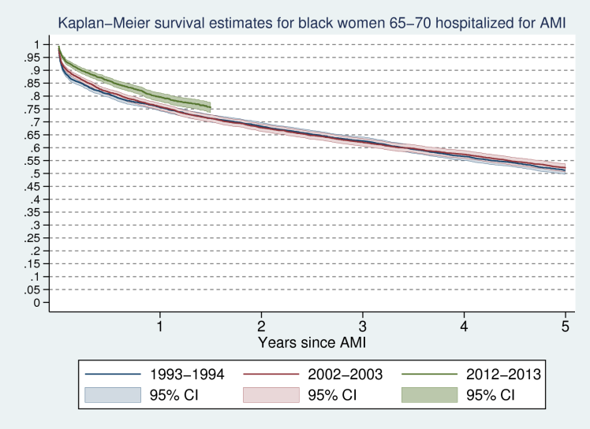

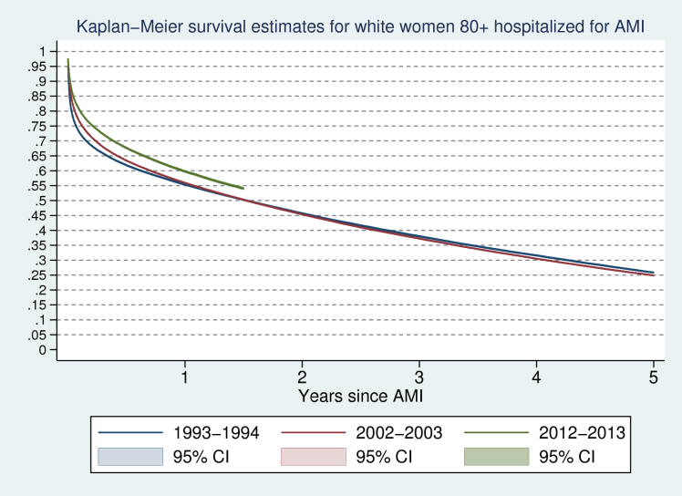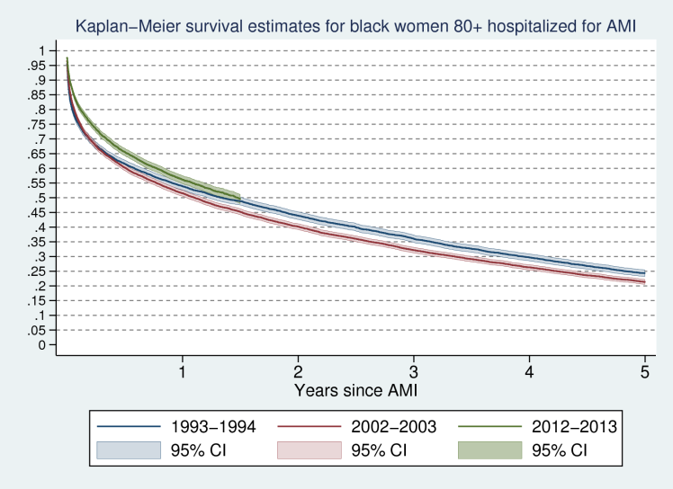

What does the adjustfor option of sts graph do? Cox-adjusted survival

e.g. sts graph, adjustfor(sex) :

1. Estimates Cox regression using sex as covariate.

2. Estimates baseline survival function using Kaplan-Meier approach.

3. Sets sex = 0; adjusts baseline survival from (2.) using coefficients from (1.) Can set sex to values different from zero by recentering the variable around them.

sts graph, adjustfor(sex) by(race)

1. Estimates Cox regressions for each race using sex as a covariate. Each race has distinct coefficient on sex.

2. Estimates separate baseline survival functions using Kaplan-Meier approach.

3. Sets sex = 0, adjusts baseline survival functions from (2.) using distinct sets of coefficients from (1.).

sts graph, adjustfor(sex) strata(race)

1. Estimates stratified Cox regressions (stratified by race) using sex as a covariate. Each race has the same coefficient on sex (but different hazard functions).

2. Estimates stratified baseline survival functions using Kaplan-Meier approach.

3. Sets sex = 0, adjusts stratified baseline survivor function from (2.) using the unique coefficient(s) from (1.).

|  |  |  |  |  |  |  |  |  |  |  |  |  |
| --- | --- | --- | --- | --- | --- | --- | --- | --- | --- | --- | --- | --- |
|  | | **Cox Survival Model: Estimated Hazard Ratios for Race = Black** | | | | | | | |  |  |  |
|  |  | |  |  |  |  | |  | |  |  |  |
|  | Year | | Unconditioned |  | Age/sex controls |  | | Age/sex and HRR controls | |  |
|  | 1993 | | 1.136*** | (0.0101) | 1.164*** | (0.0104) | | 1.133*** | | (0.0105) |
|  | 1994 | | 1.130*** | (0.00983) | 1.147*** | (0.01000) | | 1.114*** | | (0.0101) |
|  | 1995 | | 1.140*** | (0.00991) | 1.162*** | (0.0101) | | 1.124*** | | (0.0102) |
|  | 1996 | | 1.166*** | (0.0101) | 1.192*** | (0.0103) | | 1.158*** | | (0.0104) |  |  |
|  | 1997 | | 1.158*** | (0.0101) | 1.200*** | (0.0104) | | 1.160*** | | (0.0105) |  |  |
|  | 1998 | | 1.170*** | (0.0102) | 1.215*** | (0.0106) | | 1.176*** | | (0.0107) |  |  |
|  | 1999 | | 1.161*** | (0.00989) | 1.222*** | (0.0104) | | 1.184*** | | (0.0106) |  |  |
|  | 2000 | | 1.180*** | (0.00996) | 1.225*** | (0.0104) | | 1.179*** | | (0.0104) |  |  |
|  | 2001 | | 1.180*** | (0.00987) | 1.233*** | (0.0103) | | 1.186*** | | (0.0105) |  |  |
|  | 2002 | | 1.172*** | (0.00977) | 1.256*** | (0.0105) | | 1.216*** | | (0.0107) |  |  |
|  | 2003 | | 1.161*** | (0.00971) | 1.230*** | (0.0103) | | 1.188*** | | (0.0105) |  |  |
|  | 2004 | | 1.151*** | (0.0101) | 1.230*** | (0.0108) | | 1.194*** | | (0.0110) |  |  |
|  | 2005 | | 1.152*** | (0.0105) | 1.245*** | (0.0114) | | 1.210*** | | (0.0116) |  |  |
|  | 2006 | | 1.167*** | (0.0113) | 1.261*** | (0.0122) | | 1.220*** | | (0.0124) |  |  |
|  | 2007 | | 1.164*** | (0.0120) | 1.258*** | (0.0130) | | 1.219*** | | (0.0132) |  |  |
|  | 2008 | | 1.126*** | (0.0122) | 1.232*** | (0.0134) | | 1.198*** | | (0.0136) |  |  |
|  | 2009 | | 1.134*** | (0.0131) | 1.240*** | (0.0144) | | 1.193*** | | (0.0145) |  |  |
|  | 2010 | | 1.126*** | (0.0139) | 1.242*** | (0.0154) | | 1.202*** | | (0.0156) |  |  |
|  | 2011 | | 1.097*** | (0.0145) | 1.215*** | (0.0161) | | 1.180*** | | (0.0165) |  |  |
|  | 2012 | | 1.094*** | (0.0163) | 1.202*** | (0.0180) | | 1.165*** | | (0.0185) |  |  |
|  | 2013 | | 1.062** | (0.0225) | 1.173*** | (0.0250) | | 1.149*** | | (0.0258) |  |  |
| Exponentiated coefficients; Standard errors in parentheses | | | | | | | ="* p<0.05 | |
|  | | | | | | | ** p<0.01 | |
|  | | | | | | | *** p<0.001" | |
| Null Hypothesis: . | | | | | | |  | |
|  | | | | | | |  | |