Outcome plots (Mortality & one-day PCI)

Ben Berger, September 21, 2017

Notes for Amitabh:

* The third year-cohort contains only years 2010 - 2012 because we use 1-year follow-up to predict 5-year follow-up.
* I haven’t yet been able to figure out how to properly compute confidence intervals for projected 5-year mortality using my method. They are likely fairly small and comparable to adjusted mortality from other year-cohorts, but the model specification (i.e. which covariates I include in the model) is likely more important than the size of confidence interval.
* Adjusted outcomes are computed by:
  1. Calculating the average value of “potential” covariates (age, race, sex) for the entire population of STEMI patients. Race and sex are binary in this application, so their averages are just population proportions.
  2. Estimating a logistic regression model for the cohort we are interested in (e.g. black women), controlling for year-cohort and any variables that are not fixed by cohort definition (so we can control for age and age^2 for the cohort of black women).
  3. Computing fitted values and standard errors for each year-cohort using the average values from step 1.
* 5-year mortality projections for the 2010-2012 cohort are predicted as the sum of 1-year observed adjusted mortality and estimated 5-year mortality conditional on 1-year survival weighted by probability of surviving 1 year:
  1. As an equation: $E\left[Mort5y | X=x\right]= P\left[Mort1y=1 | X=x\right]+ E\left[Mort5y \right| X=x, Mort1y=0]*(1-P\left[Mort1y=1 | X=x\right])$
  2. $E\left[Mort5y \right| X=x, Mort1y=0]$ is estimated with the command:   
     logit mort\_1825 race sex diag\_year racesex `age\_controls' if mort\_365 == 0
  3. $P\left[Mort1y=1 | X=x\right]$ is estimated with the command:  
     logit mort\_365 race sex diag\_year racesex `age\_controls' if year\_cohort == 3
  4. Notice both regressions include linear year terms, and that the regressions are estimated on different samples.
     + I am using a linear year term because I cannot use fixed-effects to predict 5-year mortality for years without that data.
     + The first regression is estimated on all patients who survived at least 1 year and have 5-year follow up data.
     + The second regression is estimated only on patients in the 2010 - 2012 cohort.
     + Because these results are somewhat driven by coefficients derived from earlier data, if the underlying relationship changed between mortality and the covariates, our estimates may be biased (likely upwards if health conditions for these groups have improved in excess of the linear trend).

# All patient mortality: Adjusted for age, age^2, race, sex, and interactions thereof

# C:\Users\bergerb\Dropbox\race_disparity\17-09-01_fe_plots\fe_plot_7-day mortality_men.pngC:\Users\bergerb\Dropbox\race_disparity\17-09-01_fe_plots\fe_plot_7-day mortality_men.png

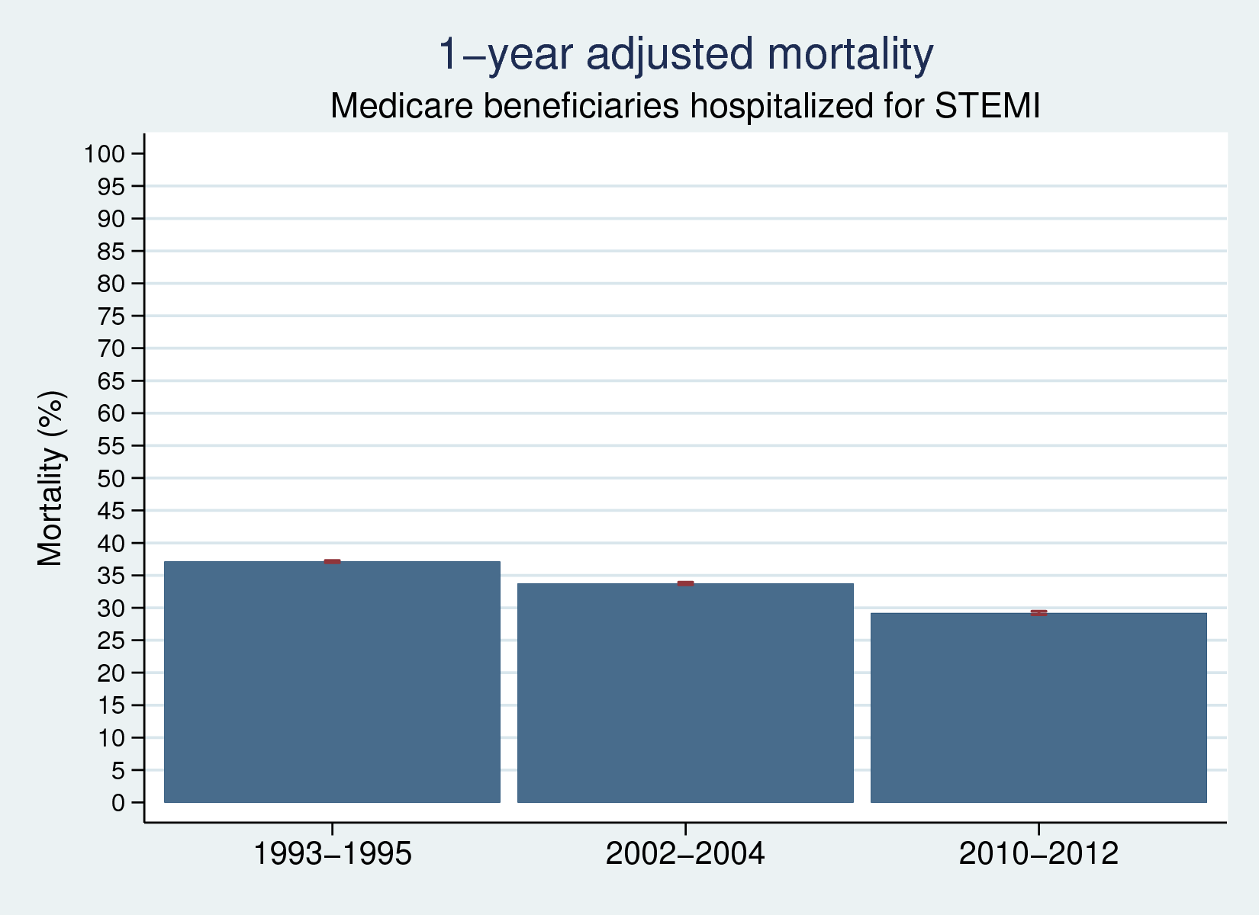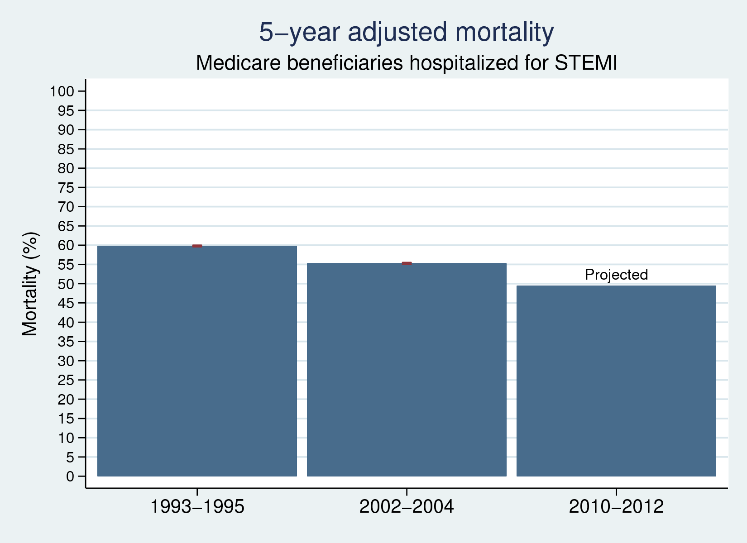

# Black male mortality: Adjusted for age, age^2

# C:\Users\bergerb\Dropbox\race_disparity\17-09-01_fe_plots\fe_plot_7-day mortality_men.pngC:\Users\bergerb\Dropbox\race_disparity\17-09-01_fe_plots\fe_plot_7-day mortality_men.png

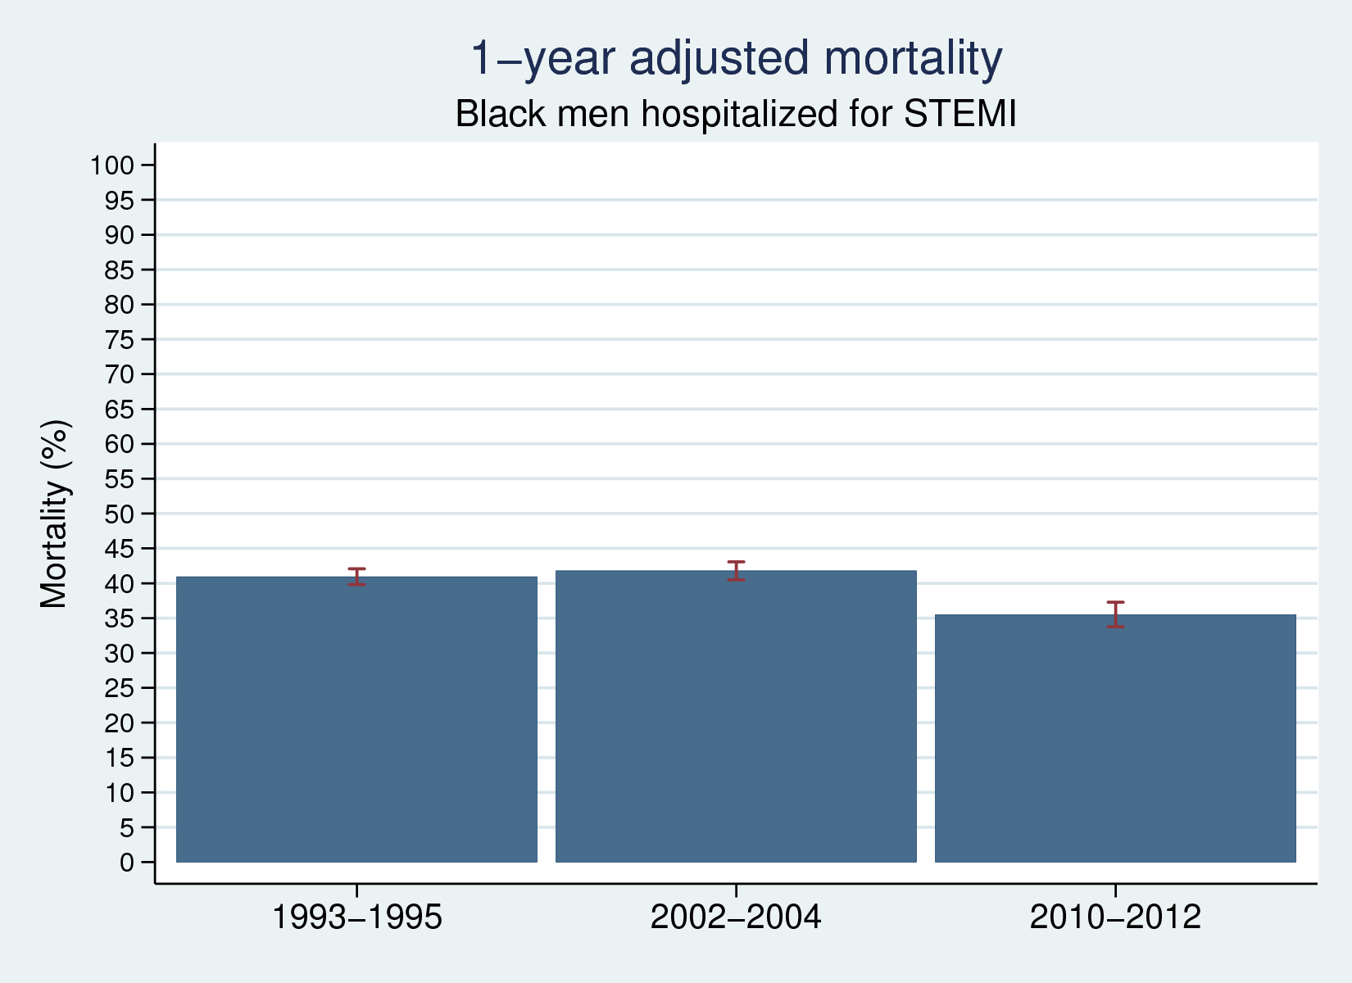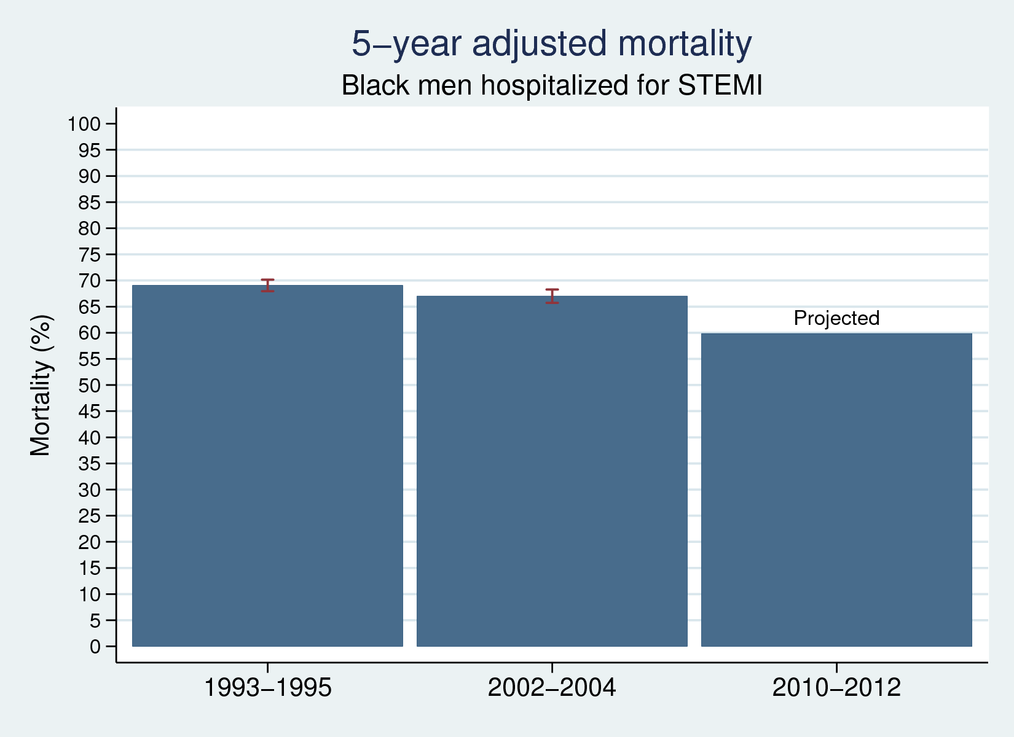

# Black female mortality: Adjusted for age, age^2

# C:\Users\bergerb\Dropbox\race_disparity\17-09-01_fe_plots\fe_plot_7-day mortality_men.pngC:\Users\bergerb\Dropbox\race_disparity\17-09-01_fe_plots\fe_plot_7-day mortality_men.png

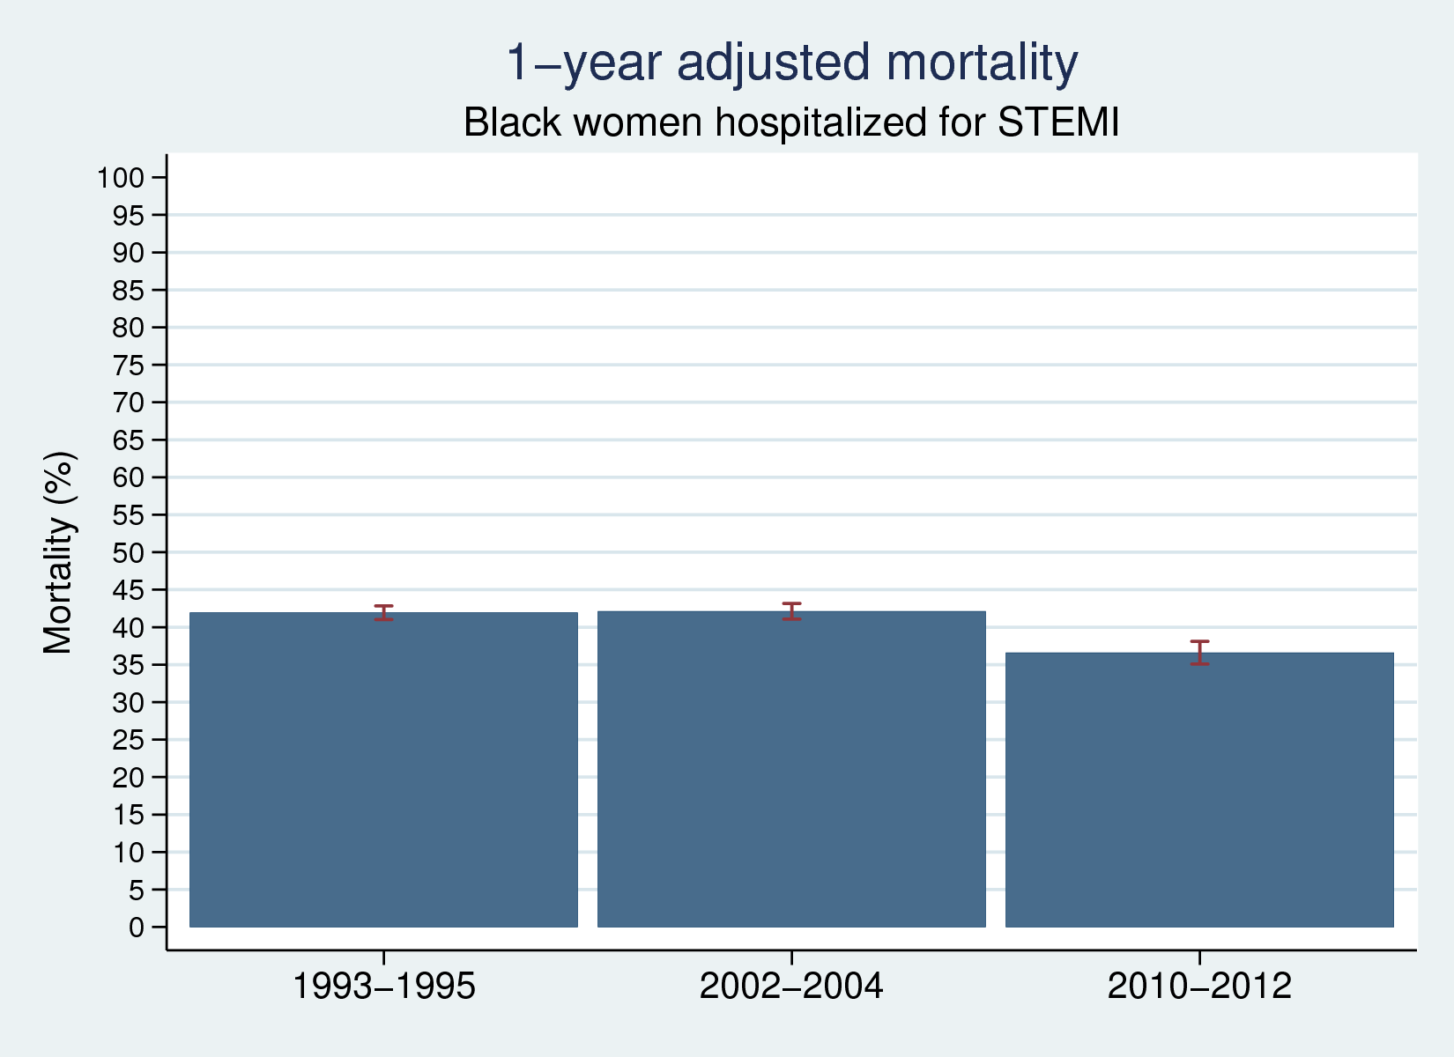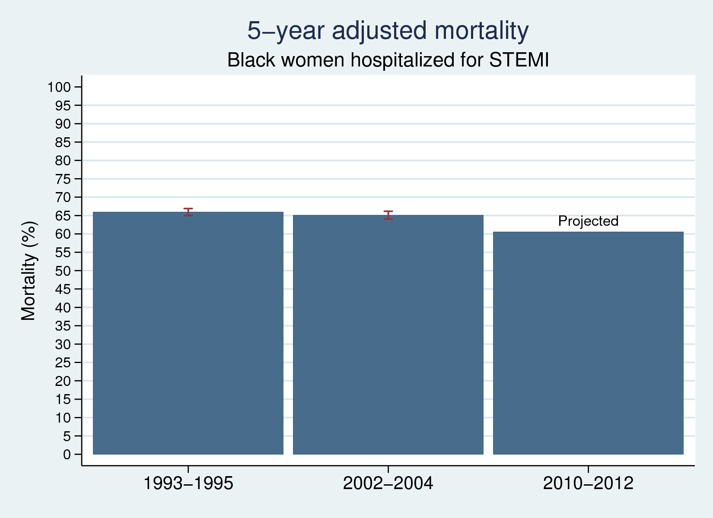

# Patients age 65-70: Adjusted for race, sex, race \* sex

# C:\Users\bergerb\Dropbox\race_disparity\17-09-01_fe_plots\fe_plot_7-day mortality_men.pngC:\Users\bergerb\Dropbox\race_disparity\17-09-01_fe_plots\fe_plot_7-day mortality_men.png

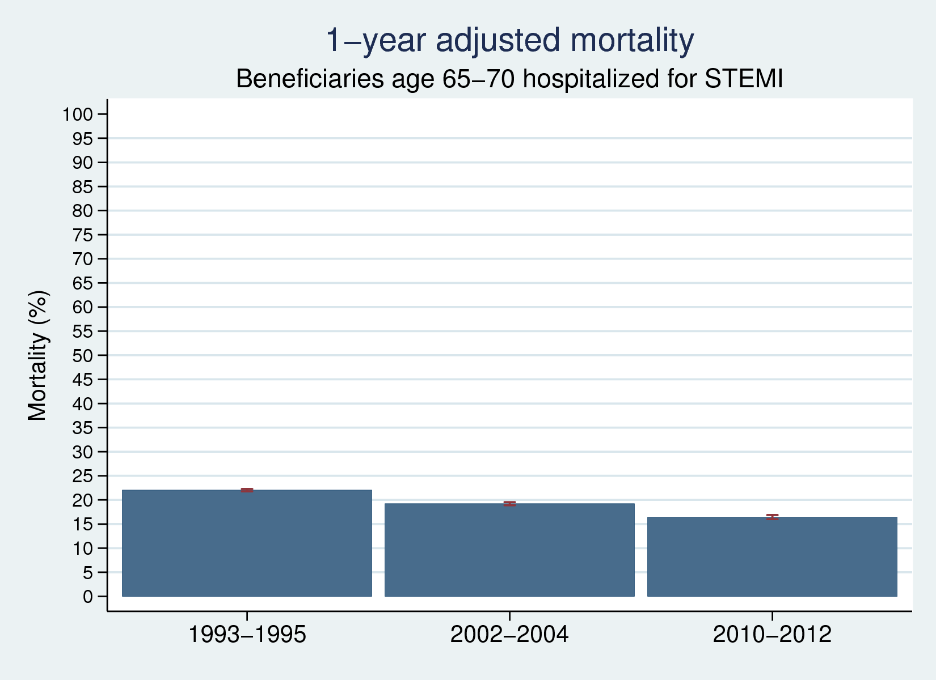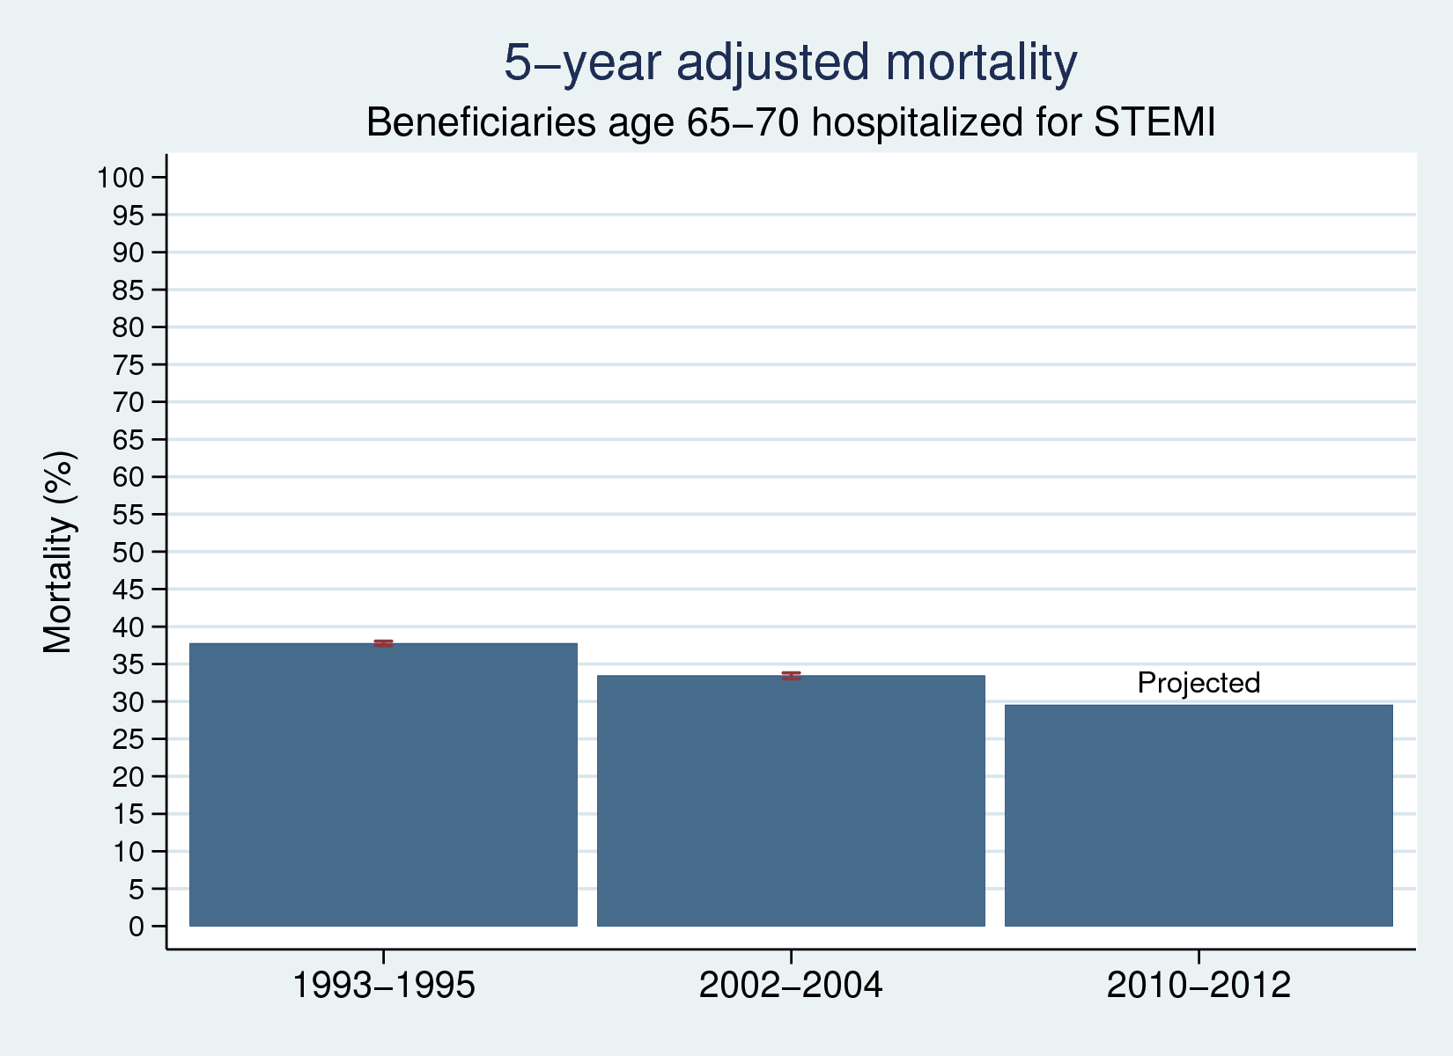

# Patients age 85-90: Adjusted for race, sex, race \* sex

# C:\Users\bergerb\Dropbox\race_disparity\17-09-01_fe_plots\fe_plot_7-day mortality_men.pngC:\Users\bergerb\Dropbox\race_disparity\17-09-01_fe_plots\fe_plot_7-day mortality_men.png

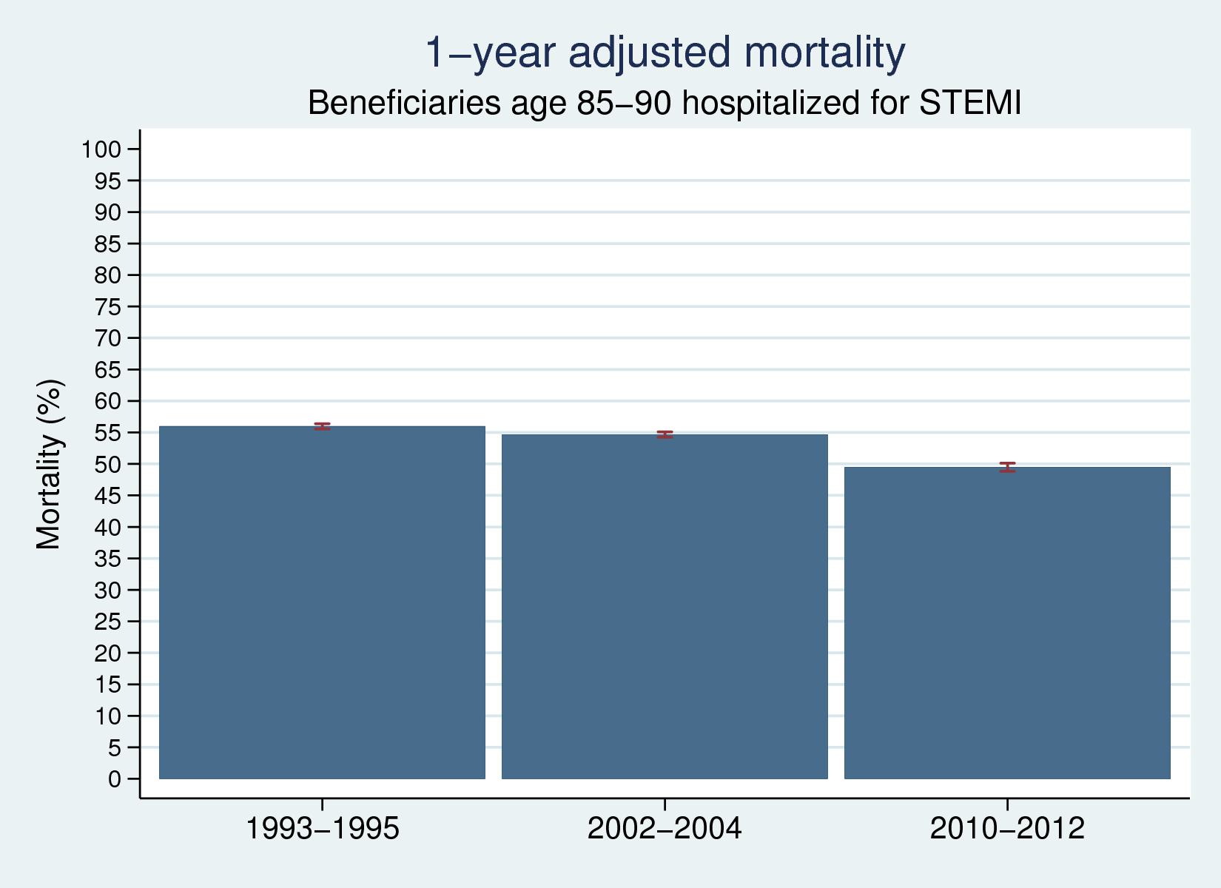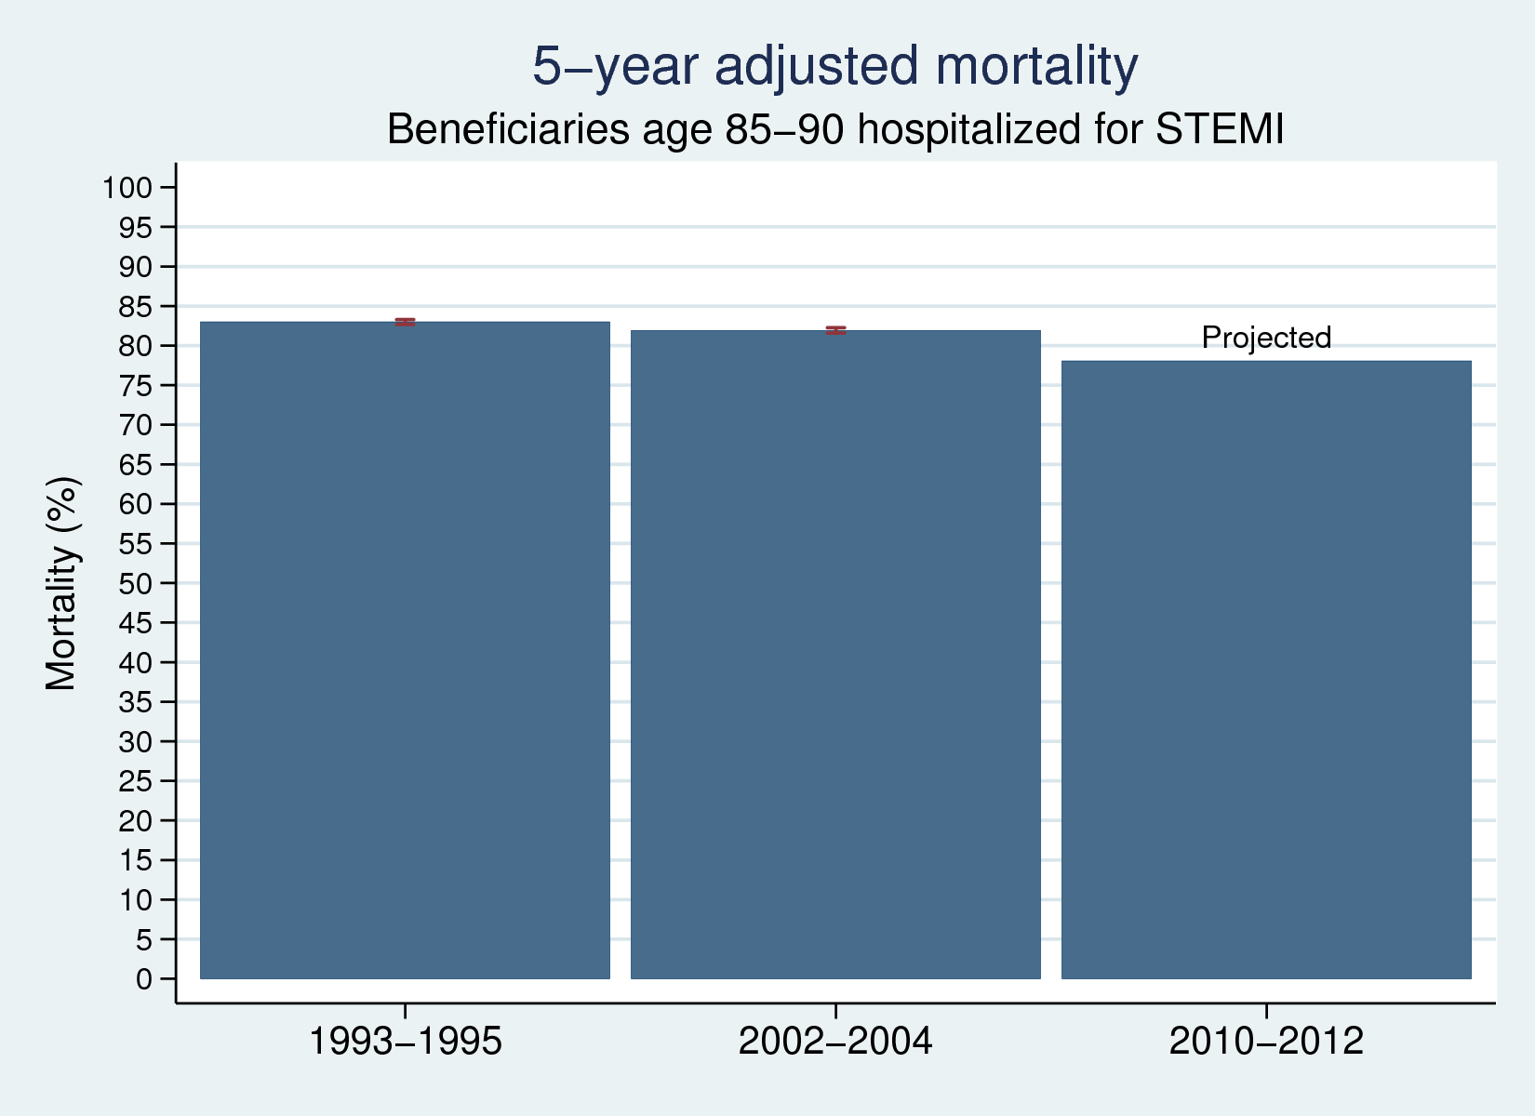

# Patients in 50 richest HRRs: Adjusted for age, age^2, race, gender, and interactions thereof

# C:\Users\bergerb\Dropbox\race_disparity\17-09-01_fe_plots\fe_plot_7-day mortality_men.pngC:\Users\bergerb\Dropbox\race_disparity\17-09-01_fe_plots\fe_plot_7-day mortality_men.png

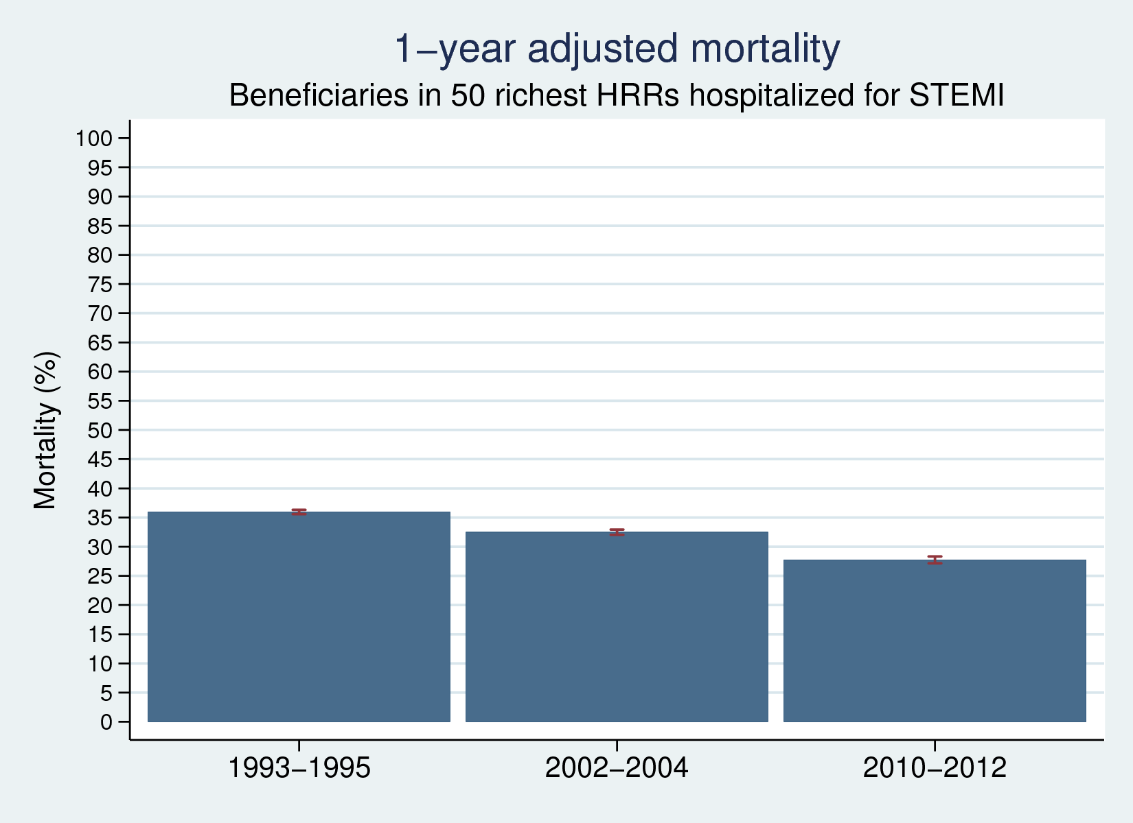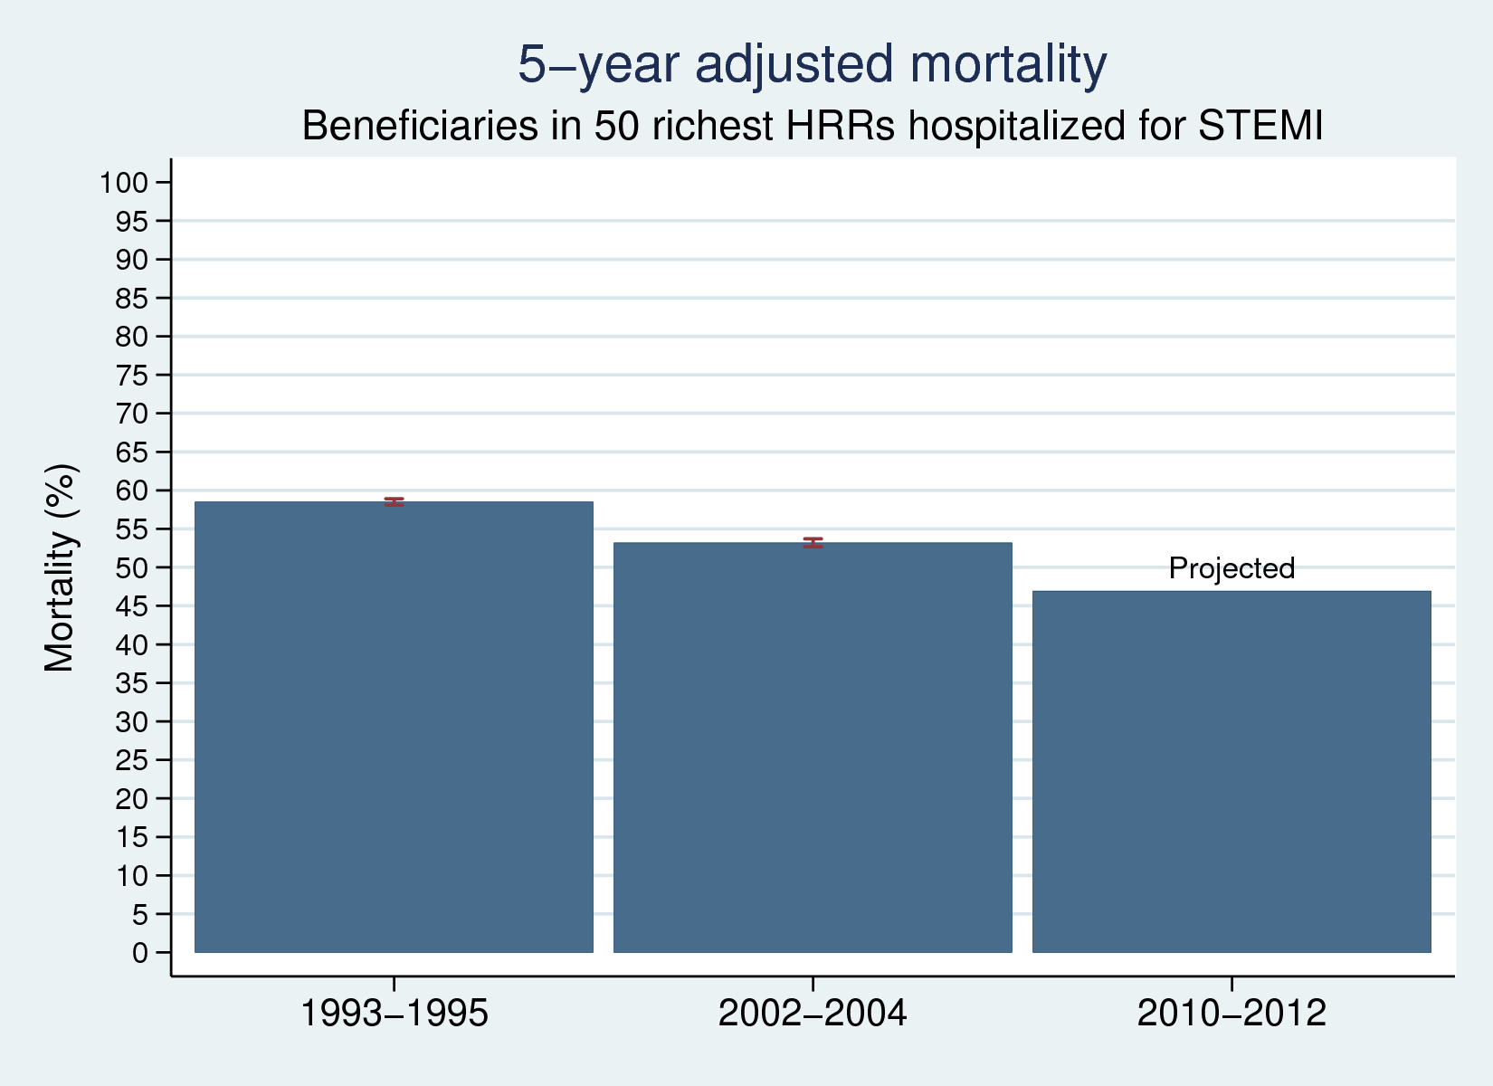

# Patients in 50 poorest HRRs: Adjusted for age, age^2, race, gender, and interactions thereof

# C:\Users\bergerb\Dropbox\race_disparity\17-09-01_fe_plots\fe_plot_7-day mortality_men.pngC:\Users\bergerb\Dropbox\race_disparity\17-09-01_fe_plots\fe_plot_7-day mortality_men.png

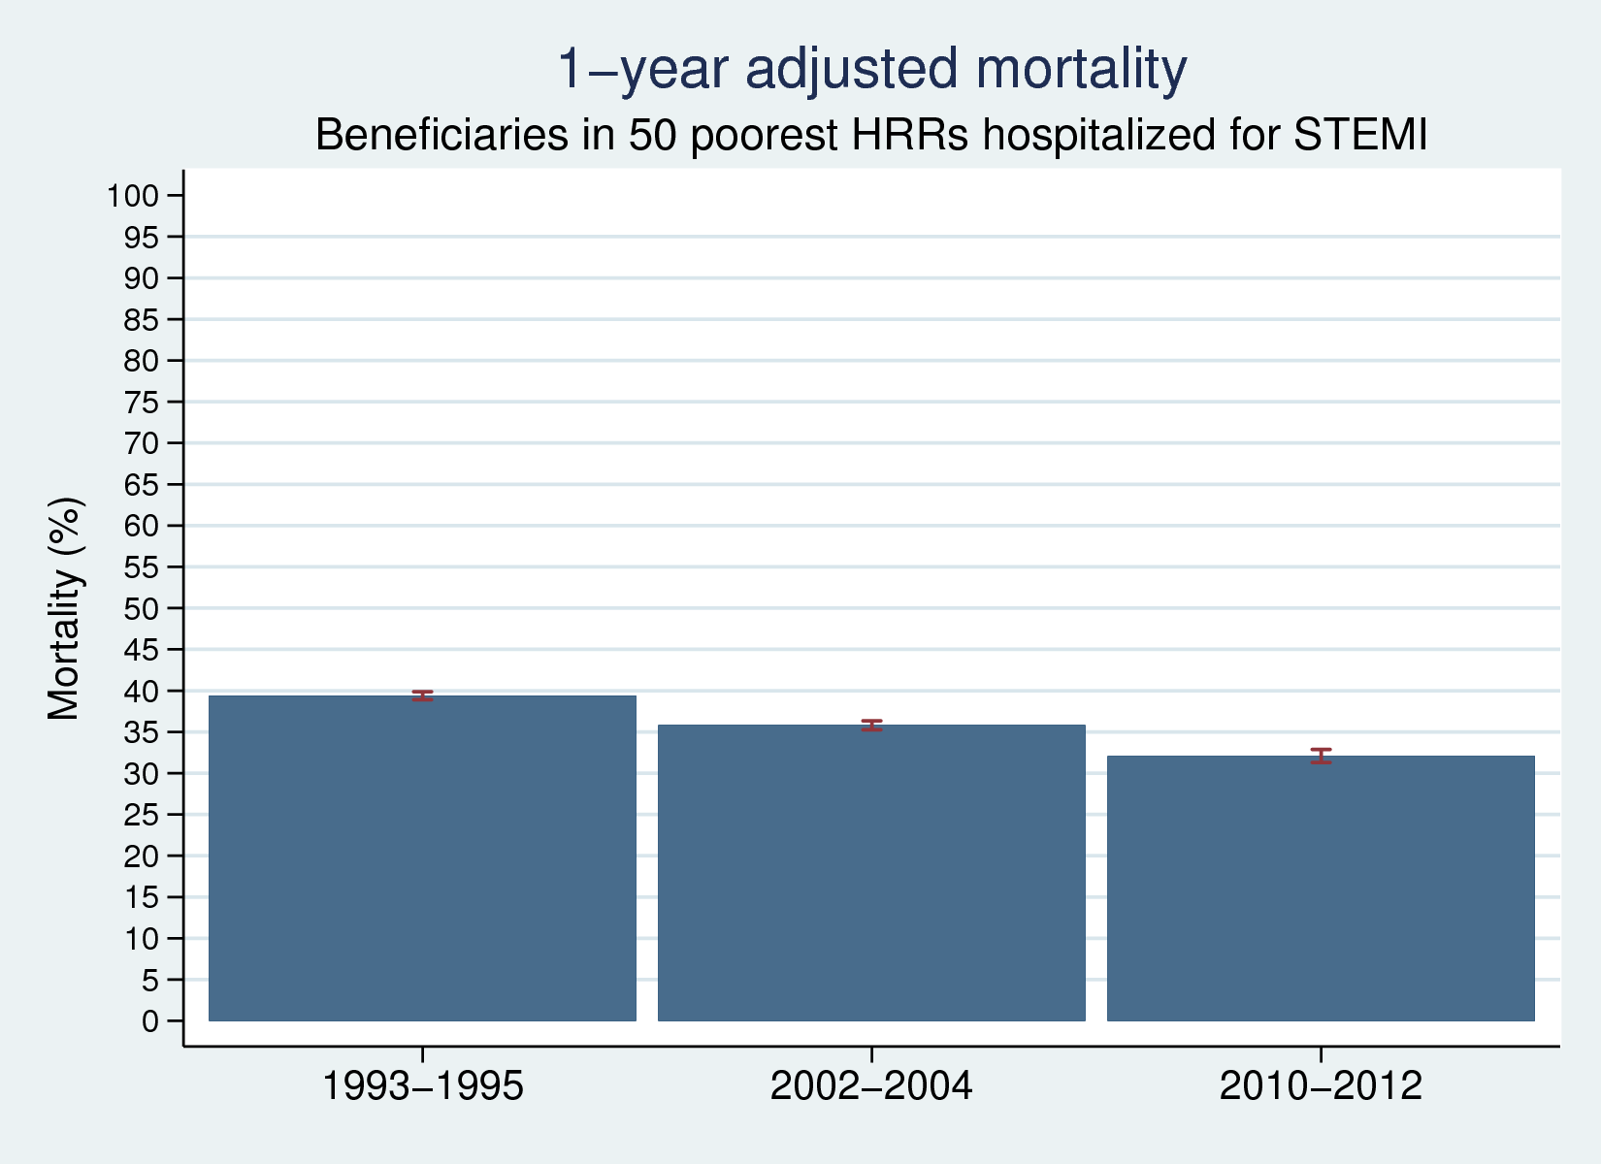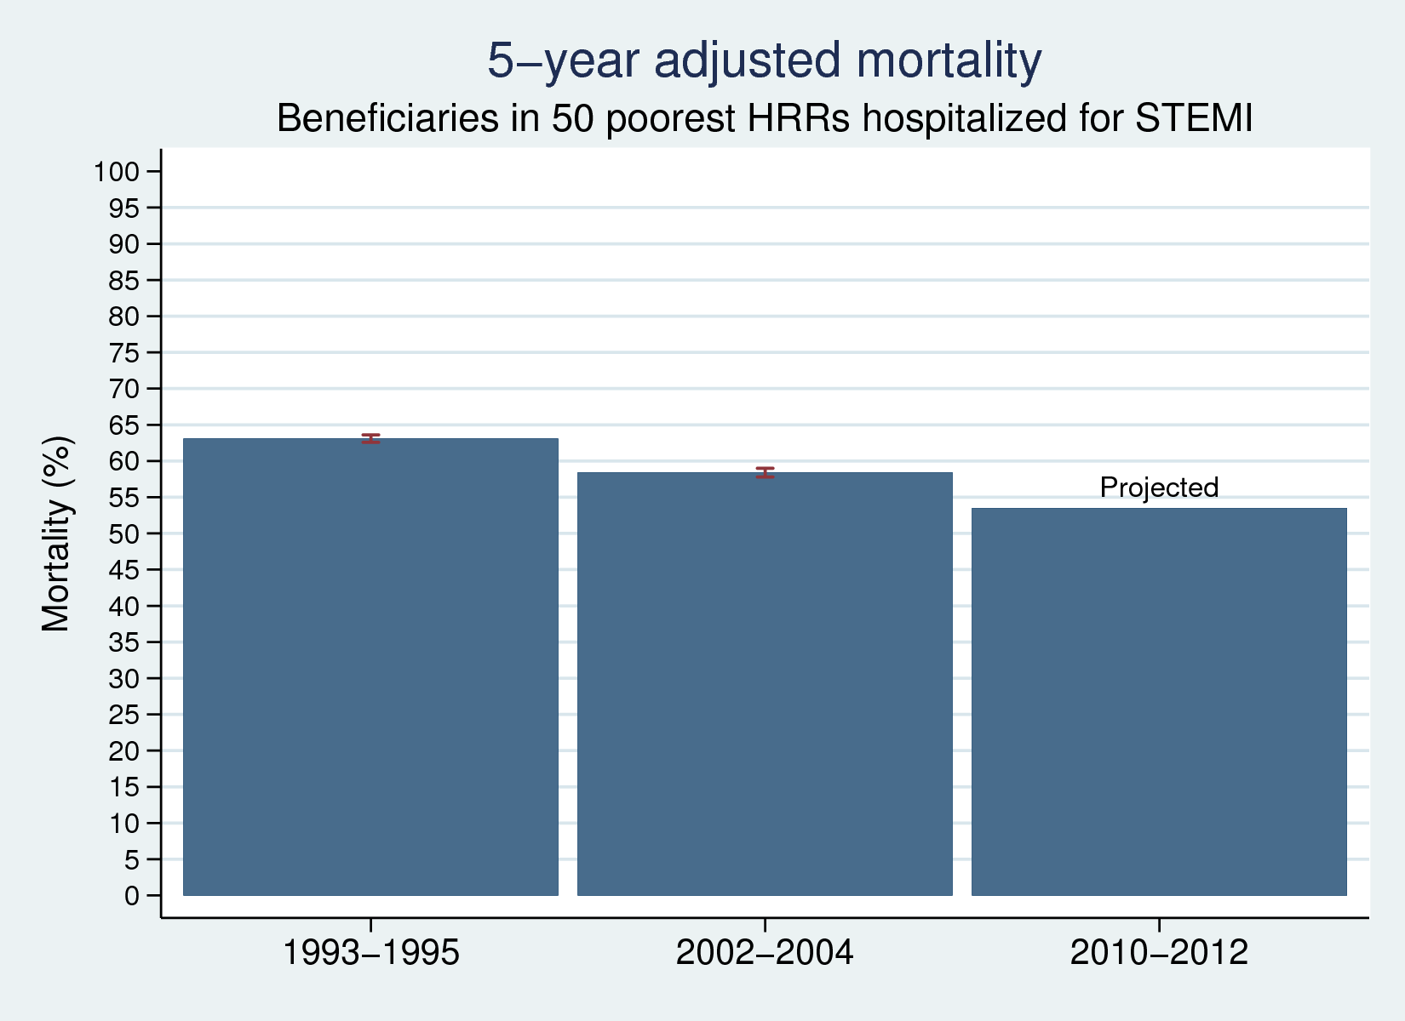

# Adjusted 1-day PCI rate: adjustment variables for each cohort are defined as they are for mortality plots

# C:\Users\bergerb\Dropbox\race_disparity\17-09-01_fe_plots\fe_plot_7-day mortality_men.png C:\Users\bergerb\Dropbox\race_disparity\17-09-01_fe_plots\fe_plot_7-day mortality_men.pngC:\Users\bergerb\Dropbox\race_disparity\17-09-01_fe_plots\fe_plot_7-day mortality_men.png

# Adjusted 1-day PCI rate, continued

# C:\Users\bergerb\Dropbox\race_disparity\17-09-01_fe_plots\fe_plot_7-day mortality_men.pngC:\Users\bergerb\Dropbox\race_disparity\17-09-01_fe_plots\fe_plot_7-day mortality_men.pngC:\Users\bergerb\Dropbox\race_disparity\17-09-01_fe_plots\fe_plot_7-day mortality_men.pngC:\Users\bergerb\Dropbox\race_disparity\17-09-01_fe_plots\fe_plot_7-day mortality_men.png