# Kaplan-Meier survival estimates: Medicare-age AMI hospitalizations

## Kaplan-Meier for all AMIs, STEMIs, and NSTEMIs

Among all race-sex cohorts, long-term survival fell between patients hospitalized in the early 90’s and those hospitalized in the early 00’s. This may be driven largely by an aging and therefore sicker Medicare population. Cox-adjusted estimates that control for age-effects are presented under *Cox-adjusted survival estimates* and Kaplan-Meier plots that are grouped by age group are presented under *Additional Estimates*. Decreased survival was most extreme among blacks and patients who were diagnosed with an ICD-9 corresponding to NSTEMI.

Survival increased between the early 00’s and early 10’s for all cohorts. Survival estimates for black cohorts hospitalized for STEMI in 2012-2013 are reported for only half the duration of white patients due to high levels of censoring and imprecise estimation for patients hospitalized near the end of the time period covered by data.

## Kaplan-Meier limited to 90 day time horizon

White patients, especially the oldest, show small gains in short- and medium-term survival between the early 90’s and early 00’s. Black men show nearly no change in survival in the same period while black women showed only modest gains in short-term survival.

Short- and medium-term survival increased for all patient cohorts between the early 00’s and 10’s.

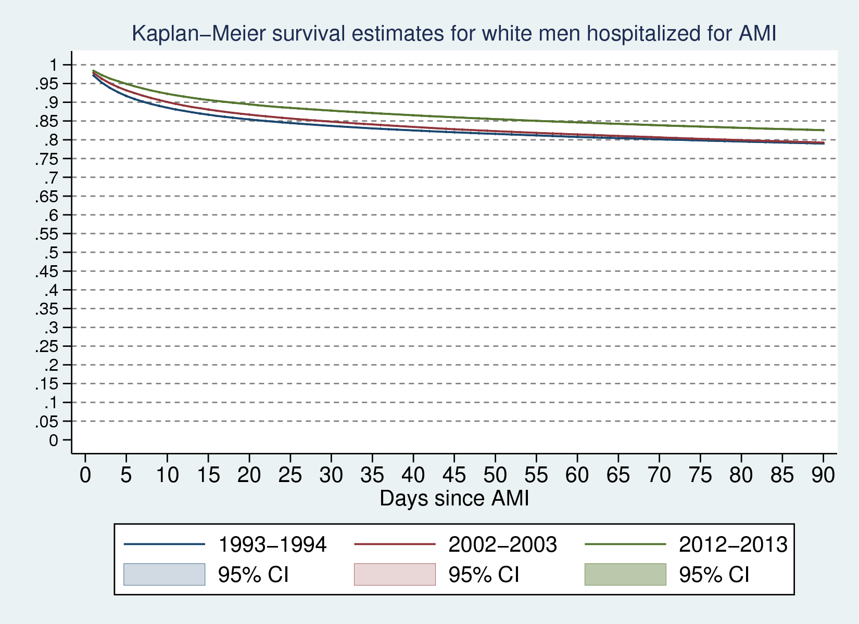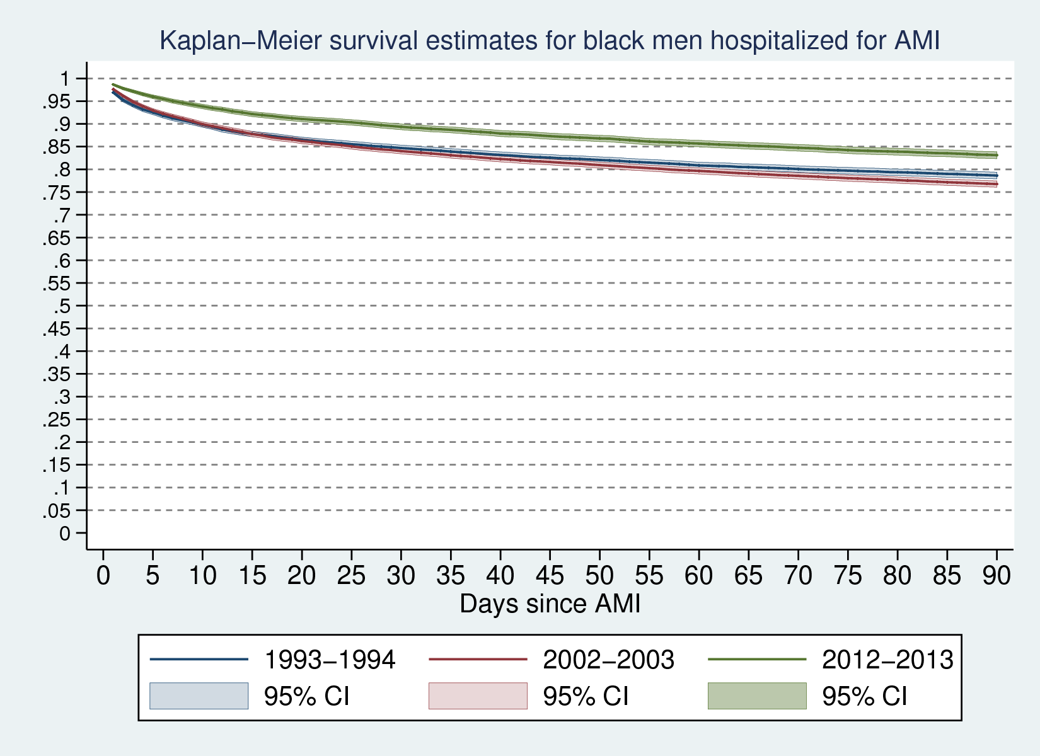

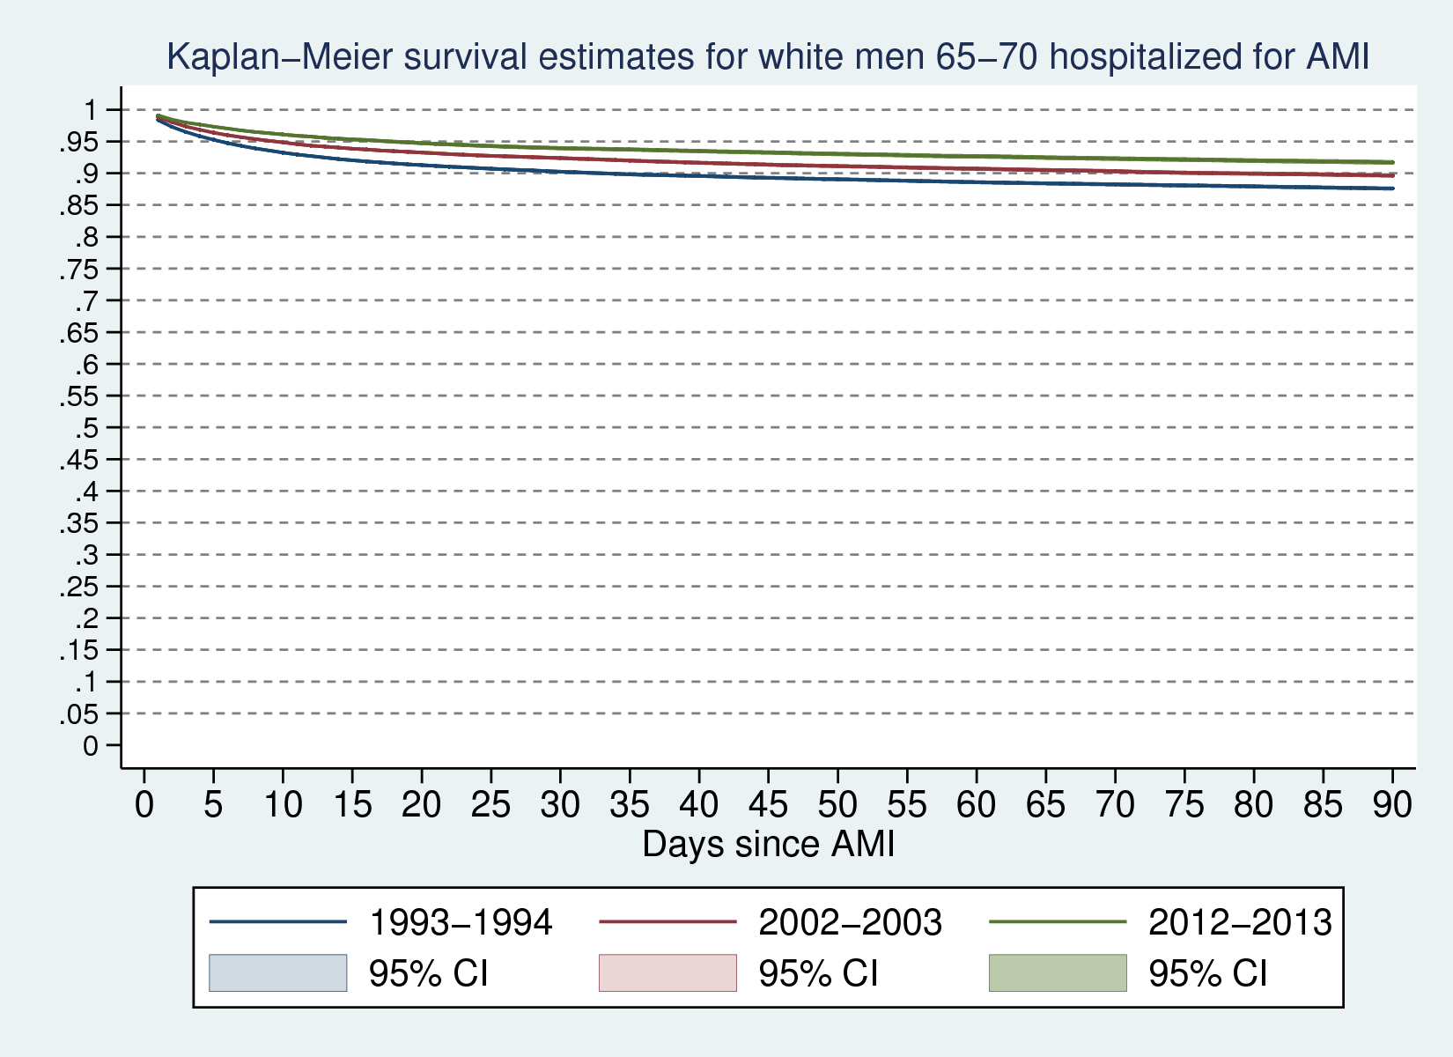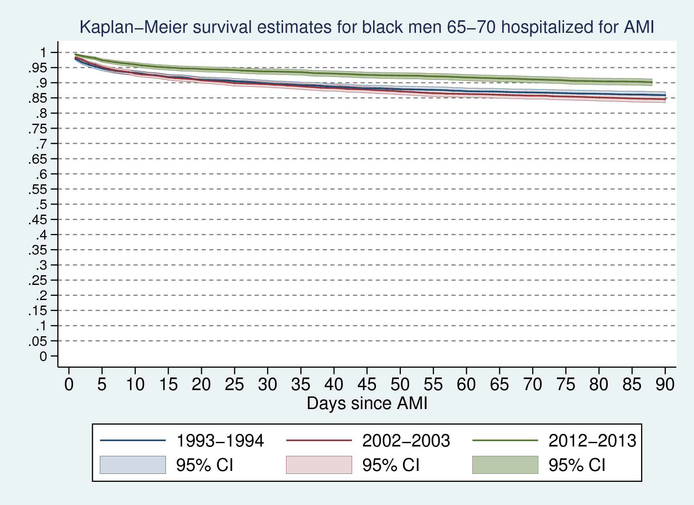

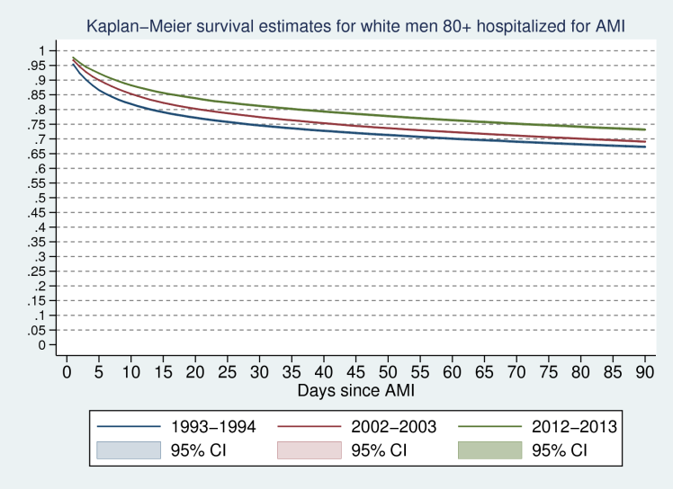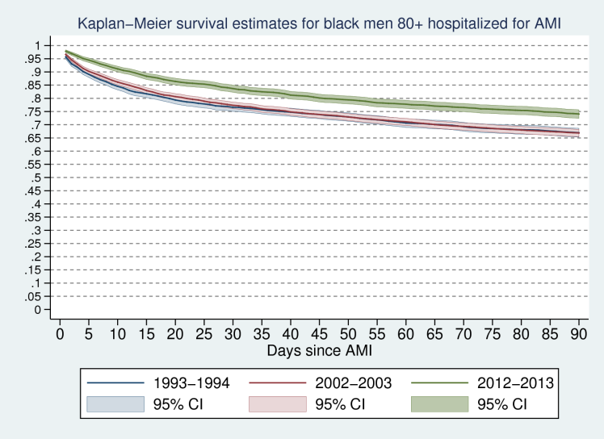

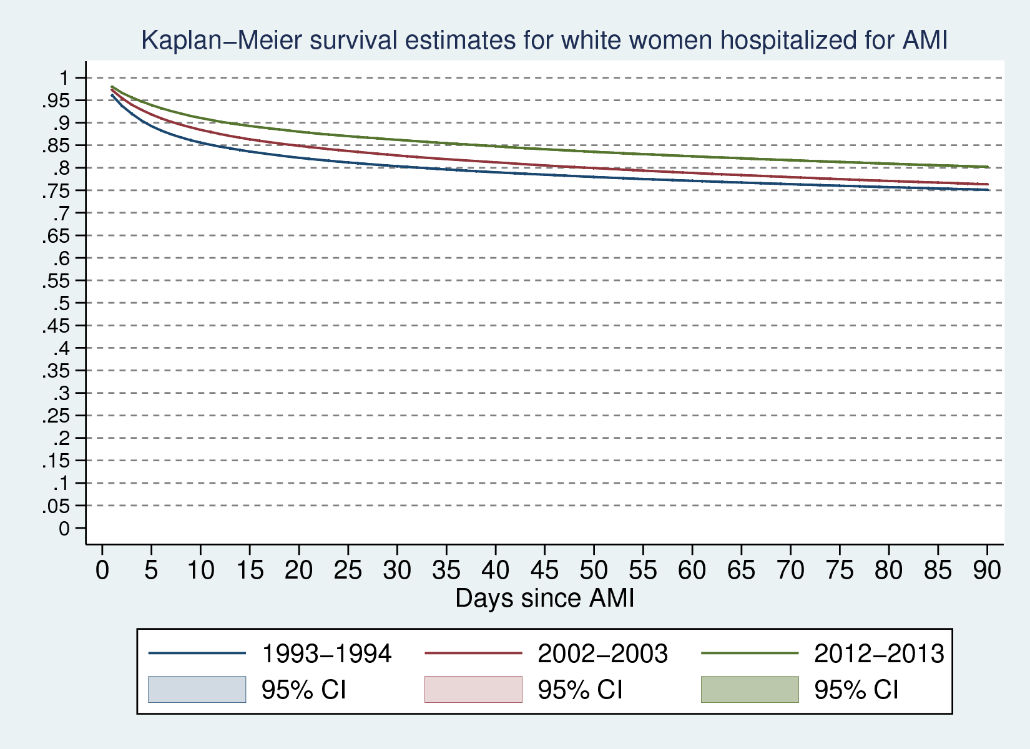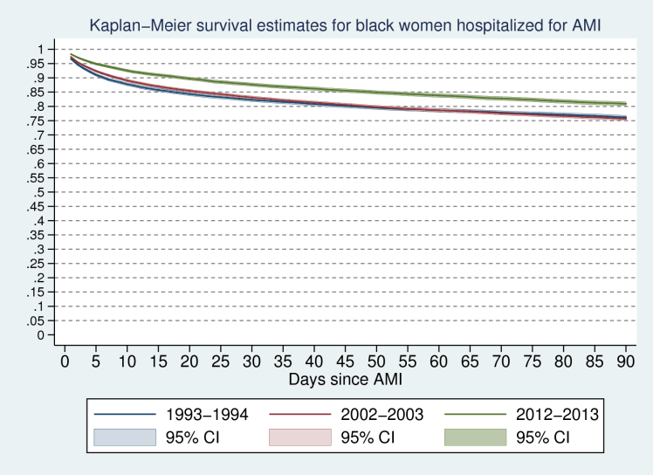

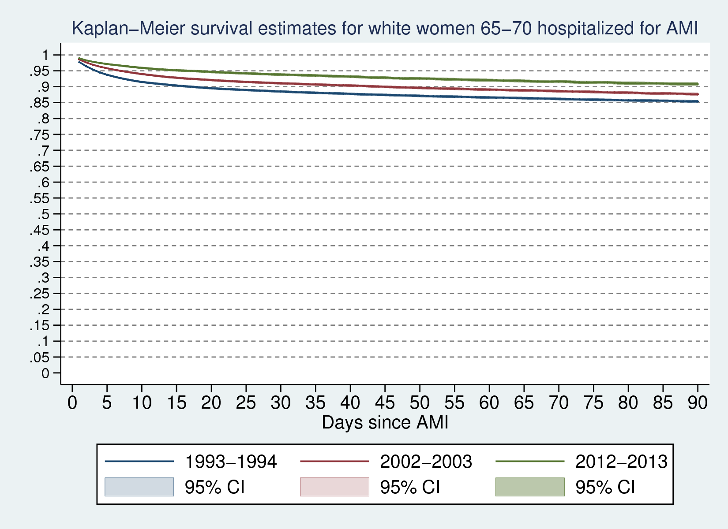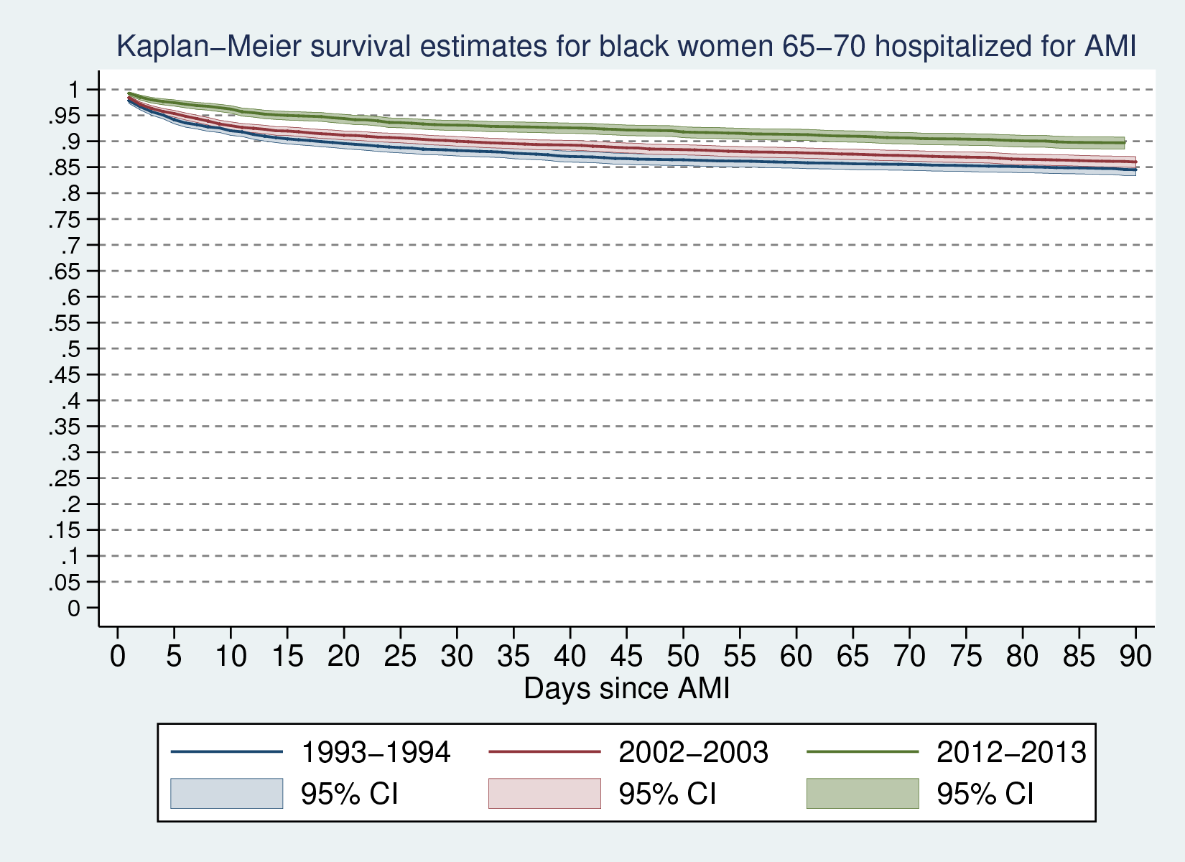

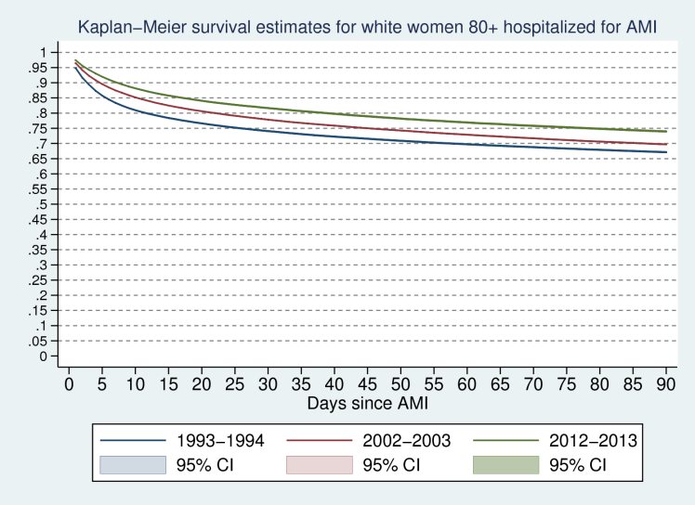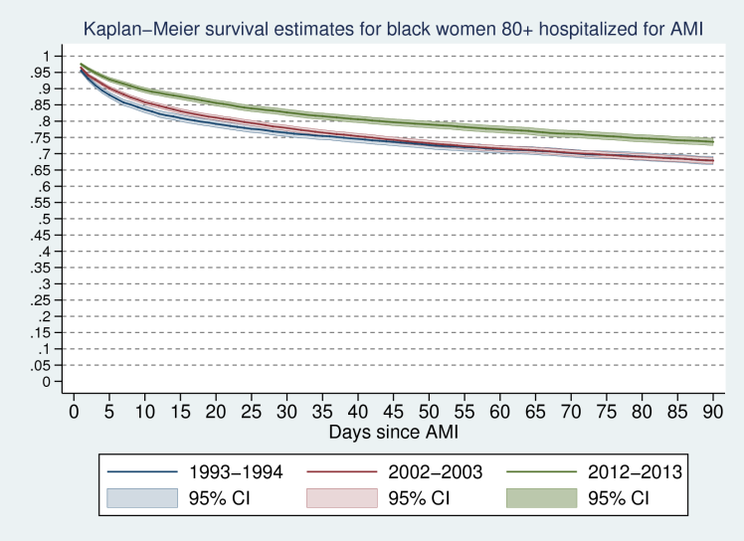

## Cox-adjusted survival estimates (adjusted for age group)

Stata’s sts graph allows plotting Cox-adjusted survival estimates using its *adjustfor* option. Variables passed into *adjustfor* are set to 0. To control for age, I centered age at its mean and generated a quadratic term in the demeaned age, thereby estimating survival for each race-sex-year cohort with age in each cohort fixed to the mean age of all patients.

The estimates below show that, conditional on age, survival among white males and females increased between the early 90’s and 00’s and then again between the early 00’s and 10’s. On the other hand, long-term survival (conditional on age composition) among blacks fell between the 90’s and 00’s, with this change most pronounced among black men. Notably, short-term was nearly unchanged among black men over this period and fell somewhat among black women.

Survival among blacks reversed dramatically by the early 10’s, when black men and women saw strong gains in survival at short, medium, and long time horizons.

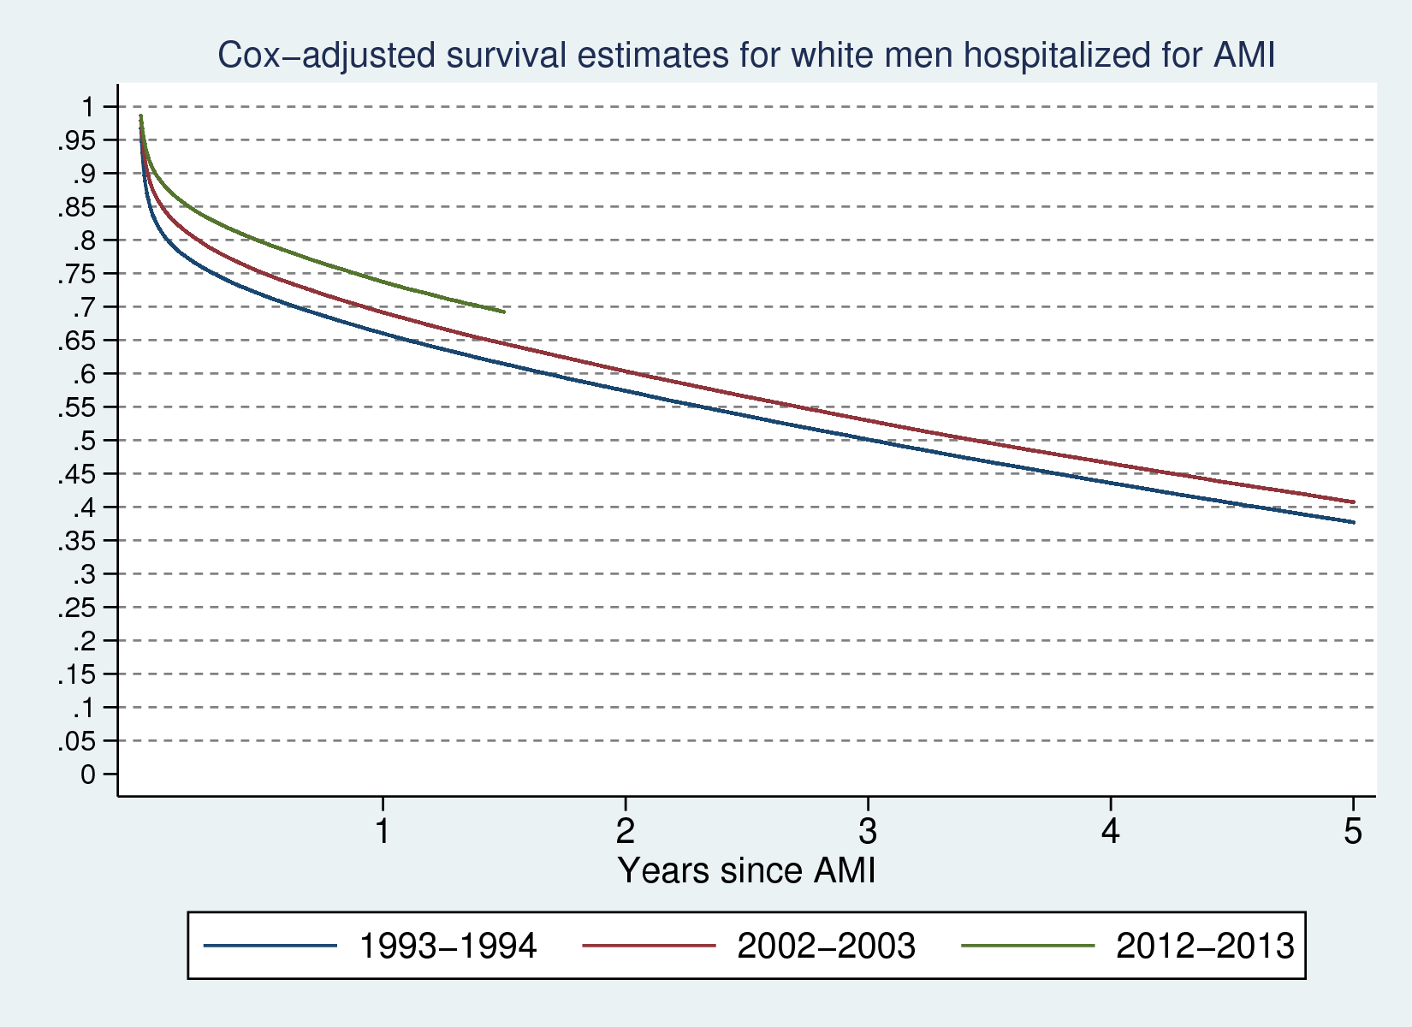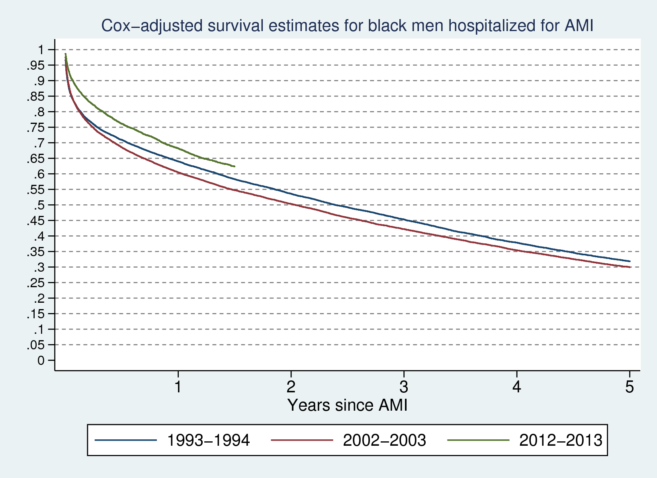

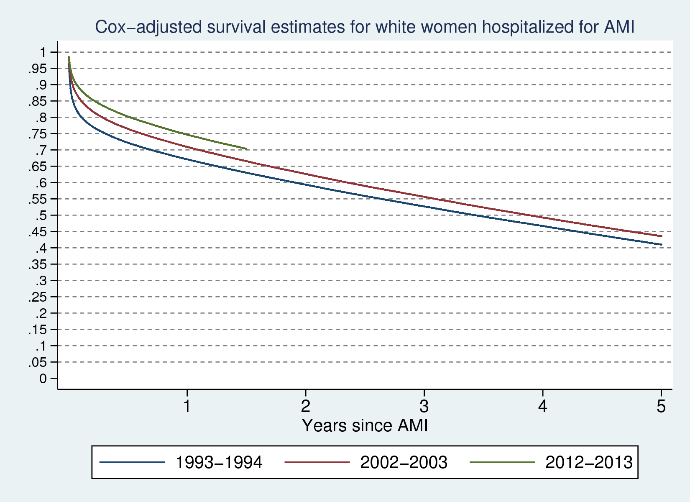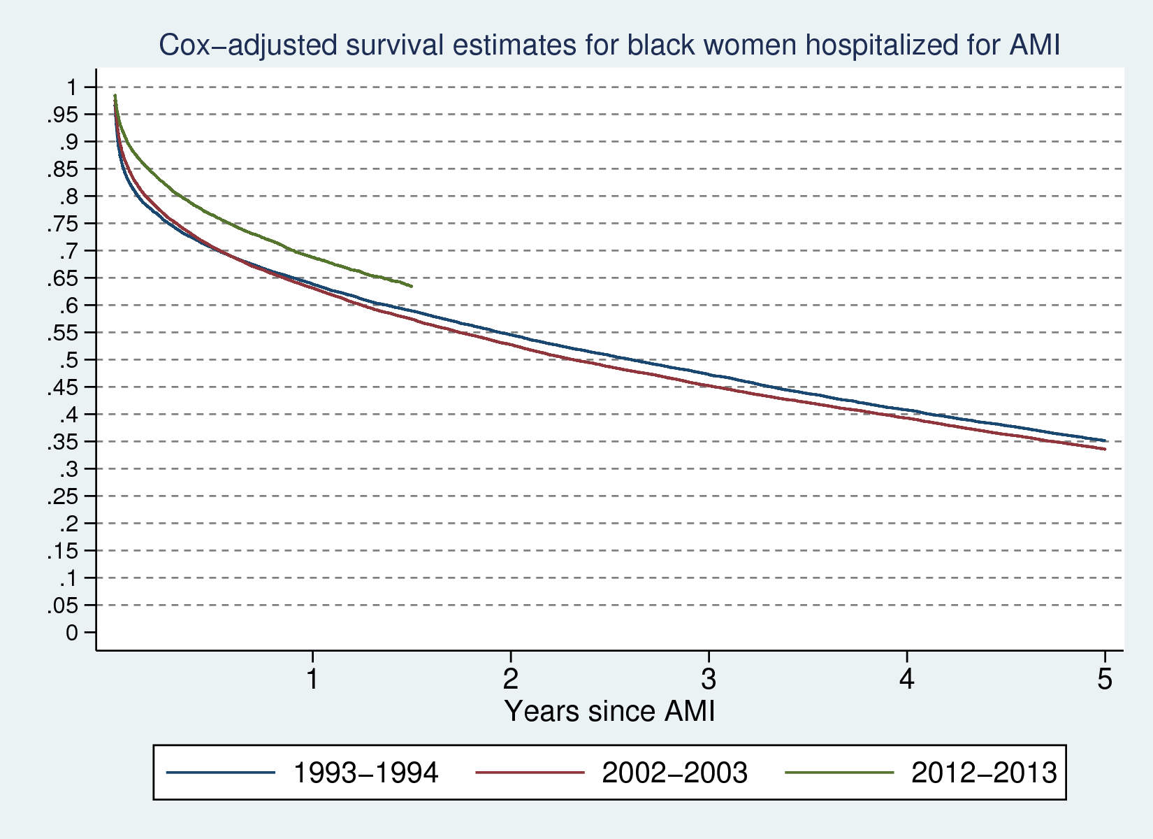

## Proportional hazards robustness tests

Analytic tests of the PH assumption all reject PH for quadratic age as well as age measured in 5 year groups. The graphical test below indicates that violations of the assumption may not be of large practical concern. If PH was perfectly satisfied we should see parallel lines for each age group. While the plotted curves are not perfectly straight, they show only limited intersection near the end of the period measured. In comparison, blacks have marginally higher (transformed) survival probability in the first few weeks after AMI and suffer lower survival rates in the years after, flagrantly violating PH.

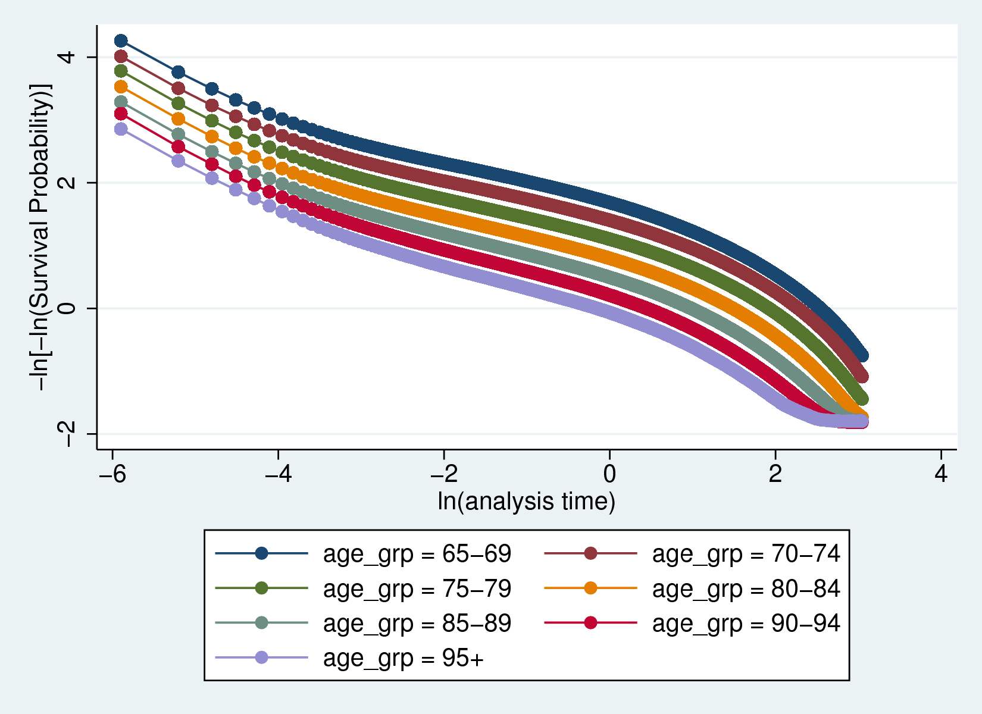

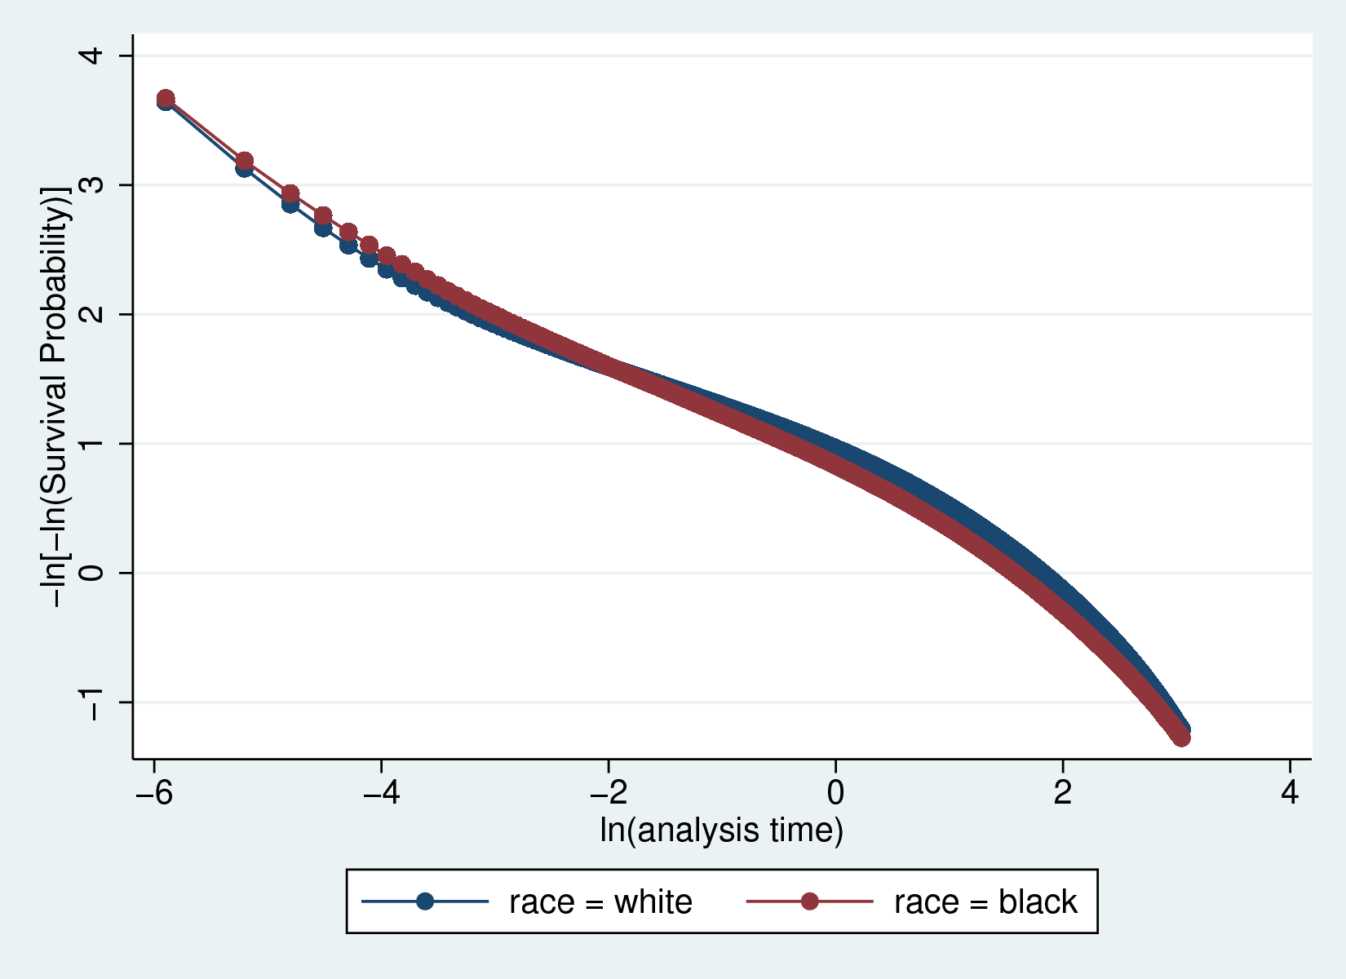

## Additional Estimates

