Names:

Teamwork (5) | Discussion (5) | Completeness (5) | Correctness (5) | Total (20)

Angular Size

This old one runs forever

But never moves at all.

He has not lungs nor throat,

But still a mighty roaring call.

What is it?

Pre-Lab Quiz
Record you team’s answers as well as your reasoning and explanations.
1.
2.
3.
4.

Part 1: The Small Angle Formula
1. Class Discussion Working with another group, think of couple situations where you are standing some distance d from a object with height h, some where and others where the values are more comparable. Draw the geometry on a white board and calculate the angular size in degrees using trigonometry, . Then apply the small angle formula to estimate the angular size in degrees. Note that there are 2π radians in 360° (or 1 rad = 57.3°).

After your group has produced a few examples on the white board, go around the room and look at the results of other groups and be prepared to discuss when the small angle formula
- does a very good job estimating the angle
- provides a nice ballpark estimate of the angle
- does a poor job estimating the angle

You may write in the space below to record your thoughts, but your response will not be graded.

2. In this question we’ll get a better grasp of the accuracy of the small angle formula by employing the Python programming language. We’ll consider the case of the Danforth Chapel, which is about 10 meters in height, and calculate the angular size at different distances from the chapel over the range .

Open an Anaconda Prompt, type ipython, and press return. We’ll begin by importing the numpy (Numerical Python) library, which is useful for working with data:

In[1]: import numpy as np

Next, let’s store our height and distances in two variables as follows:

In[2]: h = 10
In[3]: d = np.linspace(start=10, stop=1000, num=500)

The linspace function returns an array of linearly spaced values ranging from the start (10) to the stop (1000) with a designated number of values (500). To see the values, try

In[4]: print(d)

To calculate the angular size using , we can use the np.arctan function. Thus the angular size (in radians) of the chapel at the given distances can be calculated as follows:

In[5]: angle = np.arctan(h/d)

Next, we’ll calculate the angular size estimates using the small angle approximation

In[6]: small_angle = h/d

To gauge how accurate the small angle formula is we’ll use the percent error formula. First, lets define a function pe that takes as input the actual value act and the estimated value est and returns the percent error

In[7]: def pe(act, est):
... return 100 * abs(act – est) / act
...

(abs is a built-in function that returns the absolute value) and use it to calculate the percent error when using the small angle formula

In[8]: err = pe(angle, small_angle)
Finally, let’s plot the percent error as a function of the angular size using the matplotlib library, and convert the angular size to degrees via np.rad2deg

In[9]: import matplotlib.pyplot as plt
In[10]: plt.plot(np.rad2deg(angle), err)
In[11]: plt.xlabel("Angular Size (deg)", fontsize=20)
In[12]: plt.ylabel("% Error", fontsize=20)
In[13]: plt.show()

For each of the following angular sizes, record the percent error if you were to use the small angle formula, rounding to reasonable values.
Angular Size | 10° | 20° | 30° | 40°
% Error

Part 2: Measuring Angles
You will have access to paper, pens, paperclips, rulers, tape, and other materials you can use to construct an angular measurement device. Working with another group, brainstorm to see if you can design a device for measuring angles with the available supplies. After groups have had some time for discussion, the TA will have you share your thoughts with the class and then each group will construct their own device for measuring angles.

1. For this question feel free to collaborate with other groups, but make sure to take your own angular size measurements. As a test of your device,

- Measure the height h of 3 individuals and record it in the table below.
- Have each person stand some distance d away and record the distance.
- Use your device to measure their angular size (in radians).
- Calculate their angular size using the small angle approximation (in radians).
- Take the absolute value of the difference between the measured and calculated values and average your results. We’ll use this as a measure of the uncertainty of your device.
h (m) | d (m) | _{meas} (rad) | _{calc} = h/d (rad) | |_{meas} - _{calc}|
 |  |  | Average

Part 3: Size, Distance, and Parallax
In this section we’re going to estimate either the diameter of the dome of the Old Capital Building or the clock on the clocktower to the south using our angular measurement device. First, we’ll need to know the distance to the object, which can be estimated using parallax.

Consider the figure below. Two observers are some distance s apart and looking at an object that is some distance away. Each observer will perceive the object at a different location relative to the distant background. This angular offset is called the parallax angle and we’ll denote it by . From the small angle formula we have

(1)

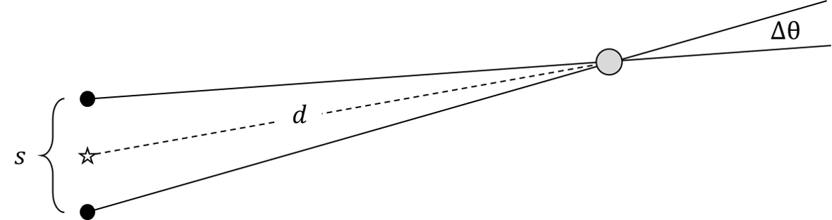
To find , we can measure the angular separation of the object from a very distant background object for each observer and call our measurements and . The parallax angle is just the difference between these measurements,

(2)

On a historical note, the ancient Greeks attempted to measure the parallaxes of stars, but noticed no apparent change in their positions, which led them to reject the heliocentric model. While the human eye has a resolution of about an arcminute (1/60 of a degree), it isn’t precise enough to measure stellar parallaxes, which are much less than an arcsecond (1/3600 of a degree) for all but the nearest stars.
1. Working with another group, estimate the distance to the object using parallax. Explain the steps you took to arrive at your answer.

2. Using your distance estimate from the previous problem, estimate the diameter of the dome or clock. Show your work.

