Names:

Teamwork (5) | Discussion (5) | Completeness (5) | Correctness (5) | Total (20)

The HR Diagram
& Globular Clusters

Walk on the living,

They don’t even mumble.

Walk on the dead,

They mutter and grumble.

What is it?

Pre-Lab Quiz
Record your team’s answers as well as your reasoning and explanations.
1.
2.
3.
4.
Part 1: The HR Diagram
We’ll be using magnitudes for much of today’s lab. Note that B and V represent the apparent magnitude in the blue and green (visual) photometry bands respectively.
1. Are stars becoming brighter or fainter with increasing V magnitude?

2. Are stars becoming redder or bluer with increasing B – V color?

3. On the HR diagram below indicate
- the direction of increasing temperature
- the direction of increasing luminosity
- the location of the Main Sequence, Giants, Supergiants, and White Dwarfs
- the location of the Sun (B – V = 0.65, M_{V} = 4.83)
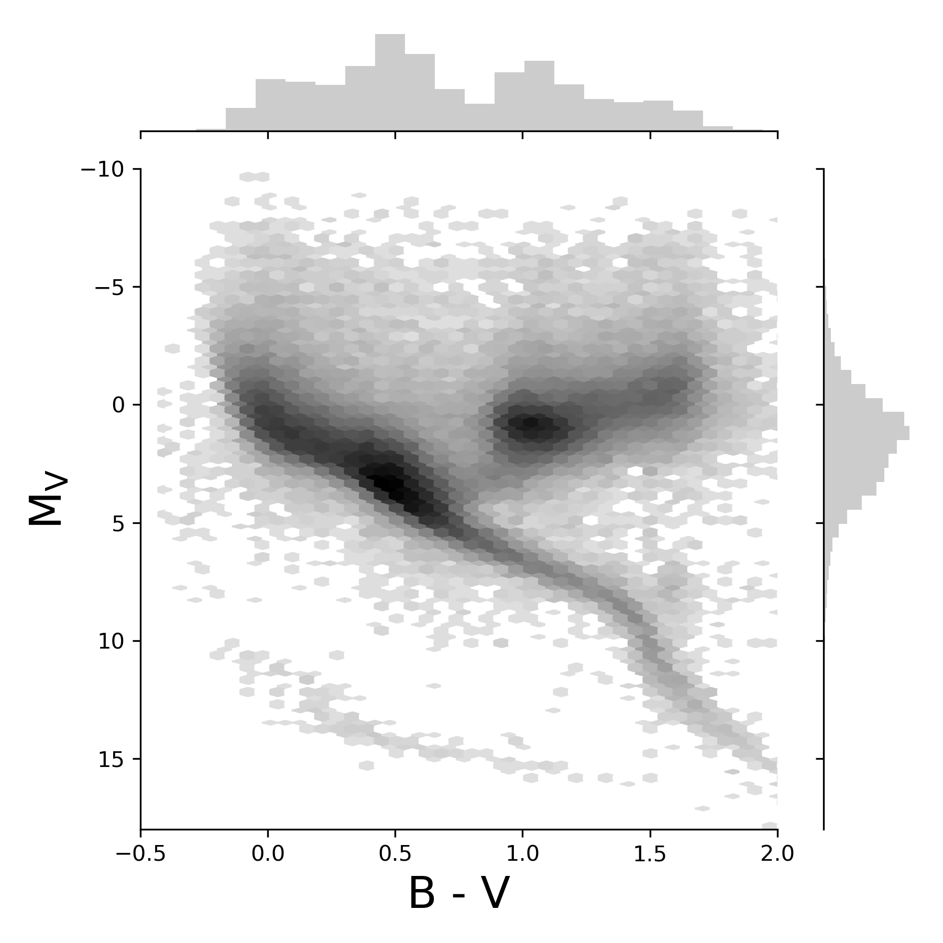

4. Using the HR Diagram Explorer, estimate the various quantities for each of the stars below.
Star | Arcturus | Deneb | α Centauri A | Sirius B
B – V | +1.23 | +0.09 | +0.71 | -0.03
M_{V} | -0.30 | -8.38 | +4.38 | +11.18
Spectral
Type
Luminosity
Class
Temperature
(K)
Luminosity
(L☉)
Radius
(R☉)

5. Class Discussion At the botton of the HR Diagram explorer click the button to plot the nearest stars, which you’ll find are mostly red dwarfs. If you look at the HR Diagram on the previous page, however, very few of these are plotted. Why is there a discrepancy here?
4. In this problem we’ll create an HR diagram using data from >80,000 stars and the Julia programming language. First, we’ll need to download and import a few libraries

import Pkg
Pkg.add(["CSV", "DataFrames", "Gadfly"])
using CSV, DataFrames, Gadfly

CSV is a library for working with CSV (Comma Separated Values) files, DataFrames is useful for manipulating tabular data, and Gadfly is a plotting library (gadflyjl.org).

Next download the file hr_data.csv from the lab website. To open the file, we’ll need to direct Julia to the proper directory, which can be done as follows:

pwd() # Show current directory
cd() # Change to home directory
pwd() # Show current directory
cd("Downloads") # Change to Downloads directory
readdir() # Show files in directory

We can then load the file using the CSV library

df = CSV.read("hr_data.csv")

If some of the columns aren’t displayed, you can find their names by typing names(df).

For our purposes, we’re only interested in the distance (column = Distance), the apparent magnitude V (Mag), the absolute magnitude M_{V} (absmag), and the B – V color index (ci). Let’s create a new data frame called stars that contains only these columns and give them the names d, m, M, and c respectively:

stars = DataFrame(d=df.Distance, m=df.Mag, M=df.absmag, c=df.ci)

Some of the stars (rows) have missing values. To remove these entries, we can use the dropmissing function (part of the DataFrames library):

stars = dropmissing(stars)

Next, let’s plot the relationship between the apparent magnitude m and the distance d. We’ll use histogram binning rather than plotting each star separately (if you make a mistake, you can press the up-arrow to reuse and modify your code):

plot(
stars, x = "d", y = "m",
Geom.histogram2d(xbincount=100, ybincount=50),
Coord.cartesian(yflip=true),
Scale.x_log10
)

It might take a while for the plot to appear the first time.

Class Discussion: When plotting distance against the apparent magnitude, there is a magnitude cutoff. Why is this the case?

Class Discussion: When plotting distance against the absolute magnitude (use the up-arrow to reuse your code and change y="m" to y="M") a different relationship is observed. What does this relationship indicate about our dataset?

Finally, let’s create our HR diagram using hexagonal bins:

plot(
x = stars.c,
y = stars.M,
Guide.xlabel("B – V"),
Guide.ylabel("M<sub>V</sub>"),
Geom.hexbin(xbincount=200, ybincount=100),
Coord.cartesian(xmin = -0.5, xmax = 2.0, yflip = true)
)
Part 2: Globular Clusters
1. What are globular clusters?

2. Draw an edge-on schematic of the Milky Way Galaxy in the space below and indicate where the globular clusters are located. Label the bulge, disk, and halo components.

3. For the HR Diagram of the globular cluster M3 below, label the main sequence (MS), the main sequence turnoff point (TP), the giant branch (GB), the horizontal branch (HB), and the blue stragglers (BS).
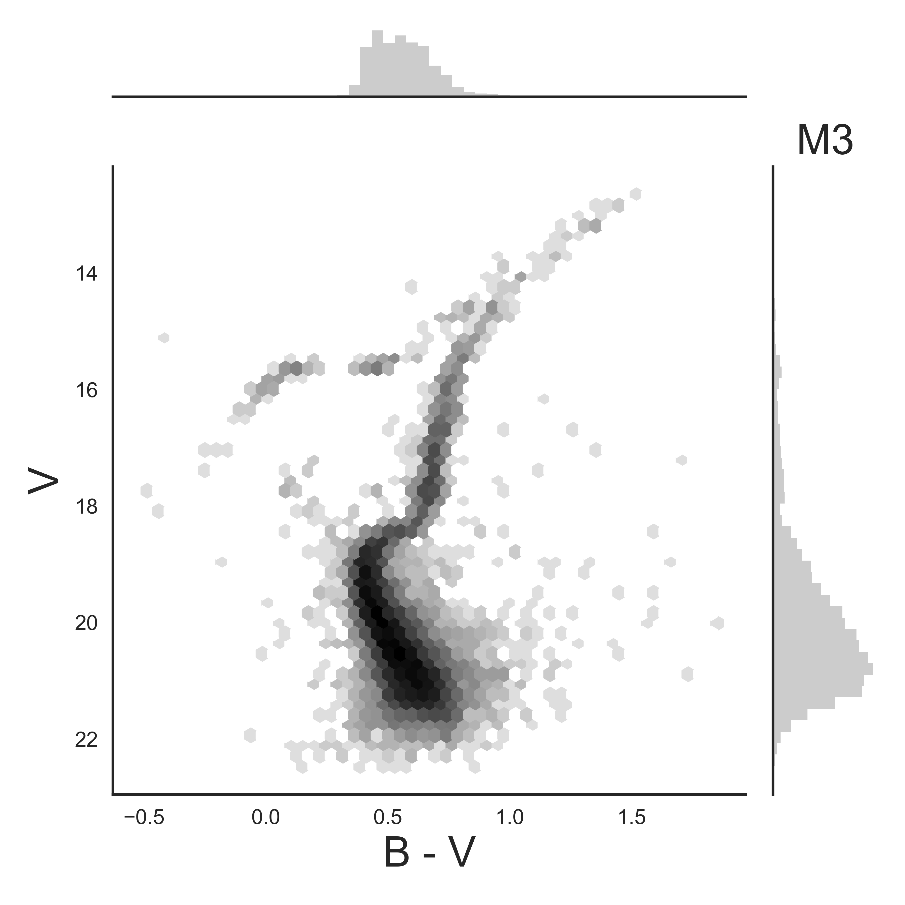

4. Using the B – V color associated with the TP, determine the spectral type associated with these stars by examining the plot on the website.
B – V |  | Spectral Type
Work with another group as you answer the remaining questions.

5. Determine the age of the globular cluster using the TP from the previous problem. Explain your answer.

6. Suppose we looked at an identical globular cluster that was simply farther away. How would the increased distance affect the V magnitude and B – V color?

7. Suppose a dust cloud moved between us and the globular cluster. How would this change the V magnitude and B – V color? Note that dust particles preferentially scatter blue light.

8. How might the distance or the presence of dust complicate our age estimates when using the TP? Explain your answer.

9. Examine the HR Diagrams of the four star clusters on the website and rank them from youngest to oldest. Explain your rankings.

Hint: Think about your answer to question 8 for why using the TP won’t work in this case. How else can we rank the relative ages of the clusters?

