Names:

Teamwork (5) | Discussion (5) | Completeness (5) | Correctness (5) | Total (20)

Image Analysis 2

I have four wings, but cannot fly,

I never laugh and never cry;

On the same spot I’m always found,

Toiling away with little sound.

What am I?

Pre-Lab Quiz
Record you team’s answers as well as your reasoning and explanations.
1.
2.
3.
4.

Part 1: The speed of Asteroid 3 Juno
labimage → Asteroid → 3_Juno → 105
Open all the images then follow the directions below to make an animated image showing the asteroid’s movement across the sky.

- Under Process click Align
  - In the Select Images window that appears, add the images
  - In the Align Images window that appears, set the align mode to Auto – star matching and click OK
- Under View click Animate
  - In the Select Images window that appears, add the images
  - In the Animate window that appears, click the play button

1. Why is it important to align the stars?

2. Determine the angular distance (in pixels) that the asteroid traveled from the first to the last image. Record the horizontal (Δx) and vertical (Δy) shifts, as well as the total number of pixels traveled (_{pixel}). Show your work. Note: Use the coordinates at the bottom right rather than the information window.
Δx | Δy | _{pixel}

3. Working with another group, on a white board

- Draw the geometry for estimating the distance s the asteroid traveled using the small angle formula, labeling each of the variables .
- Using the small angle approximation, , calculate how far the asteroid traveled in km. Make sure to perform unit conversions, e.g.
  - The pixel scale for this image is 0.73ʹʹ / pixel.
  - The asteroid was about 315 million km away when the images were taken
- Calculate the speed of the asteroid in km/s.
  - You can use the FITS header (ctrl-f) to get the date and time of the first and last observations. Note that the times are Coordinated Universal Time (UTC), or Greenwich time.
- What assumption did you make when calculating the speed that might cause you to underestimate its true speed? Illustrate how this assumption might not be valid on your diagram.

Have your TA mark below when done. You may find it helpful to record your work on the last page for future reference.
TA

Part 2: Photometry of a Variable Star

The star AB Andromedae (AB And) is an eclipsing binary, which means that as the stars orbit one another, the light from one star will occasionally be blocked by the other star, making the system appear fainter. In this part, we’ll calculate the magnitude of the brightness drop when the system is eclipsed vs. uneclipsed.

- Under Analyze click Photometry
  - Click Add Files and open all the files in the indicated directory below
    - labimage → VarStar → AB Andromedae
    - You can use ctrl-a to select all the files
  - Under the Match tab, set the mode to Auto – star matching
  - Under the Identify tab, expand the list in the left panel and select an image to display it. Then
    - Go to the online Simbad Astronomical Database, perform a basic query, and search for AB And.
    - Click the query around button after changing the radius to 20 arcmin. Identify the star in Maxim DL.
    - We’ll need to identify two stars in our image to serve as a reference star and a check star. We’ll use the two stars listed below. For each star, record its V-band magnitude and locate it on your image.
Star | V Magnitude | Type
TYC 2763-683-1 |  | Reference
BD+35 4975 |  | Check

Maxim DL uses the magnitude of the reference star to calculate the magnitudes of the other stars. The check star is used to verify that our magnitudes are consistent from image to image and make sense.

- Returning to the Identify tab in the Photometry window, under Tag mode
  - Select "New Object" and click on AB Andromedae in the image
  - Select "New Reference Star" and click on the reference star in the image.
    - Enter the magnitude into the Mag column.
    - You can hit tab once after selecting the star, otherwise try clicking into the cell.
  - Select "New Check Star" and click on the check star in the image.

For performing photometry, note the following features

- Aperture
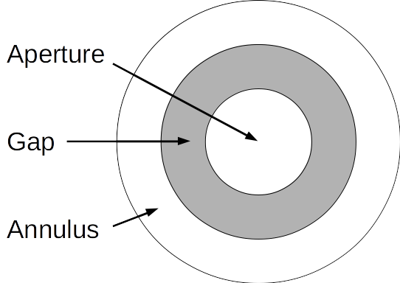
  - Used to extract the light from the object
- Gap
  - Used to separate the aperture from the annulus.
- Annulus
  - Used to estimate background flux
  - No background sources (e.g. stars) should be present in this region

Right click on your image and adjust the size of the aperture, gap, and annulus. Once you’ve settled on appropriate sizes, click the Graph tab to generate a plot of the brightness over time.

You can right-click on the plot and deselect the check and reference stars.

The magnitude m of a star is defined as

(1)

where is the magnitude of the reference star, the flux (brightness) of the reference star, and f the flux of the star. Partnering with another group, on a white board work through the following steps:

- Starting with the expressions
(2)
subtract from and simplify the expression.
- Use the property of logarithms,

(3)

to remove the flux of the reference star from the expression.
- Use the relationship

(4)

to solve for the ratio of fluxes . You should end up with

(5)

- Letting denote the magnitude when the system is uneclipsed and the magnitude during the eclipse, calculate the brightness ratio . If both stars have the same brightness (both have G5 spectral types), does this mean that we experience a partial or total eclipse?

TA

