Names:

Teamwork (5) | Discussion (5) | Completeness (5) | Correctness (5) | Total (20)

Measuring the Sky

Until I am measured

I am not known,

Yet how you miss me

When I have flown.

What am I?

Pre-Lab Quiz
Record your team’s answers as well as your reasoning and explanations.
1.
2.
3.
4.

Part 1: The Celestial Sphere
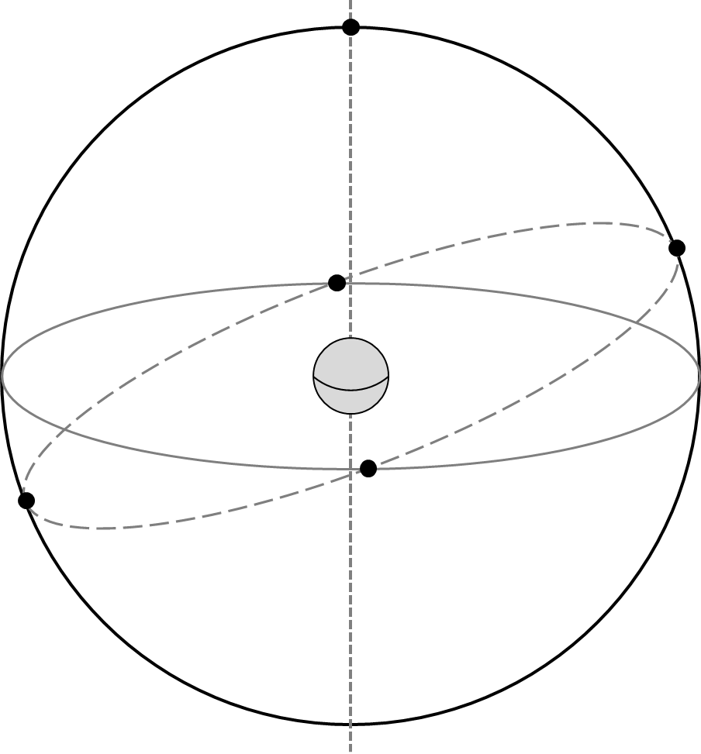
1. In this problem we’re going to familiarize ourselves with the celestial sphere. After partnering with another group, your goal will be to draw the provided diagram on a white board and label the following features:

- Earth’s Equator
- Celestial Equator
- North & South Celestial Poles
- The Ecliptic
- Position of Polaris
- Earth’s Rotational Axis
- Summer & Winter Solstices
- Autumnal & Vernal Equinoxes

Before you work through the problem you’ll be using Stellarium to help visualize the celestial sphere and how it relates to the motion of celestial objects.

In the bottom panel of Stellarium turn off the ground, cardinal points, and atmosphere. Then click Switch between equatorial and azimuth mount (it should be highlighted) and click Increase time speed several times to set the Sun and planets in motion.

In the left panel click Sky and viewing options and change the projection from Stereographic to Orthographic✝ and zoom out using the scroll wheel on the mouse. Then under the Markings tab check (using of date) Equator, Ecliptic, Celestial Poles.

Have your TA mark below when done.
TA

✝ Note that Orthographic swaps east and west, so the Sun and planets will appear to orbit backwards relative to the diagram above, but in the same direction as the Stereographic projection. The human eye most closely aligns with the Perspective projection.
The Celestial Sphere: Local Viewpoint
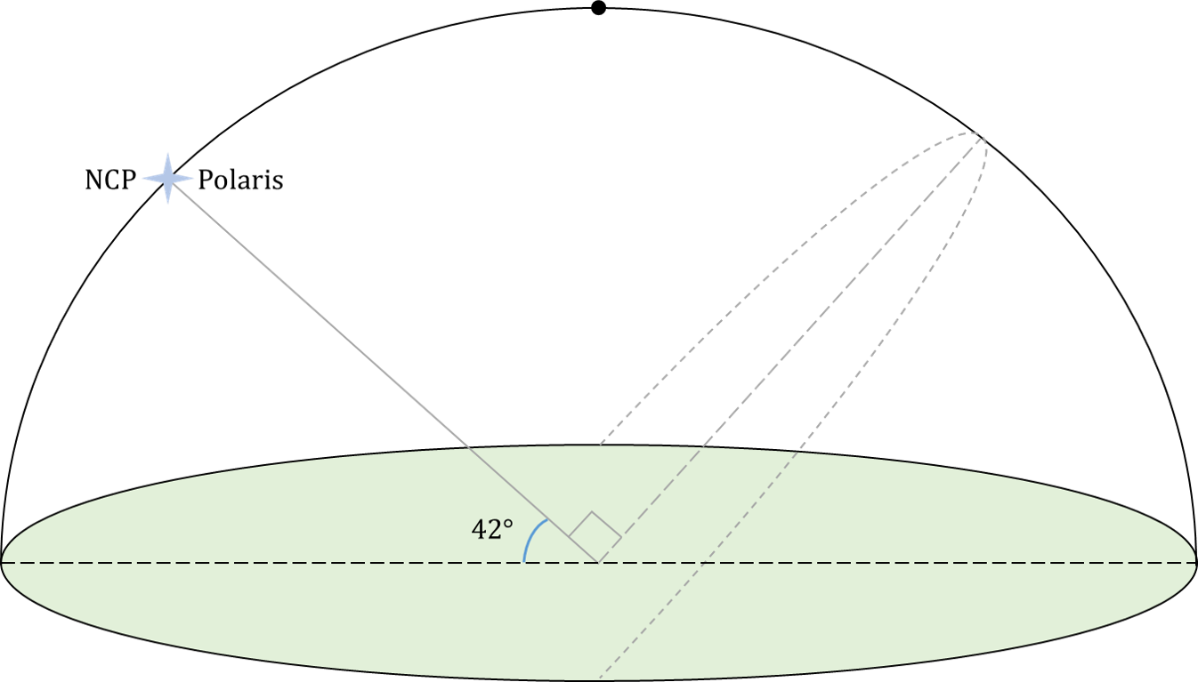
2. In this problem we’ll consider the case of the local celestial sphere. Working with the same group (but have someone else be responsible for writing), your goal will be to draw the provided diagram on a white board and label the following features:

- Zenith
- Meridian
- Celestial Equator
- Horizon
- Cardinal directions with their azimuth angle

where the azimuth angle is the angle around the horizon, starting from the North (0°) and increasing to the East, through 360°. In addition to labeling these features,

- indicate the elevation of the celestial equator
- draw the path of a non-circumpolar star over the course of a night.

Before you work through this problem you’ll be using Stellarium to help visualize the celestial sphere and how it relates to the motion of celestial objects. After restarting Stellarium, in the left panel

- Click Location window – search for and select Iowa City as the current city and check the box Use current location as default.

- Click Sky and viewing options – under the SSO tab uncheck Solar System objects so that we can see the stars during the day. Under the Markings tab check Equator, Meridian, Celestial poles, and Zenith and Nadir.

Then click Increase time speed a couple times in the bottom panel to set the stars in motion. Have your TA mark below when done.
TA
Celestial Coordinates
A common coordinate system for describing the position of an object on the celestial sphere is the azimuthal system. In the azimuthal system, coordinates are specified in terms of their

Azimuth – angle around the horizon, starting from the North and increasing to the East. Ranges from 0° to 360°.

Altitude – angle above the horizon. Ranges from 0° at the horizon to 90° at the zenith.

Using the set-up from the local celestial sphere part in Stellarium, turn the Azimuthal grid on in the bottom panel, which will display lines of constant azimuth and altitude (the value of the grid lines can be found along the edges of the screen).

3. Class Discussion As the stars move across the sky, you’ll notice that their azimuth and altitude are constantly changing while the coordinate grid stays fixed. What are some advantages and disadvantages of using this coordinate system?

You may write in the space below to record your thoughts, but your written response will not be graded.
Part 2: Estimating Angles
In this session we’ll begin the practice of observing the night sky. The main point of this activity will be to estimate the azimuth, altitude, and angular size of a number of objects. Familiarize yourself with the figure below. It is a handy guide for estimating angles with your hand when held at arm’s length.

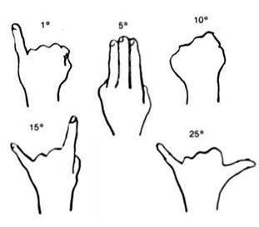

A quadrant is an instrument that was commonly used to measure altitudes before the modern age. Your TA might have you spend a few minutes constructing a basic one for use in question 3.

1. Using the scaled planets from the first lab, set one planet from each pair at a distance of about 1 meter from your head and estimate the angular size.

Earth / Venus | Jupiter / Saturn | Uranus / Neptune
Roof Observing
2. Class Discussion Together with your lab group partners, discuss how you would trace out the meridian, the celestial equator, the NCP, and the zenith. Your TA will then lead a class discussion on how to trace these out.

3. When estimating azimuth or altitude, don’t use more than two hand-angle combinations (you can also start at the zenith for the altitude). If part of a night lab, check with your TA about doing part (a).

a) Terrestrial Observing
For each of the following objects, estimate the indicated quantities. For the angular size, measure it in terms of their height.
Object | Angular Size | Azimuth
Clock on Clocktower
to the South
Grey Church to
the Northwest
Old Capitol Dome
(just the dome at the top)
Red Church
to the North
Slanted Roof
Building to South

Object | Angular Size | Azimuth | Altitude
Cross on Red Church
b) Night Observing

If the skies are cloudy your TA may have you use Stellarium to do this part using its Angle Measurement tool and the markings Meridian and Prime Vertical. Make sure to approximate the angles as up to two hand-angle combinations.

Your TA will point out several objects in the night sky. Record their names and estimate the indicated quantities. Note: The altitude should NOT exceed 90°!

Object | Angular Size | Azimuth | Altitude

