Names:

Teamwork (5) | Discussion (5) | Completeness (5) | Correctness (5) | Total (20)

Observing the Night Sky

Always old, sometimes new.

Never sad, sometimes blue.

Never empty, sometimes full.

Never pushes, always pulls.

What is it?

Pre-Lab Quiz
Record your team’s answers as well as your reasoning and explanations.
1.
2.
3.
4.
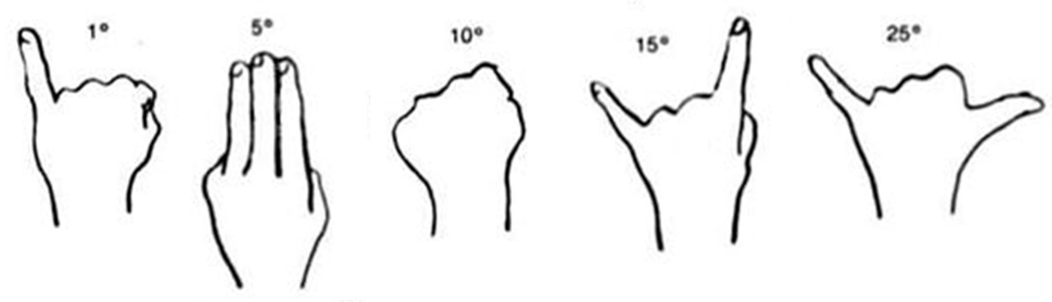
Part 1: The Changing Sky
Open Stellarium and in the left-hand panel,
- Click Location window – set the current location to Iowa City and check the boxes Use current location as default and Enable daylight savings at the bottom.
- Click Sky and viewing options – under the SSO tab uncheck Solar System objects so that we can see the stars during the day.
In the bottom panel, click Increase time speed a couple times to set the stars in motion.

1. Class Discussion After watching the stars move in the Iowa sky, change the location to the South Pole and then Quito, Equador (which is near the equator). Be prepared to discuss your thoughts to the following questions with the class:
- Compare and contrast their path at each location
- Between the three, which place allows you to see the most stars over the course of a year?

You may write in the space below to record your thoughts, but your written response will not be graded.
Part 2: Stars & Constellations
1. Dial up 9 pm on your star wheel by aligning today’s date with 9 pm. Find a constellation that has just risen. Find a constellation that has just set. Hint: how can one simulate the passage of time throughout the night on a star wheel?
Rise |  | Set
2. Partnering with another group, assign a question to each group, answer it using standard time, then show the other group how you arrived at your answer.
- The Summer Triangle consists of the three bright stars Altair, Deneb, and Vega. While it isn’t a constellation, it is one of the most famous asterisms (pattern of stars) in the night sky. During which months will it be visible at midnight?
- Orion the Hunter is a prominent constellation in the night sky. Will Orion be visible tonight? If so, during what times? If not, when will it become visible at 4 am again?

3. Arcturus (Guardian of the Bear) is the 4th brightest star in the night sky and is located in the constellation Boötes, the celestial plowman. Working with another group, draw a diagram of the Big Dipper on a white board and illustrate how to find Arcturus and Polaris using the Big Dipper as your starting point (and below when done). Also label the stars Mizar & Alcor, and be prepared to explain what is special about them (The Stargazer’s Handbook, pg. 34).
TA

4. The Pleiades (pg. 74) is prominent in many cultures. In the Epic of Gilgamesh, the Pleiades is associated with the monster Humbaba the Terrible and his seven splendors. Among the Chinese, it represents the hairy head (昴, mao) of the White Tiger of the West (西方白虎, Xī Fāng Bái Hǔ). Native Americans once used it as a vision test and the Aztecs based their calendar on it. What is the Pleiades and when is it observable at 9 pm?

5. The primordial tale of Ursa Major is thought to have involved a herbivore escaping a human hunter by reaching the heavens. Its identification with a bear is immortalized in The Odyssey,

… forever scanning
the stars, the Pleiades and the Plowman late to set
and the Great Bear that mankind also calls the Wagon:
she wheels on her axis always fixed, watching the Hunter,
and she alone is denied a plunge in the Ocean’s baths.
– The Odyssey, 5:270–274

When is Ursa Major observable at midnight? In the Greek tradition, what is the relationship between the constellations Boötes, Canis Venatici, and the bears Ursa Major and Ursa Minor (pg. 42)?
6. In the bottom panel of Stellarium, turn on the constellation lines, labels, and art. Then under Sky and viewing options → Starlore find the following constellations after selecting the indicated starlore and identify its western counterpart. You might find it helpful to turn off the ground in the bottom panel.
Starlore | Constellation | Western Constellation
Inuit | Caribou
Norse | Aurvandil’s Toe†
Hawaiian | The Chief’s Fishline  (Maui’s Hook)
Belarusian | Ploughman
Belarusian | The Cross
Ojibwe | Ajijaak  (Crane)
Ojibwe | Biboonkeonini  (The Wintermaker)
† In his work on Norse mythology, The Prose Edda, Snorri Sturluson records that Thor carried Aurvandil (luminous wanderer) in a basket on his back from the land of the frost giants, but:

one of Aurvandil's toes had stuck out of the basket, and became frozen; wherefore Thor broke it off and cast it up into the heavens, and made thereof the star called Aurvandil's Toe.

Aurvandil (Earendil in old English) is thought to refer to the morning star (Venus) and is mentioned in The Lord of the Rings:

And for you, Frodo Baggins, I give you the light of Eärendil our most beloved star. May it be a light to you in dark places when all other lights go out.

In Tolkien’s retelling, Eärendil was a great seafarer who bore on his forehead the morning / evening star – one of the jewels of Fëanor (also called the Silmarils) – and carried it through the sky on his vessel Vingilot.
7. The ancient astronomer Hipparchus ranked stars based on their brightness. Ptolemy expanded upon his idea, assigning the brightest stars to 1st magnitude and down onto the faintest at 6th magnitude. Astronomers nowadays use a more precise definition based on a mathematical formula that is similar to Ptolemy’s system.
In the bottom panel of Stellarium turn the constellation lines, labels, and artwork off and the ground back on. In the left panel click Date/time window and change the time to around midnight on July 1.
Under Sky and viewing options → Starlore make sure "Western" is selected and check the boxes Show asterism lines and Show asterism labels and find the Summer Triangle and Northern Cross asterisms. Then click on the star Vega and mark its position and magnitude on the diagram below. Do the same for Deneb, Sadr, η Cyg, and Albireo, which are along the upright pole of the cross. You’ll be using this diagram to estimate the magnitudes of several stars in Part 3.

Part 3: Observing the Night Sky
If the skies are cloudy or part of a day lab, use Stellarium to do this part.
1. Find the following objects in the night sky and point them out to your TA.
Object | Type | TA
Big Dipper | Asterism
Arcturus | Star
Polaris | Star
Mizar-Alcor | Double Star
Summer Triangle | Asterism
Northern Cross | Asterism
2. Estimate the apparent magnitudes of the following stars. Do NOT look up the magnitude, but estimate it by comparing its brightness with the stars in Problem 2.7.
Star | Constellation | Magnitude
Altair | Aquila
Tarazed | Aquila
Aljanah | Cygnus
Fawaris | Cygnus
Polaris | Ursa Minor
3. Night Observing Only Measure the angular distances of Arcturus and Polaris from the Big Dipper’s handle and ladle respectively and add the values to your diagram in Problem 2.3.

