Names:

Teamwork (5) | Discussion (5) | Completeness (5) | Correctness (5) | Total (20)

Navigating the Sky

I live above a star

but never burn.

I have eleven neighbors

but they never turn.

What am I?

Pre-Lab Quiz
Record your team’s answers as well as your reasoning and explanations.
1.
2.
3.
4.
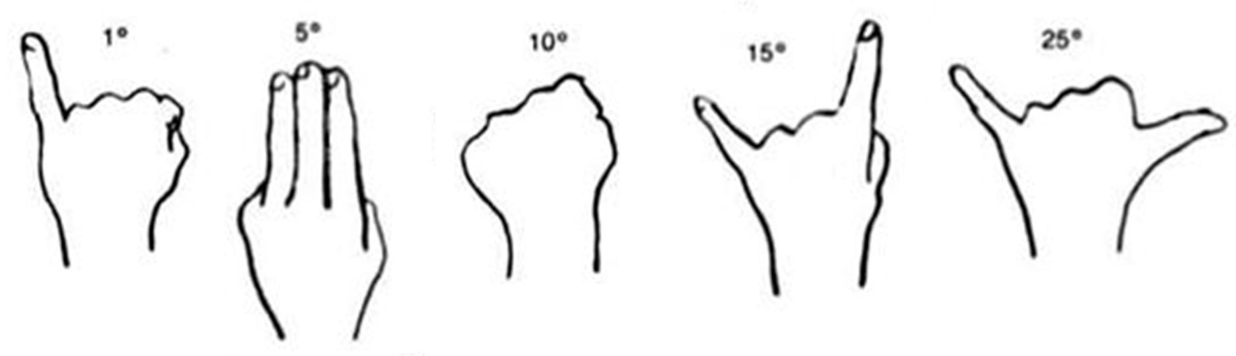

Part 1: Celestial Coordinates
Coordinates of celestial objects are usually listed in terms of right ascension (RA, α) and declination (DEC, δ), which are similar to longitude and latitude (The Stargazer’s Handbook, pg. 13)
On the SC1 chart, the right ascension axis spans the width of the chart and runs from 0 to 24 hours. The declination axis spans the height of the chart and runs from –60° to +60° (if the more polar regions were included, it would run from –90° to +90°).

1. Several famous objects in the night sky are M1 (in Taurus), M33 (in Triangulum), and M42 (in Orion). (The M stands for Messier, a catalog of deep space objects). Working with another group or two, have each group select a different object and determine its right ascension and declination using the SC1 chart. Then look up the object online and in The Stargazer’s Handbook and find an interesting fact about it. Once complete,

- show the other groups how to find the object on the SC1 chart using its (α, δ)
- show them a picture of it
- tell them what you learned about it

Object | RA | DEC

The Ecliptic
On the SC1 chart there is a curved line that represents the path of the Sun throughout the year. This path is called the ecliptic. The dates listed along this path correspond to the location of the Sun on that particular date.

1. What is the current right ascension and declination of the Sun?
RA |  | DEC
2. There are two dates when the Sun has a declination of zero. What are these dates and what is the right ascension of the Sun at these times? What special names are given to these dates?
Day | RA | DEC | Special Name
 |  | 0°
 |  | 0°
3. What dates correspond to when the Sun is at its maximum and minimum values of declination? What is the right ascension and declination of the Sun at these times? What special names are given to these dates?
Day | RA | DEC | Special Name
4. Class Discussion On average, how many minutes of right ascension does the Sun move each day? Answer the question using unit conversions.
Local Sidereal Time
Local sidereal time (LST) is defined as the right ascension of stars that are on the meridian. Rather than using the Sun to demarcate time, it uses the stars.
On the SC1 chart, along the right ascension axis you will find dates listed below the hour values. These dates indicate when stars with the listed right ascension will be on the meridian at 8 pm. For daylight savings (March – October), this becomes 9 pm.
To find the meridian at a later time, increase the right ascension by 1 hour for every hour of time difference (so if the right ascension of the meridian is 5 hours at 8 pm, then it is 6 hours at 9 pm and 7 hours at 10 pm).

1. The best time to observe an object is when it is close to the meridian, as this is when it is highest above the horizon. List some constellations that will make for excellent viewing at 10 pm tonight.

2. At midnight tonight (Standard Time), what will be the local sidereal time? Is this what you would expect based on the Sun’s current right ascension? Why? Share your answers with another group.

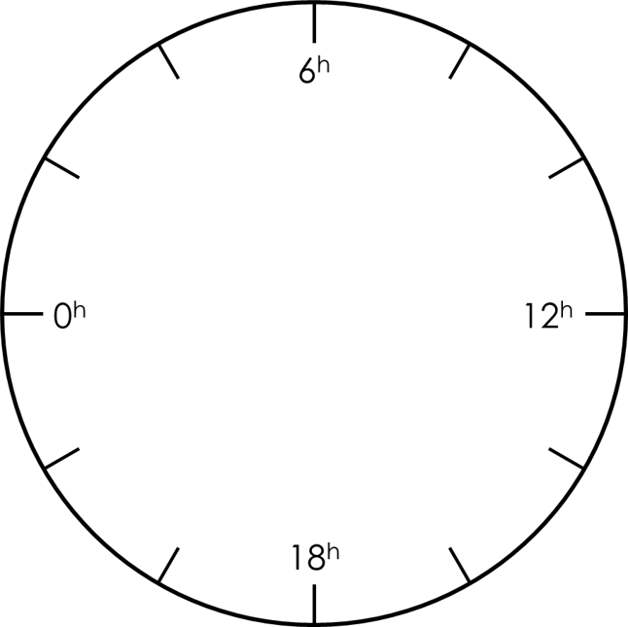
3. The right ascension of the Crab Nebula is α = 5^{h} 35^{m}. Without using the SC1 chart, work with another group to determine when it will be visible at midnight. Draw some diagrams on a white board illustrating your answer and have your TA mark below. Feel free to round the coordinates.
TA
Part 2: Observing the Night Sky
If the skies are cloudy or part of a day lab, use Stellarium to do this part. For day labs, your TA will indicate what time to use for your observations.
1. Using the SC1 chart, record the current local sidereal time (LST).
LST

2. Class Discussion Given that the sky rotates 15° per hour towards the west, estimate the right ascension and declination of the following objects. If using Stellarium, do NOT look up the coordinates, but use the Angle Measure tool and turn on the Meridian and Equator under Sky and Viewing Options → Markings.
Object | Constellation | RA | DEC
Altair | Aquila
Deneb | Cygnus
Vega | Lyra
Jupiter | Ophiuchus
Saturn | Sagittarius

