Names:

Grade

Observing with Telescopes

Halo of water, tongue of wood

Skin of stone, long I’ve stood.

My fingers short reach to the sky

Inside my heart men live and die.

What am I?

Part 1: Phases of the Moon

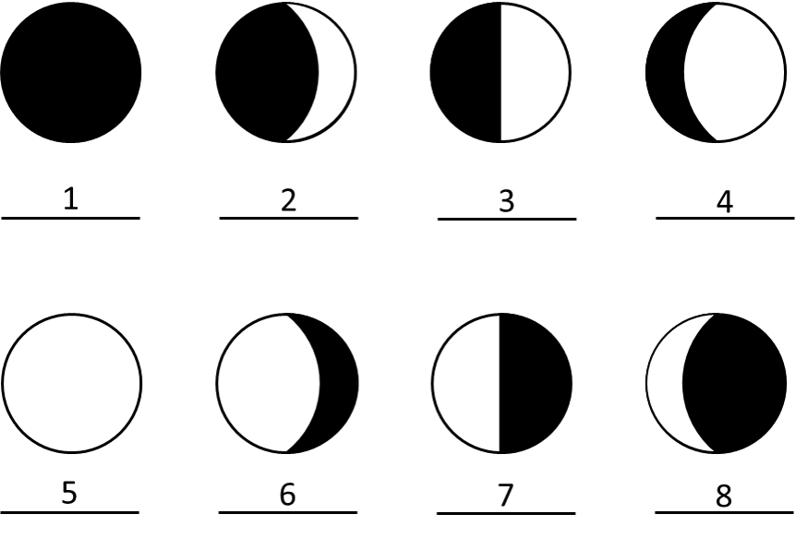
1. Identify the phase of the Moon for each case above.

Number | Moon Phase
1
2
3
4
5
6
7
8
Part 2: Observing the Moon
1. Find the Moon with your telescope and have your TA mark below. Make a sketch of the lunar surface as you see it though the telescope. Using the MoonGlobeHD app on the iPad (passcode=184756), identify and label some features that you can observe.
- In MoonGlobeHD, click the icon at the top left
  - For Viewpoint, make sure Earth Telescope is selected
  - If your telescope inverts/flips the image, click Orientation and find the option that correctly displays the view through your telescope
  - If the screen is rather bright, you can set Vision → Night Vision
TA

2. What is the current phase of the Moon? What side of the Moon is illuminated?
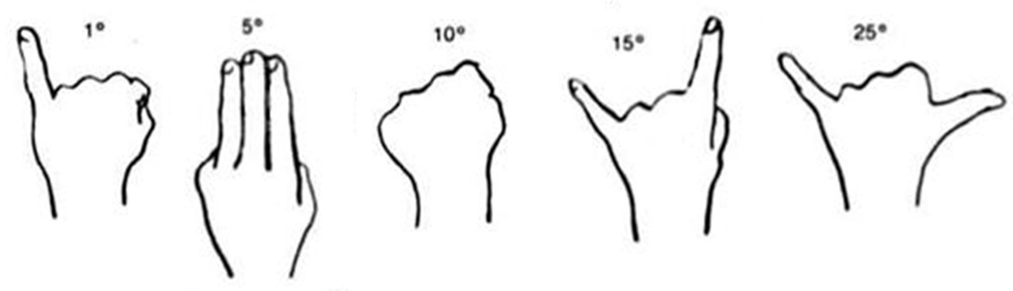
3. Estimate the azimuth, altitude, and angular size of the Moon.
Azimuth – angle around the horizon, starting from the North and increasing to the East. Ranges from 0° to 360°.
Altitude – angle above the horizon. Ranges from 0° at the horizon to 90° at the zenith.
Azimuth | Altitude | Angular Size
4. Given that the sky rotates 15° per hour towards the west, estimate the rise, set, and meridian transit times of the Moon. Explain how you arrived at your answers.
Part 3: Observing Planets & Stars
1. Find the following objects with a telescope and have your TA mark once complete. Also estimate the azimuth and altitude.
Note that not all objects may be visible; check with your TA about which objects to observe and where they are located. For * objects, see the next question.
Object | Azimuth | Altitude | TA
Venus*
Jupiter*
Saturn*
Mars
Albireo
Mizar-Alcor
2. In the space below or on the next page perform the following (if applicable).
- Draw the phase of Venus as seen through the telescope
- Draw the Jupiter system and label the moons (see Stellarium in the dome)
- Draw Saturn and any of its faint moons that you see

