WD: SAM stock assessment of Sardine in North west Africa

Benoit Berges^{1*}

¹ Wageningen Marine Research, The Netherlands

* benoit.berges@wur.nl

Input data and model configuration
The hereby document describes an exploratory assessment for Sardine in the North West Africa region. The various input data were taken from the FAO excel spreadsheet that contains information built over the years. In term of data, the Sardine in the North West Africa region is spread over 3 regions: region north, region A+B and region C. The north region only contains a small part of the stock yielding very small catches and is therefore not assessed.

The SAM model

Configuration options for the SAM model can be found here: http://www.nielsensweb.org/configurations.html

All the code developed is stored at:

Assessment results

Reference points

Short term forecast

(a)  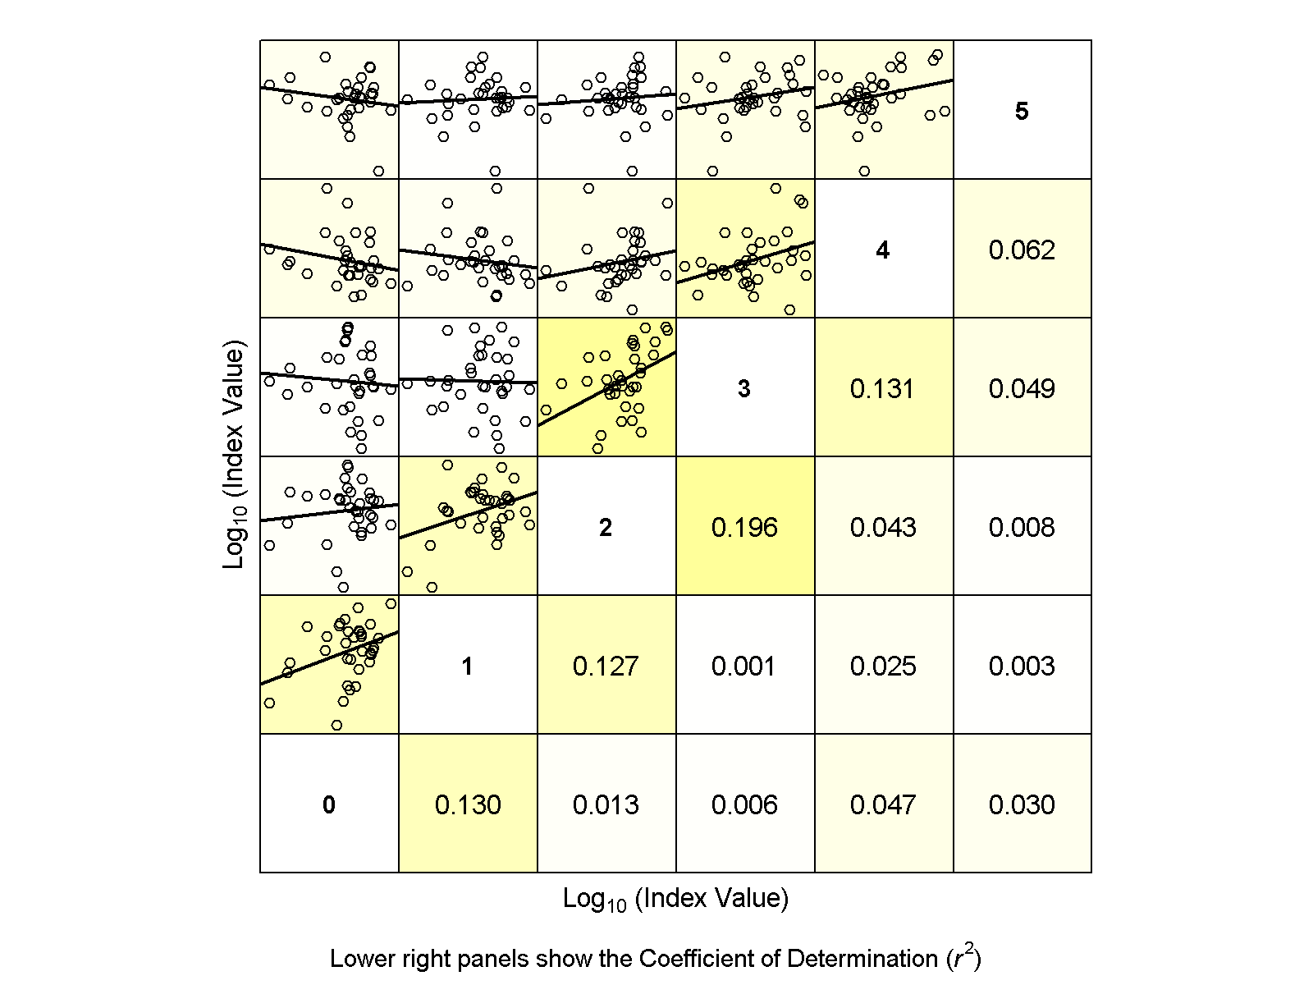 | (b)  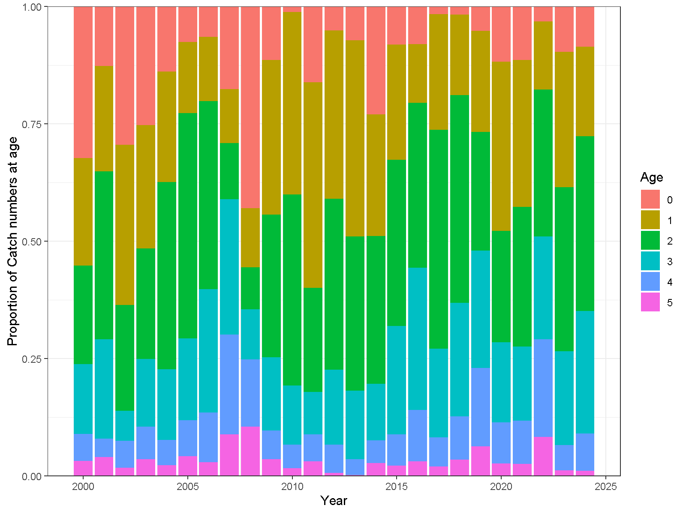
Figure 1: text

(a)  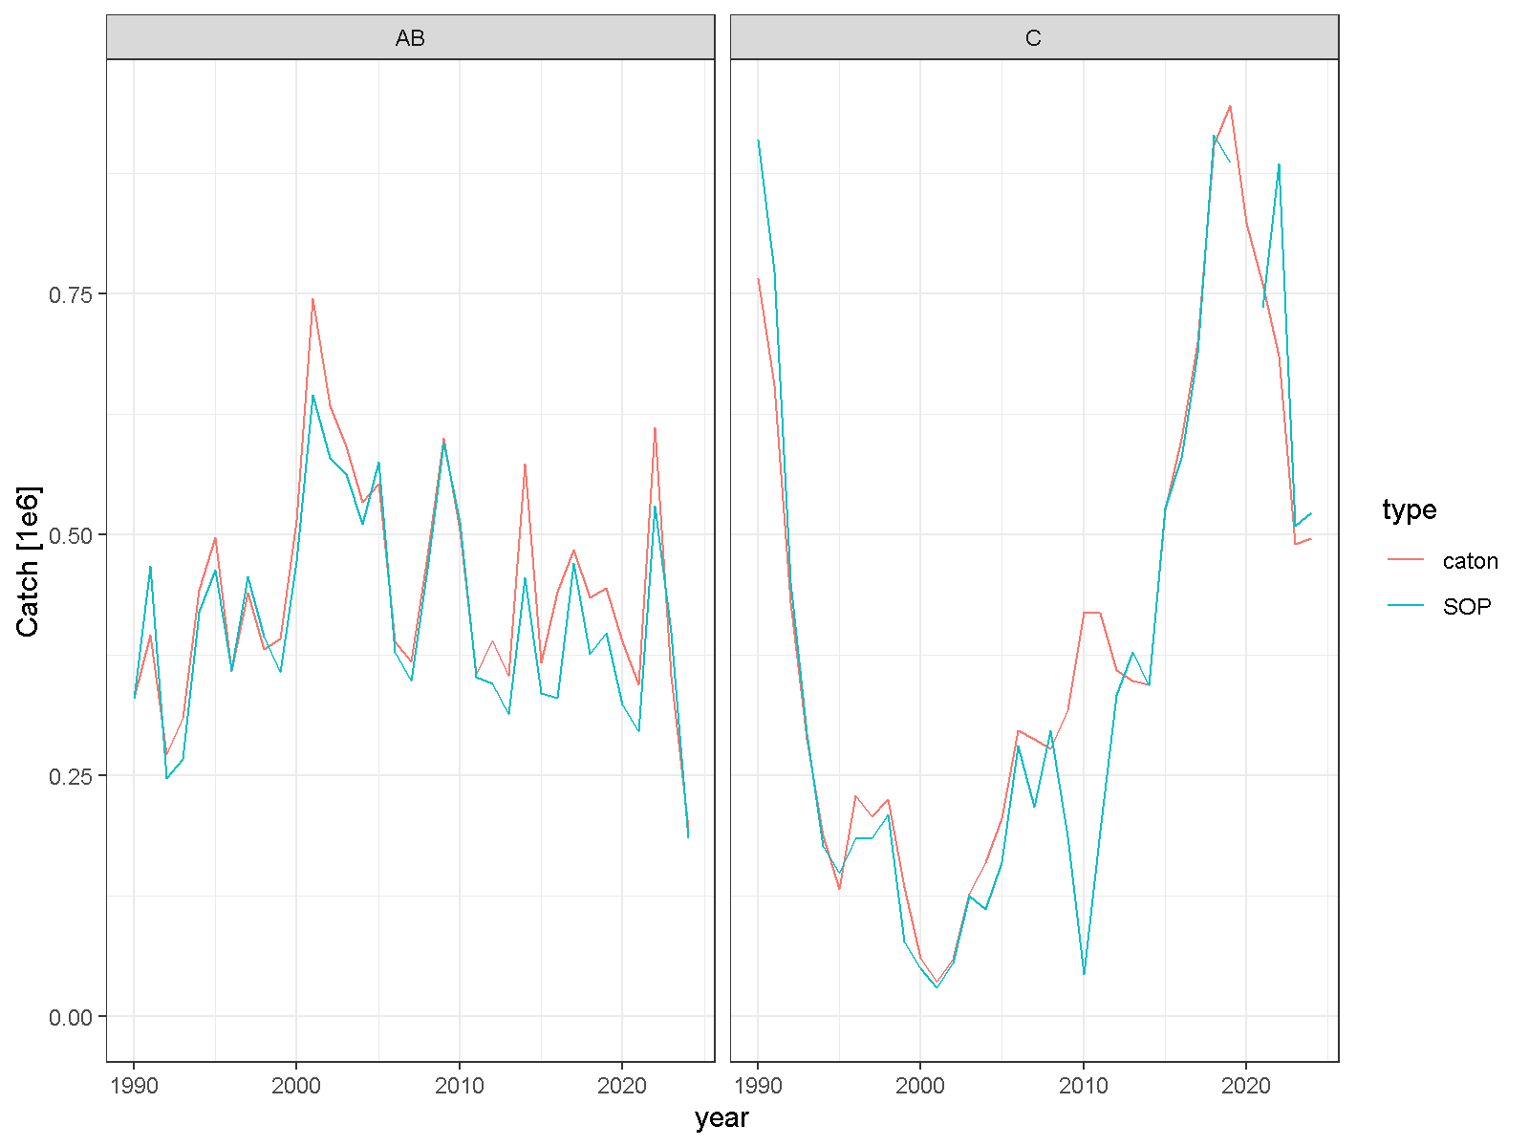 | (b)  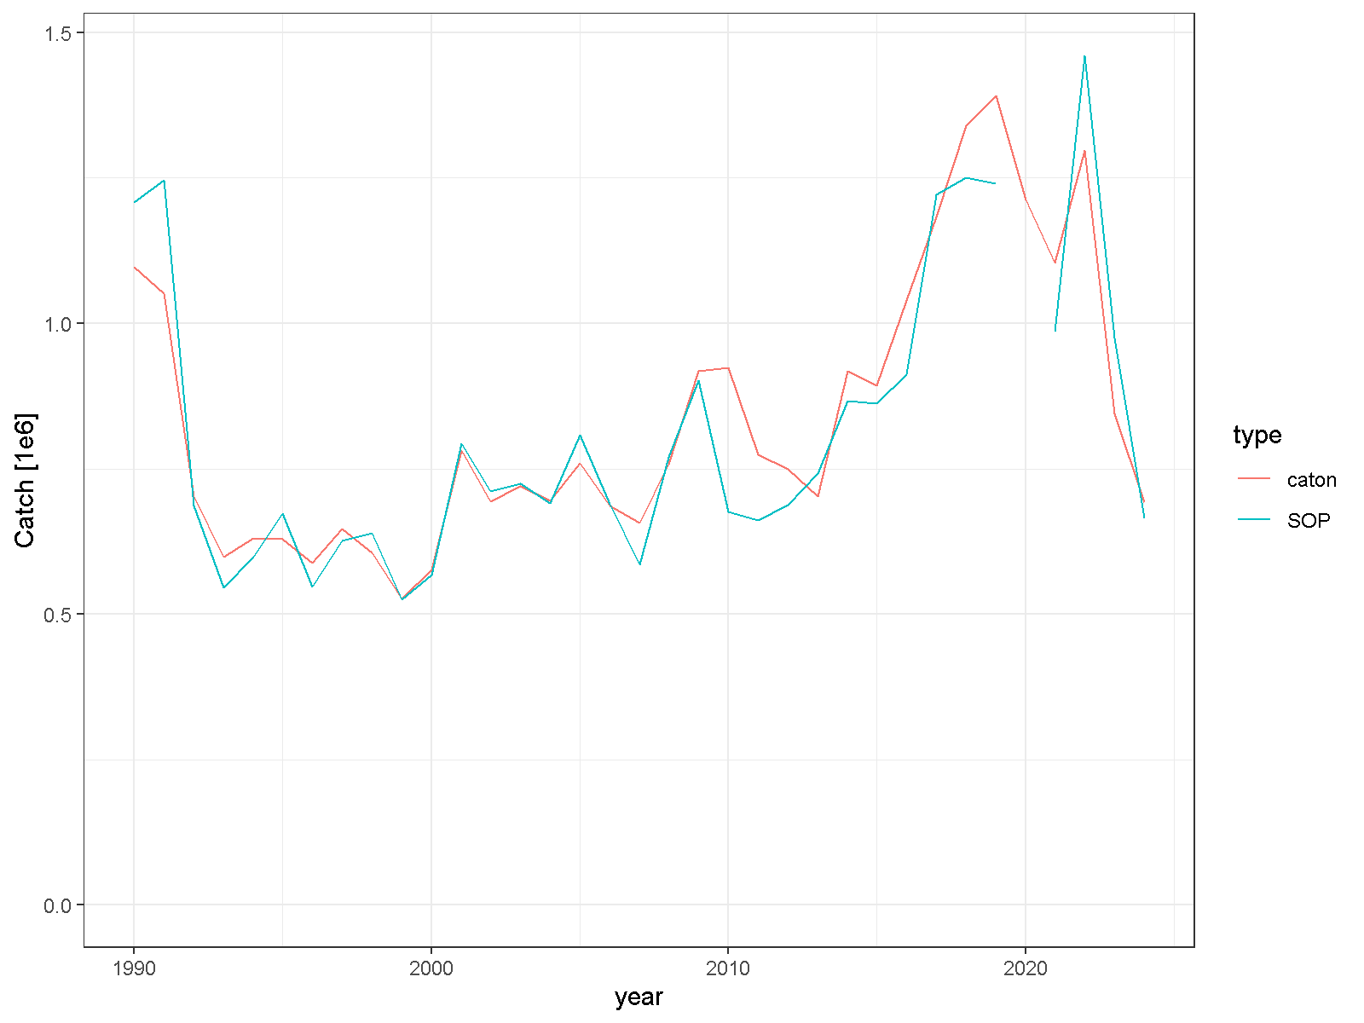
(c)
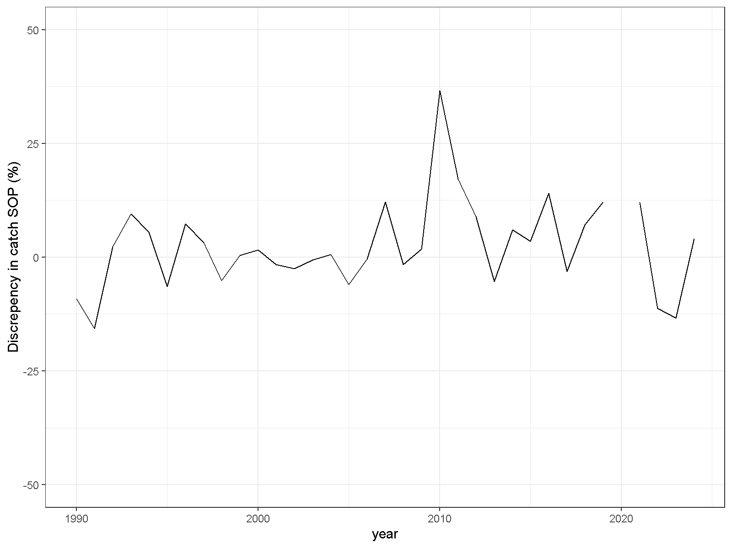
Figure 2: text.

(a)  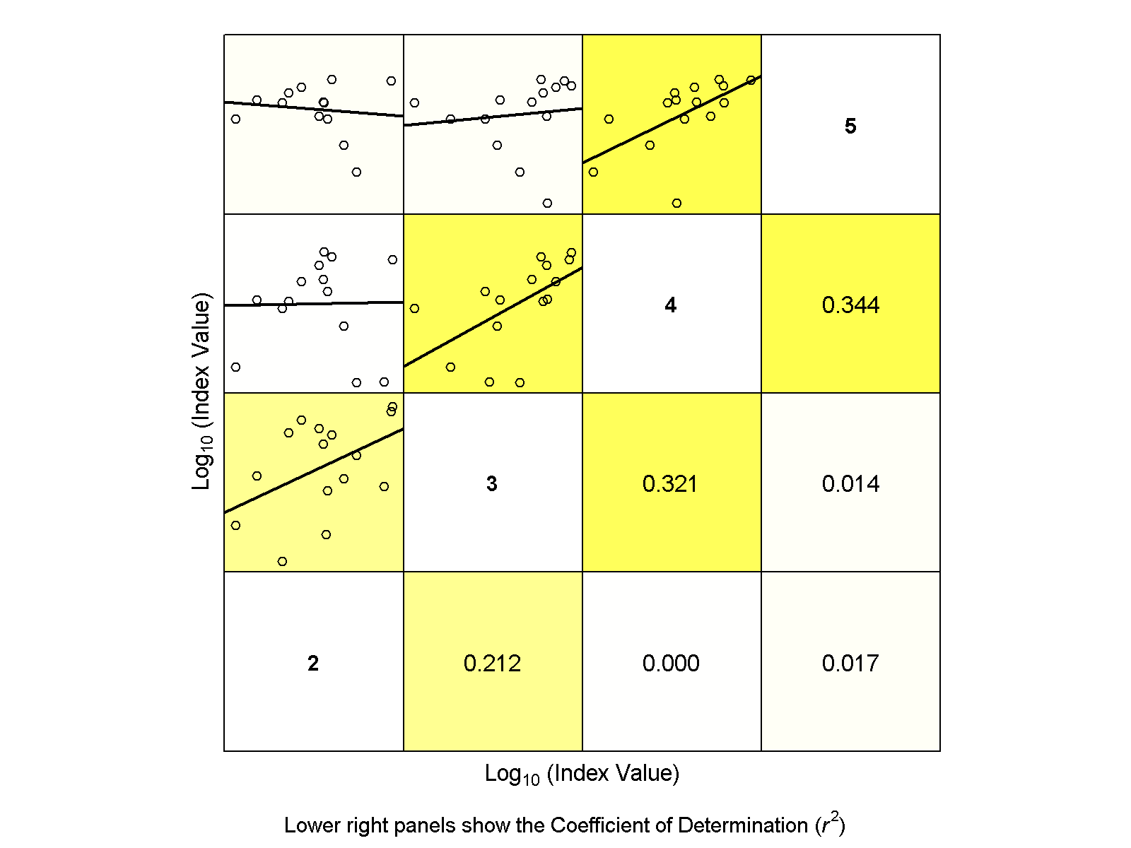 | (b)  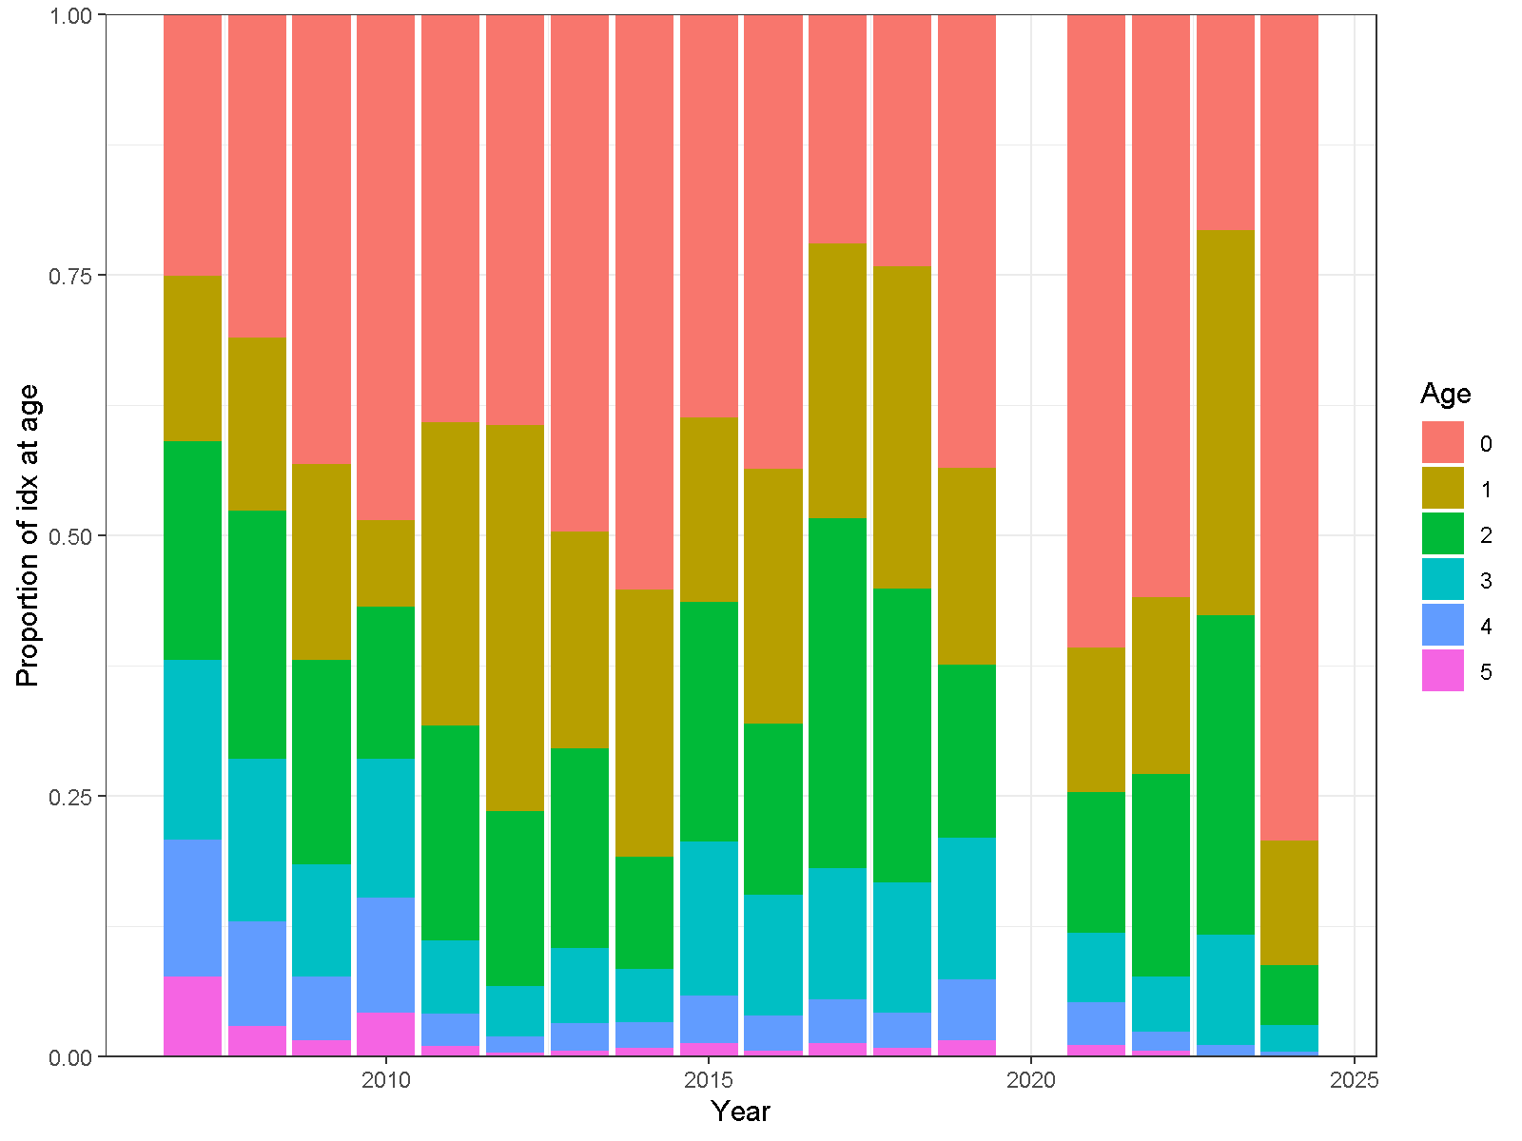
Figure 3: text.

(a)  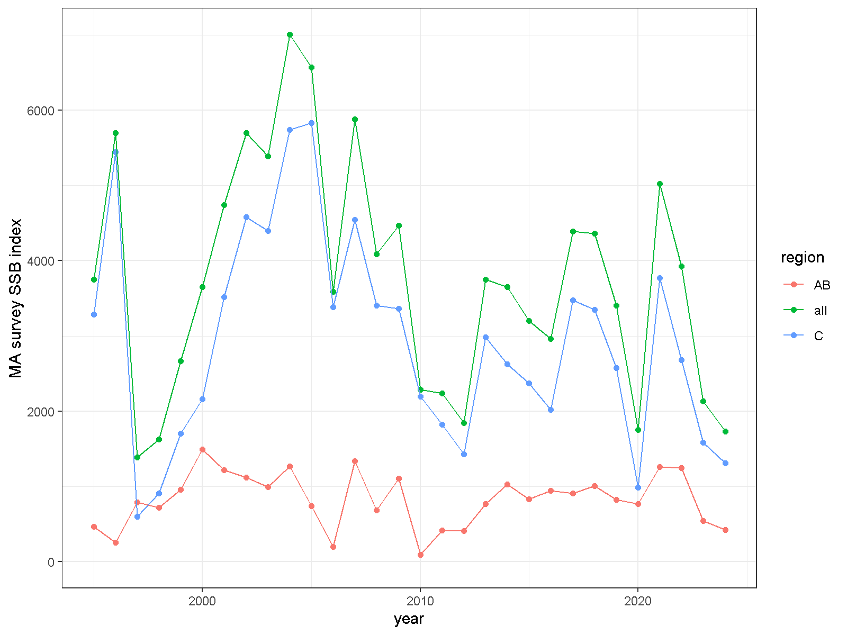 | (b)  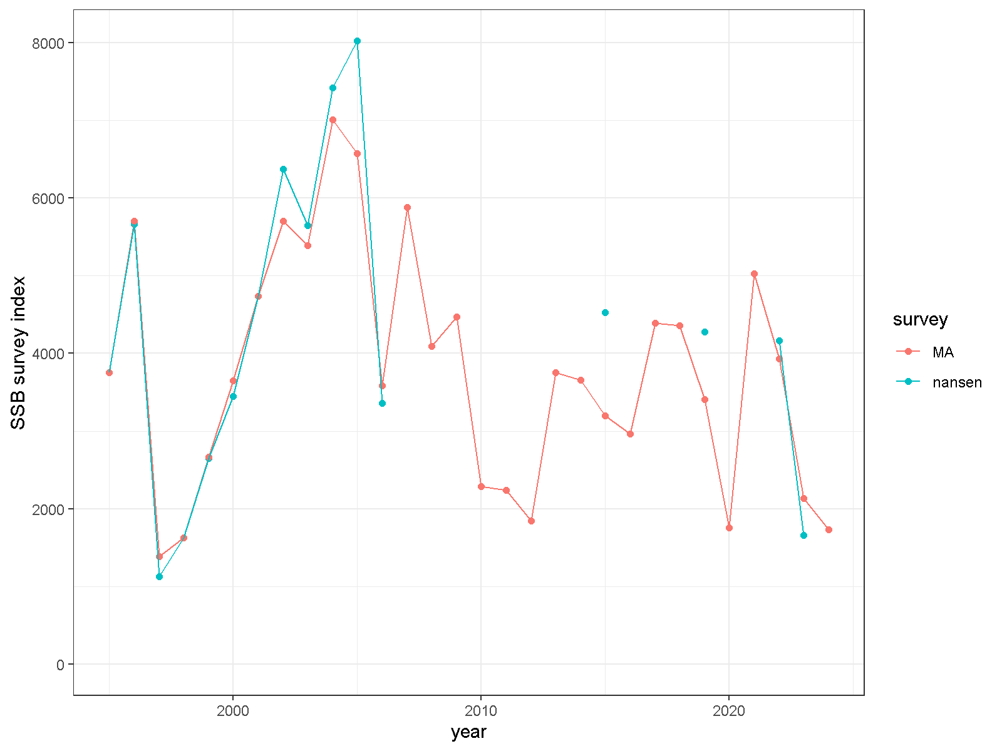
Figure 4: text

(a)  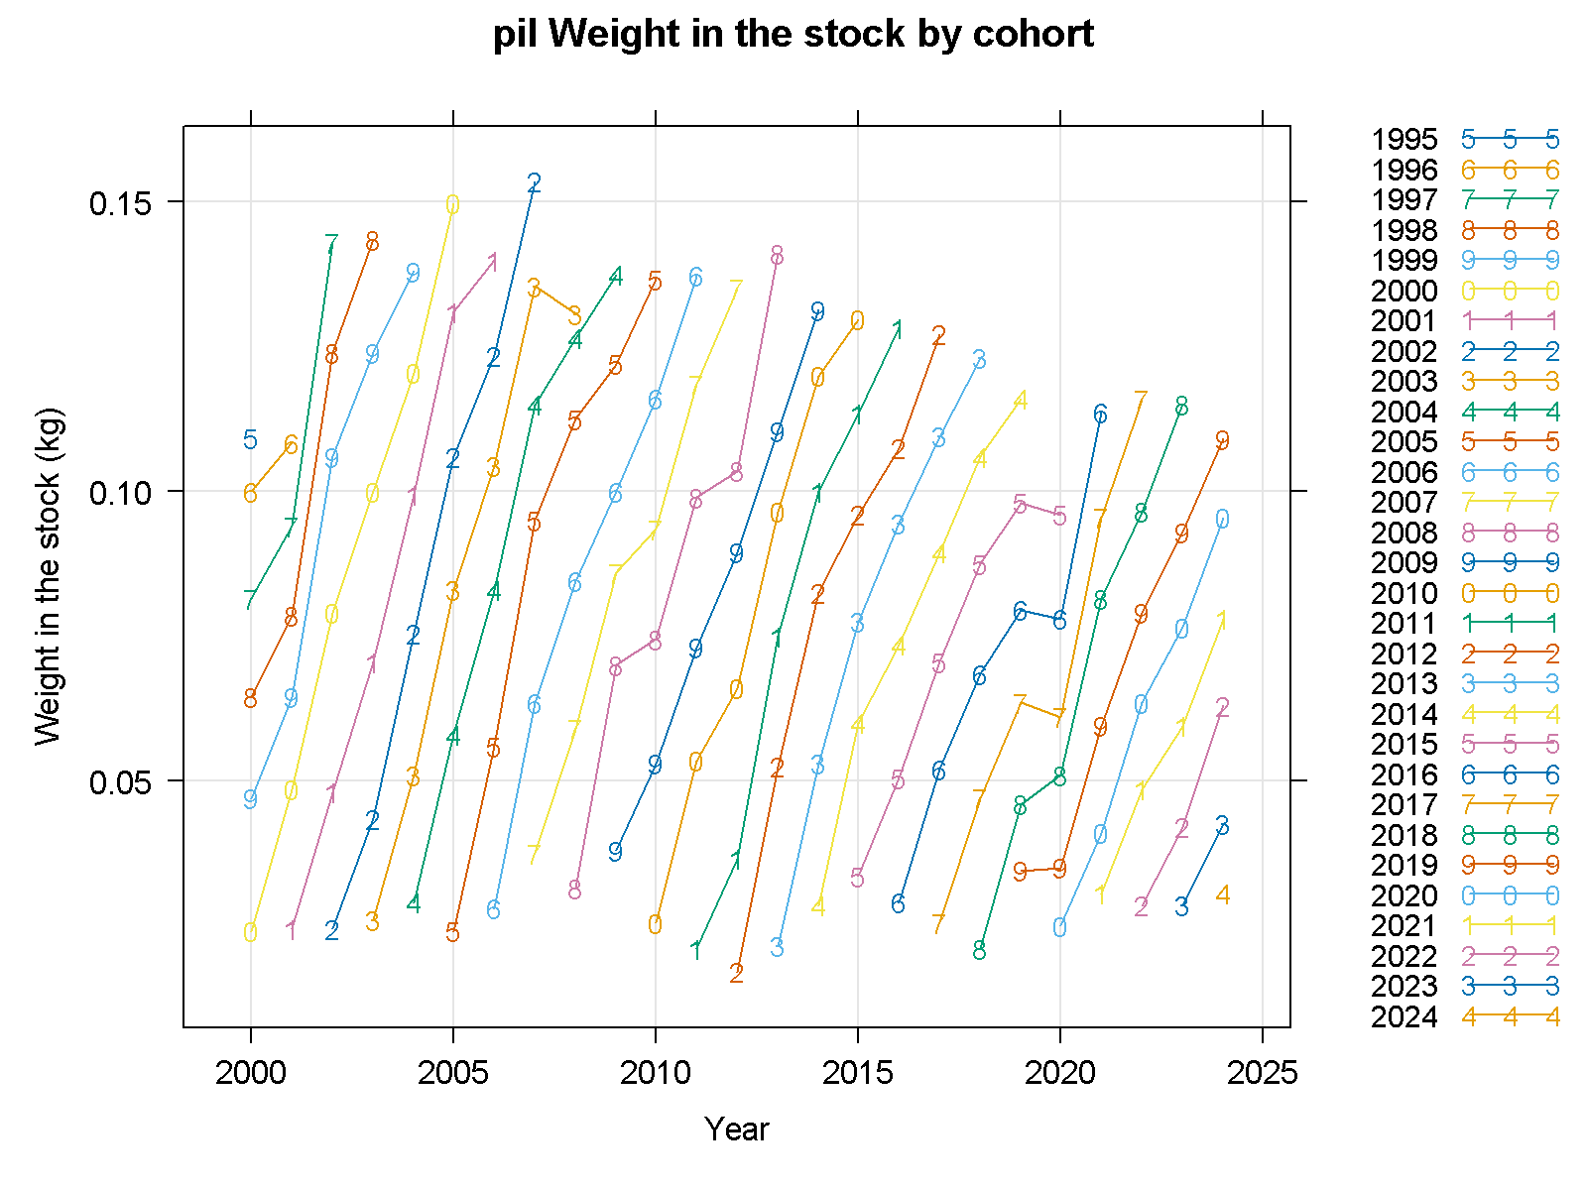 | (b)  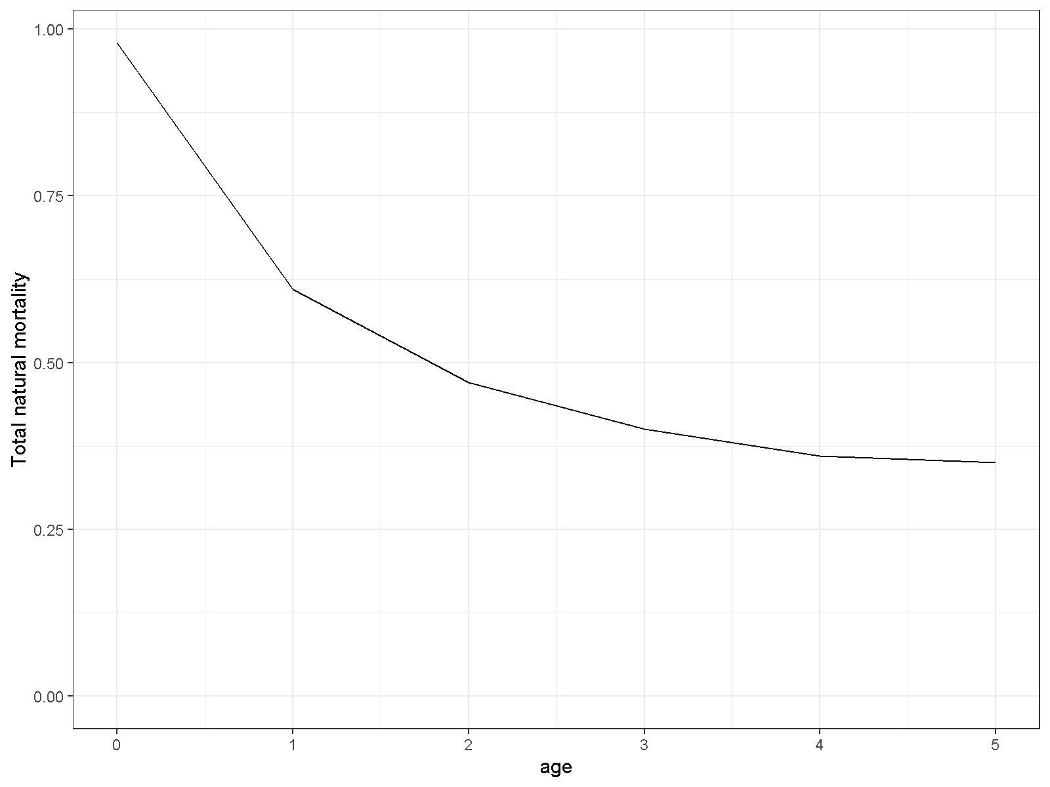
Figure 5: text

Figure 6: text

Figure 7: text

Figure 8: text

Figure 9: text

Figure 10: text

(a) | (b)
(c) | (d)
(e)

Figure 11: text

(a) | (b)
Figure 12: text

(a) | (b)
Figure 13: text

Figure 14: text

(a) | (b)
Figure 15: text

Figure 16: text

(a) | (b)
Figure 17: text

(a) | (b)
Figure 18: text. Region AB

(a) | (b)
Figure 19: text, region C.

Figure 20: text

(a) | (b)
(c)

Figure 21: text

