Modeling Connectivity
Modeling Connectivity Using Triangular Irregular Networks and Graph-Theoretic Algorithms
Benjamin D Be^{s}t*, Dean L. Urban
Nicholas School of the Environment and Earth Sciences
*Duke University, Box 90328, Durham, NC 27708-0328 USA. E-mail: bbest@duke.edu, Telephone: +1-919-613-8021, Fax: +1-919-684-8741.

Abstract
Quantifying connectivity between patches of habitat is important to the prediction of population viability, genetic exchange and spread of contagion. Here we describe a novel geospatial method for creation of a network to describe habitat patches and connecting corridors. The majority of conservation-based networks to date have been based on simple graph-theoretic structures to describe habitat patches as nodes and corridors as connected straight edges. We further discriminate between three node types (centroid, perimeter and matrix) as well as two edge types (interior and exterior). Only two inputs are required: polygons uniquely identifying habitat patches, and a raster of cost identifying resistance in dispersing over a given cell. The network is created by extraction from a Triangulated Irregular Network (TIN) representation of the cost surface accumulating away from patches. The resulting network has several major advantages over simpler approaches: the corridors are non-linear and shaped by the matrix (i.e. the cost-surface outside the patches), the functional distance (i.e. cumulative cost along a corridor) and spatial topology (i.e. geographical coordinates) are both preserved, and huge computational efficiencies are gained with least-cost path and other graph-theoretic algorithms over typical raster-based methods.
[ Should we mention the example area (Chapel Hill) and species (?) in abstract?]

Keywords: graph theory, connectivity, ArcGIS, triangulated irregular networks, TIN, conservation, ecology

Introduction
Corridors are important to biodiversity (Damschen et al. 2006) and population viability (?). Graph theory provides a useful framework for quantifying the relative importance of patches across a landscape (Bunn et al. 2000, Urban and Keitt 2001). The matrix matters (Ricketts 2001). [ Much more here…]

Methods

GIS Toolbox
Geographical information systems (GIS) are dedicated to modeling geospatial processes. Here we use the industry-leading commercial software ESRI ArcGIS [although could be replicated with open-source GRASS and Kepler projects]. With this software bundle comes several applications which enable easy reuse of the connectivity modeling tools. ESRI’s Model Builder allows you to drag tools from a toolbox and drop them into a model. You can similarly add input data and parameterize tools which can be successively connected. This allows for effective visualization of the modeling steps as well as easy replication of the analysis. This concept of scientific workflows makes these tools easily transferable to end-users with different analytical goals that may utilize common processes. So far we have packaged three tools: 1) Create Network, 2) Network Least-Cost Path, and 3) Network Centrality Metrics. (See Figure 1.)
[Use of TIN:
Nodes: centroid (within), patch perimeter, matrix
Edges: interior to patch, exterior to patch (matrix)
Patch simplification with BoundaryClean]
[NetworkX, Python]

Results
[Insert Results here]

Discussion
[Insert Discussion here]

Conclusions
[Insert Conclusions here]

Acknowledgements
[Insert Acknowledgements here]

Future Papers
These are regurgitations of recent graph group discussions, especially with Bronwyn and Dalia.
- MULTI-PATH. Run least-cost paths between all perimeter points in patches to all other patch perimeter points. Summarize patch-to-patch edge with distance vs. frequency histogram. Could further fit a cumulative distribution function (cdf) to the histogram and attribute with parameters of distribution (e.g. alpha and beta) and some measure of mean path length or overall frequency max. Results in a probabilistic, non-binary summary of graph. When multiplying together with animal dispersal density, the cdf will negate result (i.e. low probability of connection) when frequency is low and be non-limiting when high. The integral, or area under curve, could be used to determine based on some threshold whether to include in final graph as connected. Could scale a given edge based on maximum distance frequency across whole landscape. Introduce processes separate from graph creation/connections. Complexity of points to describe perimeter of patch could skew results (perhaps DENSIFY function to fix). Similarly apply measures of fragility/redundancy/etc in a probabilistic multiplicative manner.
- MULTI-SPECIES. Ecosystem-based management dictates we address the needs of multiple species at once. When analyzing connectivity, species-specific habitat needs will often define patches, ie nodes, differently as well as corridors, ie edges, based on differing dispersal abilities. One method for dealing with this problem is performing a geometric intersection of the habitat patches. Species-level attributes where present get assigned to all patches. Bisected patches will be given zero-length edges to immediate adjoining patches. All other edges will be attributed with applicable species attributes. Given different cost surfaces, edges between patches may have differing routes amongst species. If questions are about the important matrix features, redundant corridor segments may be a useful metric.

Literature Cited
Bunn, A. G., D. L. Urban, and T. H. Keitt. 2000. Landscape connectivity: A conservation application of graph theory. Journal of Environmental Management 59:265-278.
Damschen, E. I., N. M. Haddad, J. L. Orrock, J. J. Tewksbury, and D. J. Levey. 2006. Corridors increase plant species richness at large scales. Science 313:1284-1286.
Ricketts, T. H. 2001. The matrix matters: Effective isolation in fragmented landscapes. American Naturalist 158:87-99.
Urban, D., and T. Keitt. 2001. Landscape connectivity: A graph-theoretic perspective. Ecology 82:1205-1218.

Tables
[Insert Tables here.]

Figures
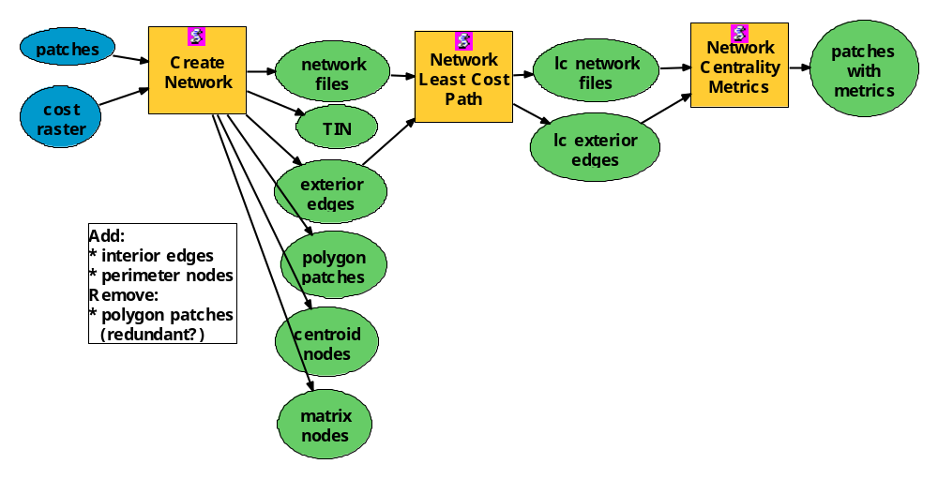
Figure 1. Scientific workflow within ESRI’s ModelBuilder demonstrating new tools (orange boxes) connected via original inputs (blue elipses) as well as derived inputs/outputs (green ellipses).
[ TODO: add interior edges and perimeter nodes, remove polygon patches. ]
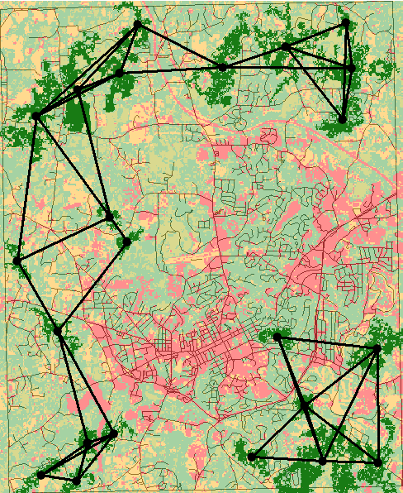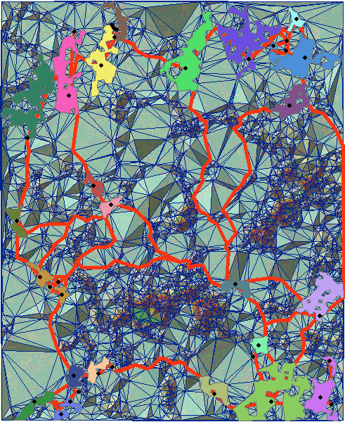
Figure 2. Traditional (left) and Novel (right) creation of conservation network connecting patches of habitat with corridors. Note the flat point and line representation in black on the left, versus the network on the right preserving habitat shape and corridor path.

