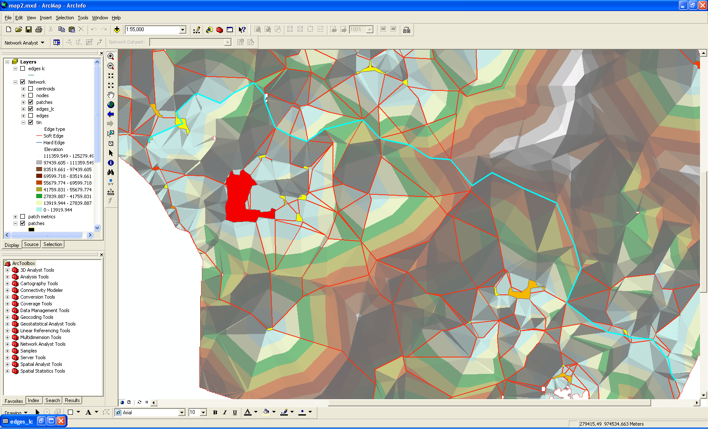

So why does path travel along high-cost ridge?
Yes, makes sense: imagine hiker traveling along, would otherwise have to go into valley

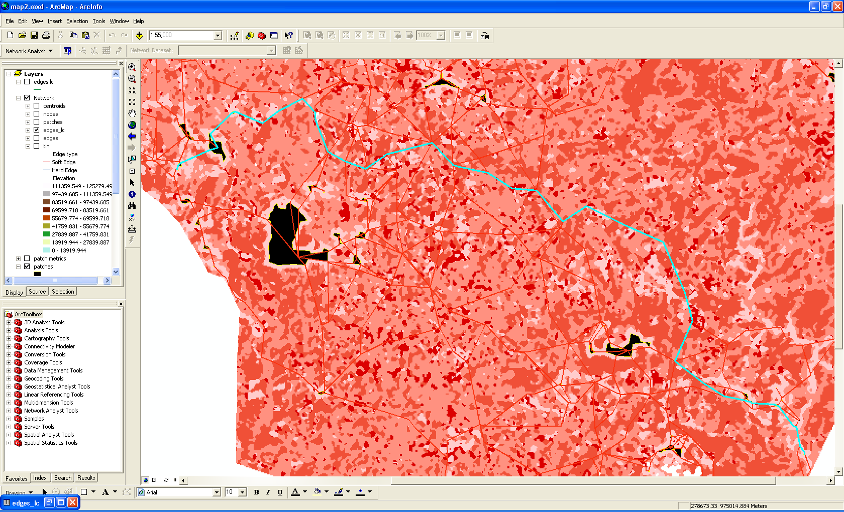

Actually, patch is surrounded by high cost surface so would be like dropping into a valley and having to still climb up the other edge.

Remove FID 15, Tag_Value 112
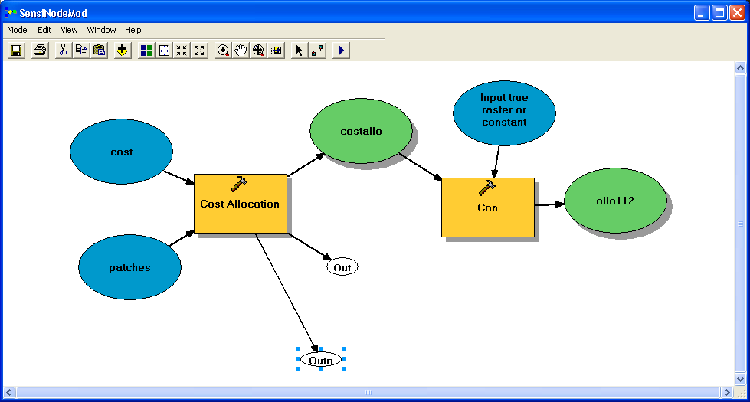

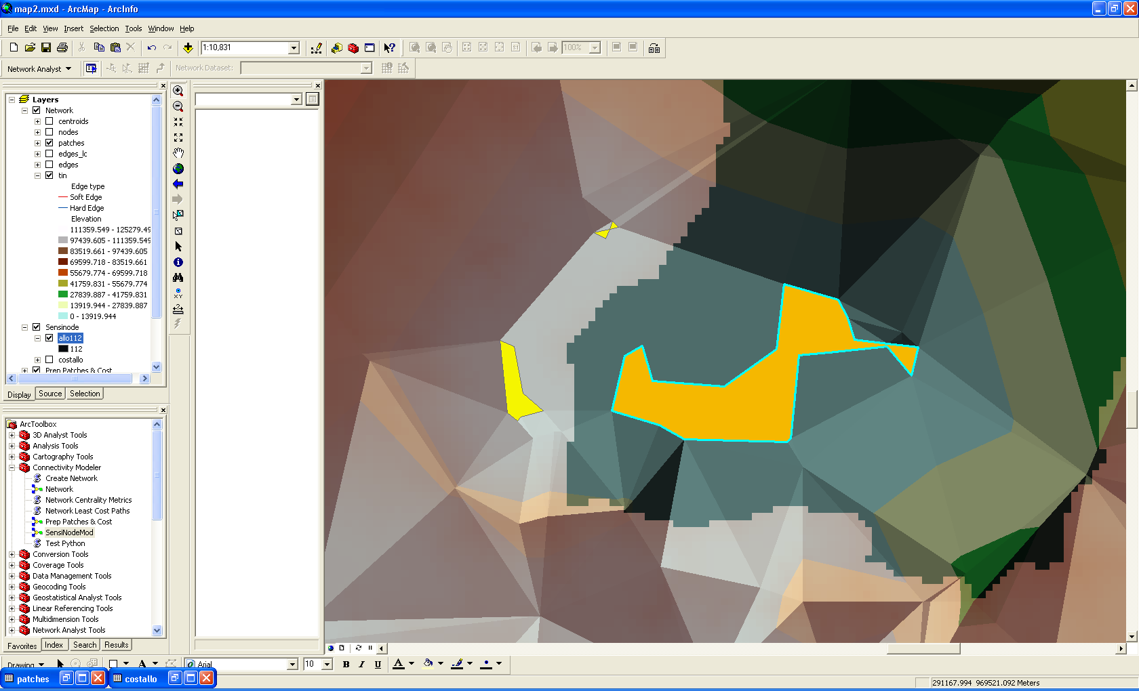

So we have the cost allocation telling us where the zone of influence for a given patch is at, ie where the ridge from which to invert (flip up, instead of down) exists. Now how do we create nodes, ie inflect ridge into TIN and add up values consistently?

