viz

Ben Best

April 16, 2016

## Load

* load libraries
* inspect

## Simple Scatterplot

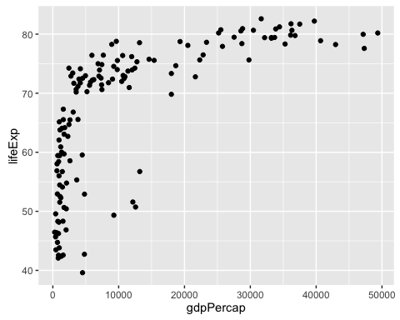

## With Aesthetics and Labels

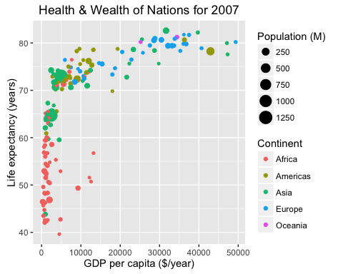

## Interactive