CMPUT-340
Brandon Best
Assignment 4
Exercise 1

Exercise 4

a)

Degree | Fitted Polynomial
0 | 5.5833
1
2
3
4
5

Here is a plot of the fitted polynomials at the given values of t:
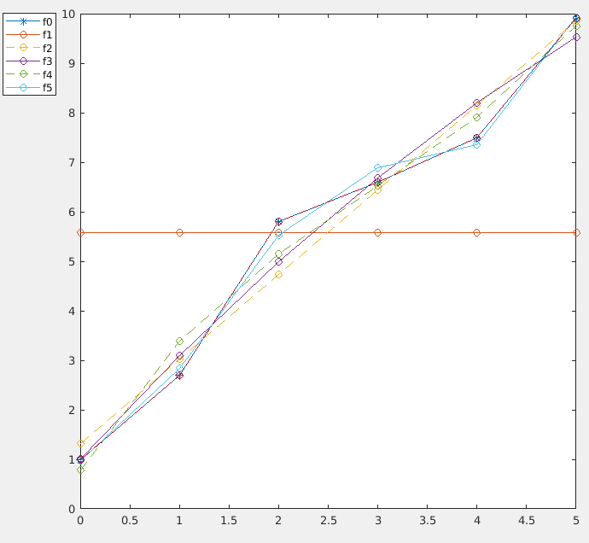

Polynomial | Derivative
 | 0

The higher the degree of the fitted polynomial the better the fit as seen from the plotted data. When comparing the slopes of the tangent lines given at each point from the derived derivatives from the above table and the approximate values from forward, backward, and central difference methods, the central difference method always had the most accurate results.

When the forward difference was off it was always below the actual derivative value by some difference say p. Interestingly enough when the forward difference method was not exact neither was the backwards difference method and that value was above the actual derivative value by the same difference p.

Exercise 5

