
Tribhuvan University
Faculty of Computer Science and Information Technology
Final Year Project
PROJECT TITLE: Tomato Care (Disease Classification using CNN)
In partial fulfillment of the requirements for the Bachelor's Degree in Computer Science and Information Technology (BSc. CSIT)
Submitted by:
Abishek Thapa (79010276)
Avisheak Shrestha Hemba (79010284)
Krish Sitikhu (79010301)
Submitted to:
Bhaktapur Multiple Campus
Department of Computer Science and Information Technology
Date of submission: May 13, 2026



Supervisor’s Recommendation
I hereby recommend that the project work entitled “: A Tomato Disease Classifier System Using Convolutional Neural Network” submitted by Abishek Thapa (79010276), Avisheak Shrestha Hemba (79010284) and Krish Sitikhu (79010301) of Bhaktapur Multiple Campus, Dudhpati, Bhaktapur is prepared under my supervision as per the procedure and format requirement laid by the Faculty of B.Sc. CSIT, Tribhuvan University, in partial fulfillment of the requirement for the Bachelor’s Degree in Computer Science and Information Technology (B.Sc. CSIT). I, therefore, recommend the project work report for evaluation

…………………………………
Mr. Surya Bam
Supervisor
Department of Computer Science & IT
Bhaktapur Multiple Campus



Letter of Approval
This is to certify that this project prepared by Abishek Thapa(79010276), Avisheak Shrestha Hemba (79010284) and Krish Sitikhu (79010301) entitled “Tomato Care – Disease Classification using CNN” in partial fulfillment of the requirements for the degree of BSc. CSIT has been well studied. In our opinion, it is satisfactory in the scope and quality of the required degree.

……………………………….
Mr. Sushant Paudel
Coordinator

……………………… ………………………………
Mr. Surya Bam External Examiner
Supervisor

ACKNOWLEDGEMENT
We would like to express our sincere gratitude to the Bhaktapur Multiple Campus for providing us with the opportunity to work on this project. We are very thankful for receiving valuable guidance, support, and encouragement from many individuals, and we would like to acknowledge their contributions. Most importantly, we would like to express our sincere thanks to our highly respected supervisor, Mr. Surya Bam, for his continuous support and insightful guidance throughout the journey of this project work. His expertise and valuable feedbacks have been very helpful in shaping our work. This project has been a wonderful learning experience where we got a chance to apply our knowledge into practical field and gained further learnings. At the end, we would like to express our sincere thanks to all the friends and others who helped us directly or indirectly during this project work.
With respect,
Abishek Thapa (79010276)
Avisheak Shrestha Hemba (79010284)
Krish Sitikhu (79010301)

ABSTRACT
It has always been an inconvenience for a farmer to identify different diseases and take preventive actions and cure against them immediately. Either due to the lack of extensive knowledge of Agriculture or unaffordability, farmers often struggle. There’s a need of such a reliable system for the disease classification that could also virtually support farmers in dealing with the above mentioned problems. This project focuses on the use of Deep Learning Convolutional Neural Network to address the diseases often occurring in tomato plants. This project aims to tackle this problem by providing feature of LLM integration that provides the symptoms, preventions and cure about the disease that has been detected by the scanning of the tomato leaf. Concerning the reliability and Support factors for farmers, the system provides rigorous Virtual community Chats and an extensive support to contact with the agro expert to consult about the disease. Our system keenly focuses on applying the Convolutional Neural Network model that has been trained with a large dataset to predict the disease in tomato plants accurately and side-by-side support the farmer with the features in the system mentioned above.
The primary objective of this project is to improve the quality of agriculture in agriculture dependent country like Nepal by leveraging the Artificial Intelligence technology alongside, encouraging the active participation of farmers. The system allows farmers to register and login into the system allowing them to upload tomato leaf’s image, get the disease class and supportive information about the disease including symptoms, preventions and cure. The virtual community platform allows the farmer to interact with other people regarding different issues related to the disease. On the other hand, an agro expert can register and login. This system aims to support the development or e-agriculture initiatives in Nepal.

Keywords: agriculture, convolutional neural network, farmer, tomato, virtual community

TABLE OF CONTENTS

Supervisor’s Recommendation i
Letter of Approval ii
ACKNOWLEDGEMENT iii
ABSTRACT iv
LIST OF ABBREVIATIONS vii
LIST OF FIGURES viii
LIST OF TABLES ix
CHAPTER 1: INTRODUCTION 10
1.1 Introduction 10
1.2 Problem Statement 11
1.3 Objectives 11
1.4 Scope and Limitation 12
1.4.1 Scope 12
1.4.2 Limitation 12
1.5 Development methodology 12
1.6 Report Organization 13
CHAPTER 2: BACKGROUND STUDY AND LITERATURE REVIEW 14
2.1 Background Study 14
2.2 Literature Review 15
CHAPTER 3: SYSTEM ANANLYSIS 17
3.1 System Analysis 17
3.1.1 Requirement Analysis 17
3.1.3 Analysis 21
CHAPTER 4: SYSTEM DESIGN 27
4.1 Design 27
4.1.1 System Architecture Design 27
4.1.2 Refinement of Class Diagram, Sequence Diagram, Activity Diagram 28
Figure 4.2 Refinement of Class Diagram 28
4.1.4 Deployment Diagram 35
4.2 Algorithm Detail 36
CHAPTER 5: IMPLEMENTATION AND TESTING 41
5.1 Implementation 41
5.1.1 Tools Used 41
5.1.2 Implementation details of Modules 42
5.2.1 Test Case for Unit Testing 54
5.2.2 System testing 58
5.3 Result Analysis 59
CHAPTER 6: CONCLUSION AND FUTURE RECOMMENDATIONS 61
6.1 Conclusion 61
6.2 Future Recommendation 61
REFERENCES 62
APPENDICES 63

LIST OF ABBREVIATIONS

CNN | Convolutional Neural Network
ANN | Artificial Neural Network
ADAM | Adaptive Momentum Estimation
LLM | Large Language Model
OTP | One Time Password
API | Application Programming Interface
ORM | Object Relational Mapper
OS | Operating System
SQL | Structured Query Language
GPU | Graphics Processing Unit
IDE | Integrated Development Environment
DOS | Denial of Service
HTTP | Hypertext Transfer Protocol
REST | Representational State Transfer

LIST OF FIGURES

LIST OF TABLES

CHAPTER 1: INTRODUCTION

1.1 Introduction
In today’s world, Agriculture has been a must considerable sector due to its vital role in human survival, nation’s economy and country’s development. In Countries like Nepal which greatly depends upon Agriculture for its sustain and economy, it is very important to work for increasing the productivity and quality of crops. Tomato is one of the widely consumed vegetable crop in Nepal. Farmers often bears loss in Tomato Cultivation due to the diseases often affecting the tomato plants and significantly affecting productivity and quality. Identifying these diseases at early stage and taking proper actions could solve the problem however, it requires expert knowledge, which is not accessible to farmers, especially in rural areas of Nepal. People still use local techniques as to tackle with the diseases in tomato plants and could barely visit to the agro center to consult with an agro expert. This becomes expensive, slow and inefficient way.
To address this issue, the project proposes the development of a CNN based Image Classification System that identifies diseases in tomato plants from leaf images and helps in early diagnosis and treatment of the disease. The system uses the concept of Deep learning and through the use of Convolutional Neural Networks, the system predicts the disease for the current image of tomato plant leaf and delivers possible symptoms, prescriptions and related disease image sets from previously classified images from other diseases. By providing an interactive web interface between a user and agro expert, the system improves the reliability of the system.
The proposed system leverages the Convolutional Neural Networks concept and algorithms along with the Large Language Models to generate the respective symptoms and prescriptions based on classified diseases. A feature of Virtual Community platform within a system supports collaborative ideas and information sharing between different people associated to the same domain of agriculture. This technology further helps in increasing awareness, decision making and knowledge broadening in farmers. The system will contribute to more efficient way to tackle with the diseases in tomato plants and significantly increases the productivity and quality leading farmers to the profit zone.

1.2 Problem Statement
The Manual Plant disease detection methods are time-consuming, inefficient, and less reliable and often it is not possible to regularly visit the agro expert every time for solving the issues of diseases in plants. Especially, in the rural areas of Country like Nepal lacks the transport facility, laborites, and equipment to identify the diseases in plants like tomato. Traditional disease detection techniques, such as visual inspection are susceptible to errors and often require a team of experts. Reaching agro expert with samples on regular basis has also been an inefficient way. It has been time consuming, expensive and less affordable by most of the farmers. The Current Situation lacks the virtual community platform where people with the same domain of agriculture could discuss, share ideas and information and support each other in decision making to enhance the agriculture productivity and quality
Moreover, early disease detection is essential to control and prevent the disease in tomato plant, which traditional technique cannot guarantee. Farmers are to be supposed to get the knowledge about the disease they have identified, their symptoms and possible prescriptions to solve this issue. Therefore, there is a need for an accurate, efficient , and automated disease detection approach for tomato plants that can provide early detection and effective prevention with certain features where farmers can virtually consult with and agro expert through a web interface and a virtual community where different people with the same domain share ideas and information.

1.3 Objectives
The project seeks to achieve the following objectives:
- To develop a CNN model that can accurately detect and classify common tomato leaf diseases, such as two spotted spider mite, late blight mold, bacteria spot, target spot, yellow leaf curl virus, mosaic virus, leaf mold, septoria leaf spot, early blight.
- To contribute to sustainable agriculture by providing a cost-effective, automated solution to identify tomato leaf diseases at an early stage, their symptoms and prescriptions thereby enabling farmers to take preventive measures and reduce crop losses.
- To provide a user friendly web interface for the communication between a farmer and an agro expert to consult and follow up eliminating the needs of physical visit to the agro expert.
- To contribute towards the awareness, knowledge and help in decision making for the farmers in different situations regarding the diseases types, their home remedies, additional symptoms etc. by providing a virtual platform for discussion in real time.

1.4 Scope and Limitation

1.4.1 Scope
- User can simply upload the image of tomato leaf to get disease and derive additional information about the disease
- Can support the real time chats between farmers, farmer and agro expert.
- Allows reactions in the posts posted by farmers in the forms and likes and dislikes.

1.4.2 Limitation
- The system could only classify disease for tomato plants.
- The accuracy of our system greatly depends on the size and quality of training dataset
- The real time communication between agro expert and farmer is possible only when both have active Internet Connection
- The system may classify wrong results for the given input image in case it has low quality; often characterized as blurry images.
- The system doesn’t imply the proper rules, constraints and restrictions in virtual community chats.
- It doesn’t cover all kinds of diseases that occur in tomato plants.

1.5 Development methodology
For our project, we employed the agile model, as it enables us to develop our work in a repeatable and flexible manner, continuously improving throughout the process. The working mechanism of agile development for a Disease Classification System involved iterative development, continuous feedback from mentors and supervisors, and frequent delivery of small, functional increments.
Our team collaborated within the agile framework, specifically using SCRUM, to manage tasks such as data collection, data preprocessing, model training, and performance evaluation. Regular sprints during the process, along with gathered feedback and reflection, ensured that the proposed system aligns closely with user needs and provides tangible value.

1.6 Report Organization
This report has been organized as per the guidelines provided by TU. The report is separated into Different chapters. Each chapter consists of various sub-chapters with its content. The preliminary section of the report consists of a Title Page, Acknowledgments, Abstract, Table of contents, and List of Abbreviations. List of Figures. The main report is divided into 6 chapters which include:
- Chapter 1: Introduction
It consists of an introduction and background of the project, its objective, scopes, and limitations. This gives a general overview of the whole project and its focus points.

- Chapter 2: Background Study and Literature Review
Studying the existing situation and setting in which the system will be implemented is part of it. It comprises, among other things, an analysis of the prevailing patterns, human preferences, the systems in place, and potential areas for development.

- Chapter 3: System Analysis
It includes database design, activity design, and system design with architecture and all required diagrams.

- Chapter 4: System Design
It contains the project's summary, background, objective, scope, and limitations. This is a general overview of the project's goals.

- Chapter 5: Implementation and Testing
It includes data about the many design and development tools that were employed, as well as information about how the modules were put together and presented as function and class code samples. A number of test cases are listed here.

- Chapter 6: Conclusion and Future Recommendations
It displays the project's completion along with potential improvements for the project's future.

- References:
It contains the citations to the books we have read about the software development process.

- Appendices:
It includes images from our projects that highlight their usefulness and provide examples of the suggestions.

CHAPTER 2: BACKGROUND STUDY AND LITERATURE REVIEW

2.1 Background Study
For a developing nation like Nepal, there’s a great role of agriculture to sustain people’s life. However, plant diseases significantly affect the crop yield and quality. All over the world, Tomato is cultivated widely and for Nepal, one of the economic crop. According to the Agriculture Ministry, Nepali farmers cultivate tomatoes across an area of over 22,000 hectares and produce over 400,000 tons annually. In 2021/22, Nepal produced 422,703 tons of tomatoes on 22,911 hectares. [1] Farmers often bear economic loss on tomato cultivation due to diseases affecting tomato plants and farmers lacking the proper knowledge. That’s why identifying diseases at an early stage becomes vital for effective prevention and curing.
The traditional way of detecting the diseases on manual observation by farmers or agricultural experts is time-consuming, costly, and sometimes inaccurate. The advancement in Artificial Intelligence has touched the Agriculture sector. In Particular, Convolutional Neural Network (CNN) has proven to be highly effective in image classification. Convolutional neural networks are deep learning algorithms that can train large datasets with millions of parameters, in form of 2D images as input and convolve it with filters to produce the desired outputs. [2] CNNs have been particularly successful in image recognition tasks, achieving state-of-the-art results on several benchmarks. Their success is due to their ability to capture spatial features and patterns in images by using a hierarchical architecture of layers that perform convolution operations and extract features at different levels of abstraction .[3]
The background study clearly highlights the need of an intelligent system in the agriculture sector that identifies the disease in tomato plants and supports farmers by providing seamless interaction with an agricultural expert that’s fulfilled by the proposed system.

2.2 Literature Review
More recent research has utilized various established methods and techniques for plant disease identification utilizing machine learning and deep learning techniques. Older approaches utilized K-means and artificial neural networks (ANNs) for feature data extraction and classification. These traditional methods often use manual feature engineering, whereas deep learning-based models provide much better classification accuracy and are also more efficient relative to traditional approaches.
With the rise of new technologies in relation to machine and deep learning there is now a shift to utilize deep learning based models for image-based analysis of plant disease identification, particularly in using convolutional neural networks (CNNs), which have been shown to outperform both of those approaches mentioned above because of CNNs automatic ability to recognize and extract features from images.
One study that utilized CNN techniques on embedded low-cost hardware (OPENMV CAM H7 PLUS) was written in the journal HardwareX [4], where a low power and memory efficient CNN model was developed for the purpose of detecting plant diseases; it performed with high accuracy levels, while being able to perform quickly, demonstrating that it is viable to deploy CNN models on constrained resource embedded hardware.
Yang Li et al. [5], proposed an intelligent pest recognition system that was using CNNs and triplet loss/information to perform feature extraction using few-shot learning based methods. This research indicated that many times when you have very limited training data you can classify correctly most of the time if you use the right algorithms and hardware (substantial embedded systems) to run these algorithms on for real-time processing.
Brahimi et al. [6] investigated 14,828 images of tomato leaves infected by nine different diseases. By focusing on localized diseased regions of the leaves and leveraging a comprehensive dataset, their CNN model achieved an impressive accuracy of 99.18%. This study showcased the high potential of deep learning models in accurately identifying and classifying plant diseases.
Kumari et al. [7] proposed a two-step approach for leaf disease detection, involving feature extraction using K-means clustering and disease classification using an artificial neural network. The study demonstrated the effectiveness of this method in accurately identifying leaf diseases, contributing to improved accuracy and efficiency in disease detection systems.
Kumar et al. [8] focused on disease detection in coffee plants using a convolutional neural network (CNN). By training the CNN on a dataset of coffee leaf images, the authors achieved significant accuracy in disease detection, highlighted the potential of CNNs in automated diagnosis systems for plant diseases.
Therefore, most of the papers revealed the fact that different image classification systems exist for the disease detection in plants and they have remarkable accuracy in performance. They highlight the maximum leverage of Deep Learning in the agriculture sector. However, the study shows that there still lacks a complete system that could be made applicable in the real world agriculture to solve the current problems. Our proposed System ‘Disease Classifier in Tomato Plants’ fulfils this gap by introducing some beneficial features to make it more applicable. The use of Large Language Models to generate the feedbacks about the detected disease helps farmers gain further ideas and information about the diseases in Tomato plants and take preventions and treatments. A web interface for the communication with an agro expert and the digital platform to share and discuss ideas among various people related to the agriculture makes our system unique and more applicable oriented. Thus the CNN architecture is designed and developed from scratch such that the model maximizes its performance.

CHAPTER 3: SYSTEM ANANLYSIS

3.1 System Analysis
System analysis presents the analysis of the proposed system (i.e; Tomato Care), focusing on identifying system requirements, evaluating feasibility, limitations, and scopes. System analysis helps us operate within defined boundaries while achieving the specified objectives. The system analysis process involves several key activities, including defining system objectives, gathering user requirements, selecting appropriate technologies, training classification models, and designing an intuitive interface. These steps ensure that Tomato Care assists farmers by accurately classifying the tomato leaves with its disease class and connecting them with agricultural experts.

3.1.1 Requirement Analysis
Requirement analysis for Tomato Care was conducted through various observations, consultation with actual farmers, experts and other related domain individuals. The system requirements were identified based on the need to assist farmers in detecting tomato leaf diseases and providing timely expert consultation.
The analysis focused on identifying the functional requirements, as well as non-functional requirements like system performance, usability, and security needs. Special attention was given to ensuring that the system remains simple and accessible for farmers with limited technical knowledge.

- Functional Requirements
- Disease Classification: Farmers and experts can upload a tomato leaf image in a trained model, which results in the correct disease class along with the disease description, cause and prescription.
- Expert Consultation: Framers can query with approved experts for more discussion related to the disease and its causes.
- User Management: Users can register the account along with the roles like farmers, expert or admin, providing the controlled system access.
- Community Discussion: Users can post the queries in the community section, comment the post, reply the comments etc.

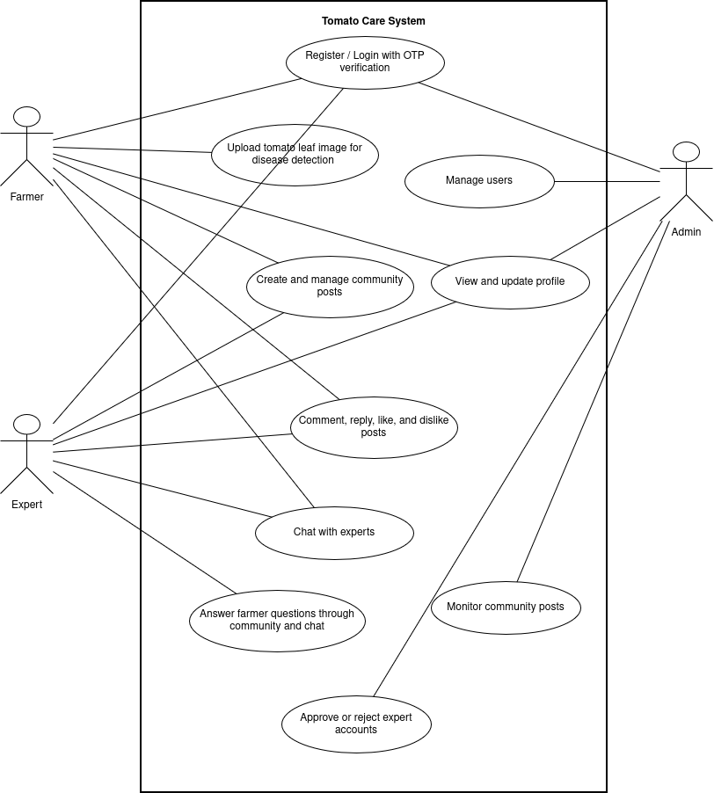
Figure 3.1: Use Case Diagram of Tomato Care
This Use Case Diagram represents a high level, visual overview of Tomato Care System. The interactions between the System and its actors are illustrated in the figure.
The farmer can register and login in the system after verification of OTP. Several functionalities such as uploading the tomato leaf for detecting the disease, creating and posting various posts in community, reacting to the posts, chatting with the experts, are done by farmer. An expert can also perform same functions whatever a farmer could. On the other side, an admin registers and login, Manage users, view and update profile, monitor community posts and approve or reject the expert account requests providing the greater level of access privilege.

- Non-Functional Requirements
- Security : The system implements authorization, authentication, cryptographic hashing and OTP based email confirmation to ensure data protection and controlled access
- Performance: System returns image classification result within the second, while handling multiple concurrent users.
- Usability: The system has interactive user interfaces and is easy to use, supports multiple image extensions for classification.
- Reliability: System implements API rate limit, reducing the chance of DOS attacks, use of short lived access token reducing the chance of impersonating.

3.1.2 Feasibility Analysis
- Technical Feasibility
TomatoCare project is technically feasible based on the utilization of the popular development frameworks Fastapi and Nextjs. These frameworks provide well-documented materials and have wide developer’s community. Besides, these technologies are lightweight and provides extensive support that avoids the hurdles in the development process.

Hardware requirements:
- A computer with a minimum 8GB RAM and a multi-core processor
- Dedicated GPU of at least 8GB RAM
Software requirements:
- Operating System: Windows 10/11 or Linux.
- Web Browser: Chrome, Firefox, Brave, or Microsoft Edge.
- Python 3.6 or above: Required to run FastAPI and various Python libraries used in the project.
- FastAPI Framework: Used to build the web application and API for the system in the backend.
- NextJs Framework: For developing the frontend using TypeScript/JavaScript.
- Database: postgresql for storing users data and other information
- Development Tools: Visual Studio Code for coding and debugging.
- Version Control: GitHub for managing source code and collaboration.

- Operational Feasibility
The proposed project, TomatoCare, is designed to be user-friendly and highly accessible. The system provides smooth, and easy navigation for the users for the role of both farmers and Agro experts ensuring effortless access. The system keeps everything simple and easy for users to operate. People familiar with normal common websites or social media can navigate the platform effortlessly, eliminating the need of any specialized training.

- Economic Feasibility
The system will be built mostly using the open source softwares and tools that are freely available in the Internet. No additional costs will be needed for the development tools, database, and storage. So, the project is estimated to be completed within low budget and hence is economically feasible as per the current circumstances.

iv. Schedule
Schedule were managed by using Gantt’s Chart which is illustrated below:

3.1.3 Analysis
- Object Modeling using Class Diagram

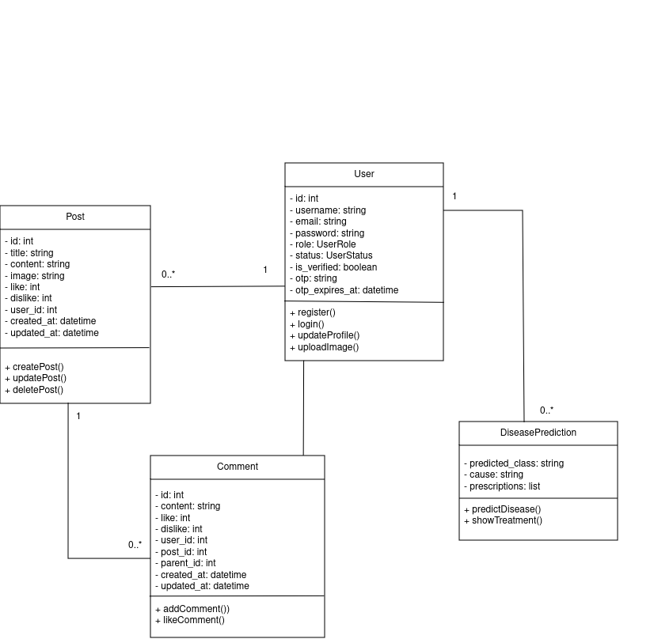

Figure 3. 2 Object Modeling Diagram Using Class Diagram
The above figure 3.2 represents class Diagram of Tomato Care illustrating the relationship between various classes and their attributes in the system. The user registers, logs in and upload image of tomato leaf. The user interacts with the Disease Prediction to get the predicted disease, its causes and prescriptions. A single user can create as many posts where a post includes attributes such as: title, content, like, dislike, image, etc. Users are allowed to comment in the posts posted by other users as well as in their own
- Process modeling using Activity Diagram

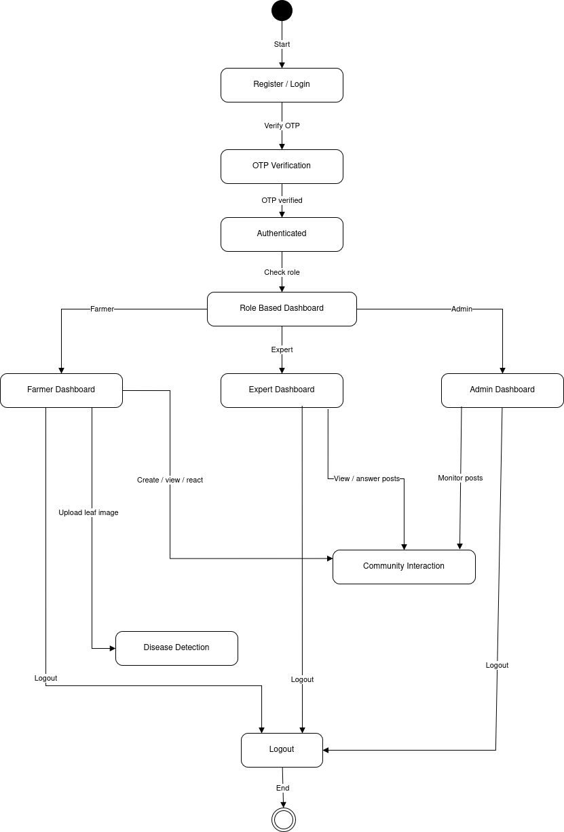
Figure 3.3 Process Modeling using Activity Diagram
Figure 3.3 represents the Activity Diagram for the Tomato Care System, illustrating the user flow from registration to logout. The process begins with user registering or logging into the system requiring a two factor authentication using OTP. Upon Successful authentication, the system checks the role of the user and the user if redirected to the respective dashboard. Then the user performs respective task such as farmer uploads image of leaf to detect the disease, expert views and reply on different posts, admin monitors the posts in community chats. The process concludes with the logout action, ensuring a structured and secure user experience.

- Dynamic modeling using sequence diagram

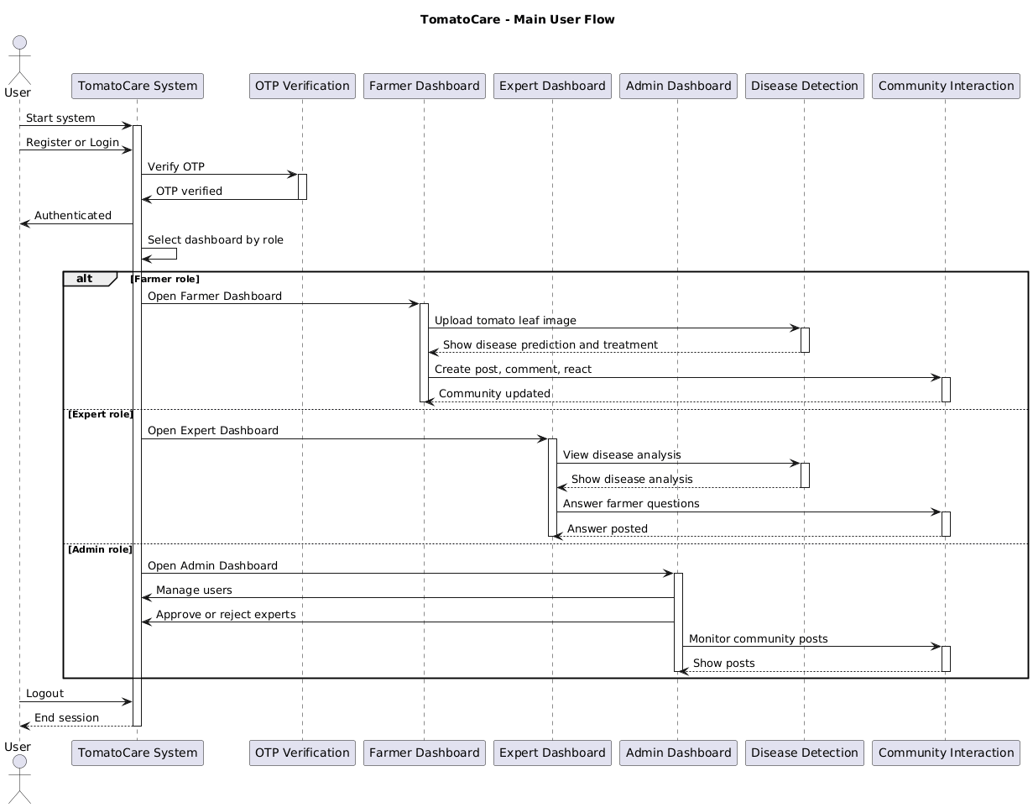
Figure 3.4: Dynamic modeling using sequence Diagram
The above figure 3.4 represents a sequence diagram that shows how a user interacts with the Tomato Care system. The interaction differs by the user’s role. Initially interaction starts with user registering or logging into the system. The system interacts with the OTP verification module and then verifies the OTP to complete authentication. Then Farmer, Expert and Admin interacts in different ways as illustrated in the figure above.

- Dynamic modeling using State Diagram

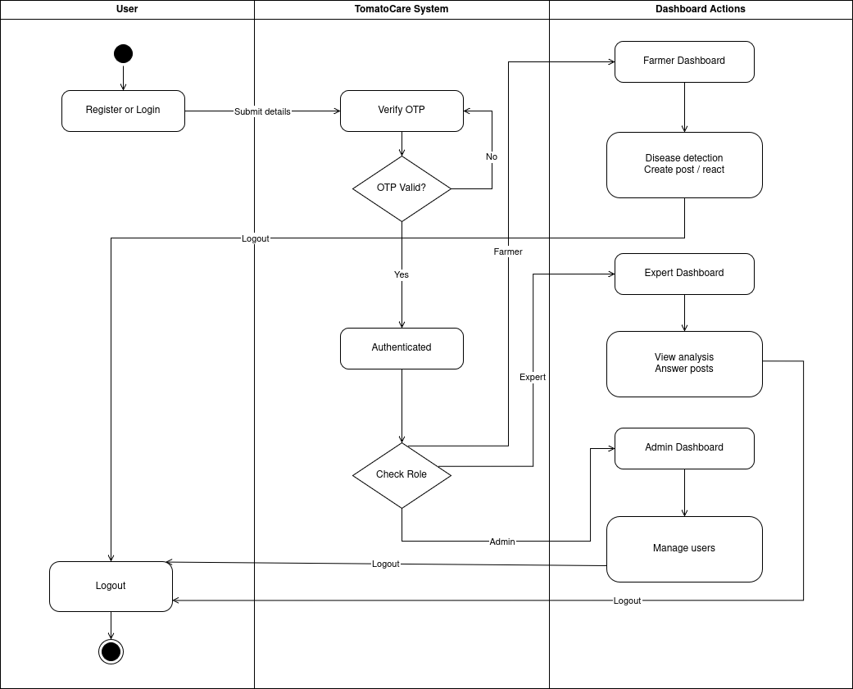
Figure 3.5 Dynamic modeling using State Diagram
Figure 3.5 represents a state diagram of Tomato Care System that shows how this system changes from one state to another based on events. The user submits credentials to register into the system. On receiving valid OTP from the user, the system allows user to login and check for user role to redirect to the respective dashboard. Based on the role, a farmer, an expert and an admin performs their respective task. The user can logout of the system by clicking the logout button.

CHAPTER 4: SYSTEM DESIGN

4.1 Design
System design involves defining the architecture, interfaces, and components that make up a system. It can be understood as the practical application of system theory in the development of a product.

4.1.1 System Architecture Design
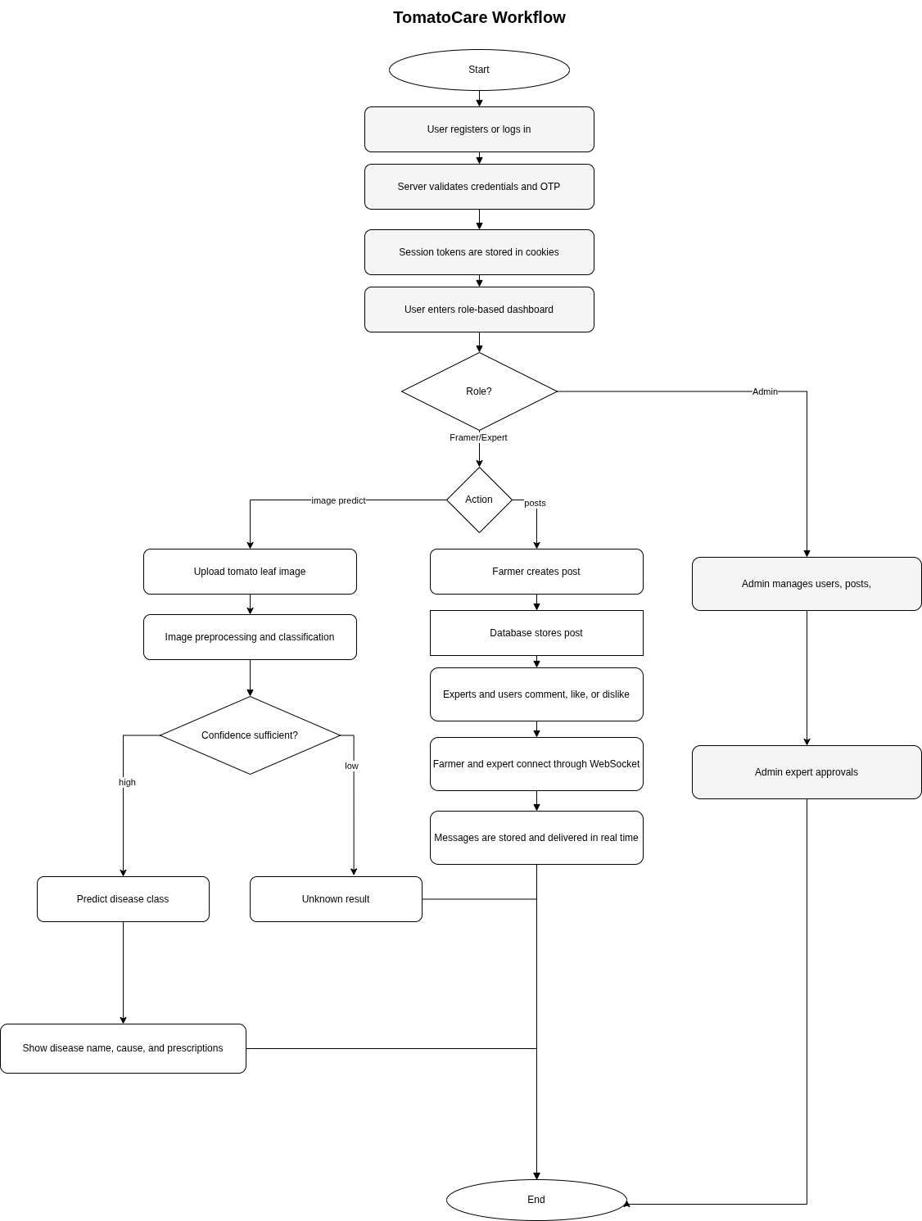
Figure 4.1 Flowchart illustrating the flow of Tomato Care system

This flowchart represents the overall workflow of a tomato leaf disease detection and farmer support system. The process begins when a user registers or logs into the system. The server verifies the user credentials and OTP, then stores session tokens in cookies for secure authentication. After login, users are directed to a role-based dashboard where different functionalities are provided for farmers, experts, and admins.
Farmers can upload tomato leaf images for disease prediction. The system preprocesses the image and performs classification using the CNN model. If the prediction confidence is high, the system displays the detected disease along with its causes and treatment recommendations. If the confidence is low, the result is marked as unknown. Farmers can also create posts to discuss agricultural issues. These posts are stored in the database, and users or experts can interact through comments, likes, or dislikes. Real-time communication between farmers and experts is enabled using Web Socket messaging. Admins manage users, posts, and expert approvals to ensure proper system operation. The workflow ends after all processes are completed successfully.

4.1.2 Refinement of Class Diagram, Sequence Diagram, Activity Diagram
- Refinement of Class Diagram

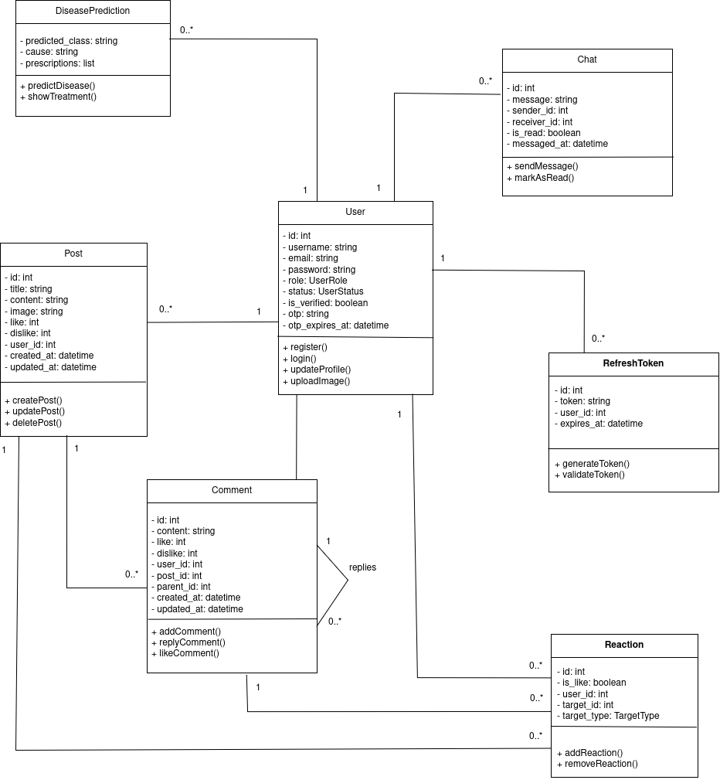

Figure 4.2 Refinement of Class Diagram
Figure 4.2 shows the refined class diagram of Tomato Care System, illustrating the relationship between various classes and their attributes in the system. The user registers, logs in and upload image of tomato leaf. The user interacts with the Disease Prediction to get the predicted disease, its causes and prescriptions. A single user can create as many posts where a post includes attributes such as: title, content, like, dislike, image, etc. Users are allowed to comment in the posts posted by other users as well as in their own. User can react in the posts by liking or disliking the post. A user can also chat with an expert. The refresh token is added to so that an extent of secureness is stretched.

- Refinement of Activity Diagram

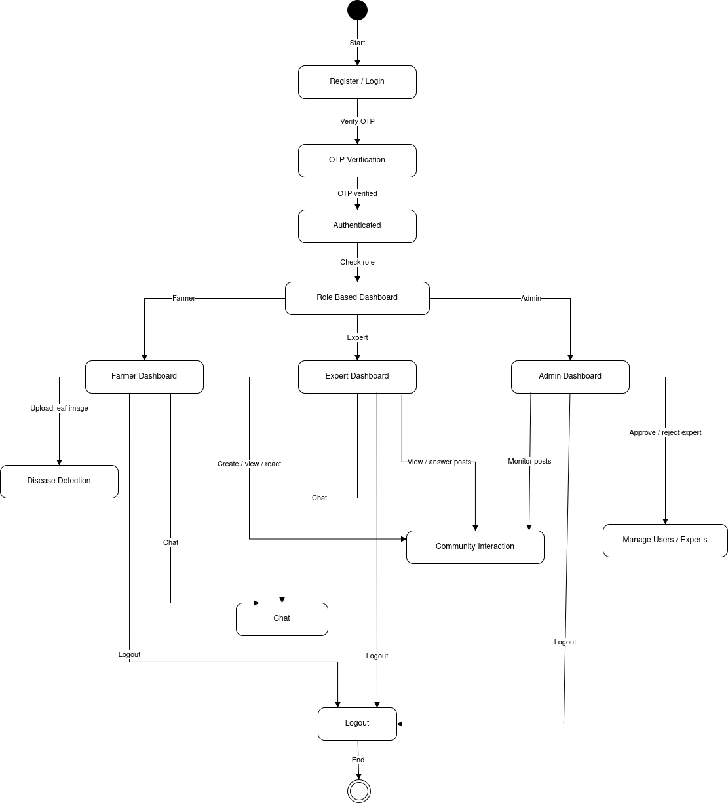
Figure 4.3 Refinement of Activity Diagram
Figure 3.3 represents the refined Activity Diagram for the Tomato Care System, illustrating the user flow from registration to logout, added some more components. The process begins with user registering or logging into the system requiring a two factor authentication using OTP. Upon Successful authentication, the system checks the role of the user and the user if redirected to the respective dashboard. Then the user performs respective task such as farmer uploads image of leaf to detect the disease, can create view and react on the community posts that is shared across different users. An expert views and reply on different posts, admin monitors the posts in community chats. Additionally, an expert can chat with the farmer providing solutions and recommendations regarding the diseases. An Admin along with monitoring the posts, has a responsibility to approve or reject the expert request accounts. The process concludes with the logout action, ensuring a structured and secure user experience.

- Refinement of Sequence Diagram
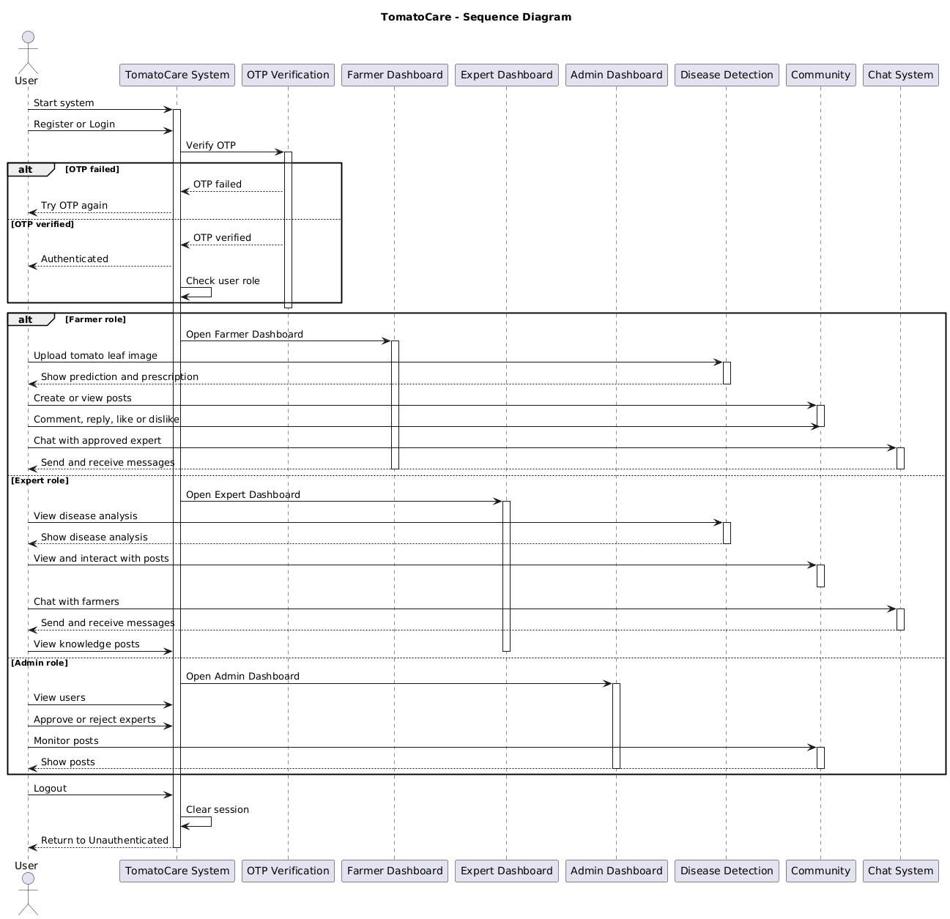
Figure 4.4 Refinement of Sequence Diagram
The above figure 3.4 represents a sequence diagram that shows how a user interacts with the Tomato Care system. The interaction differs by the user’s role. Initially interaction starts with user registering or logging into the system. The system interacts with the OTP verification module and then verifies the OTP to complete authentication. Then Farmer, Expert and Admin interacts in different ways as illustrated in the figure above. The chat component is added where a user can communicate with an approved expert using chat.

- Refinement of State Diagram

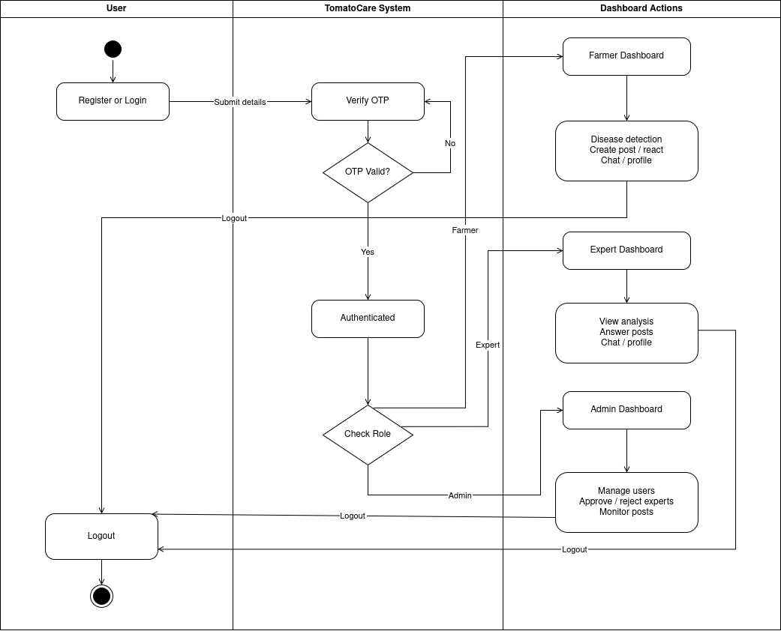

Figure 4.5 Refinement of State Diagram
Figure 4.5 represents the refinement of state diagram of Tomato Care System that shows how this system changes from one state to another based on events. The user submits credentials to register into the system. On receiving valid OTP from the user, the system allows user to login and check for user role to redirect to the respective dashboard. Based on the role, a farmer, an expert and an admin performs their respective task.

4.1.3 Component Diagram

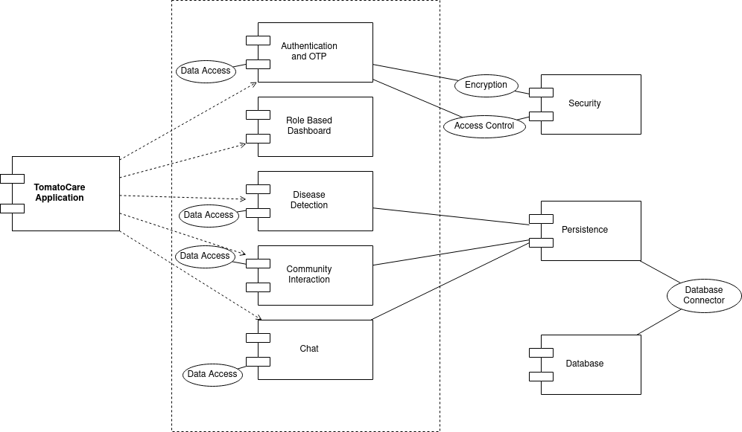
Figure 4.6 Component Diagram
This component diagram represents the architecture of a Tomato Care System. The Authentication and OTP component handles the authentication process involving checking the user credentials, OTP generation.

4.1.4 Deployment Diagram
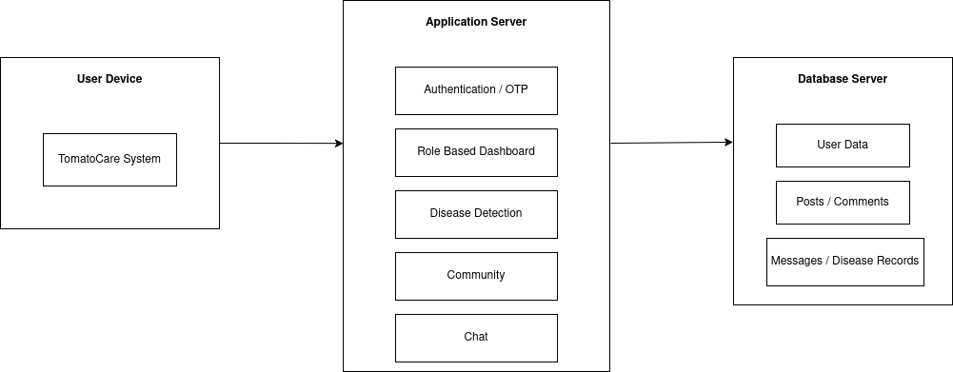

Figure 4.7 Deployment Diagram
The User Device executes the Tomato Care application and initiates calls to the Application Server. The Application Server manages all the core functions like user authentication using OTP, user role-based dashboards, disease detection, community functionality, and messaging services. The Application Server communicates with the Database Server, where all the user information, posts, comments, disease records, and other related information are stored.

4.2 Algorithm Detail
The proposed system uses a Convolutional Neural Network (CNN) to perform image classification which automatically learns spatial features of tomato leaves from input images using convolutional layers, followed by non-linear activation, pooling, and fully connected layers for final classification.
Image Transformation and Normalization
The model expects an image for classification of size (256, 256, 3). Before feeding image into the CNN, each input image is preprocessed to ensure uniform size, numerical stability, and normalization for fast conversion.

Image Resizing
All input images are resized to a fixed dimension:
$$X∈R^{H×W×C}⇒X^{'}∈R^{256×256×C}$$
Normalization
Normalized using mean and standard deviation:
$$X^{'}=\frac{X-μ}{σ}$$
Convolution Operation (Feature Extraction)
The convolution layer applies a filter (kernel) over the input image to extract features. These kernels slide across the image and perform a cross-correlation operation, producing what is known as a feature map. Each filter learns to detect specific patterns such as edges, corners, and textures, which are automatically optimized during the training process through back propagation.
Mathematically:
$$Y\left(i,j\right)=\sum_{c}{}\sum_{m}{}\sum_{n}{X\left(i+m,j+n,c\right).K\left(m,n,c\right)+b }$$
Where,
- Y(i , j) is a output feature map
- X is input
- K is kernel/filter
- ‘B’ is bias
Activation Function
An activation function is a mathematical function applied to the output of a neuron to introduce non-linearity into the model. Since tomato leaf images contain complex patterns such as spots, textures, and color variations, non-linear transformations are necessary to effectively extract these features. The ReLU (Rectified Linear Unit) activation function has been used in models to introduce non-linearity and help the model learn complex feature representations efficiently.
Mathematically,
$$f\left(x\right)=max⁡(0,x)$$
Pooling Operation
Pooling is a down sampling operation applied to feature maps (output of convolution layers) which summarizes a small region into a single value reducing spatial dimensions while preserving important features. Pooling extracts important features of tomato leaves while reducing the spatial dimension.
Max Pooling is defined as:
Mathematically,
$$Y\left(i,j\right)=\max\left(m,n\right) X(m,n)$$
Flattening Layer
The flattening layer converts multi-dimensional feature maps into a one-dimensional vector, enabling the transition from convolutional layers to fully connected (dense) layers. After feature extraction from tomato leaf images through convolution and pooling operations, the resulting feature maps are flattened into a 1D vector and passed to the dense layers for classification.
Mathematically,
$$F∈R^{n×1}$$
Fully Connected Layer
After convolution and pooling layers extract spatial features, the Fully Connected (FC) layer interprets these features to perform final classification.
The operation of a single neuron in a fully connected layer is defined as:
$$z=WX+b$$
Where,
- W : learned weights
- X : input feature vector (flattened vector)
- b : bias
Output Layer (Classification)
Class logits which are calculated by a fully connected layer, are passed to the output layer which converts these scores into probabilities using softmax. The class of tomato disease with the highest probability is taken as the predicted class.
Mathematically,
$$σ\left(z_{i}\right)=\frac{e^{z_{i}} }{\sum_{\left\{j=1\right\}}^{n}{e^{z_{j}}}}$$
Loss Function (Cross-Entropy Loss)
After prediction, the model compares predicted probabilities with actual labels using a loss function. Cross Entropy loss function is used to calculate the loss between actual class and predicted class.
Mathematically,
$$CE= -\frac{1}{N}\sum_{i=1}^{N}{\sum_{j=1}^{C}{(y_{i,j} .\log\left(p_{i,j}\right))}}$$
Where,
N is number of samples
C is number of classes
y_{i} ,_{j} is 1 if class j is correct for sample i, 0 otherwise
p_{i},_{j} is a model predicted probability of sample i begin in class j.

Back propagation
Back propagation is a learning algorithm used to determine the contribution of each weight to the final prediction error. The algorithm propagates the error backward through the network and updates the weights accordingly to minimize the loss function.
After the loss is computed, back propagation calculates gradients that indicate the direction and magnitude of weight adjustments required for optimization. These gradients are then used by the optimizer to update the network parameters and improve model performance.
Gradient is calculated as:
Mathematically,
Gradient w.r.t kernel (w):
$$\frac{∂L}{∂W}= X *\frac{∂L}{∂Y}$$

Gradient w.r.t bias (b):
$$\frac{∂L}{∂b}= \frac{∂L}{∂Y}$$
Gradient w.r.t input (x):
$$\frac{∂L}{∂X}= W ⋆\frac{∂L}{∂Y}$$
Now, weights are updated using ADAM optimizer, which updates neural network parameters by using adaptive rates based on estimates of first and second moments of the gradients. This optimization algorithm utilizes both AdaGrad (Adaptive Gradient) and Momentum optimization, resulting in the most powerful optimizer.
Mathematically,
$$W_{t+1}= W_{t}- α* \hat{\frac{m_{t}}{\sqrt{\hat{v_{t}}+ϵ}}}$$
Where,
$$\hat{m_{t}}=\frac{m_{t}}{1-β_{1}^{t}} , \hat{v_{t}}=\frac{v_{t}}{1-β_{2}^{t}}$$
$$m_{t}=β_{1}*m_{t-1}+\left(1-β_{1}\right)*\frac{∂L}{∂w_{t}}$$
$$v_{t}=β_{2}*v_{t-1}+\left(1-β_{2}\right)*{\left(\frac{∂L}{∂w_{t}}\right)}^{2}$$

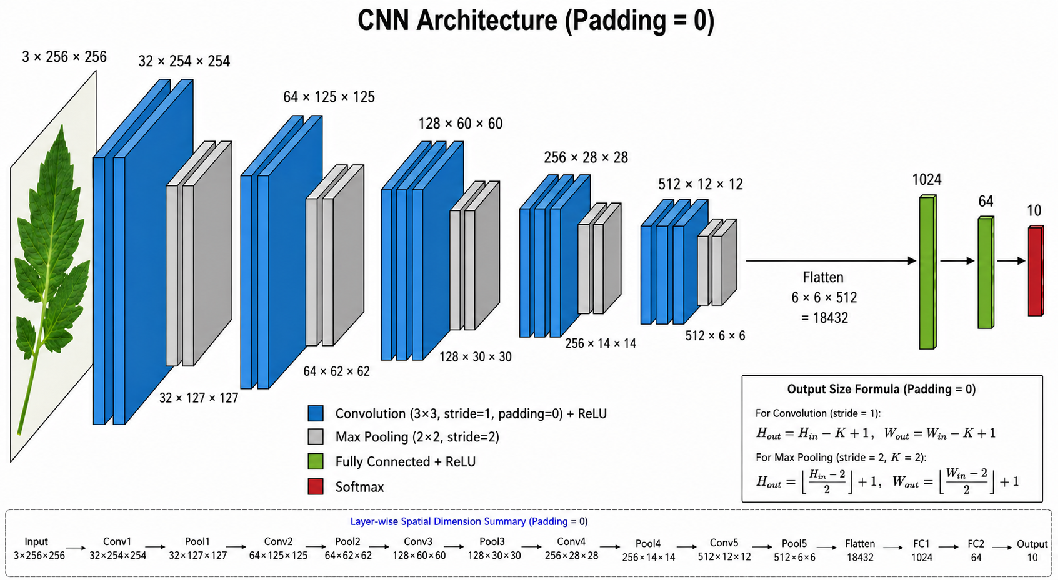

CHAPTER 5: IMPLEMENTATION AND TESTING

5.1 Implementation
This chapter describes the implementation details of the proposed system (Tomato Care), which was developed through modern web technologies, deep learning techniques. The implementation process includes frontend development, backend integrations, database designs, dataset collections, training deep learning models.

5.1.1 Tools Used
Different tools and technologies were employed to implement this system. They are listed and explained below along with their roles in the project.

- Frontend Framework
  - Next.js : Next.js serves as the primary framework for developing interactive user interfaces, allowing users to interact with the system seamlessly. Allows users to easily classify the leaves disease, with single image upload.

- Backend Framework
  - FastAPI: FastAPI is a modern, fast (high-performance), web framework for building APIs with Python based on standard Python type hints. FastAPI handles the core functionality of the system by integrating with database, LLM and CNN models through REST API. Python based ORM (SQLAlchemy) ensures efficient handling of the interaction with databases.

- Database Platform
  - Postgres SQL: Postgres is a powerful, open source object-relational database system. This stores system data like user authorization data, images of tomato leaves, chat histories and post data along with its comments and replies.

- Deeplearning Framework
  - Pytorch: Pytorch is a deep learning framework used to develop custom models. Custom CNN models for classifying tomato leaves based on diseases are developed through pytorch framework.

- Development Environment
  - Neovim: Neovim is a terminal based text editor which was used to implement the system. Neovim provides multiple plugins for different languages and advanced motions for easy development.
  - VS Code: VS Code serves as the Integrated Development Environment (IDE) for coding, testing, and debugging both the frontend and backend of Tomato Care.

- Diagram Tool
  - Draw.io : Draw.io was used to create various system diagrams, including UML diagrams that visually represents the architecture and workflows of Tomato Care.

5.1.2 Implementation details of Modules
Authentication Modules
The Authentication Module handles user security and access control in the system. It includes features such as user registration, login, and logout, email verification using OTP, and token management using access and refresh tokens. The main purpose of this module is to ensure that only authenticated and verified users can access the system.
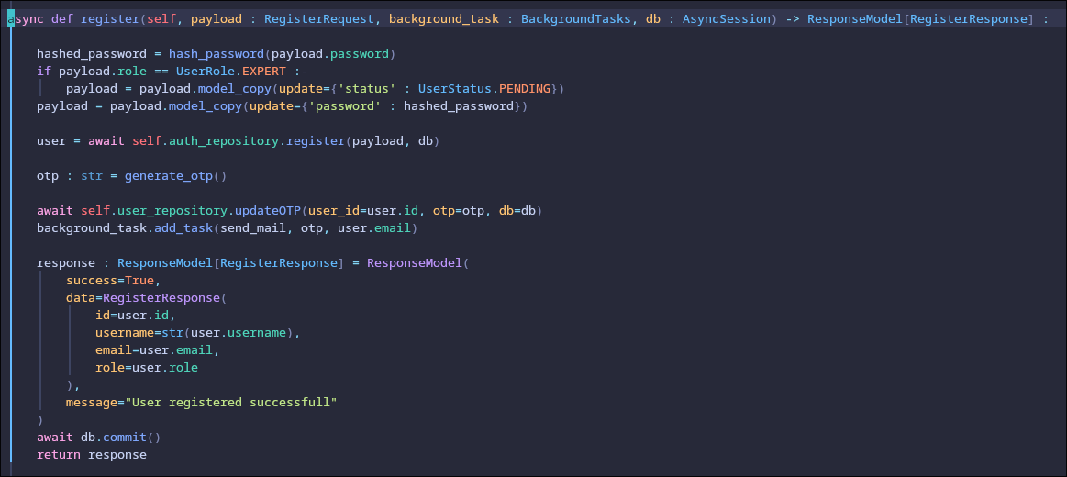
During registration, a user provides details like username, email, password, and role. The password is securely hashed before storing it in the database. After successful registration, an OTP is generated and sent to the user’s email address for verification. This OTP is stored temporarily with an expiration time, and the user must verify it to activate their account.
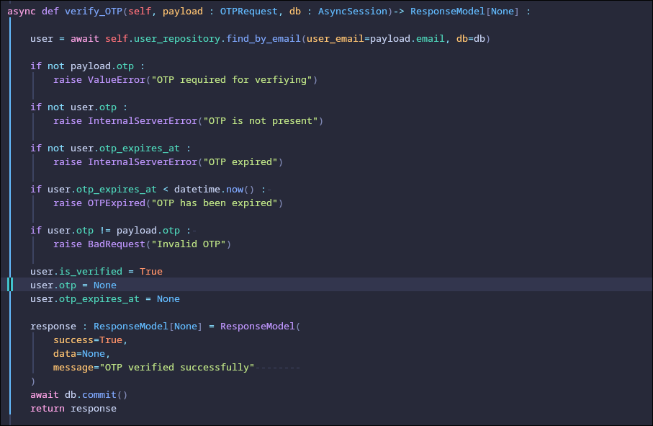
OTP verification ensures that the email belongs to the user. The system checks if the OTP is valid, not expired, and matches the stored value. Once verified, the user account is marked as active, and the OTP is removed.
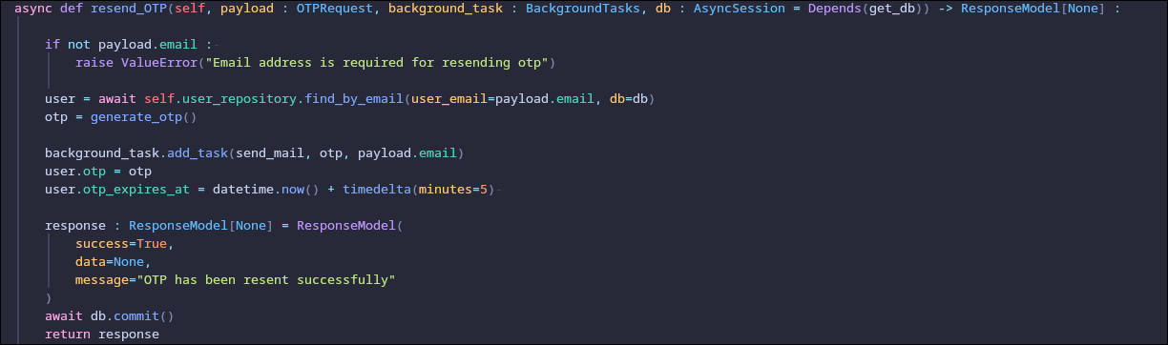
A resend OTP feature is also available to generate and send a new OTP if needed.
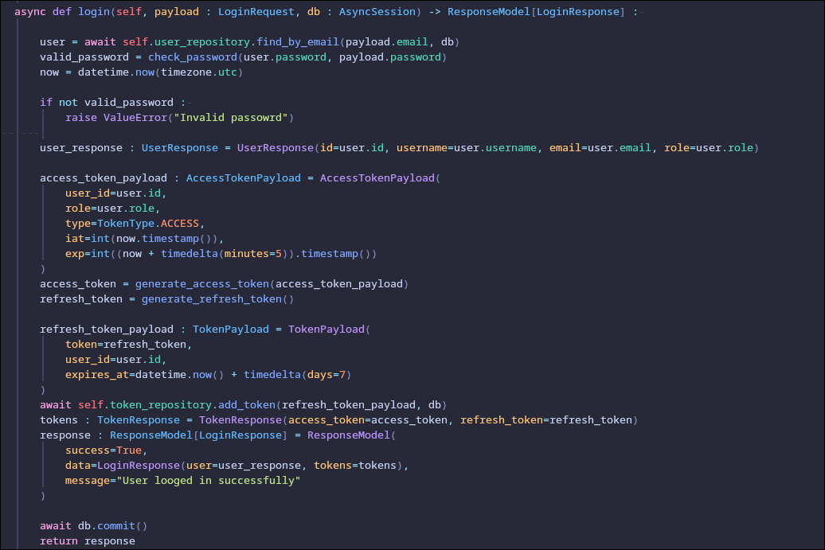
For login, the system checks the user’s credentials. If valid, it generates an access token and a refresh token. The access token is used for authentication and has a short lifespan, while the refresh token is stored in the database and used to generate new access tokens when needed.
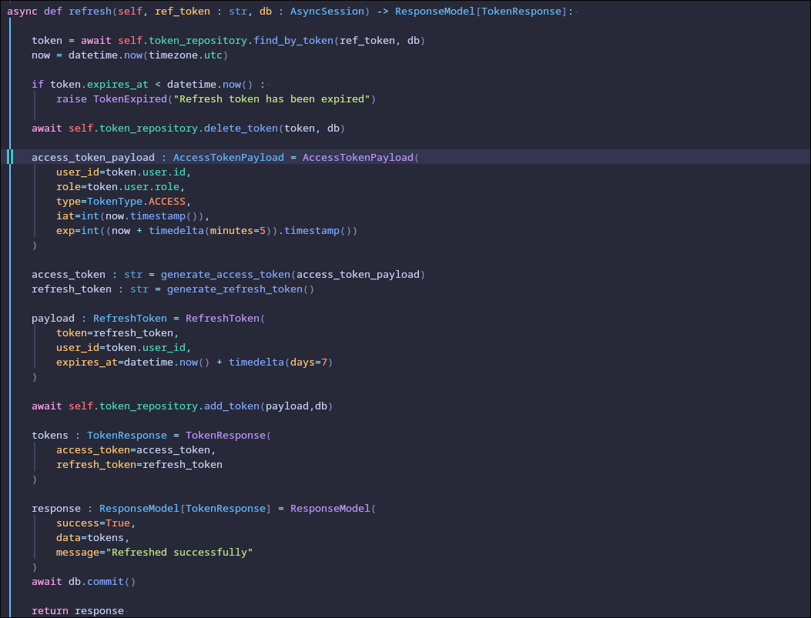
When the access token expires, the refresh token is used to issue new tokens without requiring the user to log in again.
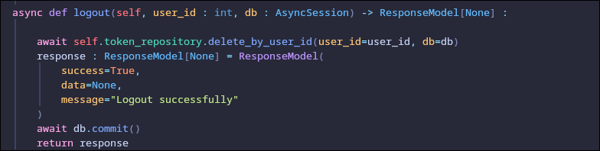
During logout, all refresh tokens related to the user are deleted, ending the session. Overall, the module provides secure authentication using password hashing, OTP verification, and token-based authentication to protect user data and system access.

Disease Prediction Module
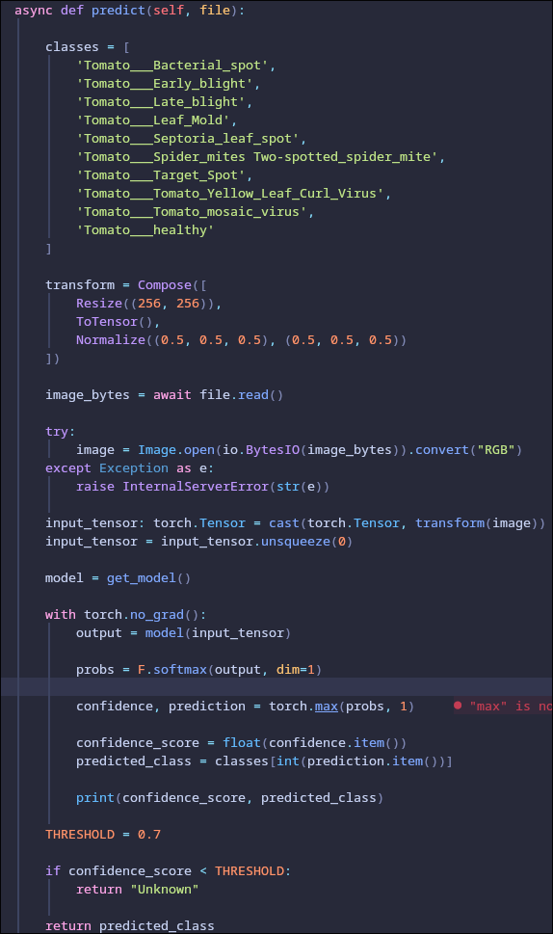
The Disease Prediction Module works by taking an uploaded tomato leaf image from the user and passing it through a trained CNN model to detect diseases. Uploaded image is transformed to required spatial dimension which then predicts probabilities for different tomato disease classes. The class with the highest probability is selected as the prediction, and a confidence score is calculated.
Finally, if the confidence score is above 0.7, the predicted disease name is returned. If it is below the threshold, the system returns “Unknown” to indicate uncertainty.
Chat Module
The Chat Module handles real-time messaging between users along with storing chat history in the database.
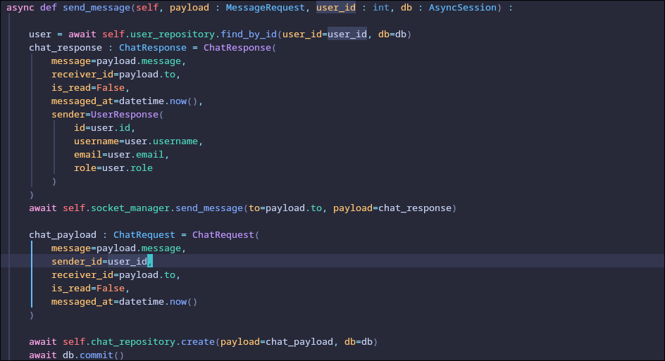
Users receive messages in real time through a socket connection. When one user sends a message, it is immediately pushed to the receiver using Web Sockets, so the message appears instantly without needing to refresh the page.
Along with real-time delivery, every message is also stored in the database. This allows the system to keep a permanent record of all conversations between users.

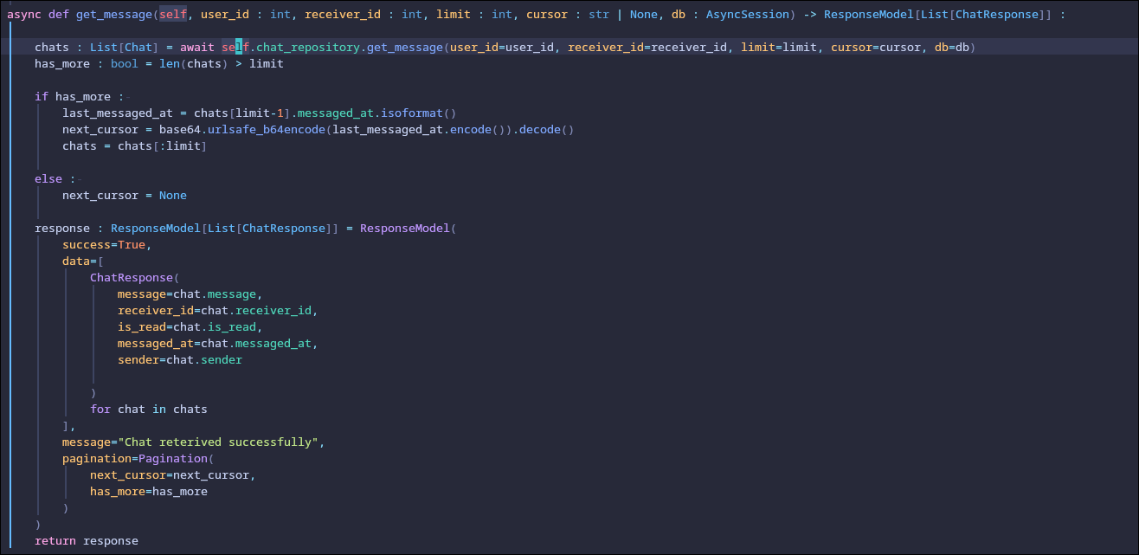
When users open a chat, the system retrieves previously stored messages from the database between the two users. This chat history is loaded in order, and supports unlimited scrolling, so older messages can be fetched when needed.
Community Module
The Community Module allows users to post their query, where other users can comment, reply, like, dislike it.
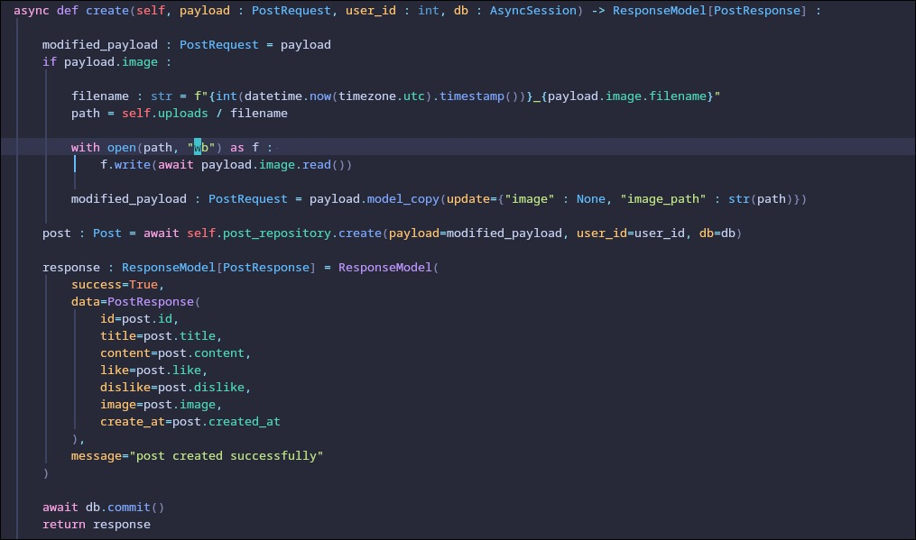
If an image is included, it is saved to the server with a unique filename and its path is stored instead of the actual file. Then the post data (title, content, image path, and user ID) is saved in the database. Finally, the created post details are returned in the response after committing the transaction.
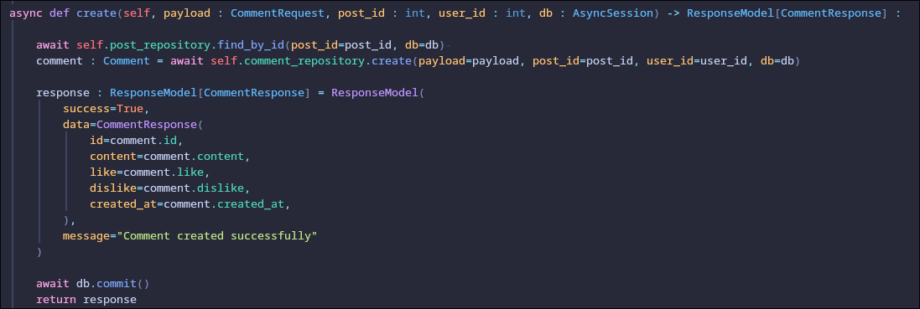
This creates a comment on a specific post. First, it verifies that the post exists. Then it saves the comment in the database with the post ID and user ID. After saving, it returns the created comment details like content, likes, dislikes, and timestamp in the response. Finally, the changes are committed to the database.

Custom CNN module
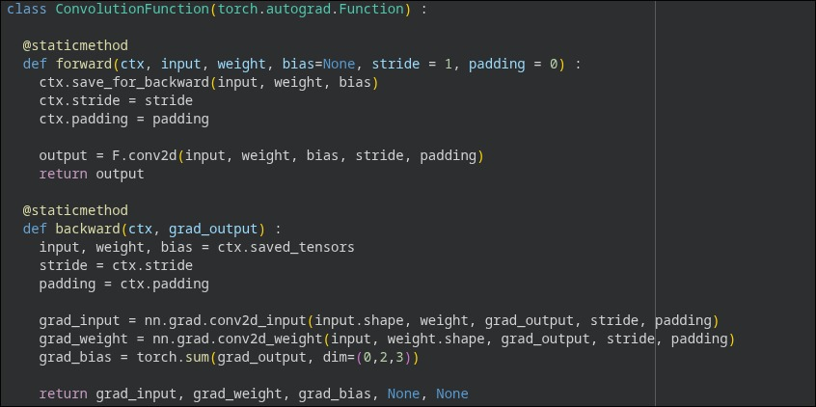
This module is a custom convolution operation using PyTorch’s autograd system. In the forward pass, it performs a standard 2D convolution and stores the required values such as input, weight, bias, stride, and padding for use in back propagation. In the backward pass, it computes the gradients with respect to the input, weights, and bias for convolution. These gradients are then returned so that the model parameters can be updated during training. Overall, it manually implements both forward and backward operations of a convolution layer.

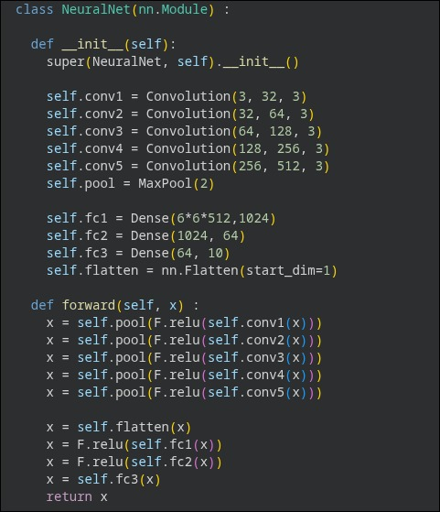
The NeuralNet class defines the CNN architecture used for tomato leaf disease classification. The model consists of multiple convolution layers followed by ReLU activation and max pooling operations for feature extraction. Each convolution layer increases the number of feature channels, allowing the network to learn more complex patterns from the input images. After feature extraction, the output is flattened into a one-dimensional vector and passed through fully connected (dense) layers for classification. The final layer produces predictions for 10 different tomato disease classes.
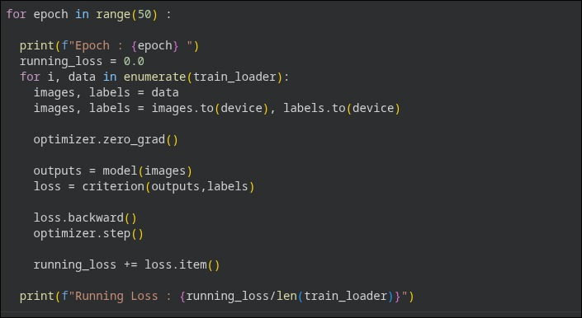
The training process is performed over 50 epochs. In each epoch, batches of training images and labels are loaded and transferred to the device. The optimizer gradients are reset before every iteration to prevent accumulation of previous gradients. The images are then passed through the model to generate predictions, and the loss is calculated using the loss function. Back propagation is performed using loss.backward() to compute gradients, and optimizer.step() updates the model parameters. The running loss is accumulated throughout the epoch and printed after each epoch to monitor training performance.

5.2.1 Test Case for Unit Testing
Unit testing is a testing approach that focuses on verifying individual software modules and the components that form the complete system. Its goal is to ensure that each unit of code functions correctly as intended.
Table: Unit Test for User Authentication
Test Case ID | Test Scenario | Input | Expected Result | Status
1 | Register a new user | Valid user details (username, email, password) | User registered successfully with status code 201 | Pass
2 | Register with existing email | Existing email | Error message returned with status code 400 | Pass
3 | Login with valid credentials | Valid email and password | Login successful with access token | Pass
4 | Login with invalid credentials | Invalid email/password | Authentication failed with status code 401 | Pass
5 | Verify OTP with valid code | Valid OTP | OTP verified successfully | Pass
6 | Verify OTP with invalid code | Invalid OTP | Verification failed with status code 400 | Pass
7 | Resend OTP | Registered email | New OTP sent successfully | Pass
8 | Refresh access token | Valid refresh token | New access token generated | Pass
9 | Logout user | Valid access token | Logout successful | Pass
Table: Unit Test for User Management
Test Case ID | Test Scenario | Input | Expected Result | Status
1 | Retrieve all users | None | List of users returned successfully | Pass
2 | Retrieve logged-in user profile | Valid token | User profile returned successfully | Pass
3 | Retrieve user by valid ID | Valid user_id | User details returned successfully | Pass
4 | Retrieve user by invalid ID | Invalid user_id | Error message returned with status code 404 | Pass
5 | Retrieve expert users | None | List of expert users returned | Pass
6 | Retrieve pending experts | None | List of pending experts returned | Pass
7 | Approve expert request | Valid user_id | Expert approved successfully | Pass
8 | Reject expert request | Valid user_id | Expert rejected successfully | Pass

Table: Unit Test for Post Management
Test Case ID | Test Scenario | Input | Expected Result | Status
1 | Create a post | Valid post data | Post created successfully with status code 201 | Pass
2 | Retrieve all posts | None | List of posts returned successfully | Pass
3 | Retrieve post by ID | Valid post_id | Post details returned successfully | Pass
4 | Retrieve post with invalid ID | Invalid post_id | Error message returned with status code 404 | Pass
5 | Delete existing post | Valid post_id | Post deleted successfully | Pass
6 | Like a post | Valid post_id | Post liked successfully | Pass
7 | Dislike a post | Valid post_id | Post disliked successfully | Pass
8 | Retrieve posts by user | Valid user token | User posts returned successfully | Pass

Table: Unit Test
Test Case ID | Test Scenario | Input | Expected Result | Status
1 | Create comment on post | Valid comment data (content) | Comment created successfully | Pass
2 | Retrieve comments by post ID | Valid post_id | List of comments returned successfully | Pass
3 | Retrieve comment by ID | Valid comment_id | Comment details returned successfully | Pass
4 | Delete comment | Valid comment_id | Comment deleted successfully | Pass
5 | Reply to comment | Valid reply content | Reply created successfully | Pass
6 | Retrieve replies of comment | Valid comment_id | Replies returned successfully | Pass
7 | Like a comment | Valid comment_id | Comment liked successfully | Pass
8 | Dislike a comment | Valid comment_id | Comment disliked successfully | Pass
9 | Create empty reply | Empty request body | Validation error returned | Pass

Test Case ID | Test Scenario | Input | Expected Result | Status
1 | Retrieve chat messages | Valid receiver_id | Chat messages returned successfully | Pass
2 | Retrieve messages with invalid receiver ID | Invalid receiver_id | Error message returned with status code 404 | Pass

Test Case ID | Test Scenario | Input | Expected Result | Status
1 | Predict image with valid image | Valid image file | Prediction result returned successfully | Pass
2 | Predict image without image upload | Empty request | Error message returned with status code 400 | Pass

5.2.2 System testing

Test Case ID | Test Scenario | Input | Expected Result | Status
1 | Complete user registration flow (Register to OTP verification to activation) | User registration data and OTP | User account is created and activated successfully | Pass
2 | User login and session creation | Valid email & password | System stores access token and refresh token in cookie | Pass
3 | Access user profile after authentication | Valid JWT token | Logged-in user profile is returned | Pass
4 | Expert approval workflow | Admin clicks approve to the pending experts | User status updated to “active” | Pass
5 | Expert rejection workflow | Admin click reject to the pending experts | User status updated to rejected | Pass
6 | Create post and display in feed | Post content and auth token | Post is created and visible in global feed | Pass
7 | Like/dislike post interaction | Post ID and user action | Like/dislike count updates correctly | Pass
8 | Comment creation and retrieval | Post ID and comment text | Comment appears under correct post | Pass
9 | Comment reply threading | Comment ID and reply text | Reply appears nested under correct comment | Pass
10 | Comment like/dislike interaction | Comment ID + action | Reaction is stored and reflected correctly | Pass
11 | Chat message exchange between users | Sending text messages to valid experts. | Message is stored and retrieved in correct order | Pass
12 | Image prediction workflow | Uploaded image file | System returns disease info successfully | Pass
13 | Unauthorized access prevention | No authentication token | System returns 401 Unauthorized error | Pass

5.3 Result Analysis
After integrating all modules such as authentication, user management, post management, commenting system, chat system, and image prediction, the system was tested through multiple end-to-end workflows. The results indicate that the system performs as expected in most scenarios, with successful communication between different modules and correct data flow across the system.
1. Functional Correctness
All core functionalities including user registration, login, post creation, commenting, chatting, and AI-based image prediction executed successfully. The expected outputs matched the actual results, confirming that the system logic is correctly implemented and integrated.
2. Integration Performance
The interaction between different modules worked smoothly. For example:
- After successful authentication, users were able to access protected routes without issues.
- Posts created by users were immediately available in the feed.
- Comments and replies were correctly linked to their respective posts.
- Chat messages were properly stored and retrieved between users.
- The image prediction module successfully communicated with the server, LLM and CNN model and returned valid results.
This confirms that inter-module communication is stable and reliable.
3. Security and Access Control
The system correctly enforced authentication and authorization rules. Unauthorized requests were blocked with proper error responses (e.g., 401 Unauthorized), ensuring that protected resources are secure and accessible only to authenticated users.
4. System Reliability
Repeated execution of test cases showed consistent behavior without unexpected failures. The system handled typical user workflows efficiently, indicating good stability under normal usage conditions.
5. Overall Observation
The system meets the intended functional requirements and demonstrates successful integration of all modules into a unified application. The end-to-end testing confirms that the platform is ready for deployment, with all major features working as expected.

CHAPTER 6: CONCLUSION AND FUTURE RECOMMENDATIONS

6.1 Conclusion
Tomato Care becomes an intelligent system that uses the CNN as its backbone to assist the farmer in classifying the tomato diseases. The CNN model that has been trained with large available datasets has been successful to deliver good results in terms of performance metrics that further extends the degree of reliability for farmers. The further information about the classified disease including symptoms, preventions and cure generated automatically with the help of LLM has really been a great support for farmers in gaining further more ideas and knowledge regarding various diseases in tomato plants. The virtual community platform provided in the system greatly helps farmers to share their experiences and queries about farming. In Other hands, the real time communication service through chat with Agro expert has greatly reduced the frequency of need of physical visits to the agricultural expert.
Therefore, Tomato Care is a complete system that further helps in the development of e-agriculture initiatives in a development country like Nepal encouraging the active participation of farmers and leveraging the use of emerging technologies of Artificial Intelligence.

6.2 Future Recommendation
Despite Tomato Care provides a set of extensive features to improve the agriculture; especially in the context of Tomato Cultivation, there still exists significant room for further enhancement. One of the key improvements include use of larger diverse data sets that increases the accuracy of the CNN model that significantly helps it in adjusting the real world data. The System could be extended to support multiple crop types beyond tomato plants, increasing its versatility for agriculture use.
Further works may contribute to make it more enhanced, effective and efficient by improving the areas of user Interface, enabling the facility of real time VoIP communication that’s limited to real time chats for now, multi-language support etc. The use of advance deep learning architecture may further help in improvement in the performance of the system.

REFERENCES
[1] “Article title,” The Annapurna Express, Aug. 2023. [Online]. Available: The Annapurna Express
[2] R. Chauhan, K. K. Ghanshala and R. C. Joshi, "Convolutional Neural Network (CNN) for Image Detection and Recognition," 2018 First International Conference on Secure Cyber Computing and Communication (ICSCCC), Jalandhar, India, 2018, pp. 278-282, doi: 10.1109/ICSCCC.2018.8703316.
[3] M. Krichen, “Convolutional Neural Networks: A Survey,” Computers, vol. 12, no. 8, p. 151, 2023, doi: 10.3390/computers12080151.
[4] L. Falaschetti, L. Manoni, D. Di Leo, D. Pau, V. Tomaselli, and C. Turchetti, “A CNN-based image detector for plant leaf diseases classification,” HardwareX, vol. 12, p. e00363, 2022, doi: 10.1016/j.ohx.2022.e00363.
[5] Y. Li and J. Yang, “Few-shot cotton pest recognition and terminal realization,” Computers and Electronics in Agriculture,vol. 169, p. 105240, 2020, doi: 10.1016/j.compag.2020.105240.
[6] M. Brahimi, K. Boukhalfa, and A. Moussaoui, “Deep learning for tomato diseases: Classification and symptoms visualization,” Applied Artificial Intelligence, vol. 31, no. 4, pp. 299–315, 2017, doi: 10.1080/08839514.2017.1315516.
[7] C. U. Kumari, S. J. Prasad, and G. Mounika, “Leaf disease detection: Feature extraction with K-means clustering and classification with ANN,” in Proc. 3rd International Conference on Computing Methodologies and Communication (ICCMC), Erode, India, 2019, pp. 1095–1098, doi: 10.1109/ICCMC.2019.8819750.
[8] M. Kumar, P. Gupta, P. Madhav, and S. Sachin, “Disease detection in coffee plants using convolutional neural network,” in Proc. 5th International Conference on Communication and Electronics Systems (ICCES), Coimbatore, India, 2020, pp. 755–760, doi: 10.1109/ICCES48766.2020.9138000.

APPENDICES
Sign up page
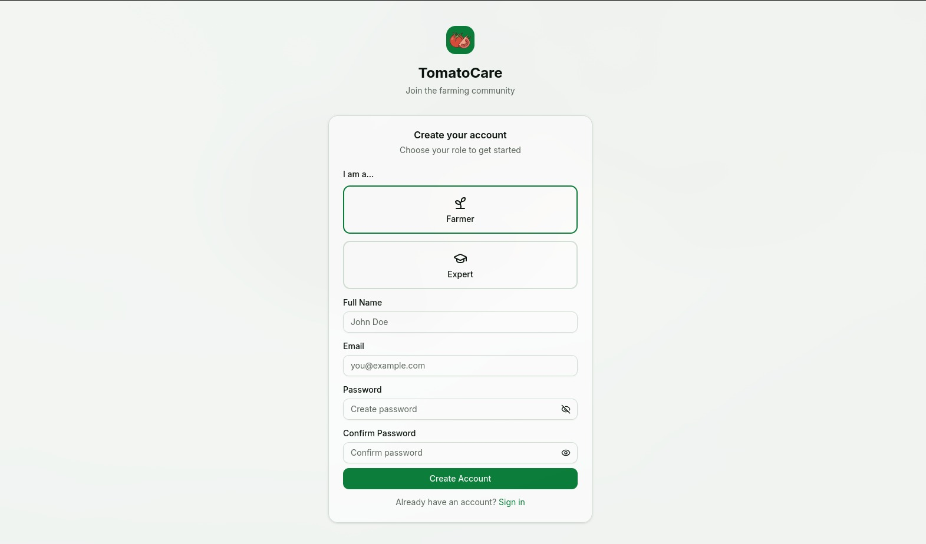

Sign in page
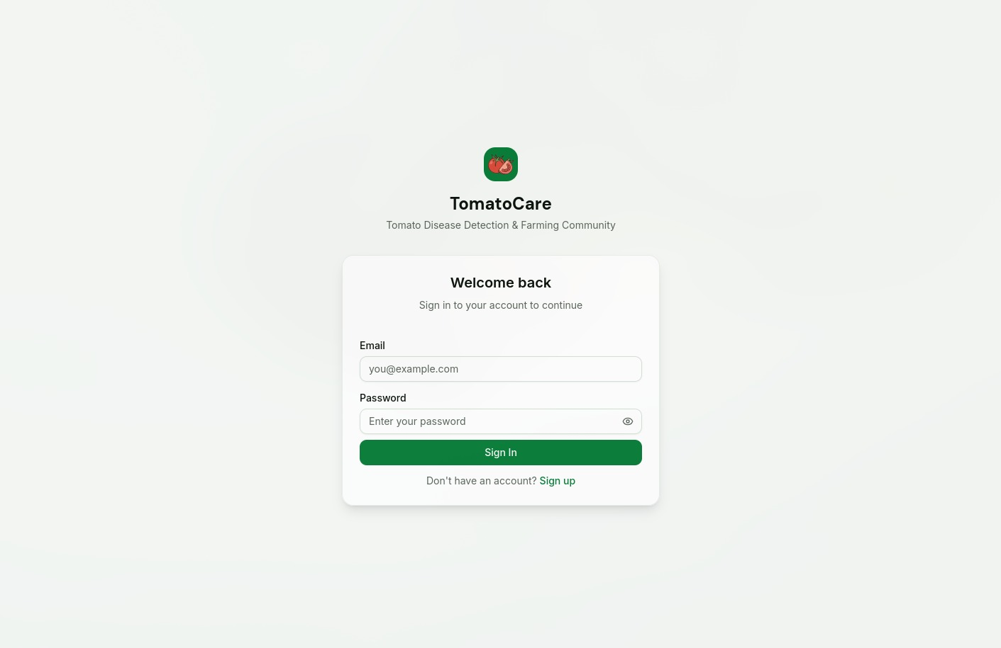

Disease Detection Page
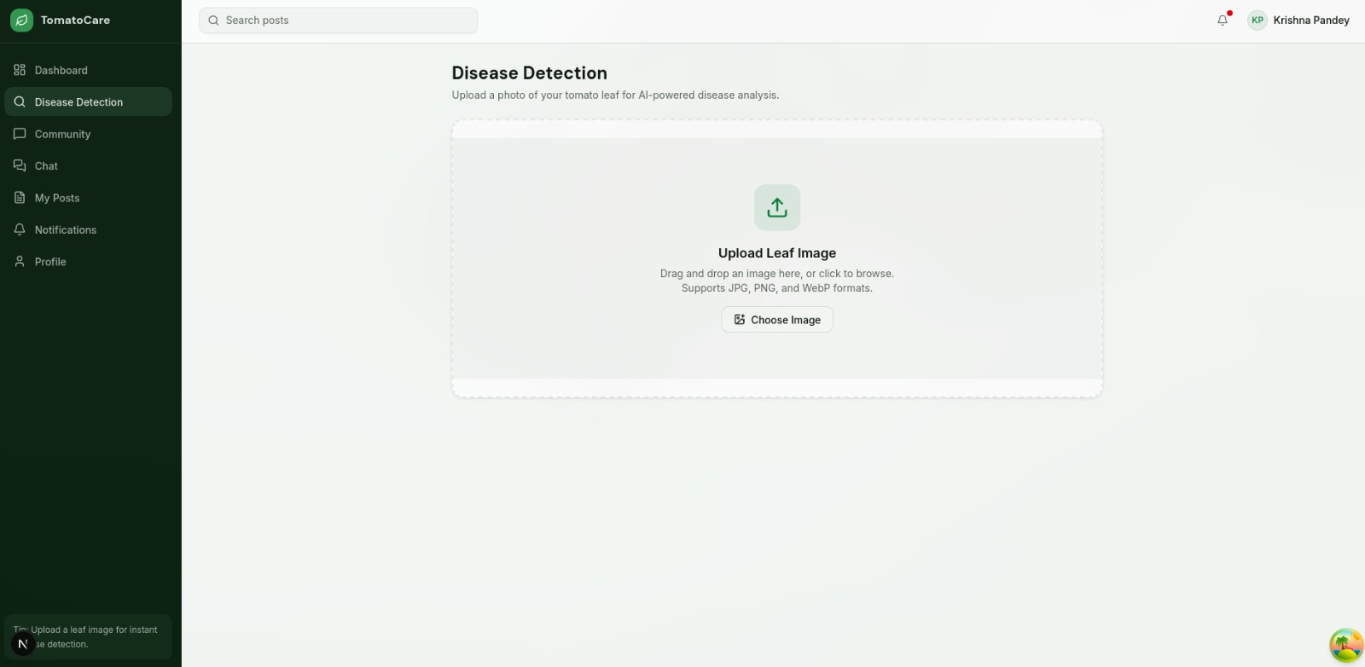

Create new post modal
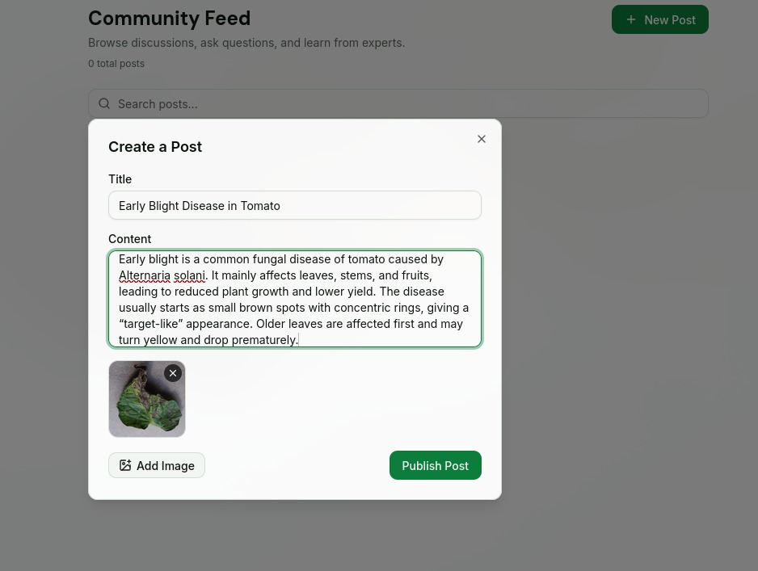

Community page
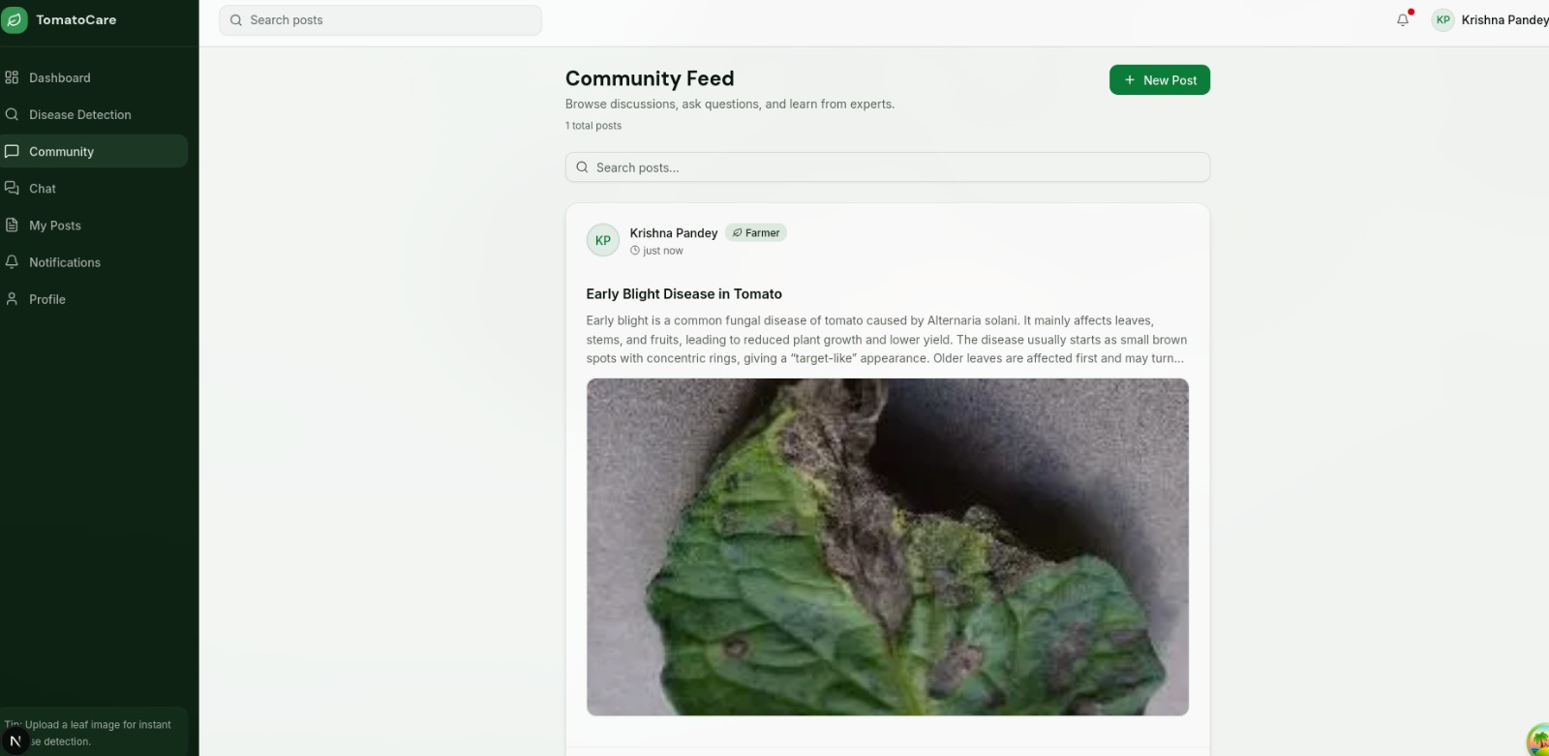

Admin page to view users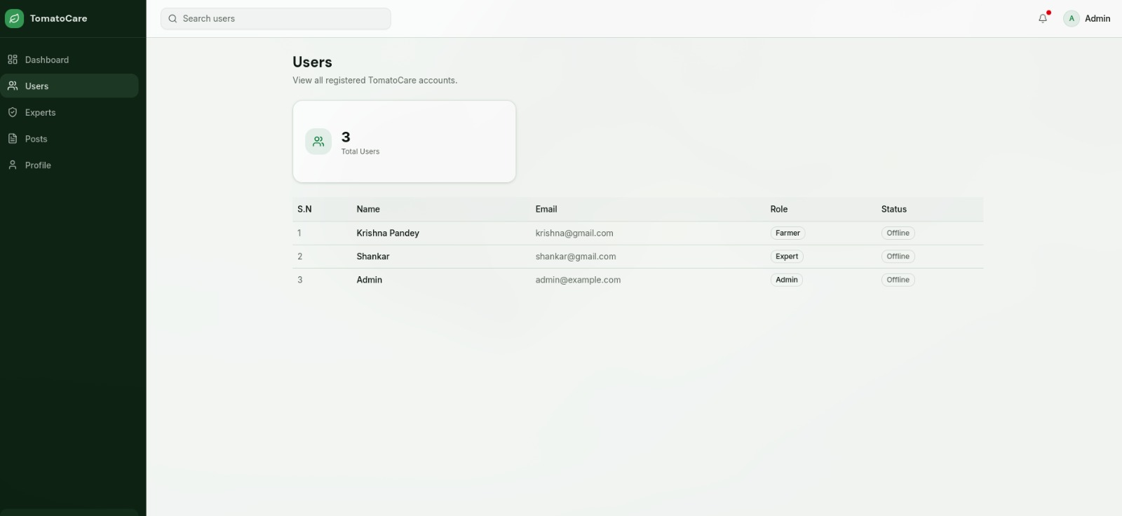

Admin page to view pending expert accounts request
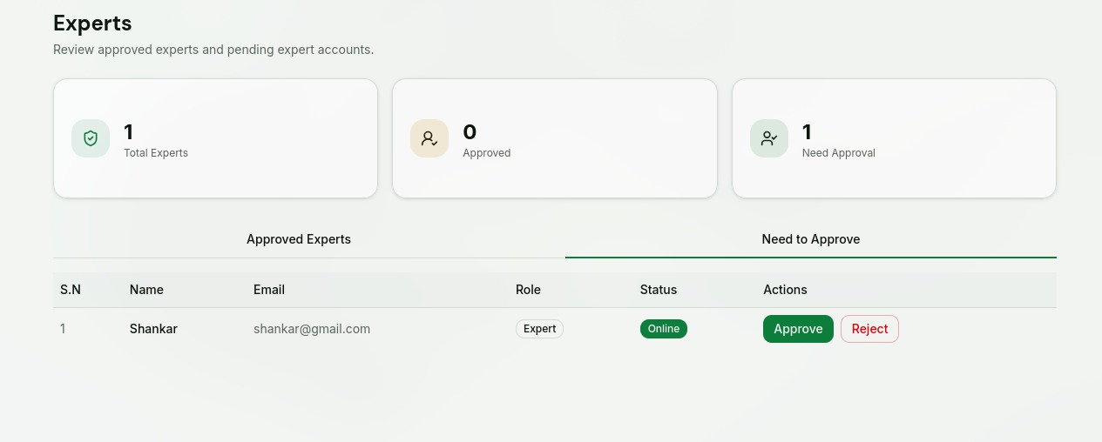

Admin Page to view Posts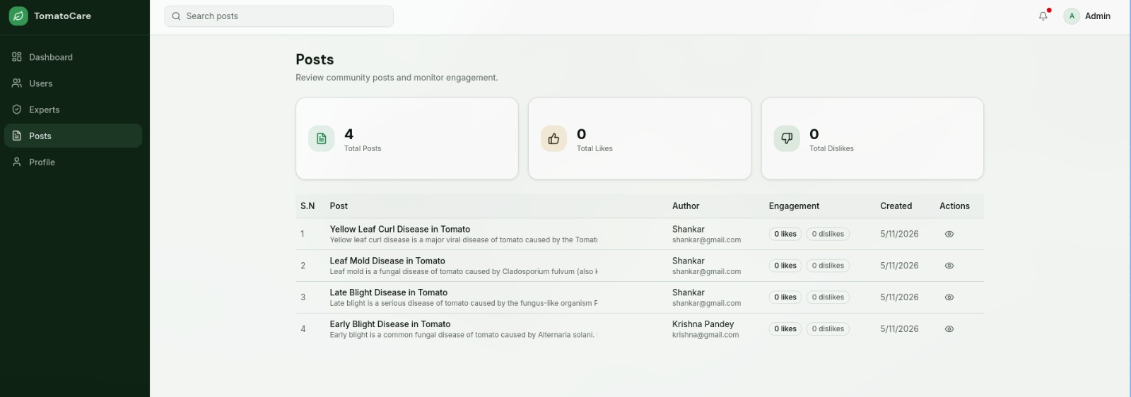

Chat Interface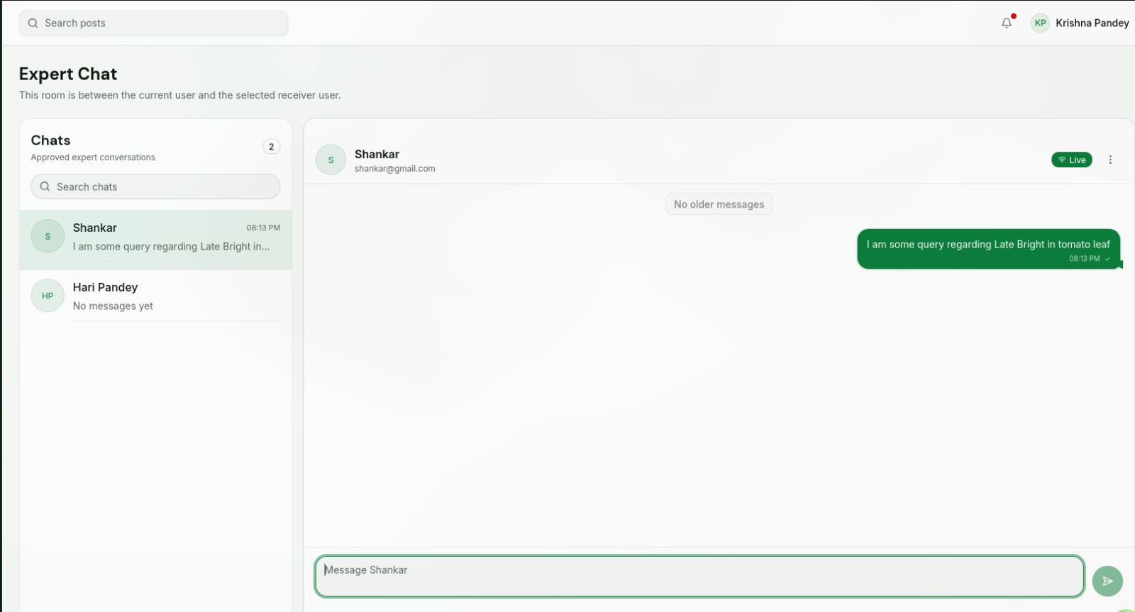

User Profile Page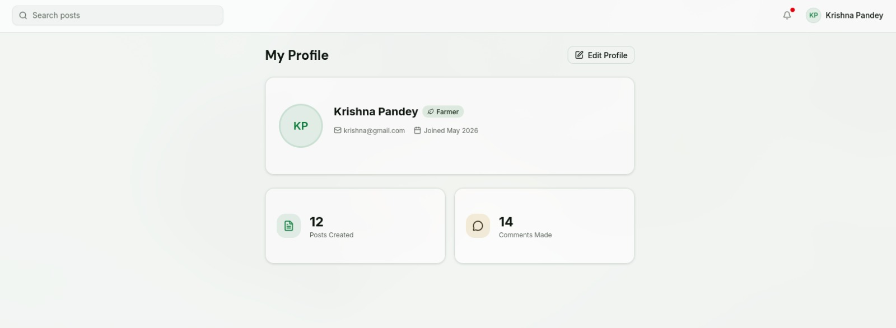

Farmer Dashboard page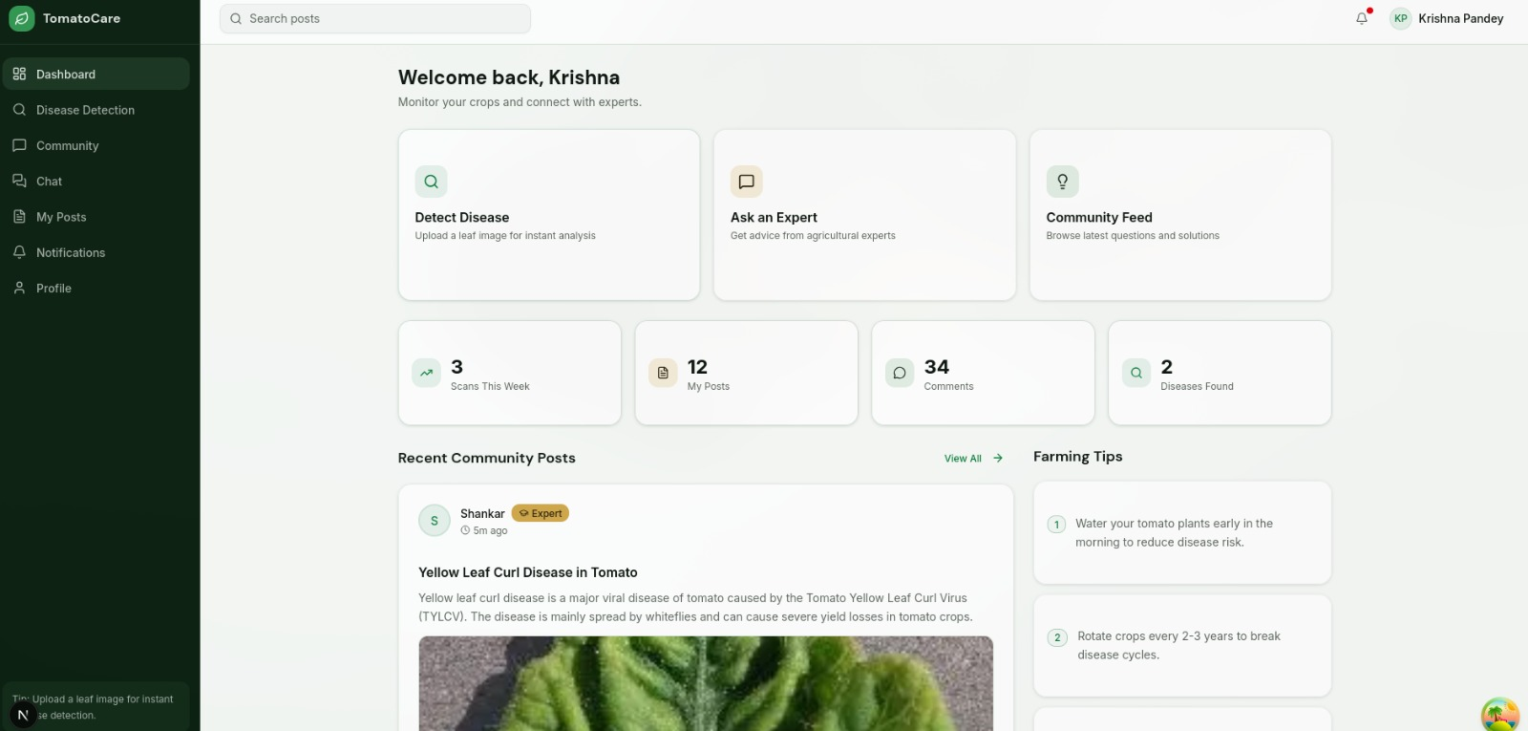

Admin Dashboard page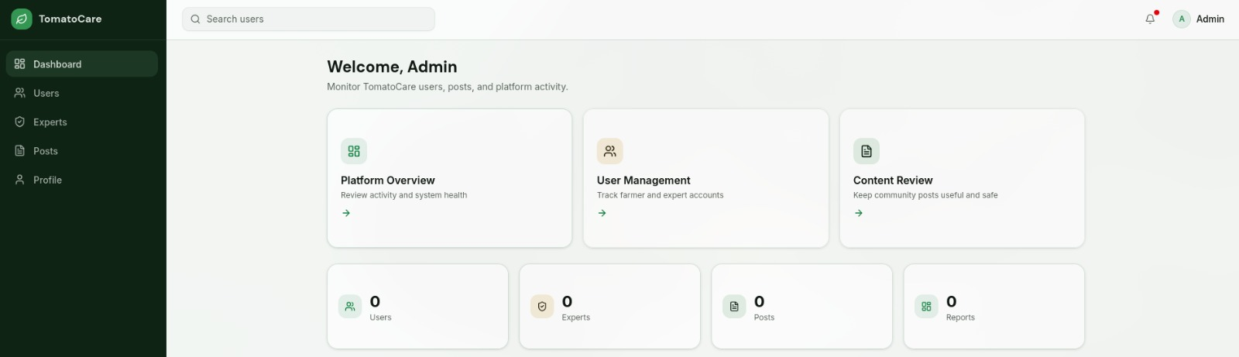

Expert Dashboard page