Ben Goodwin / Jack Kotani

Ashok Basawapatna

Mobile Programming via Android

Final Project

**Final Project: iBenJacked**

**Mission Statement:** The iBenJacked Application’s goal is to provide a clear and user friendly experience with recording progress during workouts. The application should be able help the user in terms of recording current and past progress in terms of sets/reps and the actual exercise they have done.

**Project Layout:**

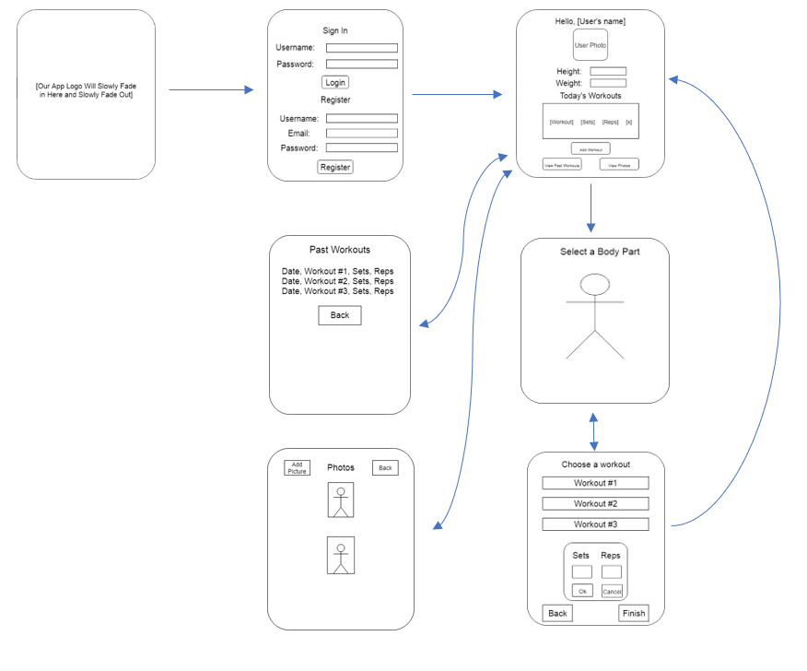

**SHORTCOMINGS/ISSUES:**

Some of the issues we have come across while creating the application is the process of storing images inside of the application. As developers we thought the best way to provide a user friendly experience is to show the individual workouts by images, however we had a difficult time compressing the size of the images and made the actual size of the application larger than expected. Other small issues we have across would be the usual coding obstacles such as creating a database for storing the workouts and also outputting previous workouts from previous days of the week. Other initial ideas that were not executed would be the body layout screen. The original idea was to have one image of a body and the User would be able to click on the individual body part and see the exercises that were available to that specific body. We realized that this would mean creating layouts for each body parts in the forms of images and the idea was scrapped due to time restraints Most of these shortcomings were solved by consultation from the Professor. Obstacles that we could not overcome would be the initial idea of storing images from the User as a week by week progress report. The process of creating this action was deemed to difficult in the short amount of time given and could be added as a challenge after the semester is over.

**USER MANUAL:**

1. The User Logins/Sign Up
   1. (Sign Up): After the user signs in with a proper email, the user will than be able to login to the iBenJacked App
2. Add Workout
   1. Once the user logins they will be greeted with the workout screen which will initially be empty
      1. The Workout can be added in after pressing the “add workout button”
      2. There will be a scrolldown menu with all the available workouts for each body part. Once the workout is selected it will prompt the user for
         1. Weight
         2. Reps
         3. Sets
      3. After the user has entered the workouts the Reps/Sets/Weights will be shown on the screen and can be deleted by swiping right.
3. Past Workouts
   1. Past workouts will be available for viewing after pressing the respective button on the menu