**Scenario Template**: Launch SpiceJet Website and Validate URL is valid

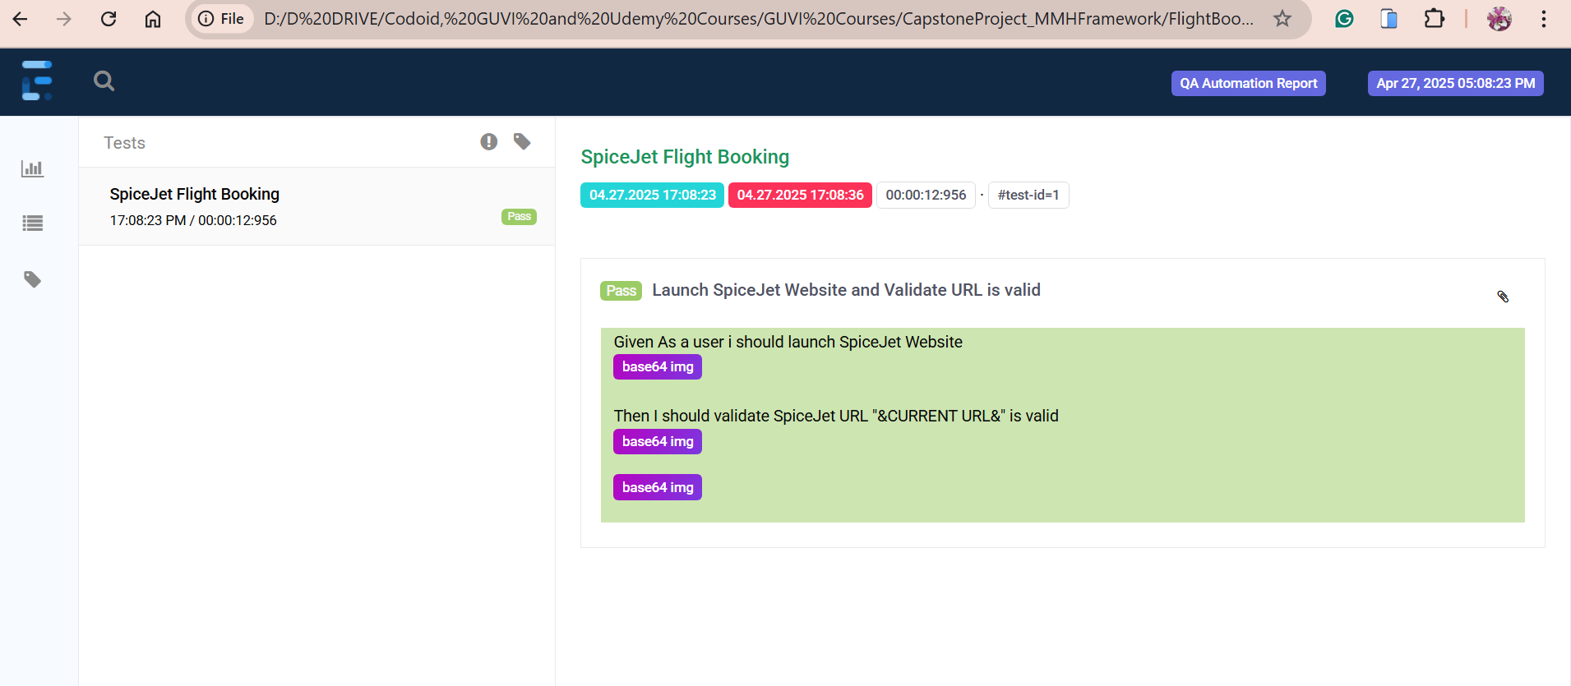

**Scenario Template**: Create Account in SpiceJet with No Test Data and Invalid Data

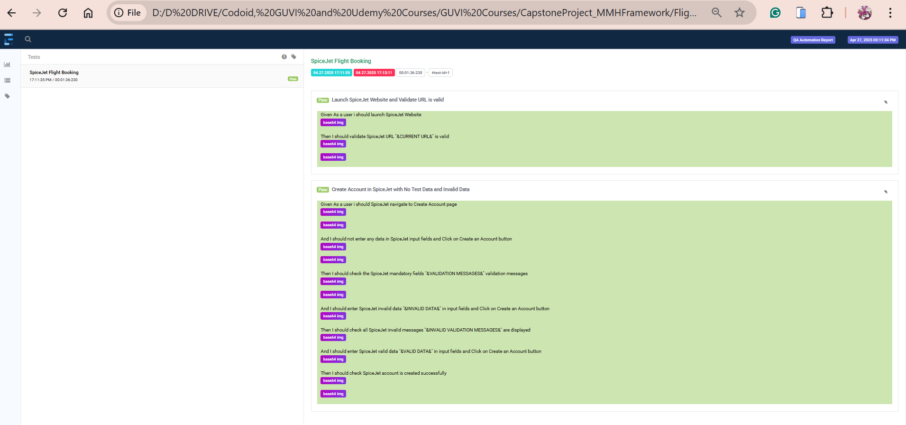

**Scenario Template**: Login with Existing User

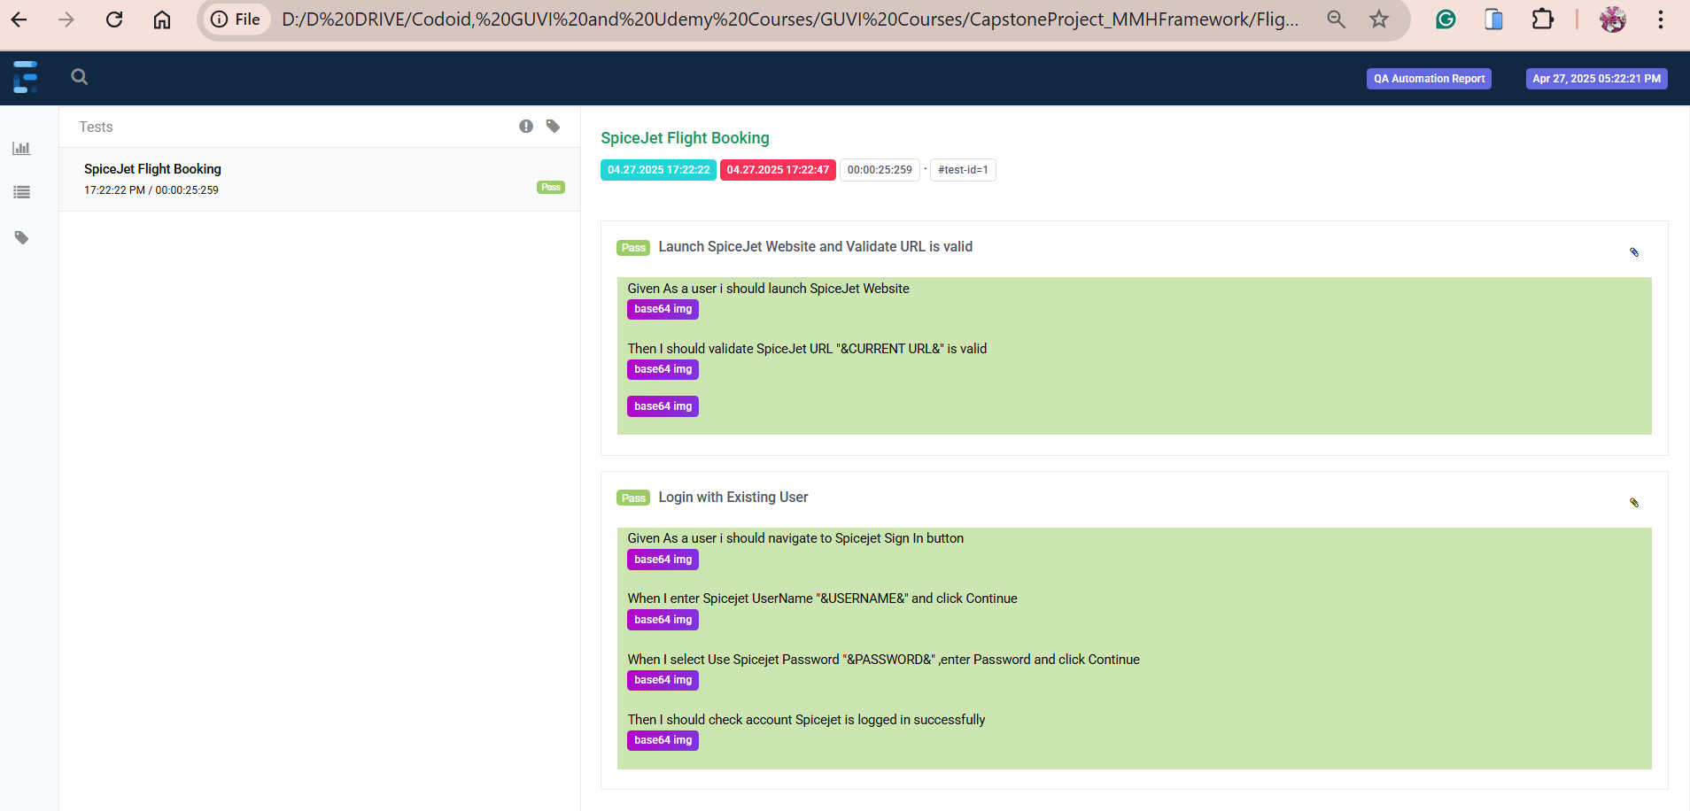

**Scenario Template**: Check flight not available for the respective route

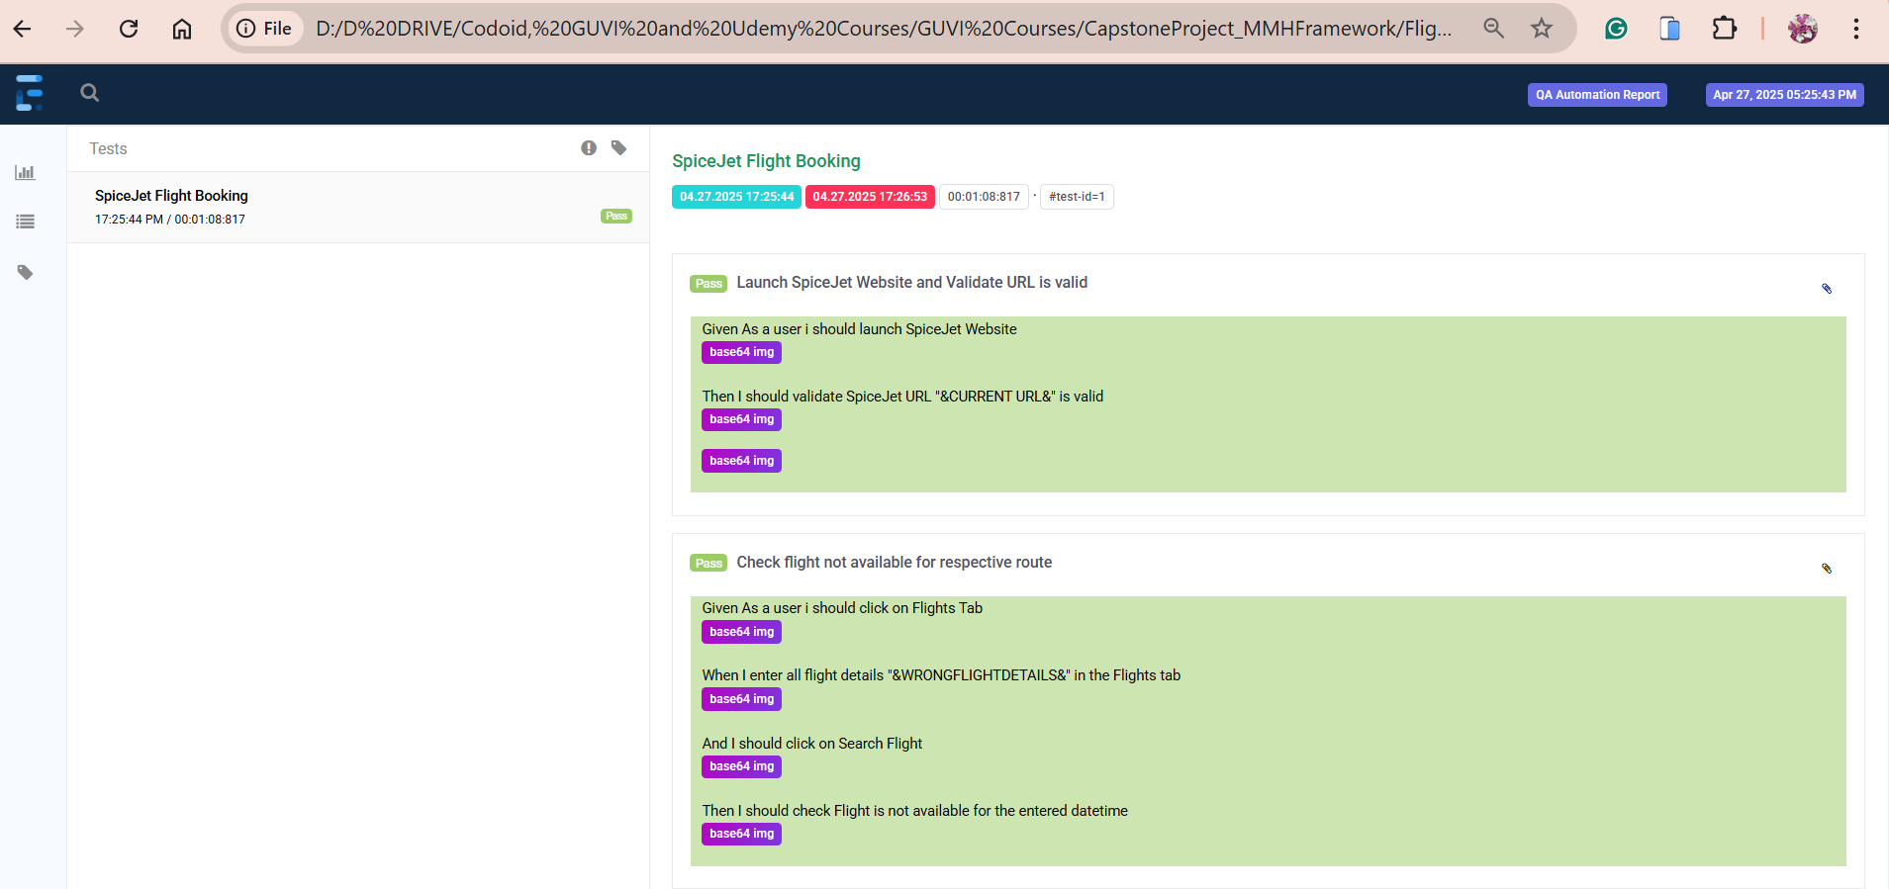

**Scenario Template**: Check Flight One Way trip can be booked successfully

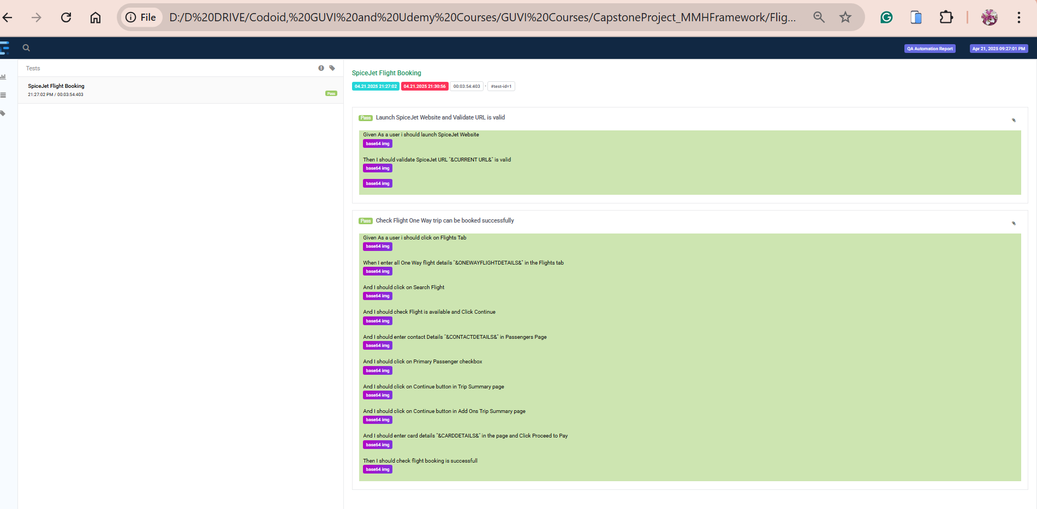

**Scenario Template**: Check Flight Two-way trip can be booked successfully

