**JENKINS Setup Windows Machine**

**1.Download the Jenkins War File**

Using Your Current Java Version

Currently I am Using Jenkins War File Version 2.346

<https://updates.jenkins.io/download/war/>

Create The Folder Save the Jenkins War file

**2.Open CMD Run the Jenkins War File Using Below Comments**

Cmd -java -jar jenkins.war

**3.Create Jenkins Run Path AND Password**

C:\Users\v-gokulakrishnan\.jenkins\secrets\initialAdminPassword

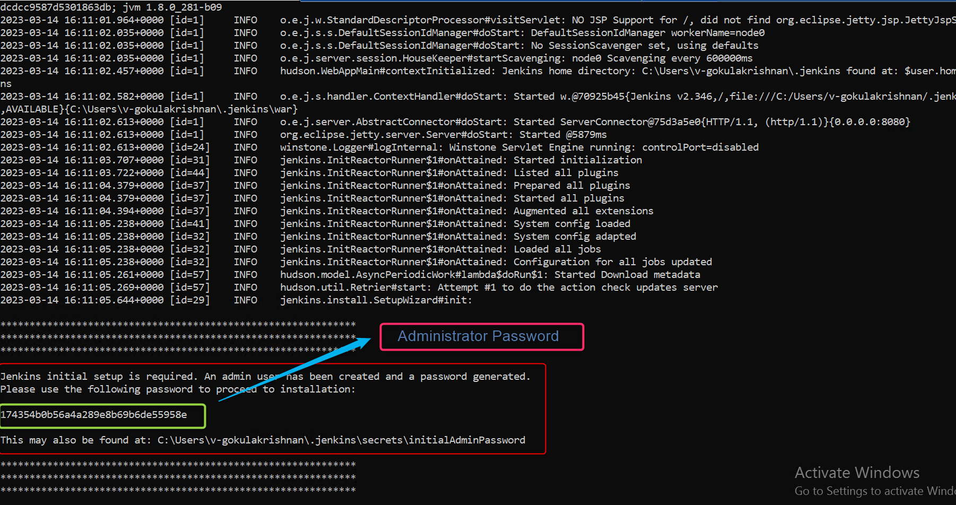

4.**Open Your Chrome Browser**

**Open:** localhost:8080

Enter Administrator Password

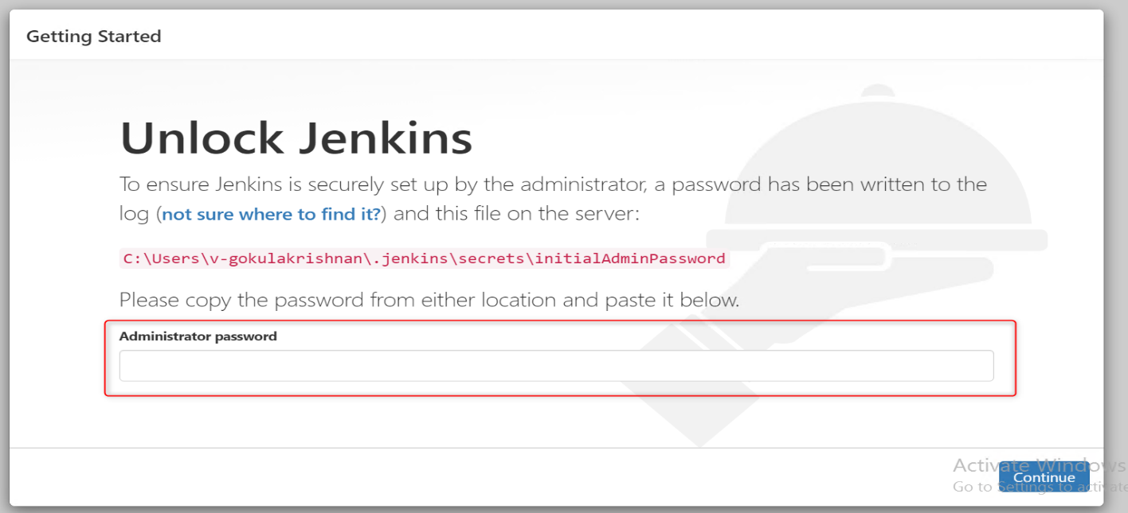

**5.Click Install Suggested Plugins**

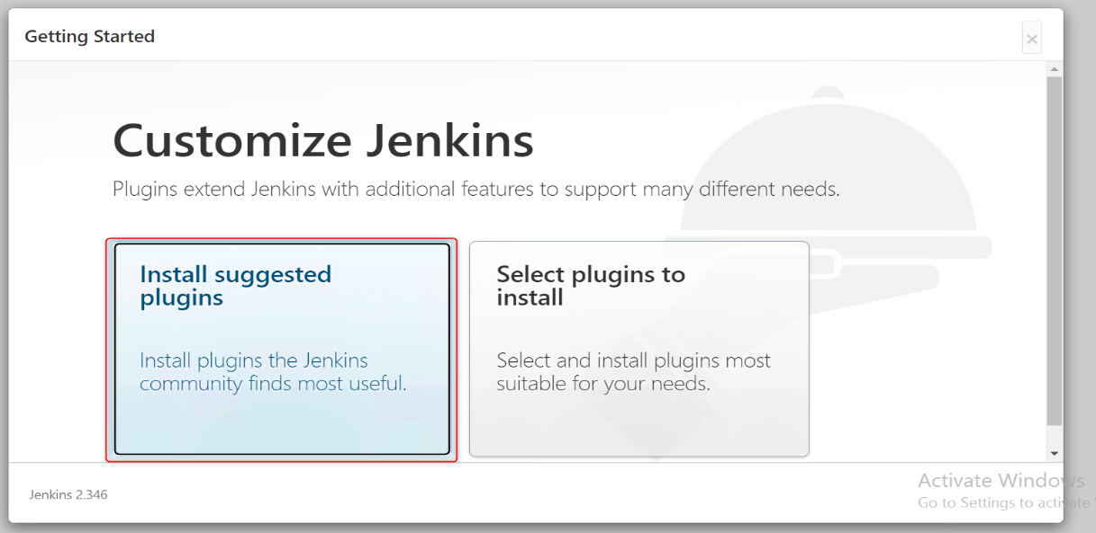

6.Successfully Download the All Files

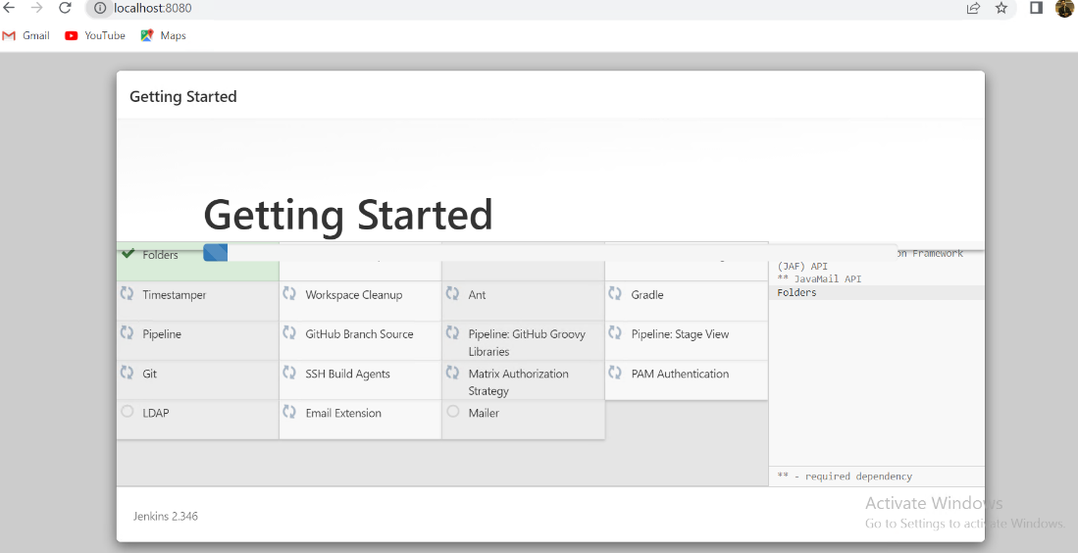

7.Create Username & Password and Enter the Valid Email Address. Click the Save and Continue Button

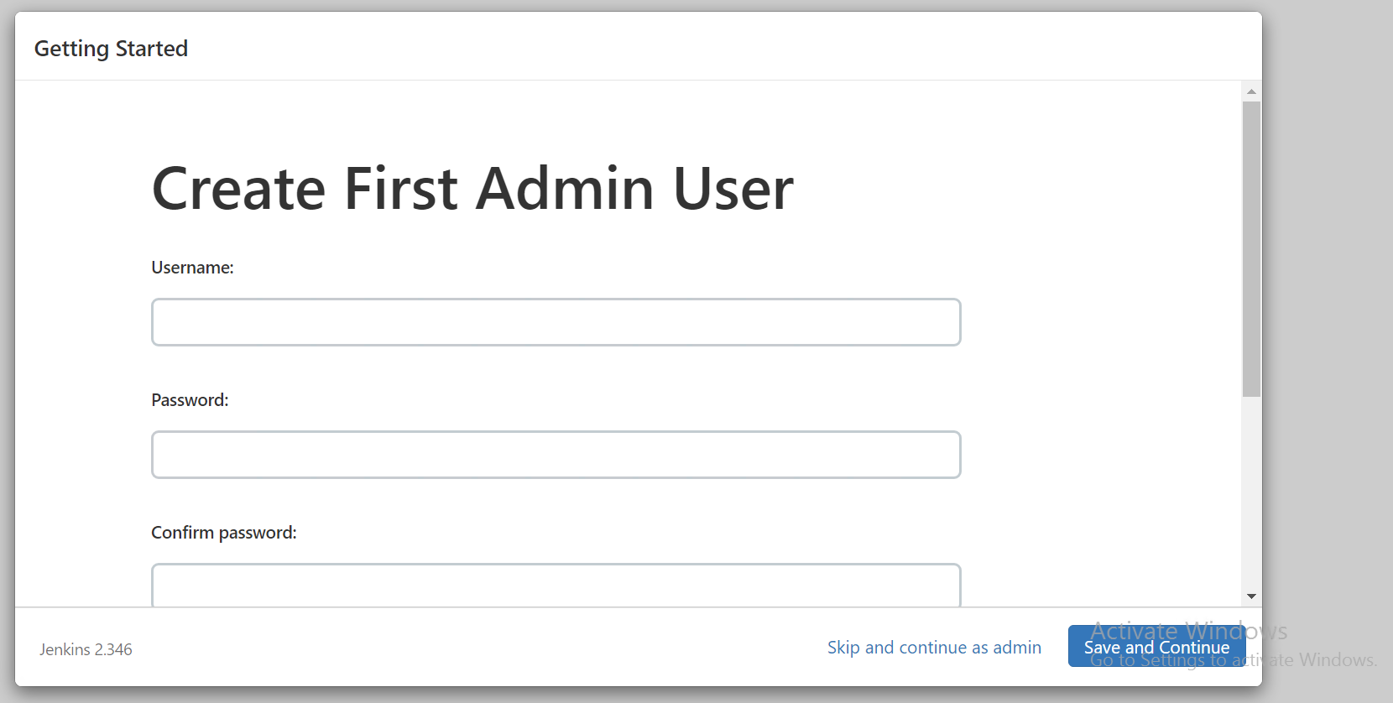

8.Click Save and Finish Button

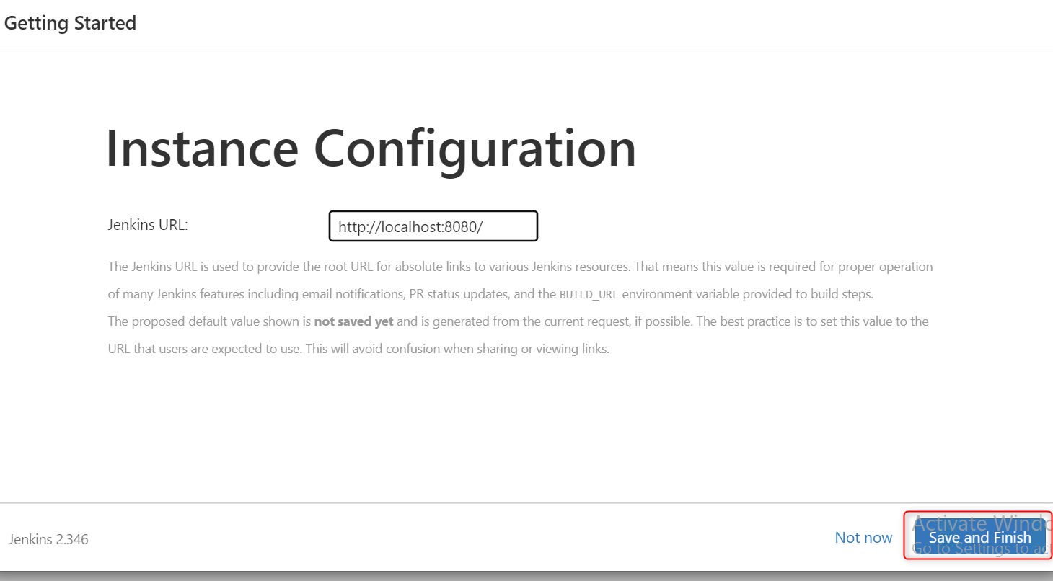

9.Start Using Jenkins

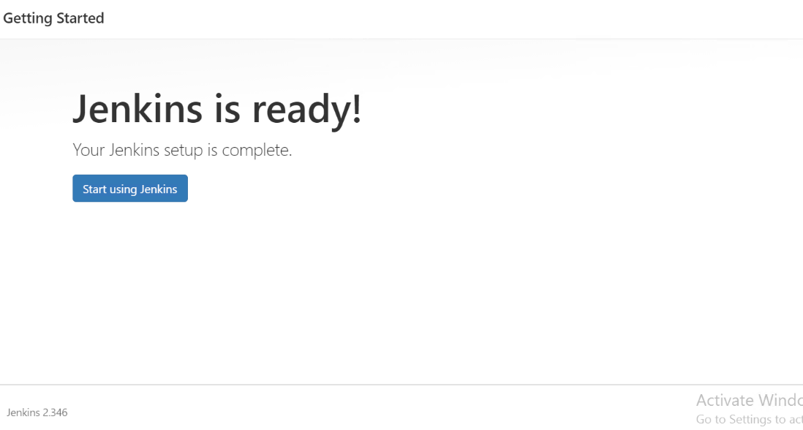

10.Click New Item Create a New Jobs in Jenkins

First Add the Maven Plugins>>Click Manage Jenkins>>Click Maven Plugins

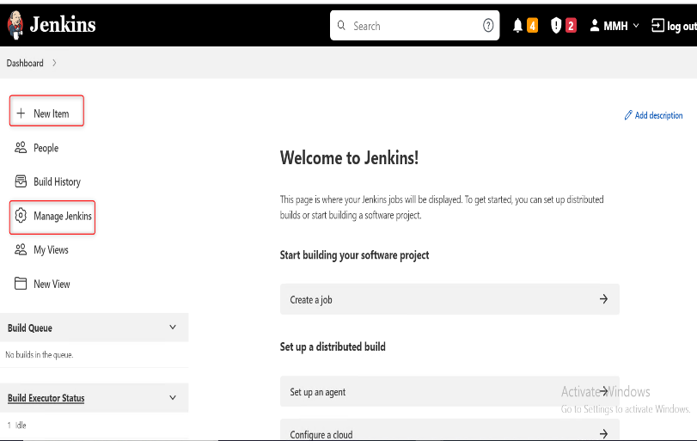 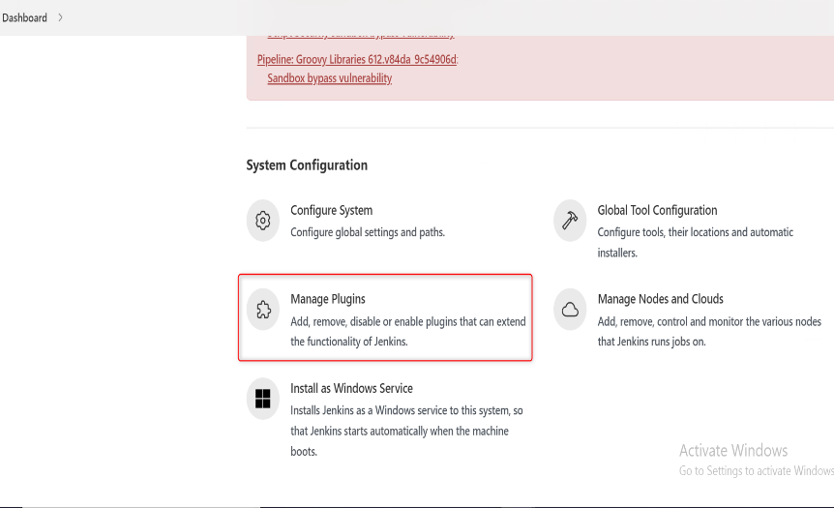

11.Enter Maven Integration >> Click Check Box >> Click Install Without Restart

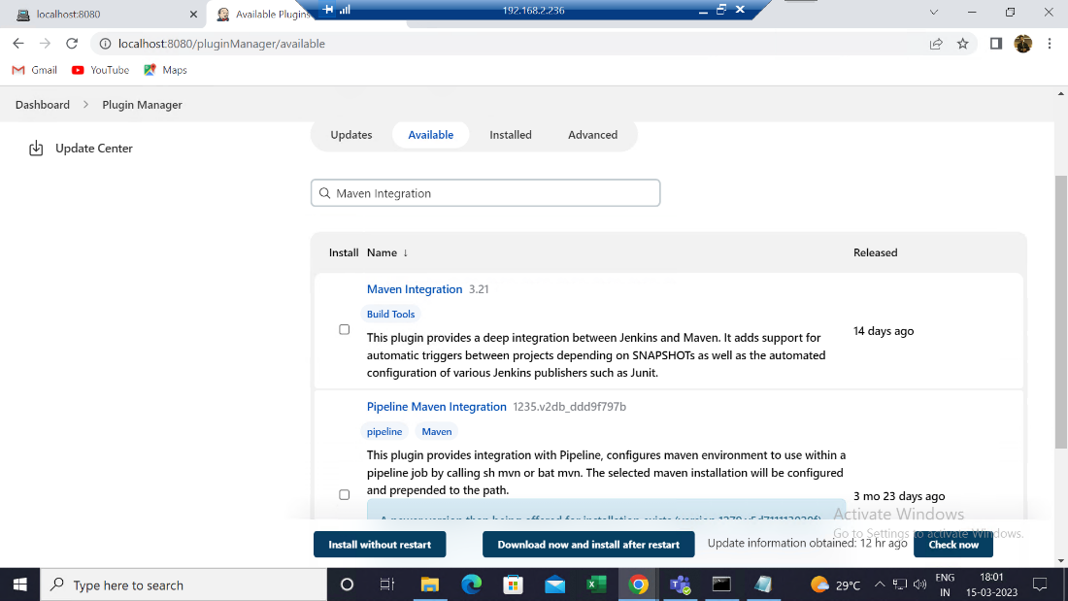

12.Click New Item >> Enter Job Name >> Choose Maven Project >> Click Ok Button

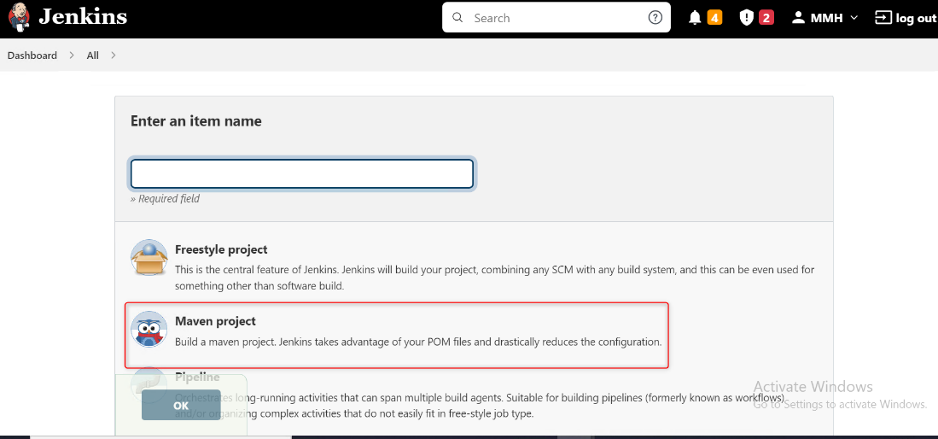

13. Enter Description

Example: **clean test -Dapp=Happy_Path_Patient_Web_and_MR -Dexecution_type=browser -Drunner=DemoWebCukes -Dbrowser_name=chrome -Denv=PROD "-DargLine=-Dextent.reporter.spark.out=reports/Extent-Report/Web-QAResults.html -Dsysteminfo.AppName=Demo-QA"**

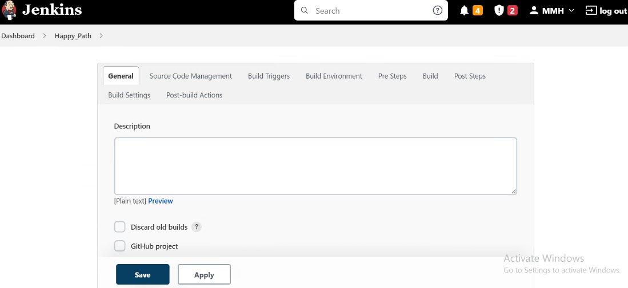

**14.Navigate to Source Code Management**

1.Choose the git You have to run the Git code in Jenkins

2.Choose None Option you have to Run Local Code

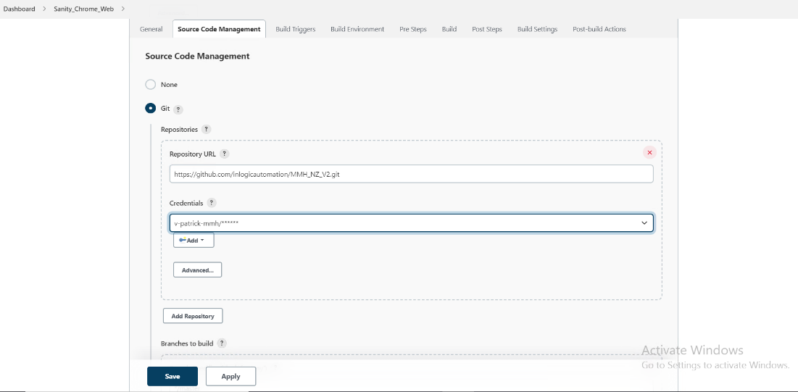

15.Click Git Option >> Add the Git Credentials >> Enter Username & Password >> Click Save Button >> Successfully Add the Git Credentials

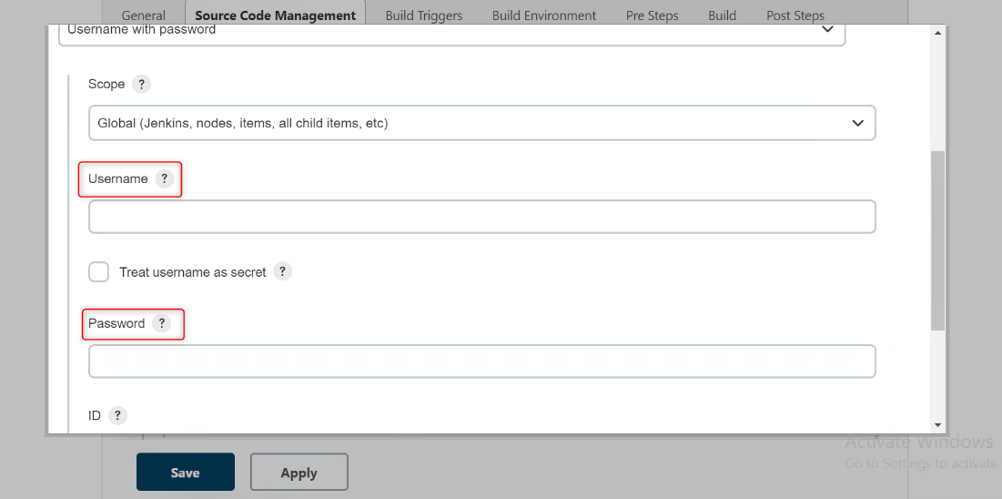

16.Add the Branch

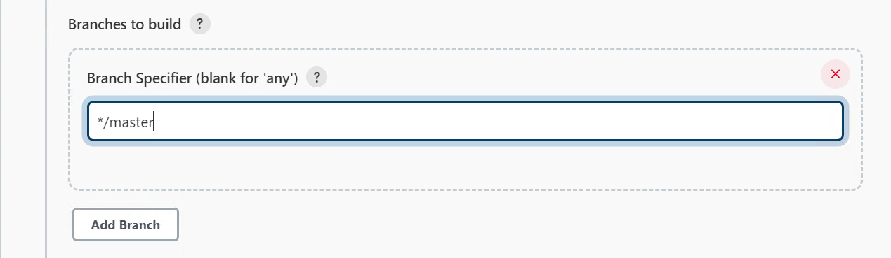

17.Set the Maven Configuration >>> Click the “**The tool Configuration**” link

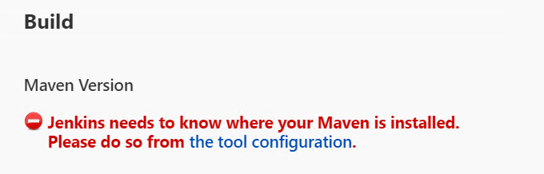

**18.Add “ JDK ”**

1.Enter Name

2. Uncheck Automatically Install Check box

3.Enter JAVA_HOME PATH

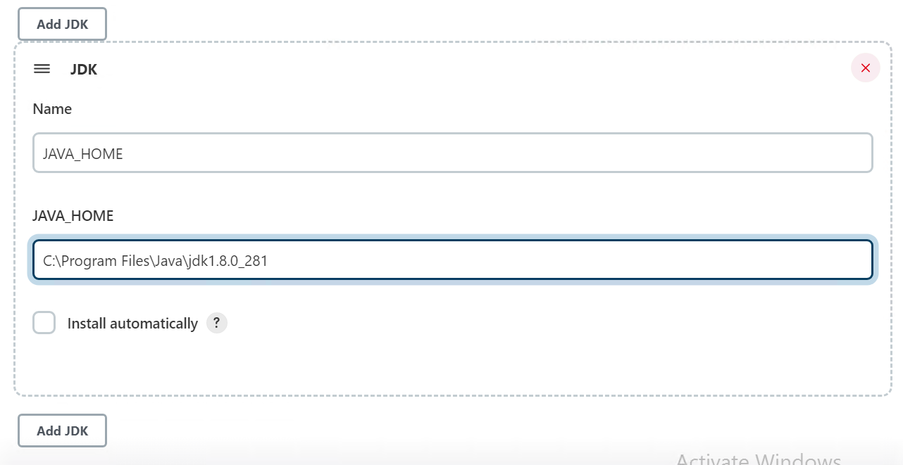

**19.Add Git**

1.Enter Name

2.Enter Git Executable Path > > choose your Git Installation Path in your Computer >> “ **git.exe** “

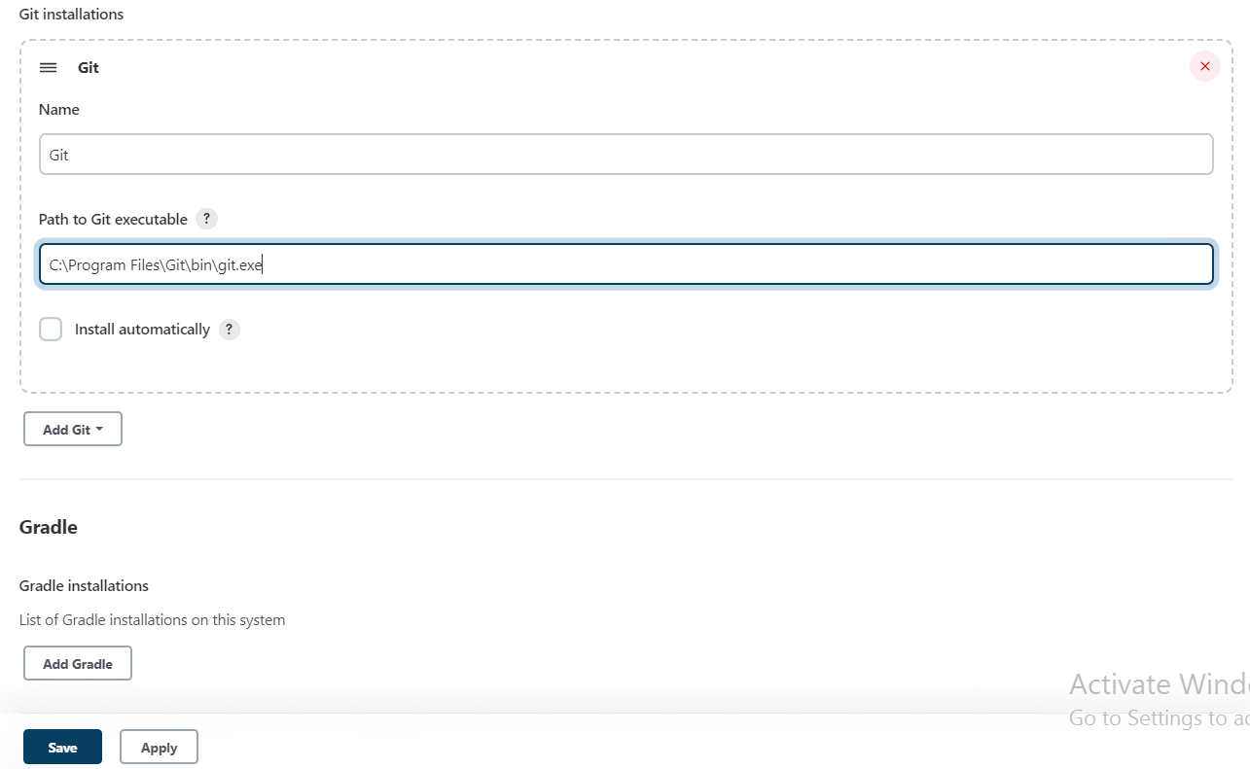

**20.Add Maven**

1.Enter Name

2.Enter Git Executable Path > > choose your Git Installation Path in your Computer

3. Uncheck Automatically Install Check box

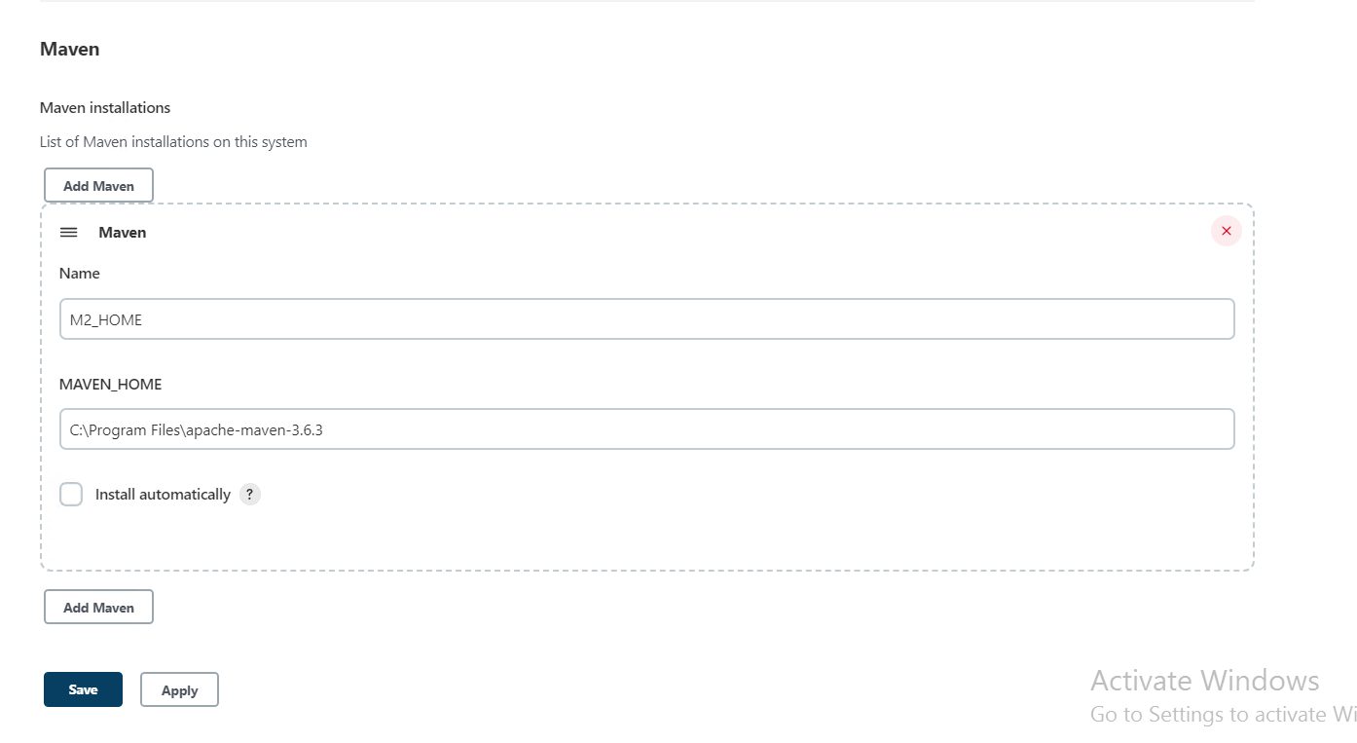

Click Apply and Save

**21.Face this Error Add the Git Plugins**

1. Click Manage Jenkins>>Click Maven Plugins

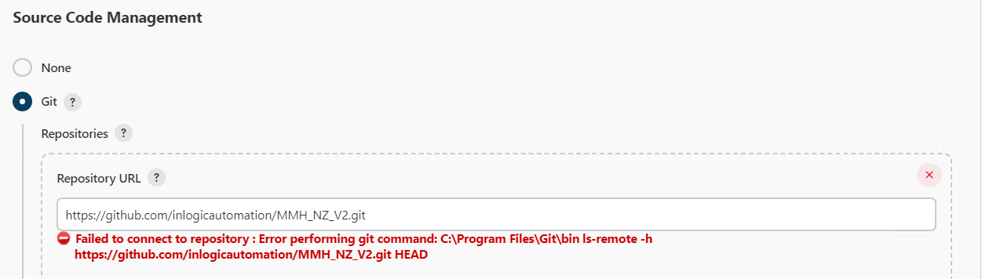

2.Search Git Server

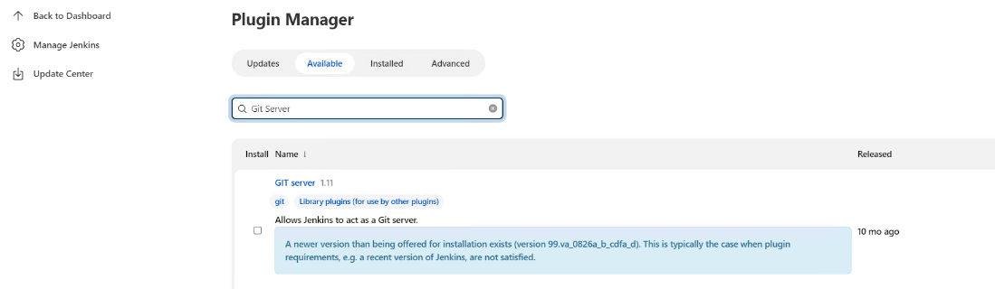

3.Click Check Box >> Click Install and Without Restart Button

**22.Navigate to Build Page**

1.Enter the Maven Goals

2.Click Apply and Save

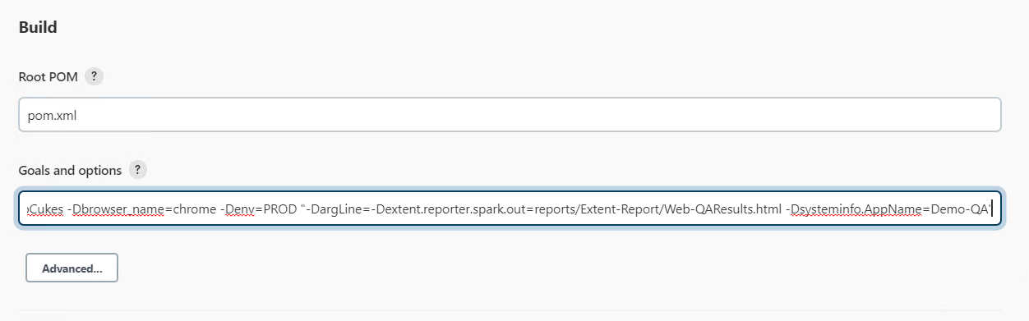

**23.Navigate to Post Build Action >> Add the Reports Section**

1. Add the HTML Publisher Plugins >> Click Manage Jenkins >> Click Maven Plugins >>Search HTML Publisher

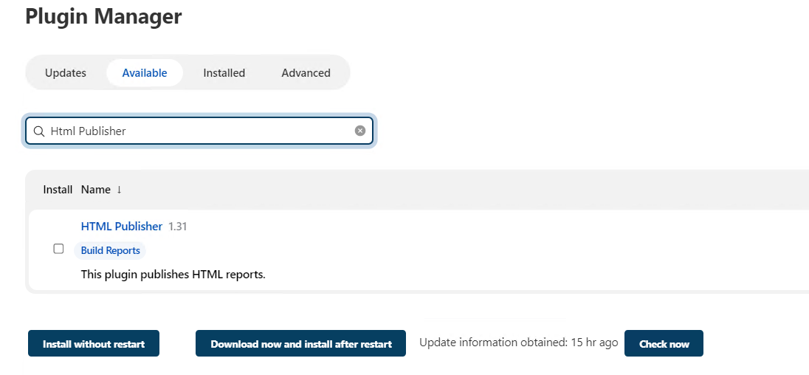

2.Click Check Box >> Click Install and Without Restart Button

3.Click Add Post Build Action >> Choose the Publish HTML reports

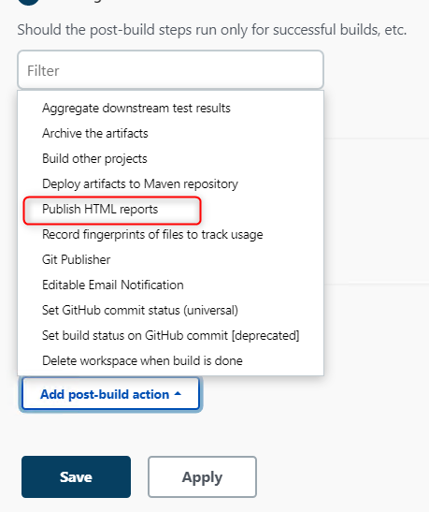

**24.Reports Storage Path**

**1.**Report storage path >> Extent.properties

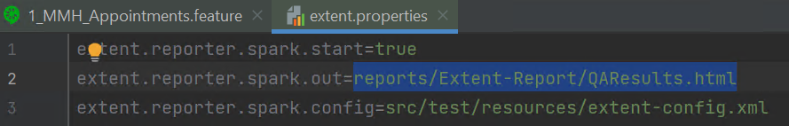

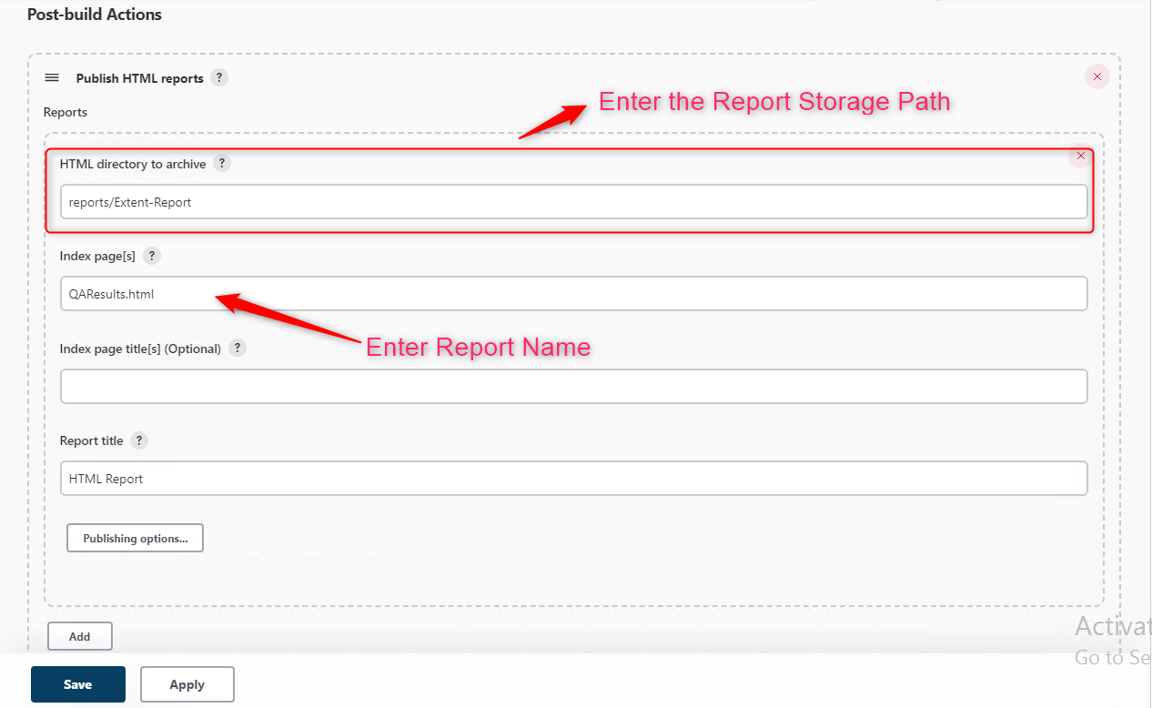

**25.Email Notification**

**1.click Add post build Action >> Choose the Editable Email Notification**

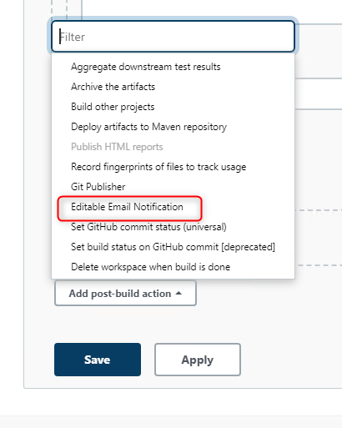

2. Project Recipient List >> Enter the sender mail in textbox

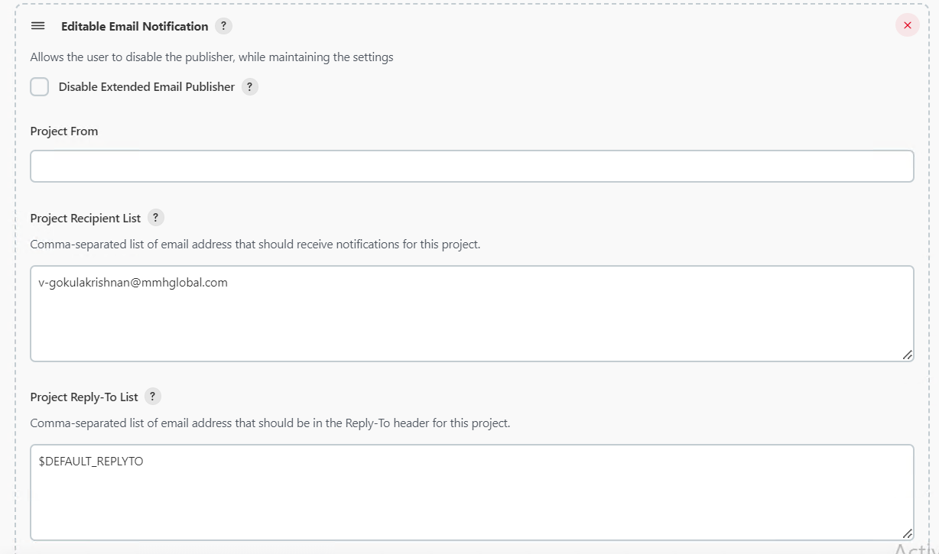

3.Attachments Option >> Sent the report Attachment in sender mail

Enter the Report part :

Example >> reports/Extent-Report/QAResults.html

