# Lab Task – 1

1. Write a c program to find the sum of elements in an array using pointers.

#include<stdio.h>

int main()

{

int a[100], n, sum=0,*p;

p=a;

printf("size of the array: ");

scanf("%d",&n);

printf("enter the values: ");

for(int i=0;i<n;i++)

{

scanf("%d",&a[i]);

}

for(int i=0;i<n;i++)

{

sum=sum+(*p);

p++;

}

printf("sum=%d",sum);

}

**Output :**

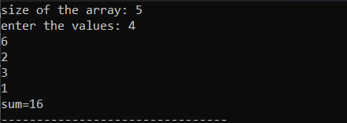

1. Write a c program to swap the values of two integers using pointers.

#include<stdio.h>

int main()

{

int x,y,*a,*b,temp;

printf("enter the values of x and y\n");

scanf("%d%d",&x,&y);

printf("before swapping\nx=%d\ny=%d\n",x,y);

a=&x;

b=&y;

temp=*b;

*b=*a;

*a=temp;

printf("after swapping\nx=%d\ny=%d\n",x,y);

return 0;

}

Output:

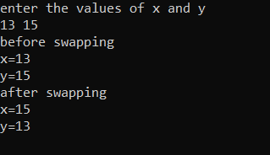

3.write a c program to reverse a string using pointers.

#include<stdio.h>

void reverseString(char *start) {

char *end = start, temp;

while (*end) {

end++;

}

end--;

while (start < end) {

temp = *start;

*start = *end;

*end = temp;

start++;

end--;

}

}

int main() {

char input[100];

printf("Enter a string: ");

gets(input); // Reads the string input

reverseString(input);

printf("Reversed string: %s\n", input);

return 0;

}

Output:



4.write a c program to calculate the power of a number using pointers to functions.

#include<stdio.h>

int power_num(int,int,int*);

int main()

{

int p,b,res;

printf("Enter base and power : ");

scanf("%d%d",&b,&p);

int (*power)(int,int,int*)=&power_num;

(*power)(b,p,&res);

printf("%d to the power of %d is %d",b,p,res);

}

int powerofnum(int x,int y,int*ans)

{

*ans=1;

for(int i=1;i<=y;i++)

{

*ans=(*ans)*x;

}

}

Output :

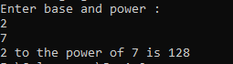

5. Write a C program that dynamically allocates memory for a 2D array based on user input.

#include<stdio.h>

#include<stdlib.h>

int main()

{

int r,c,*row,*column,*arr;

row=&r;

column=&c;

printf("Enter number of rows and columns : \n");

scanf("%d%d",&r,&c);

arr=(int*)malloc(r*c*sizeof(int));

printf("Enter the values : \n");

for(int i=0;i<(*row);i++)

{

for(int j=0;j<(*column);j++)

{

scanf("%d",&arr[i*(*column)+j]);

}

}

printf("2D matrix\n");

for(int i=0;i<(*row);i++)

{

for(int j=0;j<(*column);j++)

{

printf("%d ",arr[i*(*column)+j]);

}

printf("\n");

}

}

Output :

