Flask API and MongoDB Form Submission Project

1. Flask API Route
This project includes a Flask application with an /api route.
When accessed, this route returns a JSON list. The data is stored in a backend file (data.json),
read from it, and sent as a response.
Sample Code:
from flask import Flask, jsonify
import json
app = Flask(__name__)
@app.route('/api')
def get_data():
with open('data.json') as f:
data = json.load(f)
return jsonify(data)
if __name__ == '__main__':
app.run(debug=True)
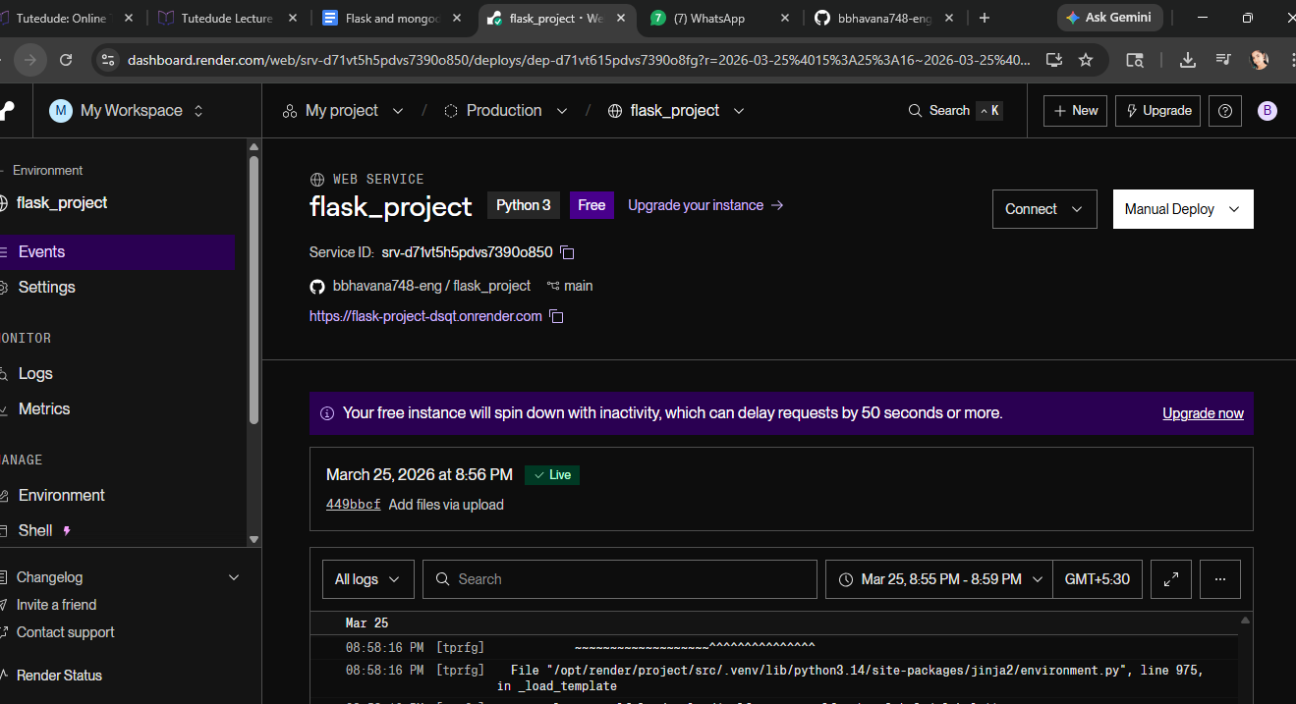

2. Frontend Form with MongoDB Atlas
A frontend form is created using HTML. When submitted, the data is stored in MongoDB Atlas.
On successful submission, the user is redirected to a success page displaying:
'Data submitted successfully'.
If an error occurs, the error message is displayed on the same page.
Sample Flask Code:
from flask import Flask, render_template, request, redirect, url_for
from pymongo import MongoClient
client = MongoClient("your_mongodb_connection_string")
db = client['testdb']
collection = db['users']
@app.route('/', methods=['GET', 'POST'])
def form():
if request.method == 'POST':
try:
data = {
"name": request.form['name'],
"email": request.form['email']
}
collection.insert_one(data)
return redirect(url_for('success'))
except Exception as e:
return str(e)
return render_template('form.html')
@app.route('/success')
def success():
return "Data submitted successfully"

