BITROXIA MULTI-TENANT PMS
Superadmin Operations Manual & Standard Operating Procedures (SOP)
Document ID: PMS-SOP-SADM-001 | Classification: STRICTLY CONFIDENTIAL — SUPERADMIN ONLY
Platform Engine: Bitroxia Multi-Tenant SaaS (Dynamic Database Isolation)
Central Master Database: pms_central | Tenant Scope: Cross-Tenant Master Administration
Release Version: v3.4.0 Production Enterprise | Effective Date: September 2026

This manual establishes the mandatory operational protocols and technical procedures governing the Bitroxia Multi-Tenant Project Management Platform. Superadmins hold complete authority across central billing, multi-database schema synchronization, tenant corporate provisioning, forensic audit investigation, infrastructure health diagnostics, developer work routing, and dispute arbitration.
1. Superadmin Authentication & Session Security
1.1 Super Admin Secure Login
🧭 Navigation Path: Direct URL Gateway > https://your-domain.com/super-admin/login

📷 SCREENSHOT PLACEHOLDER: Superadmin Login Portal
Target UI Capture: Super Admin Luxury Emerald Login Portal showing Central Logo, Email, Password, Remember Me, and 'Sign In to Command Center' CTA
Recommended Viewport: 16:9 Desktop
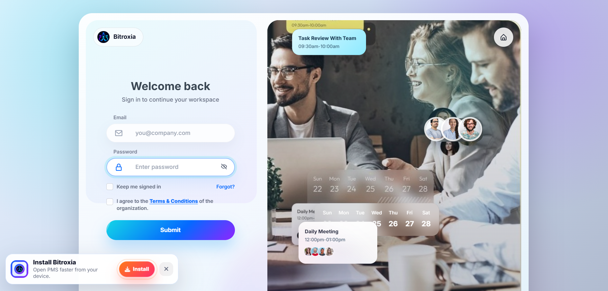

The Super Admin login portal provides isolated authentication into the central platform management database (pms_central). Unlike regular tenant login pages, this endpoint exclusively queries the super_admin authentication guard and verifies operator privileges before issuing session cookies.
Field Specifications & Requirements
- Email Address: Superadmin Corporate Email: Must match a registered platform operator record in pms_central.super_admins.
- Passphrase: Secret Master Passphrase: Encrypted using multi-round Argon2id/Bcrypt hash verification.
- Remember Me Checkbox: Extends the active session lifetime to 30 calendar days on trusted platform management terminals.
[IMPORTANT] Brute-force mitigation automatically triggers a temporary IP-level lockout after 5 consecutive failed authentication attempts. Every login attempt logs the UTC timestamp and remote IPv4/IPv6 address.

1.2 Session Invalidation & Secure Sign-Out
🧭 Navigation Path: Top Header Bar > Profile Menu (Avatar Initials) > Executive Dropdown > Click 'Sign Out'

📷 SCREENSHOT PLACEHOLDER: Executive Sign Out & Profile Dropdown
Target UI Capture: Top-right profile dropdown showing Operator Initials, Name, Email, Health Shortcuts, and Red 'Sign Out' action button
Recommended Viewport: 4:3 Desktop
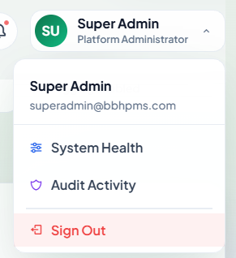

Terminating an active session flushes the authentication tokens across both the super_admin guard and the fallback web guard, regenerating CSRF tokens and clearing the PHP session store. The browser is immediately redirected to the unauthenticated landing route, preventing session hijacking.
2. Command Center Dashboard
2.1 Central Command Center Hero & Real-Time Overview
🧭 Navigation Path: Super Admin Sidebar > Command Center > Dashboard

📷 SCREENSHOT PLACEHOLDER: Command Center Hero & Live Service Status
Target UI Capture: Hero Banner with 'System Operational' pulse badge, real-time date indicator, 'Provision Tenant' CTA, and Quick Report Download
Recommended Viewport: 16:9 Desktop
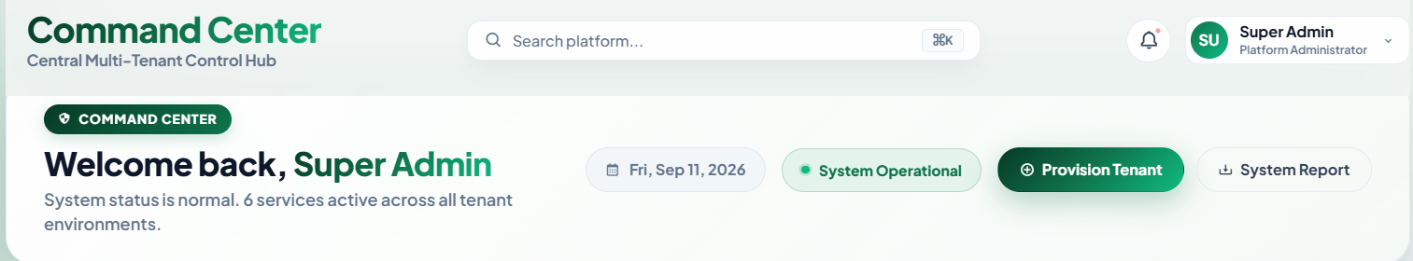

The Command Center serves as the central operational hub for executive platform operators. It aggregates cross-tenant key performance indicators (KPIs), microservice health telemetry, financial billing velocity, and recent audit activity.
2.2 Global Multi-Tenant KPI Metric Cards
🧭 Navigation Path: Super Admin Sidebar > Command Center > Dashboard > Section: 'KPI Grid'

📷 SCREENSHOT PLACEHOLDER: KPI Metrics & Sparkline Visualizations
Target UI Capture: 6 Animated Counter Cards with micro-sparklines: Total Companies, Active Tenants, Expiring Soon, Company Admins, Total Users, Monthly Revenue
Suggested Filename: docs/screenshots/04_kpi_metrics_grid.png | Recommended Viewport: 16:5 Desktop
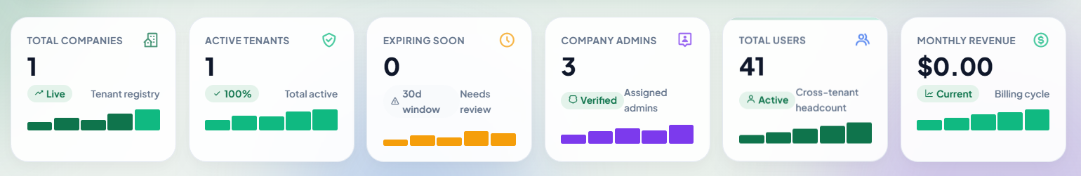

The dashboard aggregates real-time metrics across all tenant schemas into 6 counter-animated KPI cards:
- 1. Total Companies: Absolute count of tenant corporations registered in pms_central.companies.
- 2. Active Tenants: Percentage and count of corporate organizations currently authorized to operate without administrative lock.
- 3. Expiring Soon: Contracts concluding within 30 days, alerting operators to engage customer executives for renewals.
- 4. Company Admins: Total verified root tenant administrators assigned across registered company databases.
- 5. Total Headcount: Aggregate headcount of employees, managers, and client accounts operating across all tenant environments.
- 6. Monthly Revenue: Gross monthly processed subscription revenue in USD ($) derived from completed gateway invoices.
2.3 Platform Analytics & Distribution Visualizations
🧭 Navigation Path: Super Admin Sidebar > Command Center > Dashboard > Section: 'Platform Analytics & Metrics'

📷 SCREENSHOT PLACEHOLDER: Distribution Charts & Cohort Analytics
Target UI Capture: Left Bar Chart (Companies Distribution by Plan with 7D/30D/1Y filters) and Right Donut Chart (Company Status Breakdown: Active, Trial, Suspended)
Suggested Filename: docs/screenshots/05_platform_charts.png | Recommended Viewport: 16:9 Desktop
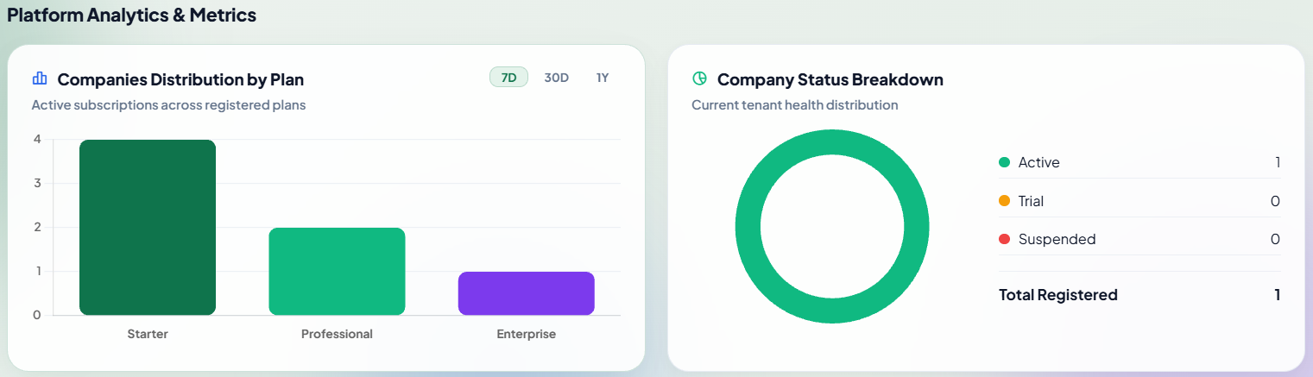

Interactive visual analytics provide continuous insights into plan adoption and overall fleet stability:
- Plan Distribution Bar Chart: Visualizes subscription density across Free, Gold, Platinum, and Diamond tiers with 7-Day, 30-Day, and 1-Year historical trend filters.
- Company Status Donut Chart: Categorizes tenant corporations into Active (Compliant), Trial (Evaluating), and Suspended (Locked due to non-payment or administrative sanction).
2.4 Quick Audit Activity Stream & Expiring Tenant Alerts
🧭 Navigation Path: Super Admin Sidebar > Command Center > Dashboard > Section: 'Activity & Alerts Row'

📷 SCREENSHOT PLACEHOLDER: Dashboard Activity Stream & Expiring Subscriptions List
Target UI Capture: Split cards: Left Audit Activity Logs timeline with tenant tags and IPs; Right Expiring Tenant Subscriptions with 1-click 'Review' buttons
Suggested Filename: docs/screenshots/06_dashboard_activity_feed.png | Recommended Viewport: 16:9 Desktop
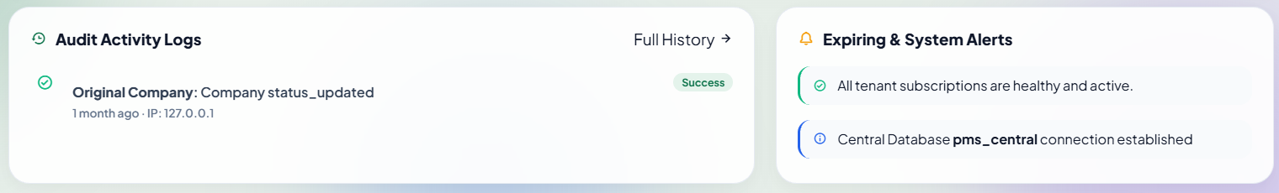

The lower dashboard row displays live platform telemetry, including the 5 most recent high-severity operational events and an actionable list of expiring tenant contracts with direct review modals.
3. Tenant Company Management & Registry
3.1 Central Tenant Registry & Search Engine
🧭 Navigation Path: Super Admin Sidebar > Tenant Management > Companies (or URL: /super-admin/companies)

📷 SCREENSHOT PLACEHOLDER: Tenant Companies Directory
Target UI Capture: Central Companies Registry table showing Company Logos, Names, Subdomains, Database Schemas, Status Badges, Plan Badges, Admins, and Action Menus
Suggested Filename: docs/screenshots/07_tenant_companies_registry.png | Recommended Viewport: 16:9 Desktop
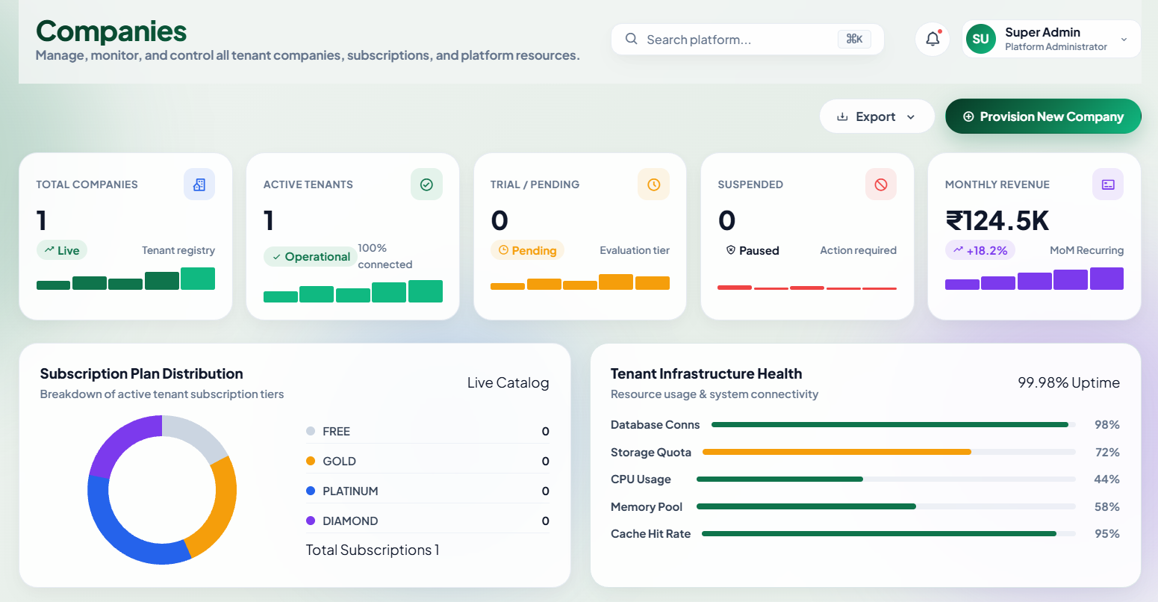

The Central Tenant Registry maintains the definitive inventory of all client corporations operating within the multi-tenant ecosystem.
Column Name | Technical Representation | Operational Purpose
Company Profile | Logo + Name + Email | Identifies corporate legal entity and billing communication channel.
Subdomain Identifier | Monospace tag (e.g. acme) | DNS host prefix used to dynamically route client HTTP requests.
Isolated Database | pms_{company_slug} | Dedicated database schema storing all company project and financial data.
Status State | Active / Trial / Suspended | Real-time licensing state controlling user ingress.
Plan Tier | Free / Gold / Platinum / Diamond | Active commercial contract determining feature entitlements.
Assigned Admin | Primary Admin Name & Link | Root corporate executive account inside the tenant database.
Expiration Date | UTC Timestamp + Days Badge | Contractual expiration date determining grace period triggers.

3.2 Tenant Lifecycle & Status Modification
🧭 Navigation Path: Super Admin Sidebar > Tenant Management > Companies > Action Menu (...) > Click 'Change Status'

📷 SCREENSHOT PLACEHOLDER: Tenant Status Modification Dialog
Target UI Capture: Status control modal with radio options (Active, Trial, Suspended, Deactivated), Reason text area, and Save confirmation button
Suggested Filename: docs/screenshots/08_tenant_status_modal.png | Recommended Viewport: 4:3 Desktop
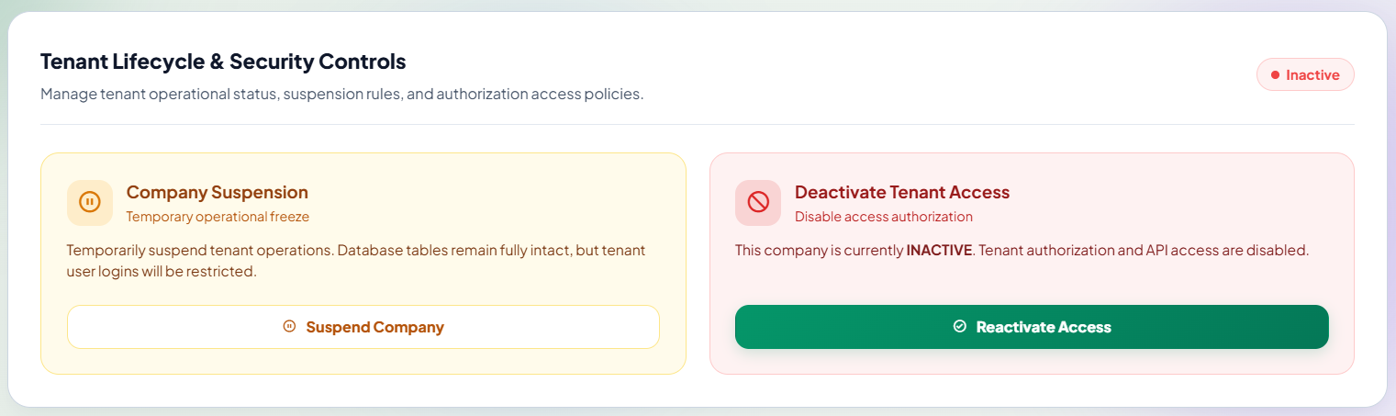

Superadmins can adjust corporate tenant lifecycle states with instant platform-wide enforcement:
- Active: Standard production state. All employees, managers, and clients experience normal authenticated access.
- Trial: Evaluation state with active top-bar countdown notifying administrators of contract expiration dates.
- Suspended: Restricted state. Tenant database remains intact; user logins are intercepted and redirected to a suspension lock screen.
- Deactivated: Decommissioned state. All tenant ingress and scheduled background cron jobs are completely halted.
3.3 Seamless Tenant Workspace Ingress (Impersonation Mode)
🧭 Navigation Path: Super Admin Sidebar > Tenant Management > Companies > Row Actions > Click 'Enter Company'

📷 SCREENSHOT PLACEHOLDER: Tenant Impersonation Mode Banner
Target UI Capture: Tenant internal dashboard view showing the top Amber Ingress Banner: 'Viewing [Company Name] in Super Admin Mode' with 'Leave Impersonation' CTA
Suggested Filename: docs/screenshots/09_tenant_impersonation_banner.png | Recommended Viewport: 16:9 Desktop
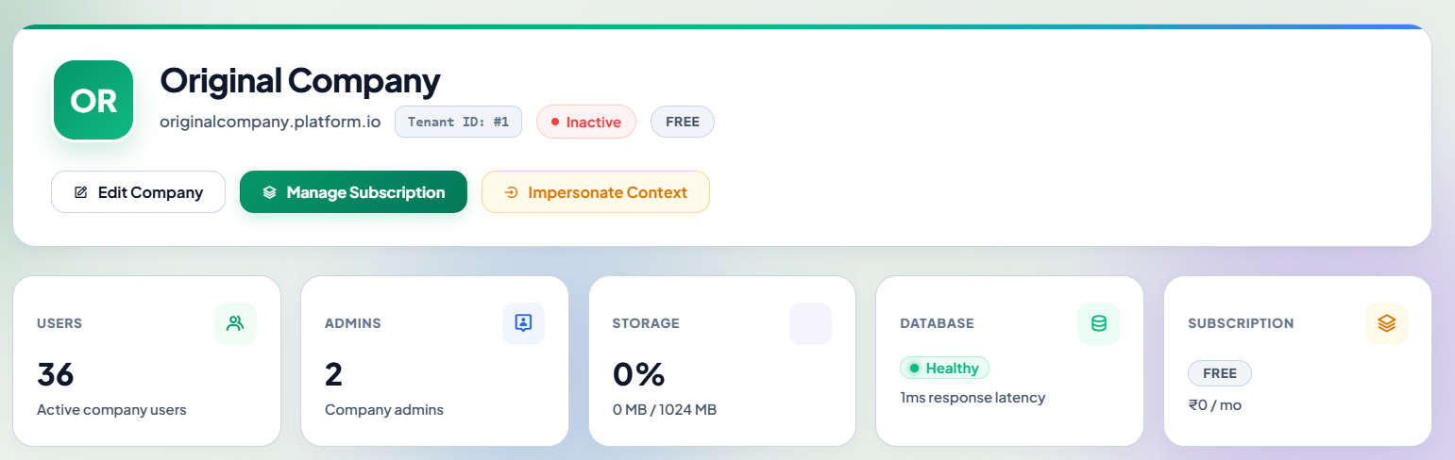

Tenant Workspace Ingress allows Superadmins to bypass standard authentication credentials and step directly into any tenant organization's environment with full administrative permissions for technical diagnostics, dispute reviews, or custom setups.
[IMPORTANT] Entering a company dynamically switches database connection contexts from 'central' to the isolated tenant schema ('pms_{company_slug}'). All actions performed during impersonation are audited with the Superadmin's real identity.

4. Tenant Provisioning & Setup Wizard
4.1 Step 1: Corporate Profile & Subdomain Routing
🧭 Navigation Path: Super Admin Sidebar > Tenant Management > Companies > Click '+ Provision Tenant' (or URL: /super-admin/companies/create)

📷 SCREENSHOT PLACEHOLDER: Tenant Provisioning - Corporate Profile
Target UI Capture: Step 1 Form: Company Legal Name, Auto-generated Subdomain Slug field, Primary Email, Phone Number, Corporate Address, and Brand Logo Uploader
Suggested Filename: docs/screenshots/10_provision_step1_profile.png | Recommended Viewport: 16:9 Desktop
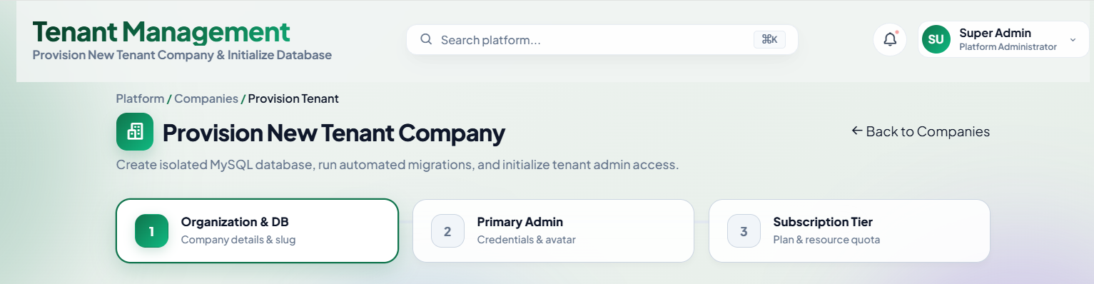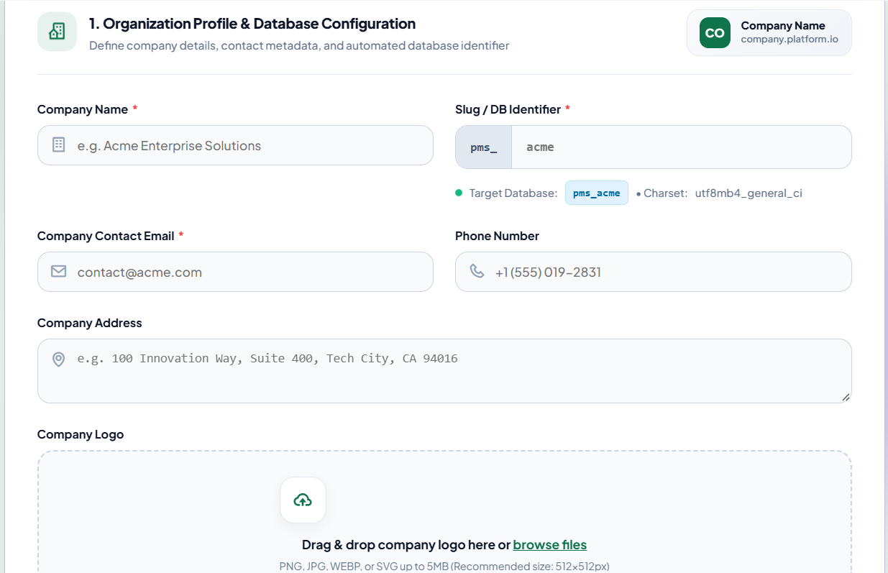

The Provisioning Wizard executes an automated pipeline that creates the central corporate metadata, dynamically provisions an isolated database schema, runs database migrations, and seeds initial administrator accounts.
- Company Legal Name (Required): Full registered commercial title of the customer corporation.
- Subdomain Slug (Required): Unique DNS prefix. Automatically sanitized to lowercase alphanumeric characters and hyphens (e.g. acme -> acme.yourplatform.com).
- Billing Email (Required): Primary corporate recipient for automated billing invoices, tax receipts, and platform notices.
- Company Brand Logo (Optional): PNG, JPG, or SVG raster/vector graphic used across corporate invoices and client portals.
4.2 Step 2: Primary Tenant Administrator Account Setup
🧭 Navigation Path: Super Admin Sidebar > Tenant Management > Companies > Provision Tenant > Section: 'Primary Administrator'

📷 SCREENSHOT PLACEHOLDER: Tenant Provisioning - Primary Administrator
Target UI Capture: Step 2 Form: Admin Full Legal Name, Corporate Admin Email, Auto-generate Strong Password button, Password input with reveal toggle
Suggested Filename: docs/screenshots/11_provision_step2_admin.png | Recommended Viewport: 16:9 Desktop
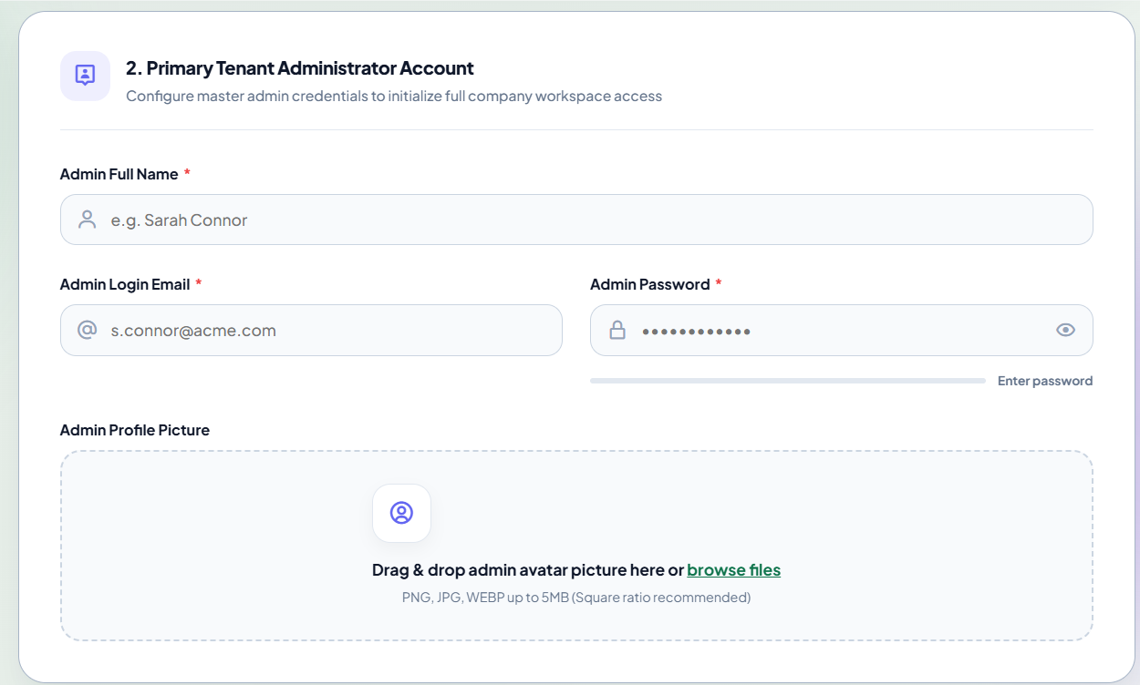

Sets up the initial root administrator account inside the isolated tenant database with full administrative privileges:
- Admin Full Name (Required): Full name of the designated corporate executive managing the platform deployment.
- Admin Email Address (Required): Corporate login credential for authenticating into the tenant's workspace.
- Initial Master Password (Required): Passphrase meeting security criteria (min 8 characters, alphanumeric + symbols). Includes a 1-click 'Generate Strong Password' button.
- Send Welcome Email (Checkbox): Dispatches an automated onboarding email containing the tenant's dedicated URL, username, and temporary credentials.
4.3 Step 3: Subscription Tier & Feature Entitlement Selection
🧭 Navigation Path: Super Admin Sidebar > Tenant Management > Companies > Provision Tenant > Section: 'Subscription Tier'

📷 SCREENSHOT PLACEHOLDER: Tenant Provisioning - Subscription Selection
Target UI Capture: Step 3 Form: Selectable Tier Cards (Free, Gold, Platinum, Diamond) with user limits, storage capacities, and module chips
Suggested Filename: docs/screenshots/12_provision_step3_plan.png | Recommended Viewport: 16:9 Desktop
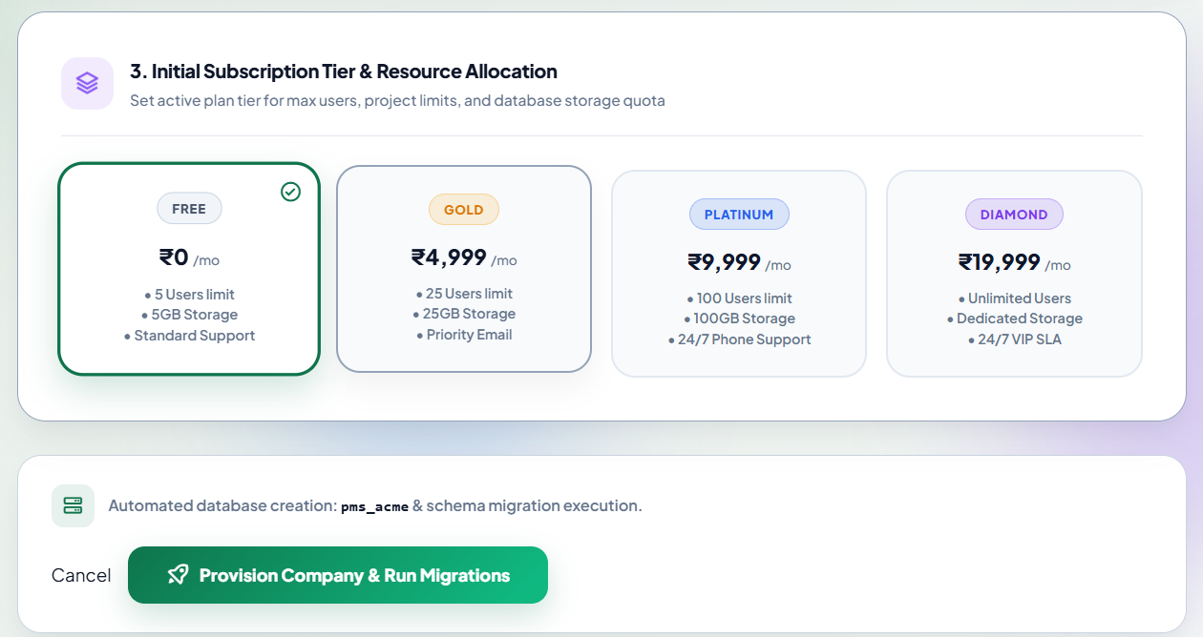

Assigns initial commercial terms. Superadmins select between standard tiers (Free, Gold, Platinum, Diamond) or enable a 14-day/30-day evaluation trial.
Automated Execution Pipeline: Clicking 'Provision Enterprise Tenant' triggers the automated background pipeline:
- 1. Central Metadata Registration: Inserts central record into pms_central.companies.
- 2. Dynamic Schema Provisioning: Executes dynamic schema creation: CREATE DATABASE pms_{slug};
- 3. Multi-Tenant Schema Migration: Applies all migration files across the new isolated database.
- 4. Default Data Seeding: Generates system settings, permission trees, and the root administrator user.
- 5. Subscription Initialization: Attaches subscription contract in pms_central.company_subscriptions.
5. Company Metrics & Platform Intelligence
5.1 Macro Platform Analytics & Storage Footprint
🧭 Navigation Path: Super Admin Sidebar > Tenant Management > Company Metrics (or URL: /super-admin/companies/metrics)

📷 SCREENSHOT PLACEHOLDER: Company Metrics & Platform Intelligence Dashboard
Target UI Capture: Macro analytics header: Total Storage Utilized, Average Headcount per Tenant, Database Schema Growth Velocity, and Active Projects Cross-Tenant
Suggested Filename: docs/screenshots/13_company_metrics_overview.png | Recommended Viewport: 16:9 Desktop
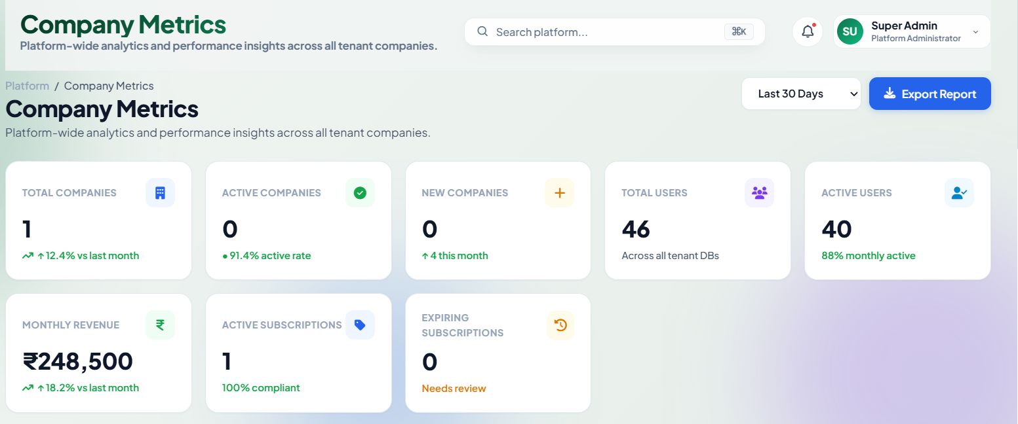

The Platform Intelligence Center aggregates infrastructure consumption and usage velocity across all tenant databases to support capacity planning.
- Aggregate Storage Utilization: Disk space consumed across all tenant upload directories (/public/user-uploads).
- Cross-Tenant Project Velocity: Real-time count of active, completed, and overdue projects platform-wide.
- Average User Density: Mean number of active employees per tenant company.
- Database Fleet Size: Total storage volume occupied by all tenant database schemas on the database cluster.
5.2 Comparative Tenant Usage & Consumption Ledger
🧭 Navigation Path: Super Admin Sidebar > Tenant Management > Company Metrics > Section: 'Tenant Consumption'

📷 SCREENSHOT PLACEHOLDER: Tenant Consumption & Quota Table
Target UI Capture: Comparative table ranking companies by active users, total projects, disk storage consumed against plan quotas, and daily time logs
Suggested Filename: docs/screenshots/14_tenant_consumption_table.png | Recommended Viewport: 16:9 Desktop
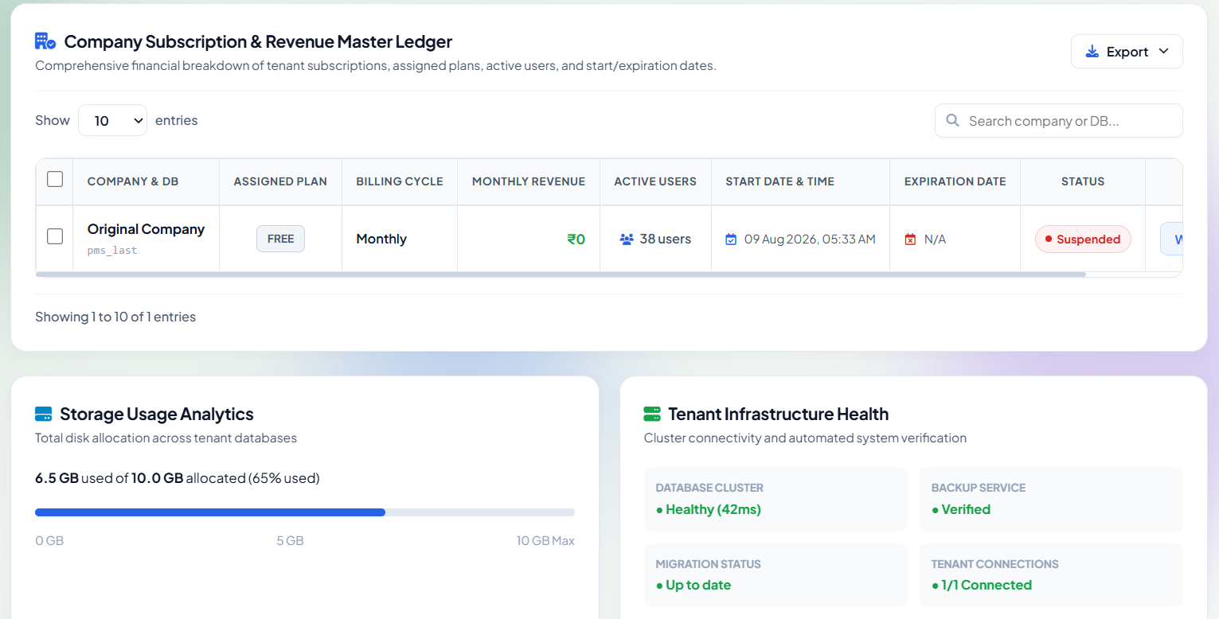

Ranks companies based on resource consumption to identify tenants requiring tier upgrades or storage expansion before limits are reached.
6. Subscription Plans Catalog
6.1 Plan Tier Architecture & Governance
🧭 Navigation Path: Super Admin Sidebar > Subscriptions > Plans Catalog (or URL: /super-admin/plans)

📷 SCREENSHOT PLACEHOLDER: Plans Catalog Overview
Target UI Capture: Plans Catalog overview displaying the 4 standard plan tier cards (Free, Gold, Platinum, Diamond) with monthly/annual pricing and module badges
Suggested Filename: docs/screenshots/15_plans_catalog_overview.png | Recommended Viewport: 16:9 Desktop
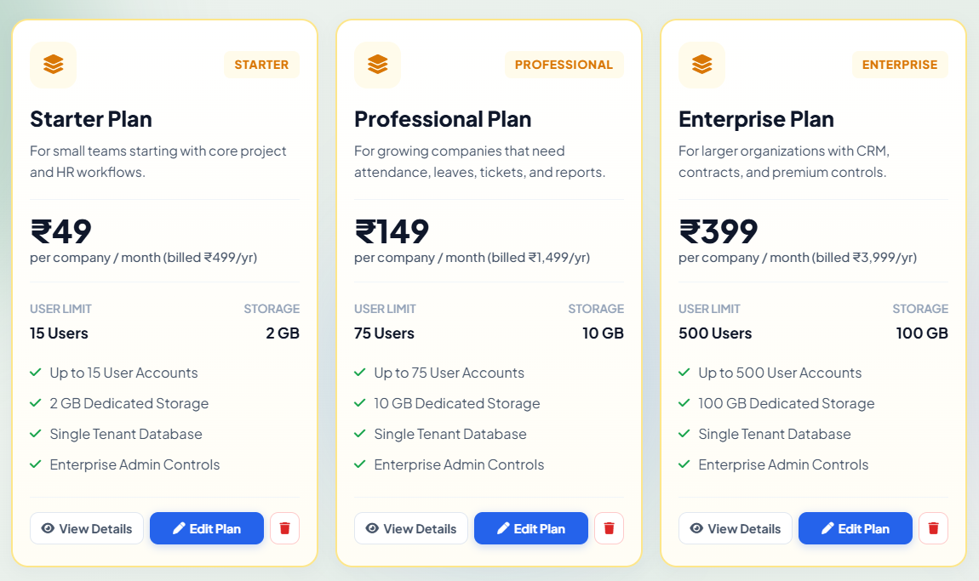

The platform enforces a standardized four-tier subscription matrix. Superadmins configure pricing, resource quotas, and module entitlements centrally.
Plan Tier | Target Segment | Max Users | Max Storage | Standard Module Entitlements
Free | Micro-teams / Trials | 5 Seats | 1 GB | Projects, Tasks, Basic Calendar
Gold | Small Businesses | 25 Seats | 10 GB | Projects, Tasks, Attendance, Leaves, HR
Platinum | Mid-Size Enterprises | 100 Seats | 50 GB | All Gold Modules + Invoicing, Finance, Tickets
Diamond | Large Scale / Corporate | Unlimited | 500 GB | Full Suite + Custom Domain + Priority Support

6.2 Creating or Modifying a Subscription Plan
🧭 Navigation Path: Super Admin Sidebar > Subscriptions > Plans Catalog > Click '+ Create Plan' (or 'Edit Plan')

📷 SCREENSHOT PLACEHOLDER: Plan Configuration Dialog
Target UI Capture: Plan Edit Modal: Plan Name, Monthly Price ($), Annual Price ($), Max Users Limit, Max Storage Limit (GB), and Module Multi-Select
Suggested Filename: docs/screenshots/16_plan_configuration_modal.png | Recommended Viewport: 4:3 Desktop
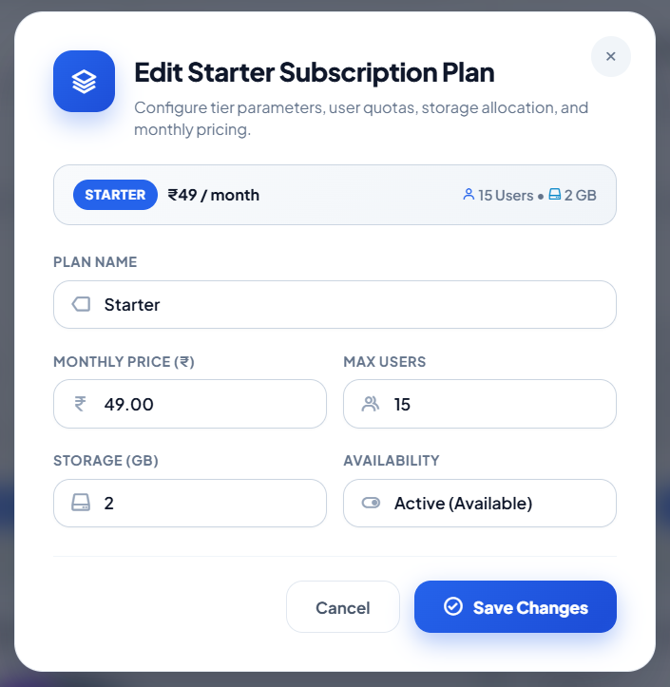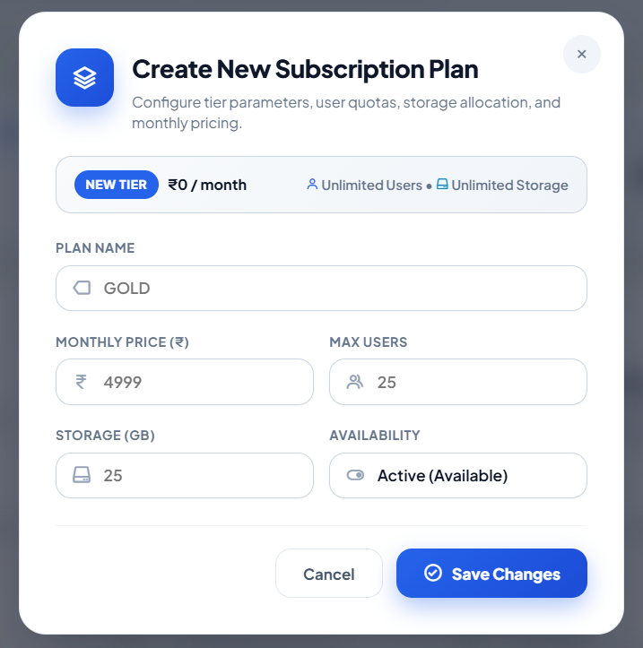

Superadmins can adjust monthly and annual billing rates, set user seat ceilings, allocate storage quotas, and toggle public visibility. Price modifications apply immediately to new subscriptions without retroactively altering active contracts.
7. Subscriptions & Billing Control Center
7.1 Active Subscriptions Ledger & Management Console
🧭 Navigation Path: Super Admin Sidebar > Subscriptions > Subscriptions (or URL: /super-admin/subscriptions)

📷 SCREENSHOT PLACEHOLDER: Subscriptions Management Console
Target UI Capture: Subscriptions table: Company, Current Plan, Billing Cycle, Start Date, Expiry Date, Status, Override Badges, and action buttons
Suggested Filename: docs/screenshots/18_subscriptions_ledger.png | Recommended Viewport: 16:9 Desktop
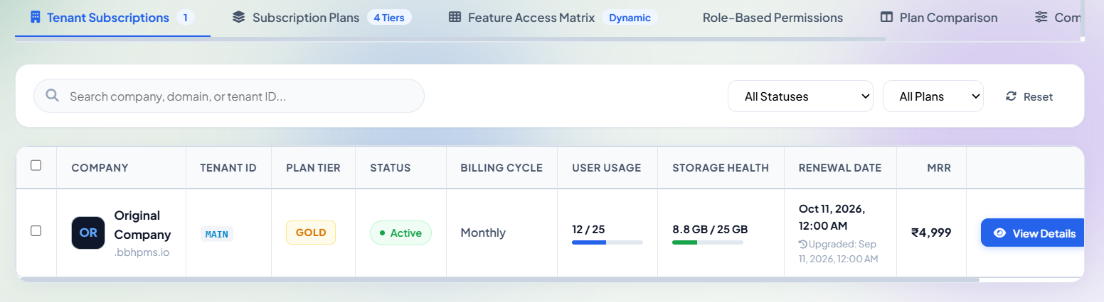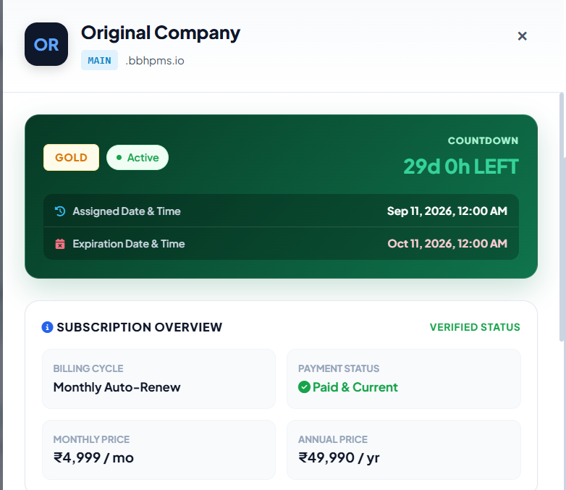

The Subscriptions Console provides master oversight over commercial licensing, manual contract extensions, plan upgrades/downgrades, and bespoke module entitlements.
7.2 Changing or Upgrading a Tenant Subscription Plan
🧭 Navigation Path: Super Admin Sidebar > Subscriptions > Subscriptions > Locate Tenant > Click 'Change Plan'

📷 SCREENSHOT PLACEHOLDER: Plan Migration & Comparison Diff Dialog
Target UI Capture: Assign Plan Modal showing Current Plan Badge, Target Plan Radio Grid, Feature Diff Comparison table, and 'Confirm Plan Migration' CTA
Suggested Filename: docs/screenshots/19_assign_plan_modal.png | Recommended Viewport: 4:3 Desktop
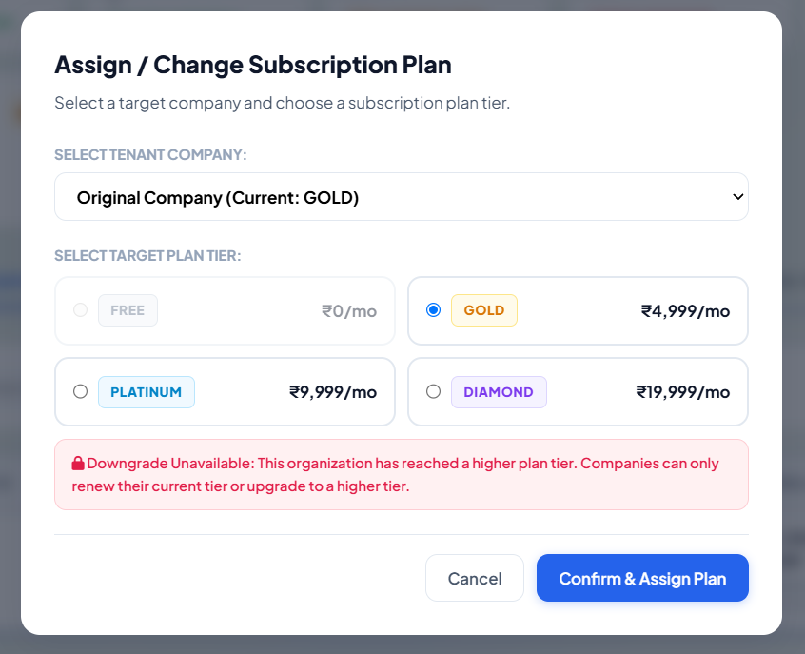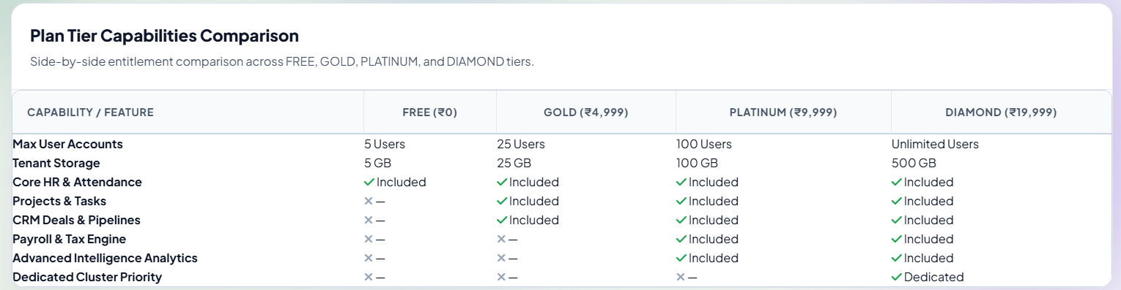

Superadmins can migrate a tenant between tiers (e.g. Gold to Platinum). The dialog displays a side-by-side feature diff and permits resetting the billing cycle date or preserving existing contractual termination dates.
7.3 Manual Subscription Duration Extensions & Reductions
🧭 Navigation Path: Super Admin Sidebar > Subscriptions > Subscriptions > Action Column > Click 'Extend' (or 'Reduce')

📷 SCREENSHOT PLACEHOLDER: Subscription Duration Adjustment Dialog
Target UI Capture: Duration Adjustment Modal: Current Expiry Date, Preset Duration Chips (+7 Days, +30 Days, +90 Days, +1 Year), Date Picker, and Reason field
Suggested Filename: docs/screenshots/20_subscription_duration_modal.png | Recommended Viewport: 4:3 Desktop
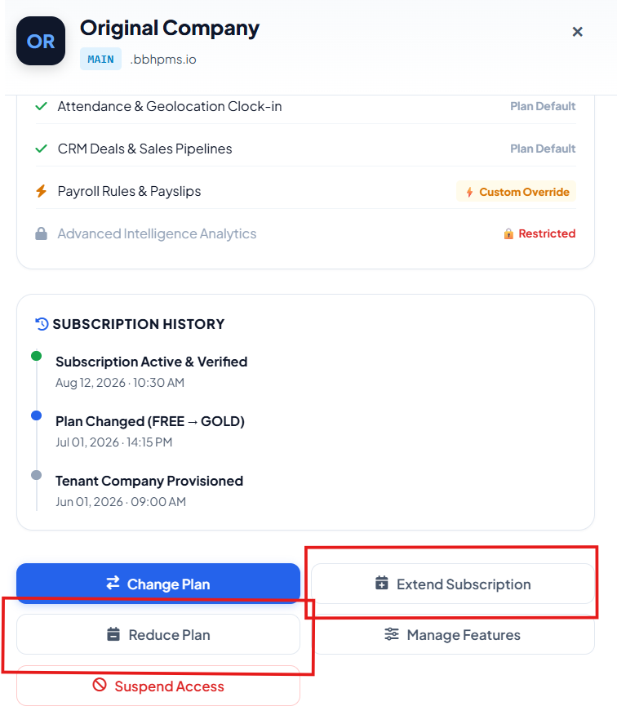

Allows operators to grant commercial grace periods using fast 1-click preset chips (+7 Days, +30 Days, +90 Days, +1 Year) or select custom calendar dates.
7.4 Granular Per-Tenant Module Overrides
🧭 Navigation Path: Super Admin Sidebar > Subscriptions > Subscriptions > Click Tenant Row > Slide-Out Drawer > Tab: 'Module Overrides'

📷 SCREENSHOT PLACEHOLDER: Tenant Bespoke Module Overrides Drawer
Target UI Capture: Slide-out Inspection Drawer showing Tenant Details, baseline plan rules, and individual module override switches with status badges
Suggested Filename: docs/screenshots/21_tenant_module_overrides_drawer.png | Recommended Viewport: 16:9 Desktop
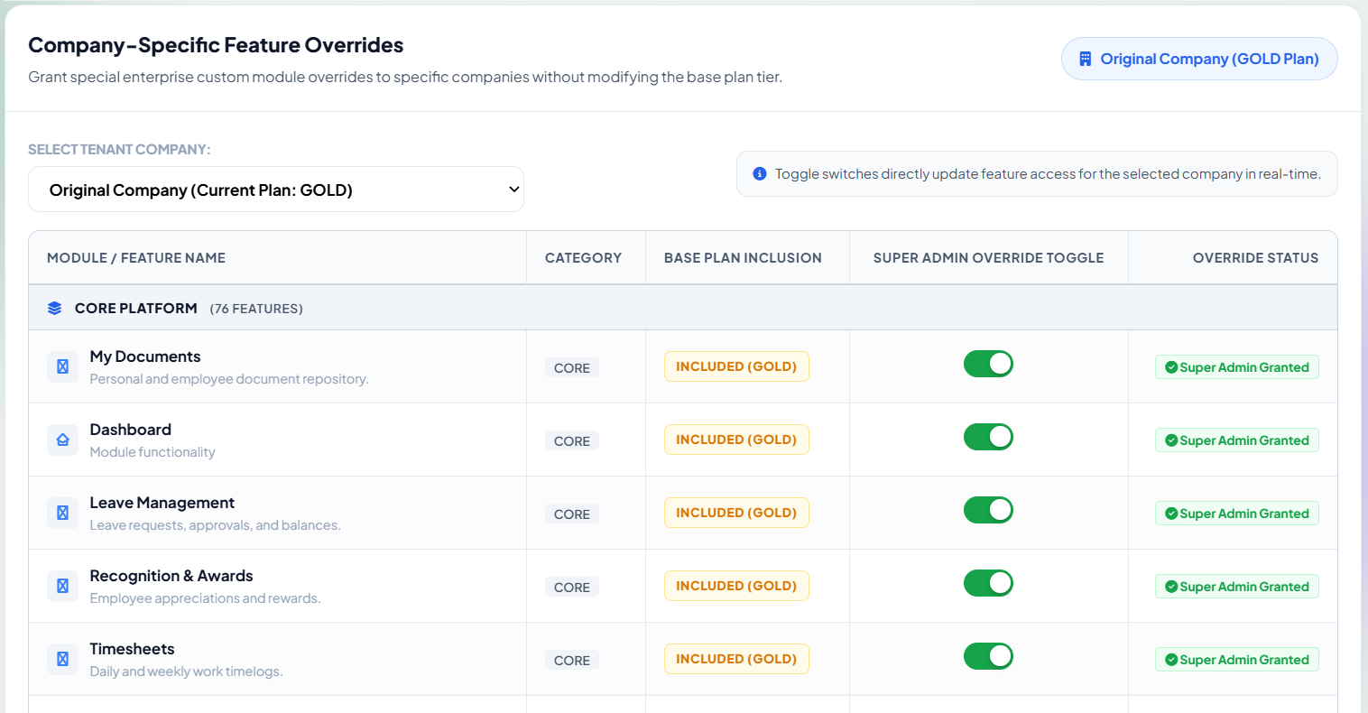

Enables Superadmins to grant access to specific premium modules (e.g. Payroll) for a specific tenant without forcing a tier upgrade. The tenant is automatically tagged with a 'Custom Override' badge in central listings.
8. Database Migrations Control Center
8.1 Multi-Tenant Schema Status & Drift Monitoring
🧭 Navigation Path: Super Admin Sidebar > Operations > Migrations (or URL: /super-admin/migrations)

📷 SCREENSHOT PLACEHOLDER: Database Migrations Control Center
Target UI Capture: Migration summary cards (Total Tenant DBs, Synchronized Schemas, Pending Migrations, Failed Migrations), 'Bulk Run All' CTA, and Status Table
Suggested Filename: docs/screenshots/22_migrations_control_center.png | Recommended Viewport: 16:9 Desktop
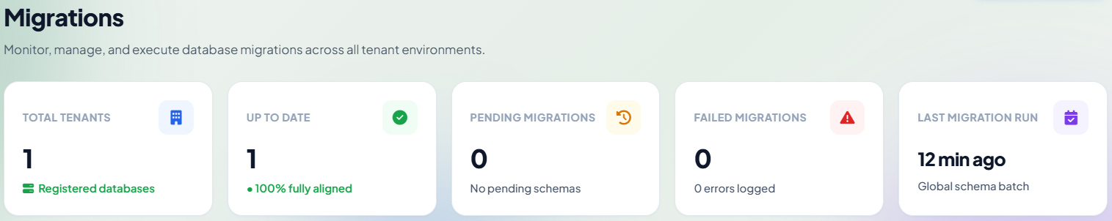

In a multi-database architecture, code updates frequently introduce new database tables or columns that must be applied across every tenant schema independently. The Migrations Control Center tracks schema synchronization across all tenant databases.
8.2 Executing Single-Tenant Migrations
🧭 Navigation Path: Super Admin Sidebar > Operations > Migrations > Locate Target Company > Click 'Run Migration'

📷 SCREENSHOT PLACEHOLDER: Single Tenant Migration Trigger
Target UI Capture: Single Tenant Migration Action: Confirmation prompt showing tenant schema name (pms_acme), pending migrations, and execution spinner
Suggested Filename: docs/screenshots/23_single_migration_run.png | Recommended Viewport: 4:3 Desktop
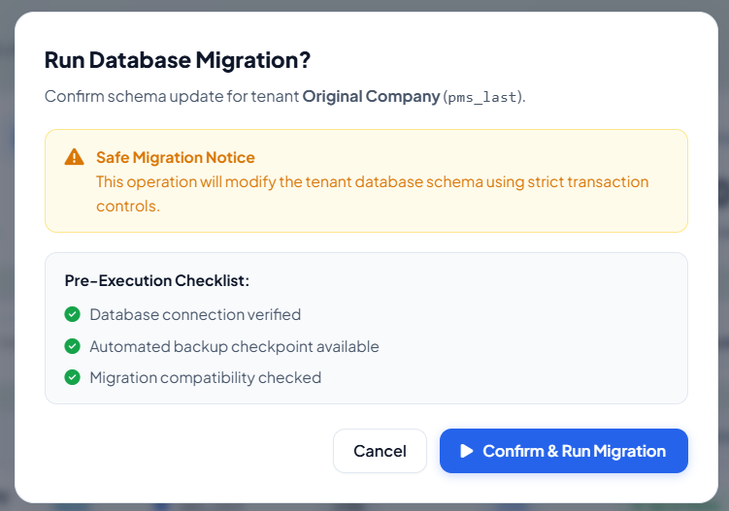

Superadmins can apply pending migration batches to an individual tenant schema dynamically using Artisan commands with zero impact on other tenants.

8.3 Real-Time Migration Execution Log Inspector
🧭 Navigation Path: Super Admin Sidebar > Operations > Migrations > Row Actions > Click 'View Logs'

📷 SCREENSHOT PLACEHOLDER: Migration Output Log Inspector
Target UI Capture: Dark Monospace Terminal Viewer displaying artisan migration stdout/stderr logs, executed SQL migration batches, and execution durations
Suggested Filename: docs/screenshots/25_migration_log_inspector.png | Recommended Viewport: 16:9 Desktop
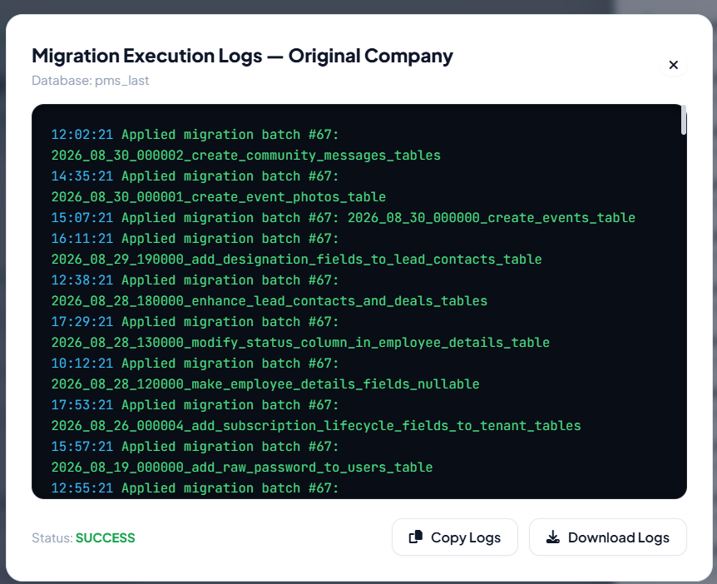

Renders raw Artisan migration logs for diagnosing schema errors, foreign key constraints, or collation mismatches.
9. Tenant Backup & Disaster Recovery Center
9.1 Backup Management Console & Snapshot Repository
🧭 Navigation Path: Super Admin Sidebar > Operations > Backups (or URL: /super-admin/backups)

📷 SCREENSHOT PLACEHOLDER: Backup Management Console & Catalog
Target UI Capture: Backup Control Center: Storage health cards (Total Snapshots, Disk Space Used, Last Fleet Backup, Verified Integrity), and Archive Table
Suggested Filename: docs/screenshots/26_backups_management_console.png | Recommended Viewport: 16:9 Desktop
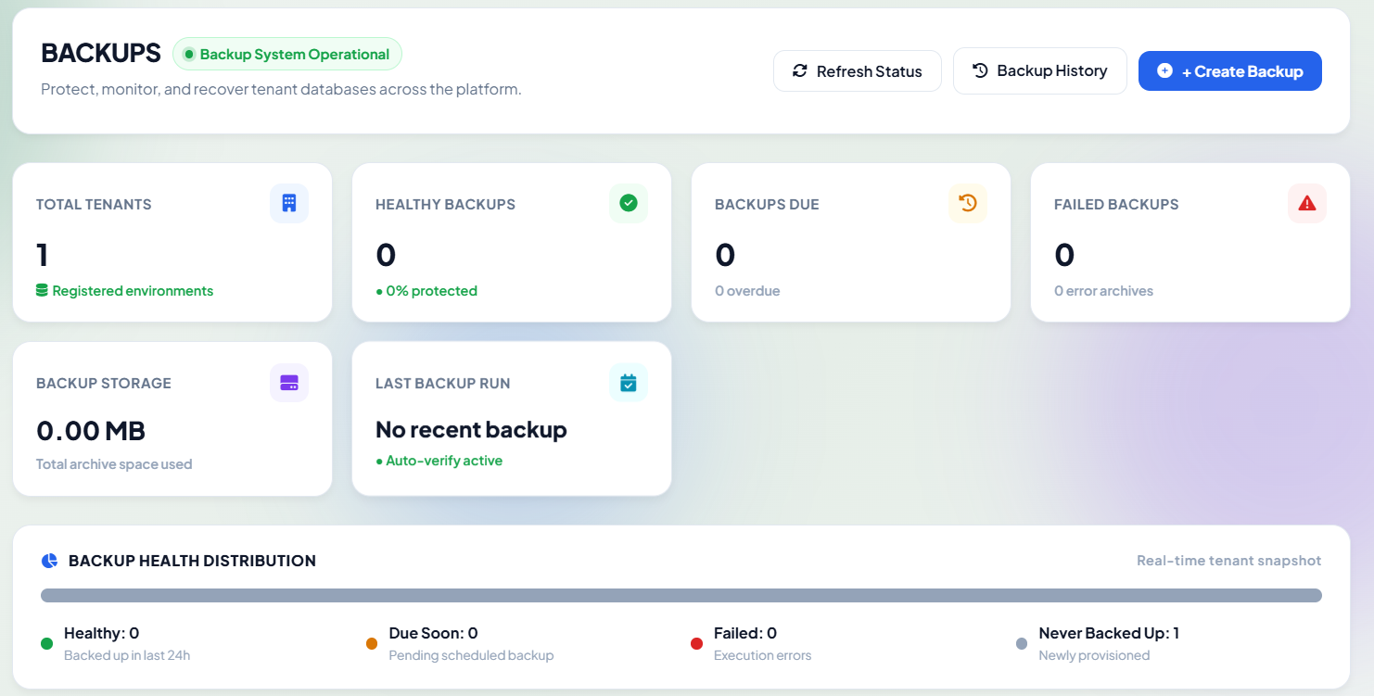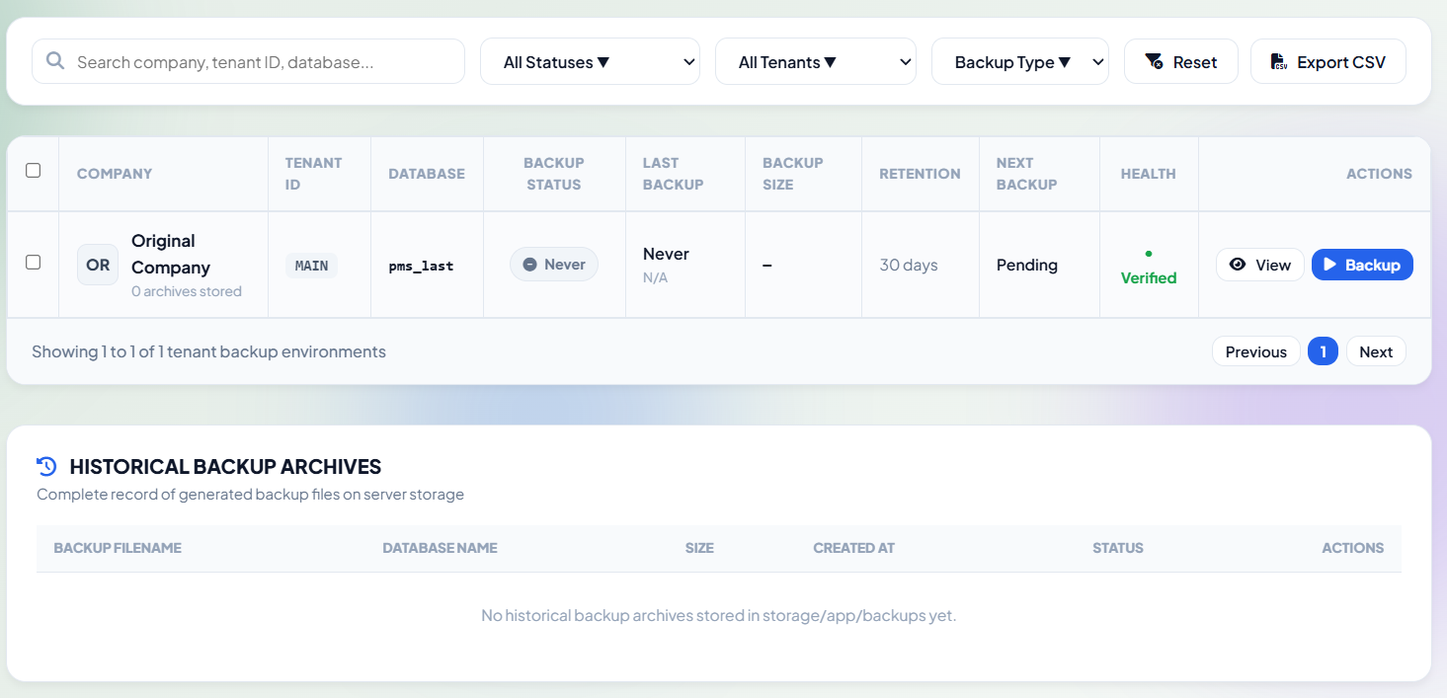

Oversees cryptographic point-in-time SQL snapshots of tenant databases with automated Gzip compression and SHA-256 checksum verification.
9.2 On-Demand Tenant Snapshot Creation
🧭 Navigation Path: Super Admin Sidebar > Operations > Backups > Click '+ Create Tenant Backup'

📷 SCREENSHOT PLACEHOLDER: Create Database Backup Dialog
Target UI Capture: Create Backup Modal: Company selector, Compression Format (Gzip), Media Files toggle checkbox, and 'Generate Snapshot Now' button
Suggested Filename: docs/screenshots/27_create_backup_modal.png | Recommended Viewport: 4:3 Desktop
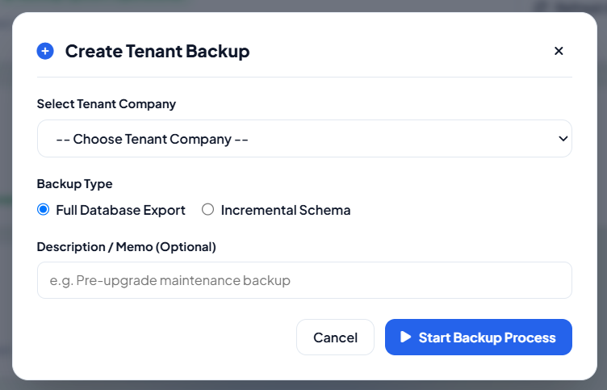

Triggers an immediate background mysqldump task for a selected tenant company, verifying archive integrity before registering it in the central backup catalog.
9.3 Restoring a Tenant Database from Snapshot
🧭 Navigation Path: Super Admin Sidebar > Operations > Backups > Locate Snapshot > Action Column > Click 'Restore'

📷 SCREENSHOT PLACEHOLDER: High-Risk Database Restore Confirmation
Target UI Capture: Restore Confirmation Modal: Red Danger Icon, Target Schema Warning, Type-to-Confirm 'RESTORE' input field, and confirmation button
Suggested Filename: docs/screenshots/28_restore_backup_modal.png | Recommended Viewport: 4:3 Desktop
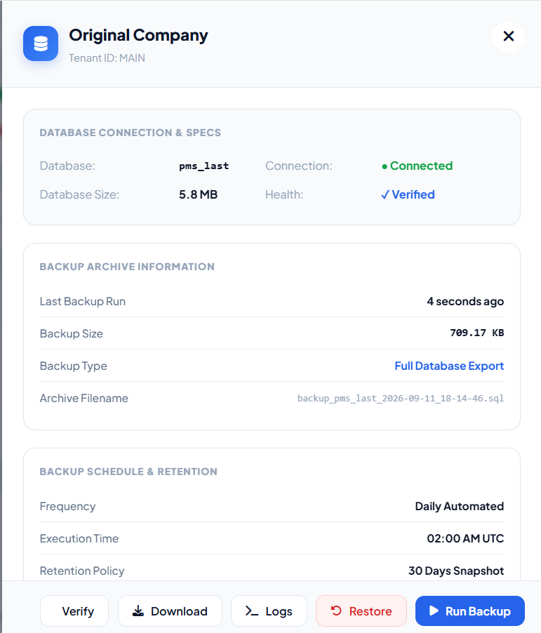

Rolls back a tenant database to a previous verified snapshot state. Requires the operator to explicitly type the word 'RESTORE' to unlock execution.
[WARNING] Restoring a database snapshot completely overwrites the target tenant schema. All data created after the snapshot timestamp will be permanently lost.

9.4 Verifying Snapshot Integrity, Downloading & Deletion
🧭 Navigation Path: Super Admin Sidebar > Operations > Backups > Action Column (Verify / Download / Delete)

📷 SCREENSHOT PLACEHOLDER: Backup Management Actions Menu
Target UI Capture: Backup Actions dropdown: 'Verify Integrity' (SHA-256 Hash check), 'Download Archive', and 'Delete Snapshot' with confirmation dialog
Suggested Filename: docs/screenshots/29_backup_actions_dropdown.png | Recommended Viewport: 4:3 Desktop

Enables operators to verify cryptographic checksums, download archives for offsite storage, or securely purge obsolete backups from disk.
10. Tenant Audit & Activity Monitoring Center
10.1 Central Audit Trail & Security Event Monitoring
🧭 Navigation Path: Super Admin Sidebar > Operations > Tenant Audit (or URL: /super-admin/tenant-audit)

📷 SCREENSHOT PLACEHOLDER: Central Tenant Audit Trail
Target UI Capture: Tenant Audit Center: Multi-parameter filter bar (Tenant, Action Type, Date Range), Activity Ledger showing Actor, Event, Entity, IP, and Timestamp
Suggested Filename: docs/screenshots/30_tenant_audit_center.png | Recommended Viewport: 16:9 Desktop
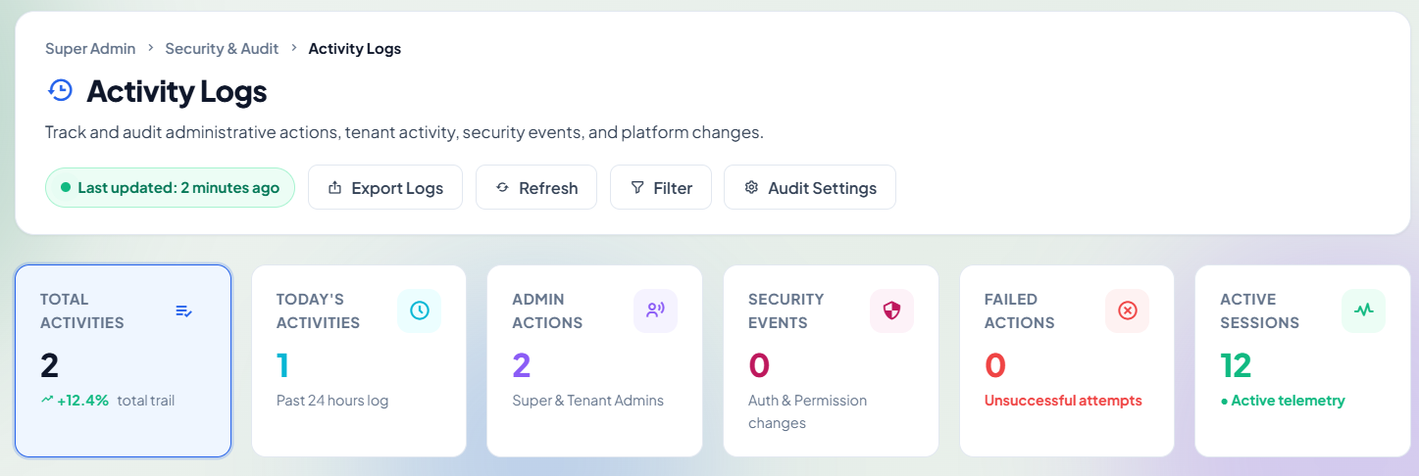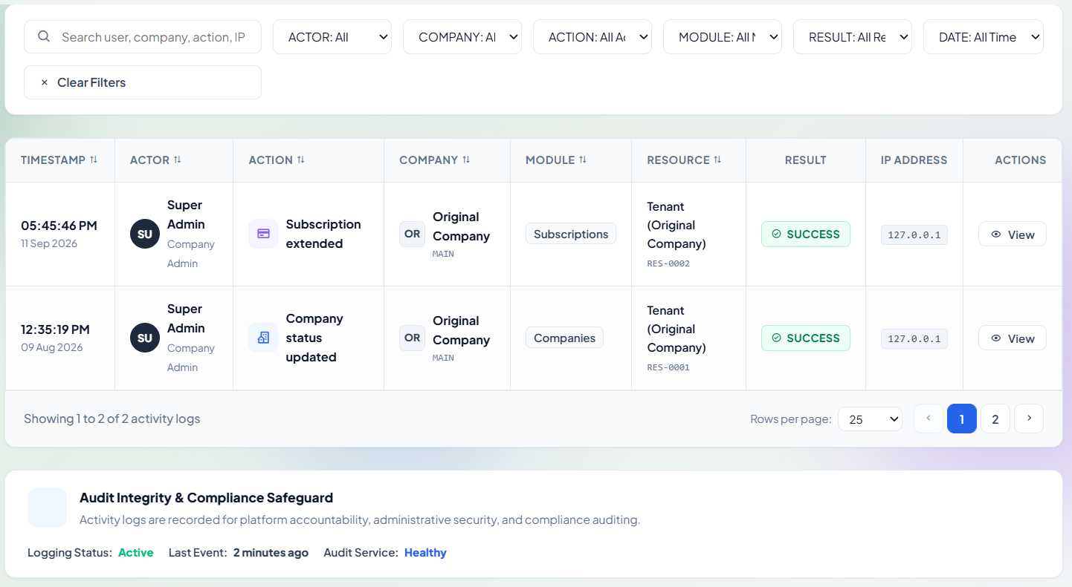

Provides immutable compliance logging of actions taken across the platform, recording company state changes, impersonation sessions, subscription adjustments, backups, and administrative operations.
10.2 Filtering & Forensic Event Payload Inspection
🧭 Navigation Path: Super Admin Sidebar > Operations > Tenant Audit > Locate Record > Click 'Inspect Event'

📷 SCREENSHOT PLACEHOLDER: Forensic Event Payload Inspector
Target UI Capture: JSON Payload Modal showing Before vs After state diff, originating User Agent string, Client IPv4/IPv6, Request Headers, and ISO Timestamp
Suggested Filename: docs/screenshots/31_audit_event_inspector.png | Recommended Viewport: 4:3 Desktop
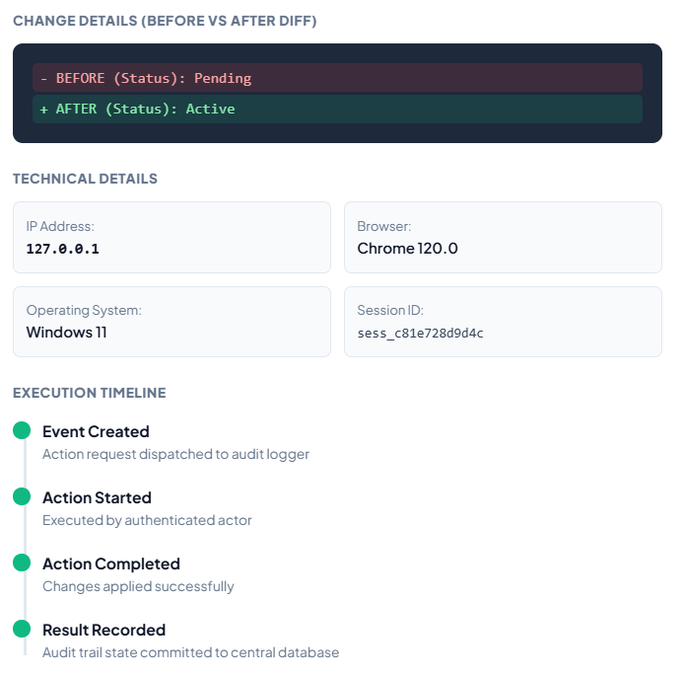

Renders full JSON forensic payloads including user details, origin IP address, user agent, and side-by-side attribute diffs. Supports exporting filtered audit trails to CSV or Excel for compliance reviews.
11. Platform System Health & Infrastructure Monitoring
11.1 Infrastructure Health Command Center
🧭 Navigation Path: Super Admin Sidebar > Monitoring > System Health (or URL: /super-admin/system-health)

📷 SCREENSHOT PLACEHOLDER: Infrastructure System Health Dashboard
Target UI Capture: System Health Grid: Database Cluster Status, Redis Cache Connectivity, Queue Workers, Storage & Disk Space Gauge, API Response Latency
Suggested Filename: docs/screenshots/32_system_health_dashboard.png | Recommended Viewport: 16:9 Desktop
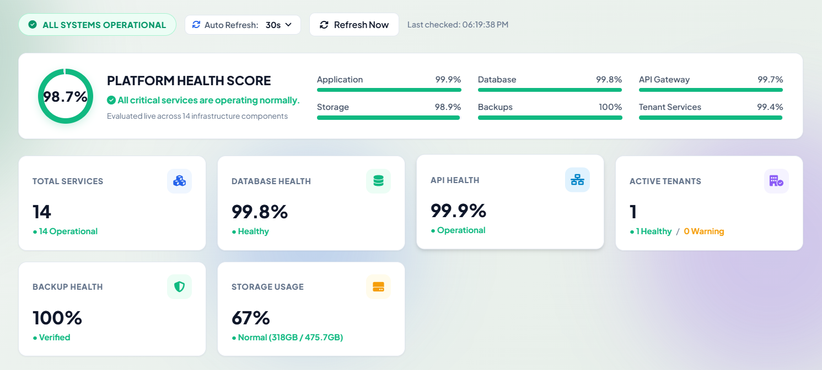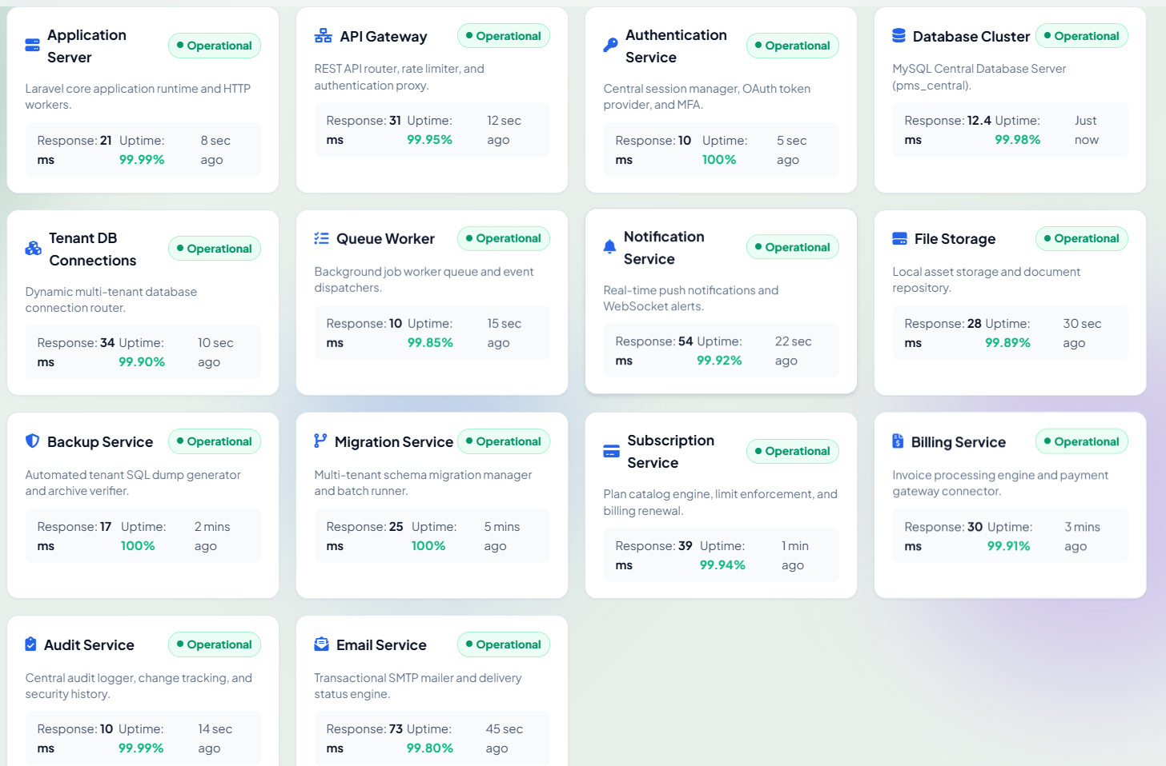

Monitors server hardware resources and underlying services supporting the multi-tenant architecture, including database cluster connections, Redis cache hit ratios, queue worker throughput, and server disk partition capacity.
11.2 Triggering On-Demand Platform Diagnostics
🧭 Navigation Path: Super Admin Sidebar > Monitoring > System Health > Page Header > Click 'Run Health Check'

📷 SCREENSHOT PLACEHOLDER: Live System Diagnostics Execution
Target UI Capture: Live diagnostics execution banner showing test ping to Database, Cache read/write verification, Storage write test, and millisecond latencies
Suggested Filename: docs/screenshots/33_system_health_check_running.png | Recommended Viewport: 4:3 Desktop
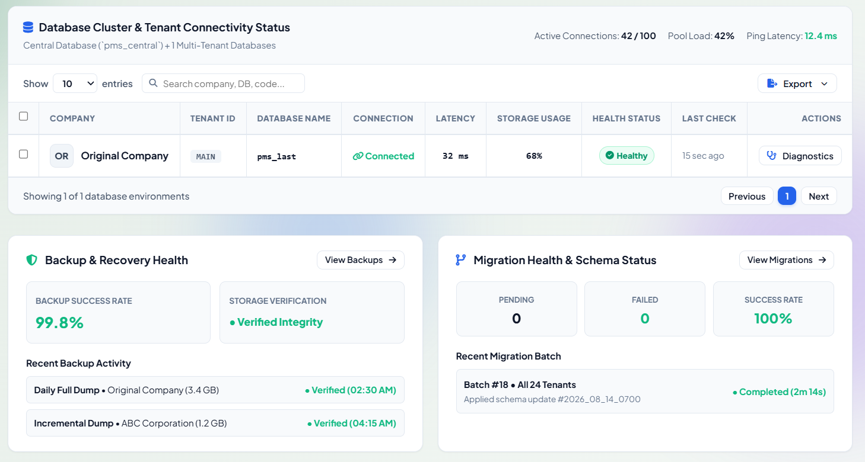

Initiates an immediate diagnostic sweep across all subsystems, refreshing status cards and logging any latency spikes or connection dropouts into the platform alerts stream.
12. Platform Alert & Notification Center
12.1 Real-Time Platform Alert Feed & Triage
🧭 Navigation Path: Super Admin Sidebar > Monitoring > Alerts (or Top Header Bell Icon) (URL: /super-admin/alerts)

📷 SCREENSHOT PLACEHOLDER: Alerts & Notifications Dispatch Center
Target UI Capture: Alerts Center: Severity summary chips (Critical [Red], Warning [Amber], Info [Blue]), 'Mark All Read' action, and Alert Feed cards
Suggested Filename: docs/screenshots/34_alerts_management_center.png | Recommended Viewport: 16:9 Desktop
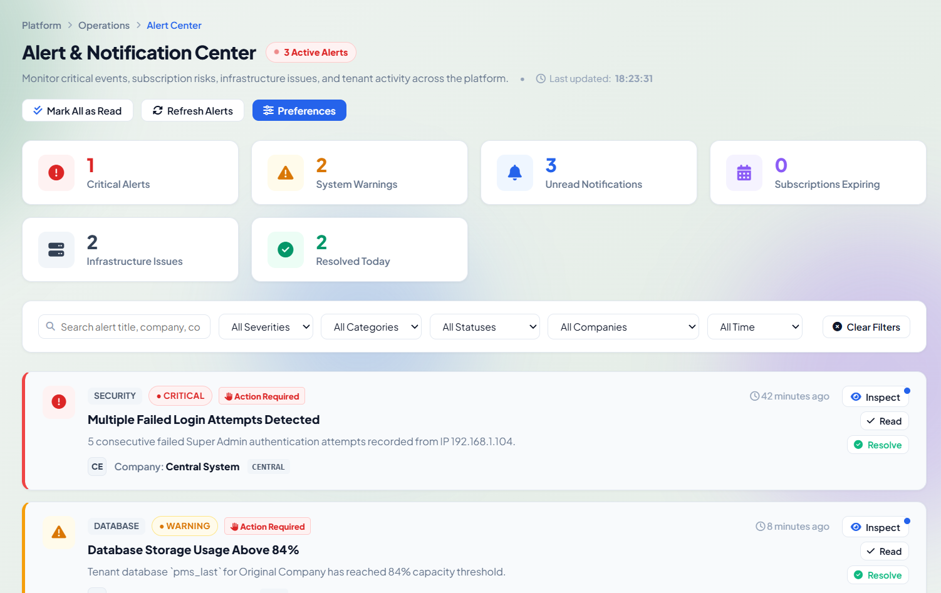

Centralizes automated system warnings, threshold breaches, expiring contracts, and infrastructure anomalies into Critical, Warning, and Informational severity tiers.
12.2 Acknowledging, Investigating & Resolving Alerts
🧭 Navigation Path: Super Admin Sidebar > Monitoring > Alerts > Locate Alert > Click 'Details' (or 'Resolve')

📷 SCREENSHOT PLACEHOLDER: Alert Investigation & Remediation Drawer
Target UI Capture: Alert Investigation Drawer: Incident summary, affected tenant company, service stacktrace, remediation steps, and 'Resolve' CTA
Suggested Filename: docs/screenshots/35_alert_details_drawer.png | Recommended Viewport: 16:9 Desktop
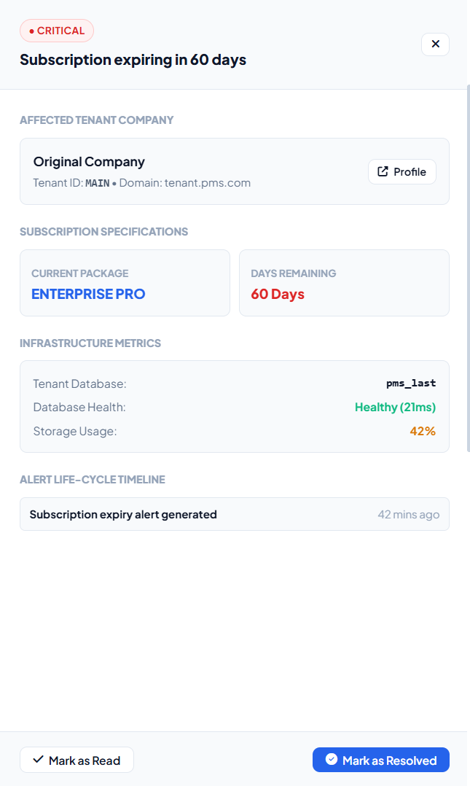

Superadmins can inspect stacktraces, review remediation recommendations, mark alerts as read, or resolve and archive alerts with operational resolution notes.
13. Company Administrators Management Center
13.1 Global Tenant Administrators Directory
🧭 Navigation Path: Super Admin Sidebar > Security & Audit > Company Admins (or URL: /super-admin/company-admins)

📷 SCREENSHOT PLACEHOLDER: Company Administrators Directory
Target UI Capture: Company Admins Directory: Search bar, Company filter dropdown, Admin Cards with name, email, company tag, status badge, and actions
Suggested Filename: docs/screenshots/36_company_admins_directory.png | Recommended Viewport: 16:9 Desktop
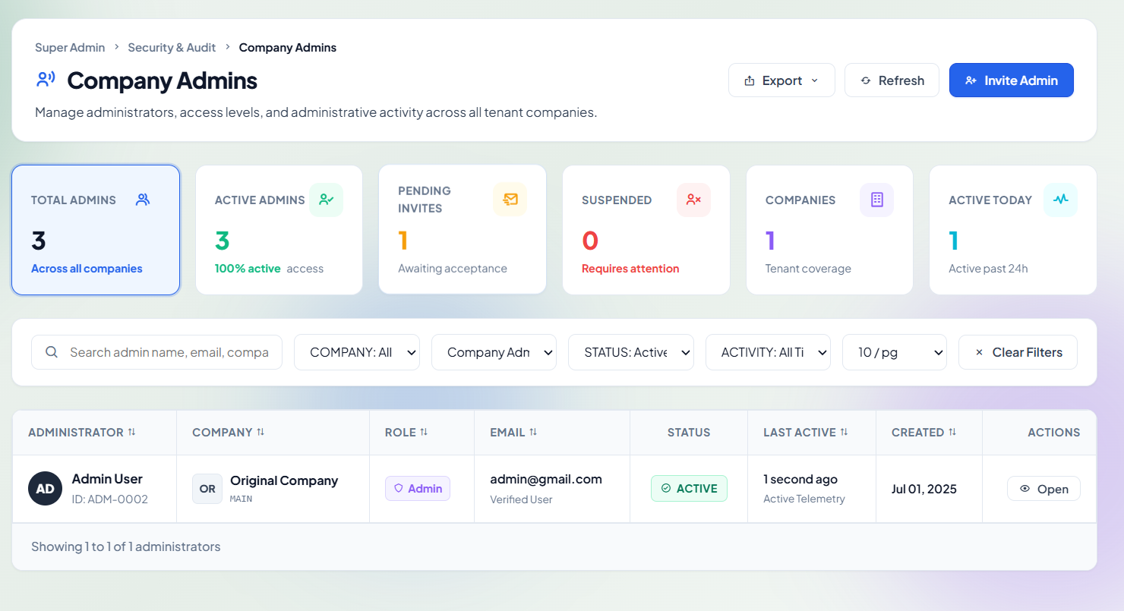

Provides centralized oversight over all tenant company administrator accounts. The system automatically identifies any tenant company lacking an active administrator and enables Superadmins to designate a new administrator with 1 click.
13.2 Creating & Assigning a New Company Administrator
🧭 Navigation Path: Super Admin Sidebar > Security & Audit > Company Admins > Click '+ Add Company Admin'

📷 SCREENSHOT PLACEHOLDER: Add Company Administrator Dialog
Target UI Capture: Add Company Admin Modal: Company dropdown selector, Full Name, Email Address, Password fields with generator, and Login Allowed toggle
Suggested Filename: docs/screenshots/37_add_company_admin_modal.png | Recommended Viewport: 4:3 Desktop
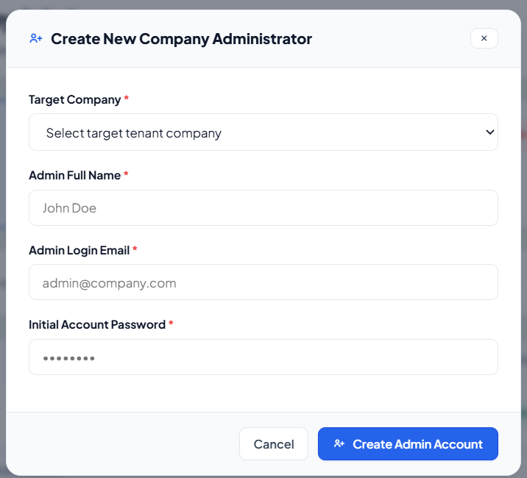

Allows Superadmins to provision new corporate administrators, assign them to specific tenant companies, configure login permissions, and dispatch initial credentials.
13.3 Archiving, Restoring & Purging Administrator Accounts
🧭 Navigation Path: Super Admin Sidebar > Security & Audit > Company Admins > Row Actions > Archive / Restore / Delete

📷 SCREENSHOT PLACEHOLDER: Admin Account Lifecycle & Archive Actions
Target UI Capture: Confirmation modal for Archiving an administrator (preserving historical project records) and Restore action button
Suggested Filename: docs/screenshots/38_admin_archive_restore_actions.png | Recommended Viewport: 4:3 Desktop
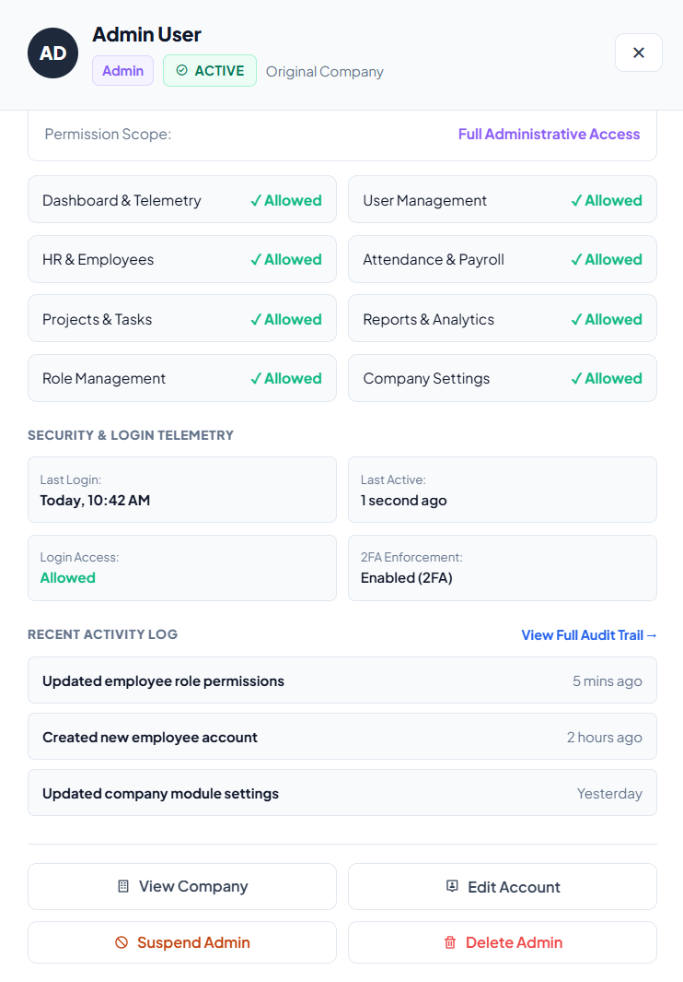

Supports soft-archiving administrator accounts to revoke login access while preserving historical project records, time logs, and invoices.
14. Developer & Work Management Center
14.1 Developer Roster & Operational Availability
🧭 Navigation Path: Super Admin Sidebar > Security & Audit > Developer Management (or URL: /super-admin/developers)

📷 SCREENSHOT PLACEHOLDER: Developer Management Dashboard & Roster
Target UI Capture: Developer Management Dashboard: Active Developer count, Pending Tasks counter, Completed Work tally, Developer Grid Cards with skill tags
Suggested Filename: docs/screenshots/39_developers_management_roster.png | Recommended Viewport: 16:9 Desktop
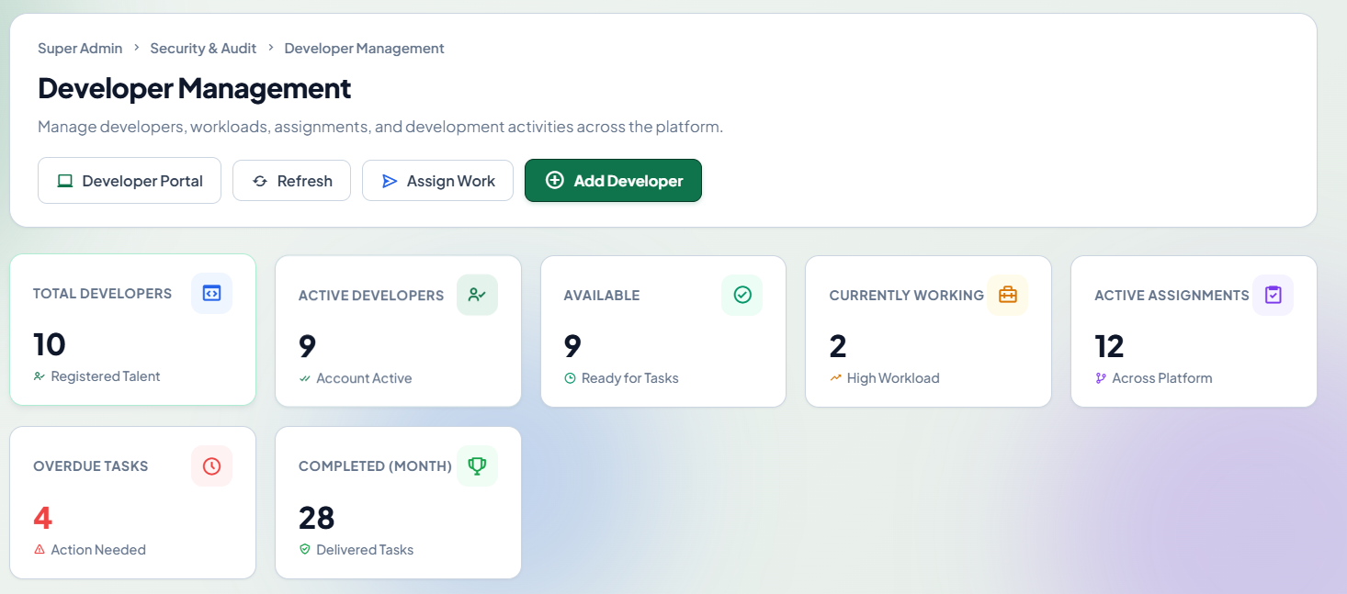

Oversees internal platform software engineers and technical contractors responsible for resolving tenant bugs, executing data fixes, or building custom modules.
14.2 Registering a Developer & Access Provisioning
🧭 Navigation Path: Super Admin Sidebar > Security & Audit > Developer Management > Click '+ Add Developer'

📷 SCREENSHOT PLACEHOLDER: Add Platform Developer Dialog
Target UI Capture: Add Developer Modal: Full Name, Email, Password, Department/Skills, Active Status switch, and 'Register Platform Developer' button
Suggested Filename: docs/screenshots/40_add_developer_modal.png | Recommended Viewport: 4:3 Desktop
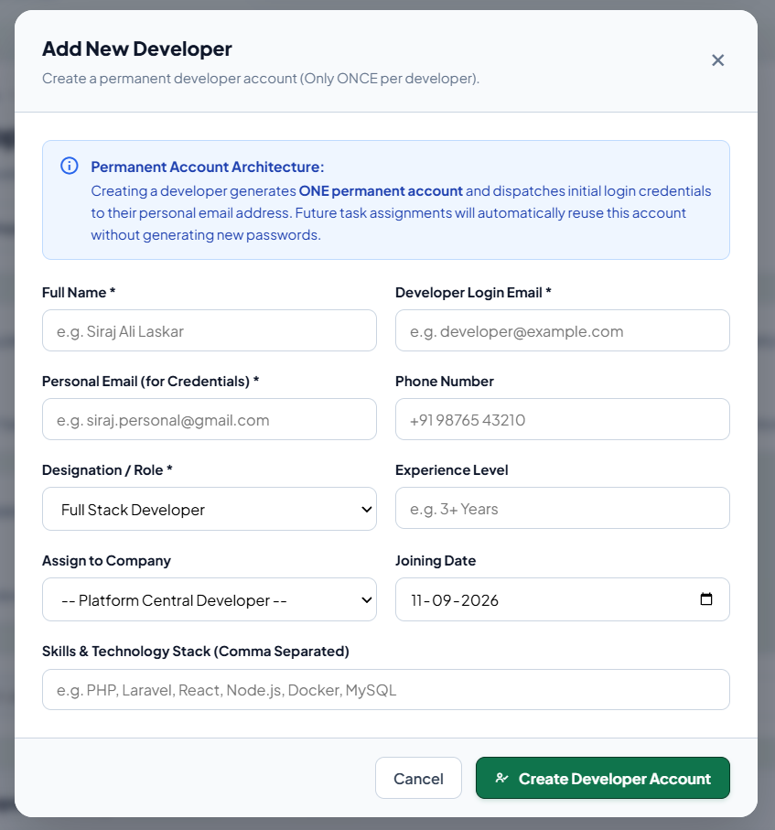

Provisions developer accounts assigned the isolated 'developer' role, restricting them to the Developer Workspace (/developer/dashboard) and preventing access to central financial ledgers.
14.3 Assigning Work, Tasks & Support Escalations to Developers
🧭 Navigation Path: Super Admin Sidebar > Security & Audit > Developer Management > Click 'Assign Work'

📷 SCREENSHOT PLACEHOLDER: Developer Work Assignment Dialog
Target UI Capture: Assign Work Dialog: Developer Selector, Related Tenant Company, Task Title, Task Description / Steps to Reproduce, Priority, and Due Date
Suggested Filename: docs/screenshots/41_assign_work_modal.png | Recommended Viewport: 4:3 Desktop
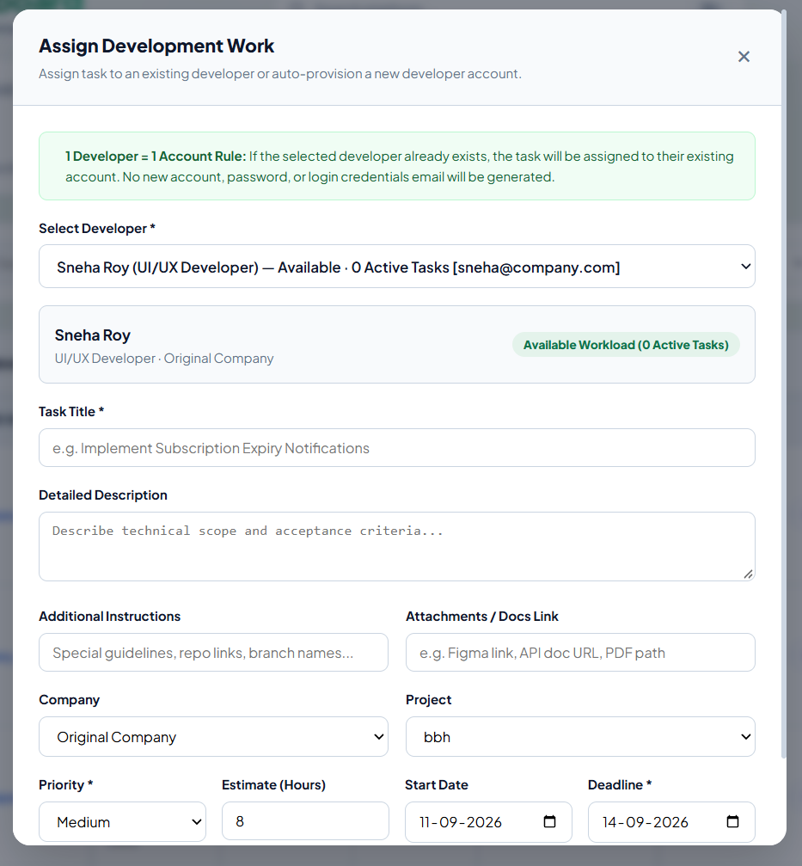

Routes technical tickets, bug fixes, and customer escalations directly to developers with priority tags (Urgent, High, Normal, Low) and completion deadlines.
14.4 Entering Developer Workspace in Preview Mode
🧭 Navigation Path: Super Admin Sidebar > Security & Audit > Developer Management > Select Developer > Click 'Enter Workspace'

📷 SCREENSHOT PLACEHOLDER: Developer Workspace Ingress Preview
Target UI Capture: Developer Workspace viewed in Super Admin Preview Mode with top notification bar: 'Viewing [Developer Name]'s Workspace in Super Admin Mode'
Suggested Filename: docs/screenshots/42_developer_workspace_preview.png | Recommended Viewport: 16:9 Desktop
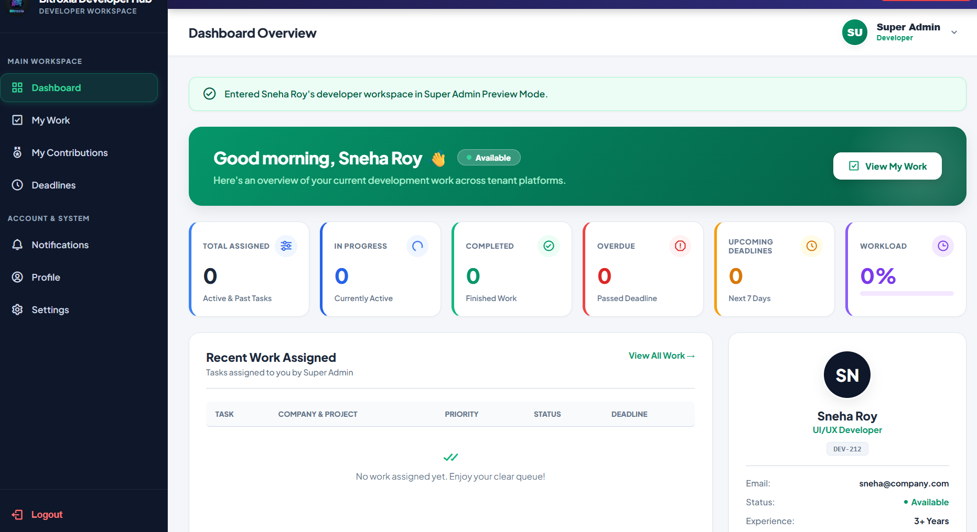

Enables Superadmins to inspect a developer's active workspace, verify task progress, review time logs, and audit deliverables.
16. Global Tools, Impersonation & Security Protocols
16.1 Global Quick Command Search (Cmd+K / Ctrl+K)
🧭 Navigation Path: Global Header > Center Search Bar (or Shortcut: ⌘K on macOS, Ctrl+K on Windows)

📷 SCREENSHOT PLACEHOLDER: Global Command Search Shortcut
Target UI Capture: Global Header Search Bar active state showing instant filtered results dropdown matching companies, administrators, and navigation links
Suggested Filename: docs/screenshots/45_global_command_search.png | Recommended Viewport: 16:9 Desktop

The global keyboard shortcut (⌘K / Ctrl+K) provides instantaneous table filtering on whichever page is currently loaded and enables rapid navigation across the platform.
16.2 Superadmin Incident Escalation Protocol & Operational Checklist
Incident Response Hierarchy: In the event of a platform anomaly, Superadmins must follow standard operating procedures:
- 1. Diagnostic Verification: Check Platform System Health (/super-admin/system-health) to verify database clusters, queue workers, and Redis cache.
- 2. Forensic Audit: Review recent event logs (/super-admin/tenant-audit) to identify the initiating user, IP address, and payload diff.
- 3. Tenant Isolation: Temporarily update company status to 'Suspended' to protect database integrity during technical investigation.
- 4. Snapshot Preservation: Generate an immediate on-demand backup snapshot (/super-admin/backups) prior to executing any manual database intervention.
- 5. Developer Dispatch: Assign an urgent repair ticket (/super-admin/developers) to engineering staff with step-by-step reproduction instructions.

