fERD Diagramming Lab

Name: __Bryan Bibb_____ Date:__Nov 10, 2023____

# Exercise Instructions

1. Type your name and the date into the space provided.
2. Use a tool such as Visio, LucidChart.COM, or ErWin to prepare IE (Information Engineering) style ERD’s for the three exercises.
3. Paste images of your solutions to exercises 1 through 3 into the indicated areas below.
4. Upload and submit before the due date.

-------------------------------------------------------------------------------------------------------------------------

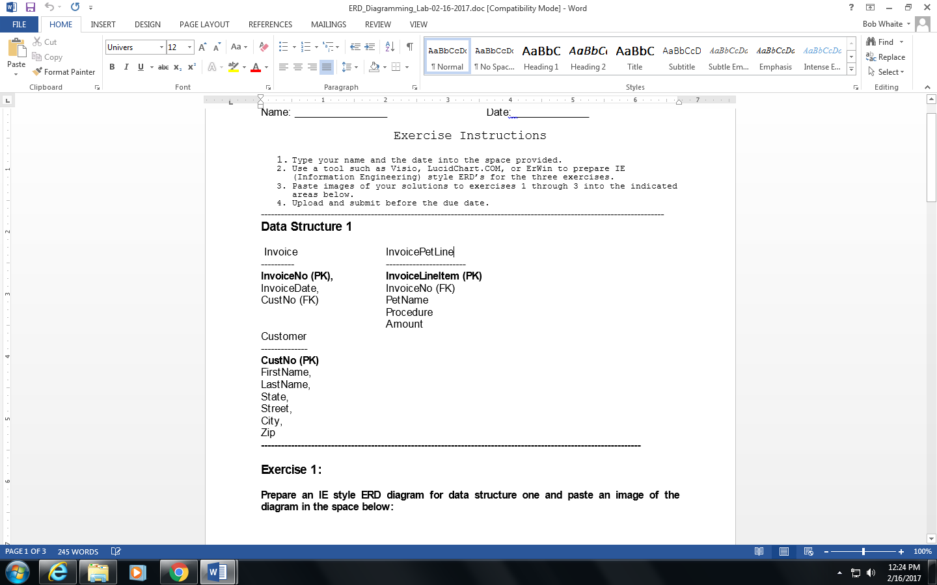

**Exercise 1:**

**Prepare an IE style ERD diagram for data structure one and paste an image of the diagram in the space below:**

Paste exercise 1 answer here:

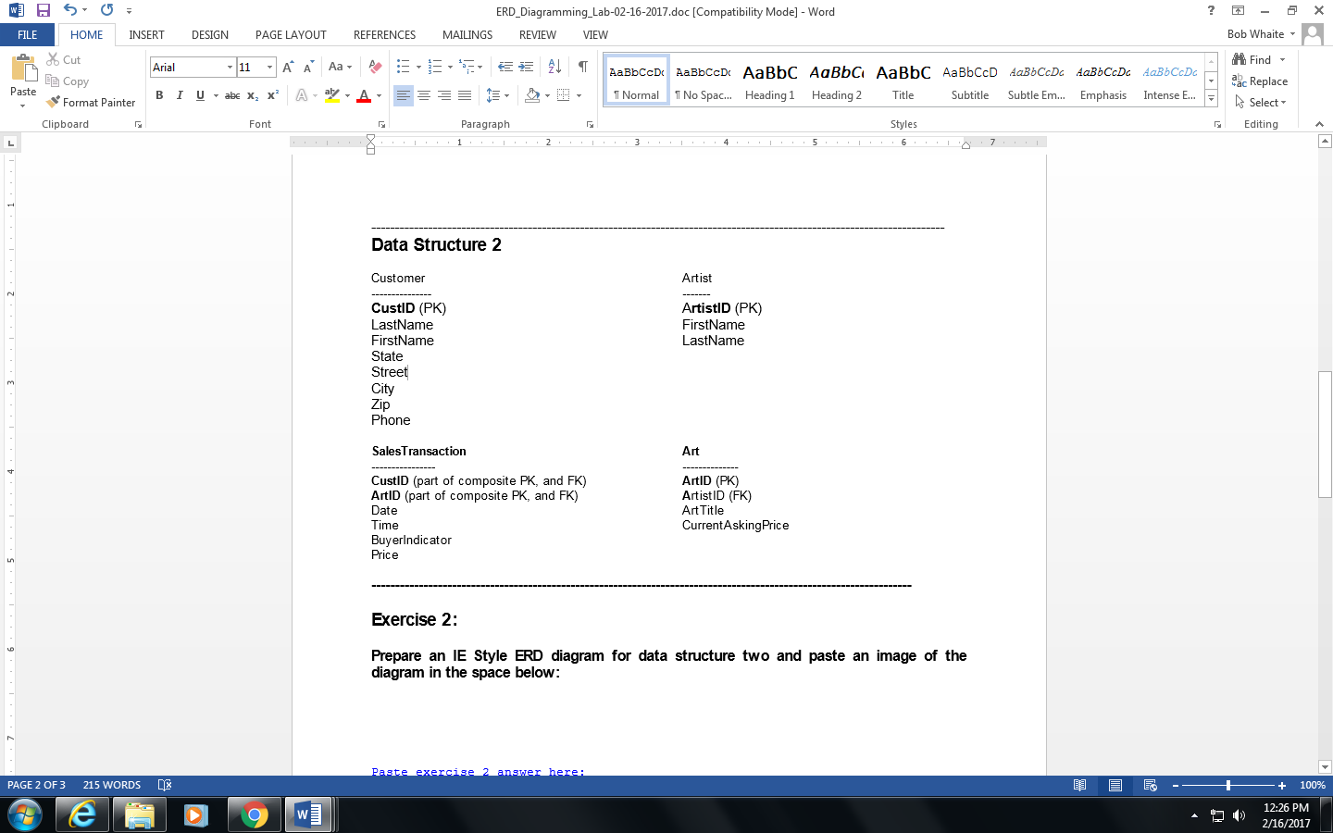

**------------------------------------------------------------------------------------------------------------------**

**Exercise 2:**

**Prepare an IE Style ERD diagram for data structure two and paste an image of the diagram in the space below:**

Paste exercise 2 answer here:

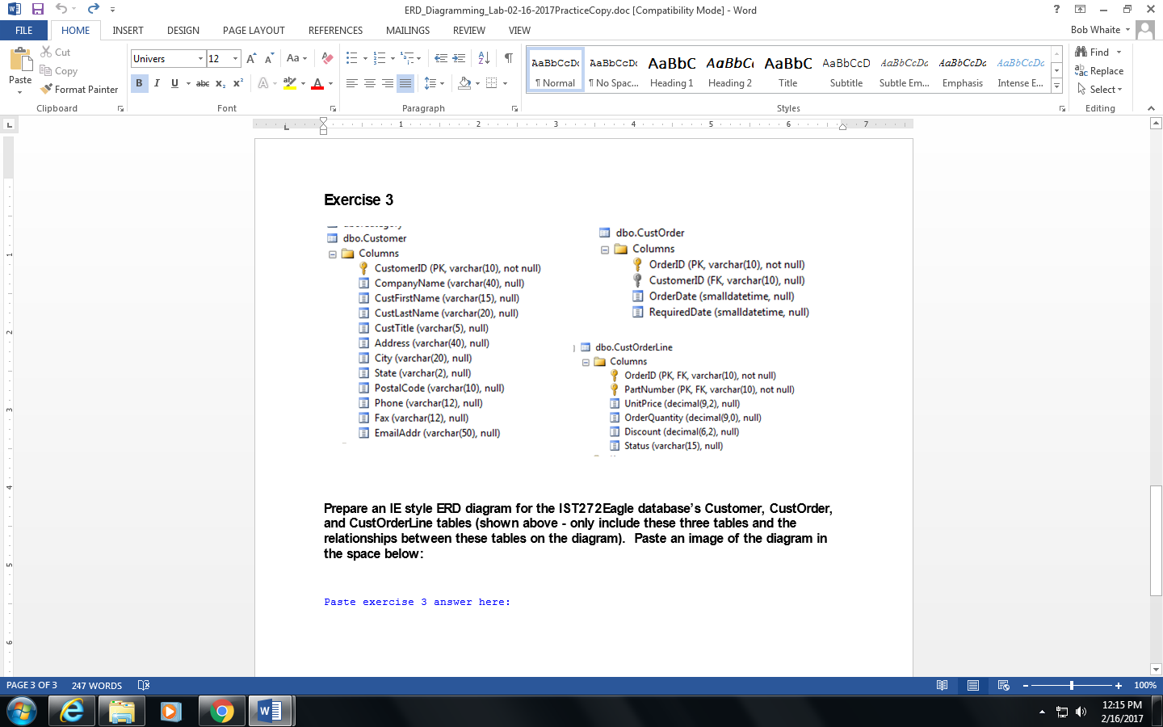

**Prepare an IE style ERD diagram for the IST272Eagle database’s Customer, CustOrder, and CustOrderLine tables (just these three tables - do not include any other tables on the diagram). Paste an image of the diagram in the space below:**

Paste exercise 3 answer here:

