**Title**

Modeling the scale-up of antiretroviral therapy coverage in sub-Saharan Africa using growth curves

**Authors**

Benjamin Bigelow SM1,2; Stéphane Verguet PhD1

**Authors’ affiliation**

1 Department of Global Health and Population, Harvard T.H. Chan School of Public Health, Boston, MA, USA

2 CareJourney, Arlington, VA, USA

**Correspondence to:** Stéphane Verguet, Department of Global Health and Population, Harvard T.H. Chan School of Public Health, 665 Huntington Avenue, Boston MA 02115, USA. Email: verguet@hsph.harvard.edu.

**Abstract**

*Background:* The rate of change in key health indicators is an understudied area of health system performance. Rates of change in health services indicators can augment traditional measures that usually solely involve the absolute level of performance in those indicators. Growths curves are a class of mathematical models that have been used in many academic disciplines to parameterize dynamic phenomena and to estimate rates of change summarizing these phenomena. However, these models are not commonly used in global health. We describe the changes over time in antiretroviral therapy (ART) coverage at the country level in sub-Saharan Africa using mathematical modeling that builds on growth curves.

*Methods:* We used publicly available data on antiretroviral therapy (ART) coverage levels from 2000-2015 in 39 sub-Saharan African countries, and we developed two ordinary differential equations models, the Gompertz and logistic growth models, that allowed for the estimation of parameters related to the scale-up and rates of change in ART coverage. We fitted the two models to ART coverage data for each country, and we assessed goodness of fit using the Bayesian information criterion (BIC). We ranked countries based on their estimated performance drawn from the fitted parameters of the models.

*Results:* Based on the BIC, the Gompertz model provided a better fit than the logistic growth model for most countries examined. With the Gompertz model, we estimated rates of scale-up of ART coverage ranging from 2.0 percentage points per year and lower (Somalia, Sudan, and Mauritania) to above 8 percentage points per year and higher (Benin, Rwanda, and Namibia).

*Conclusions:* Growth curve models can provide benchmarks to assess performance in ART coverage, and can procure a useful approach and metrics for parameterizing country performance in scaling up health services.

**Keywords:** Health systems; health services indicators; scale-up; HIV/AIDS; antiretroviral therapy; growth curves; ordinary differential equations; rates of change.

**Paper context:** The rate of change in key health indicators is an understudied area of health system performance. Rates of change in health services indicators can augment traditional measures that involve the absolute level of performance. This article reports on performance in the rate of change of antiretroviral therapy for 39 countries in sub-Saharan Africa over the period 2000-2016 using growth curve models. Growth curve models could represent a useful approach for policymakers and researchers interested in understanding health system performance.

**Introduction**

Health policymakers are increasingly concerned with measuring the effectiveness, efficiency, and overall performance of national health systems in a comparable manner. Measuring performance requires relating the attainment of specific health system objectives, such as the improvement of population health and of its distribution, to the dedicated financial resources and expenditures in a country [1-3]. Additionally, comparable data on health system performance provide a foundation for subsequent analyses of variation across countries, ultimately strengthening the evidence base for understanding variations in performance and for policy implementation and reform [1]. Stakeholders can then use such information to better analyze how performance on stated objectives may vary with several factors, including how the health system is organized, financed, and regulated [2,3].

The question of how to evaluate health system performance is difficult, as it requires choices to be made about what to measure (e.g. which outcomes, outputs, and costs), how to measure (e.g. with which administrative data, household surveys), and how to present the results (e.g. with which individual or composite indicators). For example, in its World Health Report (WHR) 2000, the World Health Organization (WHO) defined health system performance along several objectives – including overall health improvement, responsiveness to population expectations, financial protection, and the level of health inequalities – and then it ranked the health systems of WHO member states [4]. The rankings were based on country performance across metrics such as mortality and life expectancy relative to statistical predictions by income level [4]. The WHR 2000 generated immediate controversy and debate [5-7], and a number of researchers questioned the methodology behind the WHR rankings, drawing particular attention to the sensitivity of the rankings [8-10]. For instance, as an alternative, Nolte and McKee [11] subsequently examined the narrower concept of mortality amenable to healthcare (age-standardized mortality from causes amenable to medical care such as diabetes mellitus and cardiovascular disease). Using this approach, they found that among 19 countries from the Organization from Economic Cooperation and Development, no country retained the same ranking [11].

Many health outcomes and health services indicators focus on the absolute *level* of performance. The United Nations’ Millennium Development Goals (MDGs), for example, included health outcomes such as the maternal mortality ratio and the incidence of malaria, two indicators that capture performance at a single point in time [12]. Similarly, UNAIDS developed performance indicator levels into its recent 90-90-90 treatment targets for tackling the HIV/AIDS epidemic by 2030 [13]. Yet, only evaluating the levels of performance for certain outcomes can ignore long-standing determinants within countries and national health systems that may affect the ability to expand access to care, and that may also blur the ability of researchers to understand the share of performance variation that can possibly be attributable to health systems. In this respect, examining and estimating the *rates of change* of health services indicators may prove valuable in understanding the performance of national health policies, programs, and interventions [14-16]. As a case in point, in *Good Health at Low Cost: 25 Years On*, Balabanova et al. [17] used both levels and rates of changes of services coverage to select which countries to include and further study as relevant examples of good performance on health.

Simple rates of change in coverage of health services can be estimated empirically (e.g. by taking the first derivative of coverage), but their evolution over time can also be captured by mathematical models including simple ordinary differential equations such as “growth curves”. Indeed, growth curves could capture meaningful summary parameters characterizing intervention coverage scale-up, and they have been used in many other disciplines to model specific dynamic phenomena. For example, in telecommunications, the Bass diffusion equation can be used to model the spread of innovation or adoption of new technologies in a population [18]; and in cell biology, growth curves can be used to represent bacterial growth [19]. Despite these common uses, such simple differential equation models have been routinely implemented in global public health.

Rudimentary mathematical modeling including growth equations could parameterize and capture the evolution of health services coverage over time, and thus provides a stepping stone toward assessing health system performance. In this paper, we illustrate the relevance of growth curves by attempting to parameterize the growth in antiretroviral therapy (ART) coverage in 39 sub-Saharan African countries using two long-established growth models, the logistic and the Gompertz models. We then extract summary metrics (e.g. rate of scale-up, delay to scale-up) that describe the evolution of ART coverage and thus may be of interest to analysts and policymakers to better characterize cross-country variation in the ART coverage evolution in sub-Saharan Africa.

**Methods**

*Data sources*

We used country-level data on ART coverage from 2000 to 2015, directly sourced from the World Bank’s World Development Indicators database (UNAIDS estimates) [20]. ART coverage is defined as the percentage of people living with HIV who are receiving ART. We limited our analysis to sub-Saharan Africa, as the region is most impacted by HIV. According to UNAIDS, the region accounted for close to 70% of all people living with HIV in 2018 [21]. We further limited our analysis to countries with a population exceeding more than one million [22], leading to a sample of 39 sub-Saharan African countries.

**Insert Table 1 around here**

*Mathematical approach*

We used two types of ordinary differential equations to model the growth in ART coverage over time in the selected countries: the logistic and the Gompertz equations (Table 1). In their canonical forms, these models are not easily interpretable in the context of global health [19]. Therefore, we used the transformations described by Zwietering and colleagues for both the Gompertz and logistic equations [19]. The new parameters derived can have a more intuitive meaning: *A* can be interpreted as the projected maximum level of intervention coverage (in percentage points); *μ* as the maximum growth or maximum scale-up rate of intervention coverage (in percentage points per year); and *λ* as the lag or delay time prior to the start of the intervention implementation (in years). The initial level of intervention coverage is represented by *y0* (Figure 1 provides a graphical representation).

**Insert Figure 1 around here**

The logistic equation is a simple and widely used model. Though its simplicity is advantageous, it may not be well-suited to model coverage scale-up and evolution, especially since it is symmetric in shape. The maximum growth rate (i.e. the inflection point of the coverage curve) can only occur halfway between the initial value (*y0*)and the asymptotic carrying capacity (*A*). In fact, there is no *a priori* reason to believe that growth in ART coverage over time would be symmetric or that the highest rate of growth would be exactly halfway between these two points (i.e. the start and end points). On the contrary, unlike the logistic equation, the Gompertz equation allows for asymmetry, as the maximum growth rate need not occur exactly halfway between *y0* and *A*. This property may thus fit better with the study of ART coverage evolution over time: ART coverage may grow rapidly in the initial stages of a program, but marginal gains in later stages may be difficult to achieve. Exponential growth at low values of time (*t*) and the gradual approach of an asymptote could be desirable properties in modeling coverage evolution and program scale-up (exponential growth is linear on a log scale, and *ln(y)* for both the Gompertz and logistic models is linearly proportional to *t* for low values of *t*). Therefore, we retained both the Gompertz and logistic growth models in our study.

*Model estimation*

We fitted both growth models to ART coverage time series data using nonlinear regression methods. All the analyses were performed with the Python programming language; for the nonlinear regressions, we used the LMFIT package, which implements the Levenberg-Marquardt algorithm for least-squares minimization [23]. The goodness of the model fits were then assessed using the Bayesian information criterion (BIC) [24]. In addition, we compared the estimated parameters to values directly observed from the data: an observed lag time was calculated as the number of years between 2000 (when data was first available) and a country’s first year with ART coverage > 0; we also considered the average change in ART coverage, defined as current ART coverage divided by the number of years since ART coverage > 0.

**Results**

We first display the fits of the Gompertz and logistic growth models to the data of six selected sub-Saharan African countries (Figure 2), along with the estimated maximum rates of change (*μ*) across all the countries examined (Figure 3).

With the Gompertz model, the mean value of *μ* in the sample was 5.1 percentage points per year, with a range from 1.0 percentage points per year (Somalia) to 11.5 percentage points per year (Benin). For the logistic model, estimates of *μ* ranged from 1.1 percentage points per year (Somalia) to 12.5 percentage points per year (South Sudan), with a mean value of 6.1 percentage points per year. Country-specific estimates from the Gompertz and logistic models tended to cluster near similar values (Figure 3). Still, there were a few countries where estimates of *μ* diverged. For example, for Madagascar, the logistic model estimated *μ* of 2.6 percentage points per year, whereas the Gompertz model estimated *μ* of 8.1 percentage points per year; for South Sudan, 5.7 percentage points per year for the Gompertz vs. 12.5 for the logistic. These two countries were however outliers as they had ART coverage levels below 10%, which thus makes it difficult to model ART coverage scale-up [17] given the relatively low changes in coverage magnitude over time.

**Insert Figures 2 and 3 around here**

Table 2 shows the estimated rates of change per county along with an associated ranking. For a majority of countries, the rankings were similar across Gompertz vs. logistic models. For example, Benin remained a top performer, while Somalia remained a bottom performer. In between, however, the rankings were less stable. For example, when assessed on the observed crude average rate of change, South Sudan ranked 36th, while 1st on the estimated *μ* from the logistic model; Kenya ranked 8th under the observed crude average rate of change while 18th under the estimated *μ* from the logistic model. Overall, correlation in ranks on *μ* between the logistic and Gompertz models was 0.96; while it was 0.53 between Gompertz’s *μ* and the observed crude average rate of change, and 0.43 between logistic’s *μ* and the observed crude average rate of change. These differences also come from the fact that average rates of change and maximum rates of change (*μ*) capture two different things.

**Insert Table 2 around here**

As for time delays, the estimated mean value of *λ* was 6.4 years with the Gompertz model compared with 7.0 years with the logistic model (Figure 4). Most of the differences between the observed and estimated delays occur in a small group of countries such as Madagascar and South Sudan, countries which tend to have low levels of both ART coverage and HIV prevalence. For example, in 2015, Madagascar had an HIV prevalence of 0.2% and ART coverage of 4%; for South Sudan, it was 2.8% and 9%, respectively [20,25].

**Insert Figure 4 around here**

Botswana presented the shortest estimated delay in scale-up (*λ*) from both models (2.6 years for the Gompertz model and 3.2 years for the logistic model). Contrarily, Madagascar showed the longest estimated delay in scale-up (19.0 and 19.7 years according to the Gompertz and logistic models, respectively) (Table 3). Country rankings were dependent on the way lag time *λ* was estimated. A few countries, Botswana (ranked 1st) and South Sudan (ranked 38th), retained ranking across the Gompertz and logistic models; others saw important changes, such as Gabon, ranked 13th with *λ* estimated from the Gompertz model compared with 26th with *λ* estimated from the logistic model. Overall, correlation in ranks on *λ* between the logistic and Gompertz models was 0.85; while it was 0.90 between Gompertz’s *λ* and the observed time delay, and 0.66 between logistic’s *λ* and the observed time delay.

**Insert Table 3 around here**

In evaluating the goodness of fit of each growth model, we sought the model with the lowest BIC [26]. For this comparison, across countries, we subtracted the BIC of the logistic model from the BIC of the Gompertz model, and calculated a ΔBIC. When ΔBIC > 6, there is strong evidence supporting the logistic model; when ΔBIC < - 6, then there is strong evidence supporting the Gompertz model [26]. Our findings were then split between the two models, with overall the Gompertz model providing a better fit for most countries. Differences in BIC ranged from 22 for South Africa to -26 for Eritrea (Figure 5).

**Insert Figure 5 around here**

**Discussion**

In this paper, we used two simple and intuitive differential equation growth models, the logistic and the Gompertz models, to characterize and synthesize changes in ART coverage over 2000-2015 for 39 sub-Saharan African countries. Using nonlinear statistical regressions, we estimated key parameters to describe ART coverage evolution, including the maximum rate of change (*μ* in percentage points per year) and the lag time to coverage scale-up (*λ* in years). We were then able to compare these estimated parameters to observed ART coverage data to describe how ART performance and scale-up evolution might vary across sub-Saharan African countries.

Some countries performed consistently well across growth models. For example, Botswana was the highest ranking country across all estimated parameters for the time delay in ART scale-up (*λ*), and was also highly ranked for its estimates in maximum rates of change of scale-up (*μ*). This well reflects the success Botswana achieved in scaling up its ART program. Since 2002, Botswana has committed significant resources to establishing universal coverage for ART; and subsequently, mortality among people living with HIV in the country fell dramatically [27,28]. Likewise, Rwanda is another success story highlighted by our modeling approach; it ranks third in the estimated delay in ART scale-up (4.1 years) and second in the estimated maximum rate of change (8.2 percentage points per year), according to the Gompertz model. Although few people living with HIV were being treated back in 2003, the country had already achieved, by 2015, ART coverage levels greater than 80% [29]. On the contrary, South Africa demonstrated a significant delay in scale-up (around 7 years as confirmed by estimations of each growth model), consistent with the evolution of national ART coverage and the postponing of ART scale-up in the country following AIDS denialism [30]. After 2006, when ART coverage was then at 4%, South Africa significantly grew its ART program and achieved rapid coverage expansion of approximately 1.8 million people by 2011 and over 3 million people by 2017, for a current ART coverage of about 56% [31,32]. Therefore, our growth models and their estimates of *μ* and *λ* could provide policymakers and analysts with useful summary indicators for synthesizing and evaluating the evolution over time of coverage of key health services and interventions (ART in our case study).

Nevertheless, our analysis presents a number of limitations. First, our approach may not be generalizable as we have only tested it here to time series data on ART coverage. Although ART may be important in tackling the AIDS epidemic, there are indeed many other treatments and health services that could be studied for addressing HIV/AIDS, and many more for other diseases and conditions (e.g. immunization coverage). Furthermore, our time series coverage data may be subject to correlations between countries and within country, and one could potentially refine the statistical modeling by introducing country- and time-specific random effects. Second, although an estimated rate of change (*μ*) and estimated time delay (*λ*) may be useful to policymakers to summarize intervention scale-up evolution, they are merely two simple indicators: many factors influence intervention scale-up, and thus *μ* and *λ* can in no way answer the fundamental question of why a country might perform well or poorly in one of its program/intervention; *μ* and *λ* likely encapsulate many parts of a complex health system architecture [30], which requires further in-depth investigation. Third, our growth models also do not incorporate any information on country context. The prevalence of HIV – and hence the need for ART coverage – varies widely across sub-Saharan African countries. In some countries, such as Burkina Faso and the Democratic Republic of the Congo, less than 1% of the population suffers from HIV [25]; and this largely explained some of the poor regression fits. In contrast, South Africa, Swaziland, and Botswana present an adult prevalence of HIV above 20% [25]. Clearly, the latter group of countries faces different challenges to HIV management and ART scale-up than the former. Lastly, our growth models were purposely simplistic as they did not rely on existing frameworks for health system analysis. Notably, the information gleaned from our modeling approach should be augmented with the economic and historical context of a given country. As Balabanova et al. point out [17], the ability of a health system to scale-up an intervention (i.e. to achieve a high rate of change or a low lag time) is influenced by the system’s history and development. Our objective in this paper is to present a simple approach to estimate meaningful parameters summarizing intervention and health services scale-up, which may a useful first stepping stone toward characterizing and understanding health system performance.

To conclude, our analysis intends to contribute to the growing acknowledgement that rates of change in levels of health outcomes and health services coverage may provide helpful insight into the understanding of country performance on health. And although they are only a starting point, growth curves and basic differential equation models can provide a departure point and a novel perspective on characterizing the scale-up of key interventions in global health.

**Acknowledgements:** We thank Osondu Ogbuoji for sourcing the time series data used in this analysis and for useful discussions.

**Funding:** Funding was received from the Department of Global Health and Population, Harvard T.H. Chan School of Public Health.

**Disclaimer:** The views expressed in this article are those of the authors and are not the official positions of their affiliate institutions or funders.

**Conflict of interest declaration:** BB was employed by CareJourney (Arlington, VA), a healthcare software company. As part of employment package, author has received stock options from CareJourney. The majority of research, data analysis, and manuscript preparation occurred while the Author was in graduate school, prior to the Author’s employment at CareJourney. SV has no conflicts of interest to declare.

**References**

1. Murray CJL, Frenk J. A framework for assessing the performance of health systems. Bulletin of the World Health Organization 2000; 78(6):717-731.
2. Roberts M, Hsiao WC, Berman P, Reich MR. Getting health reform right: a guide to improving performance and equity. New York: Oxford University Press, 2008.
3. Smith PC, Mossialos E, Papanicolas I, Leatherman S. Performance measurement for health system improvement. Cambridge, UK: Cambridge University Press, 2010
4. World Health Organization. World Health Report 2000 – Health systems: improving performance. Geneva: World Health Organization, 2000.
5. Almeida C, Braveman P, Gold MR, et al. Methodological concerns and recommendation on policy consequences of the World Health Report 2000. Lancet 2001; 357:1692-1697.
6. Jamison DT, Sandbu ME. WHO ranking of health system performance. Science 2001; 293(5535):1595-1596.
7. Musgrove P. Judging health systems: reflections on WHO's methods. *Lancet* 2003; 361:1817-1820.
8. Blendon RJ, Kim M, Benson JM. The public versus the World Health Organization on health system performance. Health Affairs 2001; 20(3):10-20.
9. Navarro V. The World Health Report 2000: can health care systems be compared using a single measure of performance? American Journal of Public Health 2002; 92(1):31-34.
10. Navarro V. Assessment of the World Health Report 2000. Lancet 2000; 356:1598-1601.
11. Nolte E, McKee M. Measuring the health of nations: analysis of mortality amenable to health care. BMJ 2003; 327(7424):1129.
12. United Nations. Millennium Development Goals. Available from: https://www.un.org/millenniumgoals/ (accessed July 29, 2019).
13. UNAIDS. 90-90-90: an ambitious treatment target to help end the AIDS epidemic. UNAIDS, October 2014.
14. Verguet S, Jamison DT. Estimates of performance in the rate of decline of under-five mortality for 113 low- and middle-income countries. Health Policy and Planning 2014; 29(2):151-163.
15. Verguet S, Norheim OF, Olson ZD, Yamey G, Jamison DT. Annual rates of decline in child, maternal, HIV, and tuberculosis mortality across 109 countries of low and middle income from 1990 to 2013: an assessment of the feasibility of post-2015 goals. Lancet Global Health 2014; 2:e698-709.
16. Verguet S, Jamison DT. Performance in rate of decline of adult mortality in the OECD, 1970-2010. Health Policy 2013; 109(2):137-142.
17. Balanaova D, McKee M, Mills A. Good health at low cost 25 years on: what makes a successful health system? London: London School of Hygiene & Tropical Medicine, 2011.
18. Meade N, Islam T. Forecasting with growth curves: an empirical comparison. International Journal of Forecasting 1995; 11(2):199-215.
19. Zwietering MH, Jongenburger I, Rombouts FM, van’t Riet K. Modeling of the bacterial growth curve. Applied and Environmental Microbiology 1990; 56(6):1875-1881.
20. Antiretroviral therapy coverage (% of people living with HIV). Available from: https://data.worldbank.org/indicator/SH.HIV.ARTC.ZS?locations=SS-MG. [Accessed: 18-Nov-2017].
21. Joint United Nations Programme on HIV/AIDS. UNAIDS data 2019. Available at: [www.unaids.org](http://www.unaids.org) (accessed July 29, 2019).
22. World Bank. Population, total. Available from: https://data.worldbank.org/indicator/SP.POP.TOTL. (accessed July 29, 2019).
23. LMFIT: Non-Linear Least-Square Minimization and Curve-Fitting for Python. Available at: <https://lmfit.github.io/lmfit-py/> (accessed July 29, 2019).
24. Spiess A-N, Neumeyer N. An evaluation of R2 as an inadequate measure for nonlinear models in pharmacological and biochemical research: a Monte Carlo approach. BMC Pharmacology 2010; 10:6.
25. World Bank. World Development Indicators. Prevalence of HIV, total (% of population ages 15-49). Available from: http://databank.worldbank.org/data/reports.aspx?source=2&series=SH.DYN.AIDS.ZS&country=. [Accessed: 12-May-2017].
26. Kass RE, Raftery AE. Bayes factors. Journal of the American Statistical Association 1995; 90(430):773-795.
27. Farahani M, Vable A, Lebelonyane R, et al. Outcomes of the Botswana national HIV/AIDS treatment programme from 2002 to 2010: a longitudinal analysis. Lancet Global Health 2014; 2(1):e44-e50.
28. Gaolathe T, Wirth KE, Pretorius Holme M, et al. Botswana’s progress toward achieving the 2020 UNAIDS 90-90-90 antiretroviral therapy and virological suppression goals: a population-based survey. Lancet HIV 2016; 3(5):e221-e230.
29. Binagwaho A, et al. Rwanda 20 years on: investing in life. Lancet 2014; 384(9940):371-375.
30. Chigwedere P, Seage GR, Gruskin S, Lee T-H, Essex M. Estimating the lost benefits of antiretroviral drug use in South Africa. JAIDS 2008; 49(4):410-415.
31. Johnson LF. Access to antiretroviral treatment in South Africa, 2004 – 2011. South African Journal of HIV Medicine 2012; 13(1):22-27.
32. South Africa launches new plan to advance progress towards ending AIDS. Available from: http://www.unaids.org/en/resources/presscentre/featurestories/2017/april/20170403_south-africa-NSP. [Accessed: 22-Oct-2017].

**Table 1.** Mathematical formulations for the Gompertz and logistic growth models.

|  |  |  |  |
| --- | --- | --- | --- |
| **Model** | **Differential equation** | **Original solution** | **Modified solution** |
| Gompertz | $$\frac{dy}{dt}=-cylog⁡(\frac{y}{a})$$ | $$y\left(t\right)=a⋅\exp\left[-\exp\left(b-ct\right)\right]$$ $$y\left(0\right)= y_{0}$$ | $$y=A⋅exp⁡\left\{-exp⁡\left[\frac{μ⋅e}{A}(λ-t)+1\right]\right\}$$ |
| Logistic | $$\frac{dy}{dt}=cy(1-\frac{y}{a})$$ | $$y(t)=\frac{a}{1+exp⁡(b-ct)}$$ $$y\left(0\right)= y_{0}$$ | $$y=\frac{A}{\left\{1+exp⁡\left[\frac{4μ}{A}(λ-t)+2\right]\right\}}$$ |

*The modified solutions are adapted from Zwietering and colleagues [16]. They are equivalent to the canonical solutions provided, but rewritten so as to be interpretable in a global health context. ART coverage (in percentage points) is represented by y. The dependent variables represent the lag or delay time (λ, in years since 2000), the maximum scale-up rate of ART coverage (μ, in percentage points per year), and the carrying capacity of ART coverage (A, in percentage points).*

**Table 2.** Observed average rate of change (crude computation of difference in coverage over time divided by time period) and estimated maximum rate of change (*μ*) in ART scale-up (in percentage points per year) for 39 sub-Saharan African countries, with rankings.

|  |  |  |  |  |  |  |
| --- | --- | --- | --- | --- | --- | --- |
|  |  | | **Gompertz** | | **Logistic** | |
| **Country** | **Observed crude average change** | **Rank** | ***μ*** | **Rank** | ***μ*** | **Rank** |
| Benin | 6.1 | 2 | 11.5 | 1 | 11.4 | 2 |
| Senegal | 2.7 | 25 | 5.1 | 21 | 5.2 | 23 |
| Zimbabwe | 5.2 | 6 | 8.2 | 4 | 9.2 | 3 |
| Mozambique | 4.4 | 11 | 6.6 | 9 | 8.9 | 6 |
| Tanzania | 4.4 | 11 | 6.6 | 10 | 8.0 | 8 |
| Namibia | 5.8 | 3 | 8.2 | 3 | 9.0 | 5 |
| Gabon | 4.1 | 14 | 5.5 | 17 | 7.1 | 16 |
| Uganda | 3.8 | 16 | 6.0 | 14 | 7.7 | 12 |
| Swaziland | 4.5 | 10 | 6.6 | 8 | 7.4 | 14 |
| Rwanda | 6.6 | 1 | 8.2 | 2 | 9.0 | 4 |
| Malawi | 5.1 | 7 | 7.1 | 5 | 7.9 | 9 |
| Botswana | 5.2 | 5 | 6.9 | 6 | 7.6 | 13 |
| South Africa | 4.0 | 15 | 6.4 | 11 | 7.3 | 15 |
| Zambia | 4.8 | 9 | 6.4 | 12 | 7.0 | 17 |
| Kenya | 4.9 | 8 | 6.2 | 13 | 6.9 | 18 |
| Burundi | 3.6 | 17 | 5.7 | 15 | 6.3 | 19 |
| Togo | 3.2 | 19 | 4.6 | 23 | 5.2 | 22 |
| Mauritius | 2.4 | 28 | 5.1 | 20 | 5.0 | 25 |
| Cote d'Ivoire | 2.7 | 24 | 3.5 | 30 | 3.8 | 31 |
| Congo, Dem. Rep. | 2.8 | 23 | 4.9 | 22 | 7.7 | 10 |
| Eritrea | 5.5 | 4 | 6.9 | 7 | 7.7 | 11 |
| Lesotho | 3.5 | 18 | 5.4 | 19 | 5.8 | 21 |
| Ghana | 2.8 | 22 | 4.5 | 24 | 5.1 | 24 |
| Niger | 2.4 | 29 | 3.7 | 28 | 4.2 | 28 |
| Chad | 3.0 | 20 | 3.7 | 27 | 4.1 | 29 |
| Central African Republic | 2.2 | 32 | 2.8 | 34 | 2.9 | 35 |
| Burkina Faso | 4.2 | 13 | 5.5 | 18 | 6.1 | 20 |
| Guinea | 2.2 | 31 | 4.0 | 26 | 4.4 | 27 |
| Gambia, The | 2.2 | 32 | 3.4 | 31 | 3.9 | 30 |
| Sierra Leone | 2.5 | 26 | 3.2 | 33 | 3.5 | 34 |
| South Sudan | 1.6 | 36 | 5.6 | 16 | 12.5 | 1 |
| Mali | 2.2 | 34 | 4.3 | 25 | 4.5 | 26 |
| Angola | 2.9 | 21 | 3.6 | 29 | 3.7 | 32 |
| Liberia | 2.4 | 27 | 3.3 | 32 | 3.7 | 33 |
| Cameroon | 2.3 | 30 | 2.6 | 35 | 2.9 | 36 |
| Sudan | 1.0 | 37 | 1.6 | 38 | 2.6 | 37 |
| Mauritania | 1.6 | 35 | 1.9 | 37 | 2.1 | 38 |
| Somalia | 0.9 | 38 | 1.0 | 39 | 1.1 | 39 |
| Madagascar | 0.4 | 39 | 2.6 | 36 | 8.1 | 7 |

**Table 3.** Observed (crude computation of time until ART coverage > 0) and estimated (*λ*) time delays in ART scale-up (in years) for 39 sub-Saharan African countries, with rankings.

|  |  |  |  |  |  |  |  |
| --- | --- | --- | --- | --- | --- | --- | --- |
|  |  | |  | **Gompertz** | | **Logistic** | |
| **Country** | | **Observed crude delay** | **Rank** | **λ** | **Rank** | **λ** | **Rank** |
| Botswana | | 1 | 1 | 2.6 | 1 | 3.2 | 1 |
| Senegal | | 1 | 1 | 4.9 | 10 | 5.1 | 8 |
| Swaziland | | 1 | 1 | 5.1 | 12 | 5.9 | 14 |
| Burundi | | 1 | 1 | 5.9 | 17 | 6.4 | 16 |
| Uganda | | 1 | 1 | 6.0 | 20 | 7.5 | 32 |
| Gabon | | 2 | 6 | 5.4 | 13 | 7.1 | 26 |
| Mali | | 3 | 7 | 4.2 | 4 | 4.5 | 2 |
| Burkina Faso | | 3 | 7 | 4.2 | 5 | 4.8 | 5 |
| Zambia | | 3 | 7 | 4.8 | 9 | 5.4 | 10 |
| Guinea | | 3 | 7 | 5.4 | 15 | 5.8 | 12 |
| Cote d'Ivoire | | 3 | 7 | 5.4 | 14 | 5.9 | 13 |
| Togo | | 3 | 7 | 5.9 | 18 | 6.4 | 18 |
| Mauritius | | 3 | 7 | 8.9 | 37 | 8.6 | 35 |
| Cameroon | | 4 | 14 | 4.0 | 2 | 4.6 | 3 |
| Rwanda | | 4 | 14 | 4.1 | 3 | 4.7 | 4 |
| Namibia | | 4 | 14 | 4.4 | 6 | 4.9 | 6 |
| Lesotho | | 4 | 14 | 4.7 | 8 | 5.1 | 9 |
| Kenya | | 4 | 14 | 4.9 | 11 | 5.4 | 11 |
| Chad | | 4 | 14 | 5.9 | 19 | 6.4 | 17 |
| Malawi | | 4 | 14 | 6.2 | 22 | 6.7 | 20 |
| Zimbabwe | | 4 | 14 | 6.5 | 25 | 7.0 | 23 |
| Ghana | | 4 | 14 | 6.6 | 26 | 7.1 | 25 |
| South Africa | | 4 | 14 | 6.8 | 29 | 7.3 | 29 |
| Tanzania | | 4 | 14 | 7.2 | 34 | 8.3 | 34 |
| Mozambique | | 4 | 14 | 7.7 | 35 | 9.2 | 36 |
| Congo, Dem. Rep. | | 4 | 14 | 8.8 | 36 | 10.9 | 37 |
| Mauritania | | 5 | 27 | 4.5 | 7 | 5.0 | 7 |
| Eritrea | | 5 | 27 | 5.4 | 16 | 6.0 | 15 |
| Niger | | 5 | 27 | 6.4 | 23 | 6.9 | 22 |
| Gambia, The | | 5 | 27 | 6.7 | 28 | 7.2 | 28 |
| Sierra Leone | | 5 | 27 | 7.0 | 30 | 7.3 | 30 |
| Central African Republic | | 5 | 27 | 7.1 | 31 | 7.3 | 31 |
| Liberia | | 6 | 33 | 6.2 | 21 | 6.6 | 19 |
| Angola | | 6 | 33 | 7.1 | 32 | 7.2 | 27 |
| Somalia | | 7 | 35 | 7.1 | 33 | 7.6 | 33 |
| Benin | | 8 | 36 | 6.7 | 27 | 6.8 | 21 |
| Sudan | | 8 | 36 | 6.4 | 24 | 7.0 | 24 |
| South Sudan | | 9 | 38 | 13.9 | 38 | 15.3 | 38 |
| Madagascar | | 9 | 38 | 19.0 | 39 | 19.7 | 39 |

**Figure 1.** Diagram depicting a basic growth curve and its parameterization.

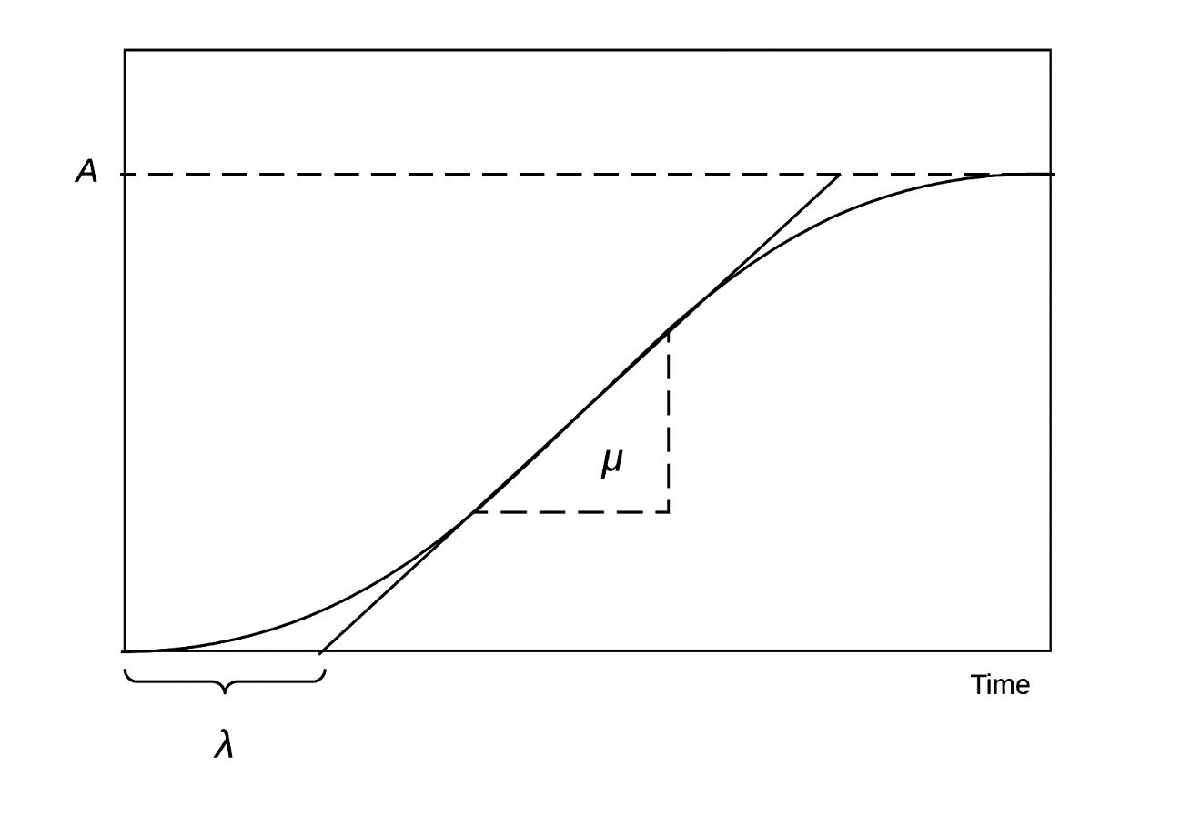

*This figure is adapted from Zwietering and colleagues [16]. A is the carrying capacity, μ is the maximum growth rate, and λ is the lag time.*

**Figure 2.** Growth curve regressions over the time-period 2000-2015 for six selected sub-Saharan African countries: Botswana, Gabon, Kenya, Rwanda, South Africa, and Uganda.

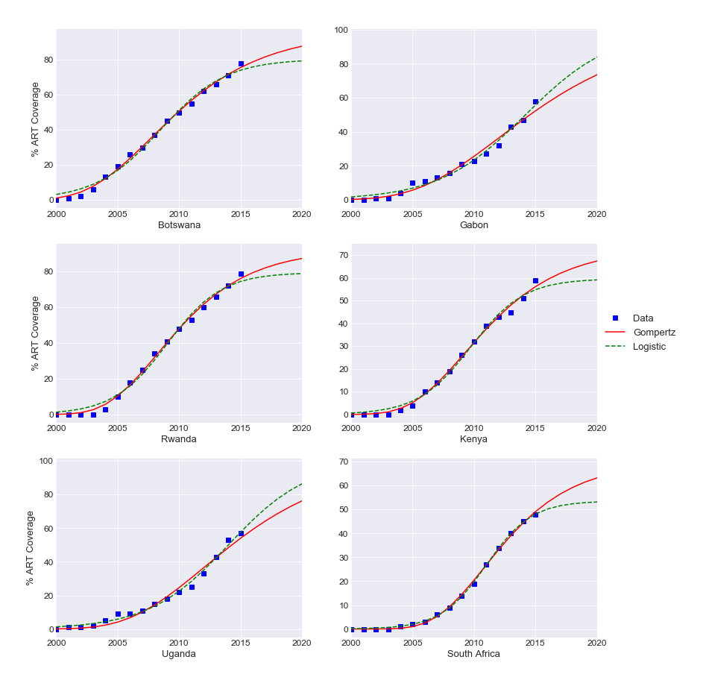

**Figure 3.** Rate of change in ART coverage (in percentage points per year) for 39 sub-Saharan African countries, ranked by *μ* estimates (maximum estimated rate of scale-up) from the Gompertz model.

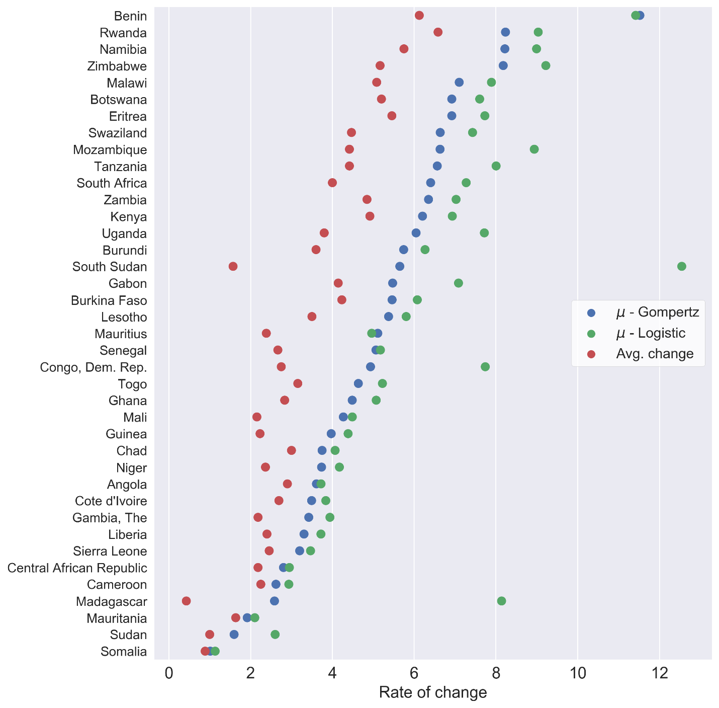

**Figure 4.** Delay in ART coverage scale-up (in years) for 39 sub-Saharan African countries, ranked by *λ* estimates (time delay) from the Gompertz model.

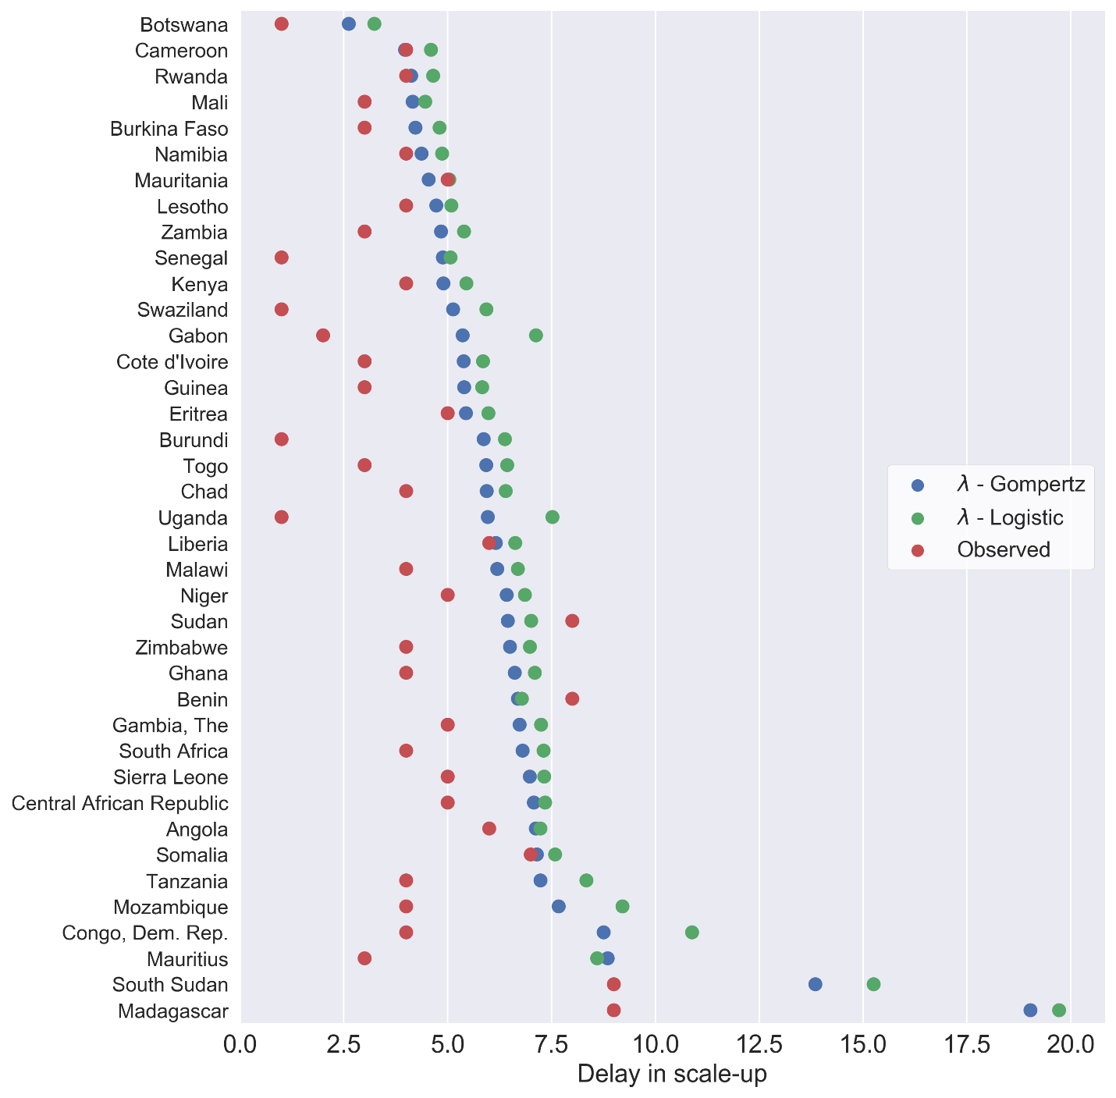

**Figure 5.** Difference in Bayesian information criterion (BIC) values between the Gompertz and logistic models for countries in sub-Saharan Africa, ranked from highest to lowest BIC values.

