**Why am I interested in programming?**

Programming is the way in which computers work. It is like being able to communicate with your computer on another level, much higher than those who do not know how to program. Technology and computing are very important parts of the present and future. You will notice that everything that can be computerized or made robotic or automatic has been. With this being said, why wouldn’t I want to learn more about this topic?

**What is GIT and why is it important?**

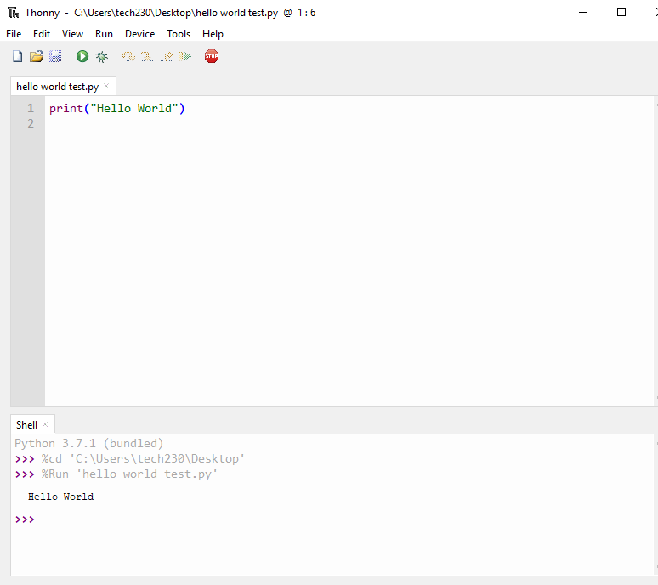GIT is a type of version control system. When you normally work on a folder, you make progress and save the folder after the progress is made. While using a VCS, each step along the way is recorded and saved so that you can access each of these steps and stages independently. You can find bugs in code this way, experiment, etc. You can do many helpful things with this tool. GIT is so valuable because of its branching model. This way you can merge many different local branches to one whole branch.