Assignment 2

Questions to answer:
1. Which of the executable files is the OnyxCrew malware? Submit a screenshot supporting your findings.

The executable file OnyxCrew used as malware is raaserver.exe. I first used PEID to scan the folder containing all the exe files on the thumbdrive. UPX was listed in the info tab for Raaserver this was also shown as a red flag for possible malware, due to malware usually being packed to not being able to get strings out of a packet as well as obfuscating the codebase. 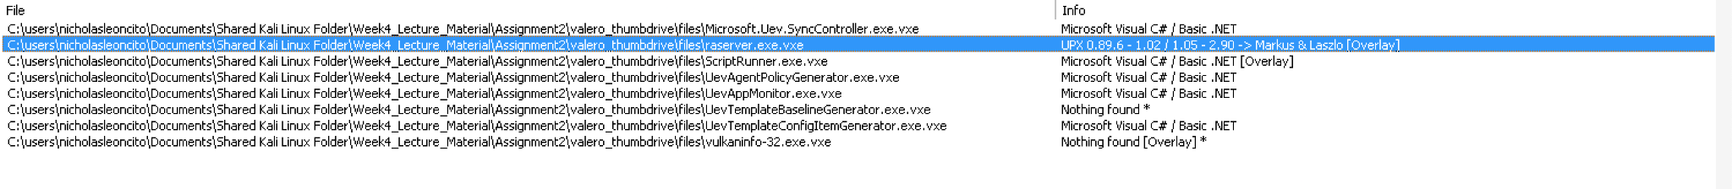
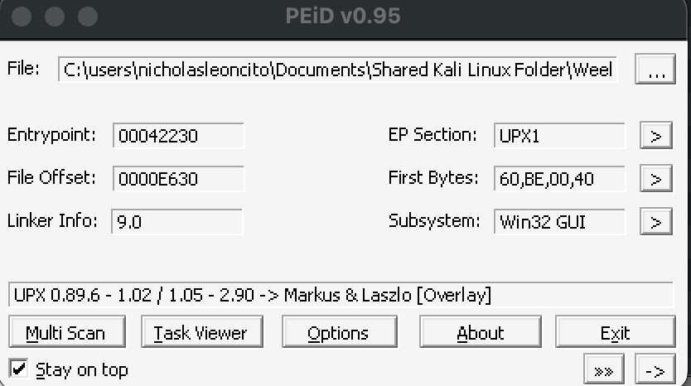
2. Once unpacked, what is Autorun persistence registry key embedded within the malware? (Submit a screenshot supporting your findings)
After unpacking, I found the malware had an autorun persistence key. This allows the program to launch every time the system boots.
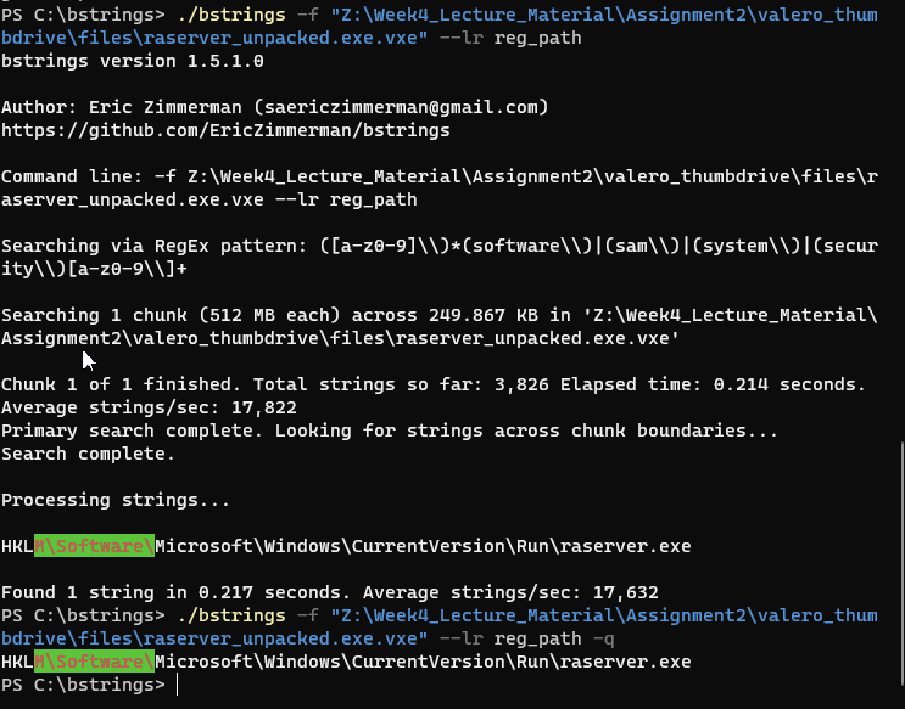

3. What is the windows file path embedded within the malware? (Submit a screenshot supporting your findings)

After unpacking, I found the malware had an autorun persistence key. This allows the program to launch every time the system boots.
The windows file path embedded within the malware is c:\OnyxCrew\ransware\raserver\release
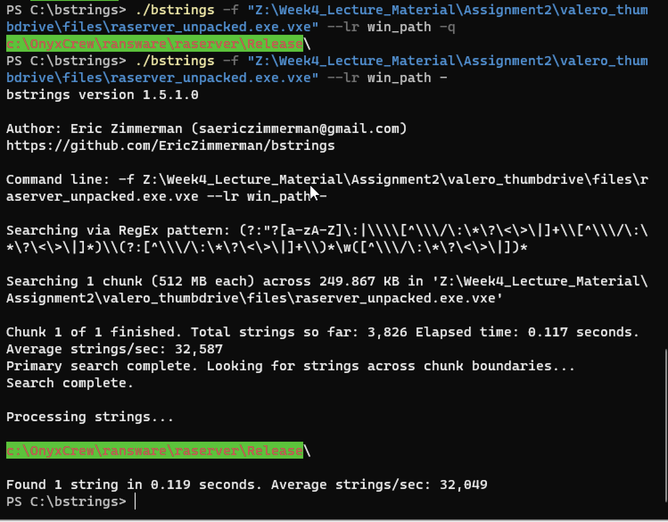
4. What is the URL embedded within the malware? (Submit a screenshot supporting your findings)
I used the bstrings command <file path> –lr url3986 to search for any Urls. This can be something important like the malware sending traffic to a domain or even being tied to the malware.
The Url takes you to a QR code that when scanned provides a bitcoin address.

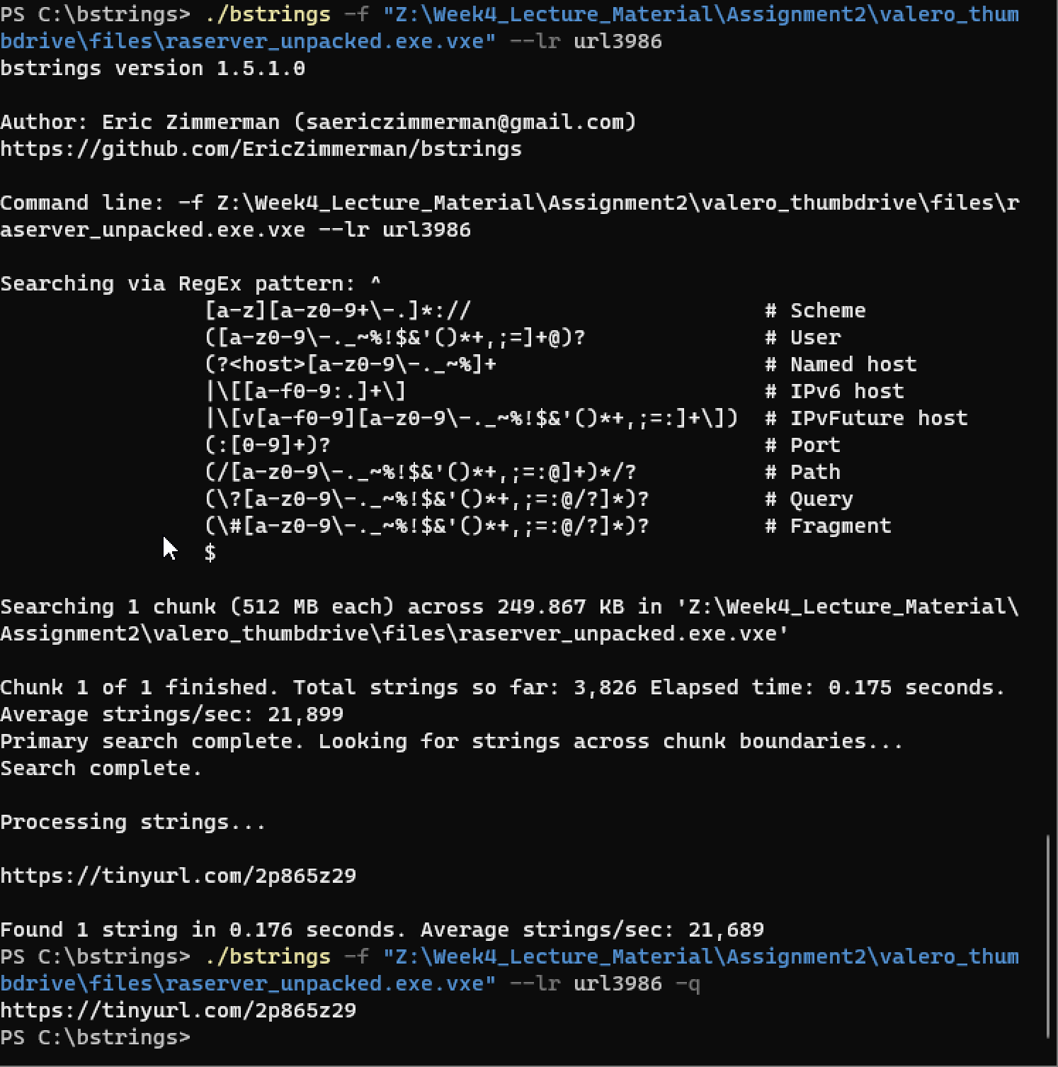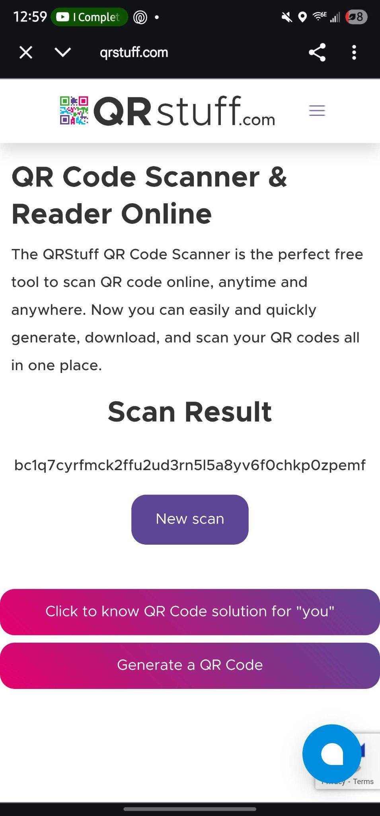
5. After visiting the URL, what is the Bitcoin Wallet address embedded at the website? (Submit a screenshot supporting your findings)
At the time of looking this up at 1am this is the conversion978.23242699 BTC = $113,249, 956.41

