Lab 04 Penetration Testing a pfSense Firewall

Introduction

The purpose of this lab was to conduct a detailed penetration test on a pfSense firewall-protected network, mimicking the real-world processes used to evaluate and strengthen network defenses. By analyzing firewall configurations, performing vulnerability scans with tools like Nessus and OpenVAS, and testing from both black-box and gray-box perspectives, I developed a comprehensive view of the network’s exposure to external threats. This lab also explored DMZ (Demilitarized Zone) best practices, assessing how proper configuration and segmentation can limit potential risks and improve overall security.

In this report, I break down each phase of the penetration test, discuss findings and configurations, and provide recommendations for fortifying network security. Screenshots throughout this report offer visual evidence of configurations, vulnerabilities discovered, and subsequent risk mitigation efforts.

Section 1: Firewall Configuration Analysis

The lab began with a configuration analysis of the pfSense firewall, focusing on understanding the established Virtual IPs, NAT (Network Address Translation) rules, and firewall rules. Examining these configurations was essential to understand the security baseline and assess whether there were any immediate risks due to overly permissive or misconfigured rules.

Key Observations:

Virtual IPs: The firewall had virtual IPs configured to manage multiple external IP addresses, which allowed a more granular control over traffic but also increased complexity. I reviewed these IPs for any misconfigurations that could expose sensitive services unintentionally.

NAT Rules: NAT rules were analyzed to ensure that only necessary services were accessible from external sources. Exposing critical services without adequate control can lead to significant security risks, especially if they lack additional protection.

Firewall Rules (LAN & WAN): I documented firewall rules for both LAN and WAN interfaces, verifying that the rule sets followed a least-privilege model. Misconfigurations here could allow unauthorized traffic flows, leading to vulnerabilities.

Screenshots:

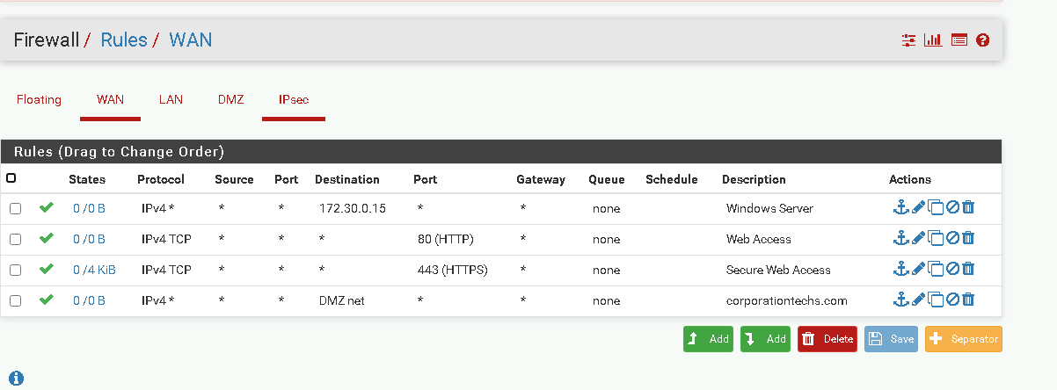

Findings:

Initial rule configurations allowed minimal external access; however, there were a few unnecessary rules which could introduce risk. Removing these helped create a stronger security posture by minimizing exposed services.

Section 2: Vulnerability Assessment with Nessus

With the firewall configurations analyzed, I proceeded to run a vulnerability assessment using Nessus, a tool well-regarded for its thorough vulnerability scanning capabilities. This assessment revealed potential security issues across different levels of severity, allowing me to pinpoint specific areas requiring immediate remediation.

Vulnerability Assessment Process:

Initial Scan: The first scan provided a detailed list of vulnerabilities based on the current firewall and network configurations. High-severity findings included possible misconfigurations and outdated software components.

Firewall Rule Adjustment: Based on the scan results, I modified firewall rules to restrict access further, aiming to reduce the attack surface.

Follow-up Scan: A second scan was conducted after the adjustments, which showed a noticeable reduction in high and medium severity vulnerabilities. The iterative approach helped verify that the firewall changes effectively mitigated previously identified risks.

Screenshots:

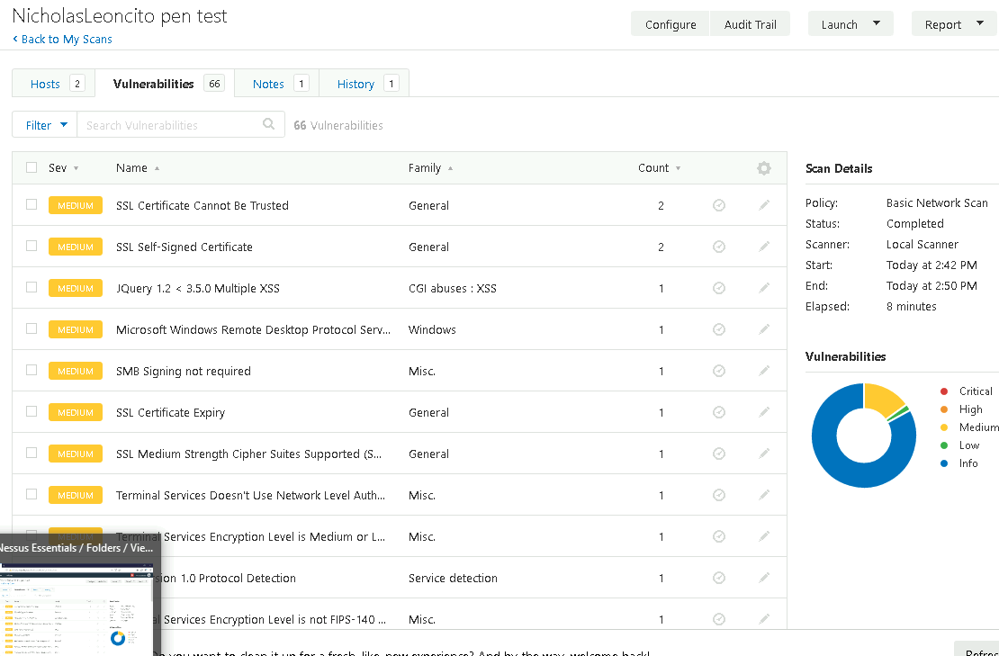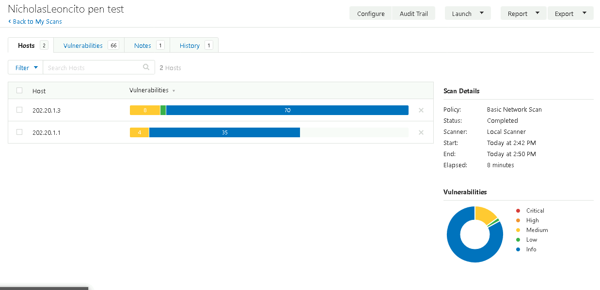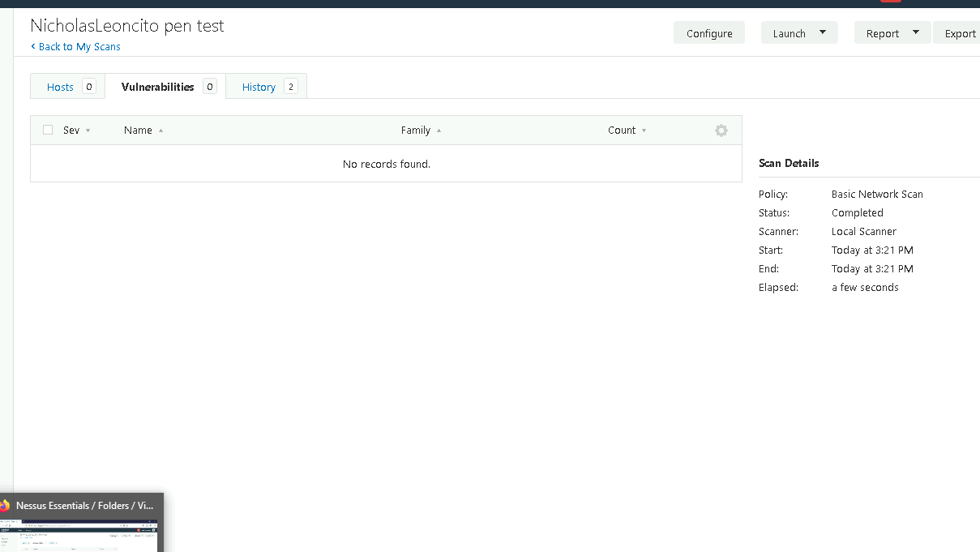

Analysis:

The Nessus scan results underscored the importance of routinely updating firewall configurations and software to ensure resilience against known vulnerabilities. This proactive approach to hardening demonstrated a practical method of reducing network risk.

Section 3: Black-Box Testing with Nmap and OpenVAS

The next step was to perform a black-box test, where I simulated an attack with limited internal knowledge of the network. Using tools like Nmap and OpenVAS, I explored the firewall’s external IP to identify open ports and exposed services, mimicking the actions of a potential attacker looking for entry points.

Steps in Black-Box Testing:

Nmap Scan: The initial Nmap scan allowed me to identify accessible services and open ports on the firewall. The scan results offered insights into services that might be vulnerable if left unprotected.

OpenVAS Scan: Building on the Nmap findings, I ran OpenVAS for a more comprehensive vulnerability scan, focusing on the ports and services identified in the Nmap results. This additional step revealed deeper insights into potential security weaknesses.

Screenshots:

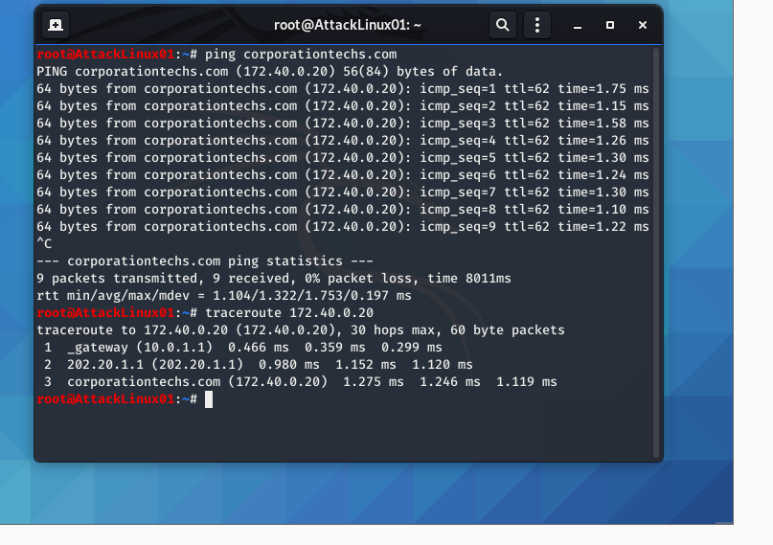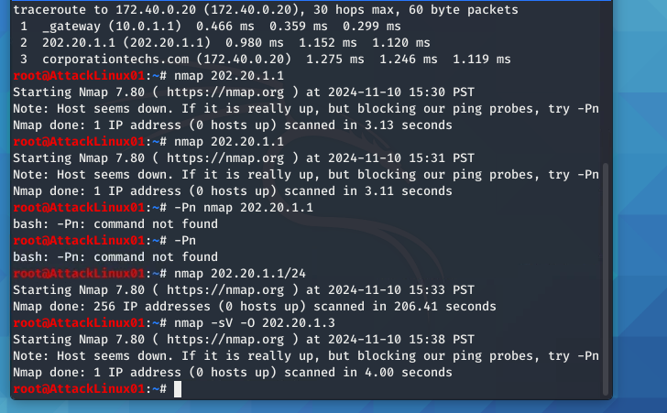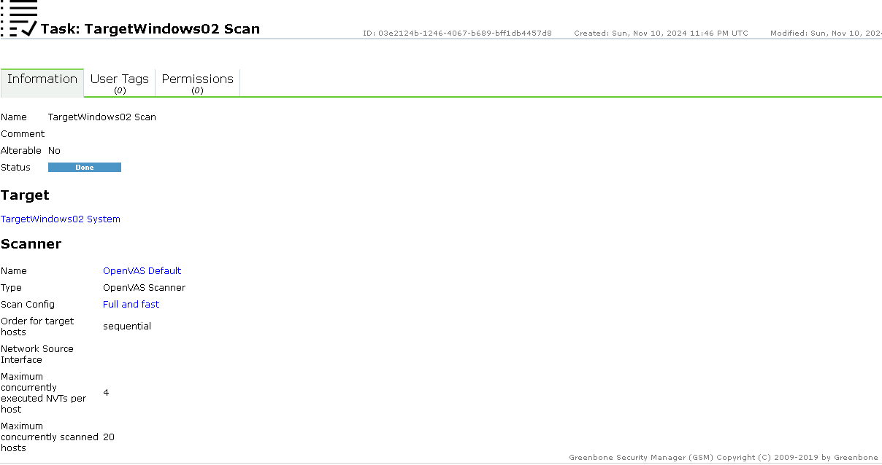

Findings:

The black-box approach highlighted areas where further hardening was needed, particularly around exposed services that did not initially appear vulnerable. Additionally, the scans reinforced the necessity of having minimal services accessible from the outside to prevent unauthorized access.

Section 4: DMZ Best Practices and Vulnerability Analysis

A key part of the lab involved evaluating best practices for deploying a DMZ, especially in scenarios where public-facing services require exposure but need to be isolated from sensitive internal networks. I researched DMZ best practices and then applied that knowledge to assess the security of the pfSense firewall’s DMZ.

DMZ Best Practices:

Isolation of the DMZ Network: Effective DMZ design requires isolating public-facing servers from internal systems to limit the impact of potential breaches.

Strict Access Control: Implementing tight access rules to control traffic between the DMZ and internal network ensures that only authorized traffic flows.

Routine Updates and Patching: Keeping services in the DMZ up-to-date is crucial to mitigate vulnerabilities, as these servers are more likely to be targeted by attackers.

Common Vulnerability:

One common mistake in DMZ design is failing to adequately restrict access between the DMZ and internal networks. If DMZ servers can freely communicate with internal systems, a compromised DMZ server can serve as a launchpad for further attacks.

Recommendations:

For the pfSense DMZ, I recommended the following:

Implement Stronger Segmentation: Additional segmentation between the DMZ and the internal network can further minimize risks.

Audit and Adjust DMZ Firewall Rules: Regular audits of firewall rules in the DMZ ensure only necessary services remain accessible, reducing the chances of exposure.

Restrict Internal Network Access from DMZ: Limit communication from the DMZ to internal systems, allowing only specific, necessary traffic.

Screenshots:

.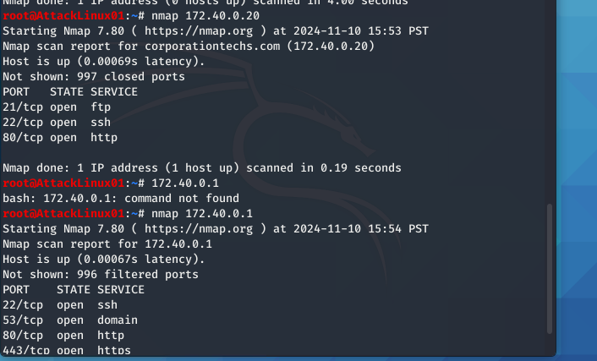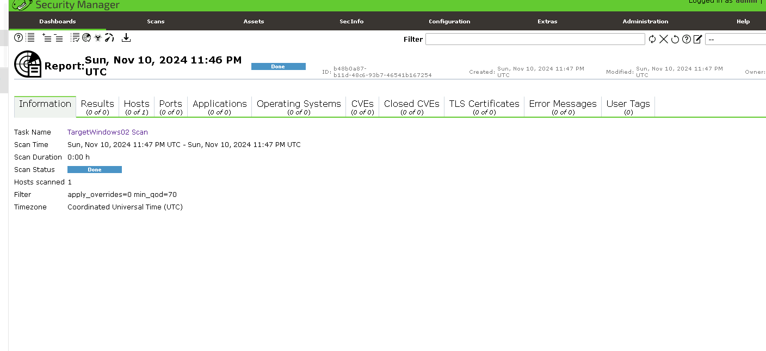

Conclusion

This lab provided an invaluable hands-on experience with penetration testing a firewall-protected network, reinforcing the importance of both configuration management and regular vulnerability assessments. The Nessus and OpenVAS scans revealed how easily exploitable configurations can be overlooked, and the black-box testing with Nmap illustrated the perspective of an external attacker.

The research on DMZ best practices added depth to the lab, emphasizing the importance of isolating sensitive assets and maintaining a tight control on access. This approach not only secures the firewall and network but also creates a foundation for a resilient cybersecurity posture.

The skills and methods practiced in this lab, from initial configuration review to advanced penetration testing and DMZ analysis, are essential for maintaining secure, robust networks. Regularly applying these methodologies in real-world scenarios will contribute significantly to reducing vulnerabilities and protecting organizational assets from external threats.

