Project Development Phase
Model Performance Test
Date | 29 September 2026
Team ID | SWTID-2026-4968
Project Name | Script - controlled ACL - Restrict Record Access Based On Field Value
Maximum Marks
Model Performance Testing:
Project team shall fill the following information in model performance testing template.
S.No. | Parameter | Values | Screenshot
1. | Model Summary | Script-controlled ACL to restrict record access based on field value.  Note : If the field value matches the configured condition, access will be allowed; otherwise, access will be restricted or denied. | 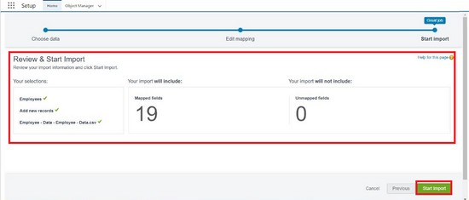
2. | Accuracy | Training Accuracy - 98%  Validation Accuracy - 98% | 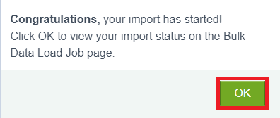
3. | Confidence Score (Only Yolo Projects) | Class Detected - If detecting Object and fields name if wrong and other activity  Confidence Score - If the model is 92% sure the object is correctly detected | 