**Jitter Plot on Mean with Standard Error for Longitudinal Data**

**Macro:** %Jitter_MeanError

**Created Date/Author:** Jan 23, 2017/Chao Zhang

**Current Version**: V1

**Working Environment:** SAS 9.4 English version

**Contact**: Dr. Yuan Liu [yliu31@emory.edu](mailto:yliu31@emory.edu)

**Purpose:** To create a Jitter Mean with Standard Error plots (repeated measure plots) for Longitudinal Data to describe the data distributions by subgroups at several points within the study. This macro can be used to create plots for batch of Y-vars (such as tumor size, weight) with same X-var.

**Notes:** The plot runs using PROC SGPLOT.

The general data structure for the macro is “long” form and it is as below.

|  |  |  |
| --- | --- | --- |
| **Group/Treatment/ID** | **X Variable** | **Y Variable** |
| 1 | 1 | 2.7 |
| 1 | 2 | 2.5 |
| 1 | 3 | 2.9 |
| … | … | … |
| 103 | 1 | 3.6 |
| 103 | 2 | 3.7 |
| 103 | 3 | 3.2 |

**A good tutorial on “Reshaping Wide to Long” can be found in the following link http://www.ats.ucla.edu/stat/sas/seminars/SAS_arrays/default_new.htm#wide_to_long**

**Reference**:

1. Nathaniel L Baker, et al. (Paper SD-002), “Jittering: A SAS® Macro to Shift Overlapping Plots.

2. http://support.sas.com/kb/42/542.html

**Parameters:**

|  |  |
| --- | --- |
| **Macro variable** | **Description** |
| DATA | The name of the data set to be analyzed. |
| X_VAR | Independent variable name (usually time or visit #); this is the variable to be jittered. |
| Y_VAR | Dependent variable name. |
| GROUP_VAR | Grouping variable, id, or treatment allocation; must be numeric (optional). |
| XAXIS_VALUE | Usage values (example: (0 12 24 36) or (0 to 18 by 3)...; specify the ticket value of X axis (optional). |
| FINENAME | File name for output table. |
| OUTPATH | File path for output table to be stored. |
| DEBUG | Set to T if running in debug mode (optional). Work datasets will not be deleted in debug mode. This is useful if you are editing the code or want to further manipulate the resulting data sets. The default value is F. |

**Usage Example:**

**libname lib H:\Jitter_plot\data';**

**%let dir= H:\Jitter_plot\output;**

**data test(drop=i);**

**do i=1 to 10;**

**do group=1 to 2;**

**do xvar=1 to 5;**

**yvar=ranuni(0)*100;**

**zvar= ranuni(1)*100;**

**output;**

**end;**

**end;**

**end;**

**run;**

**PROC format;**

**value sex 1= 'F' 2='M';**

**run;**

**data test;**

**set test;**

**label xvar= 'time (months)'**

**yvar= 'tumor vol'**

**Yvar2= 'tumor weight'**

**;**

**format group sex. ;**

**run;**

%Jitter_MeanError

(data=test,

x_var=xvar,

y_var=yvar Yvar2,

group_var= group,

outpath=&dir.\,

filename=aaa );

**Appendix:**

/*SAS code on transforming wide data to long data structure*/;

Data long;

Set wide;

time = **1**; VOL=Vol_Day1 ; WEIGHT=Weight_Day1 ; OUTPUT;

time = **3**; VOL=Vol_Day3 ; WEIGHT=Weight_Day3 ; OUTPUT;

time = **5**; VOL=Vol_Day5 ; WEIGHT=Weight_Day5 ; OUTPUT;

…

time = **17**; VOL=Vol_Day17; WEIGHT=Weight_Day17; OUTPUT;

**run**;

**Summary Plots Example:**

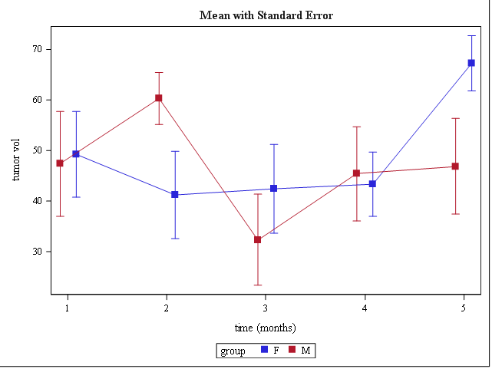

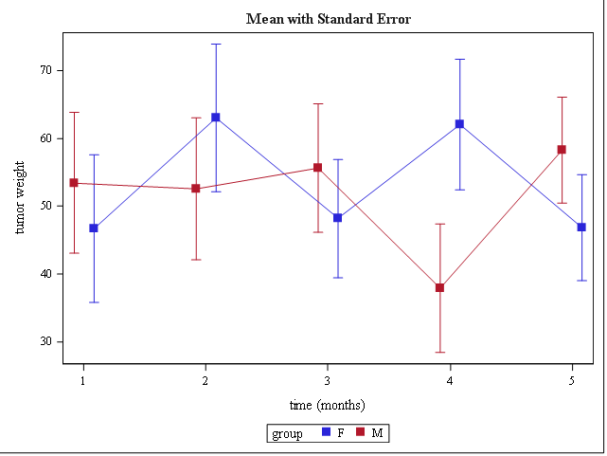

**Permission:**

Permission is hereby granted, free of charge, to any person obtaining a copy of this software and associated documentation files (the "Software"), to deal in the Software without restriction, including without limitation the rights to use, copy, modify, merge, publish, distribute, sublicense, and/or sell copies of the Software, and to permit persons to whom the Software is furnished to do so, subject to the following conditions:   
  
The above copyright notice and this permission notice shall be included in all copies or substantial portions of the Software.  
  
THE SOFTWARE IS PROVIDED "AS IS", WITHOUT WARRANTY OF ANY KIND, EXPRESS OR IMPLIED, INCLUDING BUT NOT LIMITED TO THE WARRANTIES OF MERCHANTABILITY, FITNESS FOR A PARTICULAR PURPOSE AND NONINFRINGEMENT. IN NO EVENT SHALL THE AUTHORS OR COPYRIGHT HOLDERS BE LIABLE FOR ANY CLAIM, DAMAGES OR OTHER LIABILITY, WHETHER IN AN ACTION OF CONTRACT, TORT OR OTHERWISE, ARISING FROM, OUT OF OR IN CONNECTION WITH THE SOFTWARE OR THE USE OR OTHER DEALINGS IN THE SOFTWARE.