20 17 학년도 ( 2 )학기 과제물(온라인제출용)

**교과목명 : 시물레이션**

**학 번 : 201734-358188**

**성 명 : 박병규**

**연 락 처 : 010-5037-0190**

_________________________________________________________________________

o 과제유형 : ( D ) 형

o 과 제 명 : 복수 창구의 대기 행렬 시스템

- 이하 과제 작성

(1) 유형과 간단한 조건 서술

* <조건> 도착형태 = 평균30명, 주유대 = 2대, 봉사형태= 평균 6분, 시물레이션 시간=100분
* Seed 학번 뒷자리358188
* 언어는 C 사용

(2) 프로그램과 간단한 설명

#include <iostream>

#include <cstdlib>

#include <math.h>

#define SEED **358188**

#define MEAN **6.0**

#define PRARR  **0.5**

#define TIMESTEP 1

#define PUMPNUMBER  **2**

#define TIMELIMIT **100**

using namespace std;

void random(long *pn,float *pu){

*pn=*pn* 843314861 + 453816693;

if (*pn<0) {

*pn=*pn+2147483647;

*pn=*pn + 1;

}

*pu = *pn * 0.46556612e-9;

return;

}

void poissn(long *np, float mean, int *pp){ // np = seed, mean = average, pp = random variable

float prod, b, u;

*pp = 0;

b=exp(-mean);

prod=1;

random(np, &u);

prod= prod*u;

while (prod>=b) {

random(np, &u);

prod=prod*u;

++(*pp);

}

}

int main()

{

int queue=0;

long n=SEED;

int time = 0; // 현재시간

int pump[PUMPNUMBER];

for (int i=0;i<PUMPNUMBER;i++) pump[i]=0;

int totalGuest = 0; // 누적된 손님수

int totalQueue = 0; // 누적된 대기 수

while (time < TIMELIMIT) {

time += TIMESTEP;

int arrival = 0;

float pu; // 손님이 도착할 확률을 계산하기 위한 난수 저장

random(&n,&pu);

if (pu < PRARR*TIMESTEP) { // 손님이 도착한 경우

queue +=1;

totalGuest += 1;

arrival = 1;

}

for (int q=0;q<PUMPNUMBER;q++){

if (pump[q]>0) pump[q] -= TIMESTEP;

if (pump[q] <=0 && queue > 0) {

queue -= 1;

int p;

poissn(&n, MEAN, &p);

pump[q] = p;

}

}

totalQueue += queue;

cout << endl << " TIME : " << time << " ARRIVAL " << arrival <<" QUEUE " << queue;

for (int i=0; i<PUMPNUMBER; i++) {

cout <<" pump" << i+1 << ": " << pump[i];

}

}

cout << endl << endl;

cout <<" 평균대기행렬길이(aveque = totque / (tlimit/tstep)) " << totalQueue / (TIMELIMIT/TIMESTEP) << endl;

cout <<" 평균대기시간(avgw = totque / totarr " << totalQueue / totalGuest << endl;

return 0;

}

(3) 출력결과

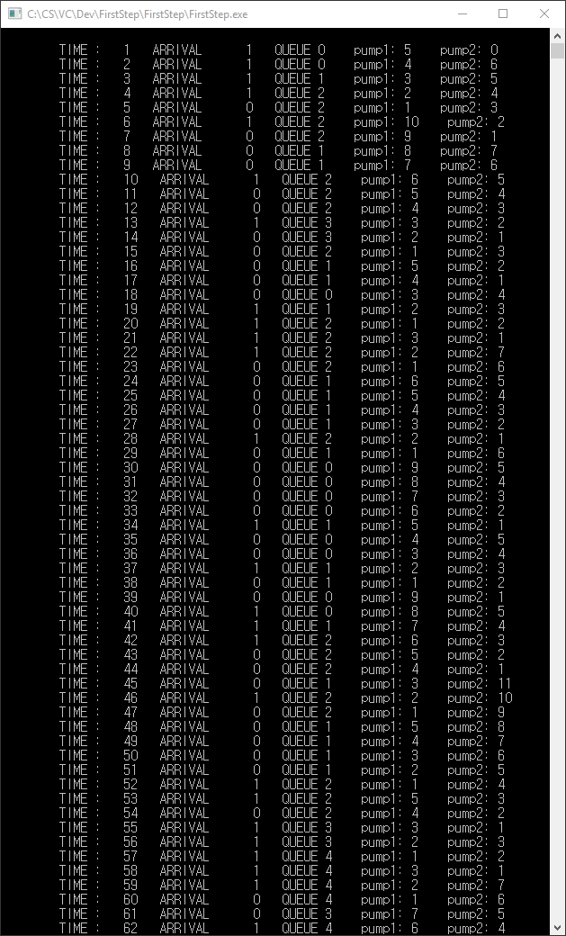

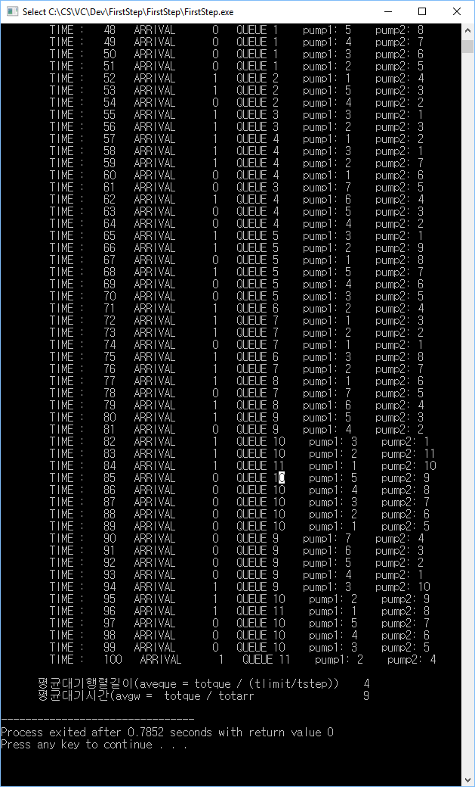

TIME : 1 ARRIVAL 1 QUEUE 0 pump1: 5 pump2: 0

TIME : 2 ARRIVAL 1 QUEUE 0 pump1: 4 pump2: 6

TIME : 3 ARRIVAL 1 QUEUE 1 pump1: 3 pump2: 5

TIME : 4 ARRIVAL 1 QUEUE 2 pump1: 2 pump2: 4

TIME : 5 ARRIVAL 0 QUEUE 2 pump1: 1 pump2: 3

TIME : 6 ARRIVAL 1 QUEUE 2 pump1: 10 pump2: 2

TIME : 7 ARRIVAL 0 QUEUE 2 pump1: 9 pump2: 1

TIME : 8 ARRIVAL 0 QUEUE 1 pump1: 8 pump2: 7

TIME : 9 ARRIVAL 0 QUEUE 1 pump1: 7 pump2: 6

TIME : 10 ARRIVAL 1 QUEUE 2 pump1: 6 pump2: 5

TIME : 11 ARRIVAL 0 QUEUE 2 pump1: 5 pump2: 4

TIME : 12 ARRIVAL 0 QUEUE 2 pump1: 4 pump2: 3

TIME : 13 ARRIVAL 1 QUEUE 3 pump1: 3 pump2: 2

TIME : 14 ARRIVAL 0 QUEUE 3 pump1: 2 pump2: 1

TIME : 15 ARRIVAL 0 QUEUE 2 pump1: 1 pump2: 3

TIME : 16 ARRIVAL 0 QUEUE 1 pump1: 5 pump2: 2

TIME : 17 ARRIVAL 0 QUEUE 1 pump1: 4 pump2: 1

TIME : 18 ARRIVAL 0 QUEUE 0 pump1: 3 pump2: 4

TIME : 19 ARRIVAL 1 QUEUE 1 pump1: 2 pump2: 3

TIME : 20 ARRIVAL 1 QUEUE 2 pump1: 1 pump2: 2

TIME : 21 ARRIVAL 1 QUEUE 2 pump1: 3 pump2: 1

TIME : 22 ARRIVAL 1 QUEUE 2 pump1: 2 pump2: 7

TIME : 23 ARRIVAL 0 QUEUE 2 pump1: 1 pump2: 6

TIME : 24 ARRIVAL 0 QUEUE 1 pump1: 6 pump2: 5

TIME : 25 ARRIVAL 0 QUEUE 1 pump1: 5 pump2: 4

TIME : 26 ARRIVAL 0 QUEUE 1 pump1: 4 pump2: 3

TIME : 27 ARRIVAL 0 QUEUE 1 pump1: 3 pump2: 2

TIME : 28 ARRIVAL 1 QUEUE 2 pump1: 2 pump2: 1

TIME : 29 ARRIVAL 0 QUEUE 1 pump1: 1 pump2: 6

TIME : 30 ARRIVAL 0 QUEUE 0 pump1: 9 pump2: 5

TIME : 31 ARRIVAL 0 QUEUE 0 pump1: 8 pump2: 4

TIME : 32 ARRIVAL 0 QUEUE 0 pump1: 7 pump2: 3

TIME : 33 ARRIVAL 0 QUEUE 0 pump1: 6 pump2: 2

TIME : 34 ARRIVAL 1 QUEUE 1 pump1: 5 pump2: 1

TIME : 35 ARRIVAL 0 QUEUE 0 pump1: 4 pump2: 5

TIME : 36 ARRIVAL 0 QUEUE 0 pump1: 3 pump2: 4

TIME : 37 ARRIVAL 1 QUEUE 1 pump1: 2 pump2: 3

TIME : 38 ARRIVAL 0 QUEUE 1 pump1: 1 pump2: 2

TIME : 39 ARRIVAL 0 QUEUE 0 pump1: 9 pump2: 1

TIME : 40 ARRIVAL 1 QUEUE 0 pump1: 8 pump2: 5

TIME : 41 ARRIVAL 1 QUEUE 1 pump1: 7 pump2: 4

TIME : 42 ARRIVAL 1 QUEUE 2 pump1: 6 pump2: 3

TIME : 43 ARRIVAL 0 QUEUE 2 pump1: 5 pump2: 2

TIME : 44 ARRIVAL 0 QUEUE 2 pump1: 4 pump2: 1

TIME : 45 ARRIVAL 0 QUEUE 1 pump1: 3 pump2: 11

TIME : 46 ARRIVAL 1 QUEUE 2 pump1: 2 pump2: 10

TIME : 47 ARRIVAL 0 QUEUE 2 pump1: 1 pump2: 9

TIME : 48 ARRIVAL 0 QUEUE 1 pump1: 5 pump2: 8

TIME : 49 ARRIVAL 0 QUEUE 1 pump1: 4 pump2: 7

TIME : 50 ARRIVAL 0 QUEUE 1 pump1: 3 pump2: 6

TIME : 51 ARRIVAL 0 QUEUE 1 pump1: 2 pump2: 5

TIME : 52 ARRIVAL 1 QUEUE 2 pump1: 1 pump2: 4

TIME : 53 ARRIVAL 1 QUEUE 2 pump1: 5 pump2: 3

TIME : 54 ARRIVAL 0 QUEUE 2 pump1: 4 pump2: 2

TIME : 55 ARRIVAL 1 QUEUE 3 pump1: 3 pump2: 1

TIME : 56 ARRIVAL 1 QUEUE 3 pump1: 2 pump2: 3

TIME : 57 ARRIVAL 1 QUEUE 4 pump1: 1 pump2: 2

TIME : 58 ARRIVAL 1 QUEUE 4 pump1: 3 pump2: 1

TIME : 59 ARRIVAL 1 QUEUE 4 pump1: 2 pump2: 7

TIME : 60 ARRIVAL 0 QUEUE 4 pump1: 1 pump2: 6

TIME : 61 ARRIVAL 0 QUEUE 3 pump1: 7 pump2: 5

TIME : 62 ARRIVAL 1 QUEUE 4 pump1: 6 pump2: 4

TIME : 63 ARRIVAL 0 QUEUE 4 pump1: 5 pump2: 3

TIME : 64 ARRIVAL 0 QUEUE 4 pump1: 4 pump2: 2

TIME : 65 ARRIVAL 1 QUEUE 5 pump1: 3 pump2: 1

TIME : 66 ARRIVAL 1 QUEUE 5 pump1: 2 pump2: 9

TIME : 67 ARRIVAL 0 QUEUE 5 pump1: 1 pump2: 8

TIME : 68 ARRIVAL 1 QUEUE 5 pump1: 5 pump2: 7

TIME : 69 ARRIVAL 0 QUEUE 5 pump1: 4 pump2: 6

TIME : 70 ARRIVAL 0 QUEUE 5 pump1: 3 pump2: 5

TIME : 71 ARRIVAL 1 QUEUE 6 pump1: 2 pump2: 4

TIME : 72 ARRIVAL 1 QUEUE 7 pump1: 1 pump2: 3

TIME : 73 ARRIVAL 1 QUEUE 7 pump1: 2 pump2: 2

TIME : 74 ARRIVAL 0 QUEUE 7 pump1: 1 pump2: 1

TIME : 75 ARRIVAL 1 QUEUE 6 pump1: 3 pump2: 8

TIME : 76 ARRIVAL 1 QUEUE 7 pump1: 2 pump2: 7

TIME : 77 ARRIVAL 1 QUEUE 8 pump1: 1 pump2: 6

TIME : 78 ARRIVAL 0 QUEUE 7 pump1: 7 pump2: 5

TIME : 79 ARRIVAL 1 QUEUE 8 pump1: 6 pump2: 4

TIME : 80 ARRIVAL 1 QUEUE 9 pump1: 5 pump2: 3

TIME : 81 ARRIVAL 0 QUEUE 9 pump1: 4 pump2: 2

TIME : 82 ARRIVAL 1 QUEUE 10 pump1: 3 pump2: 1

TIME : 83 ARRIVAL 1 QUEUE 10 pump1: 2 pump2: 11

TIME : 84 ARRIVAL 1 QUEUE 11 pump1: 1 pump2: 10

TIME : 85 ARRIVAL 0 QUEUE 10 pump1: 5 pump2: 9

TIME : 86 ARRIVAL 0 QUEUE 10 pump1: 4 pump2: 8

TIME : 87 ARRIVAL 0 QUEUE 10 pump1: 3 pump2: 7

TIME : 88 ARRIVAL 0 QUEUE 10 pump1: 2 pump2: 6

TIME : 89 ARRIVAL 0 QUEUE 10 pump1: 1 pump2: 5

TIME : 90 ARRIVAL 0 QUEUE 9 pump1: 7 pump2: 4

TIME : 91 ARRIVAL 0 QUEUE 9 pump1: 6 pump2: 3

TIME : 92 ARRIVAL 0 QUEUE 9 pump1: 5 pump2: 2

TIME : 93 ARRIVAL 0 QUEUE 9 pump1: 4 pump2: 1

TIME : 94 ARRIVAL 1 QUEUE 9 pump1: 3 pump2: 10

TIME : 95 ARRIVAL 1 QUEUE 10 pump1: 2 pump2: 9

TIME : 96 ARRIVAL 1 QUEUE 11 pump1: 1 pump2: 8

TIME : 97 ARRIVAL 0 QUEUE 10 pump1: 5 pump2: 7

TIME : 98 ARRIVAL 0 QUEUE 10 pump1: 4 pump2: 6

TIME : 99 ARRIVAL 0 QUEUE 10 pump1: 3 pump2: 5

TIME : 100 ARRIVAL 1 QUEUE 11 pump1: 2 pump2: 4

평균대기행렬길이(aveque = totque / (tlimit/tstep)) 4

평균대기시간(avgw = totque / totarr 9

--------------------------------

Process exited after 0.9206 seconds with return value 0

Press any key to continue . . .

(4) 결과분석표

|  |  |  |  |  |  |
| --- | --- | --- | --- | --- | --- |
| **고객** | **도착시간** | **도착간격** | **봉사시간** | **출발시간** | **대기시간** |
| 1 | 1 | 1 | 5 | 6 | 0 |
| 2 | 2 | 1 | 6 | 8 | 0 |
| 3 | 3 | 1 | 10 | 16 | 3 |
| 4 | 4 | 1 | X | X | X |
| 평균대기행렬의 크기 | | 4 | 평균대기시간 | | 9 |