Assignment Submission Report
Name: Robert Vinson
Course / Cohort: 114 CH 63
Assignment: 1
GitHub Repository Link: https://github.com/bbkkssv/FSDI-114.git
Evidence of Functionality

Frontend/UI
Attach 3 screenshots only:
- Main screen
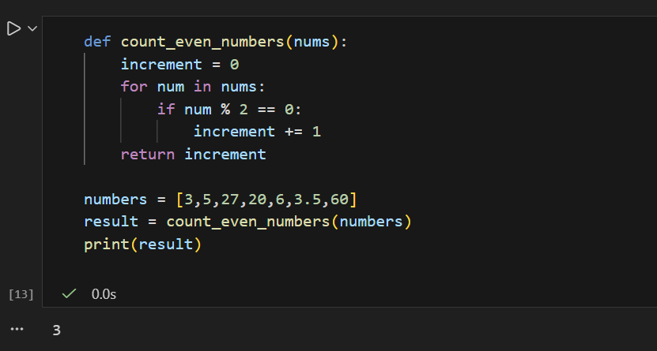
- One interaction working
The previous image also shows the code executed to sum up even numbers.
- One validation / error state
An error state passing the function a string instead of numbers
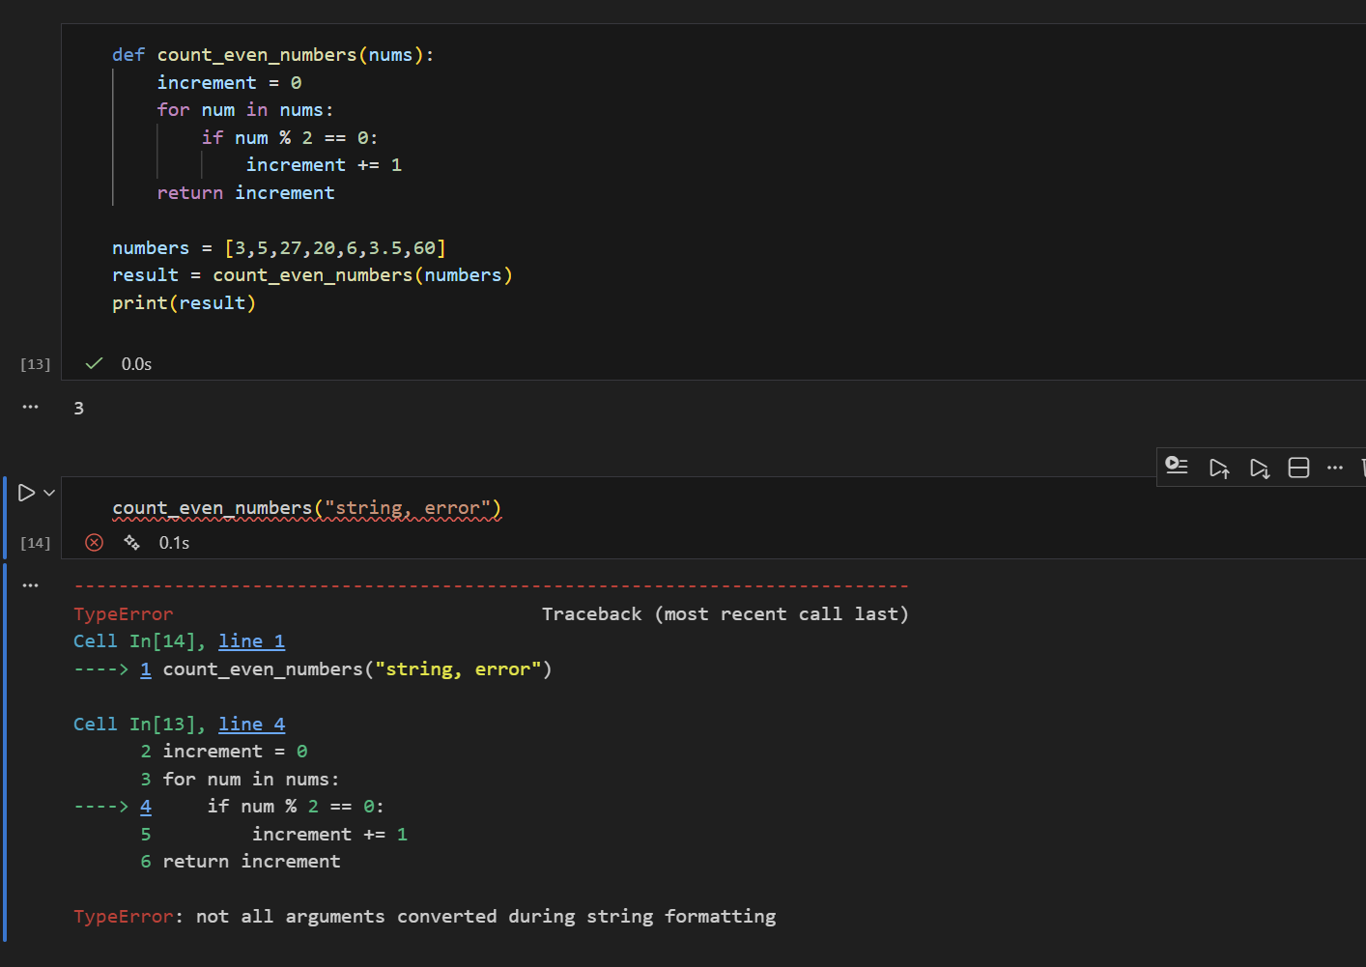

Backend/Logic
- Screenshot of one key component/element (route / controller / service)
- Not applicable to this assignment

AI Disclosure (Required) – Highlight the one that applies
- I did not use AI
- I used AI for help
- AI generated parts of my code

